Question 1 – Functional Requirements –
Functional Requirements-
A functional requirement defines a systems or product’s interactive and usable elements. A functional requirement describes functions or features developers design to enable users to complete desired actions to reach a specific objective. In other words, you can define functional requirements as the system’s basic behaviours.
Non-Functional Requirements –
A non-functional requirement defines the specifications that describe a system’s constraints or operational abilities. It also describes criteria used to judge a system’s operations and doesn’t refer to the behaviours or functions within that system. A non-functional requirement also acts as a system quality that designs solutions based on constraints and abilities.

Req ID | Req name | Req description | Priority
FR001 | Farmer registration | Farmer should be able to register with the application. | 9
FR002 | Farmer search for product | Farmer should be able to search for available product. | 8
FR003 | Manufacturer registration | Manufacturer should be able to register with the application | 8
FR004 | Manufacturer product listing | Manufacturer should be able to list their product in the catalogue. | 7
FR005 | Product details display | The application should display detail information about each product including descriptions, specification and pricing. | 9
FR006 | Add to cart | User should be able to add product to their shopping cart for purchase. | 8
FR007 | Cart management | User should be able to view and manage the contents of their shopping cart, including adding or removing products. | 8
FR008 | Wishlist management | User should be able to manage their Wishlist including adding or removing products. | 7
FR009 | Multiple payment gateways | The platform should able to integrate with multiple payment gateways. | 9
FR0010 | Order placement | User should be able to place order for selected products specifying quantity and delivery address. | 9
FR0011 | Order confirmation | User should receive order confirmation with details such as order number, products, quantities, total amount and estimate delivery date. | 9
FR0012 | Order tracking | User should be able to track the status and location of their orders in real time. | 7
FR0013 | Order history | User should be able to view their order history including past orders, order details and statuses. | 7
FR0014 | Customer support | User should have access to customer support eighter through live chat, email or phones. | 8
FR0015 | User ratings and review | User should be able to provide ratings and reviews for products they have purchase. | 7
FR0016 | Product recommendation | The platform should provide personalized products recommendations based on user preferences and browsing history. | 8
FR0017 | Social sharing | User should have the option to share products or purchase experience on social media platform. | 7
FR0018 | Secure transactions | The platform should ensure secure transactions. | 9
FR0019 | Product filtering | User should be able to filter product based on various criteria such as product range, brand or product type. | 8
FR0020 | Account management | User should be able to manage their account settings, including profile information, password changes and email preferences. | 7

Question 2– Make wireframe and prototypes –
Wireframe- A wireframe is stripping the idea down (such as an app or a webpage) to its very core. This is the 30,000-foot view of what your app or webpage may look like. It includes an outline of the structure, the user interface, and how information is laid out in front of the user. The focus here is simplicity—creating a wireframe is not a time-consuming process. Your focus here is not on the user experience or interactivity.
Prototypes- Prototypes are a high-fidelity version that, depending on user feedback, may not look and act that much different than your final product. Prototypes are great for user testing. You can test out the interactions, the user experience, the usability, and the user interface.
Registration page -

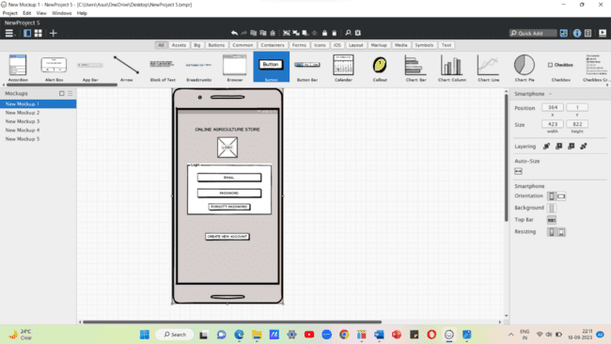
LOGIN PAGE

SEARCH AND MAIN PAGE
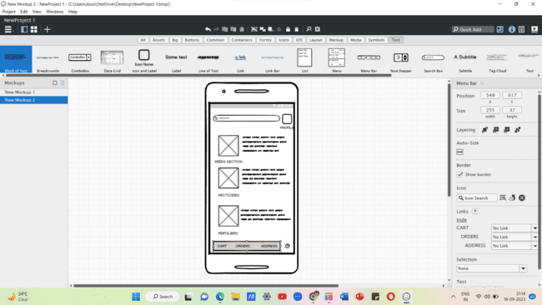
Add To Cart Page
Payment status –

Payment Page
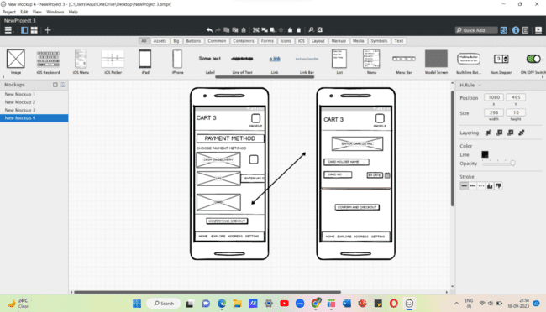

PAYMENT PAGE

Question 3 – Tools –
Visio - Microsoft Visio is a versatile application that allows users to create professional-grade diagrams such as flowcharts, network diagrams, floor plans, and much more. Microsoft Visio is a diagramming and vector graphics application included in the Microsoft 365 Business suite. It provides a wide range of templates, shapes, and tools to create professional-looking visuals, from simple flowcharts to complex technical diagrams. Visio helps business analysts document, analyse, and communicate requirements throughout the business analysis lifecycle.

Balsamiq- Balsamiq is a rapid wireframing tool that mimics the experience of sketching on a whiteboard, but on a computer. It provides a library of pre-built UI components—like buttons, input fields, and windows—that a business analyst can drag, drop, and arrange to quickly create screen layouts for websites and applications. The low-fidelity, hand-drawn aesthetic intentionally discourages discussions about aesthetic details, keeping the focus on function and user flow.

Axure RP- Axure RP stands for Rapid Prototyping, and it is a software application that enables users to quickly build functional, high-fidelity prototypes. It provides an extensive library of interactive widgets and components that can be used to assemble and test user interfaces. Its core strength lies in its ability to add conditional logic, dynamic content, and animations, making a prototype behave like a real application.

Question 4 – RTM –
Requirements traceability is a systematic approach, commonly used by business analysts or project managers to establish and maintain bi-directional links between different project artefacts, including requirements, business needs, design, or testing. Through this process, an analyst identifies the lineage of each requirement, both in the forward and backward direction, and its relationships with other requirements. This way, each requirement can be appropriately managed and approved throughout the project lifecycle. The main purpose of requirements traceability is to make sure that each requirement is accurately traced and validated, so it can be properly aligned with the overall project objectives and stakeholders’ expectations. Plus, it can help analysts discover any missing functionalities or identify implemented functionalities that are not supported by any of the project requirements.
Req ID | Req name | Req description | Design | D1 | D2 | T1 | T2 | T3 | UAT
FR001 | Website layout | Basic layout for easy navigation. | Completed | Completed | Completed | Completed | Completed | Completed | Completed
FR002 | Signup/login option | Users can register and log in securely. | Completed | Completed | Completed | Completed | Completed | Completed | Completed
FR003 | Search option | Allows users to search for products easily. | Completed | Completed | Completed | Completed | Completed | Completed | Completed
FR004 | Product Catalogue | Displays list of all available products. | Completed | Completed | Completed | Completed | Completed | Completed | Completed
FR005 | Home page | Shows featured products and categories. | Completed | Completed | Completed | Completed | Completed | Completed | Completed
FR006 | cart | Users can add or remove items before buying. | Completed | Completed | Completed | Completed | Completed | Completed | Completed
FR007 | EMI options | Provides EMI payment method for users. | Completed | Completed | Completed | Completed | Completed | Completed | Completed
FR008 | Create a Wishlist | Let’s users save products for later. | Completed | Completed | Completed | Completed | Completed | Completed | Completed
FR009 | Saved payment option | Saves payment details for future use. | Completed | Completed | Completed | Completed | Completed | Completed | Completed
FR010 | COD option | Allows users to pay cash on delivery. | Completed | Completed | Completed | Completed | Completed | Completed | Completed
FR011 | Return/exchange | Users can request return or exchange. | Completed | Completed | Completed | Completed | Completed | Completed | Completed
FR012 | Live chat box | Users can chat with support team. | Completed | Completed | Completed | Completed | Completed | Completed | Completed
FR013 | Upload reference picture search option | Search products by uploading images. | Completed | Completed | Completed | Completed | Completed | Completed | Completed
FR014 | FAQs | Provides answers to common questions. | Completed | Completed | Completed | Completed | Completed | Completed | Completed
FR015 | Email notification after order is placed | Sends email after successful order. | Completed | Completed | Completed | Completed | Completed | Completed | Completed
FR016 | Live order tracking option | Tracks live order delivery status. | Completed | Completed | Completed | Completed | Completed | Completed | Completed
FR017 | Cancel order if not required | Users can cancel order before dispatch. | Completed | Completed | Completed | Completed | Completed | Completed | Completed
FR018 | Review by the verified user | Verified users can post reviews. | Completed | Completed | Completed | Completed | Completed | Completed | Completed
FR019 | Details about the product uploaded by the manufacturer | Shows product details added by seller. | Completed | Completed | Completed | Completed | Completed | Completed | Completed
FR020 | Direct chat | Enables direct chat with manufacturer. | Completed | Completed | Completed | Completed | Completed | Completed | Completed

Question 5 – 10 Test Case Documents-
Test Case Documents are critical tools that provide a detailed, step-by-step guide for testing software to ensure it meets the defined business requirements. A BA's role is not to write every test case, but rather to translate the business needs into clear, testable criteria that testers can use to build those cases.
Test case id | ABCD0001 |  | Test case name |  | Search query
Project id | ABCD |  | Project name |  | Online agriculture shop
Test strategy | ABCD0051 |  | Tester id |  | T12345
Test plan id | ABCD00P1 |  | Date of test
Test schedule id | ABCDOS1
 |  | Set 1 |  | Set 2
Input Data |  | Pesticides |  | Seeds
 |  | Organic pesticides |  | Soyabean
 |  | 1 quantity |  | 1 kg
 |  | 200 Rs is cost |  | 550 Rs/kg
Expected behaviour |  | 100 farmers should visit and order for above data
Actual behaviour |  | 75 farmers visited and orders successfully
Comment |  | Tester tested and UAT Completed
Result-Pass/Fail |  | Pass

Test case id | ABCD0002 | Test case name | Search query
Project id | ABCD | Project name | Online agriculture shop
Test strategy | ABCD00S2 | Tester id | T12345
Test plan id | ABCD00P2 | Date of test
Test schedule id | ABCDOS2

 | Set 1 | Set 2
Input Data | Mail ID | First name
 | Mobile number | Last name
 | password | password
Expected behaviour | Mandatory fields are marked with * against the fields. Password masking.
Actual behaviour | After entering all the mandatory details register button will appear below and then press register yourself
Comment | You have been successfully registered
Result-Pass/Fail | pass

Test case id | ABCD0003 | Test case name | Search query
Project id | ABCD | Project name | Online agriculture shop
Test strategy | ABCD00S3 | Tester id | T12345
Test plan id | ABCD00P3 | Date of test
Test schedule id | ABCDOS3

 | Set 1 | Set 2
Input Data | Images of the product
 | Price of the product
 | Product specification
Expected behaviour | Select the required product
Actual behaviour | After selecting the product to buy the page will take you to the payment page to select the mode of payment
Comment | Order placed
Result-Pass/Fail | pass

Test case id | ABCD0004 | Test case name | Search query
Project id | ABCD | Project name | Online agriculture shop
Test strategy | ABCD00S4 | Tester id | T12345
Test plan id | ABCD00P4 | Date of test
Test schedule id | ABCDOS4

 | Set 1 | Set 2
Input Data | Check different payment option | Receives OTP
 | Enter card details | Check total amount
 | Payment details
Expected behaviour | Text confirmation with the order number generated
Actual behaviour | While making payment farmers can select their preferred mode of payment after entering the valid payment details press the pay button
Comment | Payment done order has successfully placed
Result-Pass/Fail | pass

Test case id | ABCD0005 | Test case name | Search query
Project id | ABCD | Project name | Online agriculture shop
Test strategy | ABCD00S5 | Tester id | T12345
Test plan id | ABCD00P5 | Date of test
Test schedule id | ABCDOS5

 | Set 1 | Set 2
Input Data | Check placed order reflected in page | Check order status
 | Name and delivery address is correct | Check delivery status
 | Item order is same as showing in order page
Expected behaviour | Item is shipped and will be deliver on date
Actual behaviour | We have imputed on in selection of one order id at a time after selecting order id press track button
Comment | Page will display the shipment status
Result-Pass/Fail | pass

Test case id | ABCD0006 | Test case name | Search query
Project id | ABCD | Project name | Online agriculture shop
Test strategy | ABCD00S6 | Tester id | T12345
Test plan id | ABCD00P6 | Date of test
Test schedule id | ABCDOS6

 | Set 1 | Set 2
Input Data | Link provided by delivery partner is correct or not | Tracking id number page in any browser
 | Link is reachable or not
Expected behaviour | If farmer click on the tracking link provided by the delivery partner it should be able to open the tracking page
Actual behaviour | Page should display the correct tracking details
Comment | Page will display the delivery status
Result-Pass/Fail | Pass

Test case id | ABCD0007 | Test case name | Search query
Project id | ABCD | Project name | Online agriculture shop
Test strategy | ABCD00S7 | Tester id | T12345
Test plan id | ABCD00P7 | Date of test
Test schedule id | ABCDOS7

 | Set 1 | Set 2
Input Data | Cancel the order | Replacement
 | Return
Expected behaviour | Testing of relevant option available after the order is placed change the order
Actual behaviour
Comment | If any option is selected then next page will display the next confirmation
Result-Pass/Fail | Pass

Test case id | ABCD0008 | Test case name | Search query
Project id | ABCD | Project name | Online agriculture shop
Test strategy | ABCD00S8 | Tester id | T12345
Test plan id | ABCD00P8 | Date of test
Test schedule id | ABCDOS8

 | Set 1 | Set 2
Input Data | Have all the questions and answers covered? | Search option is working or not
 | Alphanumeric keywords can be entered in the search bar
Expected behaviour | Testing of questions and answers available related to product or service can be searched or not
Actual behaviour | Farmers are searching different type of questions and answers
Comment | If any Q AND A searched then this FAQ page should be able to display the result on the same page
Result-Pass/Fail | Pass

Test case id | ABCD0009 | Test case name | Search query
Project id | ABCD | Project name | Online agriculture shop
Test strategy | ABCD00S9 | Tester id | T12345
Test plan id | ABCD00P9 | Date of test
Test schedule id | ABCDOS9

 | Set 1 | Set 2
Input Data | Email and phone number of customer care team | Registered office address
 | Escalation team contact details
Expected behaviour | Testing of all Q and A has been covered in the example
Actual behaviour | Any Escalation or any query farmer will contact to customer care team through this page
Comment | This page will display the available option to connect the customer care team
Result-Pass/Fail | Pass

Test case id | ABCD00010 | Test case name | Search query
Project id | ABCD | Project name | Online agriculture shop
Test strategy | ABCD00S10 | Tester id | T12345
Test plan id | ABCD00P10 | Date of test
Test schedule id | ABCDOS10

 | Set 1 | Set 2
Input Data | Product name and amount details | Total amount
 | Amount paid | Bill is prepared or COD
 | Delivery address of farmers
 | Seller address and GST number
Expected behaviour | Testing of invoice generation process
Actual behaviour | Amount paid by farmer and invoice generation
Comment | This page will display the invoice and there is an option to download the invoice
Result-Pass/Fail | Pass

Question 6 – DB Design-
Database design is the process of creating a blueprint for how to store and manage data efficiently, accurately, and securely. A well-designed database organizes information into structured tables and defines the rules and relationships between those tables. This structure ensures that a database works reliably and quickly for the applications that use it.
database schema - database schema is the blueprint or a map that defines the structure of a database. It is the foundation of the database, outlining how the data is organized, what rules govern it, and how different pieces of information relate to each other.
Entity-Relationship (ER) diagram- An Entity-Relationship (ER) diagram is a visual tool that maps out the structure of a database. In simple terms, it is a blueprint that shows all the different "things" (entities) you want to store information about and how they relate to each other.

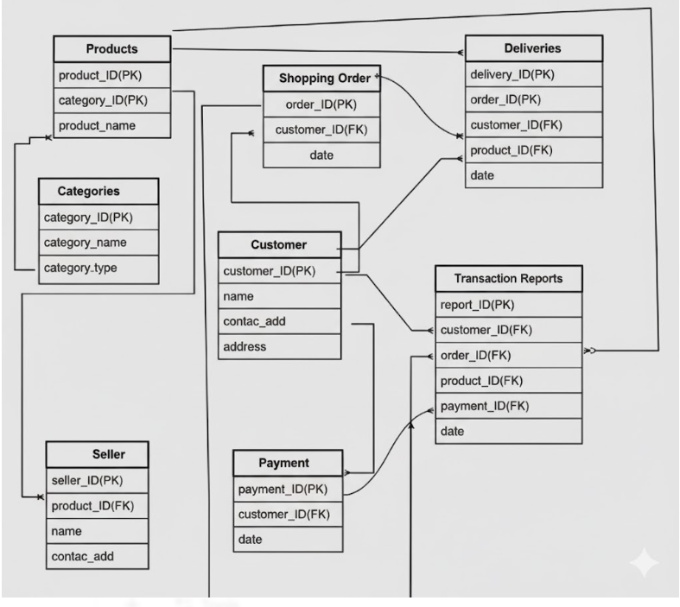

Question 7 – Data Flow Diagram-
A data flow diagram (DFD) is a visual representation of the flow of data through an information system or business process. The DFD also provides information about the outputs and inputs of each entity and the process itself. A data-flow diagram has no control flow — there are no decision rules and no loops. Specific operations based on the data can be represented by a flowchart.

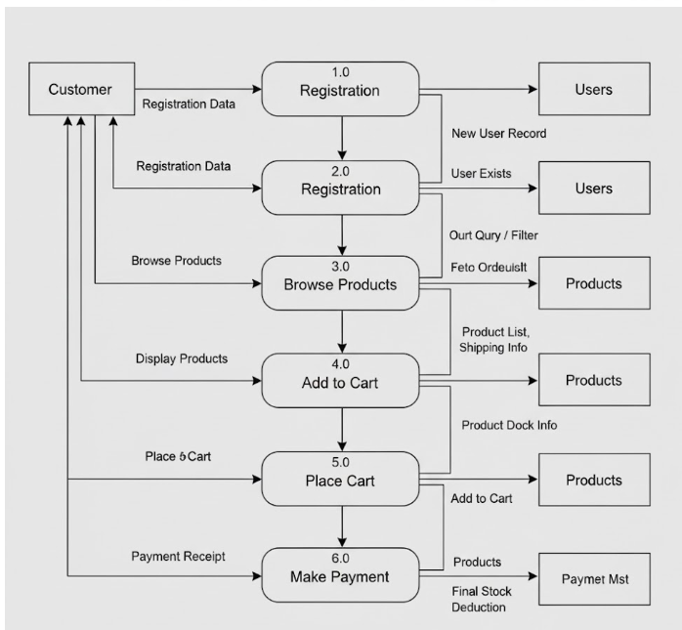

Question 8 – Change Request-
Handling change request in a project involves a systematic process to ensure that changes are effectively managed while minimizing disruption to the projects scope, timelines and resources. Here are steps typically followed to Handel change request.
1 Change request identification- Identify and document the change request including specific details of the requested change, the reason for the change and its potential impact on the project.
2 Change impact analysis- Access the impact on the change on various aspect of the project such as timeline, cost scope, resources and risk. Evaluate the feasibility and implications of implementing the change.
3 Change evaluation- review the change request with key stakeholders. Discuss the potential benefit and risk with the change. Consider the projects objectives and priorities in the evaluation process.
4 Change prioritization- prioritize the change request based on its urgency, and impact with project goal. Determine whether the change is critical and must be implemented immediately or can be schedule for future phase.
5 Change approval- obtain formal approval from appropriate stakeholders, such as project sponsor or change control board. Ensure all stakeholders are in agreement regarding the change and its implementations.
6 Change implementation- incorporate the approval change into project plan including any necessary adjustments to the scope, schedule, budget or resources. Communicate the change to the project team and other relevant stakeholders. Update the project documents such as requirements, designs and test plan, to reflect the approved change.
7 Change communication- communicate the approved change to all related parties, including team members, client and other stakeholders. Clearly explain the reason for the change, its impact on the project and any adjustments to expectations or deliverable.
8 Change tracking and documentation- track and document all approved changes. Maintain a change log or change register to ensure transparency and accountability throughout the project.
9 Change control and monitoring- continuously monitor the impact of implemented changes of the projects progress, risk and quality. Maintain open lines of communication with stakeholders to address any concern or issue related to the approved changes.
By following these steps, a project can effectively manage the change requests, ensuring that changes are evaluated, approved and implemented in a controlled manner.

Question 9 – Change Request Vs an Enhancement-
As a business analyst my response to the Ben and Kevins request would be to classify it as an enhancement rather than a change request. A change request typically involves modifications to existing functionality or requirements, while encashment introduce new features or capabilities that were not initially specified.
In this case the request to allow farmers to add their crop yield, display them to the general public and enable selling through the application represents an encashment because it introduces new functionality that goes beyond the initial scope of the project.
To address this encasement request, I would follow the standers process of handling new requirements-
1 Requirement gathering- I would meet with Ben and Kevin to gather detail requirements for the new functionality. This would involve understanding the new features they envision.
2 Impact analysis- I would analyse the impact on this encasement on the existing projects scope, timeline, budget and resources. This assessment would help determine the feasibility and potential implications of incorporating the requested features.
3 stakeholder analysis- I would identify and involve relevant stakeholders such as the project sponsor, development team and other key personnel to access their prospective and gather their inputs.
4 Documentation and communication- I would document the detail requirements and changes in the projects scope and communicate them to the project team. This would ensure everyone is aware of proposed enhancements.
5 Evaluation and prioritization- I would work with the project team and stakeholders to evaluate the value and priority of the requested enhancements.
6 Planning and execution- if the enhancements are deemed feasible and approved, I would update the project plan, schedule and resources accordingly.
By treating this request as an enhancement, the project can effectively manage the additional requirements and deliver the desired functionality while considering the impact on the ongoing project.

Question 10 – Estimations-
Estimating the number of man hours required for the requested enhancements would depend on various factor including complexity of the feature, size of the existing system, development teams’ expertise and the development methodology used. Following is the general guidelines based on the industry standards-
1 Requirement gathering and analysis: 10–20-man hours.
This includes meeting with stakeholders, gathering detailed requirements, analysing the impact and documenting the enhancements.
2 Design and architecture: 20–40-man hours.
This involve designing the system components, database structure and user interface for new features.
3 Development and coding: 40-80man hours.
The actual development of new features including backend and frontend coding, integration with existing module.
4 Testing and quality assurance: 20-40man hours
This phase involves writing taste cases, performing unit testing, integration testing and ensuring the proper functioning and stability of the added features.
5 Deployment and UAT: 10–20-man hours
Deploying the updated system to a testing environment, conducting UAT and resolving any issues identified during UAT.
6 Documentation and training: 10-20man hours
Documenting new features, updating user manuals or guides and providing trainings.

Question 11 – UAT-
Steps to follow in UAT-
1 UAT planning- prepare plan for UAT in consolation with the client. This plan should include the scope of testing, test data and timelines.
2 Test environment setup- ensure that the required test environment is setup and available for the client to perform testing.
3 Test execution- coordinate with the client to execute the planned test scenarios. Monitor the testing progress, provide the support for any question.
4 Defect management- If any defects are identified during UAT, work closely with client to understand the issues, document them and track their resolution.
5 UAT sign off- Once the client has completed testing and is satisfied with the products functionalities, obtain their formal sign off or approval.
Regarding the process to close the project, it typically involves the following steps:
1. Final Documentation: Ensure that all project-related documentation is complete, including requirements, design documents, test cases, and user manuals. Review and update these documents to reflect the final product.
2. Project Review: Conduct a project review meeting with key stakeholders, including the client, to discuss the overall project performance, achievements, and lessons learned. Gather feedback and suggestions for improvement.
3. Project Closure Report: Prepare a project closure report summarizing the project's objectives, deliverables, timeline, budget, and overall success. Include any important metrics or performance indicators.
4. Handover or Deployment Coordinate with the necessary teams, such as deployment or operations, to ensure a smooth transition of the final product to the production environment. Provide any necessary training or documentation to support the deployment process.
5. Post-Project Evaluation: After the product is deployed and operational, conduct a post-project evaluation to assess its performance, gather user feedback, and identify any areas for further improvement.
UAT Acceptance Process:
The User Acceptance Testing (UAT) Acceptance process involves the following steps:

1. Test Planning: Define the scope of UAT and identify the key features or functionalities to be tested. Prepare test scenarios and test cases based on user requirements.
2. Test Execution: Perform the planned test scenarios, following the test cases provided. Validate the system's behaviour against the expected outcomes and verify that it meets the user's acceptance criteria
3. Defect Reporting: If any issues or defects are identified during UAT, document them in a structured manner, including detailed steps to reproduce the problem. Communicate the issues to the development team for resolution.
4. Defect Resolution: Collaborate with the development team to address the reported defects. Verify the fixes provided by the development team and retest the affected areas.
5. Sign-off: Once all test scenarios have been executed, defects have been resolved, and the system meets the user's acceptance criteria, provide formal sign-off or approval. This signifies that the client accepts the product as meeting their requirements.
6. UAT Closure: Document the UAT results, including the test execution summary, any outstanding issues, and the overall assessment of the product.

Question 12 – Project Closure Document-
A project closure document is a final report that officially ends a project by summarizing its results, assessing its success, and documenting lessons learned. It acts as a final record that includes details on the project's accomplishments, final budget, and any problems or successes, providing a clear picture of the project's outcome and its impact on future work. The document typically includes the following section –
Project overview: The initial goals, objectives, and success metrics.
Performance analysis: A comparison of the project's actual outcome against its original plan, covering scope, budget, and schedule.
Outcomes and deliverables: A list of all completed deliverables and a confirmation that they were approved by the client or stakeholders.
Financial summary: An overview of the project's finances, including actual vs. planned expenses and confirmation that all invoices have been settled.
Lessons learned: A summary of key takeaways and recommendations for the future.
Official sign-off: A final sign-off from the project manager, client, or key stakeholders to formally terminate the project.
A Project Closure Document serves to formally conclude a project and capture all the necessary administrative, financial, and performance details. It provides a complete record of the project's successes, failures, and lessons learned, which is crucial for future projects and continuous improvement.

