Document 6
Please prepare a use case diagram, activity diagram and a use case specification document.
Use Case Diagram:
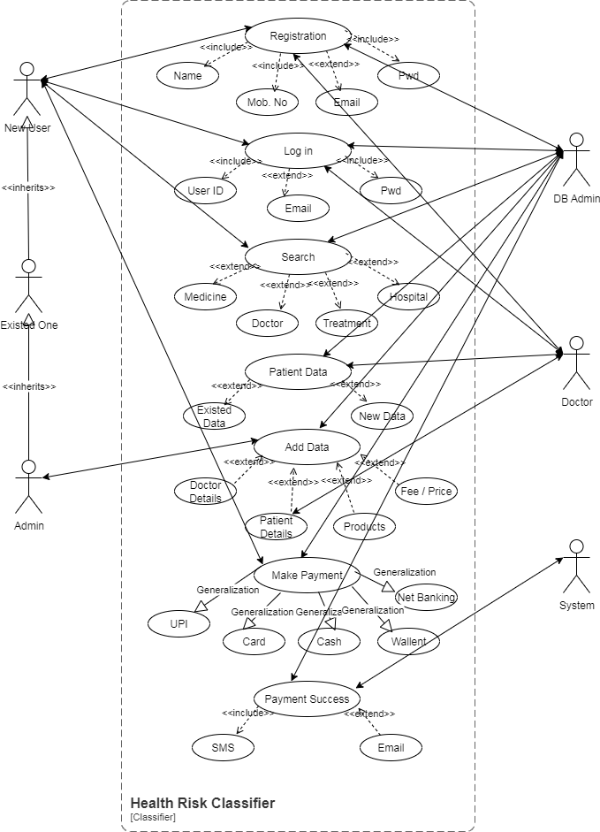
Activity Diagrams:
Login/ Register | Enter Health Data | Search/Browse Products
Classify Health Risk | View Health Report | Doctor Consultation
Send Health Alerts | Update Health Data | Make Payment

Use Case Specifications:
UC001 – Login/ Register
- Use Case Name: User Login/Register
- Use Case Description: This use case allows a user (patient, doctor, or admin) to log in to the Health Risk Classifier system by entering valid credentials (username and password). Successful login grants access to role-specific features
- Actor :
Primary Actor: User (Patient, Doctor, Admin)
Secondary Actor: Authentication System (validates credentials)
- Basic Flow:
User navigates to the login page.
User enters username and password.
System validates the credentials.
If valid, the system identifies the user role (patient/doctor/admin).
User is redirected to the respective dashboard.
- Alternate Flow:
If the user clicks "Forgot Password", the system initiates the password recovery process.
If the user enters invalid credentials but retries, the system allows re-entry up to 3 attempts.
- Exceptional Flows
If the user enters incorrect credentials more than 3 times, the account is temporarily locked.
If the authentication system is down, the login request cannot be processed and a maintenance message is displayed.
- Pre-Conditions
The user must be registered in the system.
Authentication server/database must be available.
- Post-Conditions
User successfully logs in and gains access to system features based on their role.
Failed login attempts are logged for security monitoring.
- Assumptions
User has stable internet connectivity.
Users remember their login credentials or have access to recovery options.
- Constraints
System should lock accounts after 3 failed login attempts.
Login session should expire automatically after a set timeout (e.g., 15 minutes of inactivity).
- Dependencies
Database for storing user credentials.
Authentication service for validating login details.
- Inputs and Outputs
Input: Username, Password.
Output: Access granted (dashboard view) or error message.
- Business Rules
Only registered users can log in.
Each user role has restricted access to specific modules.
Passwords must meet security policy requirements.
- Miscellaneous Information
System should support multi-device login (web and mobile).
Login page must be user-friendly and secure (SSL encryption).
UC002 – Search/Browse Products
- Use Case Name: Search/Browse Products
- Use Case Description: This use case allows users (patients or doctors) to search and browse through available health-related products (e.g., supplements, diagnostic kits) within the Health Risk Classifier system. Users can filter, sort, and view product details before making a purchase or recommendation.
- Actors:
Primary Actor: User (Patient/Doctor)
Secondary Actor: Product Catalog System / Database
- Basic Flow:
User navigates to the Products section.
User enters keywords (e.g., "Vitamin D", "Blood Pressure Monitor") in the search bar or selects a category.
System retrieves matching products from the database.
User browses the product list with options to filter/sort by price, category, or rating.
User clicks on a product to view detailed information.
- Alternate Flow
If no search keyword is entered, system displays all products by default.
If filters (e.g., "Low Price First") are applied, system reorders results accordingly.
If user searches by category (e.g., "Supplements"), only relevant products are shown.
- Exceptional Flows
If the database is unavailable, an error message is displayed: “Products cannot be retrieved at this time.”
If no products match the search query, the system displays: “No products found.”
- Pre-Conditions
The product catalog must be available in the database.
User must be logged in (if browsing is restricted to registered users).
- Post-Conditions
User successfully views the list of products matching the search.
System logs the search history for personalization or analytics.
- Assumptions
Product catalog is updated and contains accurate information.
User has internet access to load search results.
- Constraints
Search results must load within 3 seconds.
Maximum number of search results per page should be limited (e.g., 20 items).
- Dependencies
Product Database/Catalog system.
Search engine algorithm within the application.
- Inputs and Outputs
Input: Search keyword, category filter, sort option.
Output: Product list with details (name, price, category, description).
- Business Rules
Users can only view products relevant to their role (e.g., doctors see medical kits, patients see wellness products).
Out-of-stock products must be shown as unavailable.
Product details must be verified and approved before being displayed.
- Miscellaneous Information
The system should support both text-based search and category browsing.
Products should be displayed with images for better user experience.
UC003 – Enter Health Data
- Use Case Name: Enter Health Data
- Use Case Description: This use case allows the patient to input health-related parameters into the system for classification.
- Actors:
Primary Actor: Patient
Secondary Actor: System
- Basic Flow:
Patient logs into the system.
Patient enters required health parameters (age, weight, blood pressure, sugar levels, etc.).
System accepts and stores the data temporarily for validation.
- Alternate Flow: Patient may auto-import data from wearable health devices (optional).
- Exceptional Flows: Missing/invalid data → System prompts user to re-enter.
- Pre-Conditions: Patient is authenticated.
- Post-Conditions: Data is stored and ready for validation/classification.
- Assumptions: Patient provides accurate details.
- Constraints: Only predefined parameters are accepted.
- Dependencies: Database storage availability.
- Inputs and Outputs
Input: Patient’s health data.
Output: Confirmation of data entry.
- Business Rules: Mandatory fields must be completed before proceeding.
- Miscellaneous Information: Data can later be edited before submission for classification
UC004 – Classify Health Risk
- Use Case Name: Classify Health Risk
- Use Case Description: This use case describes how the system classifies the patient’s health data into a risk level (Low, Medium, High).
- Actors:
Primary Actor: System
Secondary Actor: Patient, Doctor
- Basic Flow:
System validates the entered data.
System applies classification algorithm (e.g., decision tree, logistic regression).
System generates health risk output.
- Alternate Flow: Patient may request re-classification with updated data.
- Exceptional Flows:
System error → Risk classification fails → Display error.
Database connection fails.
- Pre-Conditions: Valid patient data must exist.
- Post-Conditions: Risk level (Low/Medium/High) is generated.
- Assumptions: Classification algorithm is pre-trained and accurate.
- Constraints: Classification limited to defined health parameters.
- Dependencies:
Algorithm model availability.
Database connectivity.
- Inputs and Outputs:
- Input: Patient health data.
- Output: Risk category (Low/Medium/High).
- Business Rules: Classification must comply with medical guidelines.
- Miscellaneous Information: The system may allow upgrading the algorithm in the future
UC005 – View Health Report
- Use Case Name: View Health Report
- Use Case Description: This use case allows the patient to view, download, or share their risk classification report.
- Actors:
Primary Actor: Patient
Secondary Actor: Doctor, System
- Basic Flow:
Patient logs into the system.
Patient requests health risk report.
System retrieves and displays the report.
- Alternate Flow:
Patient downloads/prints report.
Patient shares report with doctor.
- Exceptional Flows:
Report not found → Error message.
Network issue → Report fails to load.
- Pre-Conditions: Report must already exist in the system.
- Post-Conditions: Patient successfully views/downloads report..
- Assumptions: Patient has access to internet/system.
- Constraints: Report format fixed (PDF/HTML).
- Dependencies:
Database and storage.
Doctor’s consultation module.
- Inputs and Outputs:
- Input: Patient request.
- Output: Health risk report.
- Business Rules:
Report must not be altered once generated.
Only the patient/doctor can access the report.
- Miscellaneous Information:: Future scope: Reports may be integrated into national health systems.
UC006 – Update Health Data
- Use Case Name: Update Health Data
- Use Case Description: Allows patients to edit/update previously entered health data.
- Actors: Primary – Patient | Secondary – System
- Basic Flow: Patient selects record → Updates → Saves changes.
- Alternate Flow: Patient deletes outdated records.
- Exceptional Flows: Invalid values → Error.
- Pre-Conditions: Patient must be logged in.
- Post-Conditions: Updated data stored.
- Assumptions: Patient provides correct values.
- Constraints: Historical records cannot be fully erased.
- Dependencies: Database.
- Inputs/Outputs: Input → Modified health data | Output → Confirmation.
- Business Rules: Latest data overwrites old one.
- Miscellaneous: System may keep version history
UC007 – Doctor Consultation
- Use Case Name: Doctor Consultation
- Use Case Description: Enables patient to consult a doctor based on risk level.
- Actors: Primary – Patient | Secondary – Doctor, System
- Basic Flow: Patient requests consultation → Doctor reviews report → Provides feedback.
- Alternate Flow: Online chat or video call.
- Exceptional Flows: Doctor unavailable.
- Pre-Conditions: Health report exists.
- Post-Conditions: Doctor feedback stored.
- Assumptions: Doctor has account.
- Constraints: Only certified doctors allowed.
- Dependencies: Communication module.
- Inputs/Outputs: Input → Request | Output → Feedback.
- Business Rules: Only patient’s assigned doctor can consult.
- Miscellaneous: Could integrate telemedicine API.
UC008 – Send Health Alerts
- Use Case Name: Send Health Alerts
- Use Case Description: Sends notification if patient’s risk level is high.
- Actors: Primary – System | Secondary – Patient, Doctor
- Basic Flow: Classification result = High risk → System sends alert.
- Alternate Flow: Doctor receives parallel alert.
- Exceptional Flows: SMS/Email delivery failure.
- Pre-Conditions: Contact info registered.
- Post-Conditions: Alert delivered.
- Assumptions: Communication server is active.
- Constraints: Limited to predefined channels (SMS/Email).
- Dependencies: Notification service.
- Inputs/Outputs: Input → Risk level | Output → Alert message.
- Business Rules: Alerts only for Medium/High risk.
- Miscellaneous: Critical alerts may trigger emergency contact.
UC009 – Add to Cart
- Use Case Name: Add to Cart
- Use Case Description: This use case allows a user to add selected health-related products (e.g., supplements, diagnostic kits) to their virtual shopping cart for later review or purchase.
- Actors
Primary Actor: User (Patient/Doctor)
Secondary Actor: Product Catalog System / Shopping Cart System
- Basic Flow
User searches or browses a product.
User clicks on the “Add to Cart” button.
System verifies product availability (stock check).
System adds the product to the user’s cart.
System displays a confirmation message “Product successfully added to cart.”
- Alternate Flow
If product is already in the cart, system updates the quantity.
If user wants to change quantity, they can modify it in the cart.
- Exceptional Flows
If product is out of stock, system shows an error: “Product unavailable.”
If the cart system is down, an error message is displayed: “Unable to add product to cart at this time.”
- Pre-Conditions
User must be logged in.
Product must be available in the catalog.
- Post-Conditions
Product is added to the user’s cart successfully.
Cart is updated with the latest information.
- Assumptions
Cart can hold multiple items.
System maintains cart state until checkout.
- Constraints
Maximum number of items per cart (e.g., 50 products).
Only available products can be added.
- Dependencies
Product Database.
Cart Management System.
- Inputs and Outputs
Input: Product ID, quantity.
Output: Updated cart with product details.
- Business Rules
Cart must always show accurate prices and stock availability.
Users cannot add items beyond available stock.
- Miscellaneous Information: Cart should persist even if user logs out and logs back in.
UC010 – Make Payment
- Use Case Name: Make Payment
- Use Case Description: This use case enables users to make payments for their selected products after checkout using various payment methods such as credit/debit card, net banking, or UPI.
- Actors
Primary Actor: User (Patient/Doctor)
Secondary Actors: Payment Gateway, Bank/Financial Institution
- Basic Flow
User proceeds to Checkout.
User reviews order summary and selects a payment method.
System redirects to the secure payment gateway.
User enters payment credentials (e.g., card details, UPI PIN).
Payment gateway validates and processes the transaction.
System receives confirmation from payment gateway.
System updates order status as Paid and generates a receipt.
User receives confirmation and receipt.
- Alternate Flow
If user cancels during payment, system redirects back to Checkout.
If one payment method fails, user may retry with another method.
- Exceptional Flows
If payment gateway is unavailable, system shows “Payment service temporarily unavailable.”
If transaction fails due to insufficient funds or incorrect details, system displays an error and prompts retry.
- Pre-Conditions
User must have products in the cart.
User must be logged in.
- Post-Conditions
Payment is successfully processed.
Order status is updated in the system.
- Assumptions
User has valid payment credentials.
Payment gateway is secure and reliable.
- Constraints
Payment must be completed within a session timeout period (e.g., 5 minutes).
Only supported payment methods are accepted.
- Dependencies
Payment Gateway API.
Bank/Financial Institution.
Order Management System.
- Inputs and Outputs
Input: Payment credentials, order ID, amount.
Output: Payment confirmation, receipt.
- Business Rules
Payment must be authorized and validated before order confirmation.
Refund policies must be enforced if payment is reversed.
- Miscellaneous Information
System must use SSL/TLS for secure payment communication.
Payment logs should be stored for auditing.

Document 7- Screens and pages
Wire Frames:
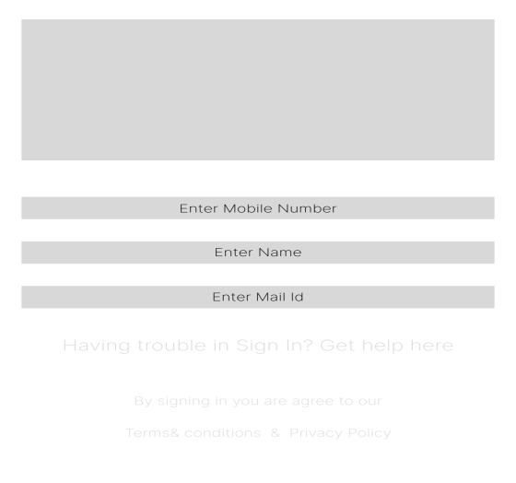
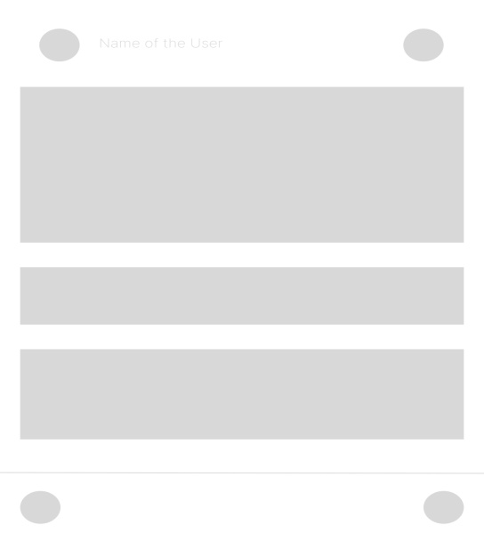
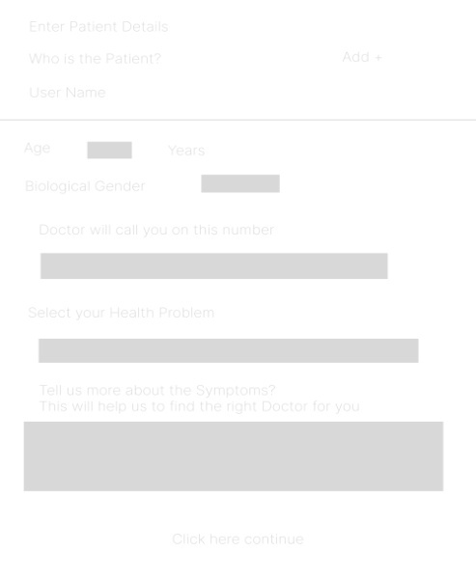
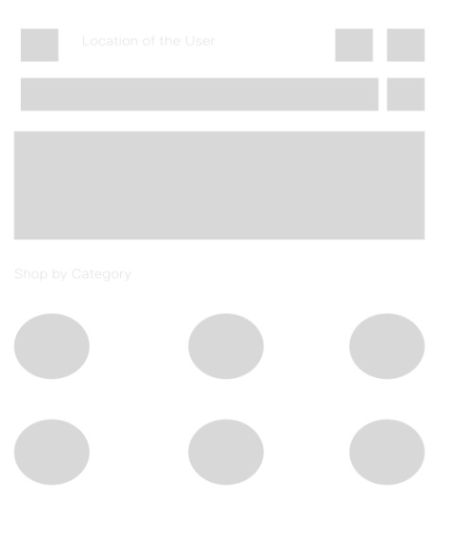
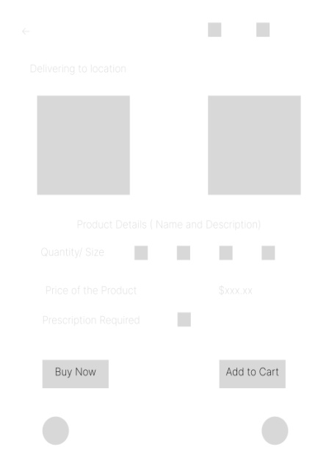
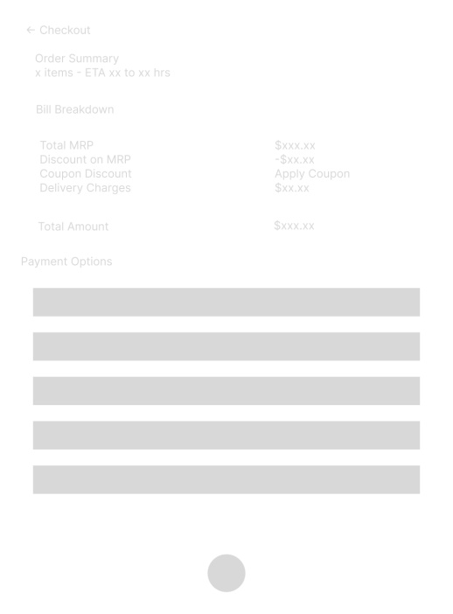
Proto Types:
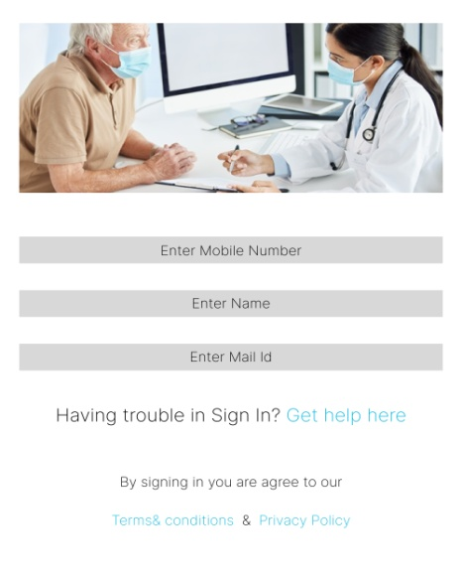
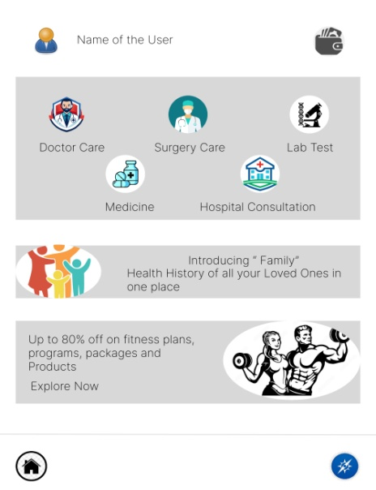
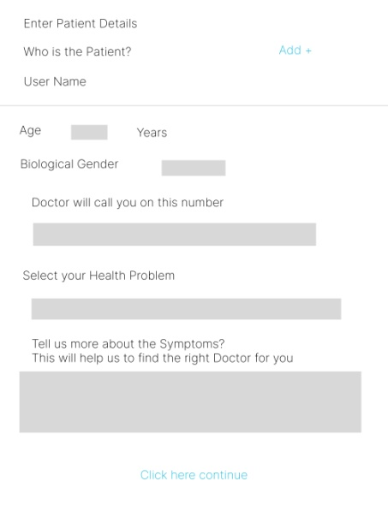
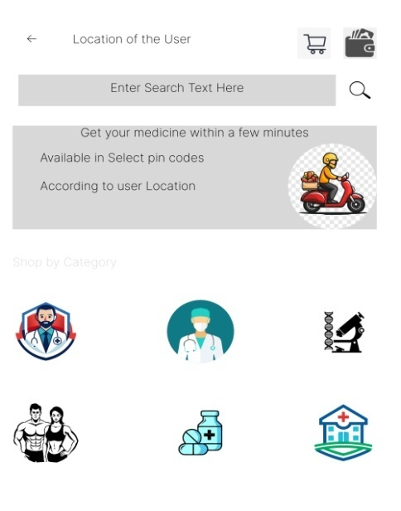
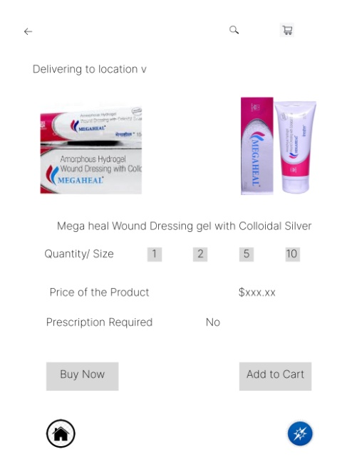
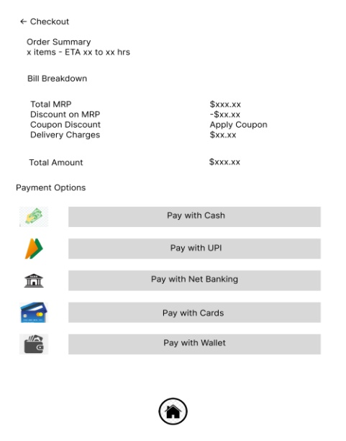
Document 8- Tools-Visio and Axure
Write a paragraph on your experience using Visio and Axure for the project.
As a Business Analyst on the Health Risk Classifier project, which followed the Waterfall Model, I extensively used Microsoft Visio and Axure to support clear communication and documentation throughout the project lifecycle. During the requirements gathering phase, I utilized Visio to create detailed process flow diagrams and system context diagrams, which helped stakeholders visualize the data flow and system interactions. These diagrams served as foundational references for developers and testers during the design and implementation stages. Simultaneously, I used Axure to develop interactive wireframes and prototypes for key user interfaces, ensuring early validation of UI requirements with stakeholders. The Axure prototypes allowed the project team to detect usability issues before development began, reducing rework later in the project. Using these tools in a structured Waterfall environment ensured well-documented, sequential handoffs between phases, contributing to a smooth and traceable development process.

Document 9- BA experience
My experience as BA in following phases:
- Requirement gathering:
- To gather requirements, we used MOSCOW technique.
- Client is not available for some period of time during this phase. So as a BA i need to source out point of contacts from his side and get the information ASAP.
- I validate the requirements using FURPS technique
- There are many requirements which are duplicated or repeated. We need to remove them immediately
- Prototyping is used to give more specific requirements
- Requirement Analysis:
- We need to draw UML diagrams to visually describe the requirements
- Activity diagrams also used to describe the process flow
- Communicate the diagrams to team. Some team members might not agree with them and might make changes.
- As a BA we need to consider the points and make modifications
- Prepare BRS and SRS

- Design:
- From the use case diagrams, we prepare test cases
- Communicate with client on design and solution documents
- Write negative test cases as well along with positive test cases.
- Do not miss a single test case. It might have huge impact on project development in later stages
- Prepare test data for testing
- Update RTM. This is just as we need to make sure that all the requirements are met
- Development:
- Organized JAD sessions
- Clarifying queries of tech team during coding
- There might be some team members who doesn't agree with the concept or who doesn’t cooperate during JAD sessions.
- As a BA i handle the situation gently and had one on one discussion with them.
- Explained how their actions are going to affect the project. Setup healthy environment within the team.
- Referred diagrams to code the Unit
- Conduct regular meetings with technical team and client which is challenging.
- Some team members might not be available for the meeting.
- Recording the session and providing that to missed one and having one to one discussion later with that missed person is all i need to do
- Testing:
- Prepare test cases from use cases
- Perform high level testing
- Test data is requested by BA from client
- Updated RTM
- Take signoff from client
- Prepare client for UAT
- Deployment:
- Forwarded RTM to client which should be attached to project closure document
- Coordinates to complete and share end user manuals
- Plans and organizes training sessions
- Make sure all the candidates attend the meeting

