Waterfall Project 1 – Part 1/2

Business Analysis Documents
Project: Secure Content Flow – Content Moderation and Business Verification
Version: v1.0
Date: 07-Aug-2025

Document 1: Business Case
Why is this project initiated?
The project is initiated due to the increasing volume of offensive and inappropriate content online. There is a pressing need for real-time content moderation to protect users and ensure compliance with platform and legal standards. It also addresses the requirement to verify online businesses accurately.
What are the current problems?
- Offensive content reaching users without checks.
- Lack of real-time moderation.
- Inaccurate or missing business verification.
- Legal risks due to non-compliance.
- Backend systems not updated consistently with findings.
With this project how many problems could be solved?
- Offensive content can be filtered before reaching users.
- Verified and accurate business listings.
- Improved legal compliance.
- Enhanced user trust and platform safety.
- Timely updates to backend systems.
What are the resources required?
- Skilled content reviewers trained in research and compliance.
- Guidelines, SOPs, and moderation rulebooks from clients.
- BA team for coordination.
- Tools and research services (estimated cost ₹50,000).
How much organizational change is required to adopt this technology?
Moderate change: primarily involves training moderators, establishing clear workflows, and integrating moderation tools with backend systems.
Time frame to recover ROI?
The ROI could be recovered within a few months of implementation through improved compliance, reduced legal risks, and increased user trust.
How to identify Stakeholders?
Stakeholders can be identified through:
- Client-side (Business Owner, Legal Team, End Users)
- Internal teams (BA, Moderators, Developers, Project Sponsor, Manager)

Document 2: BA Strategy
➤ Project Name:

Secure Content Flow – Moderation and Business Verification Project

➤ Business Analyst Strategy Overview:

Requirement Gathering:

Conduct stakeholder meetings to capture content moderation needs and verification goals.

Identify regulatory and legal standards to be followed.

Define scope boundaries (content types, region, language, etc.).1

Stakeholder Engagement:

Schedule regular sync-ups with clients and internal teams.

Involve content reviewers, compliance experts, and backend developers.

Define communication protocols and escalation paths.

Documentation:

Maintain clear, detailed documents: BRD, Functional Specs, and Traceability Matrix.

Update process documents based on client feedback.

Tool and Platform Evaluation:

Collaborate with IT to select or customize moderation tools.

Ensure integration capabilities with existing backend systems.

Change Management:

Plan for periodic SOP updates based on rulebook revisions.

Communicate changes clearly and provide training to moderators.

Quality Assurance and Testing Support:

Define acceptance criteria for both moderation rules and verification steps.

Support UAT by clarifying requirements and validating test results.

Risk Mitigation:

Address inconsistencies in moderation by standardizing rules.

Plan fallback mechanisms for tool access or SOP delays.

Document 3: Functional Specifications
Project Details:
Project Name: Secure Content Flow
Customer Name: [Atidiv Pvt Ltd.]
Project Version: v1.0
Project Sponsor: Priyanka Madki
Project Manager: Sadaf
Project Initiation Date: [07-08-2025]
➤ Functional Requirement Specifications Table:
Req ID |  | Req Name | Req Description | Priority
FR0001 |  | Login | Users should be able to log in securely to access moderation and verification tools. | 10
FR0002 |  | Content Moderation | Users should review and flag offensive content as per defined SOPs. | 9
FR0003 |  | Business Verification | Verify authenticity of business details and update backend. | 9
FR0004 |  | Backend Update | Moderators should update backend with research results. | 8
FR0005 |  | Reporting | Generate compliance and performance reports.  Document 4- Requirement Traceability Matrix | 7
 | Req ID | Req Name | Req Description | Design | D1 | T1 | D2 | T2 |  | UAT
 | FR0001 | Login | Users must be able to log in securely | Yes | ✓ | ✓ | ✓ | ✓ |  | Yes
 | FR0002 | Content Moderation | Flag offensive content using defined rules | Yes | ✓ | ✓ | ✓ | ✓ |  | Yes
 | FR0003 | Business Verification | Verify and research business entries | Yes | ✓ | ✓ | ✓ | ✓ |  | Yes
 | FR0004 | Backend Update | Push updates to backend accurately | Yes | ✓ | ✓ | ✓ | ✓ |  | Yes
 | FR0005 | Reporting | Generate reports on moderation performance | Yes | ✓ | ✓ | ✓ | ✓ |  | Yes

Document 5: Business Requirements Document (BRD)
Project Name: Secure Content Flow
Project ID: SCF-2024-001
Version ID: v1.0
Author: [Sonali]

1. Document Revisions
Date | Version Number | Document Changes
05/08/2025 | 0.1 | Initial Draft Created

2. Approvals
Name – Sonali
Roles- Business Analyst
Signature – Sonali Kumari
Date – 11/08/2025

3. RACI Chart
Task / Phase | Project Sponsor | Project Manager | Business Analyst | Content Reviewers | Client
Requirement Gathering | A | R | R/A | C | C
System Design | C | A | R | C | C
Implementation (Moderation & Verification) | C | A | C | R | C
Verification (Quality Check) | C | A | C | R/A | C
Maintenance & Updates | C | A | C | R | C
Client Feedback Review | C | A | R | C | R/A
Final Approval & Handover | A | R | C | C | C

R (Responsible): Person(s) doing the work.

A (Accountable): Person ultimately answerable for the task being completed.

C (Consulted): Person(s) providing input before/during the work.

I (Informed): Person(s) kept updated on progress (not directly in chart but can be added if needed).

4. Introduction
4.1 Business Goals
To provide a secure, scalable solution for content moderation and business verification to ensure user safety and compliance.
4.2 Business Objectives
- Review and flag inappropriate content.
- Verify businesses.
- Ensure backend data accuracy.
- Generate compliance reports.
4.3 Business Rules
- All flagged content must follow SOPs.
- Only verified businesses updated.
- Role-based access.
4.4 Background
Due to harmful content online, this project was proposed to improve moderation and verification workflows.
4.5 Project Objective
Review and remove harmful content before it reaches to users.
Conduct business verification for CF project.
Update client back-end with accurate research findings.
Ensure platform policies are followed consistently

4.6 Project Scope
4.6.1 In Scope
- Moderator login
- Content moderation
- Business verification
- Reporting
4.6.2 Out of Scope
- End-user interface
- Financial transaction modules

5. Assumptions
- Moderators will be trained.
- SOPs provided by client.
- Backend APIs accessible.

6. Constraints
- ₹50,000 budget for tools.
- Tight deadlines.
- Client dependencies.

7. Risks

Inconsistent application of moderation rules.

Legal challenges if inappropriate content is missed.

8. Business Process Overview
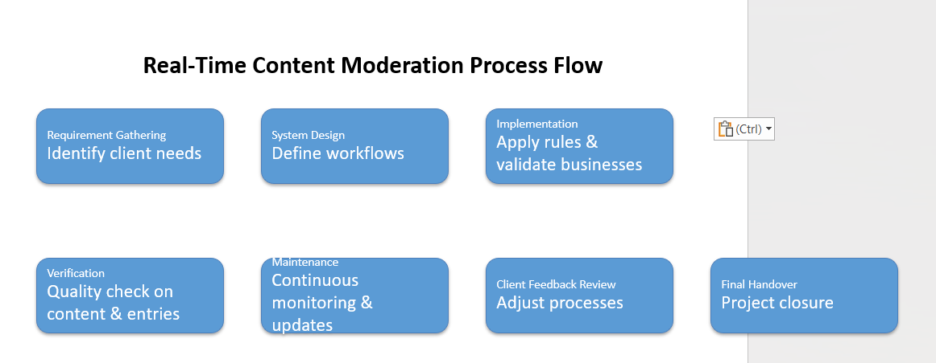
8.1 Legacy System (AS-IS)
Manual moderation: humans read reports/posts and take action by hand.
Delayed backend updates: moderator actions are entered into backend systems after a lag (minutes → hours → days).
No integration: moderation tools, client back-end and reporting are separate — no automated pipelines or APIs.

8.2 Proposed System (TO-BE)
Structured, real-time moderation pipeline that processes text, images and video.
Tight integration between moderation engine, human review UI, and client backend so verification and reporting happen automatically.

9. Business Requirements
ID | Requirement | Priority | Notes
BR001 | Secure Login | High | Role-based access
BR002 | Content Moderation Module | High | With flagging and SOP rules
BR003 | Business Verification Module | High | Research, verify, then update
BR004 | Backend Update Function | Medium | API-based integration
BR005 | Reporting Dashboard | Medium | Compliance & performance logs

10. Appendices
10.1 Acronyms
- SOP: Standard Operating Procedure
- UAT: User Acceptance Testing
- BRD: Business Requirements Document
10.2 Glossary
Moderation: Reviewing content
Verification: Authenticating business
Backend: Client system updated by project team
10.3 Related Documents
- Waterfall Project Proposal (Waterfall 1)
- SOPs
- Functional Specs

Functional Requirements Specification (FRS)
Project Name: Real-Time Content Moderation & Business Verification
Version: 1.0
Prepared By: Sonali
Date: 11/08/2025

1. Introduction
The system will provide structured, real-time moderation of offensive and inappropriate content online and integrate with backend systems for verification and reporting.

2. Functional Requirements
FR ID | Requirement Description | Priority | Source
FR-01 | The system shall detect offensive/inappropriate content in real time using AI and rule-based engines. | High | Project Objectives
FR-02 | The system shall automatically flag or remove harmful content before it reaches users. | High | Project Objectives
FR-03 | The system shall allow human moderators to review flagged content. | High | Project Objectives
FR-04 | The system shall perform business verification tasks as per client guidelines. | High | Project Objectives
FR-05 | The system shall update the client backend with accurate research findings. | High | Project Objectives
FR-06 | The system shall log all moderation actions for auditing purposes. | Medium | Success Criteria
FR-07 | The system shall generate compliance and performance reports. | Medium | Success Criteria

3. Non-Functional Requirements
NFR ID | Requirement Description | Priority
NFR-01 | Real-time moderation latency should be under 500 ms. | High
NFR-02 | Detection accuracy should be >95% true positive rate. | High
NFR-03 | The system should handle millions of content items daily without performance degradation. | High
NFR-04 | Ensure 99.9% uptime. | High
NFR-05 | Comply with GDPR, COPPA, and other relevant regulations. | High

UAT – User Acceptance Test Cases
UAT ID | Test Scenario | Test Steps | Expected Result | FR Ref
UAT-01 | Detect and remove harmful content | Upload offensive text/image | System removes/flags content instantly | FR-01, FR-02
UAT-02 | Human review of flagged content | Submit borderline content | Moderator sees item in dashboard & can approve/remove | FR-03
UAT-03 | Perform business verification | Submit business details | Verified result stored in backend | FR-04, FR-05
UAT-04 | Audit log creation | Remove a harmful post | Action recorded with timestamp & user | FR-06
UAT-05 | Compliance report generation | Request monthly report | System generates PDF/Excel report | FR-07

Requirements Traceability Matrix (RTM)
Req ID | Requirement Description | FRS Section | UAT ID | Status
FR-01 | Detect offensive/inappropriate content in real time | 2 | UAT-01 | Pending
FR-02 | Automatically flag/remove harmful content | 2 | UAT-01 | Pending
FR-03 | Allow human moderators to review flagged content | 2 | UAT-02 | Pending
FR-04 | Perform business verification tasks | 2 | UAT-03 | Pending
FR-05 | Update backend with accurate research findings | 2 | UAT-03 | Pending
FR-06 | Log all moderation actions | 2 | UAT-04 | Pending
FR-07 | Generate compliance/performance reports | 2 | UAT-05 | Pending

