COEPD
Nurturing Process - Capstone Project1 – Part -1/3

CAPSTONE PROJECT - 1 VAISHNAVI C

Q. Identify Business Process Model for Online Agriculture Store – (Goal, Inputs, Resources, Outputs,Activities, Value created to the end Customer)
- A Business process is a collection of activities designed to produce a certain
output for a client or customer
- It has clear goals, Inputs,Resources,output,activities,values.
- Value is seen from end user perspective
- Other parameters are seen from business owner perspective.

goal | To facilitate online store to farmers,where they can buy products from the manufacturers,communicate with them directly.
Inputs | Product details, Farmer details (login credentials,payment card,details,pin,address,portfolio of agricultural products,Trained employees
Resources | Hardware,software,technical experts,delivery men
Outputs | Delivery of products to customer,online agricultural products platform
Activities | Upload products,browse,view,add to card,payment ,deliver product
Value | At home delivery of products delivery,widerange of products available to buy,communication directly with manufacturers.

2.

Q.Mr Karthik is doing SWOT analysis before he accepts this project. What Aspects he Should consider as Strengths, as Weaknesses, as Opportunity and as Threats..

STRENGTHS

1.Wide range of products are available
2.easy and simple UI experience for user.
3.online payment option(24/7)access to the app
4.cloud based storage(scalability)
5.presence of well experienced technical team.

WEAKNESS
1.Techincal challenges for the user on how to operate
2.high dependence on internet
3. Competition from similar apps

OPPORTUNITY:

1.Multilingual and regional language support
2.Easy user friendly UI interface
3.Expansion into different digital agriculture sectors
4.User interaction through manufacturers

THREATS:

1.Data security and privacy issues
2.competition from existing app
3.rural area penetration issues
4.digital illetaracy

Q..Mr Karthik is trying to do feasibility study on doing this project in Technology (Java), Please help him
with points (HW SW Trained Resources Budget Time frame) to consider in feasibility Study.

Feasibility study: It is an assessment conducted in business analysis to determine the viability and potential success of uptaking project by evaluating various spheres.

Feasibility study for online agriculture store for farmers,

Mr.karthik,who is the Delivery Head in APT IT SOLUTIONS and his team are going to work on this project. He is going to use java for development of this app.

Total Budget :2 Crores INR
Duration: 18 months

technology used:
Frontend: React.js
backend:Java
Database:MySQL
Cloud: AWS
Total: 12 Lakh INR

Hardware:
Cloud based virtual servers: 2 lakh INR
1 central database : 1 lakh INR
Developer machines : 1 lakh INR
Test environments : 1 lakh INR
Total : 5 lakh

Software used:
Ecommerce:Magento : 1 lakh INR
Payment gateway: Razorpay/paytm.: 1 lakh INR
Security: firewall : 1 lakh INR
Total : 3 lakh

Resources:
Mr Karthik – Delivery Head 18 lakh ( 18months)
Mr Vandanam – project Manager, 15 lakh
Ms. Juhi – Senior Java Developer, 12 lakh
Mr Teyson – Java Developer 8 lakh
Ms Lucie – Java Developer 8 lakh
Mr Tucker – Java Developer 8 lakh
Mr Bravo – Java Developers. 8 lakh
Mr Mike – Network Admin 7 lakh
Mr. John –.DB Admin 6 lakh
Mr Jason – the Tester. 5 lakh
Ms Alekya – Tester. 5 lakh
Ms.Vaishnav i– BA. 5 lakh
Total : 1.05 cr

Total : 1,25,00,000
1.25 cr (within range)

Q.Mr Karthik must submit Gap Analysis to Mr Henry to convince to initiate this project. What points
(compare AS-IS existing process with TO-BE future Process) to showcase in the GAP Analysis

GAP analysis: A business analysis technique in which current state of the business is compared with the desired state to bridge the business GAP.

Current state :
- Farmers are facing difficulty in procuring fertilizers which are vital in agriculture.
- They are facing problem in buying seeds for farming certain crops.
- The lack of pesticides is also a big problem for farmers.
- They have to go all the way to market to procure agriculture essentials from a remote village.
- The range of products is also very less
- The problem of transportation is also hurting them
- They do not get product at the right time

To be desired state:

1.Farmers can buy products from an online application from the comfort of their own homes.
2. They can get wide range of products from wide range of manufacturers.
3.They can browse and use the app in their regional language
4. Items will be delivered to the farmers place.
5 .farmers can track their products from the app.
6.farmers can send feedback to manufacturers via reviews.

5. List down different risk factors that may be involved (BA Risks And process/Project Risks)

Risk Analysis: Risk Analysis is the process in which we identify,assess potential events that could negatively impact the project objectives.

There are different kinds of risks that a project can come under such as ..internal risk,external risk,BA risk,Project Risk.

Internal risk:
Internal risks come from within the organization. They are caused by internal factors such as people, processes, systems, or company structure. These risks are usually controllable or manageable by the organization.

1.There could be technical issues,like the slowing of system
2.overdependency on the manufacturers on the products
3.lack of technical expertise in creating the application

External Risk:
External risks come from outside the organization and are beyond its direct control. They arise from changes in the external environment such as market conditions, legal regulations, competitors, or natural events.
1.There is any change in agriculture policy by the government.
2.There is any restriction by the government or any rule to use certain chemical
3.lack of digital literacy among the farmers to use the application.
4.Competition from similar apps which might sway away the users.
5.Natural disasters or pandemic which effected the production of the crop.

BA RISK : BA risks are specific to the business analysis process - the discovery, documentation, and communication of business needs and requirements. These risks impact how well the final solution meets business goals.

- The inability of the BA to use proper elicidation techniques to gather requirements from the farmers and other stakeholders.
- The BA team is not able to document the requirements adequately from the farmers
- The BA has improper knowledge of the agriculture industry
- The Ba has no knowledge about the compliance measures,the laws regarding agriculture in the country.
- Miscommunication between various stakeholders
- If the requirements are being changed continuously.

PROJECT RISK:
Project risks affect the overall success of a project - its scope, schedule, cost, or quality. They may come from technical challenges, resource issues, or management problems.

- If the resources leave or take sick leave in between the project,then it will be tough for the project to be completed in the required time period.
- If the client keeps changing requirements after finalising
- Any natural calamity can change the timeline of the project..

Q.The Committee of Mr. Henry , Mr Pandu , and Mr Dooku and Mr Karthik are having a discussion on Project Development Approach. Mr Karthik explained to Mr. Henry about SDLC. And four methodologies like Sequential Iterative Evolutionary and Agile. Please share your thoughts and clarity on Methodologies

A. SDLC (Software Development Life Cycle) is a structured process used for developing software applications efficiently and with high quality.
It has several stages,they typically include:
planning, requirements analysis, design, development (or coding), testing, deployment, and maintenance.

The 4 software models:

1.sequential model:

1. Sequential Model (Waterfall Model)
The Waterfall model is a linear, step-by-step approach to software development. As the name suggests,Each phase must be completed before the next one begins.Common phases in the model include requirements, design, implementation, testing, and maintenance.Once a phase is finished, revisiting it is difficult and costly.It provides a clear structure and documentation for each stage.This makes it easy to manage and understand for both developers and clients. However, it is not flexible if requirements change later in the process.Testing is usually done only after all coding is completed.Errors found late in the project can be expensive to fix. The Sequential model is best for small projects with fixed, well-understood requirements.
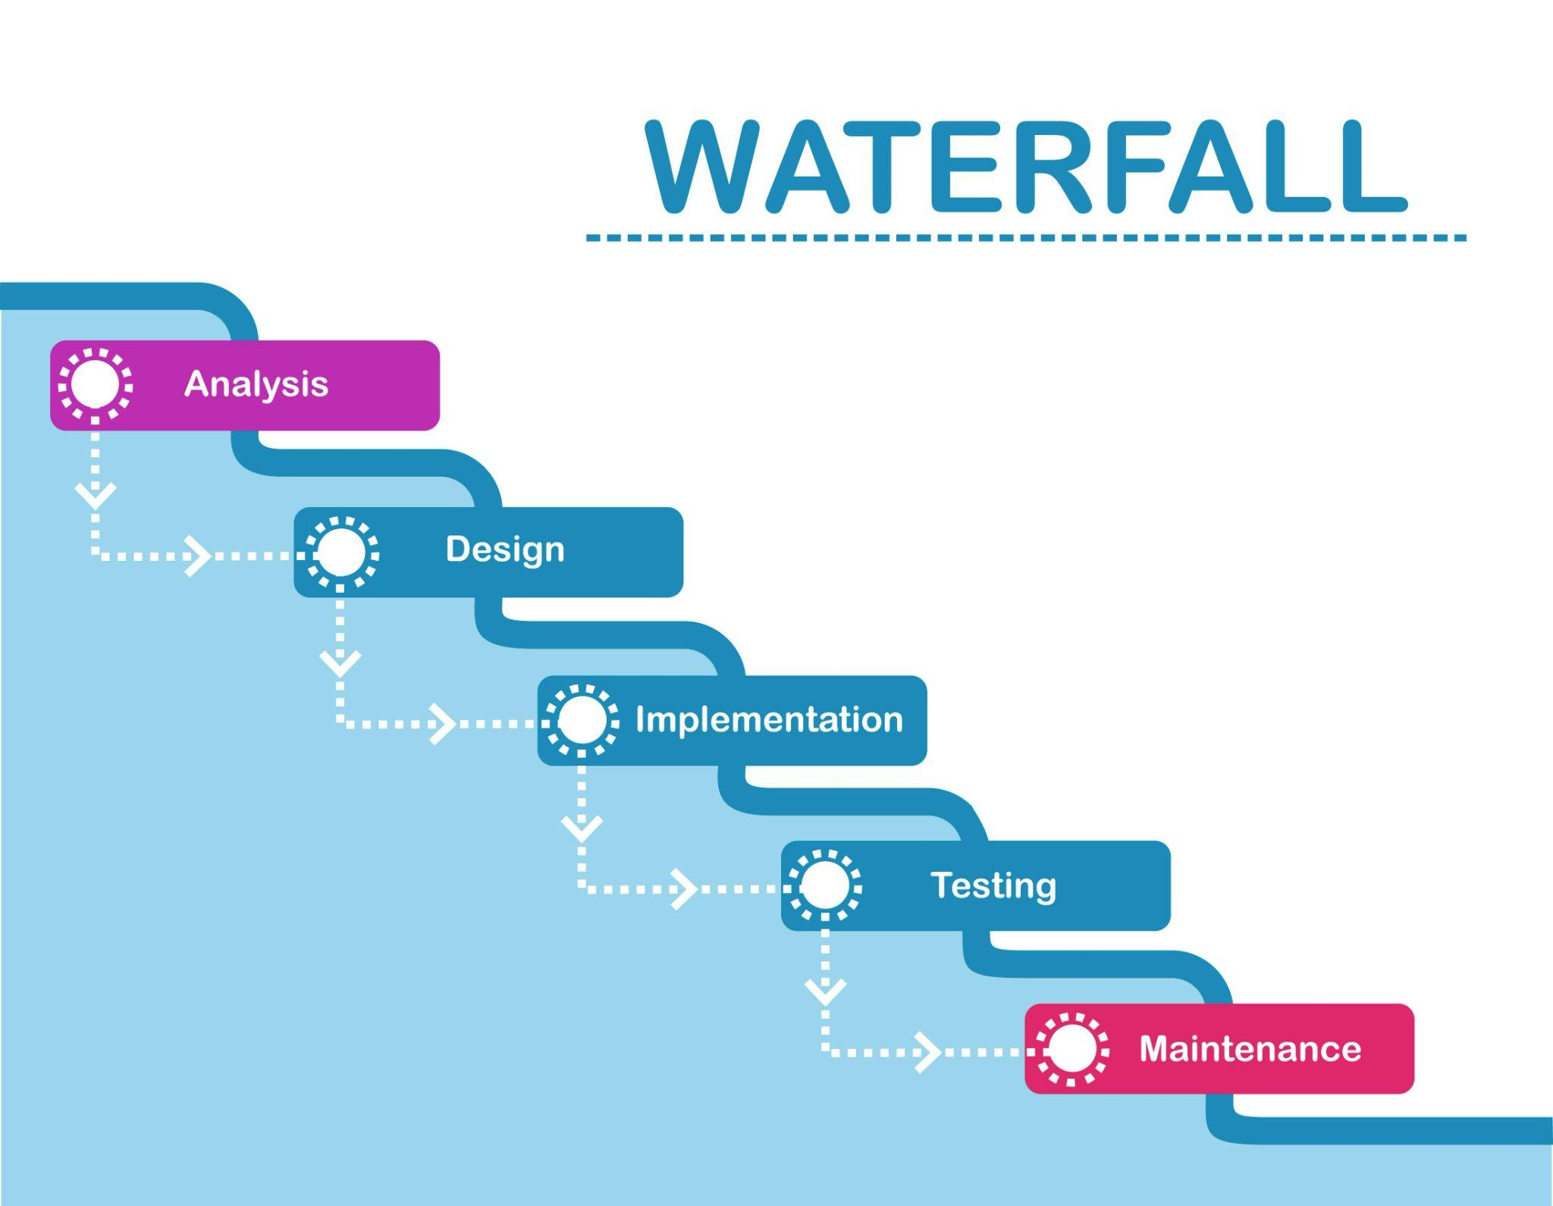

2. Iterative Model
The Iterative model focuses on building software in small, repeated cycles called iterations.Each iteration results in a working version of the software with some added features.Feedback is collected after each iteration to improve the next one. The iteration model allows developers to identify and fix issues early.The product gradually becomes more complete and functional with every cycle. It is more flexible than the Sequential model because changes can be made easily.Each iteration includes planning, designing, coding, and testing.This approach helps in risk management since problems are found early.However, it may require more time and resources due to repeated cycles.The Iterative model is ideal for large or complex projects where requirements may evolve.

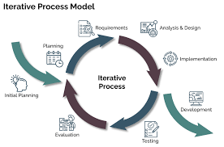

3. Evolutionary Model
- The Evolutionary model develops software in stages, based on user feedback and changing needs.It combines features of both iterative and incremental development.The product is built, refined, and expanded over several versions.Each version is improved by incorporating user suggestions and testing results.This model is useful when the requirements are unclear or constantly changing.It allows early delivery of a basic working version of the system.Developers can then add more features gradually as understanding improves.This leads to a product that better fits user expectations.However, it can be hard to plan schedules and budgets precisely. The Evolutionary model is best for research-based or prototype-driven projects.
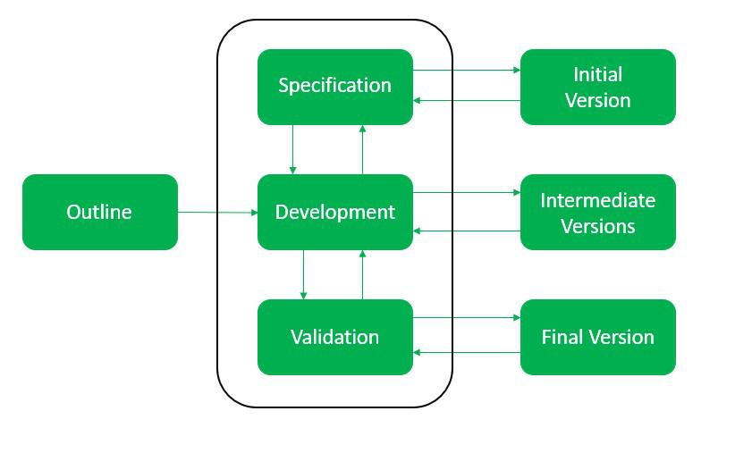

4. Agile Model
Agile is a flexible, adaptive, and customer-focused approach to software development.It divides work into small, manageable sprints that typically last a few weeks.Each sprint delivers a usable product increment with real value.The team works closely with the customer to get feedback frequently.Changes are welcomed at any stage of development.Agile promotes team collaboration, communication, and transparency.It reduces risks by delivering parts of the project early and continuously.Testing and development happen side by side, ensuring high quality.However, Agile requires strong teamwork and constant communication.It is best for dynamic projects where requirements are expected to change frequently.
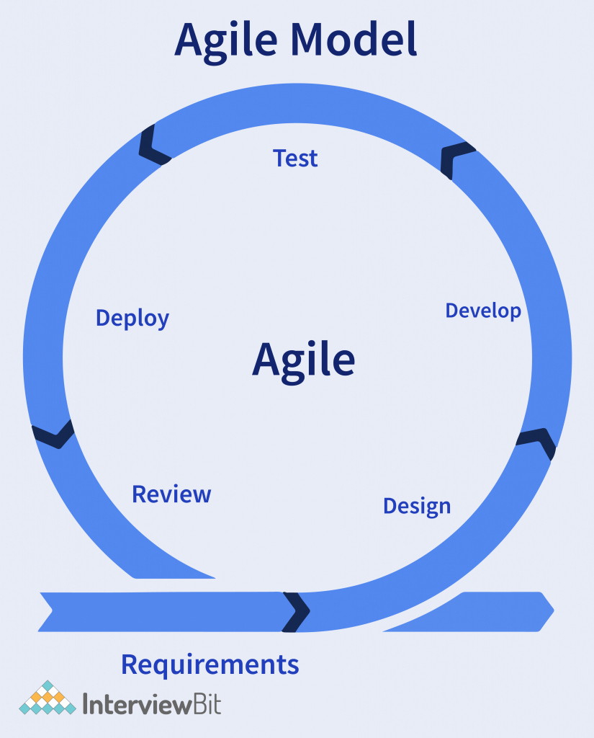
Q.Write down the differences between waterfall model and V model.

Waterfall model | V model
Flexibility is rigid | Little flexible compare to waterfall
The cost of the model is low | V model is expensive
There is no way to return to earlier stage | There is no such constraint here
Steps move in a linear way | Steps dont move in a linear way
Reusability of waterfall model is limited | V model can be reused for some extent
Testing activities start after development is over | Testing activities start in the first stage itself
It is a continuous process | It is a simultaneous process

Q.Explain the difference between Fixed Bid and Billing projects

Fixed Bid | Billing projects
A project where the total cost is agreed upon upfront, regardless of the actual time or resources spent. | A project where billing is based on actual time spent and materials used.
Limited flexibility changes require renegotiation or change orders. | Highly flexible scope can evolve throughout the project.
High total cost known in advance. | final cost depends on project duration and complexity
Vendor bears most of the risk (if project takes longer or costs more) | Client bears the risk since they pay for actual time and materials
Delivery time is Fixed and agreed in advance. | It is Flexible and may vary depending on project progress.
Suited for with well-defined scope, stable requirements, and low uncertainty | Projects with evolving scope, R&D, or where flexibility is needed

Q.Waterfall RUP Spiral and Scrum Models, They discussed models in SDLC like waterfall RUP Spiral and Scrum . You put forth your understanding on these models

1. Waterfall Model:
The Waterfall model is a traditional and linear approach to software development. It divides the process into sequential phases such as requirements, design, implementation, testing, deployment, and maintenance where each phase must be completed before moving to the next. This model works best when project requirements are clearly defined and unlikely to change. However, it offers little flexibility to accommodate changes once a phase is completed. It is simple to understand and manage, but not ideal for complex or evolving projects.

2. RUP (Rational Unified Process):

RUP is an iterative software development framework developed by IBM. It divides the project into four main phases Inception, Elaboration, Construction, and Transition. Each phase involves iterations that include analysis, design, coding, and testing activities. RUP emphasizes risk management, use-case-driven design, and continuous integration of software components. It provides a structured yet flexible approach, making it suitable for medium to large projects that require rigorous documentation and control.

3. Spiral Model:

The Spiral model combines elements of both iterative development and the Waterfall model, with a strong focus on risk analysis. The development process is represented as a spiral with multiple loops, each representing a development phase. In every loop, planning, risk assessment, engineering, and evaluation are carried out. This model allows for repeated refinement through iterations, making it ideal for large, high-risk projects where requirements may evolve over time. Its major strength lies in its emphasis on early identification and mitigation of risks.

4. Scrum Model:

Scrum is an Agile framework used for managing and completing complex projects. It focuses on delivering working software in short, time-boxed iterations called sprints, typically lasting two to four weeks. Each sprint involves planning, execution, review, and retrospective phases. The team works collaboratively under defined roles Product Owner, Scrum Master, and Development Team. Scrum promotes flexibility, transparency, and continuous improvement, making it highly effective for dynamic projects where requirements frequently change.

Q.When the APT IT SOLUTIONS company got the project to make this online agriculture product store,
there is a difference of opinion between a couple of SMEs and the project team regarding which
methodology would be more suitable for this project. SMEs are stressing on using the V model and
the project team is leaning more onto the side of waterfall model. As a business analyst, which
methodology do you think would be better for this project?

- I would go with the V model for the development of the model for the following reasons
The V-Model is an extension of the Waterfall model but with a stronger focus on testing and quality assurance at every development stage. Since this project involves an online agricultural store which typically requires high reliability, secure transactions, proper integration of payment gateways, and user-friendly interfaces .The V-Model ensures that each phase of development is directly verified and validated through corresponding test plans. This structured approach helps in detecting and correcting errors early, reducing the risk of failures after deployment. If it is waterfall model,then the testing phase happens after development phase,if we found any error in the code,then it would delay the process of deployment and UAT.

Q. As a BA, state your reason for choosing one model for this project

As a Business Analyst, I would choose the Agile Model for developing the online agriculture product store. The Agile methodology is highly flexible and adaptive to changing requirements, which makes it ideal for projects where customer needs and market trends can evolve over time. In Agile, the development work is divided into sprints short, iterative cycles where specific features are planned, developed, tested, and reviewed. At the end of each sprint, a Minimum Viable Product (MVP) or a working module is demonstrated to the client. This allows the stakeholders to review progress, provide feedback, and suggest changes early in the process, ensuring that the final product aligns with their expectations.
Agile promotes continuous collaboration between the project team and stakeholders, improving communication and reducing misunderstandings. It also allows for incremental delivery, meaning valuable features can go live sooner instead of waiting for the entire system to be completed. This approach supports risk reduction, as potential issues can be identified and resolved during each sprint rather than at the end of the project. Furthermore, Agile encourages team empowerment, adaptability, and constant improvement through sprint retrospectives.
Overall, the Agile Model is the most suitable choice for this project because it provides the flexibility, transparency, and customer involvement needed to build a successful and user-friendly online agriculture product store that can adapt to business and market changes efficiently.

Q. The Committee of Mr. Henry, Mr Pandu, and Mr Dooku discussed with Mr Karthik and finalised on the V Model approach (RG, RA, Design, D1, T1, D2, T2, D3, T3, D4, T4 and UAT) Mr Vandanam is mapped as a PM to this project. He studies this Project and Prepares a Gantt chart with V Model (RG, RA, Design, D1, T1, D2, T2, D3, T3, D4, T4 and UAT) as development process and the Resources are PM, BA, Java Developers, testers, DB Admin, NW Admin.

A Gantt chart is a type of bar chart that illustrates a project schedule, showing the start and end dates of individual tasks, their duration, and how they overlap or depend on one another.

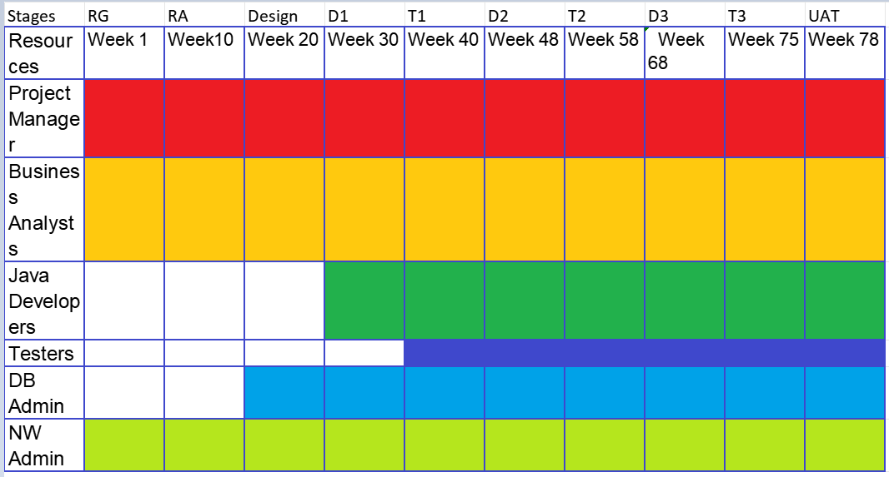

A RACI matrix is a project management tool that clarifies roles and responsibilities by assigning each task to a team member as Responsible, Accountable, Consulted, or Informed.

RACI Matrix for online agricultural store.

 | Name | Designation in organisation | Details
Responsible | Mr. Karthik  Mr Vandanam  Ms. Juhi  Mr Teyson  Ms Lucie  Mr Tucker  Mr Bravo.  Mr Mike  Mr. John  Mr Jason  Ms Alekya  Ms.Vaishnavi | Delivery Head  project Manager  Senior developer  Java Developer  Java Developer  Java Developers  Java Developers  Network Admin  DB Admin  Tester  Tester.  Business Analyst | Mail ID  Contact NO.
Accountable | Mr Mr. Vandanam | P project Manager | Mail ID  Contact NO.
Consulted | Mr.Henry | Committee member | Mail ID  Contact NO.
Informed | Mr.Pandu  Mr.Dooku  Mr.Henry  peter,Kevin,Ben | Finance Head  EProject coordinator  Committee Member  Farmer | Mail ID  Contact NO.

Q.Help Mr Karthik to prepare a business case document

A Business Case Document is a formal, structured report that explains why a project or initiative should be undertaken. It provides a clear justification for the investment in terms of business value, expected benefits, costs, risks, and alignment with organizational goals.
The purpose of this business case is to propose the development of an Online Agriculture Product Store for APT IT Solutions. The platform aims to provide farmers, agricultural suppliers, and consumers with a convenient, efficient, and reliable way to buy and sell agricultural products online.

What is the need of the project?
To facilitate an online platform between the farmers and the manufacturers.
From where the the farmers can buy products online and get them delivered to their location.
Farmers can get to choose between wide range of products.

What are the current problems faced?
Currently,the farmers are facing several problems with regard to buying agricultural products
They face challenges such as limited market reach, lack of transparent pricing, and inefficient manual transactions.
They have to go to far off places to buy products.
They do not have direct link with the manufactures to say problems
The range of products they have is very low.

How can the project solve the problem?
The online application facilitates an online store for farmers to buy products from various manufacturers.
The farmers can choose necessary products and buy them online
The products will be delivered to home.
The Farmer can evaluate the products and share the review with the manufacturer

How long is it going to take and the budget.
The total estimated cost of the project is 2cr INR, which includes design, development, testing, deployment, and maintenance . It is going to take period of 18 months to develop.This is taken under CSR

What is the Scope of the project:
In Scope:
Development of a responsive web and mobile application.
Integration of a secure payment system.
Product management and order tracking features.
User authentication and role-based access.
Testing and deployment on a cloud platform.
Out of Scope
On-ground logistics management.
Third-party supplier onboarding beyond phase one.

Q. Prepare Timesheets of a BA in various stages of SDLC
Design Time sheet of BA

S.no | Tasks | Outcome | From | To | Duration
1 | Validate and review functional & non-functional requirements. | Validated and reviewed | 10:00 AM | 11:00  AM | 1 Hours
2 | Participate in design walkthroughs with technical team. | Finalised design for the application | 11:00  AM | 1:00  PM | 2 Hours
3 | Review wireframes, process flows, and data models | Modified UI  design | 2:00 PM | 4:00 PM | 2 Hours
4 | Update Requirements Traceability Matrix (RTM) | RTM Matrix has been updated | 4:00 PM | 6:00  PM | 2 Hours
5. |  |  |  |  | 7 hours

Development Timesheet of a BA

S.no | Tasks | Outcome | From | To | Duration
1 | Clarify business logic and requirements to developers. | Clarity on business logic | 10:00 AM | 11:00  AM | 1 Hours
2 | Attend daily stand-up or scrum meetings. | Sought requirements from developers | 11:00  AM | 1:00  PM | 2 Hours
3 | Review functional specifications or user stories. | Updated user stories with more details | 2:00 PM | 4:00 PM | 2 Hours
4 | Track progress and ensure alignment with requirements. | RTM Matrix has been updated | 4:00 PM | 5:00  PM | 2 Hours
5. | Update documentation for any change requests | Updated documents | 5:00 PM | 6.00PM | 1 hour
6 |  |  |  |  | 8 hours

Testing Timesheet of a BA

S.no | Tasks | Outcome | From | To | Duration
1 | Assist QA team in preparing test scenarios & cases. | Updated functionality | 10:00 AM | 11:00  AM | 1 Hours
2 | Analyze test results and confirm fixes. | Confirmed fixes | 11:00  AM | 1:00  PM | 2 Hours
3 | Participate in system testing | Completed a part of system testing | 2:00 PM | 4:00 PM | 2 Hours
4 | Provide business clarifications to testers | Confirmed product meets requirements | 4:00 PM | 5:00  PM | 2 Hours
 | Validate traceability of requirements in RTM. | RTM Matrix has been updated | 5:00 PM | 6.00PM | 1 hour
6 |  |  |  |  | 8 hours

UAT Timesheet of a BA

S.no | Tasks | Outcome | From | To | Duration
1 | Prepare UAT plan, test cases, and acceptance criteria. | UAT plan signed off | 10:00 AM | 11:00  AM | 1 Hours
2 | Coordinate UAT execution with business users | Finalised execution of UAT | 11:00  AM | 1:00  PM | 2 Hours
3 | Capture and document user feedback. | Documented user feedback and improved | 2:00 PM | 4:00 PM | 2 Hours
4 | Facilitate defect resolution with technical team. | Analysed bugs with team. | 4:00 PM | 5:00  PM | 1 Hour
5. | Obtain UAT sign-off from stakeholders.. | Signed off by stakeholders | 5:00 PM | 6:00 PM | 1.hour
6 |  |  |  |  | 7 hours

Deployment n Implementation Timesheet of a BA

S.no | Tasks | Outcome | From | To | Duration
1 | Support release and go live planning | Planned for go live | 10:00 AM | 11:00  AM | 1 Hours
2 | Prepare user manuals and training materials. | Finalised execution of UAT | 11:00  AM | 1:00  PM | 2 Hours
3 | Conduct end-user training sessions. | Conducted end user training session | 2:00 PM | 4:00 PM | 2 Hours
4 | Monitor early production issues. | Reported feedback to production team | 4:00 PM | 5:00  PM | 1 Hours
5. | Gather feedback for improvements. | Documented user feedback and improved | 5.:00 PM | 6.:00 PM | 1 hours
6 |  |  |  |  | 7 hours

