Use Case :
This use case diagram represents the recruitment process using an Applicant Tracking System (ATS) tool. It includes the primary actor (Candidate), secondary actors (HR Recruiter, System), essential and supporting use cases, and their relationships.

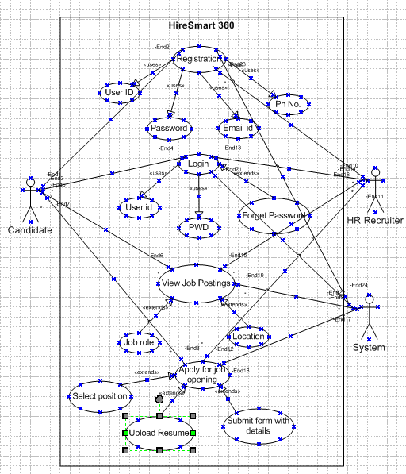

Use Case Specification – Hire Smart 360

1. Use Case Name
Apply for Job Opening

2. Use Case Description
This use case describes the process by which a candidate applies for a job through the Hire Smart 360 ATS. The candidate browses job listings, selects a position, uploads a resume, fills out the required fields, and submits the application.

3. Actors
Primary Actor: Candidate
Secondary Actor: ATS System, HR Recruiter

4. Basic Flow
1. Candidate accesses the Hire Smart 360 portal.
2. Candidate views available job listings.
3. Candidate selects a desired job role.
4. Candidate fills out the application form and uploads resume.
5. Candidate submits the application.

5. Alternate Flow
If the candidate has already registered, they may log in to pre-fill data from their profile.

6. Exceptional Flows
- If required fields are left empty, system prompts user to complete them.
- If resume file format is invalid, system rejects upload.
- System fails to connect to server – prompts error message and retry option.

7. Pre-Conditions
- The candidate must have internet access.
- Job listings must be active on the portal.

8. Post-Conditions
- The application is stored in the ATS database.
- Notification is sent to the HR recruiter.

9. Assumptions
- Candidate has a valid email address.
- Recruiter will review the application within 48 hours.

10. Constraints
- Resume size must not exceed 5MB.
- Form submission timeout is 5 minutes.

11. Dependencies
- Resume format must support the system.
- Job database should be up and functional.

12. Inputs and Outputs
Inputs: Registration, Login, View Job Postings, Apply for job role
Outputs: Application stored in system

13. Business Rules
- Only one application per job per user.
- Resume must be in PDF or DOCX format.
- Mandatory fields include Name, Email, and Resume.

14. Miscellaneous Information
- This use case supports localization in English.

Activity Diagram- Candidate Applying through ATS tool:
This diagram shows the candidate's job application process through an ATS tool. It includes fork and join logic, decision boxes, and branching paths. The system runs resume validation and form filling in parallel after resume upload.

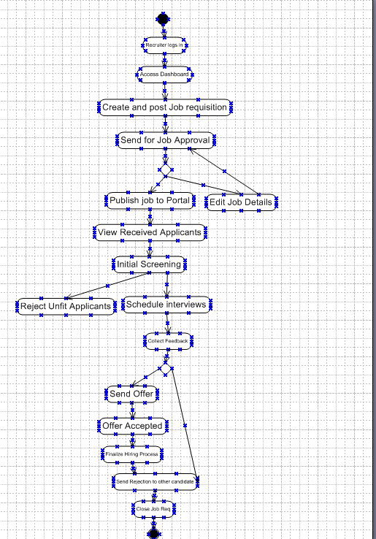

ACTIVITY Diagram-Candidate applying job in ATS.

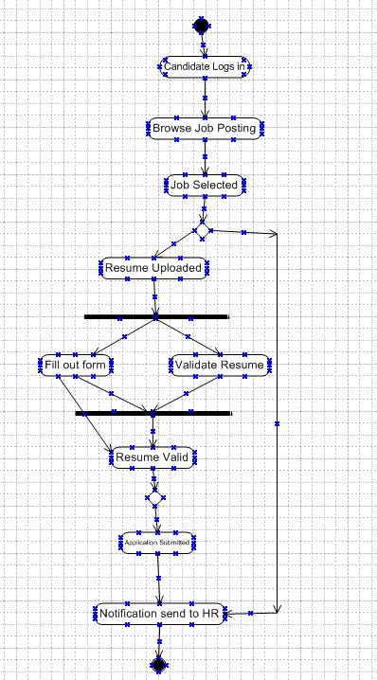

Document 7- Screens and pages(Mock-ups using Balsamiq)
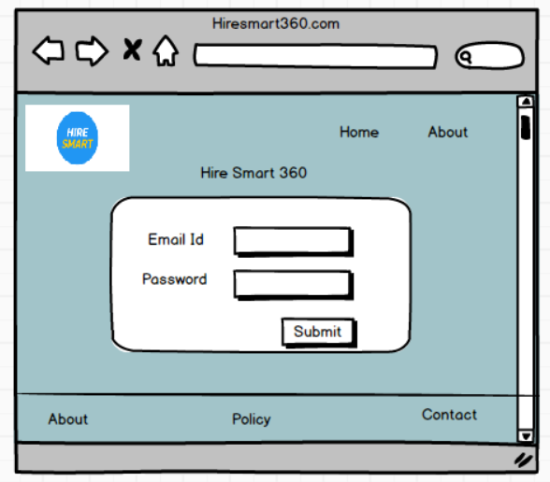

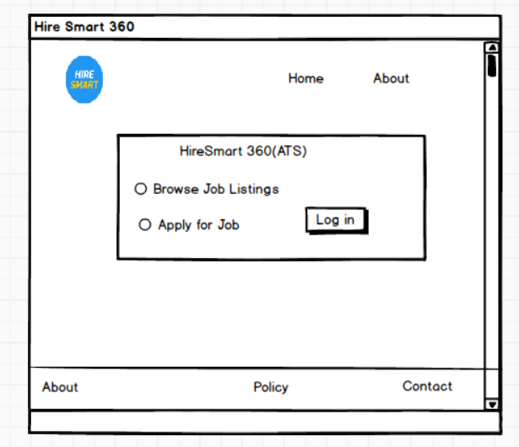
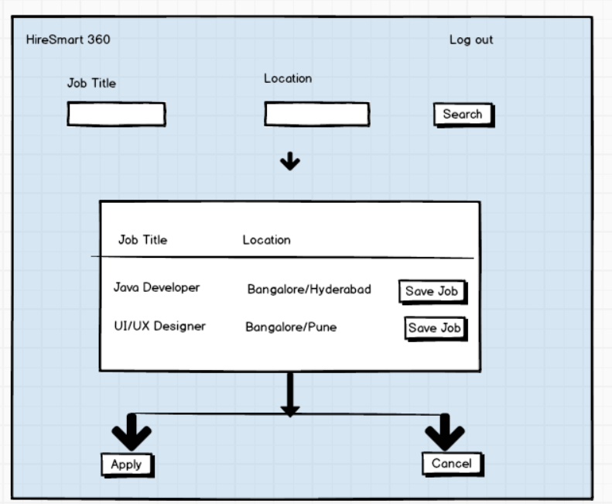
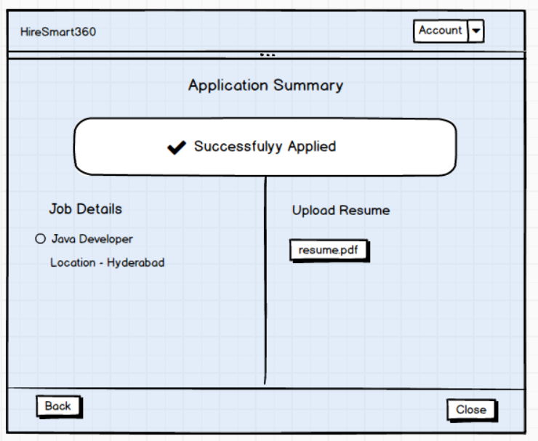

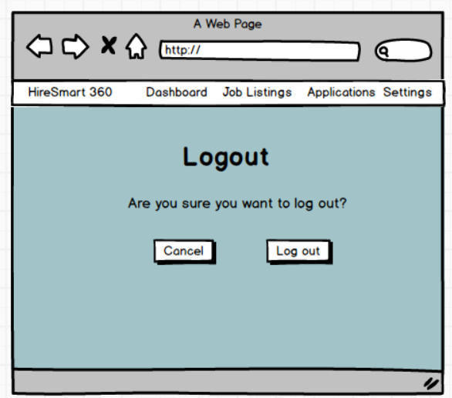

Document 8:
For this project, I used both Microsoft Visio and Balsamiq to create the screens and flows for the HireSmart 360 ATS.
Utilized Microsoft Visio extensively to design precise and professional UML diagrams, including activity diagrams, use case diagrams, and process flows for the recruitment process within the ATS tool. Visio’s flexibility in adding fork and join nodes, decision points, and relationship connectors allowed me to clearly represent process logic, actor interactions, and validation paths.
Additionally, I used Balsamiq for creating quick, low-fidelity wireframes to visualize the candidate’s application journey before moving into detailed diagramming.
Balsamiq’s drag-and-drop simplicity helped in brainstorming user interface layouts and gaining stakeholder alignment early in the design phase, while Visio ensured the final deliverables were technically accurate and presentation-ready. This combination of tools streamlined the transition from conceptual mock-ups to fully detailed technical diagrams, improving both clarity and collaboration with the project team.

Document 9- BA experience My experience as BA in following phases:
1. Requirement Gathering:
- We used the MoSCoW technique to prioritize the requirements into Must Have, Should Have, Could Have, and Won’t Have.
- Conducted interviews and workshops with stakeholders like recruiters, hiring managers, and candidates to understand the key needs of the ATS.
- During stakeholder absence, I identified alternate points of contact from the client side to ensure smooth information flow and avoid delays.
- I used prototyping to gather more specific requirements—this helped clients visualize the screens and refine their inputs.
- Cleaned up duplicate and unclear requirements to maintain a clear and organized scope.
2. Requirement Analysis:
- Created detailed UML diagrams like use case diagrams and activity diagrams to represent system behavior and flow.
- Used branch/merge and fork/join logic in the activity diagram to capture all possible flows in the candidate journey—from login to logout.
- Shared these diagrams with the team for review; when there were disagreements, I facilitated discussions, collected feedback, and revised the diagrams accordingly.
- Prepared BRS (Business Requirement Specification) and SRS (System Requirement Specification) to document and finalize the functional and non-functional requirements.
3. Design:
- Translated use cases into detailed test cases—covering both positive and negative scenarios.
- Communicated regularly with the client to discuss design documents and solution flows to ensure expectations were aligned.
- Made sure no test case was missed, understanding how even one missed scenario could impact the entire development and testing later.
- Prepared relevant test data for QA teams to simulate various candidate profiles.
- Updated the Requirement Traceability Matrix (RTM) regularly to make sure all requirements were covered in development and testing.

4. Development:
- Organized JAD (Joint Application Development) sessions between developers, testers, and stakeholders to ensure alignment.
- Acted as a bridge between the technical team and client—clarifying functional queries raised by developers during the coding phase.
- Some team members had conflicting views or showed resistance during sessions; I handled such situations with one-on-one discussions, addressing concerns and explaining the larger project impact, creating a healthy and cooperative environment.
- Referred the previously created use case and activity diagrams to assist developers in understanding the logic for different user actions like job search, apply, and logout.
- Set up regular sync-up meetings with developers and clients. For any team member who missed a session, I ensured to share recordings and have follow-up discussions to keep everyone in sync.

5. Testing:

- Closely worked with the QA team to validate each requirement during system, integration, and user acceptance testing (UAT).
- Reviewed all test cases to ensure complete coverage based on the Requirement Traceability Matrix (RTM).
- For any unclear test results or failed cases, I coordinated between the QA and development teams to identify root causes and provide clarity.
- Actively ensured that both functional and non-functional requirements (like resume upload limits, response time, and browser compatibility) were tested as per the original SRS.

6. Deployment:
- Participated in release planning meetings, helping define the scope of what features should go in each deployment phase.
- Ensured that release notes included all finalized functionalities, bug fixes, and known limitations, making them easy to understand for business users.
- Conducted post-deployment sanity checks to ensure all modules (like Candidate Login, Job Listing, Apply, Resume Upload, and Logout) were functioning as expected in the production environment.
- Captured early user feedback post-deployment and created a backlog of enhancements and minor fixes to be considered for future releases.
- Helped in drafting the training material and user manual to support end users in adopting the new system smoothly.

