Question 1 – Functional Requirements – (Identify minimum 20 functional requirements)
Below is a list of 20 core functional requirements (FR) for the Online Agriculture Products Store, capturing the end-to-end shopping flow as well as manufacturer and user management.
Req ID | Req Name | Req Description | Priority
FR0001 | Farmer Registration | The system shall allow a new Farmer to create an account by providing name, email, password and contact details. | 9
FR0002 | Farmer Login | The system shall authenticate Farmers via email and password to grant access to personalized features. | 10
FR0003 | Password Reset | The system shall allow any user (Farmer or Manufacturer) to reset their password via email-based “forgot password” workflow. | 8
FR0004 | Manufacturer Registration | The system shall allow a new Manufacturer to create an account by providing company details, email, password and contact information. | 9
FR0005 | Manufacturer Login | The system shall authenticate Manufacturers via email and password to grant access to their product-management dashboard. | 10
FR0006 | Product Catalog Browsing | The system shall display a paginated catalog of all available fertilizers, seeds and pesticides to any (logged-in or guest) user. | 9
FR0007 | Product Search | The system shall allow Farmers to search products by keyword, category (fertilizer/seed/pesticide), brand or SKU. | 10
FR0008 | Product Filtering | The system shall allow Farmers to filter catalog results by price range, manufacturer, crop type and availability. | 8
FR0009 | Product Details View | The system shall display detailed information for a selected product, including description, price, manufacturer info and stock status. | 9
FR0010 | Add to Cart | The system shall allow Farmers to add one or more products (with desired quantities) to a shopping cart. | 10
FR0011 | Update Cart | The system shall allow Farmers to view, update quantities or remove items in their cart before checkout. | 9
FR0012 | Save for Later (Wishlist) | The system shall allow Farmers to move products from their cart to a “buy-later” list (Wishlist) for future purchase. | 7
FR0013 | Checkout Initiation | The system shall allow Farmers to initiate checkout from their cart, confirming delivery address and contact details. | 10
FR0014 | Payment Method Selection | The system shall present payment options (COD, Credit/Debit Card, UPI) and allow the Farmer to select one. | 10
FR0015 | Payment Processing | The system shall integrate with the payment gateway to process Credit/Debit Card and UPI transactions, and record COD selections. | 10
FR0016 | Order Confirmation | Upon successful order placement, the system shall generate an order record and display a confirmation page with order summary. | 10
FR0017 | Email Notifications | The system shall send automated emails to Farmers on order placement, payment success/failure, dispatch and delivery. | 9
FR0018 | Delivery Tracking | The system shall allow Farmers to view real-time status of their order’s shipment on a tracking page. | 9
FR0019 | Order History | The system shall allow Farmers to view their past orders with details (items, date, status, total, payment method). | 8
FR0020 | Manufacturer Product CRUD | The system shall provide Manufacturers with create, read, update and delete capabilities for their product listings (fertilizer/seed/pesticide). | 9

Question 2–Minimum 5-page designs
Following are the designed wireframe & prototype pages:
- Login Page
- Registration Page
- Dashboard
- Product Catalogue
- Checkout Page

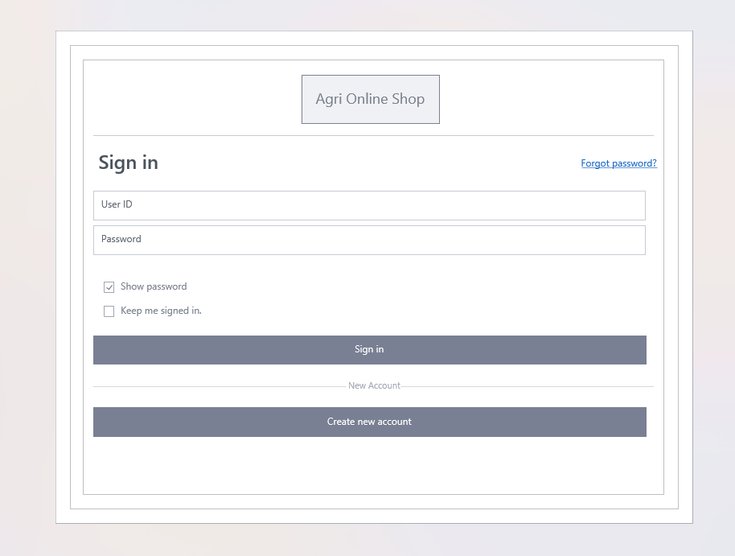
- Login Page.

- Registration Page
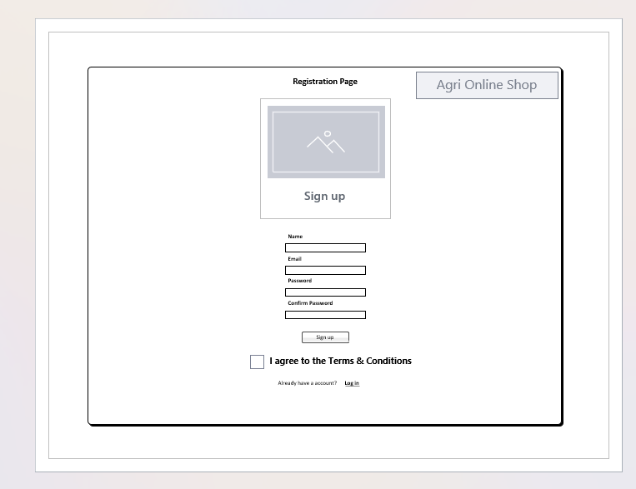

- Dashboard
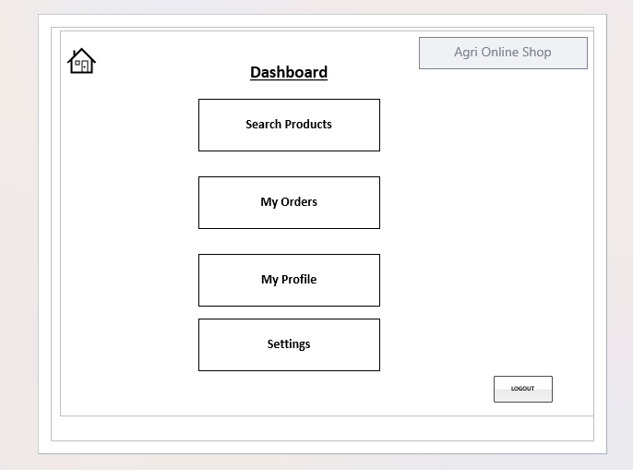

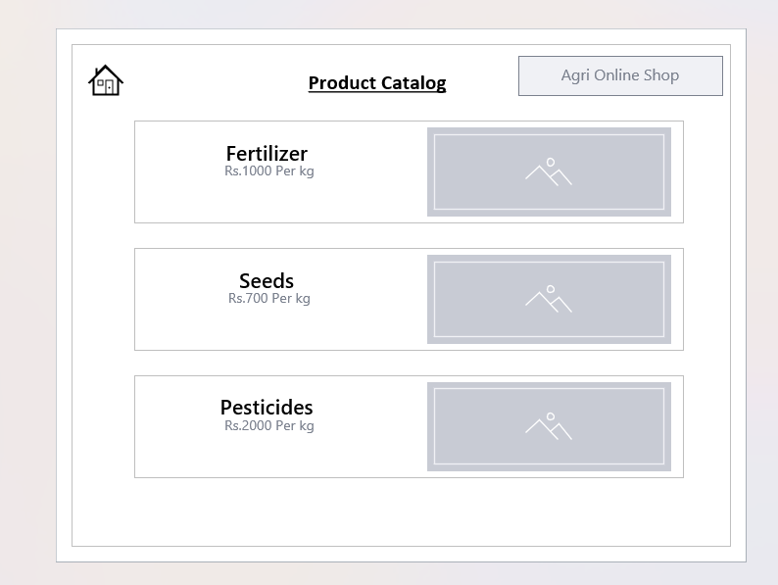
- Product Catalog

- Checkout Page
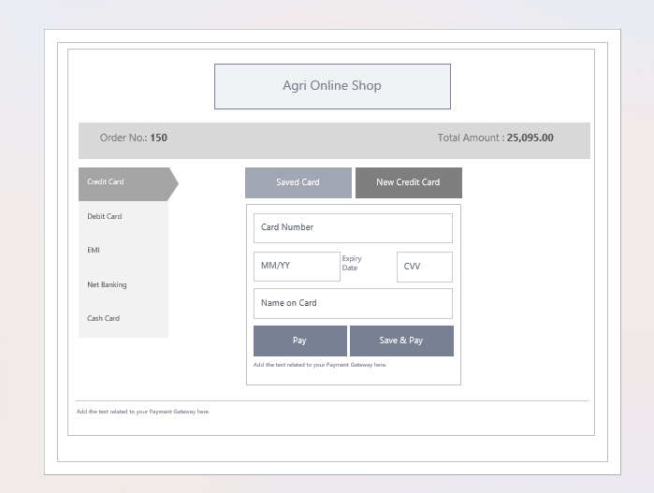

Question 3 – Tool used Visio.
1. Microsoft Visio
- Purpose: Creation of all technical diagrams (wireframes, ERDs, DFDs, Gantt charts, RTM layouts).
- Key Features:
  - Pre-built Wireframe and UML stencils for rapid diagramming.
  - Precise alignment, snap-to-grid and shape-connection capabilities, ensuring clean, professional layouts.
  - Gantt Chart and Timeline templates to visualize man-hour estimates.
  - Easy annotation of Primary Key (PK) and Foreign Key (FK) relationships in ERDs.

Question 4 – RTM (Requirements Traceability Matrix
As a BA, it is my responsibility to ensure every functional and non-functional requirement is properly tracked, validated, tested, and delivered. Since Mr. Henry and Peter have asked for the current status, I will provide an updated RTM that maps each requirement to its respective design and test stages (D1 to T4 and UAT), showing the progress transparently.
Requirements Traceability Matrix (RTM)
Req ID | Req Name | Req Description | Design | D1 | Unit testing | Integration testing | System testing | Regression testing | UAT
FR0001 | Farmer Registration | Farmers should be able to register with the application | ✅ | ✅ | ✅ | ✅ | ✅ | ✅ | ✅
FR0002 | Farmer Search for Products | Farmers should be able to search for available products in fertilizers, seeds, pesticides | ✅ | ✅ | ✅ | ✅ | ❌ | ⬜ | ⬜
NFR0101 | Page Loading Time | Each page should load within 2 seconds time | ✅ | ✅ | ✅ | ⬜ | ⬜ | ⬜ | ⬜
NFR0102 | WCAG 2.1 Compliance | The system must meet Web Content Accessibility Guidelines WCAG 2.1 | ✅ | ✅ | ⬜ | ⬜ | ⬜ | ⬜ | ⬜

Legend
- ✅ Completed
- ❌ Failed
- ⬜ Not Yet Started

- Follow up with the Dev and QA teams to ensure T3, T4, and UAT for pending items are completed.
- Track and update this RTM throughout the SDLC.
- Will share this RTM with stakeholders regularly to maintain transparency.
Question 5 – 10 Test Case Documents (10 Marks)
Test case includes:
- Test Case, Test case name, Project ID, Project name, Online shopping, Project Manager ID, Project Manager name, Test Strategy ID, Tester ID, Test plan ID, Tester name, Test schedule ID, Date of test.
Test Case ID | Test Case Name | Project ID | Project Name | Online Shopping | Project Manager ID | Project Manager Name | Test Strategy ID | Tester ID | Test Plan ID | Tester Name | Test Schedule ID | Date of Test
TC001 | Farmer Registration | PJT001 | Online Agriculture Store | Yes | PM001 | Mr. Vandanam | TS001 | T001 | TP001 | Mr. Jason | SCH001 | 2025-06-12
TC002 | Manufacturer Registration | PJT001 | Online Agriculture Store | Yes | PM001 | Mr. Vandanam | TS001 | T002 | TP001 | Ms. Alekya | SCH001 | 2025-06-12
TC003 | Login Functionality | PJT001 | Online Agriculture Store | Yes | PM001 | Mr. Vandanam | TS001 | T001 | TP001 | Mr. Jason | SCH001 | 2025-06-12
TC004 | Product Search | PJT001 | Online Agriculture Store | Yes | PM001 | Mr. Vandanam | TS001 | T002 | TP001 | Ms. Alekya | SCH001 | 2025-06-12
TC005 | Product Filter | PJT001 | Online Agriculture Store | Yes | PM001 | Mr. Vandanam | TS001 | T001 | TP001 | Mr. Jason | SCH001 | 2025-06-12
TC006 | Add to Cart | PJT001 | Online Agriculture Store | Yes | PM001 | Mr. Vandanam | TS001 | T002 | TP001 | Ms. Alekya | SCH001 | 2025-06-12
TC007 | Place Order | PJT001 | Online Agriculture Store | Yes | PM001 | Mr. Vandanam | TS001 | T001 | TP001 | Mr. Jason | SCH001 | 2025-06-12
TC008 | View Order History | PJT001 | Online Agriculture Store | Yes | PM001 | Mr. Vandanam | TS001 | T002 | TP001 | Ms. Alekya | SCH001 | 2025-06-12
TC009 | Delivery Tracking | PJT001 | Online Agriculture Store | Yes | PM001 | Mr. Vandanam | TS001 | T001 | TP001 | Mr. Jason | SCH001 | 2025-06-12
TC010 | Logout Functionality | PJT001 | Online Agriculture Store | Yes | PM001 | Mr. Vandanam | TS001 | T002 | TP001 | Ms. Alekya | SCH001 | 2025-06-12

Question 6 – DB Design

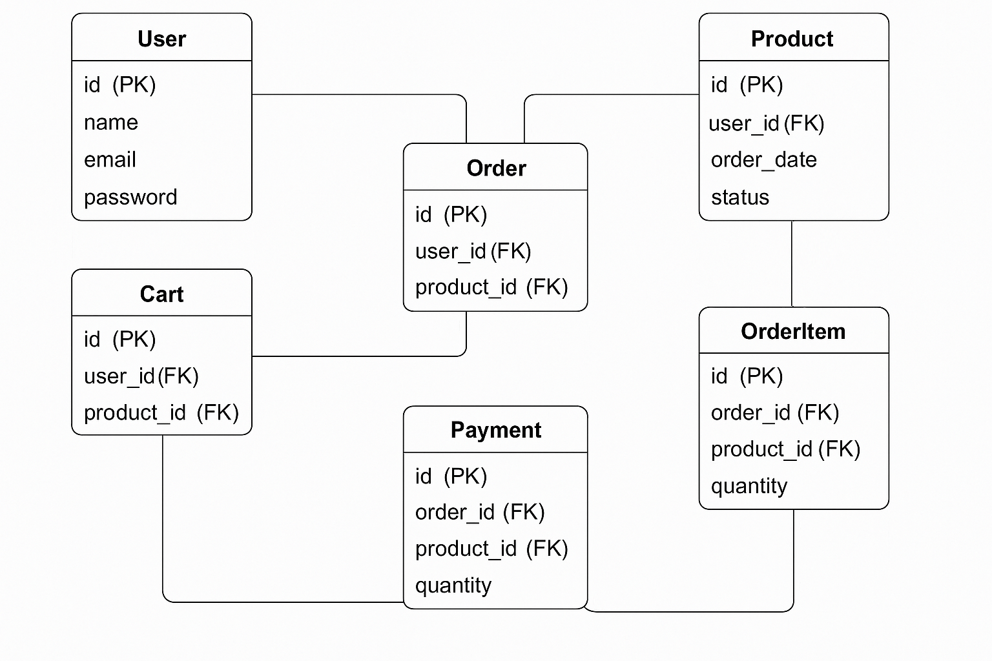

Each table clearly shows:
- Primary Keys (PK)
- Foreign Keys (FK)
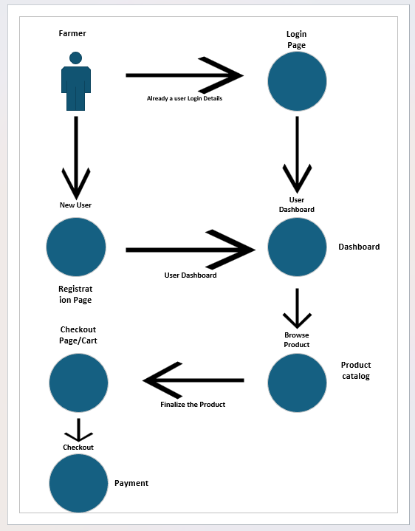
Question 7 – Data Flow Diagram

Question 8 – Change Request – 10 Marks
As a Business Analyst, I would handle this change request using the following structured approach:
1. Receive and Log the Change Request
- The change will be formally raised by a stakeholder (e.g., Government Regulatory Team or Internal Legal/Finance Department).
- I will log the change request in the Change Request Tracker (usually maintained in Excel, Jira, or SharePoint).
- Assign a unique Change Request.
2. Perform Impact Analysis
- Collaborate with developers, testers, architects, and DBAs to assess the impact of the change on:
  - Backend tax calculation logic
  - Checkout & billing modules
  - Order summaries and invoices
  - Historical data (invoices generated with previous tax rates)
- Identify affected documents:
  - BRD (Business Requirement Document)
  - FRD (Functional Requirement Document)
  - Use Cases, Test Cases
  - UI prototypes (if tax values are shown on the interface)
3. Organize a Change Control Meeting
- Convene a meeting with the Change Control Board (CCB), including:
  - Project Manager
  - Business Owner
  - Senior Developer/Architect
  - QA Lead
  - Compliance/Finance Representative
- Present the impact analysis, effort estimates, risks, and timeline adjustment.
4. Update Documentation
- Upon approval, update the following:
  - BRD and FRD with new tax calculation rules
  - Use case diagrams and sequence flows (if impacted)
  - Test scenarios (include regression + new test cases for revised tax logic)
5. Communicate with Stakeholders
- Communicate the change scope, expected timeline, and business implications with:
  - Product Owner
  - End-users (Farmers/Manufacturers)
  - Internal billing/finance teams
- Update project plans and milestones accordingly.
6. Coordinate Development and Testing
- Ensure development follows updated tax rules.
- Support the QA team to validate:
  - Updated tax breakdown on UI and PDFs
  - Correctness across all payment methods (COD, UPI, Cards)
  - Compatibility with invoice and reporting systems
7. UAT & Approval
- Facilitate User Acceptance Testing (UAT) with relevant stakeholders (Finance, Legal).
- Collect sign-off and approval on the change implementation.
8. Go-Live and Post-Deployment Monitoring
- Coordinate go-live activities with deployment and support teams.
- Monitor transactions post-deployment to ensure the new tax structure is functioning correctly.
9. Document Change History
- Record the final implementation details, decision logs, and approvals for audit/compliance purposes.
Change Request Log Entry:
Change ID | Description | Raised By | Status | Impact | Owner | Target Release
CR-2025-04-GovTaxRev | Update system to reflect revised Government Taxation Structure (2025) | Finance Head | Approved | High | Nikhil (BA) | v2.3.1

Question 9 – Change Request Vs an Enhancement
A Change Request refers to a formal request to modify a feature, function, or scope that was already defined or approved in the original project requirements.
- It is typically reactive, raised due to:
- Regulatory changes (e.g., government tax updates)
- Errors or gaps in original requirements
- Technical constraints discovered during development
- Stakeholder dissatisfaction with current behavior
An Enhancement is a request to add a new feature or improve existing functionality that was not part of the initial requirements. It often originates from user feedback, competitive analysis, or future expansion goals.
- It is typically proactive, aimed at improving user experience or extending capabilities.
Key Differences Table
Aspect | Change Request | Enhancement
Purpose | Modify existing approved functionality | Add new or improved features
Initiation | Reactive (compliance, bugs, stakeholder gap) | Proactive (innovation, user feedback)
Scope | Often urgent and critical | Optional, based on value addition
Impact on Timeline | Usually immediate or short-term | May be scheduled in future sprints/releases
Example | Changing tax structure as per new law | Adding crop auction system

This is an Enhancement. It introduces new functionality (crop selling and auction feature) that was not part of the initial requirement scope.

Question 10 – Estimations – 6 Marks
As a Business Analyst, I will use the Work Breakdown Structure (WBS) method combined with expert input from the project team (developers, testers, DB admin, designers) to estimate manhours.
Module | Activity | Role Involved | Estimated Hours
1. Requirement Gathering | Stakeholder meetings, BRD, RTM | BA | 30 hrs
2. UI/UX Design | Wireframes, mockups | BA + UI Designer | 40 hrs
3. Use Cases & UML | Use case diagrams/specs, activity diagrams | BA | 25 hrs
4. DB Design | ERD, Schema creation | BA + DBA | 20 hrs
5. Backend Development | APIs, logic for registration, cart, order, payment | Java Developers | 160 hrs
6. Frontend Development | Web pages for login, catalog, checkout, dashboard | Java Developers | 100 hrs
7. Testing – Functional | Test case writing + execution | QA Team | 80 hrs
8. Testing – UAT Support | BA coordination + UAT fixes | BA + QA + Dev | 20 hrs
9. Deployment | Hosting, environment setup | Network Admin + DBA | 15 hrs
10. Documentation | Project closure, manuals | BA | 10 hrs

Total Estimated Manhours: 500 Manhours
Notes:
- This estimation is based on assumptions of a 5-person team working in parallel sprints.
- Buffer of 10–15% is advised for risks, bugs, rework, or unexpected enhancements.
The total manhours estimated for the Online Agriculture Products Store project is approximately 500 hours, assuming a standard development life cycle and current scope.
Question 11 – UAT (User Acceptance Testing) – 6 Marks
I would handle UAT and Closure:
1. Pre-UAT Preparation
Before initiating UAT, I will:
- Ensure the application is stable and has passed internal QA.
- Prepare a UAT Plan, listing:
  - Scope
  - Roles & responsibilities
  - Entry/Exit criteria
  - Test environment details
- Identify UAT testers from the client side (e.g., 2–3 end-users/farmers, manufacturer rep).
- Conduct a UAT Kickoff Meeting with the client to explain:
  - What to test
  - How to log feedback
  - Timelines for completion
- Provide a UAT Test Kit:
  - UAT Test Scenarios
  - Expected Results
  - Sample data
  - Defect log template
2. UAT Execution Phase
During UAT:
- Track all user activities and feedback.
- Log and categorize bugs:
  - Critical – Immediate fix needed
  - Medium/Minor – Can be deferred
- Communicate regularly with:
  - Dev team (for bug fixes)
  - Client (for status updates)
- Maintain a UAT Defect Log
3. UAT Sign-Off Process
Once UAT is successfully completed:
- Collect a formal sign-off via:
  - Email
  - Signed UAT Sign-off Document
- This confirms:
  - Application is working as per agreed business requirements
  - Client is satisfied with the solution
  - All major defects are resolved or acknowledged
4. Project Closure Process
After UAT sign-off:
- Conduct a Final Review Meeting with stakeholders.
- Prepare and submit:
  - Final BRD/FRD (version-controlled)
  - User Manuals / Training Materials
  - UAT Report
  - Known Issues Document (if any)
- Move project into Support & Maintenance phase
- Update Change Logs and Archive All Documents
- Submit a Project Closure Report to the client and project sponsor.
UAT Acceptance & Closure Flow:
Step | Description
UAT Planning | Create UAT plan, scenarios, environment, assign users
UAT Execution | Clients perform testing, log feedback
Defect Management | Triage, resolve and re-test issues
UAT Sign-off | Collect formal sign-off document
Closure Activities | Submit docs, conduct handover, close the project

It is my duty to ensure the UAT phase is handled professionally, expectations are met, and the project is transitioned smoothly from delivery to closure with complete documentation and satisfaction.

Question 12 – Project Closure Document – 6 Marks
The Project Closure Document is a formal record created at the end of a project to officially close the project and confirm that all deliverables have been completed, accepted, and handed over to the client or support team.
It serves as:
- A sign-off artifact
- A lesson learned log
- A transition record to support/maintenance
- A confirmation that the objectives were met
Key Contents of a Project Closure Document
Section | Description
1. Project Overview | Project name, scope summary, key objectives and stakeholders
2. Deliverables Summary | List of final deliverables submitted and approved
3. Final Project Status | Whether all requirements were met, and any pending items
4. UAT Sign-off | Reference to UAT completion and client sign-off
5. Budget & Time Summary | Final comparison of planned vs actual time/cost
6. Change Requests Summary | All major change/enhancement requests during the project lifecycle
7. Lessons Learned | Insights, what worked well, what could improve
8. Risks & Issues Summary | Major risks faced and how they were handled
9. Client Feedback | Comments or testimonials from the client
10. Sign-Off Section | Final sign-off by client and project manager

It is important because:
- Audit & Compliance: Ensures traceability and accountability.
- Knowledge Transfer: Helps future teams learn from past work.
- Formal Handover: Transitions the application to support/maintenance teams.
- Official Closure: Prevents scope creep after project completion.
My role includes:
- Coordinating with the Project Manager to compile the closure report
- Ensuring UAT completion is documented
- Including finalized BRD, RTM, test results, and defect logs
- Organizing the project handover meeting with stakeholders
- Getting formal sign-off and filing the document in the project repository
The Project Closure Document is the last but crucial step in delivering a professional, well-managed project. It reinforces stakeholder satisfaction and sets the groundwork for post-go-live support.

