Waterfall Project- 1 Part- 2

Document- 6 Please prepare a use case diagram, activity diagram and a use case specification document.

Document- 7 Screens and pages
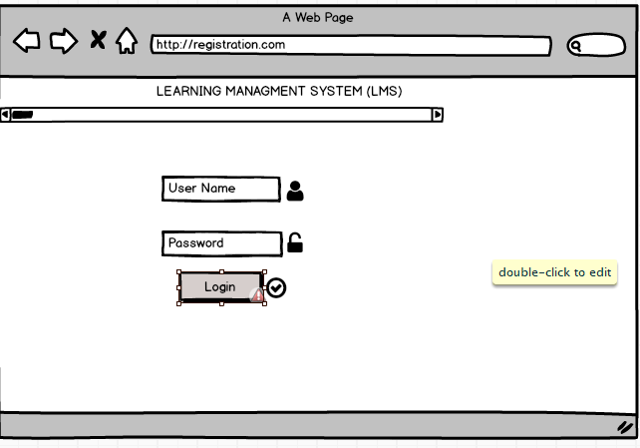
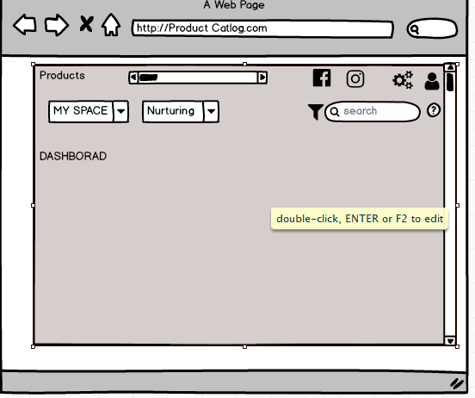
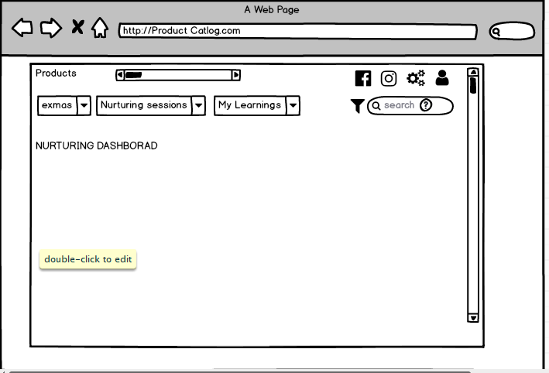
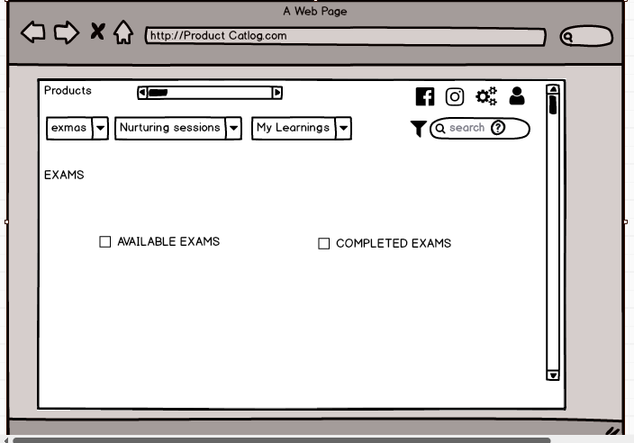
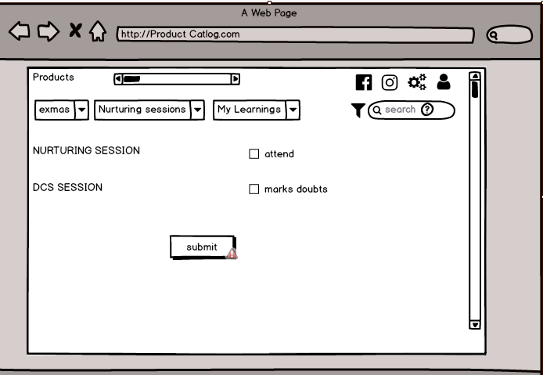
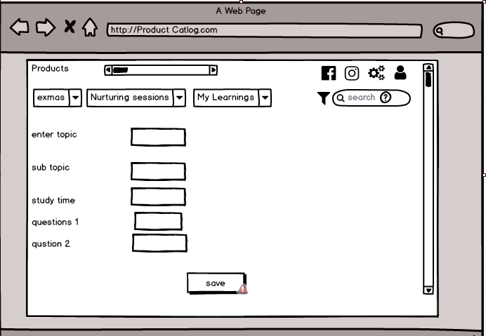

Document- 8 Tools-Visio and Axure
Ans.
During the Emerson Portal IP Workflow Automation project, I leveraged Microsoft Visio extensively for creating process flow diagrams and activity diagrams. Visio helped in clearly documenting both the AS-IS and TO-BE workflows, enabling stakeholders to easily visualize the inefficiencies in the current process and the streamlined flow in the proposed portal solution. Additionally, I used Axure to design interactive wireframes and mock-ups for the portal. Axure’s capability to simulate user interactions allowed stakeholders to experience a near-realistic prototype of the system before development, which was highly effective in validating requirements and aligning expectations. Together, Visio and Axure supported effective communication, requirement clarity, and stakeholder buy-in throughout the project lifecycle.
Document- 9 BA experience
Ans.
Business Analyst Experience
1. Requirement Gathering
In the requirement gathering phase, I applied the MoSCoW prioritization technique to classify requirements into “Must Have, Should Have, Could Have, and Won’t Have.” During this stage, the client was unavailable for certain periods, so I proactively identified alternate points of contact to ensure requirements were collected without delays. I validated the requirements using the FURPS framework (Functionality, Usability, Reliability, Performance, Supportability) to ensure quality. I also identified and eliminated duplicate or repeated requirements to avoid redundancy. Prototyping was used to elicit more specific requirements and help stakeholders visualize the solution.
2. Requirement Analysis
For requirement analysis, I created UML diagrams to visually represent system behavior and activity diagrams to capture the process flow. These artifacts were shared with the team, and I considered feedback from team members, incorporating changes wherever needed. I prepared both Business Requirement Specification (BRS) and System Requirement Specification (SRS) documents to provide clarity for all stakeholders.
3. Design
In the design phase, I derived test cases directly from use case diagrams, ensuring both positive and negative test cases were covered to avoid gaps that could impact development later. I coordinated with the client to review and validate the design and solution documents. I also prepared test data and continuously updated the Requirement Traceability Matrix (RTM) to confirm that all requirements were mapped and met.
4. Development
During development, I organized Joint Application Design (JAD) sessions to bridge communication between business and technical teams. I clarified queries from developers, referring back to requirement diagrams to ensure accurate implementation. When conflicts or lack of cooperation arose among team members, I addressed them by conducting one-on-one discussions, explaining the impact of their actions, and fostering a healthy, collaborative work environment. Regular meetings with both the technical team and client were arranged, and for those unable to attend, I shared recordings and followed up individually to maintain alignment.
5. Testing
In the testing phase, I prepared test cases from use cases, conducted high-level testing, and ensured that test data requested from the client was available. I updated the RTM to verify complete coverage of requirements. I also coordinated client sign-offs and prepared stakeholders for User Acceptance Testing (UAT), ensuring smooth validation of the system.
6. Deployment
In the deployment phase, I forwarded the RTM to the client as part of the project closure documentation. I coordinated the preparation and distribution of end-user manuals and organized training sessions to ensure users were confident in using the new system. I also made sure that all identified users attended the training sessions, enabling a seamless transition from development to production.

