CAPSTONE PROJECT 3 PART1
Q.1 Draw a Use Case Diagram.
Ans.

Q.2 Derive Boundary Classes, Controller classes, Entity Classes.
Ans.
Boundary Classes-
Class that is use to handle interactions between the system and actors. refer dig. |-O

Ex .PaymentOptionBoundary
CardPaymentBoundary

Controller Class-
This class act as intermediaries between boundary and entity class.

Ex. RegistrationController, LoginController, PaymentinitiatedController, PaymentController, LogoutController

Entity Class-
This class represent the core data and business logic of the application.

Ex. Customer, Cash, Card, Net banking.

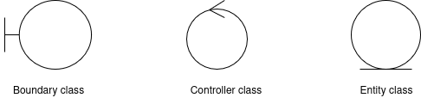

Q.3. Place these classes on a three tier Architecture.

Ans. In a three-tier architecture, the application is divided into three layers:
the Presentation Layer, the Business Logic Layer, and the Data Access Layer. Each layer has its own responsibility.

1) Application Layer/Presentation Tier (UI Layer)- These are the Boundary Classes that handle user interaction.
Classes :- CustomerRegistration, CustomerLogin
PaymentPage, CardPaymentForm, WalletPaymentForm, CashPayment, NetBankingPage

2) Business Layer() - These are the Controller Classes that process inputs(business logic) and coordinate between UI and data.
Classes :-PaymentController, CardPaymentController , WalletPaymentController , CashPaymentController , NetBankingController

3) Data Layer - These are the Entity Classes that represent data and manage storage logic.
Classes :- Customer, WalletPayment, CashPayment, CardPayment, NetBankingPayment

Q.4 Explain Domain Model for Customer making payment through Net Banking
Ans.
Definition: - A Domain Model is a conceptual representation of the entities involved in a system and the relationship among them. It helps to visualize how data is structured and how various components interact in a specific domain- in this case, net banking payment.

Difference between ER diagram and domain model-
ER Model- don not have attributes inside the box.
Domain Model- do have attributes mentioned inside the box.

ER Model- it is a data modelling technique used in database design to represent tables.
Domain Model- it is a conceptual model that represents real world entities.

ER Model- focuses on relationships required for storing and retrieving the data
Domain Model- it focuses on capturing the behaviour of application.

ER Model- primarily used in database design.
Domain Model- used throughout the software development lifecycle.

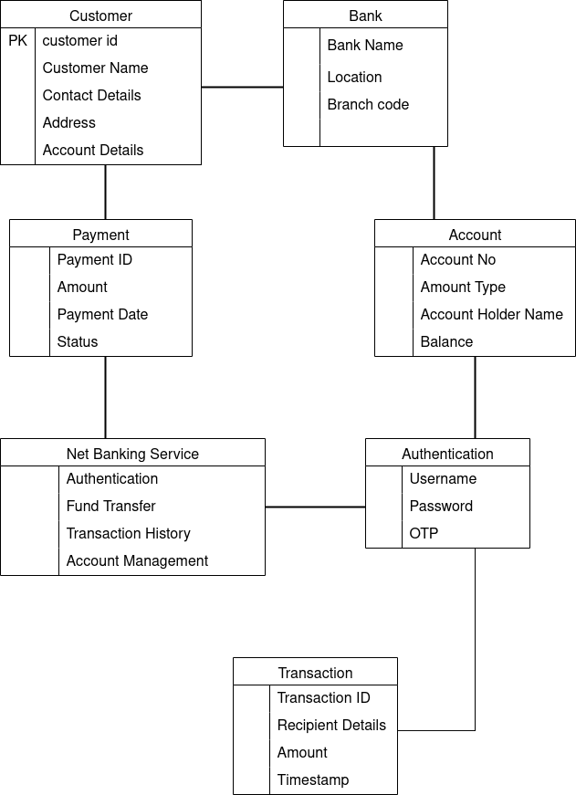

Q.5 Draw a sequence diagram for payment done by Customer Net Banking
Ans. This diagram shows how the objects in the system interact and communicate with each other with time to achieve specific task.

Developer will draw this.
It is used to show the flow of messages, events or actions between the objects of the system.
This diagram helps to visualize the behaviour of the system.
This diagram shows the process in detail.

Q.6 Explain Conceptual Model for this Case
Ans. A conceptual model is a high-level representation of a system that helps in understanding, visualizing and communicating the essential aspects of a domain.

Its Provides a clear and simplified view of the domain, making it easier to understand.

Key elements of a Conceptual Model:-
1) Entities- Customer, Product, Order & Payment.

2) Attributes- customerId, name, emailId, phoneNumber

3) Relationships- a customer places an order.

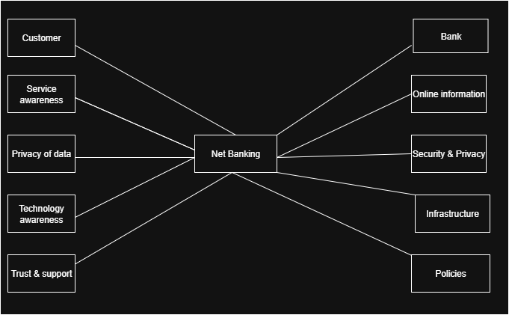

Q. 7. What is MVC architecture? Explain MVC rules to derive classes from use case diagram and guidelines to place classes in 3-tier architecture.
Ans. MVC (Model-View-Controller) is a design pattern used in software engineering, particularly in web applications. It divides the application into three main components:

Model:
Represents the business layer of the application.
It is responsible for accessing, processing, and managing the data from a database.
The model does not directly interact with the user interface.
Example: A Customer class that retrieves and stores customer data from a database.

View:
Represents the user interface (UI) layer.
It displays the data from the model to the user and can send user input to the controller.
Example: Application pages or screens.

Controller:
Acts as the intermediary between the model and the view.
Receives user input from the view, processes it (often involving updates to the model), and returns the appropriate response to the view.
Example: A Customer Controller that handles input from the UI and updates the Customer model.

MVC Rules to Derive Classes from Use Case Diagram

Identify Actors:
Determine the actors in the use case diagram. Each actor may correspond to a controller or view component.

Identify Use Cases:
Each use case represents a specific functionality. Translate these into methods within the controller.

Define Models:
Identify data entities involved in each use case. Create model classes that encapsulate data and business logic related to these entities.

Establish Relationships:
Determine how models, views, and controllers interact. Define the flow of data between these components.

Create Views:

For each use case, define corresponding views that present data to the user. Associate each view with a specific controller.

Guidelines to place classes in 3-tier architecture
In a 3-tier architecture, classes are typically organized into three layers: presentation, business logic, and data access. Here are guidelines for placing classes in each tier:

Presentation layer-
Responsible for displaying information and receiving input from user.
These classes interact directly with the user.

Business Layer-
Responsible for functionality and business rules of the application.
It processes data received from the presentation layer and communicates with the data layer to retrieve, manipulate, or store data.

Data Layer-
It handles the storage, retrieval, and management of data in databases.
It communicates with the business logic layer to fulfil data requests.

Q. 8 Explain BA contributions in project (Waterfall Model – all Stages)
Ans.
Business Analysts (BAs) play a crucial role throughout all stages of the project lifecycle. Their contributions are essential for ensuring that the project meets business needs and requirements.

Here’s a breakdown of the contributions of BAs at each stage of the Waterfall Model:

1. Requirements Analysis-
This stage involves gathering and documenting the requirements of the system from stakeholders.
BAs conduct interviews, surveys, and workshops with stakeholders to gather detailed business requirements.

2. System Design-
In this stage, the gathered requirements are translated into a system architecture and design specifications.
BAs work with the technical team to translate business requirements into system specifications and design documents.

3. Implementation-
The actual coding and development of the system take place in this stage, where developers build the software according to the design specifications.
BAs provide support to the development team by clarifying requirements and answering questions that arise during implementation.

4. Testing-
This stage involves verifying that the system works as intended and meets the specified requirements through various testing methods.
BAs assist in creating test plans and test cases based on the requirements and acceptance criteria.

5. Deployment-
The completed system is deployed to the production environment, making it available for end-users.
BAs contribute to the creation of user manuals, training materials, and documentation to support end-users during the transition to the new system.

6. Maintenance-
After deployment, the system enters the maintenance phase, where it is monitored for issues, and updates or enhancements are made as needed.

Q.9 what is conflict management? Explain using Thomas – Kilmann technique
Ans.
Conflict management refers to the process of identifying and addressing conflicts in a constructive manner. It involves understanding the sources of conflict, facilitating communication between parties, and finding solutions that satisfy the needs and interests of all involved.

Importance of conflict management-
Effective conflict management helps maintain productive relationships, improves teamwork, and promotes healthy communication in organizations.

The Thomas-Kilmann Conflict Mode Instrument (TKI) is a widely used framework for understanding and managing conflict, that identifies five conflict-handling styles based on two dimensions:

Assertiveness – the degree to which a person tries to satisfy their own concerns.

Cooperativeness – the degree to which a person tries to satisfy the other person’s concerns.rs).

The five modes are:

1) Competing (High Assertiveness, Low Cooperativeness)
Focus:"I win, you lose"
Description: Assertive and uncooperative; seeks to win at the other's expense.
Use:When quick decisions are vital (e.g., emergencies).
Example: A manager enforces a decision without team input to meet a tight deadline.

2. Collaborating (High Assertiveness, High Cooperativeness)
Focus: "Win-win"
Description: Assertive and cooperative; works towards a mutually beneficial solution.
Use: when both sides’ concerns are important and time allows for discussion.
Example: Two departments negotiate resource allocation to satisfy both needs.

3. Compromising (Moderate Assertiveness, Moderate Cooperativeness)
Focus: "Split the difference"
Description: Moderately assertive and cooperative; each party gives up something.
When to Use: When time is limited or both parties have equal power.
Example:Two team members agree to share responsibilities evenly.

4. Avoiding (Low Assertiveness, Low Cooperativeness)
Focus: "Ignore the conflict"
Description: Unassertive and uncooperative; withdraws from the conflict.
When to Use: For trivial issues or when emotions are high.
Example: A team member postpones discussing a minor issue to avoid escalation.

5. Accommodating (Low Assertiveness, High Cooperativeness)
Focus: "You win, I lose"
Description: Unassertive and cooperative; gives in to the other party's demands.
When to Use: When the relationship is more important than the issue.
Example: A team leader agrees to a colleague's proposal to maintain harmony.

Q.10 List down the reasons for project failure
Ans. Here are some common reasons for project failure:

1. Improper Planning-
Inadequate project scope definition.
Lack of clear objectives and goals.

2. Lack of Stakeholder Engagement-
Poor communication with stakeholders.
Ignoring stakeholder needs and expectations.

3. Poor Risk Management-
Failure to identify potential risks early.
Lack of contingency plans for unforeseen issues.

4. Lack of Resources-
Inadequate budget or funding.
Lack of skilled personnel or expertise.
Insufficient time allocated for project completion.

5. Lack of Leadership-
Weak project management and leadership skills.
Poor decision-making and conflict resolution.

6. Unrealistic Expectations-
Setting unattainable goals or deadlines.
Underestimating the complexity of the project.

7. Inadequate Testing and Quality Assurance-
Insufficient testing of deliverables before deployment.

Q. 11 List the Challenges faced in projects for BA
Ans. Business Analysts plays a key role in bridging the gap between stakeholders and development teams.

Challenges throughout the project lifecycle are-

1. Incomplete or Unclear Requirements-
Requirements are vague, ambiguous, or frequently changing.
Lack of standardized documentation practices.

2. Changing Requirements-
Continuous addition of new features without assessing impact on time and cost.

3. Communication Gaps-
Differences in understanding business language vs. technical terms.
Miscommunication between BAs, developers, testers, and stakeholders.

4. Stakeholder Issues-
Conflicting requirements from different stakeholders.
lack of engagement from stakeholders.

5. Time Constraints-
Limited time to gather and analyse requirements.

6. Lack of Domain Knowledge-
Limited understanding of the business domain or industry.

7. Poorly Defined Roles and Responsibilities-
Confusion between BA and project manager or product owner roles.
Overlapping duties leading to accountability issues.

Q.12 Write about Document Naming Standards
Ans. Document Naming Standards refer to a set of rules and guidelines used to name files and documents in a consistent, clear, and structured way.

Importance:-
1) Avoid confusion and duplication.
2) Helps in the document search and filtering.
3)Maintain consistency across teams and projects.
4)Enable effective version control and audit tracking.

Best practise for naming of document standards
1)Avoid Special Characters, Use underscores (_) or hyphens (-) instead of spaces.
2)Include meaningful keywords.
3)Use the same order of elements in every filename.
4)Use Date format and add version number.

Example :- AgriStore_Products_1.0_22082025_john.docx.
BankPortal_Requirements_v1.0_20250822_JohnDoe.docx

Q13. What are the Do’s and Don’ts of a Business Analyst?
Ans.

Sr. No. | DO’S | DON’TS
1 | Consult an SME for clarifications in requirements. | Never say NO to the client.
2 | Listen to the client very carefully and after he I done, then ask question | There is no word as “By default”
3 | Concentrate on the important requirements | Don’t interrupt the client when he is giving you the problem
4 | Try to extract maximum leads to the solution from the client himself | Never imagine anything in term of GUI (Graphical User Interface)
5 | Question everything in the world | Go to the client with plain mind i.e. with no assumption
6 | Always appreciate the stakeholder even for small efforts | Never criticize the stakeholders
7 | Be like a lotus mud- if a client comes with a fancy requirement, then talk to the product manager first | Requirement hurried- project buried.

Q14. Write the difference between packages and sub-systems
Ans.
Definition of Packages: A Package is a way to group related elements in UML (Unified Modeling Language) or programming. It acts like a folder or container that holds related classes, interfaces, diagrams, or other packages.
Definition of Sub- systems: A Sub-System is a self-contained functional unit within a larger system. It performs a specific business function and can operate independently or interact with other sub-systems.

Aspect | Package | Sub-system
Purpose | Organize model elements to reduce complexity | Represent a larger logical unit or functional block of a system
Scope | Typically internal grouping in design or model | Often externally visible and interacts with other sub-system
Reusability | Used for modular design, but usually not reused alone | Designed for reusability and independent deployment
Representation | Shown in UML as a folder-like icon | Shown in UML as a composite structure or with <<subsystem>> stereotype
Real World Analogy | Like a folder on your computer that contains multiple word or excel files related to a single project | In a supermarket, the Billing Counter is one sub-system, and the Inventory Store Room is another. Both are part of the supermarket but do different jobs independently.

Q.15 What is camel-casing and explain where it will be used
Ans.
Meaning of Camel-Casing:
- Camel-casing refers to the naming convention of variable, parameters or properties.
- Here, multiple words are combined together
- In camel-casing, the starting letter of the first word starts with small letter and other words first letter starts with capital letters.
- Ex- firstName, lastName
- It makes long names easier to read compared to all lowercase( e.g.studentDateOfBirth vs studentdateofbirth).
- Used in language like Java, C#, JavaScript, Python, etc

Types of Camel-Casing:
Type | Ex | Usage
Lower camel case | customerName | Common for variables, object names
Upper camel case | CustomerName | Used for class names, method names

Where camel-casing is used:
- In BA, Camel-Casing is used in requirements documentation
- In requirement documentation, BA often use camel-casing to name the entities like use case, features, user stories like validateCustomerDetails, calculateInterestRate, etc
- Business rules, which should be satisfied by the system use camel-casing
- Without documenting business process or workflows, camel-casing can be used to individual in steps, this will help maintain consistency in the document.
- The database tables name also uses camel-casing
- Requirement naming camel-casing is used in requirement document also, to name the functional and non-functional requirements.
- By using camel-casing in the documents, it helps to maintain consistency in the entire document and also increases readability.

Q.16 Illustrate Development server and what are the accesses does business analyst has?
Ans.
Definition of Development Server: Is an environment where developers and technical teams build, test, and integrate software before it is moved to testing, staging or production.

Purpose of a Development Server:
- To develop and test code in a safe environment
- To integrate features and detect bugs early
- Used before moving code to QA or UAT environment

The access a BA has are:
- ReadOnly-

BA’S may be granted with the readonly access to the development server. This will allow them to view the user interface of the application, navigate through the features and also they will be able to observe the behaviour of the application.
- Limited access-
Depending upon the project needs, the BA’s will be granted limited access to the specific modules in the application
- Limited configuration access-
Means the BA have the authority to make changes in certain areas of application where they have the access.
- Raise Issues to Dev-

Report missing features, logic mismatches, or unclear behaviour

- Demo preparation-

Prepare flows/screens to showcase to business to stakeholders

Q.17. What is Data Mapping

Ans.
Data mapping is the process of matching fields from one data source to another.
It ensures data is transferred accurately between databases, applications, or file formats.

Types of Data Mapping:

Manual Mapping: Defined by developers using scripts.

Automated Mapping: Done using tools (e.g., Talend, Informatica).

Schema Mapping: Aligning fields across different schemas (XML to JSON).

Purpose of Data Mapping:-
1)To ensure data is transferred accurately and meaningfully between systems.
2)To facilitate data transformation, such as converting formats or structures.
3)Enables faster and error-free migrations.

Uses:-
1)Database migrations (e.g., from MySQL to Oracle).
2)API integrations.

Benefits:-
1)Ensures data consistency and accuracy.
2)Enables faster and error-free migrations.

Difficulties:-
1)Missing or incomplete data, Inconsistent data formats.
2)Different naming conventions , Complex transformation rules.

Q.18 what is API. Explain how you would use API integration in the case of your application Date format is dd-mm-yyyy and it is accepting some data from Other Application from US whose Date Format is mm-dd-yyyy
Ans.
- API stands for Application Programming Interface
- An API allows two software applications to communicate and exchange data with each other in a standardized format
- It is the set of rules, protocols and tools that define how different software application should interact with each other
- API allows sharing of only necessary information and keeps the internal system details hidden, which helps the system security

For the above scenario-
- Establish API communication- set up API communication between your application and other application to exchange data
- Do Data formatting- While sending the data from one application to other, convert the date format from dd-mm-yyyy to mm-dd-yyyy.
- While receiving the data from other application, parse the data and extract the date, month and year and re-arrange them accordingly
- Perform Data Validation and ensure that the converted date remains in a valid format.

