COEPD
Capstone Project 3 - Online Agriculture Products Store

Submitted by – Annu Singh

Question 1– Functional Requirements Identify minimum 20 functional requirements
Answer –

ID | Req Name | Req Description | Priority
FR001 | Farmer Registration | Farmer should be able to register with the application | 10
FR002 | Search option | Farmer should be able to search for the available products in fertilizers, Seeds, Pesticides | 8
FR003 | Product comparison | Farmer should be able to view various products on same screen for comparison purpose the product with other manufactures | 5
FR004 | Place order | Farmer should be able to place the order from his cart list | 8
FR005 | Payment option | System should pop up the available payment option like Cash, card UPI etc. | 8
FR006 | Summary | Summary of the purchase order should be displayed on the screen | 7
FR007 | Order received | Upon receipt of order system will pop up message alerts to the manufacturer. | 7
FR008 | Delivery tracking system | Execution of the dispatch tracking system will get activated for further alerts | 7
FR009 | Payment system | Once farmers receive the goods farmers can do the payment and manufacturer will receive the payment confirmation. | 6
FR010 | Login Error | Error messages will appear if incorrect credential is used | 9
FR011 | duplicate alert | Availability of pop-up message in case of duplicate selection of same product by the user if any | 8
FR012 | Notification of new product | Farmers should be able to receive the notification  for newly launched or arrived product from the manufacturer | 6
FR013 | Return Policy | Availability of product return option /Cancelation of product in the application | 6
FR014 | No duplicate register | If the mail id is already registered with system, it should pop up the message | 6
FR015 | Taxes | Product price should be inclusive of government taxes | 5
FR016 | Review column | Review and feedback column should be available for each product | 5
FR017 | Queries | If any queries, then should be able to interact with the BOT | 7
FR018 | Address update | Update Address and save options for delivery | 5
FR019 | Order cancel | Cancel order option and money return | 8
FR020 | Language | Farmer should be able to browse in their local language | 8

FR021 | Support helpline | Farmer should have option on website to call support helpline for any help. | 9
NFR0101 | Page Loading timing | Each page should load within 2 Second time | 8
NFR0102 | WCAG 2.1. | Ensure the website/app is usable by all users, including people with disabilities. | 8
NFR0103 | Accessibility |  | 5
NFR0104 | Time limit for OTP | Max 120 sec time allowed for inputting OTP while registration or login process | 3
NFR0106 | Stock Available | Availability of stock with the manufacturer and should get updated on real time basis. | 3
NFR0109 | Payment Receipt | Generation of payment details on white paper receipt of 4” 6 | 3
NFR0110 | Theme | website should have greenery-based theme. | 8
NFR0112 | Disable policy | User id should be disable if not login for 90 days | 3
NFR0113 | Taxation | 15% government taxes should be added to the product finale price. | 5

Question 2–Minimum 5-page designs Make wireframe and prototypes Answer –

- Log In Page

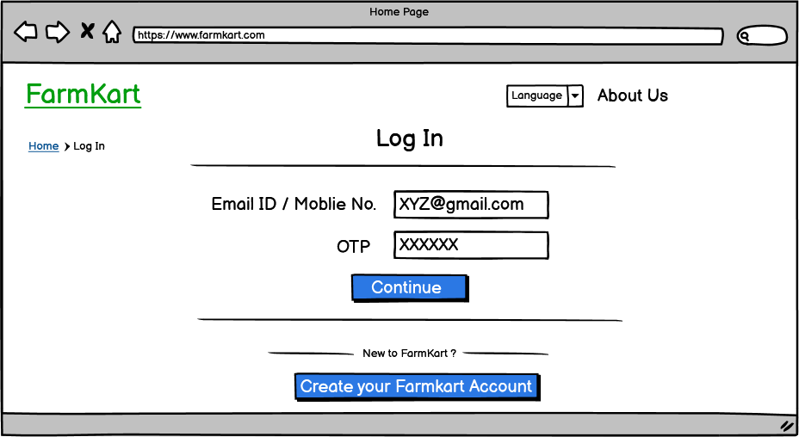

- Home Page with search option

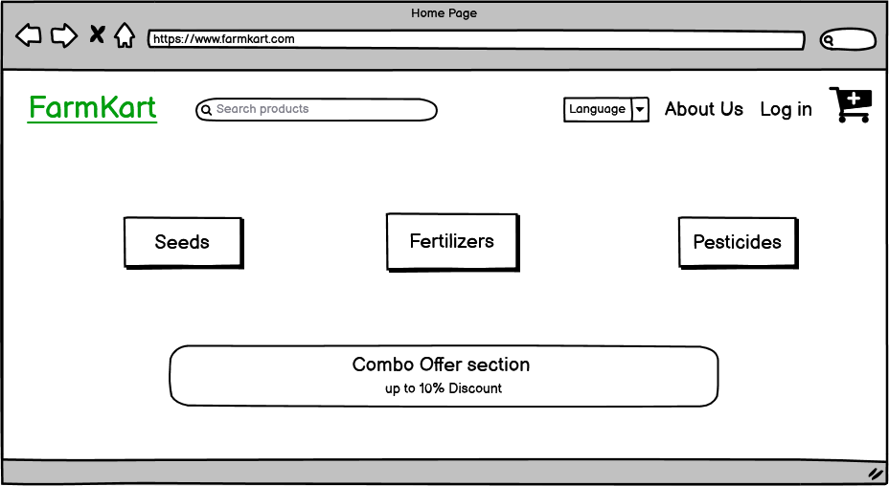

- Browse product

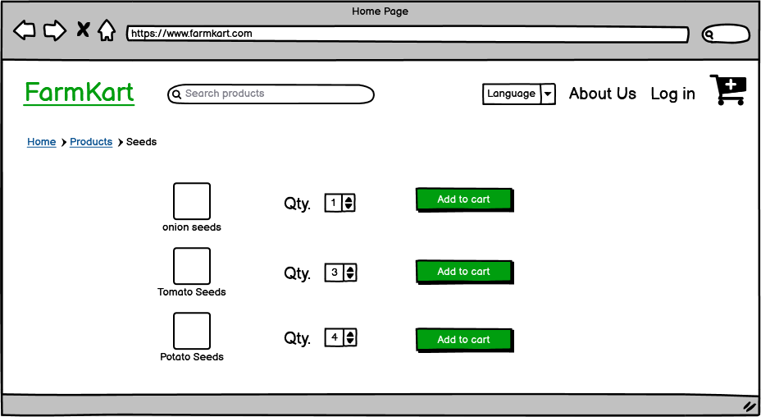

- Cart page

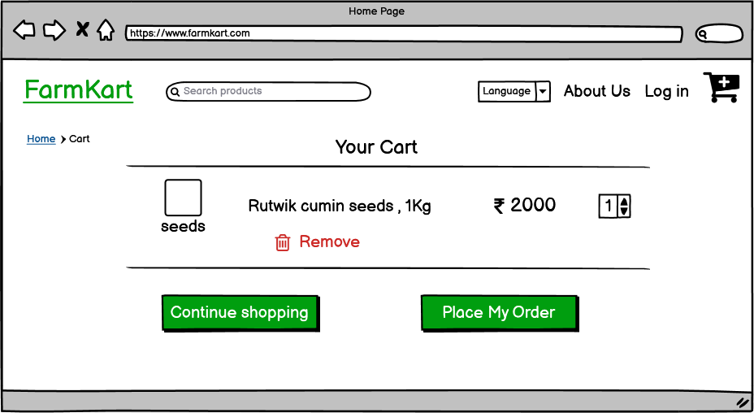

- Order and delivery confirmation

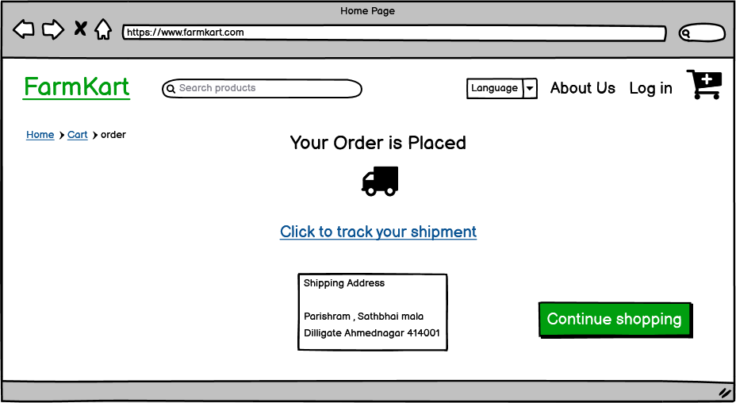

Question 3– Tools (Visio, Balsamiq)
Make a note of the Tools, which you are using for above concepts. Answer -
There are various tools used in projects like Axure, Visio, and Balsamiq.
In our case, we are using Microsoft Visio and Balsamiq for various designing purposes. For preparing the wireframe and prototype we have used Balsamiq.
Both these tools are briefed below for better understanding.
Visio: Microsoft Visio is a well-known flow chart and diagramming software. It is mostly used by designing users. We can draw flowcharts, org charts, data flow diagrams, and process flow diagrams using Microsoft Visio. It is a commonly used tool in the software industry.
As a BA we have features of Flowchart, Organization Chart, and Business Process Modelling in Visio that can be effectively used for data representation. Visio thus we can say can be used to present complex data in a much easier and simpler way
Balsamiq: It is a raw kind of UI wireframing tool used for framing the screen design. It helps in creating the basic structure of the page irrespective of colors and detailed imaging which comes later in the phase. It has various design templates which can be customized according to user requirements.

Question 4 – RTM
A business analyst’s key responsibilities are to keep track of the requirements and make sure that no requirement is missed. Mr. Henry and peter have approached you regarding the status of the project. How will you tackle this situation? Prepare RTM
Answer –

ID | Req Name | Req Description | Design | D1 | T1 | D2 | T2 | D3 | T3 | D4 | T4 | UAT
FR001 | Farmer Registration | Farmer should be ableto  register with the application | ✔ | ✔ | ✔ | ✔ | ✔ | ✔ | ✔ | ✔
FR002 | Search option | Farmer should be ableto search for the available  products in fertilizers, Seeds, Pesticides | ✔ | ✔ | ✔ | ✔ | ✔ | ✔ | ✔ | ✔
FR003 | Product comparison | Farmer should be ableto view various product on same screen for comparison purpose the product with other  manufactures |  |  |  | ✔ | ✔ | ✔ | ✔ | ✔
FR004 | Place order | Farmer should be able to  place the order from his cart list |  |  |  | ✔ | ✔ | ✔ | ✔ | ✔

FR005 | Payment option | System should pop up the available payment  option like Cash, card UPI etc. |  |  |  | ✔ | ✔ | ✔ | ✔ | ✔
FR006 | summary | Summary of the  purchase order should be display on screen |  |  |  | ✔ | ✔ | ✔ | ✔ | ✔
FR007 | Order received | Upon receipt of order system will pop up  message alerts to the manufacturer. |  |  |  | ✔ | ✔ | ✔ | ✔ | ✔
FR008 | Delivery tracking system | Execution of the dispatch tracking system will get activated for  further alerts | ✔ | ✔ | ✔ | ✔ | ✔ | ✔ | ✔ | ✔
FR009 | payment system | Once farmer received the goods farmers can do the payment and manufacturer will receive the payment  confirmation. | ✔ | ✔ | ✔ | ✔ | ✔ | ✔ | ✔ | ✔
FR010 | login error | Error message will appear if incorrect  credential is used | ✔ | ✔ | ✔ | ✔ | ✔ | ✔ | ✔ | ✔
FR011 | duplicate alert | Availability of pop-up message in case of duplicate selection of same product by the  user if any | ✔ | ✔ | ✔ | ✔ | ✔ | ✔ | ✔ | ✔
FR012 | Notification of new product | Farmers should be able to receive the notification for newly launched or arrived product from the  manufacturer |  |  | ✔ | ✔ | ✔ | ✔ | ✔ | ✔ | ✔
FR013 | Return Policy | Availability of product return option  /Cancelation of product in the application |  |  | ✔ | ✔ | ✔ | ✔ | ✔ | ✔ | ✔ | ✔
FR014 | No duplicate register | If the mail id is already registered with system,  it should pop up the message |  |  | ✔ | ✔ | ✔ | ✔ | ✔ | ✔ | ✔ | ✔
FR015 | Taxes | Product price should be inclusive of government  taxes |  |  | ✔ | ✔ | ✔ | ✔ | ✔ | ✔ | ✔
FR016 | Review column | Review and feedback column should be  available for each product |  |  | ✔ | ✔ | ✔ | ✔ | ✔ | ✔ | ✔
FR017 | Queries | If any queries, then  should be able to interact with the BOT | ✔ | ✔ | ✔ | ✔

FR018 | Address update | Update Address and save options for delivery | ✔ | ✔ | ✔ | ✔
FR019 | Order cancel | Cancel order option and money return | ✔ | ✔ | ✔ | ✔
FR020 | language | Farmer should be able to  browse in their local language | ✔ | ✔ | ✔ | ✔
FR021 | Support helpline | Farmer should have option on website to call  support helpline for any help. | ✔ | ✔ | ✔ | ✔
NFR001 | Page  Loading timing | Each page should load within 2 Second time | ✔ | ✔ | ✔ | ✔
NFR002 | All product catalog | On the web page preview maximum 5 products are display of Manufacturing  companies’ catalog | ✔ | ✔ | ✔ | ✔
NFR003 | Technical  supported system | Application can be used on any android mobile. | ✔ | ✔ | ✔ | ✔
NFR004 | Time limit for OTP | Max 120 sec time allowed for inputting  OTP while registration or login process | ✔ | ✔ | ✔ | ✔
NFR006 | Stock Available | Availability of stock with the manufacturer and  should get updated on real time basis. |  | ✔ | ✔ | ✔ | ✔ | ✔ | ✔ | ✔
NFR009 | Payment Receipt | Generation of payment  details on white paper receipt of 4” 6 |  | ✔ | ✔ | ✔ | ✔ | ✔ | ✔ | ✔
NFR0010 | Theme | website should have greenery-based theme. |  | ✔ | ✔ | ✔ | ✔ | ✔ | ✔ | ✔
NFR0012 | Disable policy | User id should be disable if not login for 90 days |  | ✔ | ✔ | ✔ | ✔ | ✔ | ✔ | ✔
NFR0013 | Taxation | 15% government taxes should be added to the  product finale price. | ✔ | ✔ | ✔ | ✔ | ✔ | ✔ | ✔

Question 5 – 10 Test Case Documents Prepare 10 Test Case Documents Answer –
Test Case ID |  | AB_001 | Test Case Description | Test the Login Functionality in Online agriculture  product store
Created By |  | ABC | Reviewed By | xyzzy | 2
S # | Prerequisites: |  |  | S # | Test Data
1 | Access to Chrome Browser |  |  | 1 | User id = ABC1234
 |  |  |  | 2 | Pass =  XYZ@1234567

Test  Scenario 1) | Verify on entering valid user id and password, the customer can login
Step # | Step Details | Expected Results | Actual Results | Pass / Fail / Not executed /  Suspended
1 | Download the Online Agriculture Product Store App | Site should open | Site opened | Pass
2 | Enter wrong User id & wrong Password | Credential can be entered | Credential not entered correctly | Fail
3 | Enter valid User id & valid Password | Customer is logged in | Credential entered correctly | Pass
Test Scenario  2) | Maximum 5 product should be displayed on page
Step # | Step Details | Expected Results | Actual Results | Pass / Fail / Not executed /  Suspended
1 | Open Product List | Site should open | Site opened | Pass
2 | 5 products should display | Maximum 5 product should be displayed on page | 5 Product displayed | Pass
3 | 6 products should display | Maximum 5 product should be displayed on page | 5 Product displayed | Fail

Test  Scenario 3) | After selecting the product, it must show in Cart
Step # | Step Details | Expected Results | Actual Results | Pass / Fail / Not  executed / Suspended
1 | Open Product List | Site should open | Site opened | Pass
2 | Product Selected from the list | Product displayed in cart list | Product does not display in cart list | Fail
3 | Product Selected from the list | Product displayed in cart list | Product  displayed in cart list | Pass
Test Scenario  4) | Manufacturer stock should be reduce once product order is confirm by the buyer
Step # | Step Details | Expected Results | Actual Results | Pass / Fail / Not  executed / Suspended
1 | Farmer should buy the product online | Site should open | Site opened | Pass
2 | Farmer buy the product online | Stock should reduce from manufacturer stock | Stock not reduced from manufacturer stock | Fail
3 | Farmer buy the product online | Stock should reduce from manufacturer stock | Stock reduced from manufacturer stock | Pass
Test Scenario  5) | Various payment option will provide the user after finalize the product to buy COD, Card 16 number card not expired debit card credit card, UPI
Step # | Step Details | Expected Results | Actual Results | Pass / Fail / Not executed /  Suspended
1 | Farmer should make a payment online | Site should open | Site opened | Pass
2 | Farmer Select The card payment option | Payment should do through UPI | Payment option redirect to Card | Fail
3 | Farmer Select the UPI | Payment should do through UPI | Payment done through UPI | Pass

Test  Scenario 6) | If the user is not active maximum 10 min log out the user automatically
Step # | Step Details | Expected Results | Actual Results | Pass / Fail / Not  executed / Suspended
1 | Farmer Should login the Application | Site should open | Site opened | Pass
2 | Farmer Login on application | After 10 min user should log out | user not logout after 10 min | Fail
3 | Farmer Login on application | After 10 min user should log out | user logout after 10 min | Pass
Test Scenario  7) | Receipt of OTP on register mail and register mobile number within Max 10 sec time
Step # | Step Details | Expected Results | Actual Results | Pass / Fail / Not executed /  Suspended
1 | Farmer Should login the Application for buying the product | Site should open | Site opened | Pass
2 | SMS & Email send to farmer | Max 10 sec Otp received on email id and Mobile | Otp not received on email as well as Mobile  Number | Fail
3 | SMS & Email send to farmer | After 10 min user should log out | Otp received on email as well as Mobile Number | Pass
Test  Scenario 8) | Validity of the OTP is maximum 60 seconds
Step # | Step Details | Expected Results | Actual Results | Pass / Fail / Not  executed / Suspended
1 | Farmer Should login the Application for buying the product | Site should open | Site opened | Pass
2 | Otp Send on farmers Email id and Mobile number | Max 60 second otp should active | Otp not valid after 10 sec | Fail
3 | SMS & Email send to farmer | Max 60 second otp should active | Otp valid till 60 sec | Pass

Test  Scenario 9) | Addition of government tax price of the produc
Step # | Step Details | Expected Results | Actual Results | Pass / Fail / Not  executed / Suspended
1 | Farmer Should login the Application for buying the product | Site should open | Site opened | Pass
2 | Addition of Gov tax price of product 15 % | Gov tax should add 15% | Gove Tax added 30 % | Fail
3 | SMS & Email send to farmer | Gov tax should add 15% | Gove Tax added 15 % | Pass
Test Scenario 10) | unique email id for registration
Step # | Step Details | Expected Results | Actual Results | Pass / Fail / Not  executed / Suspended
1 | Farmer Should login the Application for buying the product | Site should open | Site opened | Pass
2 | Farmer should be able to register with unique email id | Unique email id should enter | Existing id inputted which already exist in  system | Fail
3 | SMS & Email send to farmer | Unique email id should enter | Unique email id entered | Pass

Question 6 – DB Design
After the requirements are thoroughly explained to the entire project team by business analyst, the Database architects have decided to do the database design and to represent the in-flow and out-flow of data.
Draw database schema and ER diagram Answer –
ER diagram

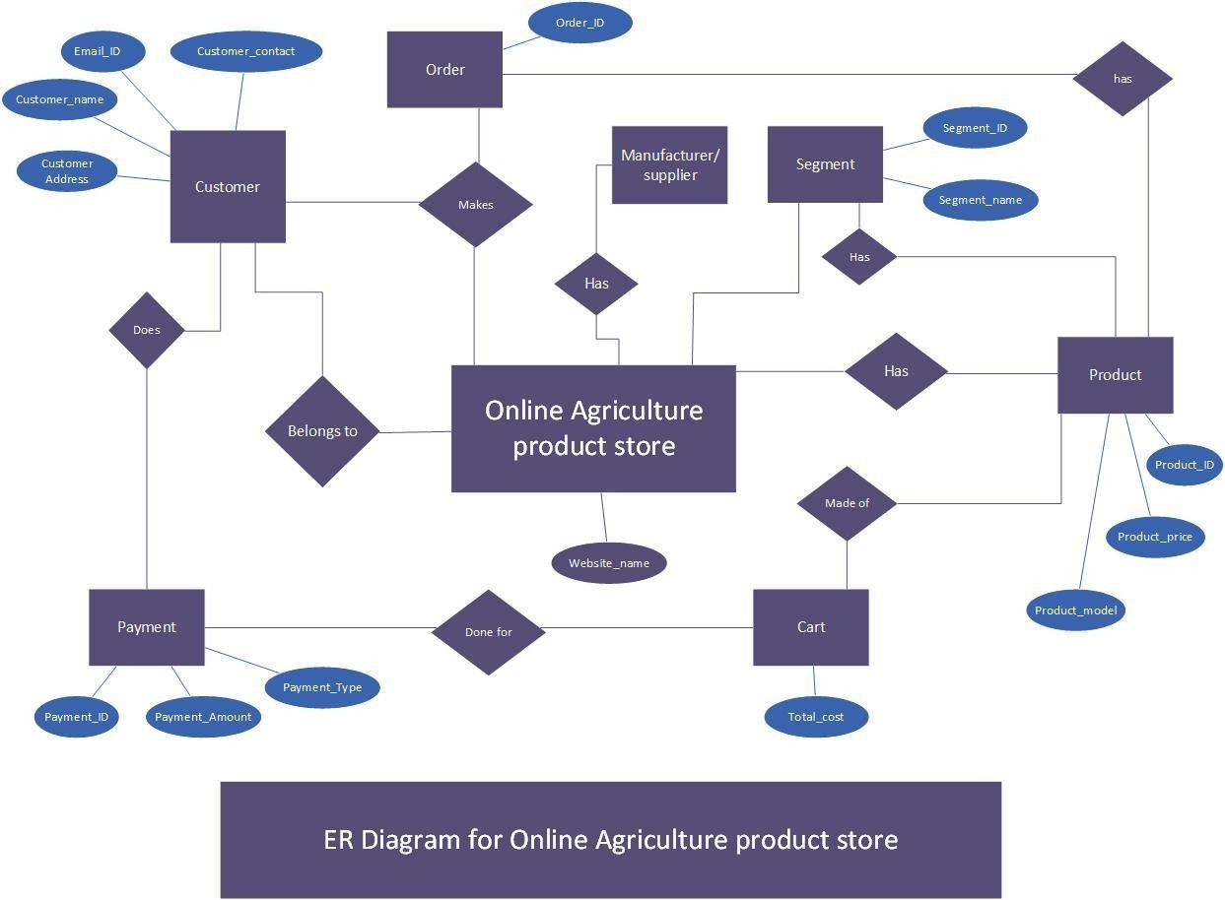
Database Schema
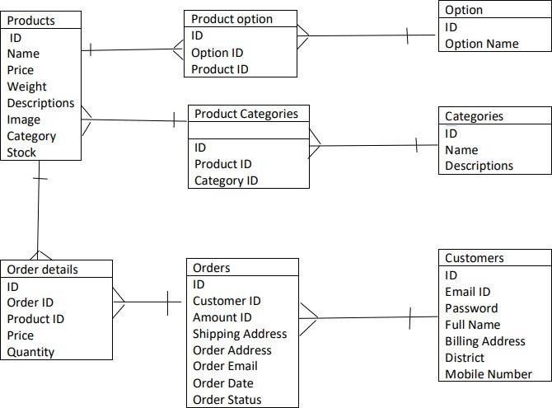

Question 6 – Data Flow Diagram
What is a data flow diagram? Draw a data flow diagram to represent the in-flow and out-flow of data when a Farmer is placing an order for the product
Answer –
Dataflow Diagram is a graphical representation of data. It is method of representing a flow of data through a process or system. It helps in providing information about the output and input of each entity. It’s a symbolic visualization of the data flow from one stage to another.
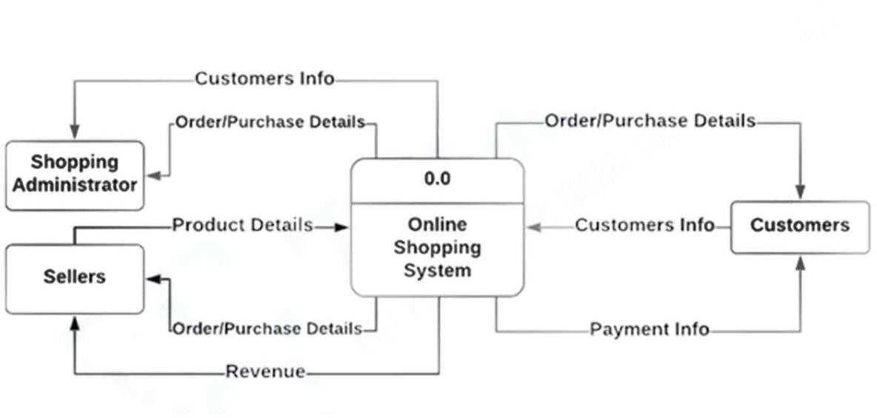

Question 7 – Change Request
Due to a change in the Government Taxation structure. we should change the Tax structure How do you handle change requests in a project?
Answer -
A change request can be initiated by customers intentionally or forcefully. change request needs to be handled carefully depending on the stage of the project. the change request should be approved by the concerned authorities like the project manager. once approved change request needs to be documented and signed by the customer.
budgeting/ time is one of the crucial parameters in case of a change request. an additional budget may be required, and approval should be taken before implementing any changes.
Steps in change request we can take -
- We will convey the clients change request to the concerned team,
- After receiving the change request discussed with PM & SME
- Extension of period or budget can be asked for approval from the client if required
- Necessary documentation for change request will be prepared and a sign should be obtained from the customer
- Once the extension or budget is approved by the client the change request is shared with the technical team for making necessary changes in the application.
- Modify the RTM done as per the change request.

Question 9– Change Request Vs an Enhancement
As the project is in process, Ben and Kevin have contacted you. The reason is to inform you that they want the Farmers to sell their crop yields through this application i.e., Farmers should be able to add their crop yields or products and display them to the public and should be able to sell them. They also want to introduce an Auction system for their Crop yields. As a BA, what will be your response? Is this a change request or anenhancement?
Answer –
We as BA will treat this request as a change request, not enhancement because the display of farmer products or availability of farmer sell of crop yields was not given by the client initially its a totally new requirement
Enhancement: - Whenever there is a modification in the initial requirement given by the customer it is known as an enhancement request. In short, whenever an initial requirement gets modified it will be treated as an enhancement.
Example: -Changes in % of GST while calculating the price of the product. In this case formula of calculation, the price of a product already exists in the original requirement. The only modification to be done is in the % of GST
Change Request: - In case of change requires the total new requirement given by the customer which initially doesn’t exist, whenever a customer gives a fresh requirement that was not given by him initially will be treated as a change request for implementing such type of request major changes need to be done.
Example: - Farmers should be able to add their crop yields or products and display them to the public and should be able to sell them.

Question 10 – Estimations
Come up with estimations – How many Manhours required

Answer -
This is a totally new requirement no provision has been made initially no such requirement provision was made for farmer products earlier for utilizing this change in application
We need to revisit all the app parameters once again it is as like adding one more application to existing one hence the estimated cost and men hours will be almost equivalent to the present one

Consider 8 hours a day for 5 days for a week for a total 18-month project 11 x 8 x 5 x (4 weeks in a month) x 18 months = 31680 man hours.

Question 11 – UAT
The project has finally completed all the stages i.e., design, development, testing, etc. Now, it is the role of a business analyst to contact the client for testing the final product and to successfully complete it. How are you going to handle this situation? And once it is done, what will be the process to close the project?
Explain the UAT Acceptance process Answer -
The user Acceptance process UAT is the final stage of any software development or changes request lifecycle before go- live. Actual users test the software to determine if it does what it was designed to do in real-world situations, validating changes made and assessing adherence to their organization’s business requirements.
UAT Process
Step 1) Analysis of Business Requirements - One of the most important activities in the UAT is to identify and develop test scenarios. These test scenarios are derived from the following documents:
- Project Charter
- Business Use Cases
- Process Flow Diagrams
- Business Requirements Document (BRD)
- System Requirements Specification (SRS)
Step 2) Creation of UAT Plan: - The UAT test plan outlines the strategy that will be used to verify and ensure an application meets its business requirements. It documents entry and exit criteria for UAT, Test scenarios and test cases approach, and timelines of testing.
The UAT test plan outlines the strategy that will be used to verify and ensure an application meets its business requirements. It documents entry and exit criteria for UAT, Test scenarios and test cases approach, and timelines of testing.
Step 3) Identify Test Scenarios and Test Cases:
Identify the test scenarios with respect to high-level business processes and create test cases with clear test steps. Test Cases should sufficiently cover most of the UAT scenarios. Business Use cases are input for creating the test cases.
Step 4) Preparation of Test Data:
It is best advised to use live data for UAT. Data should be scrambled for privacy and security reasons. A tester should be familiar with the database flow.
Step 5) Run and record the results:
Execute test cases and report bugs if any. Re-test bugs once fixed. Test Management tools can be used for execution.

Step 6) Confirm Business Objectives met:
Business Analysts or UAT Testers need to send a sign-off mail after the UAT testing. After sign-off, the product is good to go for production. Deliverables for UAT testing are Test Plan, UAT Scenarios and Test Cases, Test Results, and Defect Log
As a project has completed all the stages of SDLC, first as a BA will do a dry run of the project, wherein all the systems with each option will be tested and once satisfied, will consult the project manager.

After doing the testing analysis the project manager will send an official email to the client for UAT and will fix up a meeting date and time with the client, stakeholders, and all our team members.
BA will showcase the project with live go screens and will welcome suggestions from clients or stakeholders if any and will take the sign-off from the client to close the project.
After this, we will start the process of handing over the application to the client and we will give all documentation to the client for future help.

Question 12– Project Closure Document Explain the Project closure document
Answer –

The purpose of the Project Closure document is to formally close a project and authorize the handoff from project to operations. It would include final information about the project deliverables, scope, milestones, and budget, as well as lessons learned.
Steps to Closing a Project
Thecloseoftheprojectisthefinalphaseofyourjob,it’sthelastturnoftheprojectlifecycle,andlikeanyotheraspect of a project, it requires a process. The following are five steps you should take to make sure you’ve dotted all the I’s and crossed all the T’s, as well as taken full advantage of the experience.
- Arrange a Postmortem
Managing a project isn’t only about tasks and resources, budget, and deadlines, it’s an experience you can constantly learn from. While you should have been learning throughout the project, now is a great time to look back without the pressure and distractions that might have dulled your focus.
- Complete Paperwork
As noted, projects generate reams of documents. These documents are going to have to get sign-off and approval from stakeholders. Everything needs attention and must be signed for, which is the legal proof that in fact, these documents have concluded. That includes closing all contracts you might have made with internal partners or vendors or any other resources you contracted with
- Release Resources
You assemble team for the project, and now you must cut them loose. It’s a formal process,and acrucial one, frees them for the next project. Each team is brought together for the mix of skills and experience they bring to a project. The project determines the team members you’ll want to work with, and each project is going to be a little bit different, which will be reflected in the team hired to execute it.
- Archive Documents
There are lessons to be learned from old projects, which is why you meet with your team regularly during the project and look back on the process afterward. However, if you don’t have an archive in which to pull the old records, then whatever knowledge you gain is lost because of poor organization and management. You worked hard to have great project documentation, don’t lose it.

