04 BA Mock - Case study
A company with multiple manufacturing plants and warehouses across the country manufactures ice-cream and milk products.
They want to build software to achieve two goals:
>Manage the Inventory
>Ensure Quickest Delivery to the Customers
Assignment 1:
1. Please make a BRD which can be presented to the client along with complete development and resource plan.
Project Name: Smart Inventory Management System (SIMS)
Project ID: SIMS-INV-001
Version ID: 1.0
Author: Likhitha
1. Document Revisions
Date | Version | Changes Made
8/9/2025 | 0.1 | Initial Draft
9/9/2025 | 1 | Final BRD Submission
2. Approvals
Role | Name | Title | Signature | Date
Project Sponsor | Mr. Mehra | Senior Director
Business Owner | Ms. Anita | Operations Head
Project Manager | Mr. Rakesh | PMO
System Architect | Ms. Varsha | Enterprise Architect
Development Lead | Mr. Vivek | Technical Lead
Quality Lead | Ms. Priya | QA Manager
3. RACI Chart
Name | Position | R | A | S | C | I
Ms.Anita | Operations Head |  | A |  | C | I
Mr. Rakesh | PMO | R |  |  |  | I
Ms. Varsha | Enterprise Architect |  |  | S | C
Mr. Vivek | Technical Lead | R |  |  |  | I
Ms. Priya | QA Manager |  |  | S |  | I

4. Introduction
4.1 Business Goals
The organization aims to modernize its inventory ecosystem to ensure real-time visibility, optimized stock levels, and reduction of wastage across multiple plants and warehouses. This initiative supports improved efficiency in supply chain operations and enables faster fulfillment of customer orders.
4.2 Business Objectives
Implement a centralized inventory management system that integrates manufacturing units, warehouses, and distribution centers.
- Provide real-time stock updates to avoid understocking/overstocking.
- Enable predictive demand planning using consumption and seasonal trends.
- Streamline warehouse operations with barcode/RFID scanning.
- Ensure system accessibility via mobile and web-based applications.
4.3 Business Rules
- All inventory transactions must be digitally logged and auditable.
- Expiry-date-based inventory rotation (FIFO/FEFO) is mandatory for dairy and ice-cream products.
- Warehouse managers must approve stock adjustments before system updates.
- Access controls will restrict data visibility based on user roles.
4.4 Background
Currently, inventory tracking is manual or semi-digital, leading to discrepancies, product expiries, and delayed deliveries. To overcome these issues, management has proposed a unified IT solution that provides end-to-end visibility of inventory across all operational nodes.
4.5 Project Objective
The project’s objective is to design, develop, and implement an intelligent inventory management system that aligns with business needs, reduces manual errors, and supports seamless customer delivery.
4.6 Project Scope
In Scope
- Inventory tracking across plants, warehouses, and distribution centers.
- Real-time stock visibility dashboard.
- Barcode/RFID-based stock movement.
- Forecasting and demand planning module.
- Integration with order management and delivery systems.
Out of Scope
- HR and payroll management.
- Manufacturing machinery automation.
- Third-party logistics integration in Phase 1.
5. Assumptions
- Users have access to internet-enabled devices.
- All warehouses will adopt standardized stock-keeping units (SKUs).
- Adequate training will be provided to warehouse staff.
6. Constraints
- Budgetary limits may restrict advanced AI features in Phase 1.
- Data migration from legacy systems may be time-consuming.
- Seasonal product demand variations could affect system performance.
7. Risks
Risks are potential factors that may impact the successful implementation of the Integrated Inventory Management System. Each risk is analyzed for likelihood, impact, and an appropriate mitigation/handling strategy.
7.1 Technological Risks
Risk ID | Description | Likelihood | Impact | Strategy
Tech-01 | Integration with existing ERP or order management systems may fail or take longer than planned. | Medium | High | Mitigate: Perform early API testing, use middleware solutions, involve ERP vendor support.
Tech-02 | Barcode/RFID scanners may not work uniformly across different warehouses due to hardware compatibility. | Medium | Medium | Mitigate: Conduct pilot testing at select sites before full rollout; standardize scanner procurement.
Tech-03 | Centralized system may face downtime during peak demand (summer season). | Low | High | Avoid/Mitigate: Deploy load balancing and cloud scalability; run stress tests pre-go-live.
7.2 Skills Risks
Risk ID | Description | Likelihood | Impact | Strategy
Skill-01 | Warehouse staff may lack technical knowledge to operate barcode/RFID-based system. | High | Medium | Mitigate: Conduct hands-on training, create user manuals, and appoint local system champions.
Skill-02 | Shortage of IT staff to maintain system after implementation. | Medium | High | Mitigate: Hire/train additional IT support, consider managed services for maintenance.
7.3 Political Risks
Risk ID | Description | Likelihood | Impact | Strategy
Pol-01 | Resistance from regional warehouse managers accustomed to manual methods. | Medium | Medium | Mitigate: Involve managers in design workshops, highlight efficiency benefits, provide incentives.
Pol-02 | Lack of management support if system ROI is not immediately visible. | Low | High | Accept/Mitigate: Set realistic expectations, provide phased ROI reporting after rollout.
7.4 Business Risks
Risk ID | Description | Likelihood | Impact | Strategy
Biz-01 | System downtime during migration could disrupt deliveries to customers. | Medium | High | Mitigate: Plan migration during off-peak hours, keep manual backup process ready.
Biz-02 | Budget reallocation may reduce scope or delay implementation. | Low | High | Transfer/Mitigate: Document ROI, present phased rollout to leadership for incremental funding.
Biz-03 | Customer dissatisfaction if deliveries are impacted during transition. | Medium | High | Mitigate: Communicate with distributors/customers; use fallback manual dispatch temporarily.
7.5 Requirements Risks
Risk ID | Description | Likelihood | Impact | Strategy
Req-01 | Incomplete capture of warehouse-specific needs may lead to gaps in functionality. | Medium | High | Mitigate: Conduct detailed stakeholder workshops; validate requirements with pilot runs.
Req-02 | Forecasting module may not align with actual seasonal demand patterns. | Medium | Medium | Mitigate: Calibrate system with historical sales data; refine forecasting algorithm iteratively.
7.6 Other Risks
Risk ID | Description | Likelihood | Impact | Strategy
Other-01 | Cybersecurity breaches or unauthorized access to sensitive stock data. | Low | High | Avoid/Mitigate: Implement role-based access, two-factor authentication, regular audits.
Other-02 | Power/network outages in remote warehouses may delay updates. | Medium | Medium | Mitigate: Provide offline data entry option with sync feature; explore backup power solutions.
Other-03 | Regulatory non-compliance in cold-chain management for dairy products. | Low | High | Mitigate: Ensure system tracks storage temperature logs; align with FSSAI regulations.
8. Business Process Overview
This section provides a detailed understanding of the current (AS-IS) state and the recommended improvements (TO-BE) being implemented
8.1 AS-IS Process (Current State)
Currently, inventory management in the company’s manufacturing plants and warehouses is manual and fragmented, with little system integration. The following describes the typical flow:
- Order Capture
- Customer orders are received through phone, email, or distributor visits.
- Orders are recorded in spreadsheets or legacy tools at the sales desk.
- Production Planning
- Weekly or monthly production plans are created in Excel based on historical demand and manager judgment.
- No real-time demand forecasting or automated material requirement planning (MRP).
- Procurement & Raw Material Check
- Raw material availability is checked manually.
- If materials are insufficient, procurement teams call/email suppliers. This causes delays and uncertainty.
- Manufacturing & Quality Control (QC)
- Production batches of ice-cream and milk are created.
- QC checks (temperature, fat, SNF) are noted on paper forms.
- Any non-conformance requires manual escalation, delaying decisions.
- Inventory Recording
- Finished goods are moved to cold storage.
- Stock entries are updated manually in registers or spreadsheets.
- Expiry and batch details are not consistently tracked.
- Dispatch Preparation
- Warehouse staff pick stock manually, often relying on printed expiry sheets.
- FEFO (First Expiry, First Out) is not always followed, leading to wastage.
- Delivery & Documentation
- Delivery challans and invoices are prepared manually.
- Customer feedback about delays or wrong deliveries is managed ad hoc.
Pain Points in AS-IS:
- Frequent stock mismatches between plants and warehouses.
- High wastage due to expired products (especially ice-cream).
- Manual QC and expiry tracking increase errors.
- No real-time visibility of inventory levels.
- Delays in dispatch and poor customer satisfaction.
AS-IS Process Flow
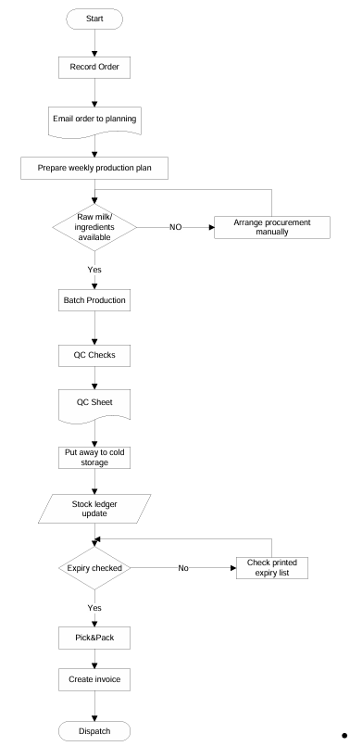
8.2 TO-BE Process (Proposed System)
The Smart Inventory Management System (SIMS) will replace manual and fragmented processes with an integrated, automated, and real-time solution. The TO-BE flow is as follows:
- Order Capture & Planning
- Customer orders are directly captured in the IMS via web or mobile portal.
- IMS auto-generates a production plan based on historical sales, seasonality, and safety stock.
- The system runs MRP checks against raw materials and auto-triggers purchase requests when shortages are identified.
- Manufacturing & Quality Control (QC)
- Each production batch is assigned a barcode/RFID label at creation.
- QC results are entered digitally into IMS, with automatic alerts for non-conformance.
- Approved batches are marked “Ready for Storage.”
- Inventory Recording & Storage
- Finished goods are scanned into IMS when moved to cold storage.
- The system assigns optimal storage locations and logs batch/expiry details automatically.
- Real-time stock updates are visible to management, sales, and warehouse staff.
- Dispatch Preparation (FEFO & Compliance)
- IMS generates picking lists based on FEFO (First Expiry, First Out).
- Warehouse staff use barcode scanners to confirm picks, ensuring accuracy.
- If any item breaches temperature requirements, the system automatically triggers a quarantine and investigation process.
- Delivery & Documentation
- Dispatch dock scanning updates the IMS, decrements inventory, and auto-generates e-waybills
- and invoices.
- GPS and transport integration allow shipment tracking.
- Proof of Delivery (POD) is captured digitally and synced into the IMS.
Benefits in TO-BE:
- Single source of truth for inventory across all plants and warehouses.
- Automated expiry tracking ensures FEFO compliance and reduces wastage.
- Real-time visibility improves decision-making.
- QC data stored digitally enhances compliance with food safety regulations.
- Faster order processing and reduced delivery delays improve customer satisfaction.
- Forecasting helps prevent both stockouts and over-production
TO-BE Process flow: 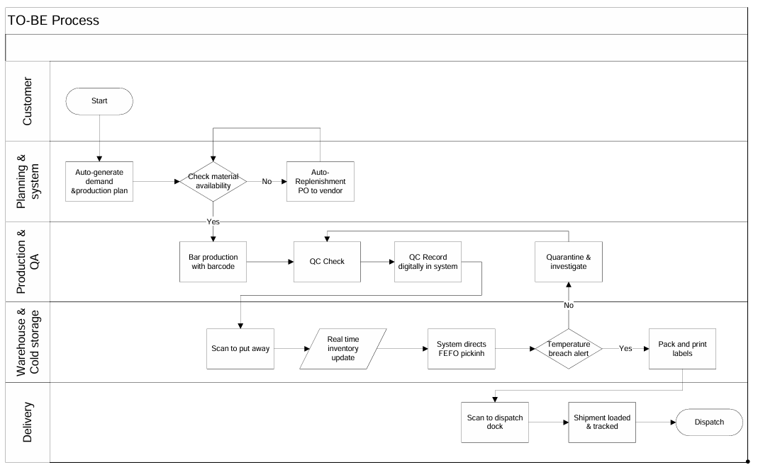
9. Business Requirements
Functional Requirements: These define what the system must do to achieve business goals.
Requirement ID | Requirement Description | Priority
FR-01 | Maintain product master with batch/expiry details | High
FR-02 | Real-time stock entry, transfer, and consumption logging | High
FR-03 | Generate automated reorder alerts when stock falls below threshold | High
FR-04 | Enable forecasting reports for demand planning | Medium
FR-05 | Role-based dashboards for management, warehouse staff, and sales | Medium
FR-06 | Track expiry dates and generate alerts for near-expiry products | High
FR-07 | Support barcode/QR code scanning for quick stock entry and dispatch | Medium
FR-08 | Provide order tracking for internal users (plant to warehouse, warehouse to distributor) | High
FR-09 | Generate audit logs of all inventory transactions | Medium
FR-10 | Integrate with sales and delivery systems for real-time updates | High
Non-Functional Requirements: These define how the system must perform and the constraints under which it must operate.
Requirement ID | Requirement Description | Priority
NFR-01 | System uptime of 99.5% | High
NFR-02 | Data security through encryption (at rest and in transit) | High
NFR-03 | Mobile responsiveness for staff access on handheld devices | Medium
NFR-04 | Scalable architecture to handle expansion of plants/warehouses | Medium
NFR-05 | System response time should be < 2 seconds for key operations | High
NFR-06 | Support for multi-language and regional settings | Low
NFR-07 | Role-based access control for different user types | High
NFR-08 | Regular backup and disaster recovery within 2 hours | High
NFR-09 | Compliance with food safety and data regulations (e.g., FSSAI, GDPR) | High
NFR-10 | Integration capability with third-party logistics and ERP systems | Medium

10. Appendices
10.1 List of Acronyms
- FIFO – First In First Out
- FEFO – First Expiry First Out
- SKU – Stock Keeping Unit
- ERP – Enterprise Resource Planning
10.2 Glossary of Terms
- Inventory Turnover: Rate at which stock is sold and replaced.
- Stock Adjustment: Manual correction in stock levels.
10.3 Related Documents
- Existing SOPs for warehouse management.
- Supply chain compliance policies.
Development & Resource Plan
1. Methodology
- Agile Scrum – 2-week sprints, incremental delivery.
2. Team Structure
- Business Analyst (1) – Requirement gathering, documentation
- Project Manager (1) – Planning, tracking
- Developers (4) – Backend, frontend, mobile app
- UI/UX Designer (1) – User-friendly design
- QA/Testers (2) – Functional & performance testing
- DevOps Engineer (1) – Deployment, monitoring
3. Timeline (High-level)
- Requirement Gathering & BRD: 2 weeks
- Design (UI/UX + Architecture): 2 weeks
- Development: 10–12 weeks
- Testing: 3 weeks
- Deployment & Training: 2 weeks
- Go-live: 20 weeks total
2. Prepare process flow diagram using your imagination.
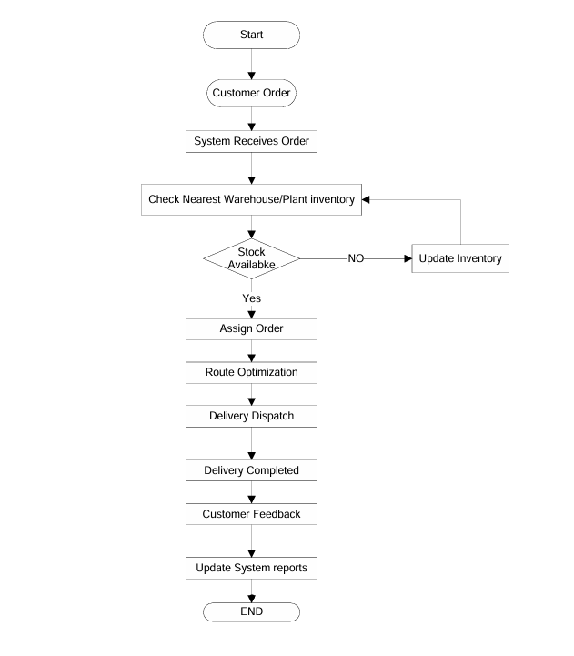
Assignment 2:
1. Write an introduction letter to a client introducing yourself as a business analyst in charge of working with the client and his team to start the business understanding process.
Introduction Letter
Subject: Introduction – Business Analyst for Upcoming Project
Dear Coepd,
I am Likhitha, the Business Analyst assigned to work with you and your team for the upcoming project. My role will be to bridge the gap between your business needs and the technical team, ensuring that the solution we build aligns with your goals.
Over the coming weeks, I will collaborate closely with your stakeholders to gather requirements, document processes, and create structured specifications for development. I look forward to understanding your vision and translating it into a successful solution.
Best Regards,

Likhitha
Business Analyst

2. Prepare a brief BRD and SRS for a project- online store.
Project: DairyDirect Online Store for Ice-Cream & Milk Products
Project ID: DDOS-2025-001
Version: 1.0
Author: Likhitha
Date: September 2025
1. Document Revisions
Date | Version | Changes Made | Author
8-Sep-25 | 0.1 | Initial Draft | BA Team
9-Sep-25 | 0.2 | Added AS-IS & TO-BE Process | BA Team
10-Sep-25 | 0.3 | Finalized Risks & Requirements | BA Team
11-Sep-25 | 1 | Approved Final Version | Sponsor
2. Approvals
Role | Name | Title | Signature | Date
Project Sponsor | Mr. Mehra | Managing Director
Business Owner | Ms. Anita | Sales Head
Project Manager | Mr. Rakesh | PM
System Architect | Ms. Varsha | Architect
Tech Lead | Mr. Vivek | IT Lead
QA Lead | Ms. Priya | QA Manager
3. RASCI Chart
Name | Position | R | A | S | C | I
Likhitha | Business Analyst | R | A
Rakesh | PM |  | A |  |  | I
Manoj | Developer | R
Priya | QA |  |  | S
Anita | Sales Head |  |  |  | C
Mehra | Sponsor |  |  |  |  | I
4. Introduction
4.1 Business Goals
- Provide customers with a digital ordering channel for ice-cream & milk products.
- Ensure quickest delivery via FEFO-based warehouse integration and optimized logistics.
- Reduce dependency on distributors and middlemen.
- Improve customer satisfaction through faster, transparent, and traceable deliveries.
4.2 Business Objectives
- Build a web + mobile online store with real-time inventory sync.
- Provide secure checkout with digital payments.
- Enable delivery slot booking for urban customers.
- Auto-generate e-waybills & invoices at dispatch.
- Track order lifecycle (Placed → Packed → Shipped → Delivered).
4.3 Business Rules
- Products are dispatched using FEFO (First Expiry, First Out).
- Expired/quarantined stock cannot be listed online.
- Deliveries must be fulfilled within 24 hours in metro cities.
- Refunds allowed only if delivery fails or product is damaged.
4.4 Background
Currently, the company depends on physical outlets and distributors. Customers have no digital channel to directly place orders, and delays occur due to manual coordination. Competitors are moving toward e-commerce, creating urgency for this project.
4.5 Project Objective
To design and implement DairyDirect Online Store integrated with IMS, ensuring the quickest delivery to customers.
4.6 Project Scope
4.6.1 In Scope Functionality:
- Online store
- product catalog
- payment gateway
- IMS integration
- FEFO-based dispatch
- Delivery tracking.
4.6.2 Out of Scope Functionality:
- HR modules
- international sales
- non-dairy items.
5. Assumptions
- Reliable internet at warehouses.
- Delivery fleet/partners available.
- Payment gateway integration approved.
- Customers will adopt digital ordering.
6. Constraints
- Must comply with FSSAI food safety regulations.
- System must handle seasonal demand spikes.
- Integration limited to existing ERP & IMS.
- Cold chain compliance required for delivery.
7. Risks
Risks are categorized into technological, business, operational, logistical, and regulatory areas to ensure comprehensive risk coverage for the Online Store project.
7.1 Technological Risks
Risk ID | Description | Likelihood | Impact | Strategy
Tech-01 | Downtime during peak demand (e.g., summer sales) | Medium | High | Mitigation :Cloud scaling, load balancing, stress testing
Tech-02 | Integration with IMS/ERP may fail | Medium | High | Mitigation :API testing, middleware, fallback sync jobs
Tech-03 | Cybersecurity breach of payment/customer data | Low | High | Mitigation :PCI-DSS compliance, encryption, 2FA
Tech-04 | Mobile app compatibility issues | Medium | Medium | Mitigation :Cross-platform testing, phased rollout
7.2 Business Risks
Risk ID | Description | Likelihood | Impact | Mitigation Strategy
Biz-01 | Low adoption by customers used to retail | Medium | High | Promotions, loyalty programs
Biz-02 | Budget overruns due to scope creep | Medium | Medium | Strict scope control, CR process
Biz-03 | Revenue loss during transition | Low | High | Phased rollout, hybrid model
Biz-04 | Negative customer experience damages brand | Medium | High | SLA monitoring, quick issue resolution
7.3 Operational Risks
Risk ID | Description | Likelihood | Impact | Mitigation Strategy
Ops-01 | Warehouse staff untrained in barcode/IMS use | High | Medium | Training programs, mock runs
Ops-02 | Order packing errors | Medium | High | Barcode scanning at pick/pack
Ops-03 | System misuse by employees | Low | High | Role-based access, audit logs
Ops-04 | High return rates due to perishables | Medium | Medium | Better packaging, cold chain SOPs
7.4 Logistics & Delivery Risks
Risk ID | Description | Likelihood | Impact | Mitigation Strategy
Log-01 | Cold chain failure in transit | Medium | High | Temp-controlled trucks, IoT sensors
Log-02 | Traffic delays/fuel shortages | Medium | Medium | Dynamic route planning, regional hubs
Log-03 | 3PL partner failures | Low | High | Multiple partners, penalty SLAs
Log-04 | Delivery staff shortage in peak | Medium | Medium | Seasonal hiring, gig workers
7.5 Regulatory & Compliance Risks
Risk ID | Description | Likelihood | Impact | Mitigation Strategy
Reg-01 | Non-compliance with FSSAI food safety | Low | High | Audits, digital QC logs
Reg-02 | Non-compliance with GST/e-invoicing | Low | High | GSTN integration, monitoring
Reg-03 | Data privacy violations | Low | High | Encryption, restricted access
Reg-04 | Consumer protection law issues (refunds) | Medium | Medium | Clear T&C, automated refunds
8. Business Process Overview
This section provides a detailed understanding of the current (AS-IS) state of the Project and the recommended improvements (TO-BE) being implemented as part of Dairy Direct Online Store for Ice-Cream & Milk Products
8.1 AS-IS Process
Currently, the company sells dairy products mainly through distributors and retail stores. The processes are manual, fragmented, and slow, leading to delays in delivery.
AS-IS Flow:
1. Customer buys from retail/distributor; no direct channel.
2. Distributors collect and relay orders manually.
3. Stock checked manually; expiry tracked in Excel.
4. Production planned weekly/monthly on historic demand.
5. Dispatch with paper challans; FEFO not consistent.
Pain Points:
- No direct customer ordering.
- Manual distributor communication causes delays.
- No real-time inventory visibility.
- Cold chain failures, wastage, late deliveries.

AS-IS Process flow
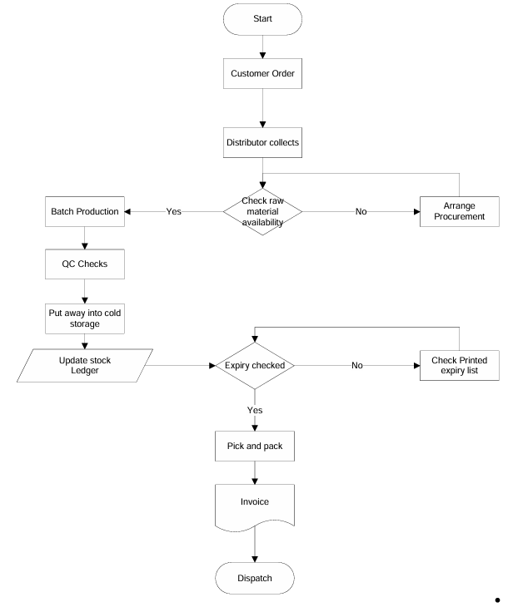
8.2 TO-BE Process
The DairyDirect Online Store provides a customer-facing platform integrated with IMS to enable quickest deliveries.
TO-BE Flow:
1. Customers order on web/app with real-time stock and delivery slots.
2. IMS confirms availability and sends instant confirmation.
3. FEFO-based picking list generated; barcode scanning ensures accuracy.
4. Packed in insulated boxes; e-waybill & invoice auto-generated.
5. Nearest warehouse dispatch with GPS-enabled transport.
6. Customer tracks shipment in real-time; POD captured.
Benefits:
- Direct online ordering.
- Real-time inventory visibility.
- Automated FEFO reduces wastage.
- Faster deliveries (<24 hrs in metros).
- Digital compliance (e-waybill, invoice).
- Improved customer experience and feedback loop.
TO-BE Process flow Diagram
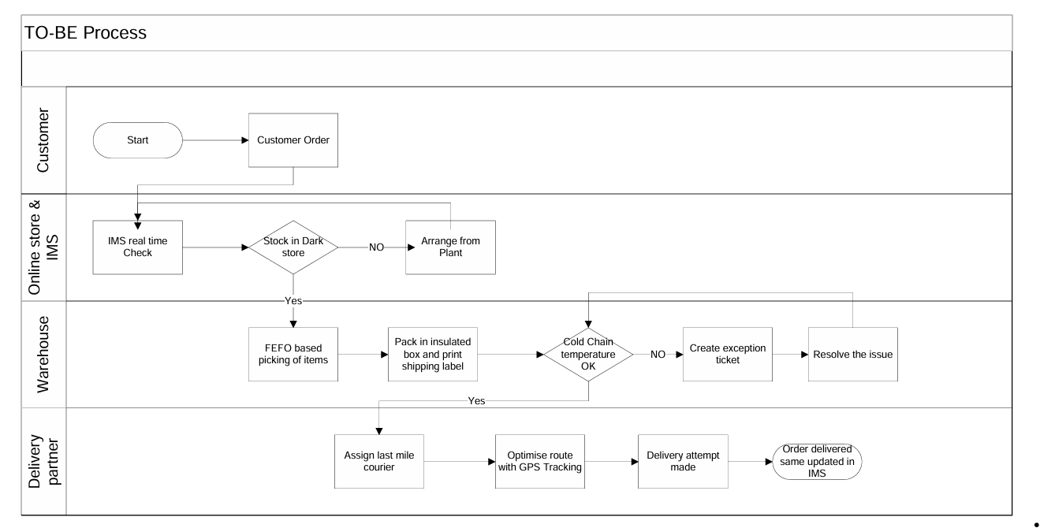
9. Business Requirements
9.1 Functional Requirements: These define what the system must do to achieve business goals.
Req ID | Functional Requirement Description | Priority
FR001 | Provide an online store (web + mobile) with a product catalog (ice-cream, milk products) | High
FR002 | Integrate with IMS for real-time stock visibility | High
FR003 | Support customer account creation & login | High
FR004 | Implement shopping cart & checkout process | High
FR005 | Integrate secure payment gateway (UPI, cards, wallets) | High
FR006 | Auto-generate invoices & e-waybills with GST compliance | High
FR007 | Enable delivery slot booking for customers | Medium
FR008 | Apply FEFO (First Expiry, First Out) logic in order picking | High
FR009 | Provide order tracking (Packed → Dispatched → Delivered) | High
FR010 | Capture Proof of Delivery (POD) digitally | Medium
FR011 | Allow customers to provide ratings & feedback | Medium
Non-Functional Requirements: These define how the system must perform and the constraints under which it must operate
Req ID | Non-Functional Requirement Description | Priority
NFR001 | System should support 10,000 concurrent users during peak demand | High
NFR002 | Online store must have 99.9% uptime availability | High
NFR003 | Order confirmation should be completed in <5 seconds | High
NFR004 | Sensitive data must be protected using encryption & PCI-DSS compliance | High
NFR005 | Mobile app must support both Android (10+) and iOS (13+) | High
NFR006 | System must generate audit logs for all financial transactions | High
NFR007 | Website and app should load in <3 seconds under normal conditions | Medium
NFR008 | Platform should be scalable to support seasonal spikes (e.g., summer demand) | High
NFR009 | Application must comply with FSSAI and GST regulations | High
NFR010 | Customer data must comply with data privacy laws (India DPDP Act / GDPR where applicable) | High
10. Appendix
10.1 List of Acronyms
- IMS – Inventory Management System
- MFC – Micro Fulfillment Center
- QC – Quality Check
- FEFO – First Expiry First Out
- SLA – Service Level Agreement
- POD – Proof of Delivery
- API – Application Programming Interface
- GPS – Global Positioning System
10.2 Glossary of Terms
- Micro Fulfillment Center (MFC): Small, strategically located warehouse used to speed up last-mile delivery.
- Exception Ticket: Automatically generated issue report for events like stockouts, QC failures, or delivery delays.
- Proof of Delivery (POD): Digital or physical confirmation that an order has been received by the customer.
- FEFO (First Expiry First Out): Inventory management rule that ensures products with the earliest expiry date are dispatched first.
- Service Level Agreement (SLA): Contractual commitment on response or resolution time for tickets/delivery.
10.3 Related Documents
- Standard Operating Procedures (SOPs) for warehouse management.
- Cold-chain compliance guidelines for dairy products.
- IT Security & Data Privacy Policies.
- Customer Service Escalation & SLA Matrix.
- Delivery Partner Agreements & Compliance Policies.
SRS (Software Requirements Specification) of Project:
Client: IceFresh Dairy Pvt. Ltd.
Project: Inventory & Delivery Management System
Date: September 04, 2025
Record of Revisions
Version | Date of Release / Revision | Prepared / Revised By | Reviewed By | Approved By | Reasons for Revisions
1 | 4-Sep-25 | Business Analyst Team | Project Manager | Client Representative | Initial Draft
1.0 Introduction
1.1 Overview
The purpose of this document is to specify the software requirements for the Inventory and Delivery Management System for IceFresh Dairy Pvt. Ltd. The system will support managing stock levels across multiple plants and warehouses while ensuring the quickest possible delivery to customers.
1.2 Acronyms and Definitions
Term | Description
ERP | Enterprise Resource Planning
SRS | Software Requirements Specification
API | Application Programming Interface
1.3 Operational Requirements
1.3.1 Software Requirements
  - Web application with mobile compatibility
  - Database: MySQL or PostgreSQL
  - Backend: Java/.NET/Python
  - Frontend: Angular/React
1.3.2 Hardware Requirements
  - Minimum server configuration: 16 GB RAM, 8 Core CPU, 500 GB SSD
  - Client system: 4 GB RAM, Dual Core CPU, Internet connectivity
1.4 References
  - Business Proposal
  - Client Requirement Workshops
  - Industry Best Practices
1.5 Design and Implementation Constraints
  - Must comply with food safety regulations
  - Integration with existing ERP systems
  - High availability with 99.9% uptime
  - Scalable architecture
1.6 Assumed Factors That Could Affect Requirements
The system depends on stable internet connectivity across warehouses and plants. External courier service API integration timelines may affect delivery features.
2.0 System Overview
2.1 Current System
Currently, inventory is managed manually through spreadsheets, and deliveries are coordinated via phone calls and emails. This results in delays and errors.
2.2 Proposed System
The proposed system will automate stock tracking, warehouse management, and delivery routing using optimized algorithms. It will provide real-time stock updates, auto-generate delivery schedules, and track shipments.
2.3 Benefits of Proposed System
  - Real-time inventory visibility
  - Reduction in delivery delays
  - Automated replenishment alerts
  - Cost savings due to optimized logistics
  - Improved customer satisfaction
3.0 UI Requirements
The system will have the following modules:
  - Dashboard: Overview of stock and deliveries
  - Inventory Module: Stock management per location
  - Delivery Module: Route optimization & shipment tracking
  - Reports: Sales, delivery efficiency, wastage analysis
  - Admin Panel: User management and role-based access
4.0 Other Parameters
4.1 Acceptance
The client will review and accept the system upon delivery of:
  - Functional Prototypes
  - Fully deployed Application
  - Documentation (Installation/User Manual)
The design and implementation of the Inventory and Delivery Management System must adhere to several constraints:
1. Regulatory Constraints
  - Compliance with FSSAI (Food Safety and Standards Authority of India) guidelines for storage and transportation of dairy products.
  - Adherence to GDPR/Local Data Protection Laws for handling customer and vendor information.
2. Technology Constraints
  - The system must be compatible with existing ERP modules used by the client.
  - The backend must be developed in Java / .NET / Python to ensure scalability.
  - The database must support high concurrency and large datasets (MySQL/PostgreSQL recommended).
3. Operational Constraints
  - The application must support real-time stock updates from multiple warehouses.
  - Mobile application must work in low-network rural areas where warehouses are located.
  - Delivery route optimization should consider perishable product timelines (ice cream has a limited storage duration).
4. Performance Constraints
  - Inventory updates must be reflected within 5 seconds across all connected systems.
  - Delivery allocation algorithms must process orders within 30 seconds for bulk orders.
  - System availability target: 99.9% uptime.
5. Hardware Constraints
  - Servers must run on 16 GB RAM, 8-Core CPU, 500 GB SSD or equivalent cloud resources.
  - Warehouse systems must include barcode/RFID scanners for stock entry.
6. Standards and Conventions
  - RESTful APIs must follow JSON standards for integration.
  - Database naming conventions should align with client’s existing ERP.
  - Coding standards: ISO/IEC 25010 quality model for maintainability and performance.
Several external and internal assumptions could influence the effectiveness of the system:
1. Dependency on External Services
  - Integration with third-party courier APIs (e.g., BlueDart, Delhivery) for tracking shipments may cause delays if their service is unavailable.
  - Payment gateways for online orders must comply with RBI regulations.
2. Infrastructure Assumptions
  - Stable internet connectivity is assumed at all warehouses and plants. If internet disruptions occur, synchronization delays may affect real-time updates.
  - Hardware devices like barcode scanners, GPS trackers, and handheld devices are assumed to be procured and maintained by the client.
3. Business Process Assumptions
  - Warehouses will follow FIFO (First In, First Out) method to avoid expired product dispatch.
  - Delivery staff will be trained to use the mobile app for order tracking and route navigation.
  - Stock entry is assumed to be performed correctly by warehouse staff; errors in data entry may affect reporting.
4. Scalability Assumptions
  - The system is expected to scale for at least 10 manufacturing plants and 50 warehouses.
  - Any expansion beyond this will require additional infrastructure investment.
5. Environmental Factors
  - Power outages in remote warehouses could affect real-time data capture.
  - Extreme weather conditions may affect delivery timelines, requiring contingency planning in the system.

3. Make an ERD of creating a support ticket/Ticketing life cycle.
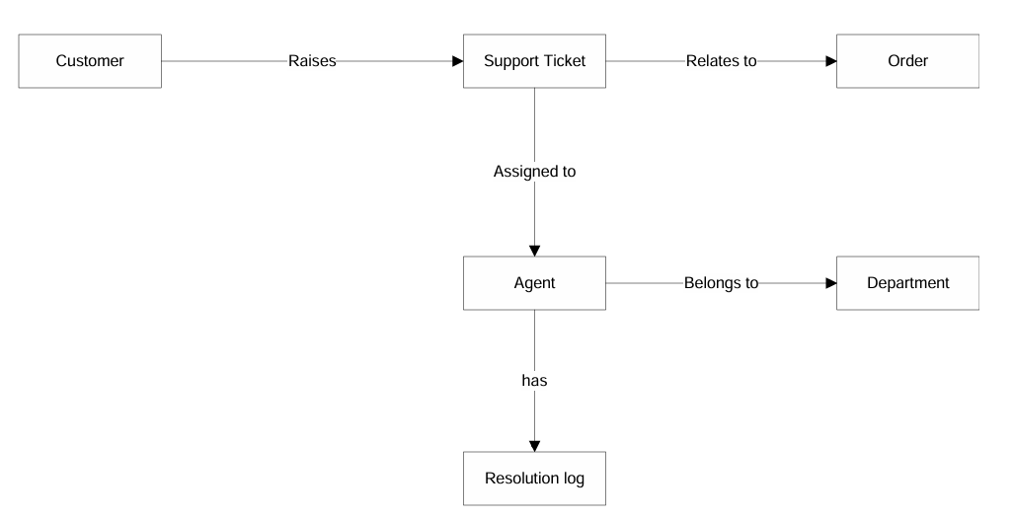
ERD for two Goals:
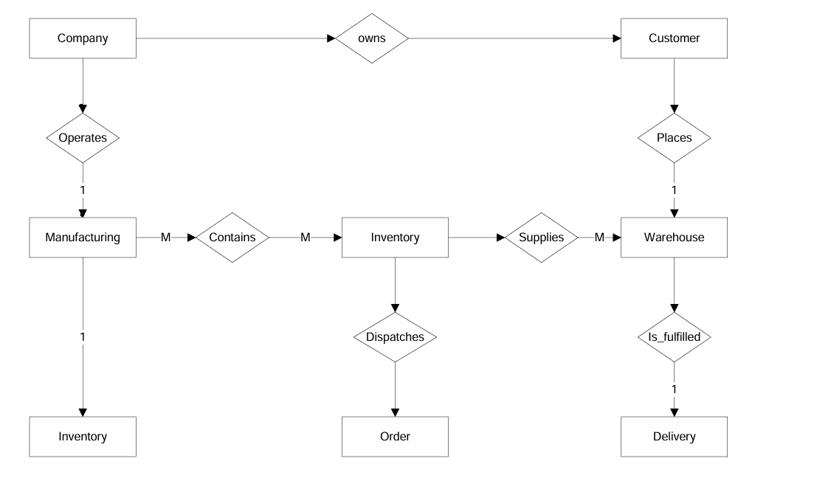
Data schema of Support Ticket view
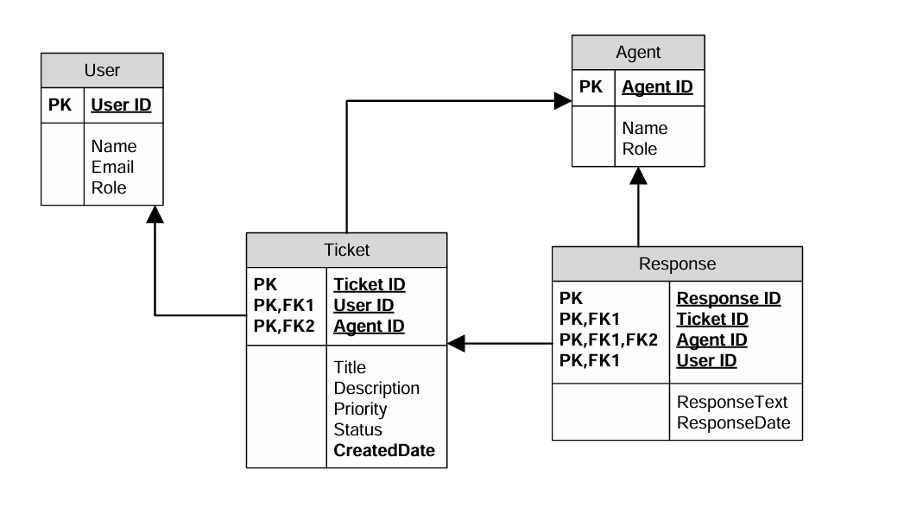
4. User story of shopping from ecommerce
Sprint 1
User story No : US001 Task: 3 Priority : Highest
As a New User
I WANT TO register with email/phone
SO THAT I can create an account and start shopping.
BV : 500 CP : 5
ACCEPTANCE CRITERIA
User can sign up with email/phone
Password encrypted
Confirmation email/SMS sent

User story No : US002 Task: 3 Priority : Highest
As a Registered User
I WANT TO log in securely
SO THAT I can access my account safely.
BV : 200 CP : 2
ACCEPTANCE CRITERIA
Login with email/phone + password
Incorrect credentials show error
Auto logout after inactivity

User story No : US003 Task: 2 Priority : High
As a Customer
I WANT TO search products
SO THAT I can find items to purchase.
BV : 200 CP : 2
ACCEPTANCE CRITERIA
Search by category, brand, price
Relevant results displayed

User story No : US004 Task: 2 Priority : High
As a Customer
I WANT TO filter products
SO THAT I can narrow down choices.
BV : 200 CP : 2
ACCEPTANCE CRITERIA
Filter by price, ratings, availability
Dynamic filtering updates results

User story No : US005 Task: 2 Priority : Highest
As a Customer
I WANT TO add products to cart
SO THAT I can purchase later.
BV : 500 CP : 5
ACCEPTANCE CRITERIA
Add/remove items from cart
Cart updates instantly

Sprint 2
User story No : US006 Task: 2 Priority : Medium
As a Customer
I WANT TO save items to wish list
SO THAT I can purchase them later.
BV : 100 CP : 1
ACCEPTANCE CRITERIA
Add/remove items from wishlist
Wishlist persists after logout

User story No : US007 Task: 2 Priority : High
As a Customer
I WANT TO view product details
SO THAT I can make informed purchase.
BV : 200 CP : 2
ACCEPTANCE CRITERIA
Show name, price, description, reviews
Zoom product image

User story No : US008 Task: 2 Priority : Low
As a Customer
I WANT TO sort products
SO THAT I can easily compare options.
BV : 50 CP : 1
ACCEPTANCE CRITERIA
Sort by price, popularity, ratings
Default sorting applied

User story No : US009 Task: 2 Priority : Highest
As a Customer
I WANT TO view cart
SO THAT I can check selected items before checkout.
BV : 500 CP : 5
ACCEPTANCE CRITERIA
View cart summary
Update quantities
Remove items

User story No : US010 Task: 2 Priority : Medium
As a Customer
I WANT TO apply discount codes
SO THAT I can save money.
BV : 200 CP : 3
ACCEPTANCE CRITERIA
Enter promo code
Validation applied instantly

Sprint 3
User story No : US011 Task: 2 Priority : Highest
As a Customer
I WANT TO checkout securely
SO THAT I can complete purchase safely.
BV : 500 CP : 5
ACCEPTANCE CRITERIA
Multiple payment options
Encrypted transaction
Confirmation shown

User story No : US012 Task: 2 Priority : High
As a Customer
I WANT TO select delivery address
SO THAT I can receive my order at preferred location.
BV : 200 CP : 2
ACCEPTANCE CRITERIA
Add/manage multiple addresses
Default address selection

User story No : US013 Task:2 Priority : Medium
As a Customer
I WANT TO choose delivery option
SO THAT I can receive products conveniently.
BV : 200 CP : 2
ACCEPTANCE CRITERIA
Standard & express delivery options
Estimated delivery date shown

User story No : US014 Task: 2 Priority : Highest
As a Customer
I WANT TO track order status
SO THAT I can know progress of my order.
BV : 500 CP : 5
ACCEPTANCE CRITERIA
Order status visible in account
Notifications on updates

User story No : US015 Task: 2 Priority : Medium
As a Customer
I WANT TO receive invoice
SO THAT I can keep record of purchases.
BV : 200 CP : 2
ACCEPTANCE CRITERIA
Invoice generated automatically
Downloadable PDF invoice

Sprint 4
User story No : US016 Task: 1 Priority : Highest
As a Customer
I WANT TO receive order confirmation
SO THAT I can be sure my purchase is successful.
BV : 500 CP : 5
ACCEPTANCE CRITERIA
Email/SMS confirmation sent
Order number generated

User story No : US017 Task: 1 Priority : High
As a Customer
I WANT TO track shipment
SO THAT I can know delivery timeline.
BV : 200 CP : 2
ACCEPTANCE CRITERIA
Shipment tracking number visible
Courier updates linked

User story No : US018 Task: 1 Priority : High
As a Customer
I WANT TO return items
SO THAT I can resolve issues with wrong/damaged products.
BV : 200 CP : 2
ACCEPTANCE CRITERIA
Return request form available
System validates return policy

User story No : US019 Task: 1 Priority : Medium
As a Customer
I WANT TO get refund status
SO THAT I can know when refund will be credited.
BV : 200 CP : 2
ACCEPTANCE CRITERIA
Refund tracking in account
Email notification when refund processed

User story No : US020 Task: 1 Priority : Medium
As a Customer
I WANT TO rate and review products
SO THAT I can share feedback.
BV : 200 CP : 2
ACCEPTANCE CRITERIA
Give star ratings
Add text review
Review visible to others

Sprint 5
User story No : US021 Task:2 Priority : Low
As a Customer
I WANT TO manage profile
SO THAT I can update personal details.
BV : 100 CP : 1
ACCEPTANCE CRITERIA
Update name, phone, address
Save changes instantly

User story No : US022 Task: 2 Priority : Medium
As a Customer
I WANT TO change password
SO THAT I can keep account secure.
BV : 200 CP : 2
ACCEPTANCE CRITERIA
Old password required
Password strength validation

User story No : US023 Task: 2 Priority : High
As a Customer
I WANT TO reset password
SO THAT I can recover account.
BV : 200 CP : 2
ACCEPTANCE CRITERIA
Password reset link via email/SMS
Temporary OTP supported

User story No : US024 Task: 2 Priority : High
As a Customer
I WANT TO contact support
SO THAT I can resolve issues.
BV : 200 CP : 2
ACCEPTANCE CRITERIA
Support ticket creation
Chat/email support option

User story No : US025 Task: 2 Priority : Medium
As a Customer
I WANT TO view order history
SO THAT I can review past purchases.
BV : 200 CP : 2
ACCEPTANCE CRITERIA
Order list visible
Filter by date range

Sprint 6
User story No : US026 Task: 3 Priority : Highest
As a Admin
I WANT TO add/edit products
SO THAT customers can view updated catalog.
BV : 500 CP : 5
ACCEPTANCE CRITERIA
Add/edit product details
Upload images

User story No : US027 Task: 3 Priority : High
As a Admin
I WANT TO manage inventory
SO THAT stock is always updated.
BV : 200 CP : 2
ACCEPTANCE CRITERIA
Update product quantities
Low stock alerts triggered

User story No : US028 Task: 3 Priority : Medium
As a Admin
I WANT TO manage users
SO THAT I can keep accounts under control.
BV : 200 CP : 3
ACCEPTANCE CRITERIA
View all registered users
Suspend/activate accounts

User story No : US029 Task: 3 Priority : High
As a Admin
I WANT TO manage orders
SO THAT I can ensure smooth operations.
BV : 200 CP : 2
ACCEPTANCE CRITERIA
View all orders
Update order status

User story No : US030 Task: 3 Priority : Medium
As a Admin
I WANT TO generate sales reports
SO THAT I can analyze performance.
BV : 200 CP : 2
ACCEPTANCE CRITERIA
Generate daily/weekly/monthly reports
Export as PDF/Excel

Sprint 7
User story No : US031 Task: 3 Priority : Low
As a Admin
I WANT TO apply discounts
SO THAT customers can avail offers.
BV : 100 CP : 1
ACCEPTANCE CRITERIA
Create/update discount codes
Set expiry date

User story No : US032 Task: 3 Priority : Medium
As a Customer
I WANT TO receive notifications
SO THAT I can stay updated.
BV : 200 CP : 3
ACCEPTANCE CRITERIA
Push/email/SMS notifications
Configurable preferences

User story No : US033 Task:3 Priority : Low
As a Customer
I WANT TO view recommendations
SO THAT I can find relevant products.
BV : 100 CP : 1
ACCEPTANCE CRITERIA
Show related products
Personalized suggestions

User story No : US034 Task: 3 Priority : High
As a Customer
I WANT TO use guest checkout
SO THAT I can purchase without account.
BV : 500 CP : 5
ACCEPTANCE CRITERIA
Guest checkout option
Prompt to create account later

User story No : US035 Task: 3 Priority : Medium
As a Customer
I WANT TO track loyalty points
SO THAT I can redeem benefits.
BV : 200 CP : 2
ACCEPTANCE CRITERIA
Points visible in account
Redemption at checkout

Sprint 8
User story No : US036 Task: 2 Priority : Low
As a Customer
I WANT TO subscribe to newsletter
SO THAT I can receive offers.
BV : 100 CP : 1
ACCEPTANCE CRITERIA
Subscribe/unsubscribe option
Confirmation email sent

User story No : US037 Task: 2 Priority : Low
As a Customer
I WANT TO upload profile picture
SO THAT I can personalize my account.
BV : 100 CP : 1
ACCEPTANCE CRITERIA
Upload image file
Preview before saving

User story No : US038 Task: 2 Priority : Medium
As a Admin
I WANT TO manage reviews
SO THAT I can ensure quality feedback.
BV : 200 CP : 3
ACCEPTANCE CRITERIA
Approve/reject reviews
Flag inappropriate content

User story No : US039 Task: 2 Priority : High
As a Customer
I WANT TO save multiple payment methods
SO THAT I can checkout faster.
BV : 200 CP : 2
ACCEPTANCE CRITERIA
Save cards securely
Select default payment method

User story No : US040 Task: 2 Priority : High
As a Customer
I WANT TO use COD option
SO THAT I can pay on delivery.
BV : 500 CP : 5
ACCEPTANCE CRITERIA
Cash on Delivery option available
COD limited by region

