Capstone Project- 1 Part- 3

Q.1) Functional Requirements
Ans. Functional requirements define the specific functions, or operations of a system. They describe what the system should do, outlining the necessary tasks, actions, or activities it must perform to achieve its objectives.
Req ID | Req Name | Req Description | Priority
FR0001 | Farmer Registration | Farmers should be able to register with the application | 10
FR0002 | Farmer Search for Products | Farmers should be able to search for fertilizers, seeds, pesticides | 8
FR0003 | Product Listing | Manufacturers should be able to list their products | 8
FR0004 | Product Details View | View product details like price, quantity, description, and reviews | 8
FR0005 | Add to cart | Add selected products to shopping cart | 8
FR0006 | Place Order | Checkout and place an order | 10
FR0007 | Track Order | Track status of placed orders | 7
FR0008 | Payment Integration | Support UPI, net banking, credit/debit card | 10
FR0009 | Delivery Address Management | Add or edit delivery addresses | 8
FR0010 | Manufacturer Registration | Manufacturers register and submit verification documents | 8
FR0011 | Admin Approval of Products | Admin approves product listings before they go live | 9
FR0012 | Inventory Management | Manufacturers update product availability | 7
FR0013 | Order Notifications | Notify farmers and manufacturers of order status | 8
FR0014 | Review and Rating | Farmers rate and review products | 6
FR0015 | Multi-language Support | Farmers use app in regional languages | 7
FR0016 | Forgot Password | Reset passwords via email or OTP | 7
FR0017 | Admin Dashboard | Admin views reports, users, products, and orders | 9
FR0018 | Role-Based Access Control | Set permissions based on user roles (farmer, manufacturer, admin) | 8
FR0019 | Download Invoice | Download invoices for placed orders | 7
FR0020 | Customer Support Chat | Farmers can raise complaints or queries via chat | 6
NFR0101 | Page Load Time | Each page should load within 2 seconds | 9
NFR0102 | System Uptime | System should maintain uptime | 9
NFR0103 | Data Encryption | Encrypt all sensitive data | 9
NFR0104 | Backup and Recovery | Automatic daily backups and recovery processes | 8
NFR0105 | Compliance | Interface should comply with accessibility standards | 8
NFR0106 | Scalability | Application must scale to handle users within 6 months | 7
NFR0107 | Responsiveness | UI should adapt to various screen sizes (mobile, tablet, desktop) | 9
NFR0108 | Error Handling | Show user-friendly error messages for system issues | 8
NFR0109 | Logging and Monitoring | System should maintain logs for transactions and errors | 7
NFR0110 | Secure Login | Use authentication | 8
NFR0111 | Session Timeout | Auto logout after 15 minutes of inactivity | 7
NFR0112 | Multi-browser Compatibility | Application should work across major browsers (Chrome, Firefox, etc.) | 8
NFR0113 | Localization Support | Support regional currency, number, and date formats | 8
NFR0114 | Performance Benchmarks | Support at least 1000 concurrent users | 8
NFR0115 | Notification Delivery | Push/SMS/email notifications must be delivered within 5 seconds | 7
NFR0116 | Compliance with IT Laws | Comply with Indian IT laws and data privacy regulations | 9
NFR0117 | Load Testing | App should pass load testing for high traffic days | 7
NFR0118 | Version Control | Deployment and code updates must use version control | 8
NFR0119 | Audit Trail | Admin should have access to audit logs for any data change | 7
NFR0120 | Cross-platform Support | Application should run smoothly on Android, iOS, and modern browsers | 9

Q.2) Make wireframe and prototypes
Ans.1.Cover Page
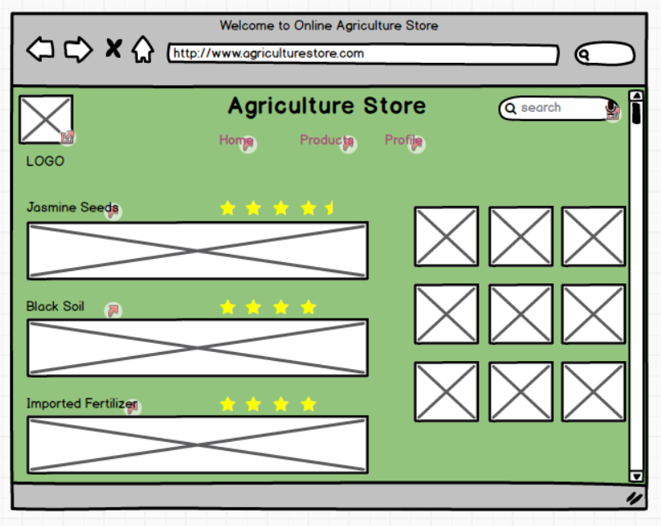

2.Home Page
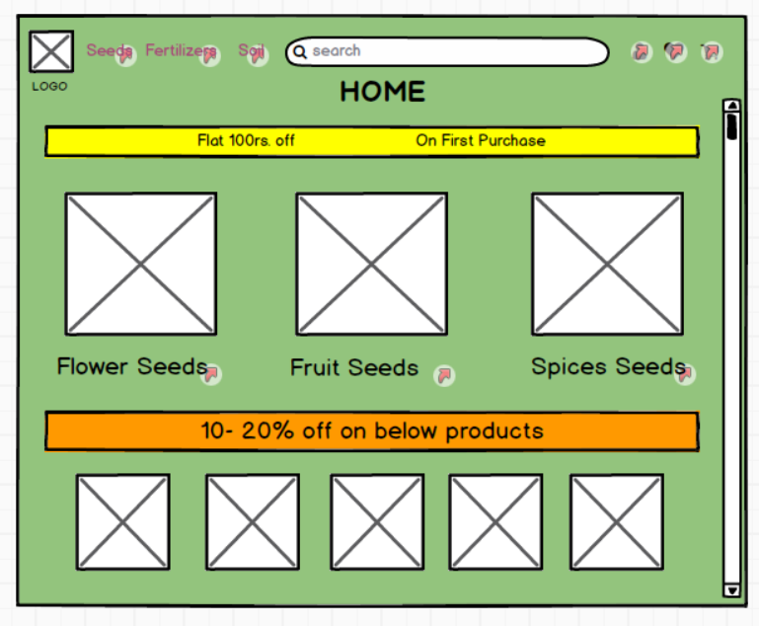

3.Products
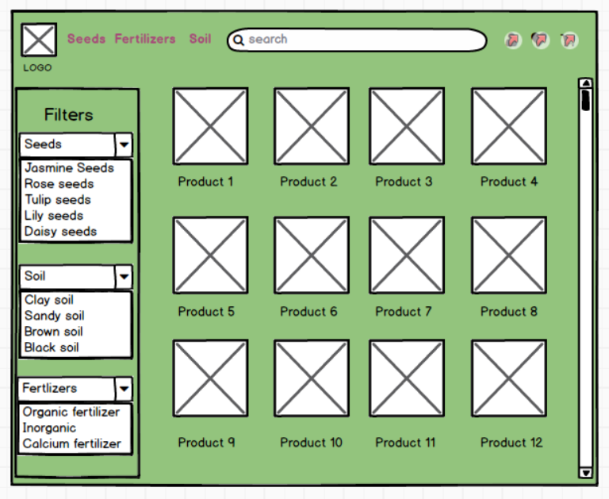

4.Cart
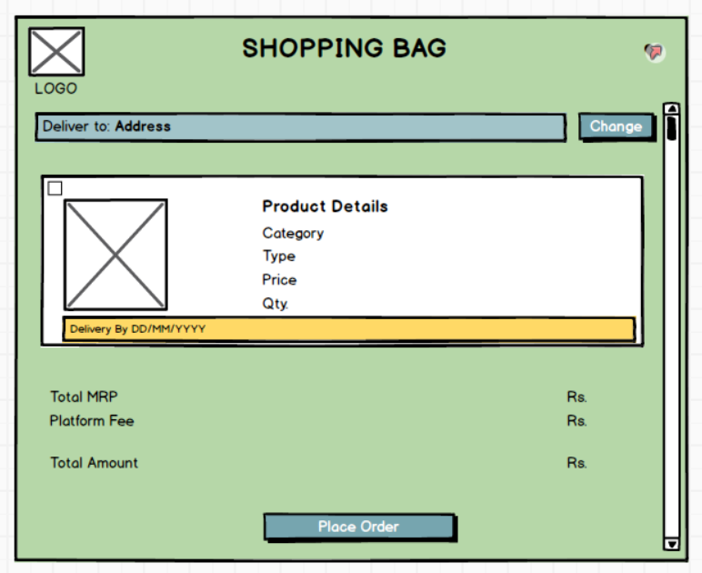

5.Profile
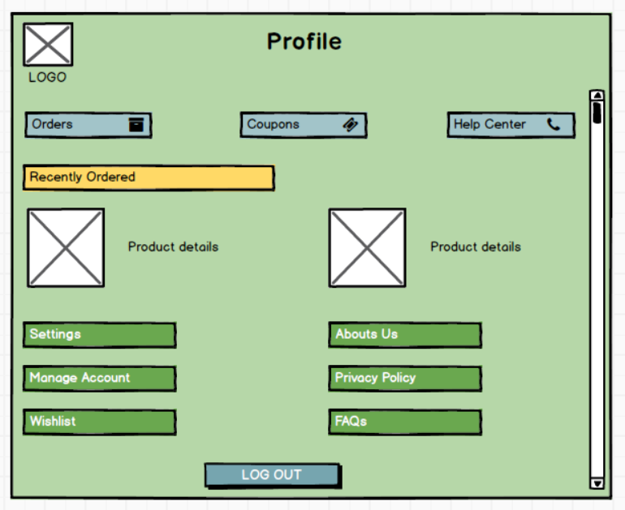

Q.3) Make a note of the Tools, which you are using for above concepts.
Ans. Balsamiq and Microsoft Visio are two widely used tools that assist in wireframing, diagramming, and modeling to ensure project success. This helped bridge the gap between business needs and technical implementation, reducing rework and ensuring better alignment among all stakeholders.
These wireframes helped stakeholders to visualize the application flow and user experience, ensuring their expectations were met even before coding started.
Balsamiq Wireframes Tool
Balsamiq is a rapid wireframing tool that helps design user interfaces and visualize how the application will look and function before development begins. It is known for its simplicity and sketch-like interface that makes it easy for non-technical stakeholders (like farmers or small manufacturers) to understand proposed solutions.
Key Features:
- Drag-and-drop UI components (buttons, menus, icons, text fields)
- wireframes for early-stage design discussions
- Easy iterations and feedback collection
- Supports export to PDF for documentation and sharing

Q.4) RTM
Ans. RTM stands for Requirement Traceability Matrix.
RTM is a document used in project management and software development to ensure that every requirement (functional and non-functional) is accounted. Each requirement is linked to corresponding design, development, test cases, and user acceptance testing (UAT). No requirement is missed or left unverified during the project lifecycle.
Req ID | Req Name | Req Description | Design | Developer (Code) | T1 | T4 | UAT
FR0001 | Farmer Registration | Farmers should be able to register with the application | Complete | Complete | Complete | Complete | Complete
FR0002 | Farmer Search for Products | Farmers should be able to search for fertilizers, seeds, pesticides | Complete | Complete | Complete | Complete | Complete
FR0003 | Product Listing | Manufacturers should be able to list their products | Complete | Complete | Complete | Complete | Complete
FR0004 | Product Details View | View product details like price, quantity, description, and reviews | Complete | Complete | Complete | Complete | Complete
FR0005 | Add to cart | Add selected products to shopping cart | Complete | Complete | Complete | Complete | Complete
FR0006 | Place Order | Checkout and place an order | Complete | Complete | Complete | Complete | Complete
FR0007 | Track Order | Track status of placed orders | Complete | Complete | Complete | Complete | Complete
FR0008 | Payment Integration | Support UPI, net banking, credit/debit card | Complete | Complete | Complete | Complete | Complete
FR0009 | Delivery Address Management | Add or edit delivery addresses | Complete | Complete | Complete | Complete | Complete
FR0010 | Manufacturer Registration | Manufacturers register and submit verification documents | Complete | Complete | Complete | Complete | Complete
FR0011 | Admin Approval of Products | Admin approves product listings before they go live | Complete | Complete | Complete | Complete | Complete
FR0012 | Inventory Management | Manufacturers update product availability | Complete | Complete | Complete | Complete | Complete
FR0013 | Order Notifications | Notify farmers and manufacturers of order status | Complete | Complete | Complete | Complete | Complete
FR0014 | Review and Rating | Farmers rate and review products | Complete | Complete | Complete | Complete | Complete
FR0015 | Multi-language Support | Farmers use app in regional languages | Complete | Complete | Complete | Complete | Complete
FR0016 | Forgot Password | Reset passwords via email or OTP | Complete | Complete | Complete | Complete | Complete
FR0017 | Admin Dashboard | Admin views reports, users, products, and orders | Complete | Complete | Complete | Complete | Complete
FR0018 | Role-Based Access Control | Set permissions based on user roles (farmer, manufacturer, admin) | Complete | Complete | Complete | Complete | Complete
FR0019 | Download Invoice | Download invoices for placed orders | Complete | Complete | Complete | Complete | Complete
FR0020 | Customer Support Chat | Farmers can raise complaints or queries via chat | Complete | Complete | Complete | Complete | Complete
NFR0101 | Page Load Time | Each page should load within 2 seconds | Complete | Complete | Complete | Complete | Complete
NFR0102 | System Uptime | System should maintain 99.5% uptime | Complete | Complete | Complete | Complete | Complete
NFR0103 | Data Encryption | Encrypt all sensitive data using AES-256 | Complete | Complete | Complete | Complete | Complete
NFR0104 | Backup and Recovery | Automatic daily backups and recovery processes | Complete | Complete | Complete | Complete | Complete
NFR0105 | WCAG 2.1 Compliance | Interface should comply with accessibility standards | Complete | Complete | Complete | Complete | Complete
NFR0106 | Scalability | Application must scale to handle 10x users within 6 months | Complete | Complete | Complete | Complete | Complete
NFR0107 | Responsiveness | UI should adapt to various screen sizes (mobile, tablet, desktop) | Complete | Complete | Complete | Complete | Complete
NFR0108 | Error Handling | Show user-friendly error messages for system issues | Complete | Complete | Complete | Complete | Complete
NFR0109 | Logging and Monitoring | System should maintain logs for transactions and errors | Complete | Complete | Complete | Complete | Complete
NFR0110 | Secure Login | Use HTTPS and token-based authentication | Complete | Complete | Complete | Complete | Complete
NFR0111 | Session Timeout | Auto logout after 15 minutes of inactivity | Complete | Complete | Complete | Complete | Complete
NFR0112 | Multi-browser Compatibility | Application should work across major browsers (Chrome, Firefox, etc.) | Complete | Complete | Complete | Complete | Complete
NFR0113 | Localization Support | Support regional currency, number, and date formats | Complete | Complete | Complete | Complete | Complete
NFR0114 | Performance Benchmarks | Support at least 1000 concurrent users | Complete | Complete | Complete | Complete | Complete
NFR0115 | Notification Delivery | Push/SMS/email notifications must be delivered within 5 seconds | Complete | Complete | Complete | Complete | Complete
NFR0116 | Compliance with IT Laws | Comply with Indian IT laws and data privacy regulations | Complete | Complete | Complete | Complete | Complete
NFR0117 | Load Testing | App should pass load testing for high traffic days (e.g., sowing season) | Complete | Complete | Complete | Complete | Complete
NFR0118 | Version Control | Deployment and code updates must use version control (e.g., Git) | Complete | Complete | Complete | Complete | Complete
NFR0119 | Audit Trail | Admin should have access to audit logs for any data change | Complete | Complete | Complete | Complete | Complete
NFR0120 | Cross-platform Support | Application should run smoothly on Android, iOS, and modern browsers | Complete | Complete | Complete | Complete | Complete

Q.5) 10 Test Case Documents
Ans. A test case document is a detailed outline used by testers to ensure that a software application or system is working as expected.

Test Case ID | TC001 | Test Case Name | Farmer Registration
Project ID |  | Project Name | Online Agriculture Store
PM ID |  | PM Name
Test Strategy ID |  | Tester ID
Test Plan ID |  | Tester Name
Test Schedule ID |  | Date of Test
Scenario | Farmer Registration- 1. Open app 2. Click Register 3. Enter details 4. Submit
Link to that page
Input data | Name, email, phone, password
Expected behaviour | Farmer account is successfully created
Actual behaviour
Comments
Result
Pass/Fail

Test Case ID | TC002 | Test Case Name | Farmer Login
Project ID |  | Project Name | Online Agriculture Store
PM ID |  | PM Name
Test Strategy ID |  | Tester ID
Test Plan ID |  | Tester Name
Test Schedule ID |  | Date of Test
Scenario | Farmer Login- 1. Open app 2. Enter credentials 3. Click Login
Link to that page
Input data | Valid email and password
Expected behaviour | User is redirected to the dashboard
Actual behaviour
Comments
Result
Pass/Fail

Test Case ID | TC003 | Test Case Name | Product Search
Project ID |  | Project Name | Online Agriculture Store
PM ID |  | PM Name
Test Strategy ID |  | Tester ID
Test Plan ID |  | Tester Name
Test Schedule ID |  | Date of Test
Scenario | Product Search- 1. Login 2. Go to search bar 3. Type “fertilizer” 4. Click Search
Link to that page
Input data | Fertilizer
Expected behaviour | Related fertilizer products are displayed
Actual behaviour
Comments
Result
Pass/Fail

Test Case ID | TC004 | Test Case Name | Product Details View
Project ID |  | Project Name | Online Agriculture Store
PM ID |  | PM Name
Test Strategy ID |  | Tester ID
Test Plan ID |  | Tester Name
Test Schedule ID |  | Date of Test
Scenario | Product Details View- Click on product card
Link to that page
Input data | Product ID
Expected behaviour | Product details page opens with full description
Actual behaviour
Comments
Result
Pass/Fail

Test Case ID | TC005 | Test Case Name | Add to Cart
Project ID |  | Project Name | Online Agriculture Store
PM ID |  | PM Name
Test Strategy ID |  | Tester ID
Test Plan ID |  | Tester Name
Test Schedule ID |  | Date of Test
Scenario | Add to Cart- 1. Open product → 2. Click “Add to Cart”
Link to that page
Input data | Selected product
Expected behaviour | Product is added to cart
Actual behaviour
Comments
Result
Pass/Fail

Test Case ID | TC006 | Test Case Name | Checkout and Payment
Project ID |  | Project Name | Online Agriculture Store
PM ID |  | PM Name
Test Strategy ID |  | Tester ID
Test Plan ID |  | Tester Name
Test Schedule ID |  | Date of Test
Scenario | Checkout and Payment- 1. Open cart → 2. Click Checkout → 3. Enter address → 4. Pay
Link to that page
Input data | UPI/Card
Expected behaviour | Order is placed and confirmation is shown
Actual behaviour
Comments
Result
Pass/Fail

Test Case ID | TC007 | Test Case Name | Order History
Project ID |  | Project Name | Online Agriculture Store
PM ID |  | PM Name
Test Strategy ID |  | Tester ID
Test Plan ID |  | Tester Name
Test Schedule ID |  | Date of Test
Scenario | Order History- 1. Login → 2. Click on profile → 3. Select “My Orders”
Link to that page
Input data | User ID
Expected behaviour | Previous orders are listed
Actual behaviour
Comments
Result
Pass/Fail

Test Case ID | TC008 | Test Case Name | Manufacturer Product Upload
Project ID |  | Project Name | Online Agriculture Store
PM ID |  | PM Name
Test Strategy ID |  | Tester ID
Test Plan ID |  | Tester Name
Test Schedule ID |  | Date of Test
Scenario | Manufacturer Product Upload- 1. Login as manufacturer → 2. Go to dashboard → 3. Add product form
Link to that page
Input data | Product Info
Expected behaviour | Product is listed and visible to farmers
Actual behaviour
Comments
Result
Pass/Fail

Test Case ID | TC009 | Test Case Name | Forgot Password Functionality
Project ID |  | Project Name | Online Agriculture Store
PM ID |  | PM Name
Test Strategy ID |  | Tester ID
Test Plan ID |  | Tester Name
Test Schedule ID |  | Date of Test
Scenario | Forgot Password Functionality- 1. Click “Forgot Password” → 2. Enter registered email → 3. Submit
Link to that page
Input data | Registered email
Expected behaviour | Password reset link is sent to the user email
Actual behaviour
Comments
Result
Pass/Fail

Test Case ID | TC010 | Test Case Name | Page Load Time
Project ID |  | Project Name | Online Agriculture Store
PM ID |  | PM Name
Test Strategy ID |  | Tester ID
Test Plan ID |  | Tester Name
Test Schedule ID |  | Date of Test
Scenario | Page Load Time- Navigate through different app pages
Link to that page
Input data | N/A
Expected behaviour | Each page loads in ≤ 2 seconds
Actual behaviour
Comments
Result
Pass/Fail

Q.6) DB Design
Ans. DB Schema is a blueprint that outlines the structure of a database, including its tables, fields, relationships, constraints and other characteristics.
1.Database Schema- Basic structure of tables, columns, and relationships.
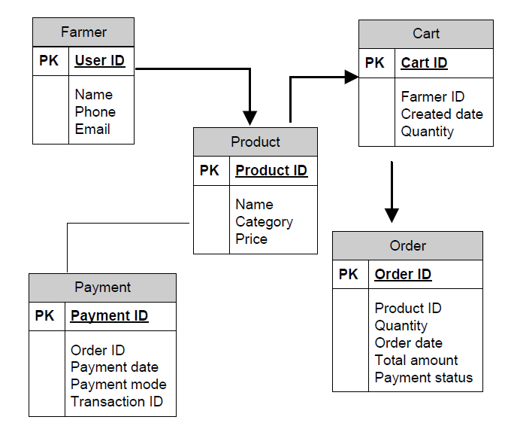
2.ER Diagram
It is a visual representation of the relationships between entities in a database. It depicts the entities (such as a table), attributes (properties or fields), and relationships between them.

Product
Search
Farmer

Order

Amount
Order

Status
Payment
Status

Q.7) Data Flow Diagram
Ans. A Data Flow Diagram (DFD) is a visual representation of how data moves through a system, showing the input, processes, storage, and output. Simple and easy to understand. Useful during both development and documentation stages.
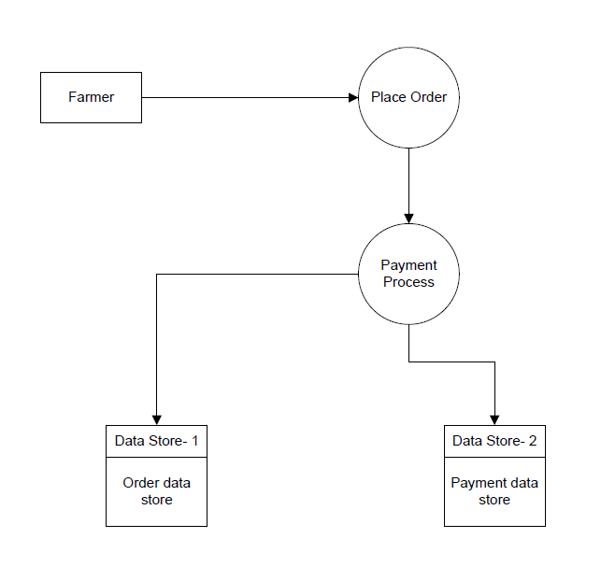

Q.8) Change Request
Ans.
1. Log the Change Request- Understand the scope of change request and document the change request. Record in the Change Request Log with date, initiator, and description.
2. Analyse the Change- Do the impact analysis. Project scope, schedule, budget, resources and risks.
Impact Analysis.
3. Prioritize the change request based on its urgency, importance, impact on project.
4. Get Approval- Project Manager, Product Owner, Client.
5. Update Requirement Documents- Update SRS, FRD, or RTM.
6. Communication- Communicate the change request & its potential impacts to all relevant stakeholders, including the project team.

Q.9) Change Request Vs an Enhancement
Ans. This is an Enhancement.
An enhancement refers to new functionality or additional features not defined in the original scope. This is an Enhancement, as it introduces entirely new features (selling crops + auctioning) beyond the original requirements.
Requirement-
- New functionality: Farmers can sell their crop yields.
- Auction system: Farmers can place crop yields for auction, and buyers can bid.
As a BA I will work as follow-
- Document the Enhancement Request – Create an Enhancement Request Form. Update Documents – FRD, RTM, UI Designs, Test Cases.
- Requirement Elicitation – work with development team. Conduct discussions to understand that, how will farmers upload crop details? Who can bid? Payment and logistics flow.
- Impact Analysis – Time, cost, technical feasibility, benefits, risks.
- Stakeholder Approval – Get approval before planning development.

Q.10) Estimations
Ans. Man hours are the required efforts of the resources to complete a project. There are 3 types of projects.
- Small- Upto 500 hours
- Medium- Upto 1000 hours
- Large- Upto 1500 hours
Analysis-
As per the case study, the duration of the project is 18 months and the current team size is around 15. This will come under medium project.
As the trained resources are available, trainers are not required.
As the structure of project is available, New and enhanced structure is not required.

Q.11) UAT
Ans. Handling UAT
- Initiate UAT Planning- Contact the client and schedule a meeting to walk them through the UAT plan.
- Provide UAT Test Cases and Support- Share predefined UAT test cases with clients.
- Capture Client Feedback- Document any defects, issues, or change requests.
Work with the development/testing team to resolve critical bugs. Maintain a UAT defect tracker.
- Obtain UAT Sign-off- Once the client is satisfied get a formal UAT Sign-off document or email confirmation. This is official approval that the application meets their requirements.
Project Closure Process
Once UAT is completed and the client gives the green light, proceed with the closure:
1. Final Documentation- Share all deliverables and documentation with the client.
2. Project Closure Report- Create a project closure report.
3. Client Handover
4. Formal Project Closure Email- Send an official closure email to all stakeholders.
UAT Acceptance Process-
  - Planning- Blue prints are made to implement UAT testing for every feature that needs to test. Schedule UAT, define scope.
  - Designing- Test cases are designed to hide all the possibilities of software packages in a real world environment.
  - UAT Testers- Testing team consist of end users that meet the criteria for implementing testing. They should know the test cases to run and understand the functionalities.
  - Bug Fixing- When bugs are found in the UAT Testing, the development team should work on them and make it software error free.
  - Sign Off- After removing all the bugs, the testing team indicates acceptance of the completion of the bugs. In this phase, all the stakeholders come to a conclusion that the software ready to GO LIVE and sign it off.

Q.12) Project Closure Document
Ans. The Project Closure Document is a formal record that marks the official end of a project. It ensures that all the planned work has been completed, objectives met, client approval received, and necessary deliverables handed over.
Purpose of Project Closure Document
- Confirm that the project goals and scope were achieved.
- Document lessons learned.
- Obtain formal client and stakeholder approval.
- Release resources (team, budget, tools).
- Close contracts and vendor agreements.
- Ensure smooth transition to support/maintenance team.
Points to be included in Project Closure Document.
- Project Overview- Brief summary of the project (name, client, start/end date, purpose).
- Lessons Learned- Key takeaways on what went well and what can be improved.
- Project Performance Summary/ Quality Assurance- Overview of scope, cost, timeline, quality metrics, and how the project performed.
- Client Acceptance- Details of UAT and formal client sign-off.
- Outstanding Issues (if any)- Any bugs, change requests, or tasks moved to future phases.
- Final Deliverables- Support/maintenance handover details, post-project contacts.
- Signatures- Project Manager, Client, and Business Analyst sign to confirm closure.

