Question1: A customer can make a payment either through cash, card, wallet, or by net banking. Draw a User Case Diagram:
Answer 1:
Use Case Diagram is the high level diagram. It is modelled from end user perspective. It’s an actor specific. It is designed to explain how external interfaces (end users, databases) are interacting with the system. It represents the individual features of the system. UCD represent only positive flows. It does not represent negative flows or sequence of steps. In UCD, we model functional requirements not technical requirements.
Generalization: The child use cases inherit everything from the parent but can also have their own extra details. Whatever is written in the parent use case (steps, rules) is automatically applies for the child use case also. The child use case does not need to repeat those steps.

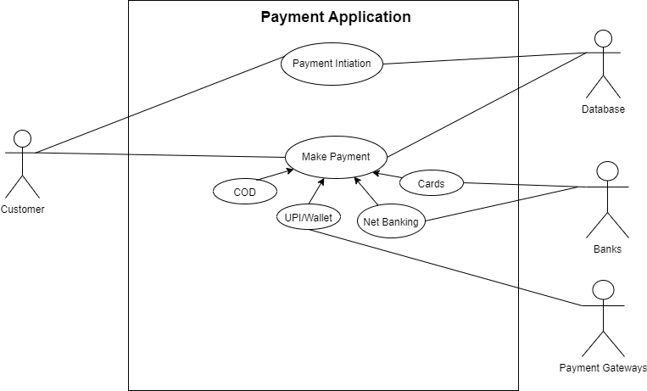

Question 2: What is Boundary Classes, Controller Classes, and Entity Classes?
Answer 2: There is an approach where we can identify the classes from use cases that is called MVC Architecture. (Model, View, Controller). These classes are drawn by system analysts & developers.
These classes are drawn by system analysts and developers.
- Entity Class: It represents core data & business logic of the application. Actors will be as Entity Classes (Each Actor will be One Entity Class). Place all entity classes in DB layer in Three Tier Architecture.

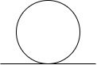
If two primary actors are there for a use case then it is not considered, only one primary actor is considered for a use case. (If two primary actors are there for a use case, split the actors with a use case separately).

- Boundary Class: Used to handle interactions between the system and external actors. Boundary class is also known as form class.
One Actor & One Use Case will be as One Boundary Class. Two Actors & 1 Use Case will be as Two Boundary Classes and so on.

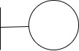

- Controller Class: Acts as an Intermediary between boundary class and entity classes. Use Cases will be Controller Class (Each Use Case will be One Controller Class).
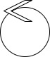
Suppose we have 2 Entity Classes, 2 Controller Classes, and 2 Boundary Classes that means we have 6 Classes.

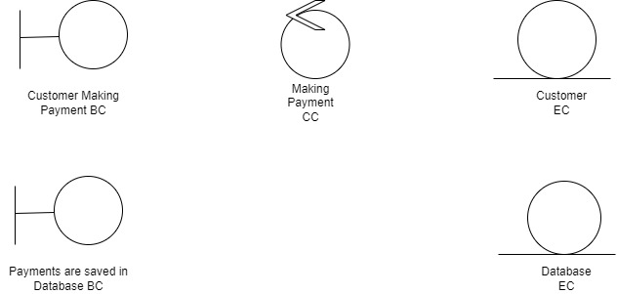

Question 3: Place these classes on a three tier architecture.
Answer 3:
Guidelines:
- Place all Entity Classes in DB Layer
- Place Primary Actor associated Boundary Class in Application Layer
- Place Controller Class in Application Layer
- If governing Body influence or Reusability is there with any of remaining Boundary Classes, place them in Business Logic Layer else place them in Application Layer.

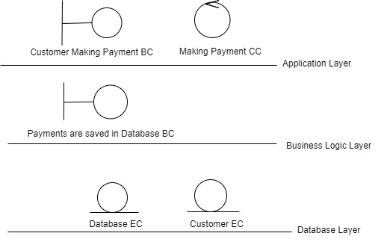
Question 4: Explain Domain Model for customer making payment through net banking?
Answer 4:
Each Participating Class will do an action part, all these classes and their action parts together will achieve one task or functionality is called domain model. It defines the structure, relationships, and behaviors of entities within a specific problem domain. It describes the key entities in a system and relationship within them.
Domain Model is drawn by system analyst or business analyst

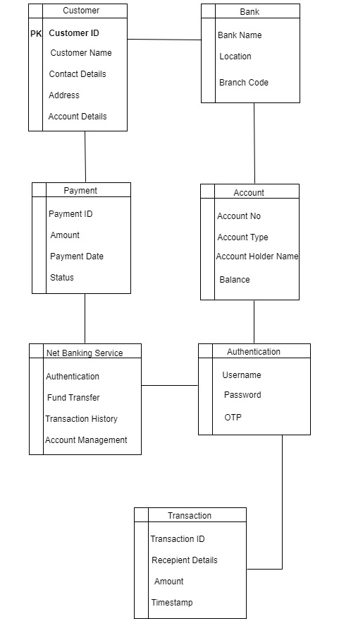

Question 5: Explain Sequence Diagram?
Answer 4: It is drawn by developers. A sequence diagram is a type of interaction diagram used in software engineering and systems design to illustrate how processes operate with one another and in what order.
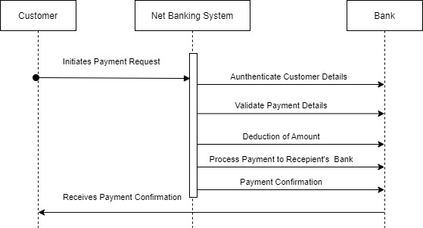

Question 6: Explain Conceptual model.
Answer6:
A conceptual model is a high level representation of a system that helps in understanding, visualizing and communicating the essential aspects of a domain. It provides a clear and simplified view of the domain, making it easier to understand. It is the initial, high-level blueprint that defines what the system is or does, without getting into the technical details of how it will be implemented. Conceptual model will show relationships for databases and it is drawn in development phase by developers.
Key Elements:
- Entities
These are the significant real-world objects, people, or concepts within the domain.
Example: Customer
- Attributes
These are the properties or data points that describe an entity.
Example: customerId, name, email, phone number.
- Relationships
These define the associations or dependencies between different entities, indicating how they interact.
Ex:
Customer: Customer ID (PK), Customer Name, Contact Details, Address Details, Account Details.
Bank: Bank Name, Location, Branch Code
Account: Account No, Account Type, Account Holder Name, Balance
Payment: Payment ID, Payment Date, Payment Amount, Status
Authentication: Username, Password, OTP
Transaction: Transaction ID, Recipient Details, Amount.

Question 7: What is MVC Architecture? Explain MVC Rules to derive classes from use case diagram and guidelines to place classes in 3-tier architecture.
Answer7: There is an approach where we can identify the classes from use cases that is called MVC Architecture. (Model, View, Controller).
It is a software design pattern that divides an application into three interconnected parts — Model, View, and Controller - to separate internal business logic from user interface concerns.
This separation makes code more organized, reusable, and easier to maintain.
- Model:
It only represents the data of an application. The model represents enterprise data and the business rules that govern access to and updates of this data. This represents Database (Tables in DB). It doesn’t depend on the user interface.
All Model Classes are represented as Entity Classes.
Entity Class, Data base classes, Persistent class (Back end designers).
The Model represents the data, business logic, and rules of the application. It interacts with the database and performs operations (Create, Read, Update, and Delete).
Ex: In an e-commerce website, the Product model stores and manages product data (like name, price, stock, etc.)
- View:
The view represents the presentation of the application. The view class refers to the model. It uses the query methods of the model to obtain the contents and renders it. The view is not dependent on the application logic. It remains same if there is any modification in the business logic.
The View is responsible for displaying the data to the user (UI part). It shows the output generated by the Controller and allows user interaction (like forms, buttons, etc.). View Class is represented as Boundary Class or Form Class.
- Controller:
Whenever the user sends a request for something then it always go through the controller. The controller is responsible for intercepting the requests from view and passes it to the model for the appropriate action. After the action has been taken on the data, the controller is responsible for directing the appropriate view to the user. In GUIs, the views and the controllers often work very closely together.
Controller Class or Transient Class (Given to Front end designers).Controller class is working based on the user’s command.
The Controller acts as a link between the Model and the View. It receives user input from view, processes it (with the help of the Model), and sends the result back to the View.

MVC Rules:
- Combination of One Actor and a use case results in one Boundary class
- Combination of Two Actors and a use case results in two Boundary classes
- Combination of Three Actors and a use case results in Three Boundary classes and so on.
Note: only one primary actor is to be considered with a use case.
- Use case will result in a controller class
- Each Actor will result in one entity class
Guidelines:
- Place all Entity Classes in DB Layer
- Place Primary Actor associated Boundary Class in Application Layer
- Place Controller Class in Application Layer
- If governing Body influence or Reusability is there with any of remaining Boundary Classes, place them in Business Logic Layer else place them in Application Layer.

Question 8: Explain BA contributions in project?
Answer8:
Stages | Activities | Artifacts | Resources
Pre-Project | Enterprise Analysis : SWOT Analysis, GAP Analysis, Market Research, Feasibility Study, Root Cause Analysis, Decision Analysis, Strategy Analysis, Project Scope and Business case writing, Risk analysis | Business Case Document; SOW (Statement of Work); | Sr. BA, Business Architects,  Presales Consultants
Planning & Estimations & Assessment | 1. Understand Assumptions and Constraints along with Business Rules and Business Goals  2. Plan Packages for Big Projects  3. Understand the project plan from PM  4. BA conducts stakeholders Analysis  5. Plan BA approach strategy (Req. gathering techniques, communication, Req. mgmt., Documents to follow, Tools to use, Change Request Handling methodology) for this Project |  | PM  Sr. BA
Requirements Gathering | 1. Stakeholders identify and document  2. Client gives BRD or BA prepares BRD by interacting with Client -Brainstorming, Document Analysis, Reverse engineering, Interviews, workshops, Focus Groups, Observation, Questionnaires.  3. Prototyping can be used by BA to make the Client to give more specific requirements.  4. Sort the gathered Requirements (avoiding duplicate Reqs, grouping into similar functionality or into modules)  5. Prioritize requirements - MoSCoW  6. Validate Requirements - FURPS | BRD (Business Requirements Document) | BA ; PM
Requirements Analysis | 1. Draws UML Diagrams (Use Case and Activity Diagrams)  2. Prepares Functional Requirements from Business Requirements  3. All Architects come up with Technical Requirements (SSD)  4. SRS will have Functional and Technical Requirements  5. Takes Signoff on SRS from Client (SRS is the first legal binding document)  6. BA prepares RTM from SRS before Design phase starts (BA is the owner of RTM)  7. BA traces how requirements are handled in each phase of development life cycle till UAT | 1.Functional Requirements Specification  2.SSD (Supplementary Support Document)  3.SRS (Software Requirements Specification)  4.RTM (Requirements Traceability Matrix) | BA, PM, Solution Architect, DB Architect, NW Architect
Design | 1.From Use Case Diagram, Test Manager or BA will prepare Test Cases  2.Communicates with Client on the design and Solution documents.( Update the status to the client to make them understand how the solution would look like to prepare them to drive for UAT).  3.BA will initiate the preparation of End User Manuals.  4. Updates RTM  5. From Use Case Diagram, Solution Architect recommends Architecture of the IT Solution.  6. DB Architect uses Persistence Classes (Entity Classes) and comes up with ER Diagrams or DB Schema.  7. GUI Designer will look into Transient Classes (Boundary Classes) and designs all possible Screens for the IT Solution |  | BA  PM  Solution Architect  DB Architect  NW Architect  GUI Designer  Test Manager
Coding | 1. BA organizes JAD Sessions  2. BA clarifies queries of Technical Team during Coding  3. Developers refer Diagrams and Transient (Controller Classes) of BA and code their unit  4. Update End User Manuals  5. Update RTM  6. Conducts regular Status meetings with Technical Team and the Client and tuning Client for participation in UAT | LDD -CDD  Application | Development Team  BA  PM
Testing | 1.BA prepares Test Cases from Use Cases or assists the Test Manager to do so.  2.BA performs high level testing.  3.BA prepares the Client for UAT (User Acceptance Testing).  4.Test Data is requested by the BA from the Client.  5.Updates End User Manuals.  6.Updates RTM (Requirements Traceability Matrix).  7.Take signoff from Client on the Client Project Acceptance form. | Test Concerning Documents, Application with less errors. | Testing Team, BA (Business Analyst), PM (Project Manager), Client.
Deployment and Implementation | 1.Forwards RTM to the Client or the PM which should be attached to the Project Closure Document.  2.Coordinates to complete and share End User Manuals.  3.Plans and Organizes Training Sessions for End Users.  4.Prepares Lessons learned from this project (to take precautions for coming projects).

Question 9: What is conflict management? Explain using Thomas Kilmann Technique.
Answer 9:
Conflict management is the process of resolving conflicts or disagreements between individuals or groups in a constructive manner.
Thomas Kilmann technique is a widely used tool for assessing conflict resolution styles & guiding individuals in selecting appropriate strategies to manage conflicts.
Five steps of conflict management:
- Identify the conflict.
- Discuss the details.
- Agree with the root problem.
- Check for every possible solution for the conflict.
- Negotiate the solution to avoid future conflicts.
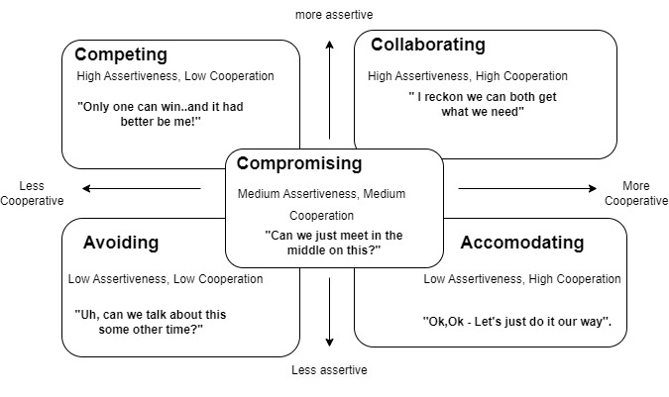
Competing:
Behaviour: You pursue your own goals at the expense of others.
When useful: In emergencies, or when a decisive action is needed.
Risk: Can damage relationships if overused.
Collaborating:
Behaviour: You work together to find a win-win solution that satisfies both sides.
When useful: When both parties concerns are important and you want a long-term solution.
Risk: Takes time and effort.
Compromising:
Behaviour: You find a middle ground where each side gives up something.
When useful: When time is limited or when collaboration isn’t possible.
Risk: The solution may only be partially satisfying for both parties.
Avoiding:
Behaviour: You sidestep the conflict and don’t address it directly.
When useful: When the issue is trivial or emotions are too high.
Risk: The problem may worsen or resurface later.
Accommodating:
Behaviour: You give in to the other’s wishes, neglecting your own needs.
When useful: When preserving the relationship is more important than winning the argument.
Risk: You may feel resentful or undervalued if used too often.

Question 10: List down the reasons for project failure:
Answer10:
- Improper requirement gathering - BA is responsible.
- Continuous change in requirements (Scope Creep) - Client & BA is responsible
- Lack of user involvement - Client is responsible
- Lack of executive support - HR, Support Admin is responsible (Resources, License)
- Unrealistic expectations - Client & Pre Sales Team is responsible.
- Improper planning - Project Manager is responsible.
- Technical Challenges
- Inadequate Risk Management

Question11: List out the challenges faced by BA for projects.
Answer11:
- Managing Stakeholder expectations.
- Obtaining sign-off on requirements
- Change Management, with respect to cost and timelines
- Coordination between developers and testers
- Conducting Meetings
- Making sure status reporting is effective
- Driving clients for UAT completion
- People Management (coordinating with different people and different teams)
- Overall making sure project health is in good shape and delivered as per the time-lines without any issues.
- Documentation Management
- Quality Assurance & Testing
Question 12: Write about Document Naming Standards?
Answer 12: All Documents will be named using some standards like Project ID, Document Type, Version, Draft, and Extension. It’s a unique identification to various documents created and used throughout the development process.
Project ID-Document Type- Version- Draft-Extension
PQ786 BRD V1.0 D1.docx

Question 13: What are the Do’s & Dont’s of a Business Analyst?
Answer 13:
Do’s of a BA:
- Consult an SME for clarifications in requirements.
- Go to the client with a plain mind with no assumptions. Listen carefully and completely until the client is done, and then you can ask queries.
- Try to extract maximum leads to the solution from the client himself.
- Concentrate on the important requirements.
- Question the existence/ Question everything.
Dont’s of a BA:
- Never say NO to the client.
- There is no word as "By default"
- Never imagine anything in terms of GUI.
- Don't interrupt the client when he is giving you the problem.
- Never try to give solutions to the client straight away with your previous experience and assumptions.
Question 14: What is the difference between packages & sub-systems?
Answer 14:
Packages: Collection of Classes is a Component. Collection of Components which are not reusable in nature.
A package is a set of features or components developed specifically for a particular business domain, and it is not meant to be reused across completely different industries. These components are custom-built or domain-specific, so they are not generic or reusable for unrelated applications. It can be sold/licensed as a whole solution. It’s a domain specific.
Ex: An IT services company builds a Billing Package for an Electricity Distribution Company. This module works only in power utility domain, not reusable for banking or e-commerce.
Application Development Companies work on Packages. Many software service companies deliver domain-specific solutions called "packages", like Banking Package, HRMS Package, and NSC Module Package.
Application Development Companies examples: TCS, Infosys, Accenture, Cognizant.
Sub-Systems: Collection of Components which are reusable in nature.
Sub-systems are high-level reusable modular units developed mainly by product-based companies. They contain components designed with generic architecture, so they can be integrated into multiple projects or clients without rewriting the logic. Product Development Companies work on sub-systems.
Ex: Billing Sub-System by Oracle used globally.
Product Based Companies Examples: Apple, Google, Microsoft, Oracle.
Question 15: What is camel casing and explain where it will be used?
Answer 15:
Camel-casing is a naming convention used in computer programming. It is used for naming variables, functions, and identifiers. In Camel casing, the first words starts with a lower case letter and each subsequent word begins with an uppercase letter.
Example:
CamelCase: camelCaseExample
Camel casing is primarily used for naming identifiers in programming languages to improve readability. Its common uses include:
- Variables: Naming data storage locations.
Example: firstName, totalAmountPaid
- Functions/Methods: Naming blocks of code that perform a specific task.
Example: calculateInterest(), getUserData()
- Objects/Instances: Naming specific instances of classes.
Example: myCar, customerRecordn
- Identifiers: Generally, any element that needs a unique name, especially in languages like Java, JavaScript where it is the standard convention for functions and variables.

Question 16: Illustrate Development server and what are the accesses does business analyst has?
Answer 16:
A development server refers to a dedicated environment or server that is used during the software development process. It provides a platform for developers and testers to build, test and debug applications before they are deployed to a production environment. As a BA, we have only limited access only (Read only).
Question 17: What is Data Mapping?
Answer 17:
Data mapping is the process of connecting data from one source to another. It’s like creating a guide or map that shows how data in one place corresponds to data in another place. This is especially important when you're moving data between different systems or databases to ensure that the data stays consistent and accurate.
Ex: A customer who is using phonepe in India, and he continued to use in USA after shifting there. So the date which he is using there, will be converted to India timing when we are checking the data here. In database, both Indian & USA timings will be there.
Converting a date format from MM/DD/YYYY in the source to DD-MM-YYYY.

Question 18: What is API? Explain how you would use API integration in the case of your application Date format is dd-mm-yyyy and it is accepting some data from Other Application from US whose Date Format is mm-dd-yyyy.
Answer 18:
An API, or Application Programming Interface, is a set of rules and tools that allows different software applications to communicate with each other. It defines the methods and data formats that applications can use to request and exchange information.
Handle API Integration:
- Receives the data from the external API. This is in mm-dd-yyyy format (from the US system).
- Before saving or displaying the data in your application, you must convert it to your local format (dd-mm-yyyy).
- Send or store the standardized date. Store the converted date (dd-mm-yyyy) in the database, and Maintain consistency across modules.
EX: If we select UPI while payments, it will have options like Gpay, Phonepe, Paytm.

