Document 6 – Please prepare a use case diagram, activity diagram and a use case specification document.

Use case diagram

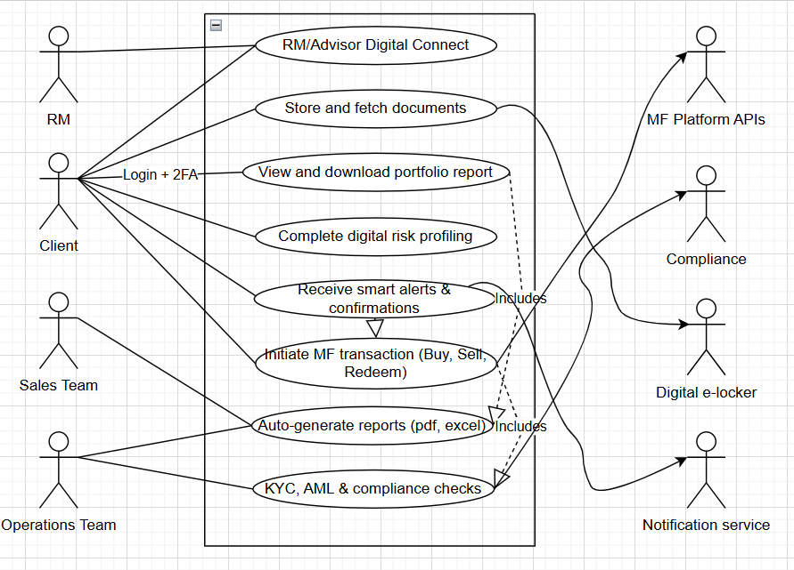
Activity diagram

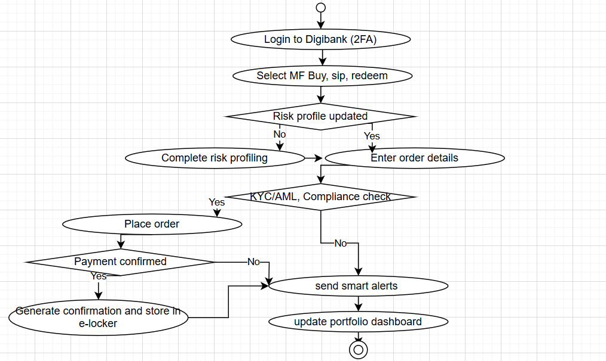

Use case specification document –
- Use case name – Digital Mutual Fund Transaction

- Use case description – Enable a retail client to initiate and complete a mutual fund transaction through the Digibank app. The system validates risk profile, performs KYC, AML and compliance checks, places the order via MF APIs, stores confirmation in the digital e-locker, send real-time alerts and updates the portfolio dashboard.

- Actors –
Primary actor – Client
Secondary actor – Relationship Manager RM, operations team, sales team, compliance engine, authorization and 2FA service, notification service, MF platform APIs, digital e-locker

- Basic flow –
- Client logs into Digibank using secure credentials and 2FA
- Client selects mutual fund – buy, sip, redeem
- System checks latest risk profile, if outdated, prompts for update
- Client enters order details like scheme, amount, sip date, frequency, payment mode
- System performs KYC, AML and compliance validations in real-time
- Order is placed via MF platform APIs, payment and units are processed
- System generates confirmation, stores it in e-locker, sends alerts and updates portfolio view

- Alternate flow –
- Risk profile update – if outdated, client completes digital questionnaire before proceeding
- Payment pending – if external authorisation is required for UPI or net banking, the app redirects and returns upon success
- Sip setup – eNACH mandate is created, sip is scheduled upon mandate approval

- Exceptional flow –
- Compliance block – transaction blocked, client notified with next steps and RM contact
- API failure – MF platform, API timeout or error, system retries and notifies client
- Payment failure – payment declined or timed out, client can retry or change payment mode, no order placed
- Data validation error – invalid inputs like PAN mismatch, client prompted to correct

- Pre-conditions –
- Client is an onboarded Digibank user with valid credentials and 2FA enabled
- KYC is completed, customer eligible for MF investments as per regulations
- Internet connectivity available, MF platform APIs operational

- Post-conditions –
- Order recorded with unique reference, confirmation stored in e-locker
- Alerts delivered, RM can view order in RM console
- Portfolio dashboard updated upon confirmation and settlement

- Assumptions –
- Client holds a valid bank account and is MF eligible per risk profile
- Regulatory consents like FATCA, e-mandate are captured digitally
- External services like authorization, MF APIs, notifications are reachable with acceptable latency

- Constraints –
- Must comply with RBI/SEBI/AMFI guidelines for KYC/AML and MF transactions
- Data privacy and security as per DBS standards, encryption at rest and in transit
- Target performance - <3s validation response, availability 99.9%

- Dependencies –
- Integration with MF platform APIs, payment gateways and eNACH service providers
- Compliance rules engine, customer master and risk profiling service
- Notification service like SMS/Email/Push and digital e-locker

- Inputs and outputs –
- Inputs – credentials and OTP, transaction type, scheme, amount, SIP date, frequency, payment mode, nominee, family flags
- Outputs – order reference and status, payment confirmation, contract note, pdf, notifications, updated portfolio view

- Business rules –
- Transaction allowed only if customer risk profile is suitable for selected scheme category
- KYC/AML (PAN, FATCA, PEP, sanctions) must be valid, otherwise block and route to RM or compliance
- Sip minimum amounts and cut-off times as per AMFI/SEBI, orders beyond cutoff processed next business day
- eNACH mandate required for sip, mandate must be approved before scheduling debits
- Contract notes and confirmations stored in e-locker for the regulatory retention period

- Miscellaneous information
- Non-functional – audit logging and traceability for all critical steps, fraud monitoring and velocity checks
- Analytics – capture funnel events for journey optimization, run A/B tests on UI changes

Document 7- Screens and pages
Please follow the following steps to create the mock-ups
1. Kindly use balsamic or Axure.
2. Always start with a home page of an application.
3. Take a feature and follow it to the end
a. Eg: Home page of SCRUM Foods b. Select Login- Create a login page
c. Let’s assume, you want to search a restaurant
d. Search page- Type the restaurant name and select the dish
e. Add to cart page
f. Payment page
g. Logout page

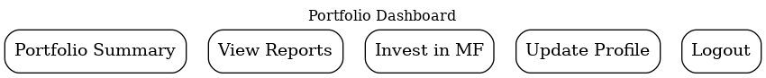

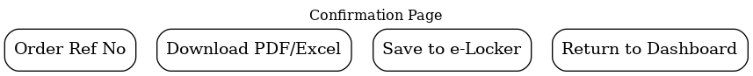

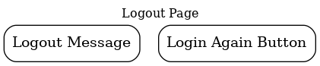

Document 8 – Tools – Visio and Axure

Write a paragraph on your experience using Visio and Axure for the project.

During this project, I used visio and axure for process visualization and UI/UX mockups.
- Microsoft Visio –
Microsoft Visio was mainly used for process flow diagrams (AS-IS and TO-BE) and UML activity diagrams. Its drag and drop stencils, connectors and templates made it easy to represent workflows such as Digital Mutual Fund Transaction and Risk Profiling. The clarity of visio diagrams helped stakeholders quickly understand business processes.

- Axure RP –
Axure RP was used for interactive screen mock-ups. It allowed me to design the Digibank app journey, starting from login to portfolio dashboards, MF search, transaction pages and payment confirmations. Axure’s prototyping features enabled me to simulate click-through flows, giving a realistic feel of the app. This was particularly useful in client demos where stakeholders could visualize the end to end customer experience.

Document 9 – BA experience
My experience as BA in following phases –

- Requirement gathering –
  - Conducted workshops and interviews with stakeholders like RMs, operations, compliance, IT teams
  - Collected business needs around digitalizing risk profiling, portfolio reporting and MF transactions
  - Facilitated Joint Application Sessions JAD to capture pain points in the AS-IS process and identify key features for the TO-BE Digibank app
  - Maintained a structured Requirement Traceability Matrix RTM to ensure all requirements were captured

- Requirement analysis –
- Translated high level business requirements into functional and non functional requirements
- Conducted gap analysis between legacy manual processes and proposed digital workflows
- Prioritized requirements using MOSCOW method
- Validated requirements against regulatory guidelines RBI, SEBI, AMFI to ensure compliance

- Design –
- Created process flow diagrams (AS-IS and TO-BE) in visio
- Designed UML diagrams like use case, activity, sequence to support development understanding
- Prepared UI/UX mock-ups in Axure to demonstrate customer journeys such as login, MF transaction, portfolio viewing
- Ensured alignment with enterprise architecture and security standards

- Development –
- Acted as a bridge between business and technical teams
- Clarified requirements, answered developer queries and updated use cases
- Reviewed API specifications and integration workflows with mf platforms and compliance engines

- Testing –
- Created test scenarios and acceptance criteria for UAT
- Supported QA team in preparing test cases and validating results
- Performed functional testing flows like login, mf transactions, risk profiling
- Validated exception handling scenarios like payment failure, compliance blocks, risk mismatch
- Ensured requirements coverage using RTM

- Deployment –
- Supported business users during UAT – sign off and production release
- Conducted training sessions and demos for RMs and operations teams
- Documented release notes, user manuals and FAQs for smooth adoption
- Monitored early adoption feedback and logged enhancements

