Online Agriculture Product Store
Q1. Identify Business Process Model for Online Agriculture Store – (Goal, Inputs, Resources, Outputs, Activities, Value created to the end Customer)
Answer :
- Goal: To bridge a gap between buyers, i.e. farmers and agriculture product manufacturers, enabling easy access, purchase and delivery of agriculture products to remote area farmers via mobile application.
- Input: Customer data, Marketing Campaigns, Companies producing farming products, to develop the mobile application.
- Resources: Office space, software company, warehouse.
- Output: Benefits for farmers and the farming companies, sales revenue, Application efficiency (User-friendly)
- Activities: Great customer service, partnering with leading brands, and maintaining good rapport with both customers and service providers (Farming companies).
- Value: Customer satisfaction, Multiple options in the Product range, hassle-free purchase and selling of farming products.
Q2. Mr Karthik is doing SWOT analysis before he accepts this project. What Aspects he Should consider as Strengths, as Weaknesses, as Opportunity and as Threats.
Answer:
STRENGTH | WEAKNESS
- Wide product availability  - Strong brand reputation  - User-friendly web Application  - Reputation in the agriculture industry | - Geographical presence (Logistic and delivery challenges)  - Supply chain distribution  - Communication gap between buyer and seller  - Too much dependency on vendors
OPPORTUNITY | THREAT
- Expansion in the Agriculture market  - Potential partnership with Argo companies and co-operatives.  - New opportunity for farmers | - Supply chain Disruption.  - Exploitation of the less knowledgeable  - Competition from existing online Agri platforms

Q3. Mr Karthik is trying to do feasibility study on doing this project in Technology (Java), Please help him with points (HW SW Trained Resources Budget Time frame) to consider in feasibility Study.
Answer:
Feasibility Study: A feasibility study is a comprehensive analysis of the practicality and potential success of a proposed project that assesses costs, benefits, risks, and necessary resources.
The feasibility study can be performed with;
- Technology: Based on data servers, Payment gateways, Security and API’s, Company’s all the available details.
- Hardware: Servers, storage, Network Equipment, end-user devices, Backup system.
- software: Programming Language, Payment gateways, Content management system, Development and testing tools, Deployment.
- Training Resources: Project Manager, Business Analyst, Java developers, testers, Network Admin, DB Admin.
- Budget: 2 Crore.
- Timeframe: 18 months under the CSR Initiative. (Includes Requirement gathering, System design, Development, testing, Deployment, Post-launch maintenance).

Q4. Mr Karthik must submit Gap Analysis to Mr Henry to convince to initiate this project. What points (compare AS-IS existing process with TO-BE future Process) to showcase in the GAP Analysis
Answer:
Gap Analysis: Gap Analysis meant the gap between the current state scenario and the desired state scenario.
Current State (AS-IS)
- Farmers are unable to get the right fertilisers, seeds, and pesticides from trusted sources at the right time and price.
- There is no system to track demand, product trends, or farmer preferences, leading to inefficiencies in supply and planning.
- Farmers have a limited understanding of mobile application technology, creating a gap between manufacturers selling products and farmers buying them.
Desired State (TO-BE)
- By using a Mobile application, farmers can easily purchase the right fertilisers, seeds, and pesticides from verified and trusted manufacturers at competitive prices and receive timely delivery without the hassle of a middleman.
- Farmers can use a simple mobile/web application to browse, select, and order products, bridging the gap between manufacturers and buyers, which maintains the transparency between both.
- The platform provides insights on product demand, usage patterns, and farmer preferences, enabling better planning, stock management, and timely delivery of agricultural supplies.
Q5. List down different risk factors that may be involved (BA Risks and Process/Project Risks)
Answer:
Risk analysis: It’s the process of identifying, assessing, and prioritising potential risks that could negatively impact a project, business, or other initiative.
The following pointers will define the risk factors:
Internal Risk
- Limited technical expertise in the development team regarding the Agriculture field.
- System downtime or server failures
- Inadequate database security and backup systems
- web design and mobile app design
External Risk
- Competition with existing online and offline vendors.
- Poor internet connectivity.
- Delay from suppliers or manufacturers.
- Natural disasters affecting logistics and delivery
BA Risk
- Incomplete or unclear requirements from stakeholders
- lack of domain knowledge
- Miscommunication between developers and stakeholders
- change in requirement.
Project-based risk
- Technology Risk
- Scope risk
- Budget constraints affecting quality or delivery

Q6. Perform stakeholder analysis (RACI Matrix) to find out the key stakeholders who can take Decisions and Who are the influencers
R/A/C/I | Name of the Resources | Designation | Details
Responsible | Mr Dooku | Project Coordinator | Contact Number:9302820367
Responsible | Mr Vandanam | Project Manager | Contact Number:7389363789
Responsible | Ms. Juhi | Senior Java Developer | Contact Number:8465940738
Responsible | Mr Teyson | Java Developer | Contact Number:6494469273
Responsible | Ms Lucie | Java Developer | Contact Number:9474529348
Responsible | Mr Tucker | Java Developer | Contact Number:9364729326
Responsible | Mr Bravo | Java Developer | Contact Number:8363529363
Responsible | Mr Mike | Network Admin | Contact Number:8492036384
Responsible | Mr Jason | Tester | Contact Number:7352926393
Responsible | Ms Alekya | Tester | Contact Number:8453926293
Responsible | Peter, Kevin, Ben | Stakeholders | Contact Number:9384048498
Accountable | Mr Henry | Founder | Contact Number:7383037393
Accountable | Mr Pandu | Financial Head | Contact Number:9373369203
Accountable | Mr Karthik | Delivery Head | Contact Number:8353943529
Accountable | Mr Vandanam | Project Manager | Contact Number:7389363789
Accountable | John | DB Admin | Contact Number:7433463266
Accountable | Myself | Business Analyst | Contact Number:9265464047
Consulted | Mr Dooku | Project Coordinator | Contact Number:9302820367
Consulted | Mr Vandanam | Project Manager | Contact Number:7389363789
Consulted | Ms. Juhi | Senior Java Developer | Contact Number:8465940738
Consulted | Mr Teyson | Java Developer | Contact Number:6494469273
Consulted | Ms Lucie | Java Developer | Contact Number:9474529348
Consulted | Mr Tucker | Java Developer | Contact Number:9364729326
Consulted | Mr Bravo | Java Developer | Contact Number:8363529363
Consulted | Mr Mike | Network Admin | Contact Number:8492036384
Consulted | Mr Jason | Tester | Contact Number:7352926393
Consulted | Ms Alekya | Tester | Contact Number:8453926293
Consulted | Peter, Kevin, Ben | Stakeholders | Contact Number:9384048498
Consulted | Mr Henry | Founder | Contact Number:7383037393
Consulted | Mr Pandu | Financial Head | Contact Number:9373369203
Consulted | Mr Karthik | Delivery Head | Contact Number:8353943529
Consulted | John | DB Admin | Contact Number:7433463266
Consulted | Myself | Business Analyst | Contact Number:9265464047
Informed | Mr Henry | Founder | Contact Number:7383037393
 | Mr Karthik | Delivery Head | Contact Number:8353943529
 | Mr Vandanam | Project Manager | Contact Number:7389363789
 | Mr Pandu | Financial Head | Contact Number:9373369203

Q7. Help Mr Karthik to prepare a business case document
Business case Document
Project title : Online Agriculture Products Store
Prepared By: Tanushree E
- Introduction
This business case focuses on developing an Online Agriculture Products Store aimed at supporting farmers living in remote rural areas. The concept was initiated by Mr. Henry, a businessman inspired by the challenges faced by his childhood friends—farmers who often struggle to access fertilizers, seeds, and pesticides at the right time.
The proposed online platform, available as both a website and a mobile application, will enable farmers to connect directly with agricultural product manufacturers and purchase essential supplies conveniently, affordably, and without middlemen.

- Problem Statement
Farmers from remote villages face problems like:
- Difficulty in procuring fertiliser.
- Difficulty in buying seeds
- Lack of availability of pesticides.

- Proposed Solution
Development of an Online Agriculture Product Store where:
- Manufacturing companies can list their products (fertilizers, seeds, pesticides).
- Farmers can browse, select, and purchase products securely online.
- Integration of payment gateway, delivery tracking, and customer support.
- The application will be user-friendly and available in local languages for better adoption.

- Objectives
- Easy, affordable, and transparent access to quality products for farmers on time.
- Wider market reach and provides farmers a direct platform to buy products without a middleman.
- Connect farmers and Manufacturing companies directly.
- Supports farmers with sustainable agriculture under SOONY Company’s CSR.

- Scope
In scope
- Development of web and mobile applications.
- User registration and login for farmers and companies.
- Product listing, catalogue management, and search functionality.
- Order placement, payment integration, and delivery tracking.
- Multi-language support for accessibility in rural areas.
Out scope
- Offline store operations or manual transactions.
- Integration with government schemes, subsidies, or loan modules.
- Third-party reseller.

- Stakeholders
Name | Role | Responsibility
Mr Henry | Project Sponsor | Initiate the project under CSR
Mr Pandu | Financial Head | Approves budgets and financial planning
Mr Dooku | Project Coordinator | Manages day-to-day project activities
Mr Vandanam | Project Manager | Manages the entire project from start to end
Ms. Juhi, Mr. Teyson, Ms. Lucie, Mr. Tucker, Mr. Bravo | Developers | Develop the application as required
Mr. Jason, Ms. Alekya | Testers | Test the developed application to provide quality output
Myself | Business Analyst | Do the requirement gathering and convey the details to the development team
SOONY Committee | Decision Makers | Guides and reviews project progress
APT IT Solutions | Vendors | Designs and develops the applications
Peter, Kevin, Ben | User/ Farmers | Share farmers' requirements and feedback
Agriculture Companies | Suppliers | List their products on the platform

- Estimated Cost and Duration
- Budget: 2 crores
- Duration: 18 Months

- Risks and Mitigation
Risk | Impact | Mitigation
Farmers may not use the app due to low digital literacy | High | Design a user-friendly interface, conduct awareness programs, and include local language options
Budget may exceed the allocated limit | High | Regular progress reviews, contingency budgeting, and implementing strict cost monitoring
Delay in the delivery of agricultural products | Medium | Partner with reliable logistics providers
Technical issues or downtime in the app | Medium | Set up server redundancy, regular maintenance, and quick technical support
Cybersecurity threats and data breaches | High | Use secure authentication, data encryption, and regular security audits
Inaccurate or incomplete product information from suppliers | Low | Implement validation checks and allow user feedback on products

- Benefits
- Provides easy access to quality fertilisers, seeds, and pesticides at fair prices.
- Expands market reach for agricultural product companies.
- Reduces dependency on intermediaries, ensuring transparent transactions.
- Yielding in farming and their income
- Enhancing SOONY Company’s CSR Reputation

- Conclusion
This project is both feasible and impactful, offering significant benefits to farmers and agricultural product companies. With an estimated budget of ₹2 Crores and a timeline of 18 months, it aims to solve the critical issue of accessibility to quality farming products while fostering digital empowerment and sustainable growth in rural communities.
Q8. The Committee of Mr. Henry , Mr Pandu , and Mr Dooku and Mr Karthik are having a discussion on Project Development Approach.
Mr Karthik explained to Mr. Henry about SDLC. And four methodologies like Sequential Iterative Evolutionary and Agile. Please share your thoughts and clarity on Methodologies
Answer:
SDLC Methodologies: These are the methodologies which IT companies follow to develop software applications.
Sequential Model
The Sequential Model, commonly known as the Waterfall Model, follows a linear and structured approach where each phase of development — from requirement gathering to deployment — is completed before moving to the next. This model is best suited for projects with clearly defined requirements and minimal scope for change, ensuring disciplined progress through each stage.
Iterative Model
The Iterative Model focuses on building a system through repeated cycles of development and refinement. Instead of finalizing all requirements upfront, an initial version of the software is developed with limited functionality. Subsequent iterations enhance the product based on user feedback, improving performance, features, and design until the complete solution is achieved.
Evolutionary Model
The Evolutionary Model combines aspects of both Iterative and Incremental development. It delivers software in multiple releases or increments, allowing flexibility to adapt to changing user needs. Early versions are refined and expanded over time as feedback and new requirements emerge, making it ideal for projects where the scope evolves during the development process.
Agile Model
The Agile Model is a modern, adaptive approach to software development that promotes collaboration, flexibility, and customer satisfaction. Development is divided into short, iterative cycles called sprints, enabling teams to deliver working software quickly and respond effectively to changing requirements. Agile emphasizes continuous improvement, team communication, and delivering value to the end user at every stage.

5 Years Project
Methodologies | Year 1 | Year 2 | Year 3 | Year 4 | Year 5 | Year 6
 | 2015 | 2016 | 2017 | 2018 | 2019 | 2020
Sequential |  |  |  |  |  | I I I I I I I I I
Iterative |  | I I | I I | I I | I I | I I
Evolutionary |  |  | I I I I | I I | I I | I I
Agile | I I I I | I I I | I I I | I I I | I I I | I I I

Q9. Waterfall RUP Spiral and Scrum Models.
When the APT IT SOLUTIONS company got the project to make this online agriculture product store, there is a difference of opinion between a couple of SMEs and the project team regarding which methodology would be more suitable for this project. SMEs are stressing on using the V model and the project team is leaning more onto the side of waterfall model. As a business analyst, which methodology do you think would be better for this project?
Answer:
Software Development Life Cycle (SDLC) Models
Waterfall Model
- The Waterfall Model is a traditional, linear approach to software development where each phase has clearly defined objectives and deliverables.
- Progress flows sequentially from one stage to the next — typically from requirements gathering to design, development, testing, and deployment.
- Reviews are conducted at the end of each phase to ensure the project is on track.
- This model is best suited for small to medium-sized projects with well-understood and stable requirements.
V- Model
- The V-Model extends the Waterfall approach by emphasizing verification and validation at every stage.
- Each development phase corresponds to a testing phase, allowing early detection of defects.
- It ensures proactive defect tracking and quality assurance throughout the lifecycle.
- Works effectively for smaller projects with clear, fixed requirements.
RUP Model
- RUP (Rational Unified Process) follows a modular, phase-wise development approach, making it suitable for long-term and complex projects.
- It allows tracking and resolution of defects at early stages, minimizing rework.
- Changes or enhancements are welcomed throughout the development phases.
- Being a heavyweight model, it requires significant resources, documentation, and budget.
Spiral Model
- The Spiral Model is a risk-driven development approach, combining iterative and prototyping elements.
- It consists of four major phases: Planning, Risk Analysis, Engineering, and Evaluation
- Each iteration (or “spiral”) refines the system by revisiting these phases, ensuring risks are managed and requirements are validated continuously.
- Best suited for large, high-risk projects with evolving requirements.
Scrum Model
- Scrum is a lightweight, Agile framework used for developing and delivering complex products in short cycles called sprints.
- It promotes flexibility, collaboration, and continuous improvement.
- Although simple to understand, Scrum requires disciplined teamwork and adaptability to frequent requirement changes.
Recommended SDLC Model for the Online Agriculture Products Store:
As a Business Analyst, the most suitable methodology for this project is the Waterfall Model, based on the following reasons:
- Clearly Defined Problem Statement – The core objective is well understood: enabling farmers to access fertilizers, seeds, and pesticides through an online platform.
- Stable and Specific Requirements – System functionalities like product browsing, manufacturer uploads, order placement, and delivery management are clearly outlined, with minimal scope for change.
- Fixed Budget and Timeline – The project has a defined budget of ₹2 Crores and a timeline of 18 months under a CSR initiative, making structured planning essential.
- Low Requirement Volatility – Stakeholders (farmers, manufacturers, and the committee) have a clear vision, reducing the likelihood of mid-project changes.
- Controlled Phase-by-Phase Execution – Waterfall’s linear progression ensures disciplined tracking of deliverables across stages — from requirements gathering to deployment — allowing effective cost, quality, and schedule control.

Q10. Write down the differences between waterfall model and V model
Answer:
Aspect | Waterfall Model | V-Model
Definition |  | An improved version of Waterfall that focuses on both development and testing together.
  A step-by-step process where one phase is finished before the next begins.
Approach | Work moves in one straight direction. | Each development step has a matching testing step.
Focus | First development, then testing.
  Development and testing happen side by side.
Testing | Done only after all development is complete. | Planned early and done during every stage.
Flexibility | Very rigid; hard to make changes once started. | Slightly better — errors can be found earlier.
Error Detection | Errors found late, during testing phase. | Errors can be caught early in corresponding test phases.
Cost of fixing defects | High, because bugs are found at the end. | Lower, because bugs are fixed early.
Best suited for | Projects with stable, well-defined requirements (e.g., CSR, government projects). | Quality-critical projects (e.g., medical, banking, aerospace).
Diagram shape |  | V-shape, showing link between dev and test stages.
  Straight downward flow (like a waterfall).
User involvement | Minimal until the final stage. | More involvement during validation/testing stages.

Q11. As a BA, state your reason for choosing one model for this project.
Answer: As a Business Analyst, the Waterfall Model is the most appropriate choice for this project for the following reasons:
- The Waterfall approach ensures a clear, step-by-step process — from requirements gathering to design, development, testing, and deployment — which helps in effective planning, cost control, and timely delivery.
- The project objectives are well-defined, focusing on providing farmers with easy online access to fertilizers, seeds, and pesticides.
- With a fixed budget of ₹2 Crores and a strict 18-month timeline under a CSR initiative, the structured nature of the Waterfall model ensures smooth execution and accountability at each stage.
Q12. Prepare the Gantt chart
The Committee of Mr. Henry, Mr Pandu, and Mr Dooku discussed with Mr Karthik and finalised on the V Model approach (RG, RA, Design, D1, T1, D2, T2, D3, T3, D4, T4 and UAT) Mr Vandanam is mapped as a PM to this project. He studies this Project and Prepares a Gantt chart with V Model (RG, RA, Design, D1, T1, D2, T2, D3, T3, D4, T4 and UAT) as development process and the Resources are PM, BA, Java Developers, testers, DB Admin, NW Admin.
Answer:
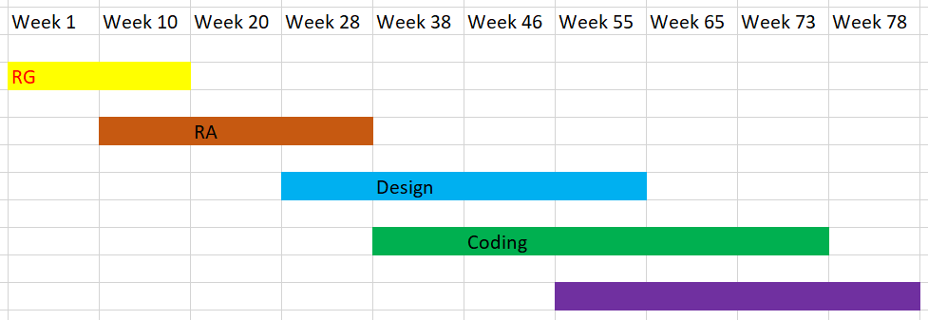

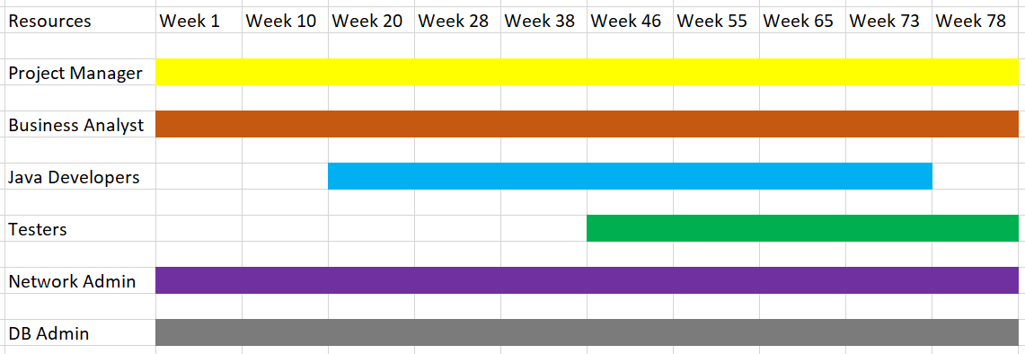

Q13. Explain the difference between Fixed Bid and Billing projects
Answer:
Fixed bid project
A fixed bid project is one in which the service provider agrees to deliver a specific scope of work for a fixed price. The scope of work, deliverables and timelines are agreed upon upfront, and the service provider assumes the risk for any cost overruns or delay.
Billing project
A billing project is one in which the service provider bills the client for the actual time and materials expended on the project. The client pays for the service provider’s time and expenses, and the scope of work can be adjusted as needed throughout the project.
As a BA, this project is a fixed bid project as it clearly mentions the budget as 2 crore rupees with timeline as 18 months.
Q14. Preparer Timesheets of a BA in various stages of SDLC
- Design Timesheet of a BA
- Development Timesheet of a BA
- Testing Timesheet of a BA
- UAT Timesheet of a BA
- Deployment n Implementation Timesheet of a BA
Answer:
Weekly TIMESHEET
Fields | Details
Name of the BA
Email
Phone Number
Project
Project timeframe
Reporting Manager

Stage-Development
Date | Stage/progress name | Start time | End time | Total hours | Task Descriptions | Remarks
DD/MM/YY | Development
DD/MM/YY | Development
DD/MM/YY | Development
DD/MM/YY | Development

Stage-Testing
Date | Stage/progress name | Start time | End time | Total hours | Task Descriptions | Remarks
DD/MM/YY | Testing
DD/MM/YY | Testing
DD/MM/YY | Testing
DD/MM/YY | Testing

Stage-UAT
Date | Stage/progress name | Start time | End time | Total hours | Task Descriptions | Remarks
DD/MM/YY | UAT
DD/MM/YY | UAT
DD/MM/YY | UAT
DD/MM/YY | UAT

Stage-Deployment and Implementation
Date | Stage/progress name | Start time | End time | Total hours | Task Descriptions | Remarks
DD/MM/YY | Deployment and Implementation
DD/MM/YY | Deployment and Implementation
DD/MM/YY | Deployment and Implementation
DD/MM/YY | Deployment and Implementation

Summary

