Online Agriculture Product Store

Question -1 Identify minimum 20 functional requirements?
Answer – Functional Requirements - Functional Requirements refer to the specific behaviors, features, and functions that a system, product, or solution must perform in order to meet the needs of stakeholders. These requirements describe how the system should behave and what it should do in terms of its operations, processes, and interactions. They provide detailed guidance for developers, designers, and testers to build and evaluate the system.
Non-Functional Requirements - Non-Functional Requirements (NFRs) define the quality attributes, performance standards, and constraints that a system or solution must meet. Unlike Functional Requirements which specify what the system should do, non-functional requirements describe how the system should perform under certain conditions. It ensures that the system operates efficiently, securely, and reliably, and that it meets various stakeholder expectations related to user experience and operational needs.
List of Functional Requirements are below:
Req ID | Req Name | Req Description | Priority
FR0001 | Farmer Registration | Farmers should be able to register with the application | 9
FR0002 | Farmer search for products | Farmers should be able to search for available products in fertilizers, seeds, pesticides | 8
FR0003 | Manufacturer’s Registration | Manufacturers should be able to register with the application | 8
FR0004 | Manufacture product listing | Manufacturers should be able to list their products in the catalogue | 7
FR0005 | Product Details | Display The application should display detailed information about each product, including descriptions, specifications, and pricing | 9
FR0006 | Add to Cart | Users should be able to add products to their shopping cart for purchase | 8
FR0007 | Cart Management | Users should be able to view and manage the contents of their shopping cart, including adding or removing products | 8
FR0008 | Wishlist  Management | Users should be able to manage their wishlist or buy-later list, including adding or removing products | 7
FR0009 | Multiple Payment Gateways | The platform should integrate with multiple payment gateways to facilitate secure and convenient transactions | 9
FR0010 | Order Placement | Users should be able to place orders for selected products, specifying quantity and delivery address | 9
FR0011 | Order Confirmation | Users should receive an order confirmation with details such as order number, products, quantities, total amount, and estimated delivery date | 9
FR0012 | Order Tracking | Users should be able to track the status and location of their orders in real-time | 9
FR0013 | Order History | Users should be able to view their order history, including past orders, order details, and statuses | 7
FR0014 | Customer Support | Users should have access to customer support, either through live chat, email, or phone, for assistance with their orders or inquiries | 8
FR0015 | User Ratings and Reviews | Users should be able to provide ratings and reviews for products they have purchased | 7
FR0016 | Product Recommendations | The platform should provide personalized product recommendations based on user preferences and browsing history | 8
FR0017 | Social Sharing | Users should have the option to share products or their purchase experience on social media platforms | 7
FR0018 | Secure Transactions | The platform should ensure secure transactions by implementing appropriate encryption and security measures | 9
FR0019 | Product Filtering | Users should be able to filter products based on various criteria such as price range, brand, or product type | 8
FR0020 | Account  Management | Users should be able to manage their account settings, including profile information, password changes, and email preferences | 7

List of Non - Functional Requirements are below:
Req ID | Req Name | Req Description | Priority
NFR001 | Usability | The application should have intuitive and user friendly | 9
NFR002 | Performance | The application must load pages in 3 seconds | 8
NFR003 | Security | The application must ensure secure user authentication | 8
NFR004 | Compatibility | The application should be compatible with major web browser | 8
NFR005 | Response Time | The application should respond to user input withing 2 seconds | 9
NFR006 | Representation | Visual representation of the pages must be detailed | 7
NFR007 | Auto readable | OTPs must be auto readable by the application | 7
NFR008 | Session time out | Session time out must be up to 2 mins | 6
NFR009 | Accuracy | Location must be accurate up to 50 meters | 8
NFR010 | Refresh | Pages must be refreshed after every 30 seconds. | 6

Question- 2 Make wireframes and prototypes.
Answer – Wireframes - Wireframes are visual representations or blueprints of a user interface (UI) that outline the structure and layout of a web page, application, or system without focusing on detailed design elements like colours, fonts, or graphics. Wireframes are typically used to represent the basic framework of a product’s interface, showing how different elements will be arranged and how users will interact with the system.
Prototypes - Prototypes are early, simplified models or representations of a system or product that simulate the functionality, user interface (UI), or processes of the final solution. Prototypes allow stakeholders, including business users, clients, and the development team, to explore and evaluate the proposed system’s features before the final product is developed. They help gather feedback, validate requirements, and refine system design by providing a tangible representation of the software or product early in the project lifecycle.
Some examples are:
Application dashboard –
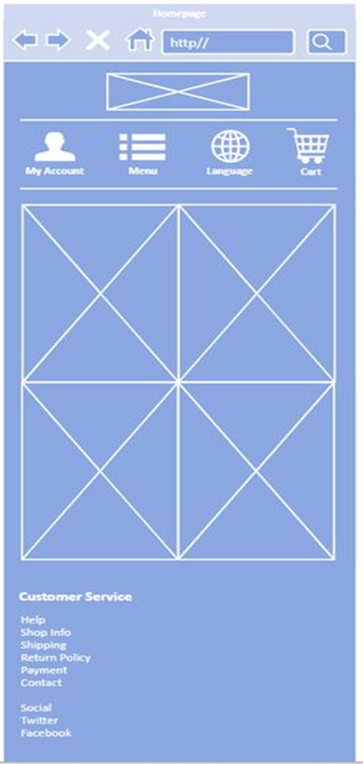

Category page –
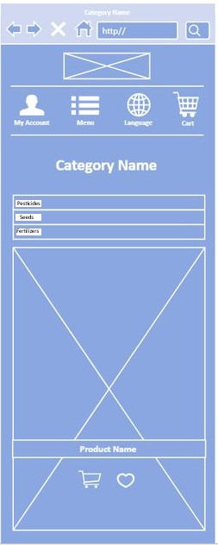

Login page –
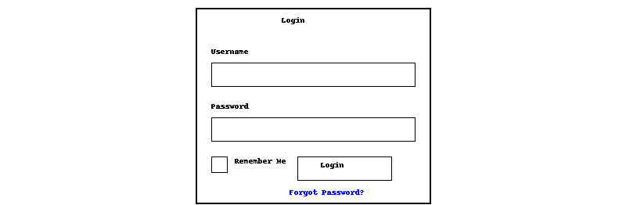Registration page –
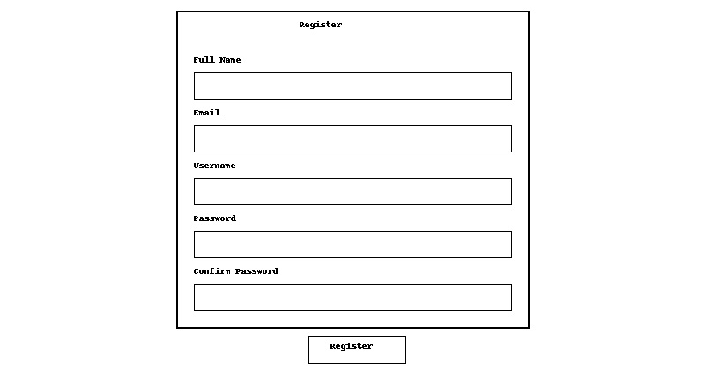

Payment page –
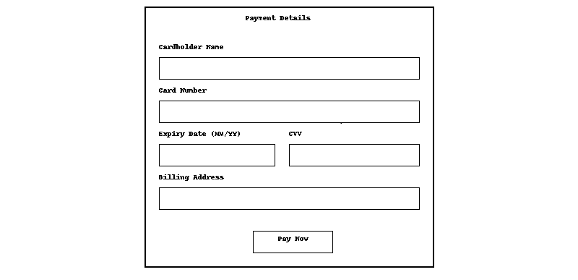

Question- 3 Make a note of the Tools, which you are using for above concepts (Visio, Balsamic)?
Answer – Business Analysis Tools – Business Analysis tools are the techniques to prepare a raw design, process flow diagram and prototype of an end product which will be covering all the aspects of the project requirements and represents the activity of how the process flows inside the project. In Business Analysis there are tools like MS Visio, Balsamic, Axure RP which helps a Business Analyst to prepare Use case diagram, Activity Diagram, Wireframes and Prototype.
MS Visio - In Business Analysis, Microsoft Visio is a powerful tool used to visually represent and communicate complex business processes, systems, workflows, and organizational structures. It plays a crucial role in helping business analysts’ model and analyse various aspects of business operations, enabling stakeholders to better understand, evaluate, and optimize processes. We can prepare flowcharts, org charts, building plans, floor plans, data flow diagrams, process flow diagrams, business process modelling, swim lane diagrams, 3D maps etc.
Balsamiq - Balsamiq is a rapid wireframing tool. It creates mock-ups and wireframes for websites, web apps, and desktop software. It allows us to picture ideas and concepts through a simple drag-and- drop interface. The wireframes created using Balsamiq have a hand-drawn style. It's designed to help business analysts, designers, product managers, and developers quickly sketch out the basic structure and layout of a user interface without focusing on visual design details.
Axure RP – Axure RP stands for Axure Rapid Prototyping which is a prototyping and wireframing tool used by business analysts, UX/UI designers, product managers, and developers to create interactive, high-fidelity prototypes and wireframes for websites, applications, and digital products. Unlike low-fidelity tools like Balsamiq, Axure RP allows users to build more detailed and interactive prototypes that closely mimic the final user experience (UX) and behaviour of a product.
Question – 4 Prepare Requirement Traceability Matrix?
Answer – Requirement Traceability Matrix (RTM) - A Requirement Traceability Matrix (RTM) is a document used in business analysis, project management, and software development to ensure that all project requirements are being met throughout the project lifecycle. It helps track the relationship between requirements and various project elements, ensuring that each requirement is linked to corresponding deliverables, test cases, and design specifications.
RTM is prepared for the Online Agriculture Project is below:
Note- 1. Completed status is represented by “Comp.”
2. Work in Progress status is represented by “WIP”
Req ID | Req Name | Req Descripti-on | Desi-gn | D1 | T1 | D2 | T2 | D3 | T3 | D4 | T4 | UAT
FR0001 | Farmer Registration | Farmers should be able to register with the application | Comp. | Comp. | Comp. | Comp. | Comp. | Comp. | Comp. | Comp. | Comp. | Comp.
FR0002 | Farmer search for products | Farmers should be able to search for available products in fertilizers, seeds, pesticides | Comp. | Comp. | Comp. | WIP | Comp. | Comp. | Comp. | Comp. | Comp. | WIP.
FR0003 | Manufacturer’s Registration | Manufacturers should be able to register with the application | Comp. | Comp. | Comp. | Comp. | Comp. | Comp. | Comp. | Comp. | Comp. | Comp.
FR0004 | Manufacture product listing | Manufacturers should be able to list their products in the catalogue | Comp. | WIP. | Comp. | Comp. | Comp. | Comp. | Comp. | Comp. | Comp. | WIP.
FR0005 | Product Details | Display The application should display detailed information about each product, including descriptions, specifications, and pricing | Comp. | Comp. | Comp. | Comp. | Comp. | Comp. | Comp. | Comp. | Comp. | Comp.
FR0006 | Add to Cart | Users should be able to add products to their shopping cart for purchase | Comp. | Comp. | Comp. | Comp. | WIP. | Comp. | Comp. | Comp. | Comp. | WIP.
FR0007 | Cart Management | Users should be able to view and manage the contents of their shopping cart, including adding or removing products | Comp. | Comp. | Comp. | Comp. | Comp. | Comp. | Comp. | Comp. | Comp. | Comp.
FR0008 | Wishlist  Management | Users should be able to manage their wishlist or buy-later list, including adding or removing products | Comp. | Comp. | Comp. | WIP. | Comp. | Comp. | Comp. | Comp. | Comp. | WIP.
FR0009 | Multiple Payment Gateways | The platform should integrate with multiple payment gateways to facilitate secure and convenient transactions | Comp. | Comp. | Comp. | Comp. | Comp. | Comp. | Comp. | Comp. | Comp. | Comp.
FR0010 | Order Placement | Users should be able to place orders for selected products, specifying quantity and delivery address | Comp. | Comp. | Comp. | Comp. | Comp. | WIP. | Comp. | Comp. | Comp. | WIP.
FR0011 | Order Confirmation | Users should receive an order confirmation with details such as order number, products, quantities, total amount, and estimated delivery date | Comp. | Comp. | Comp. | Comp. | Comp. | Comp. | Comp. | Comp. | Comp. | Comp.
FR0012 | Order Tracking | Users should be able to track the status and location of their orders in real-time | Comp. | WIP. | Comp. | Comp. | Comp. | Comp. | Comp. | Comp. | Comp. | WIP.
FR0013 | Order History | Users should be able to view their order history, including past orders, order details, and statuses | Comp. | Comp. | Comp. | Comp. | Comp. | Comp. | Comp. | Comp. | Comp. | Comp.
FR0014 | Customer Support | Users should have access to customer support, either through live chat, email, or phone, for assistance with their orders or inquiries | Comp. | Comp. | Comp. | Comp. | WIP. | Comp. | Comp. | Comp. | Comp. | WIP.
FR0015 | User Ratings and Reviews | Users should be able to provide ratings and reviews for products they have purchased | Comp. | Comp. | Comp. | Comp. | Comp. | Comp. | Comp. | Comp. | Comp. | Comp.
FR0016 | Product Recommendations | The platform should provide personalized product recommendations based on user preferences and browsing history | Comp. | WIP. | Comp. | Comp. | Comp. | Comp. | Comp. | Comp. | Comp. | WIP.
FR0017 | Social Sharing | Users should have the option to share products or their purchase experience on social media platforms | Comp. | Comp. | Comp. | Comp. | Comp. | Comp. | Comp. | Comp. | Comp. | Comp.
FR0018 | Secure Transactions | The platform should ensure secure transactions by implementing appropriate encryption and security measures | Comp. | Comp. | Comp. | Comp. | Comp. | Comp. | WIP. | Comp. | Comp. | WIP.
FR0019 | Product Filtering | Users should be able to filter products based on various criteria such as price range, brand, or product type | Comp. | Comp. | Comp. | Comp. | Comp. | Comp. | Comp. | Comp. | Comp. | Comp.
FR0020 | Account  Management | Users should be able to manage their account settings, including profile information, password changes, and email preferences | Comp. | Comp. | Comp. | Comp. | WIP. | Comp. | Comp. | Comp. | Comp. | WIP.

Approach to tackle query of Mr. Henry and Peter- When Mr. Henry and Peter approaches to me regarding the status of project then I will explain them the status with the help of Requirement Traceability Matrix which is prepared by each requirement and the development stages of the requirements are logged inside the matrix which will give overall picture of the project, how many requirements are completed, how many are in ‘in progress’ stage and how much more time it will take to complete all the cycle. Using this information, I can prepare a summary report to present in front of Mr. Henry and Peter covey them about development status, testing status, completion dates, critical areas, risk and dependencies.
Question – 5 Prepare 10 Test Case Documents
Answer – Test Case Documents - In software testing, test case documents are organized documents that specify and lay out the precise circumstances, procedures, and anticipated outcomes for confirming a given software application's feature or functioning. They are crucial for making sure that software satisfies specifications and operates as intended in various situations.
10 different Test Case Scenarios and their respective documents are below:
Test case ID | TC0001 | Test Case Name | User Registration
Project ID | Agri0213 | Project Name | Online Agriculture Store Project
PM ID | 98562 | PM Name | Mr. Vandanam
Test Strategy ID | OAS001 | Tester ID | 67542
Test Plan ID | TOAS01 | Tester Name | Mr. Jason
Test Schedule ID | XXXX | Date of Test | 10-OCT-2024
Scenario | To register new user inside web application using e mail id and creating password
Pre Conditions | Internet connectivity should be stronger enough, Website URL is working
Post Condition | Registration successful, User able to login into system with username and password
Input Data | Email Id, Mobile Number, Name of the user
Expected Behaviour | Once user register using name, mail id / mobile number and create password, System should show user created successfully.
Actual Behaviour | After entering mandatory fields, if user clicks on Register button, then system shows pop up saying ‘User created successfully’
Comments | NA
Results (Pass/Fail) | Pass

Test case ID | TC0002 | Test Case Name | User Login
Project ID | Agri0213 | Project Name | Online Agriculture Store Project
PM ID | 98562 | PM Name | Mr. Vandanam
Test Strategy ID | OAS001 | Tester ID | 67542
Test Plan ID | TOAS01 | Tester Name | Miss Alekya
Test Schedule ID | XXXX | Date of Test | 12-OCT-2024
Scenario | To login registered user using username and password
Pre Conditions | User is already registered
Post Condition | Login successful, User is able to search for the required products
Input Data | Username, Password, Captcha
Expected Behaviour | User enter Username and Password along with captcha to login and system shows login successfully
Actual Behaviour | After entering username, password and captcha, if user clicks on ‘Login’ button, then system shows pop up saying ‘Login successfully’
Comments | NA
Results (Pass/Fail) | Pass

Test case ID | TC0003 | Test Case Name | Add to cart
Project ID | Agri0213 | Project Name | Online Agriculture Store Project
PM ID | 98562 | PM Name | Mr. Vandanam
Test Strategy ID | OAS001 | Tester ID | 67542
Test Plan ID | TOAS01 | Tester Name | Mr. Jason
Test Schedule ID | XXXX | Date of Test | 15-OCT-2024
Scenario | User should be able to add selected products to cart
Pre Conditions | Products are available in inventory and add to cart is enabled
Post Condition | Total prices will be shown, Payment option would be shown
Input Data | Product Id, Product pictures, Product prices
Expected Behaviour | Once login, User will search products on the basis of requirements, and he must be able to add products in the cart for purchase.
Actual Behaviour | After selecting required products, User clicks on Add to Cart option to add products in the cart for purchase
Comments | NA
Results (Pass/Fail) | Pass

Test case ID | TC0004 | Test Case Name | Coupon code apply
Project ID | Agri0213 | Project Name | Online Agriculture Store Project
PM ID | 98562 | PM Name | Mr. Vandanam
Test Strategy ID | OAS001 | Tester ID | 67542
Test Plan ID | TOAS01 | Tester Name | Miss Alekya
Test Schedule ID | XXXX | Date of Test | 17-OCT-2024
Scenario | User should be able to add coupon code at the checkout time to avail discount
Pre Conditions | Coupon code must be valid
Post Condition | Total price will be adjusted as per coupon code
Input Data | Coupon codes, Discount codes
Expected Behaviour | At the time of checkout, User must be able to enter coupon code to get the discount on total bill
Actual Behaviour | After adding to cart, User puts coupon code and gets discount on total prices of the product
Comments | NA
Results (Pass/Fail) | Pass

Test case ID | TC0005 | Test Case Name | Payment
Project ID | Agri0213 | Project Name | Online Agriculture Store Project
PM ID | 98562 | PM Name | Mr. Vandanam
Test Strategy ID | OAS001 | Tester ID | 67542
Test Plan ID | TOAS01 | Tester Name | Mr. Jason
Test Schedule ID | XXXX | Date of Test | 19-OCT-2024
Scenario | User must be able to choose payments option and do the payment
Pre Conditions | Products added to cart and Total price is calculated
Post Condition | Redirected to 3rd party apps or COD option
Input Data | Card details, UPI details, Payment method
Expected Behaviour | User should be able to choose payment option from Net Banking, UPI or Cash on Delivery
Actual Behaviour | At the payments stage user is able to select options from Net Banking, Card payments, UPI or cash od delivery
Comments | NA
Results (Pass/Fail) | Pass

Test case ID | TC0006 | Test Case Name | Payment confirmation
Project ID | Agri0213 | Project Name | Online Agriculture Store Project
PM ID | 98562 | PM Name | Mr. Vandanam
Test Strategy ID | OAS001 | Tester ID | 67542
Test Plan ID | TOAS01 | Tester Name | Miss Alekya
Test Schedule ID | XXXX | Date of Test | 21-OCT-2024
Scenario | User should be get payment confirmation message in phone or mail
Pre Conditions | Payments is successful
Post Condition | Redirected to order confirmation page and expected delivery date
Input Data | Payment Id, Total price
Expected Behaviour | Once payments are done and amount deducted from the user’s account, user should get text or mail confirmation for payment
Actual Behaviour | After payment, User gets payments successful confirmation message or mail that payment has been successfully processed
Comments | NA
Results (Pass/Fail) | Pass

Test case ID | TC0007 | Test Case Name | Order Confirmation
Project ID | Agri0213 | Project Name | Online Agriculture Store Project
PM ID | 98562 | PM Name | Mr. Vandanam
Test Strategy ID | OAS001 | Tester ID | 67542
Test Plan ID | TOAS01 | Tester Name | Mr. Jason
Test Schedule ID | XXXX | Date of Test | 24-OCT-2024
Scenario | User should get text or mail for order confirmation
Pre Conditions | Payment is successful
Post Condition | Tracking of order is enabled
Input Data | Product Id, Product pictures, Product prices
Expected Behaviour | Once payments are done, User should get order confirmation containing Order Id, and expected delivery date
Actual Behaviour | After payments done, User should get order confirmation containing Order Id and expected delivery date
Comments | NA
Results (Pass/Fail) | Pass

Test case ID | TC0008 | Test Case Name | Cancel order
Project ID | Agri0213 | Project Name | Online Agriculture Store Project
PM ID | 98562 | PM Name | Mr. Vandanam
Test Strategy ID | OAS001 | Tester ID | 67542
Test Plan ID | TOAS01 | Tester Name | Miss Alekya
Test Schedule ID | XXXX | Date of Test | 27-OCT-2024
Scenario | User should be able to cancel wrong order
Pre Conditions | Product already ordered, Cancel window is open
Post Condition | Order status is updated, Refund initiated
Input Data | User account details, Order Id, Product Id
Expected Behaviour | User should be able to cancel the order or orders done by mistake from cancel order page
Actual Behaviour | User is able to cancel the order from cancel order page from the menu
Comments | NA
Results (Pass/Fail) | Pass

Test case ID | TC0009 | Test Case Name | Return of the order
Project ID | Agri0213 | Project Name | Online Agriculture Store Project
PM ID | 98562 | PM Name | Mr. Vandanam
Test Strategy ID | OAS001 | Tester ID | 67542
Test Plan ID | TOAS01 | Tester Name | Mr. Jason
Test Schedule ID | XXXX | Date of Test | 31-OCT-2024
Scenario | User should be able to return any order which they did not like
Pre Conditions | Product already ordered, Return window is open
Post Condition | Order status is updated, Refund initiated
Input Data | Product Id, Order id, User details
Expected Behaviour | User must be able to return the order from Return order page
Actual Behaviour | User can return the order from the Return order page with the help of order id and product id
Comments | NA
Results (Pass/Fail) | Pass

Test case ID | TC0010 | Test Case Name | Session Out timing
Project ID | Agri0213 | Project Name | Online Agriculture Store Project
PM ID | 98562 | PM Name | Mr. Vandanam
Test Strategy ID | OAS001 | Tester ID | 67542
Test Plan ID | TOAS01 | Tester Name | Miss Alekya
Test Schedule ID | XXXX | Date of Test | 03-NOV-2024
Scenario | Application must be automatically session out after staying idle
Pre Conditions | User is logged in and inactive
Post Condition | System should ask for re-login
Input Data | Product Id, Order id, User details
Expected Behaviour | Application must be session out after being idle for 30 seconds and should ask for login again
Actual Behaviour | Application gets session out after being idle for 30 seconds and asks for login again
Comments | NA
Results (Pass/Fail) | Pass

Question – 6 Draw database schema and ER diagram.
DB Schema -The structure of the database, including its tables, fields, relationships, restrictions, and other features, is described in a database schema, which is a blueprint.

ER Diagram -An entity relationship diagram is a graphic representation of the connections between the various entities in a database. It shows the attributes (fields/properties), entities (tables), and their relationships.
Answer – 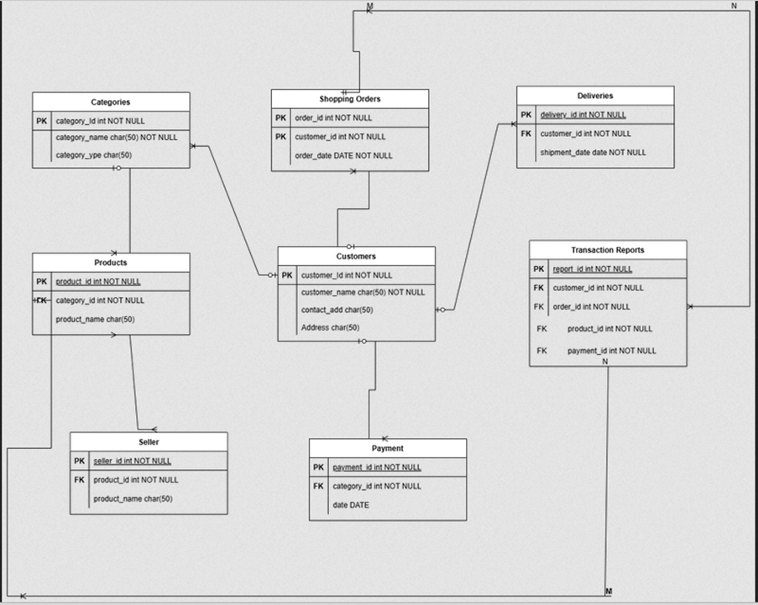
Question- 7 What is a data flow diagram? Draw a data flow diagram to represent the in-flow and out-flow of data when a Farmer is placing an order for the product
Answer – Data Flow Diagram - A Data Flow Diagram (DFD) is a graphical representation of the flow of data within a system. It shows how data moves from one part of the system to another and how data is transformed, stored, and utilized within the system. DFDs are widely used in systems analysis and design to visualize data processes and the way information is handled, stored, and transmitted between different system components.

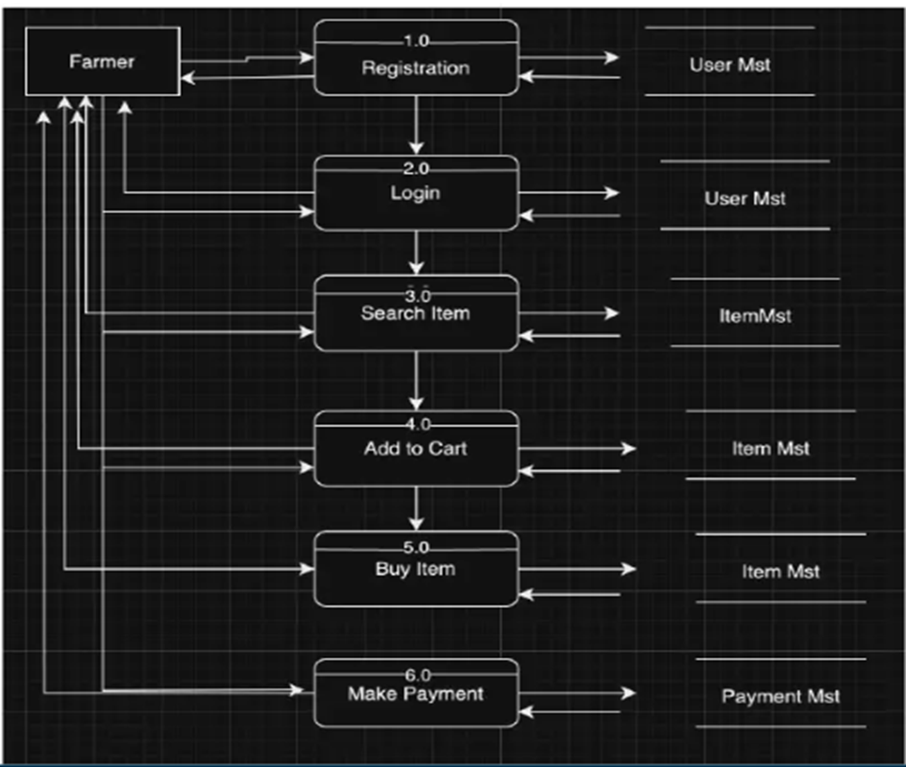
Question- 8 Due to change in the Government Taxation structure. we should change the Tax structure. How do you handle change requests in a project?
Answer- Handling change requests in a project involves a systematic process to ensure that changes are effectively managed while minimizing disruption to the project's scope, timeline, and resources. Here are the steps typically followed to handle change requests.
1. Change Request Identification: Identify and document the change request, including the specific details of the requested change, the reason for the change, and its potential impact on the project.
2. Change Impact Analysis: Assess the impact of the change on various aspects of the project, such as scope, timeline, cost, resources, and risks. Evaluate the feasibility and implications of implementing the change.
3. Change Evaluation: Review the change request with key stakeholders, including project sponsors, clients, and relevant team members. Discuss the potential benefits, risks, and trade-offs associated with the change. Consider the project’s objectives, constraints, and priorities in the evaluation process.
4. Change Prioritization: Prioritize the change request based on its urgency, impact, and alignment with project goals. Determine whether the change is critical and must be implemented immediately or can be scheduled for a future phase or release.
5. Change Approval: Obtain formal approval from the appropriate stakeholders, such as project sponsors or change control boards. Ensure that all stakeholders agree regarding the change and its implications.
6. Change Implementation: Incorporate the approved change into the project plan, including any necessary adjustments to the scope, schedule, budget, or resources. Communicate the change to the project team and other relevant stakeholders. Update project documentation, such as requirements, design, and test plans, to reflect the approved change.
7. Change Communication: Communicate the approved change to all relevant parties, including team members, clients, and other stakeholders. Clearly explain the reasons for the change, its impact on the project, and any adjustments to expectations or deliverables.
8. Change Tracking and Documentation: Track and document all approved changes, including the rationale, approvals, and implemented modifications. Maintain a change log or change register to ensure transparency and accountability throughout the project.
9. Change Control and Monitoring: Continuously monitor the impact of implemented changes on the project's progress, risks, and quality. Maintain open lines of communication with stakeholders to address any concerns or issues related to the approved changes. Monitor the project's overall alignment with the revised scope, timeline, and objectives.
By following these steps, a project can effectively manage change requests, ensuring that changes are evaluated, approved, and implemented in a controlled manner, while minimizing disruptions and maintaining project success
Question – 9 As the project is in process, Ben and Kevin have contacted you. The reason is to inform you that they want the Farmers to sell their crop yields through this application i.e. Farmers should be able to add their crop yields or products and display to general public and should be able to sell them. They also want to introduce an Auction system for their Crop yields.
As a BA, what will be your response? Is this a change request or an enhancement?
Answer – Change Requests - A Change Request (CR) is a formal proposal to modify a project, product, process, or system. It is typically used in project management, software development, and various industries to handle modifications and improvements. A Change Request can arise at any point during a project's lifecycle, whether it's due to new requirements, unforeseen issues, or the need for enhancements.
Enhancement - Enhancements refer to improvements or additions made to the software after its initial release. These changes are aimed at increasing the software’s value, performance, or functionality based on evolving business needs, user feedback, or technological advances. Enhancements can be part of the regular software maintenance cycle or occur as part of a new version or update.
As a Business Analyst, my response to Ben and Kevin's request would be to classify it as an enhancement rather than a change request. A change request typically involves modifications to existing functionality or requirements, while an enhancement introduces new features or capabilities that were not initially specified. In this case, the request to allow farmers to add their crop yields, display them to the general public, and enable selling through the application represents an enhancement because it introduces new functionality that goes beyond the initial scope of the project. Additionally, the introduction of an auction system for crop yields adds another layer of functionality to the application.
To address this enhancement request, I would follow the standard process for handling new requirements:
1. Requirement Gathering: I will meet with Ben and Kevin to gather detailed requirements for the new functionality. This would involve understanding the specific features they envision, such as the process for farmers to add and manage their crop yields, the display of products to the public, and the implementation of the auction system.
2. Impact Analysis: I would analyze the impact of these enhancements on the existing project scope, timeline, budget, and resources. This assessment would help determine the feasibility and potential implications of incorporating the requested features.
3. Stakeholder Analysis: I would identify and involve relevant stakeholders, such as the project sponsor, development team, and other key personnel, to assess their perspectives and gather their inputs on the potential enhancements.
4. Documentation and Communication: I would document the detailed requirements and changes in the project scope, and communicate them to the project team, stakeholders, and any other parties involved. This would ensure everyone is aware of the proposed enhancements and their implications.
5. Evaluation and Prioritization: I would work with the project team and stakeholders to evaluate the value and priority of the requested enhancements. This evaluation would consider factors such as the potential benefits, impact on project goals, alignment with business objectives, and available resources.
6. Planning and Execution: If the enhancements are deemed feasible and approved, I would update the project plan, schedule, and resources accordingly would collaborate with the development team and other stakeholders to incorporate the new features into the application, ensuring proper testing and quality assurance.
By treating this request as an enhancement, the project can effectively manage the additional requirements and deliver the desired functionality while considering the impact on the ongoing project.
Question – 10 Come up with estimations – How many Manhours required?
Answer – Estimation - Estimation in Software Development Life Cycle refers to the process of predicting the resources (time, cost, effort) required to complete a software development project or specific tasks within that project. Estimation is a critical part of the planning phase of SDLC, as it helps in setting realistic expectations, managing resources efficiently, and determining the project's feasibility.
Man-hours estimation in software development refers to the process of estimating the total amount of human effort required to complete a software development task, project, or feature. It is typically expressed in terms of the number of hours that a team or individual will spend working on the project. This estimation is crucial for planning, budgeting, and scheduling the project. It helps determine resource requirements, assess project timelines, and evaluate project feasibility.
Types of projects on the basis of Man-Hours:
- Small project – Upto 500 Man-Hours
- Medium project – Upto 1000 Man-Hours
- Large project – Upto 1500 Man-Hours
Manhours Required = Total hours working per day x Total number of members x Total numbers of days worked over the specific period.
Number of Working Hours a day = 8 hours
Number of Resources = 12
Time period provided = 18 months = 547 days = 78 weeks (Including Weekends and Public Holidays)
Assuming Weekends = 156
Assuming Public Holidays = 10
Total = 166
Total working days = 547-166 = 381 working days
Hence, Estimated Manhours = 8 hours * 12 resources * 381 days = 36,576 Man hours required.
Question – 11 Project has finally completed all the stages i.e., design, development, testing etc. Now, it is the role of a business analyst to contact the client for testing of the final product and have to successfully complete it. How are you going to handle this situation? And once it is done, what will be the process to close the project?
Explain UAT Acceptance process.
Answer- User Acceptance Testing (UAT) - UAT (User Acceptance Testing) is a crucial phase in the software development life cycle where the intended users of the system validate the software by testing it in a real-world or production-like environment. The primary goal of UAT is to ensure that the software meets the business requirements, functions as expected and is ready for deployment to the end users.
To handle the situation of testing the final product and successfully completing it, the business analyst can follow these steps:
1. UAT Planning: Prepare a plan for User Acceptance Testing (UAT) in consultation with the client. This plan should include the scope of testing, test scenarios, test data, and timelines.
2. Test Environment Setup: Ensure that the required test environment is set up and available for the client to perform testing. This may include providing access to the testing environment, necessary test accounts, and any additional resources needed for testing.
3. Test Execution: Coordinate with the client to execute the planned test scenarios. Monitor the testing progress, provide support for any questions or issues that arise, and track the test results.
4. Defect Management: If any defects are identified during UAT, work closely with the client to understand the issues, document them, and track their resolution. Collaborate with the development team to address the reported defects and verify their fixes.
5. UAT Sign-off: Once the client has completed testing and is satisfied with the product’s functionality, obtain their formal sign-off or approval which includes RTM and closure documents. This indicates that the client has accepted the final product and is ready to move forward with its deployment.
Regarding the process to close the project, it typically involves the following steps:
1. Final Documentation: Ensure that all project-related documentation is complete, including requirements, design documents, test cases, and user manuals. Review and update these documents to reflect the final product.
2. Project Review: Conduct a project review meeting with key stakeholders, including the client, to discuss the overall project performance, achievements, and lessons learned. Gather feedback and suggestions for improvement.
3. Project Closure Report: Prepare a project closure report summarizing the project’s objectives, deliverables, timeline, budget, and overall success. Include any important metrics or performance indicators.
4. Handover or Deployment: Coordinate with the necessary teams, such as deployment or operations, to ensure a smooth transition of the final product to the production environment. Provide any necessary training or documentation to support the deployment process.
5. Post-Project Evaluation: After the product is deployed and operational, conduct a post-project evaluation to assess its performance, gather user feedback, and identify any areas for further improvement.
UAT Acceptance Process: The UAT (User Acceptance Testing) Acceptance Process is the formal procedure through which stakeholders (typically business users or clients) validate and approve the software application to ensure it meets business requirements and is ready for deployment. It is a critical phase in the SDLC that involves testing the system in a real-world environment to ensure it works as intended before going live.
The User Acceptance Testing (UAT) Acceptance process involves the following steps:
1. Test Planning: Define the scope of UAT and identify the key features or functionalities to be tested. Prepare test scenarios and test cases based on user requirements.
2. Test Execution: Perform the planned test scenarios, following the test cases provided. Validate the system's behaviour against the expected outcomes and verify that it meets the user's acceptance criteria.
3. Defect Reporting: If any issues or defects are identified during UAT, document them in a structured manner, including detailed steps to reproduce the problem. Communicate the issues to the development team for resolution.
4. Defect Resolution: Collaborate with the development team to address the reported defects. Verify the fixes provided by the development team and retest the affected areas.
5. Sign-off: Once all test scenarios have been executed, defects have been resolved, and the system meets the user's acceptance criteria, provide formal sign-off or approval. This signifies that the client accepts the product as meeting their requirements.
6. UAT Closure: Document the UAT results, including the test execution summary, any outstanding issues, and the overall assessment of the product.

Question – 12 Explain Project closure document.
Answer – Project Closure Document - A Project Closure Document is a formal document that signifies the conclusion of a project. It provides a detailed summary of the project’s performance, achievements, lessons learned, and any remaining tasks or issues. The purpose of this document is to ensure that the project is officially closed and that all stakeholders have agreed that the project has met its objectives. The Project Closure Document is typically prepared by the project manager or the project team and is presented to stakeholders, including the client, team members, and management.
The project closure document typically includes the following sections:
1. Project Overview: This section provides an overview of the project, including its objectives, scope, and stakeholders involved. It summarizes the project’s purpose and sets the context for the closure report.
2. Project Achievements: Here, the document highlights the key achievements and deliverables of the project. It outlines the successful completion of milestones, tasks, and any significant accomplishments that were achieved.
3. Project Timeline and Budget: This section provides an overview of the project timeline, highlighting the start and end dates, major phases, and milestones. It also includes information on the project's budget, including any significant deviations or changes.
4. Lessons Learned: The lessons learned section reflects on the project successes and challenges. It includes a comprehensive analysis of what worked well and what could have been improved. It highlights valuable insights and recommendations for future projects.
5. Stakeholder Feedback: This section gathers feedback from key stakeholders involved in the project. It includes their opinions, suggestions, and any concerns they may have expressed. The feedback helps in assessing the overall satisfaction and identifying areas for improvement.
6. Risks and Issues: The closure document discusses the risks and issues encountered throughout the project. It outlines the actions taken to mitigate these risks and resolve any issues that arose during the project's lifecycle.
7. Project Performance: This section evaluates the project's performance against the defined objectives and success criteria. It assesses factors such as scope adherence, timeline adherence, budget performance, quality of deliverables, and customer satisfaction.
8. Project Sign-off: The closure document includes formal sign-off or approval from key stakeholders, indicating their acceptance and satisfaction with the project’s outcomes. This signifies the official closure of the project.
9. Project Documentation: This section provides an overview of the project documentation, including the list of documents produced, their location, and accessibility for future reference.
10.Next Steps and Recommendations: The closure document outlines any recommended actions or next steps following the project's closure. It may include suggestions for further improvements, additional tasks, or follow-up activities.
The project closure document serves as a final report that captures the project's journey, outcomes, and key learnings. It provides a reference for future projects, helps in evaluating project success, and facilitates knowledge transfer to stakeholders involved in the project.
For Example:
S/N | Points to Include | Details | Reference Link1
1 | Did the client sign off on the  UAT testing
 | Date of Signoff | 12-MAR-2026 | Business_Scope.docx
 | Name of the resource | Mr. Varun | Business_Scope.docx
2 | Objectives of the project
 | User friendliness | Achieved
 | Customer satisfaction | ROI (Return of Investment) in 6 to 12 months
 | More Categories | Achieved
3 | Functionalities worked on
 | Secured payment process | Achieved | FRD.docx
 | Categories | Achieved | FRD.docx
4 | Infrastructure
 | Software installed | Achieved | Procurement.docx
 | Laptops purchased | Achieved | Procurement.docx
5 | Funding
 | Amount approved | 2 Crores | Financialdetails.xlsx
 | Amount used | 2 Crores | Financialdetails.xlsx
6 | Overall project information
 | Escalations | 30
 | Customer satisfaction | High
7 | Value to the company
 | Positive/Negative | Company has gained  successful integration of  processes, increased  turnover by 25%, increased  efficiency by 20%

