Capstone Project3– Part -1/2

A customer can make a payment either by Card or by Wallet or by Cash or by Net banking.
Q1. Draw a Use Case Diagram

Q2. Derive Boundary Classes, Controller classes, Entity Classes.
Ans:

Boundary Class (View or Service Collaborator (: Boundaries are objects that interface with system actors: User Interface, Database Gateway, Server Proxy, etc.
Controller Class (Controls): Controls are objects that mediate between boundaries and entities. These serve as the glue between boundary elements and entity elements, implementing the logic required to manage the various elements and their interactions.
Entity Class (Model): Entities are objects representing system data often from the domain model: Customer, Product, Transaction, Cart, etc.
4 Rules apply to their communication:
- Actors can only talk to boundary objects.
- Boundary objects can only talk to controllers and actors.
- Entity objects can only talk to controllers.
- Controllers can talk to boundary objects and entity objects, and to other controllers, but not to actors.

Boundary Class | Payment Option Boundary
Boundary Class | Card Payment Boundary
Boundary Class | Wallet Payment Boundary
Boundary Class | Cash Payment Boundary
Boundary Class | Net Banking Payment Boundary
Controller Class | Payment Initiated Controller
Controller Class | Card Payment Controller
Controller Class | Wallet Payment Controller
Controller Class | Cash Payment Controller
Controller Class | Net Banking Payment Controller
Entity Class | Customer
Entity Class | Payment
Entity Class | Card
Entity Class | Wallet
Entity Class | Server

Q3. Place these classes on a three tier Architecture.
Ans:
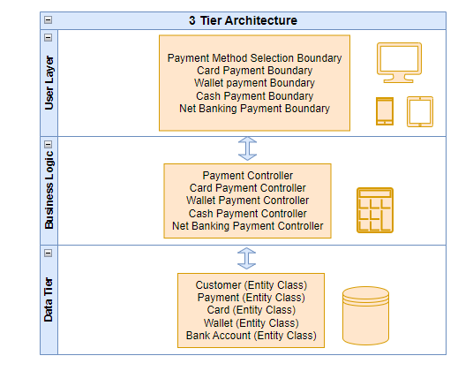

Q4. Explain Domain Model for Customer making payment through Net Banking
Ans:
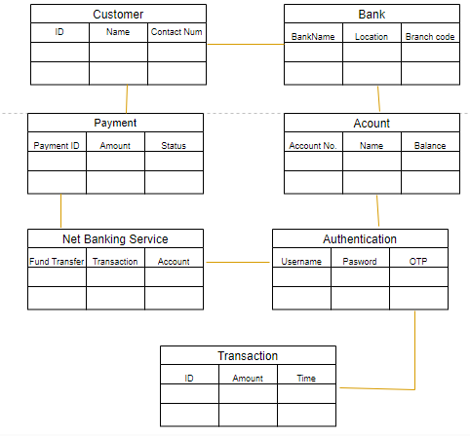

Q5. Draw a sequence diagram for payment done by Customer Net Banking
Ans:
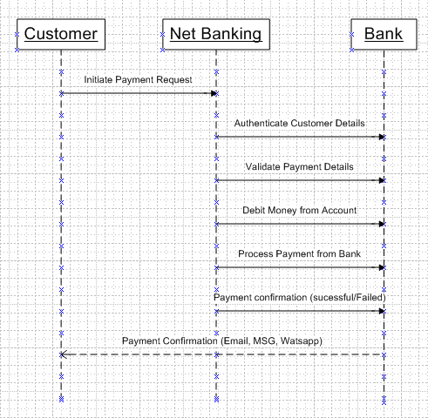

Q6. Explain Conceptual Model for this Case
Ans:
A Conceptual Model for the payment process done by a customer using net banking provides a high-level understanding of the key concepts and their relationships involved in the payment transaction. It helps in visualizing the overall structure and flow of the payment process.
It represents some type of real-world system or concept. It can be explained by defining each component of the model, as well as the functions that are carried out by each component.
Q7. What is MVC architecture? Explain MVC rules to derive classes from use case diagram and guidelines to place classes in 3-tier architecture
Ans:
The Model-View-Controller (MVC) framework is an architectural/design pattern that separates an application into three main logical components Model, View, and Controller. Each architectural component is built to handle specific development aspects of an application. It isolates the business logic and presentation layer from each other.
Features of MVC:
- It provides a clear separation of business logic, Ul logic, and input logic.
- It offers full control over your HTML and URLs which makes it easy to design web application architecture.
- It is a powerful URL-mapping component using which we can build applications that have comprehensible and searchable URLs.
- It supports Test Driven Development (TDD).

The MVC framework includes the following 3 components:
- Controller
- Model
- View

Controller: The controller is the component that enables the interconnection between the views and the model, so it acts as an intermediary. The controller doesn’t have to worry about handling data logic, it just tells the model what to do. It processes all the business logic and incoming requests, manipulates data using the Model component, and interact with the View to render the final output.
View: The View component is used for all the UI logic of the application. It generates a user interface for the user. Views are created by the data, which is collected by the model component, but these data aren’t taken directly but through the controller. It only interacts with the controller.
Model: The Model component corresponds to all the data-related logic that the user works with. This can represent either the data that is being transferred between the View and Controller components or any other business logic-related data. It can add or retrieve data from the database. It responds to the controller’s request because the controller can’t interact with the database by itself. The model interacts with the database and gives the required data back to the controller.
MVC Rules in identifying classes:
1. Combination of one actor and a use case result in one boundary class
2. Combination of two actor and a use case result in two boundary class
3. Combination of three actor and a use case result in three boundary class and so on…
Note: only one primary actor is to be considered with a use case
4. Use case will result in a controller class
5. Each actor will result in one entity class

Guidelines to place identified MVC classes in 3 tier architecture:
1. Place all entity classes in DB layer.
2. Place Primary Actor associated boundary class in application layer
3. Place controller class in application layer.
4. If governing body influence or re usability is there with any of the remaining boundary classes, place them in business layer.

Q8. Explain BA contributions in project (Waterfall Model – all Stages) – 4 Marks
Ans:
Stages | Activities | Artifacts & Resources
Pre Project | Enterprise Analysis- SWOT Analysis, GAP Analysis, Market Research, Feasibility Study, Root Cause Analysis, Decision Analysis, Strategy Analysis, Enterprise Architectural Frameworks, Project Scope and Business Case Writing, Risk Analysis | Business Case  SOW (Statement of Work)  PO (Purchase Order)  ----------------------  Sr BA (Sr. Business Analyst)  Business Architects  Presales Consultants.
Planning & Estimations & Assessment  Project Kick off  (Big Picture Plan) | 1. Understand Assumptions and Constraints along with Business Rules and Business Goals.  2. Plan packages for Big Projects.  3. Understanding the project plan from PM.  4. BA conducts Stakeholder Analysis.  5. Plan BA approach strategy (Requirement Gathering Techniques, Communication, Requirement Management, Documents to follow, Tools to use, Change Request Handling Methodology) for the project. | ---------------------------------  PM (Project Manager)  Sr. BA (Sr. Business Analyst)
Requirements Gathering | 1. Identify Stakeholders and documents.  2. Client gives BRD or BA prepares BRD by interacting with client- Brainstorming, Document Analysis, Reverse Engineering, Interviews, Workshops, Focus Groups, Observation, Questionnaires.  3. Prototyping can be used by BA to make the Client to give more specific requirements.  4. Sort gathered requirements (avoiding duplicate requirements, grouping into small functionality or modules.)  5. Prioritize requirements- MoSCoW.  6. Validate requirements- FURPS. | BRD (Business Requirements Document)  -----------------------------------  BA (Business Analyst)  PM (Project Manager)
Requirements Analysis | 1. Draws UML Diagrams (Use Cases & Activity Diagrams).  2. Prepares Functional Requirements from Business Requirements.  3. All Architects comes up with Technical Requirements (SSD).  4. SRS will have Functional Requirements and Technical Requirements.  5. Take Signoff on SRS from clients. SRS is the first legal binding document between the Business and the Technical team.  6. BA prepares RTM from SRS before design phase starts. (BA is owner of RTM)  7. BA traces how requirements are dealt in each phase of development life cycle from design till UAT. | Functional Requirements Specification.  SSD (Supplementary Support Document)  SRS (Software Requirements Specification)  RTM (Requirements Traceability Matrix)  ------------------------------------  BA (Business Analyst)  PM (Project Manager)  Solution Architect  DB Architect  NW Architect
Design | 1. From Use Case Diagram, Test Manager or BA will prepare Test Cases.  2. Communicates with client on Design and Solution documents (updates status to Client and make them understand how the solution would look to prepare them to drive UAT.  3. BA will initiate the preparation of End User manuals.  4. Updates RTM.  5. From Use Case Diagram Solution- Architect recommends Architecture of the IT Solution.  6. DB Architect uses Persistence Classes (Entity Classes) and comes up with ER Diagrams or DB Schema.  7. GUI Designer will look into Transient Classes (Boundary Classes) and designs all possible Screens for the IT Solution. | Solution Document  Design Document - HDD- ADD  BA (Business Analyst)  PM (Project Manager)  Solution Architect  DB- Architect  NW- Architect  GUI- Designer  Test Manager
Coding | 1. BA recognizes JAD sessions.  2. BA clarifies queries of Technical Team during coding.  3. Developers refer Diagrams and Transient (controller classes) of BA and code their unit.  4. Updates End User Manuals.  5. Updates RTM.  6. Conducts regular Status Meetings with technical team and the client and tuning clients for participation in UAT. | LDD- CDD Application  ------------------------------  Development Team  BA (Business Analyst)  PM (Project Manager)
Testing | 1. BA prepares Test Cases from Use Cases or assists Test Manager to do so.  2. BA performs high level testing.  3. BA prepares client for UAT.  4. Test Data is requested by BA from clients.  5. Updates End User Manuals.  6. Updates RTM.  7. Takes Signoff from Client on Project Acceptance Form. | Test Concerning Documents Application with less errors.  ----------------------------  Testing Team  BA (Business Analyst)  PM (Project Manager)  Client
Deployment & Implementation | 1. Forwards RTM to client or the PM which should be attached to the Project Closure Document.  2. Coordinates to complete and share End User Manuals.  3. Plans and Organizes Training Sessions for End Users.  4. Prepare lessons learned from project (to take precautions for coming project).

Q9. What is conflict management? Explain using Thomas – Kilmann technique
Ans:
Conflict Management refers to the process of handling and resolving conflicts or disagreements that arise between individuals or groups within an organization.
The Thomas- Kilman Conflict Mode Instrument (TKI) is widely used technique for understanding and managing conflict.
The Thomas-Kilman technique helps individuals understand their preferred conflict-handling styles and provides insights into when each mode might be appropriate.
Effective conflict management involves recognizing the existence of conflicts, actively listening to the concerns of all parties involved, seeking common ground, and working toward collaborative solutions that meet the needs of everyone.
The TKI assessment provides insight into an individual's typical response to conflict situations using one or more of five conflict-handling modes, or styles: competing, accommodating, avoiding, collaborating, and compromising. These modes reflect varying levels of assertiveness and cooperation.

Q10. List down the reasons for project failure
Ans:
Reasons for Project failure:
- Improper Requirement Gathering: A thorough analysis of requirements is essential at the initiation phase to avoid future complications. Proper requirements analysis will only lead to delivering correct product.
- Continuous Change in Requirements: Especially if the project is dynamic in nature, this becomes very true. Any change request in business needs can lead to the business case becoming outdated before a project has been completed leading to total failure.
- Lack of User involvement: It is essential to engage user during the project lifecycle as their suggestions and feedback play an important role. Failure in user involvement in the project leads to an improper end result and the product fails to meet the user expectations.
- Lack of executive support: Project may also fail if there’s no proper guidance or support from the executives. This is because, without effective leadership, team members will not be able to work together effectively.
- Unrealistic expectations: It is important that the right people are assigned to perform tasks based on their skills and performance metrics. The concerned person should have awareness and in-depth knowledge of he/she will be doing in the project. Expectations should be realistic.
- Improper planning: Planning is the first and foremost and the most important step in the journey of the project. It lays the foundation of a project. If planning is improper, the desired outcome will not fall into place.

Q11. List the Challenges faced in projects for BA
Ans:
Challenges that are faced by a Business Analyst in real time are as follows: -
Ambiguous or Changing Requirements: Business analyst have to cope up with all the changes that comes in a management while completion of the Project, he/she has to put on the whole process by being involved in the process and managing the changes in the organisation.
Resistance to change: Business analyst have to cope up with all the changes that comes in a management while completion of the Project, he/she has to put on the whole process by being involved in the process and managing the changes in the organisation.
Lack of Training: it includes all those areas which are directly or indirectly related to the project by efficient training to the people involved in project we can definitely produce a good and efficient result for the organisation.
Obtaining Sign off on Requirements: This is one of the major area where a business analyst struggles for while taking sign off on requirement it is necessary for him/her to convince them to the best that all the requirements will be satisfied for taking sign off they have to keep on approaching the clients and be in touch, book an appointment to have the sign off on requirements as well.
Coordination between Developers and Testers: In any project if the coordination between developers and tester is not well managed then the project success could not be assumed.in any project it is must to create a coordination between both these teams in an efficient way.
Conducting Meetings: Conducting meeting is very important and necessary, which is managed by the business analyst as it creates a very great impact in the view of stakeholders. one must note down one thing is to create an effective meeting and minutes and agenda should be prepared well in advance.
Making sure status report is effective: The report status is the key factor of the meeting and the one who is responsible must take care of it in such way by maintaining secrecy of the report.
Driving clients for UAT completion: The UAT completion must by the clients, and this will be the main part of the project which must be looked up by business analyst.
People Management: People management is the main quality that a business analyst must have, this helps the business analyst to control all the fields in a proper way by which they may create a well and healthy atmosphere with a productive result as well.

Q12. Write about Document Naming Standards
Ans:
1. Keep file names short but meaningful.
2. Include any unique identifiers, e.g., case number, project title.
3. Be consistent.
4. Indicate version number where appropriate.
Ensure the purpose of the document is quickly and easily identifiable.
All Documents will be named using some standards like
[Project ID] [Document Type] VD[Y]. ext.
Example:
- CP345UGDV1D1.docx
- CP298UGDV1D1.2.docx
- CP536UGDV1D1docx

Q13. What are the Do’s and Don’ts of a Business analyst
Ans:
Business analysts are responsible for working with management to improve operating procedures, reduce costs and inefficiencies, and achieve better performance Business Analyst will be independent of domain and technology.
DOS of a Business Analyst:
- Confirm understanding with client Always have a client interaction so that project will be on track. Take ownership of every requirement and be responsible for each and every requirement.
- Focus on getting solution with IT solution.
- Always open to work on any domain and technology.
- Reach office at least 15 min prior to shift timing.
- Solve the client problem only with IT solution.
- Be like a lotus in a mud.
- Never take Tensions but pass on the tensions.
- Requirement hurried – Project buried.
- Always appreciate stakeholder even they contributed even small efforts for a project.
- Never say “NO” to client.
- There is no word called as “By Default”.
- Never imagine anything in terms of GUI.
- Consult an SME for clarifications in requirement.
- Conduct daily meetings with team to take updates on project.
- Always follow up to email in a call and update model.
- Maintain individual contribution work sheet (Time Sheet).
- Ensure the users involvement Important mails are followed up by a phone call.
- All mails should be acknowledged.
- All project mails should be copied to Project Manager.
- BA should follow the decisions taken by Project Manager.
- Handle Conflict Management.
- Communicate client requirement into UML to Developers and Testers.
- Clarify doubts related to functional and non-functional requirements to tester and developers.
- Check the change request and accordingly handle change requirement.
- Identify stakeholder and document it to prepares BRD by interacting with client.
- Sort the gathered requirements.
- Prioritize requirements.
- Validate requirements.
- Organize JAD Sessions.
- Question the existence of existence/ question everything in world. E.g., what client gives is not always correct.
- Every problem of a client is unique. No two problems of different client are same. May be the approach, technology, place of use, local laws may vary to make them (problems to be different).
- Go to client with a plain mind with NO assumptions. Listen carefully and completely until client is done and then we can ask our queries.

DON’TS of a Business Analyst:
- Do not interrupt the client when he/she is giving us the problem. Maximum try t extract the leads to solution from the client itself.
- Never try to give solutions to client straight away with our previous experience and assumptions.
- Try to concentrate on the important and truly required requirements.
- Don’t be washed away by add on Functionalities or don’t imagine solutions on screen basis.
- Do not criticize stakeholders.
- Improper requirement gathering from client.
- Arrogant with team.
- Hurried in Requirement gathering from client Imaging / guessing of requirements.
- As working in a similar project and expecting that all projects will be similar model only and working in a monotonous way.
- Delaying for updating information to client as well as to PM.
- Delaying in communicating reply to emails.
- Do not leave Emails without follow up to respective team.
- Do not hide the tensions and last-minute updates.
- Do not do improper planning.
- Improper coordinating with team members.
- Not having complete information about the functional and non-functional requirement.
- Expressing individual opinion without doing pre project homework.
- Very rude attitude and not holding updates of the projects.

Q14. Write the difference between packages and sub-systems
Ans:

Packages | Subsystems
Smaller & more focused in scope | Larger and encompass multiple packages or modules.
Manage dependencies at a class/component level. | Manage dependencies at higher level, defining boundaries and interfaces between parts of the system.
It is a collection of components which are not reusable in nature. | Collection of components which are reusable in nature
Package simply groups elements. | Subsystem groups elements that together provide services such that other elements may access only those services and none of the elements themselves. E.g., Tally software.

Q15. What is camel-casing and explain where it will be used
Ans:
Camel casing is a naming convention used in computer programming and is characterized by removing spaces between words and capitalizing the first letter of each word except the first word. It is commonly used in web URLs, programming and computer naming conventions. The name “CAMEL CASING” is derived from the appearance of the resulting string, which resembles the humps of a camel.
By using camel casing, developers can create meaningful and readable names that are easier to understand and follow coding standards. It promotes consistency within the codebase and improves collaboration among team members.
Entire first word will be in lowercase and subsequent word’s first letter should be in Upper Case. There will be no gap in between words.
Example: goThere (), completeTheProject (), getEmpId (), turnLeftAndSlowDown ()

Q16. Illustrate Development server and what are the accesses does business analyst has?
Ans:
A Developer server refers to a dedicated environment or server that is used during the software development process. It provides a platform for developers and testers to build, test, and debug applications before they are deployed to a production environment. The development server typically replicates the target production environment to ensure compatibility and accurate testing.
- Read-only Access
- Collaborative Access
- Limited configuration Access.

Q17. What is Data Mapping
Ans:
Data mapping is the process of establishing a relationship or connection between data elements in two or more different data sources or data formats. It involves defining how data from one source corresponds to or transforms into data in another source. Data mapping is commonly used in data integration, data migration and data transformation process.
The purpose of data mapping is to ensure that data can be accurately and effectively transferred, converted or transformed between different systems, databases or formats. It involves identifying the source data elements, determining their meaning and structure, and mapping them to the corresponding target data elements.

Q18. What is API. Explain how you would use API integration in the case of your application Date format is dd-mm-yyyy and it is accepting some data from Other Application from US whose Date Format is mm-dd-yyyy
Ans:
An API (Application Programming Interface) is a set of rules and protocols that allows different software applications to communicate and interact with each other. An API are mechanism that enables two software components to communicate with each other using a set of definition and protocol. Developers use APIs to make their jobs more efficient by reusing code from before and only changing the part that is relevant to the process they want to improve. A good API makes it easier to create. Interface can be thought of as a contract of service between two applications.
- Establish API Communication: Set up API communication between your application and other application to exchange data.
- Data Formatting: When sending the date data from your application to the other application, convert the date from dd-mm-yyy format to mm-dd-yyy format. This can be achieved by extracting the day, month and year components from the date and rearranging them according to the target format.
- Data Parsing: When receiving date data from the other application, parse the mm-dd-yyy formatted date into your application’s dd-mm-yyy format. Again, you will need to extract the day, month and year components and rearrange them accordingly.
Data Validation: Perform data validation and ensure that the converted date remains valid after the format conversion. Check for edge cases, such as invalid dates or date ranges that might be affected by the format conversion and handle them appropriately.
Let’s understand via one example,
You want to book your flight ticket using amazon/Paytm of Indigo flight for Mumbai to Goa destination, but the amazon/Paytm have not excess of Indigo company, in this case via API the application shows the require details like available date/seat etc. API is the intermediate of two applications. using API, we can go for the booking.

