Name: Nagarjuna
Batch:2nd August 2025

Capstone project:
- 5 marks
Identify Business Process Model for Online Agriculture Store – (Goal, Inputs, Resources, Outputs, Activities, Value created to the end Customer)

Online Agriculture Products Store.

Goal: The goal is to facilitate farmers in buying seeds, pesticides, and fertilizers from anywhere through internet connectivity, and have the products delivered to the customer's doorstep. The application should also be user-friendly.

Inputs: Registration details, login data, search option, type of product, product description, and payment option. Tracking product, profile, and address section.

Resources: Agriculture products online application, internet connection, user’s ability to use the app.

Output: Based on the inputs provided by the user.

Activities: It depends on the user’s interaction with the application.
The user can prefer to buy the product or select multiple products to buy or can cancel the order.

Value created to the end user: Easy procurement of seeds, pesticides, and fertilizers, easy to access through internet at anywhere and anytime. Delivery to the customers doorstep.

2. – 5 marks
Mr Karthik is doing SWOT analysis before he accepts this project. What Aspects he Should consider as Strengths, as Weaknesses, as Opportunity and as Threats.

Strength:
In strengths Mr. Karthik should consider the team size and the ability and the expertise of the programmers. The skills and expertise of the BA. And the technology used to and how efficient it is to complete the project in the given time, price value and quality.
Weakness:
Need to consider any gaps in capabilities?
Processes and systems?
Timescale, deadlines and pressures?
Efforts on core activities distraction.
Financials? Need to complete the project with in the budget.
Opportunity:
This is a problem faced by many of the farmers not just Henrys friends so if the application successfully it would have a wide reach and we can gain a lot of users from this application.
This will open a new channel for farmers to buy seeds instead of conventional methods.
We can get similar type of projects in the future.
Technology and processes used in this project can be used in similar type of projects in the future.
Threat:
The threats which must be considered are:
Entry of new competitors.
Economic downturns.
Political and legislative factors.
Loss of key staff.
Dissatisfaction of team members.
Sustainable financial backing.
New IT developments in the market, entry of new technology.
Market demand.
Gap in knowledge of the user (if user cannot understand the language instructions are given in the app).
Question 3
Mr Karthik is trying to do feasibility study on doing this project in Technology (Java), Please help him with points (HW SW Trained Resources Budget Time frame) to consider in feasibility Study.

Feasibility study:
The main aim of doing feasibility study is to analyze the feasibility of the technology, operational capabilities and budget feasibility and trained resources.
Hardware requirements:
Component | Specification | Purpose
Server | 16-32 GB RAM, 500 GB SSD. | Application hosting.
Development Machines | I5, i7 processor, 8 GB RAM, 256 GB SSD. | Developers’ system.
Backup server | 4 – core CPU, 16 GB RAM, 1 TB HDD. | Database and code backup.
Network | 100 mbps+ internet connection | This is for continuous integration and deployment.

Software requirements:

Type | Software | Purpose
OS | Windows/ Linux depending on the server. | Platform support.
IDE | Eclipse | Java Development.
Databases | MySQL, PostgreSQL | Product and order data.
Version control | Git, GitHub | It is used for management.
Server | Apache tomcat | Web application development.
Testing tools | Selenium, Junit | For QA and automation.

Trained resources required:
Roles | Skillset | Number of persons:
Mr. Vandanum (Project manager) | Java project management | 1
Mr. Juhi (Sr Java Developer) | Application development | 1
Mr. Teyson, Mr. Lucie, Mr. Tucker, Mr. Bravo (Java developers) | Java development | 4
Mr. Mike (Network admin) | Server maintenance, networking | 1
Mr. John (DB admin) | Database administration | 1
Mr. Alekya, Mr Jason (Testers) | Software testing | 2

Additional training:
- Cloud deployment – (AWS)
- Secure payment gateway integration.
- UI/UX design best practices.
Budget estimation (2 crores INR):
- Human resources - ₹ 1.0 crore (developers, testers, PM, BA).
- Infrastructure hardware + cloud - ₹ 25 lakhs.
- Software licenses - ₹ 10 lakhs (if using paid DB/tools).
- Training and workshops - ₹ 5 lakhs.
- Contingency and maintenance - ₹ 20 lakhs.
- CSR and awareness activities - ₹ 40 lakhs.
Time frame (18 months total):
- Requirement gathering and feasibility – 2 months.
- System design – 2 months.
- Development – 8 months.
- Testing – 3 months.
- Deployment – 2 months.
- Training and support – 1 month.
- Total = 18 months hence matches the time line.

Question 4 – 5 marks

Mr Karthik must submit Gap Analysis to Mr Henry to convince to initiate this project. What points (compare AS-IS existing process with TO-BE future Process) to showcase in the GAP Analysis .

Ans: Online agriculture products store:
Process Area | AS-IS (Current Process) | TO-BE (Future Process) | Gap Identified  (Opportunity)
1. Product Procurement by Farmers | Farmers buy fertilizers, seeds, and pesticides manually from local retailers or through middlemen. | Farmers can directly purchase online from manufacturers via the web/mobile app. | Lack of accessibility and transparency in current system; online platform eliminates middlemen and delays.
2. Product Availability & Variety | Limited availability; farmers rely on nearby shops with restricted stock and brand options. | Wide range of products available from multiple companies in one platform. | Limited product choice and delayed access to new products today; online system provides instant catalog access.
3. Communication Between Farmers & Companies | No direct interaction — information flows through intermediaries. | Direct farmer–company communication via chat, inquiry, or support module. | Lack of clarity and feedback currently; online system enables trust and two-way communication.
4. Price Transparency | Prices vary by dealer; often inflated due to intermediaries. | Transparent pricing displayed in the app directly from manufacturers. | Current process lacks pricing consistency; new model ensures fairness and transparency.
5. Order Tracking & Delivery | Manual follow-up; no real-time order tracking; delays are common. | Integrated logistics module with order tracking and delivery notifications. | No visibility on delivery today; future system provides live tracking and estimated delivery updates.
6. Payment Process | Cash-based transactions; delays and risk of fraud. | Secure digital payment gateway (UPI, debit/credit, net banking). | Current cash-only model limits scalability; digital payments bring convenience and safety.
7. Record Keeping | Paper-based receipts or verbal records, prone to loss or errors. | Automated online records for all purchases, invoices, and transaction history. | Current record system is unreliable; digital system improves accountability and analytics.
8. Customer Support / Helpdesk | Farmers depend on retailers or word-of-mouth for help. | In-app support (FAQ, chat, call, or email) to address issues promptly. | No formal support process; online helpdesk improves farmer satisfaction.
9. Business Reach (for Companies) | Limited to specific regions; high cost of distribution and marketing. | Pan-India reach through digital platform; lower marketing cost. | Companies currently have low rural market penetration; digital marketplace expands reach.
10. Data & Insights | No structured data collection on farmer buying behavior. | Centralized database and analytics dashboard for demand forecasting. | Lack of data-driven decision making; future platform supports data analytics and insights.

Question 5 – 10 marks
List down different risk factors that may be involved (BA Risks And process/Project Risks)

- Business analyst risks:
Risk 1: Incomplete or unclear requirements: Incomplete or unclear requirements from stakeholders like farmers, companies. This may lead to rework, cost overrun, and incorrect system functionality.
The mitigation strategy would be to conduct detailed requirement workshops and validation sessions, use prototypes and requirement traceability (RTM).
Risk 2: Difficulty in understanding farmer’s real needs: Difficulty in understanding farmers due to lack of tech familiarity or communication barriers may lead to misinterpretation of needs causing user dissatisfaction.
We need to use simple questionnaires in local language; involve peter, Kevin, and Ben as user representatives.
Risk 3: Changing requirements during the project lifecycle. Impact project scope , time and budget
Mitigation strategy implement a formal change control process; prioritize changes using MoSCoW technique.
Risk 4 : Insufficient stakeholder engagement or delayed feedback. Causes delay in sign- offs and ambiguity in scope.
Mitigation strategy scheduled regular stakeholder meetings; maintain communication logs and follow-ups.
Risk 5: Gap between business and technical team , leads to misunderstanding of functional Vs. technical expectations.
Mitigation strategy act as liaison between users and developers; holds joint review sessions.
Risk 6: Poor documentation quality (BRD/SRS). Creates confusion during development and testing.
Mitigation strategy follow standardized templates; peer-review all documents before approval.
Risk 7: Lack of domain knowledge (AgriTech). May miss the key use cases or industry constraints.
Mitigation strategy arrange short domain training or consult agriculture SMEs, (Subject matter experts)
- Process / Project Risk
Project Risk 1: Schedule delays due to underestimated development / testing effort. Project delivery beyond 18months timeline.
Mitigation strategy -Follow Agile sprints continuous tracking via JIRA; regular process review.
Project Risk 2: Budget overrun beyond Rs 2 crores. CSR budget exceeded; financial strain.
Mitigation strategy define cost baselines; review monthly expenses; reserve 10% contingency fund.
Project Risk 3: Technical issues with java stack or integrations (eg., Payment , gateway and logistic API.) Development slowdown or system failures.
Mitigation strategy conduct early POC (Proof of concepts); preform regular code and security reviews.
Project Risk 4: Infrastructure / Network unavailability in rural areas. Farmers may not access the platform reliably.
Mitigation strategy optimize for low-bandwidth performance; consider offline / USSD features or SMS notifications
Project Risk 5 : Data security and privacy risk. Breach of sensitive farmer or company data; CSR reputation loss.
Mitigation strategy: implement SSL, encryption, role role-based access, follow OWASP standards
Project Risk 6: Users adaption risk – Farmers may be reluctant to use the apps. Low usage reduces project impact.
Mitigation strategy: conduct training workshop, awareness campaigns and provide helpdesk support.
Project Risk 7: Dependence on key resources (eg senior developer , PM). Recourse turnover could delay delivery .
Mitigation strategy creates a knowledge sharing repository; maintain backups of key roles.
Project Risk 8: Integration or compatibility issues between web and mobile platforms. Functional inconsistency and extra testing cycles.
Mitigation strategy Use REST APIs, responsive design; perform early integration testing.
Project Risk 9: Vendor or third party dependency (Cloud, payment, gateway). Delays or services disruptions.
Mitigation strategy: choose reliable vendors with SLAs; monitor uptime and support.
Project Risk 10: Post deployment maintenance challenges. Difficulty sustaining application quality after CRS period.
Mitigation strategy: allocate maintenance fund; sign SLA for support and bug fixes.
Question 6: Perform stakeholder analysis (RACI Matrix) to find out the key stakeholders who can take Decisions and who are the influencers
Ans: RACI matrix is used to do the stakeholder analysis it is used to find out the responsible, accountable, consulted, and informed stakeholders.
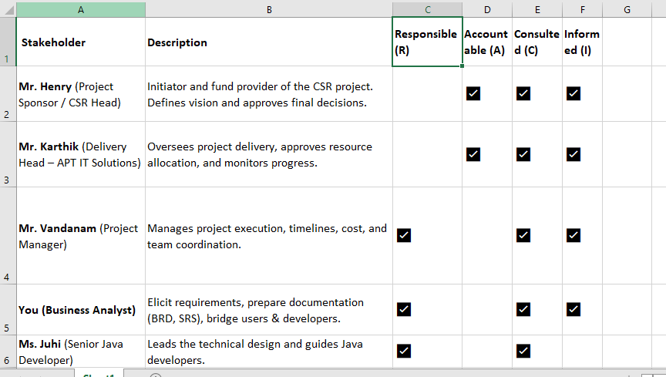
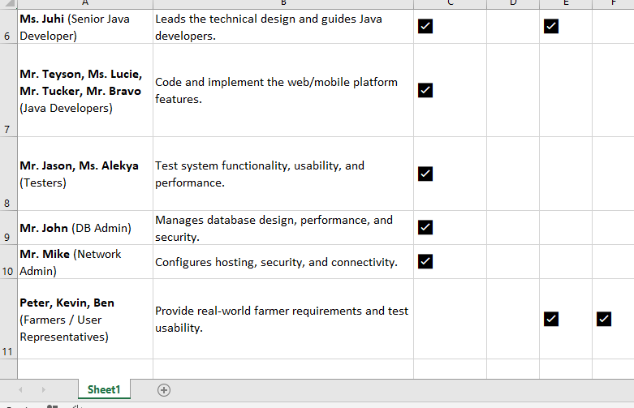

Question 7.
Help Mr Karthik to prepare a business case document.

Ans: Business case document.

Project title: Online Agriculture Product Store.
Prepared by: Mr. Karthik (Delivery head)
Date: 25/10/2025
Duration: 18 months
Budget: ₹ 2 Crores

- Executive summary:
Mr. Henry, a successful businessman, intends to invest under his CSR initiative to support rural farmers. After discussing with his friends Peter, Kevin, and Ben, it became clear that farmers in remote areas face significant challenges in procuring essential agricultural products such as fertilizers, seeds, and pesticides.
To address this, APT IT solutions proposes to design and develop a Java-based Online Agriculture Products Store (Web & Mobile Application) that connects farmers directly with manufacturers. This platform will remove middleman, improve accessibility, transparency, and empower farmers through digital inclusion.

- Business Objectives:
- Primary objective:
Build a secure, stable online platform to facilitate direct purchase of agriculture products by farmers.
- CSR objective:
Contribute to rural digital empowerment and agricultural development.
- Operational objective:
Enable manufacturers to sell directly to farmers, reducing distribution costs and improving outreach.
- Technology Objective:
Develop using Java technology to ensure performance, reliability, and scalability.

- Problem statement: (As is situation)
- Farmers in remote areas struggle to procure agricultural products.
- Dependence on middlemen leads to inflated prices and delayed supply.
- No centralized platform for transparent communication between farmers and suppliers.
- Manual, paper-based transactions lead to errors and inefficiency.
- Lack of data analytics for understanding demand and planning supply.

- Proposed solution (to be situation)
Develop an integrated Online Agriculture Store Application)
- Farmers can register, search, order, and pay online for fertilizers, seeds, and pesticides.
- Manufacturers can list products, update stock, and receive orders directly.
- The system supports secure payment, delivery tracking, and helpdesk support.
- Reports and dashboards provide insights for CSR impact analysis.

Technology stack:
Java (spring boot), HTML/ CSS/ JS frontend, MY SQL database, RESTful APIs, Android app, AWS could host.

- Feasibility study summary:
Technological feasibility: Java-based technology is reliable, scalable, and supported by the in-house team.
Operational feasibility: Farmers’ representatives (Peter, Kevin, Ben) and supplier companies are ready to collaborate.
Economic feasibility: Project cost INR 2 crores.
Time feasibility: 18 months total (from requirement to deployment)
Legal feasibility: Compliant with e-commerce, data privacy, and payment gateway regulations.

- SWOT analysis:
Strength:
Experienced java team, CSR-funded project; clear stockholder support.

Weakness:
Limited domain knowledge; user training needed.

Opportunities:
Large untapped rural market, government collaboration potential.

Threats:
Connectivity issues; digital adoption challenges, competition.

- Gap analysis: (As is vs TO BE)
As is process.
- Farmers buy through middleman.
- Paper based and local buying.
- No tracking or support.

To be process.
- Farmers buy directly via online store.
- Digital and national level buying.
- Real time tracing and online support.

Gap:
Eliminates intermediaries, improve access.
Wider reach, convince.
Improved transparency and service.

- Risk Analysis:
BA risks: Incomplete or unclear requirements.
Mitigation strategy: frequent stockholder reviews, use prototypes.
Project risks: Schedule or budget overruns.
Mitigation strategy: Strict milestone tracking, Agile sprints.
Technical risks: Integration or severe issues.
Need to use reliable cloud vendor or early POC.
Operational risks: farmer adoption resistance.
Awareness and training campaigns.
Security risks: Data breaches or payment failures.
Mitigation strategy: Implement encryption, SSL, and regular audits.

- Project time line (18 months)
Phase | Duration | Deliverables
Requirement Gathering & Analysis | 2 months | BRD, SRS
Design | 2 months | System Design Document
Development | 8 months | Working Modules
Testing (UAT, Integration) | 3 months | Test Reports
Deployment & Training | 2 months | Live System, User Manuals
Maintenance & Support | 1 month | Stabilization Support

- Expected benefits.
- Reduced cost for farmers.
- Increased sales for suppliers.
- Farmer empowerment.
- CSR brand image for Mrs. Henry and APT IT solutions.
- Data-driven agricultural growth.
Recommendations:
Based on the feasibility study, SWOT analysis, the project is technically and operationally viable with in the proposed budget (2 crores) and timeline 18 months.
It aligns strongly with CSR goals and provides socio-economic benefits for farmers while enhancing APT IT solution’s corporate reputation.

Question 8: The Committee of Mr. Henry , Mr Pandu , and Mr Dooku and Mr Karthik are having a discussion on Project Development Approach.
Mr Karthik explained to Mr. Henry about SDLC. And four methodologies like Sequential Iterative Evolutionary and Agile. Please share your thoughts and clarity on Methodologies

The Software Development Lifecycle (SDLC) contains the following phases:

- Requirement Gathering & Analysis
- System Design
- Development (Coding)
- Testing
- Deployment
- Maintenance & Support

Four main SDLC methodologies are as follows:
- Sequential model (Water fall model)
A linear and step by step approach where each phase must be completed before moving to the next.

Features:
- Phases: Requirement => Design => Development => Testing => Deployment => Maintenance.
- Well documented and structured.
- Suitable for projects with clearly defined requirements.

Advantages:
Easy to understand and manage.
Best for short term or low risk projects.
Progress is measurable at each stage.

Limitations:
- Changes are difficult once a phase is completed.
- Late detection of errors (during testing).
- Not ideal for complex or evolving requirements.

- Iterative model:
The rational unified process (RUP) is an iterative software development process framework created by the rational software corporation, which was acquired IBM in February 2003.
RUP is based on set of building blocks or content elements, describing what is to be produced, the necessary sills requires and the step-by-step explanation describing how
Specific development goals are to be achieved.
The main building blocks, or content elements are as follows:
Roles: a role defines a set of related skills, competencies, and responsibilities.

Work products: a work product represents something resulting from a task, including all the documents and models.

Tasks: a task describes a unit of work assigned to a role that provides a meaningful result.

Within each iteration, the tasks are categorized into 9 disciplines:
Six engineering disciplines:
Business modeling.
Requirements.
Analysis and design.
Implementation.
Test
Deployment.
Three supporting disciplines.
Configuration and change management
Project Management
Environment
Four project lifecycle phases.
Inception: agreement among the team and customer as to what will be built.
Elaboration: agreement within the team as to the architecture and design needed to deliver the agreed system behavior.
Construction: the iterative implementation of a fully functional system.
Transition: delivery, defect correction, and turning to ensure costumer acceptance.

Six best practices:
  - Develop iteratively, with risk as the primary iteration driver.
  - Manager requirements.
  - Employ a component-based architecture.
  - Model software visually.
  - Continuously verify quality.
  - Control changes.

Evolutionary spiral.

The spiral model gives emphasis on risk analysis.
The spiral model has 4 phases.
Planning, risk analysis, engineering, and evaluation.
Requirements are gathered during the planning phase, in the risk analysis phase, a process is undertaken to identify the risk. A prototype is produced in the rend of risk analysis phase.
Advantages:
  - High amount of risk analysis.
  - Good for large and mission-critical projects.
  - Software is produced early in the software life cycle.
Disadvantages:
- Can be s costly model to use.
- Risk analysis requires highly specific expertise.
- Project’s success is highly dependent on the risk analysis phase.
- Does not work well for smaller projects.

Agile model:
Agile model is fast passed model. It is good for change management. It bring the tech team and the business stockholders together, it’s an effective method for delivering the modules consistently.
Agile focuses on 4 philosophies.
Individuals and interactions over process and tools.
Working software over comprehensive documentation.
Customer collaboration over contract negotiation.
Responding to change over following a plan.
Considering that this online agriculture product store involves multiple stockholders, changing user needs, and evolving CSR objectives, I would recommend using the agile methodology. It allows us to develop the system in increments, gather feedback from farmers and supplies regularly. Thus, I would recommend agile model to be used in the project.
Question – 9
They discussed models in SDLC like waterfall RUP Spiral and Scrum. You put forth your understanding on these models When the APT IT SOLUTIONS company got the project to make this online agriculture product store, there is a difference of opinion between a couple of SMEs and the project team regarding which methodology would be more suitable for this project. SMEs are stressing on using the V model and the project team is leaning more onto the side of waterfall model. As a business analyst, which methodology do you think would be better for this project?

V model | Waterfall model
Works best for stable, clearly defined requirements. | Works best for stable requirements.
It has a strong testing emphasis. Tested at each stage. | Testing at the end of development
Flexible is low, changes are difficult. | Flexibility is low, and changes are difficult.
Stakeholders’ involvement is low during development. | Stakeholders’ involvement is low during development.

Recommendation as a BA.
For this project, I would recommend the Waterfall model.
Reasoning:
- Requirements are well-understood at the start (farmers want fertilizers, seeds, pesticides, companies want to sell products).
- The project duration is fixed (18 months) and the budget is defined.
- The team is experienced, and a sequential approach ensures smooth planning, design, and development.
- V model adds testing steps at each phase, which may increase complexity and cost unnecessarily, since basic CRUD (create, read, update, delete) is the main deliverable.
If the project scope were larger or requirements highly uncertain, RUP or Scrum would be better, but here, waterfall is parasitical and sufficient.

Question -10
20Write down the differences between waterfall model and V model.

Waterfall model | V-model (Validation & Verification)
Sequential SDLC model where each phase is completed before moving to the next step. | Extension of waterfall model that emphases testing at each development stage.
The developmental approach is linear and sequential. | Linear but each development phase has a corresponding testing phase.
Testing is done after the development is complete. | Testing is done parallel to the development, early testing is emphasized.
Focus is on the completing of each phase. | Focus is on the verification and validation of each phase.
High amount of documentation is required. | Very high amount of documentation is required as test plans and verification steps are documented at each phase.
Difficult to accommodate changes on the requirement. | Difficult to accommodate changes, similar to waterfall model.
Defect detection happens late in the project, only in the testing phase. | Early defect detection is possible as testing is done in each phase of the project.
It is best for projects where requirements are well defined. | It is best for projects where high quality standards are critical and testing needs emphasis.
It is simple compared to V model | It is more complex due to parallel testing activities.
Cost of changes is high if defects are found late. | High if requirements change, but defects may be caught earlier.

Question 11
As a BA, state your reason for choosing one model for this project.

Ans: As a BA I would recommend agile methodology, for the reasons listed below:
- First thing the requirements can be easily accommodated in the agile methodology and this project involves interacting with the farmers and their needs may evolve over time.
- Agile promotes continuous stockholder engagement through regular demos and iterations, ensuring the product meets real user requirement. And farmers (peter, ben, Kevin) may provide feedback, which can be implemented easily.
- Important features like fertilizer procurement, seed ordering, and pesticide purchase modules can be delivered at first. So that farmers don’t have to wait until the entire application is completed.
- Since this is a new concept for remote areas, iterative releases reduces the risk of building the product that may not meet user expectation.
- The project team including the developers, DB admin, network admin can work in sprints, focusing on high-priority modules first.
- This ensures efficient use of resources and adherence to the 18 months CSR timeline.

Agile is the best fit because this project requires frequent feedback, flexibility in requirements, and incremental delivery, all of which are crucial for an application serving farmers in remote areas.

If we compare with other models like waterfall model or V model these modes are not so flexible. As any change in the requirements can kill the project. In V model the testing in done on each phase this would increase the cost and complexity of the project. In water fall model it is very difficult to accommodate requirements hence it is a bad choice. Hence, agile model is the best choice compared to other models.

Question 12
The Committee of Mr. Henry, Mr Pandu, and Mr Dooku discussed with Mr Karthik and finalised on the V Model approach (RG, RA, Design, D1, T1, D2, T2, D3, T3, D4, T4 and UAT) Mr Vandanam is mapped as a PM to this project. He studies this Project and Prepares a Gantt chart with V Model (RG, RA, Design, D1, T1, D2, T2, D3, T3, D4, T4 and UAT) as development process and the Resources are PM, BA, Java Developers, testers, DB Admin, NW Admin.

Need to prepare a Gantt chart with the V model, which has the phases (RG, RA, D1, T1, D2, T2, D3, T3, D4, T4, and UAT).

And the resources are:
Project manager: Mr. Vandanum.
Business analyst: Mr. Nagarjuna.
DB admin: Mr. John
Network admin: Mr. Mike.
Testers: Mr. Jeyson, Ms. Alekya
Developers: Juhi, Lucie, Tucker, Bravo.

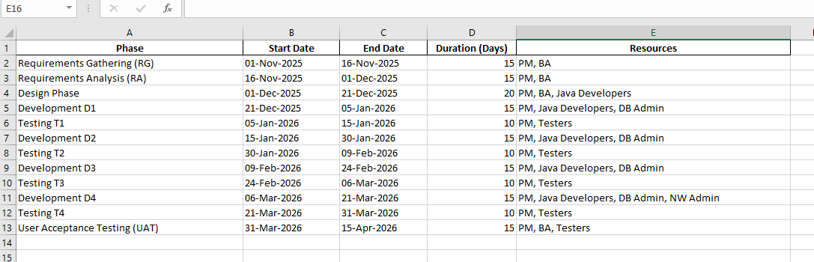
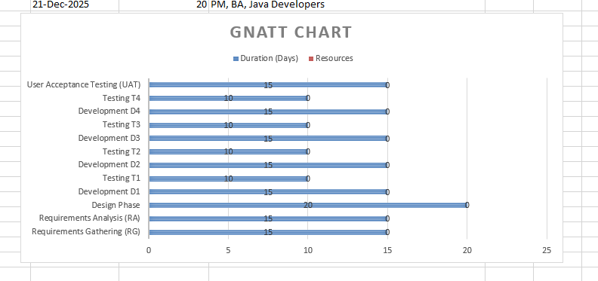

Question 13
Explain the difference between Fixed Bid and Billing projects

The difference between fixed bid and billing projects are as follows:

Fixed bid:

  - A fixed bid project is one where the client and the vendor agree on a fixed price for the entire project, regardless of the actual time or resources it takes to complete it.
  - The requirements need to be written to define the scope of the project. Wireframes also need to be created to help the development team to figure out the hours necessary to implement all features.
  - After the budget is finalized, the company cannot overcharge without notice.
  - Stright deadlines. When the customer understands what feature they want in app, the developers can come up with a clear plan and define deadlines.
  - Predictability. When everything has been discussed and planned beforehand, it’s easy to monitor the status of software development and predict the work will be completed on time.
  - Little to no management. All project details are defined in the contract, so project management can be passed down to the project manager. No excessive supervision is required on the part of the client.
  - Long planning. A fixed price contract demands in-depth planning.
Developers need to discuss every detail and every action along with possible pitfalls.

When to use fixed price model.
The fixed price model works best for small projects with limited features and clear requirement. It’s also good for MVP and projects with limited budgets and define deadlines.

Billing project:

  - With billing project, the customer is billed when a service provider has implemented a specific scope of work over a certain period of time, achieving a predefined milestone. At that point, the client needs to pay the service provider an amount that depends on the time spent and the things achieved for a given milestone.
  - Paying on achievement. The customer pays for actual functionality delivered to them.
  - Control the results. The client becomes the person who approves each milestone.
  - Criteria. Most IT companies will provide clients with a checklist they need to use when they receive a piece of work for approval. This checklist is supposed to guide them to see if everything works as expected.
  - No rigid timeframe. Since planning and project execution is iterative, there’s no specific timeframe for when the project will be completed.
  - Lack of trust. Some IT companies do not trust this model and refuse to work with clients who insist on it.
When to use:
Billing project approach is best when the service provider and client have a good relationship to eliminate the chance of fraud. If two parties, trust each other, it’s less likely that a dispute will arise. The billing project model works best for clients who have established good relationship so there are minimal downtime acceptance and disputes.

Question 14
– Preparer Timesheets of a BA in various stages of SDLC.
➢ Design Timesheet of a BA
➢ Development Timesheet of a BA
➢ Testing Timesheet of a BA
➢ UAT Timesheet of a BA
➢ Deployment n Implementation Timesheet of a BA

1.Design phase timesheet:

Date | Task Description | Hours Spent | Notes
Day 1 | Review project requirements and stakeholder inputs | 2 | Understand farmer/manufacturer needs
Day 2 | Create high-level process flows and workflows | 4 | e.g., Order process, Product listing flow
Day 3 | Prepare Use Cases & User Stories | 6 | Use cases for Farmer and Manufacturer
Day 4 | Conduct review meeting with stakeholders | 2 | Validate design concepts
Day 5 | Update and finalize BRD (Business Requirement Document) | 3 | Incorporate feedback

Total hours: 17

2.Development phase timesheet (BA)

Date | Task Description | Hours Spent | Notes
Day 1 | Discuss with developers to explain requirements | 3 | Walkthrough BRD & Use Cases
Day 2 | Clarify functional requirements during development | 4 | Answer queries from Java developers
Day 3 | Assist in data modeling discussions with DBA | 2 | Ensure farmer/manufacturer data captured correctly
Day 4 | Update documentation for changes or gaps | 3 | Maintain traceability
Day 5 | Participate in sprint/demo reviews | 2 | Validate implemented features

Total hours: 14

3.Testing phase timesheet:

Date | Task Description | Hours Spent | Notes
Day 1 | Prepare Test Scenarios & Test Cases | 5 | Based on functional requirements
Day 2 | Review Test Cases with QA team | 2 | Ensure coverage of all user stories
Day 3 | Support testing team during execution | 4 | Clarify requirements if defects found
Day 4 | Log defects & ensure proper communication | 3 | Follow up with developers for fixes
Day 5 | Participate in regression testing review | 2 | Validate resolved issues

Total hours: 16

4. UAT (User Acceptance Testing) Phase Timesheet (BA)

Date | Task Description | Hours Spent | Notes
Day 1 | Prepare UAT Plan & Scenarios | 4 | For farmers & manufacturers
Day 2 | Coordinate UAT sessions with stakeholders | 3 | Schedule meetings & demos
Day 3 | Assist end-users during testing | 5 | Explain features, record feedback
Day 4 | Collect and document UAT feedback | 3 | Highlight changes required
Day 5 | Prepare UAT sign-off documentation | 2 | Approval from Mr. Henry & stakeholders

Total hour 17

5.Deployment & Implementation Phase Timesheet (BA)

Date | Task Description | Hours Spent | Notes
Day 1 | Coordinate deployment plan with PM & DevOps | 3 | Ensure smooth rollout
Day 2 | Validate system setup in production | 4 | Check connectivity, DB, UI
Day 3 | Provide user manuals & training sessions | 5 | Train farmers & manufacturers if needed
Day 4 | Support initial post-deployment queries | 3 | Handle first-week issues
Day 5 | Document deployment report & lessons learned | 2 | Share with project team

Total hours: 17

Table of Total BA Hours per Phase

SDLC Phases | Total hours
Design | 17
Development | 14
Testing | 16
UAT | 17
Development & implementation | 17
Grand total | 81

