CAPSTONE PROJECT – SIMILAR CASE STUDY
(Prep 1 – Part 3)

Q. no 1:
Identify minimum 20 functional requirements?
Answers: -
Functional requirement:
It defines specific behaviours, functions or operation of a system. They describe what system should do, outlining necessary tasks, actions or activities it must perform to achieve objectives.

Req ID | Req Name | Req Description | Priority
FR0001 | User Registration | The users should be able to register themselves on the application. | 9
FR0002 | Manufacturer’s Registration | Manufacturers should be able to register in the application. | 8
FR0003 | User Login | The users should be able to login to their respective accounts | 8
FR0004 | Uploading Product details | Manufacturers should be able to upload all the details about their products. | 7
FR0005 | Product search | Users should be able to search all the products uploaded by manufacturers. | 8
FR0006 | Search Filter | Users should be able to apply the filters while searching products. | 7
FR0007 | Product details | Users should be able to access all the basic details about product. | 8
FR0008 | Adding product to cart | Users should be able to add products in the cart. | 9
FR0009 | Cart Management | Users should be able to view and manage contents of cart. | 8
FR0010 | Payment method | The application should allow to display different payment methods. | 9
FR0011 | Logout/checkout | The users should be able to proceed checkout from application. | 8
FR0012 | Order confirmation | The application should send users the order confirmation via message/email once order is placed. | 7
FR0013 | Order tracking | The users should be able to track the order status. | 9
FR0014 | Order History | The users should be able to view past history. | 7
FR0015 | Customer Support | Users should have access to customer support. | 8
FR0016 | User Ratings and reviews | Users should be able to provide ratings and review for purchased products. | 7
FR0017 | Product Recommendations | The application should provide personalized product recommended on their preferences. | 8
FR0018 | Share products | The users should be able to share the products link and experience on social media platform. | 7
FR0019 | Secure Transactions | The application should ensure secure transaction by taking secure measures. | 9
FR0020 | Account Management | Users should be able to manage their account settings, profile, personal information etc... | 7

Non – Functional Requirement:
It describes the qualities and attributes of a system, focusing on how the system performs rather than specific behaviours or functions.

Req ID | Req Name | Req Description | Priority
NFR001 | Usability | The application should be user friendly. | 9
NFR002 | Performance | The application should load pages in 5 seconds. | 8
NFR003 | Compatibility | The application should be compatible | 8
NFR004 | Security | Secure user authentication. | 8
NFR005 | Response Time | The application should respond within 2 seconds. | 9
NFR006 | Representation | Visual representation of pages must be added. | 7
NFR007 | Auto Readable | OTP’s must be auto readable by the application. | 7
NFR008 | Session time out | Session time out must be up to 2 minutes | 6
NFR009 | Location Accuracy | Location must be accurate up to 50 meters. | 8
NFR010 | Refresh | Pages must be auto refreshed in every 30 seconds. | 6

Q. no 2:
Make wireframe and prototypes?
Answers: -
Registration Page:
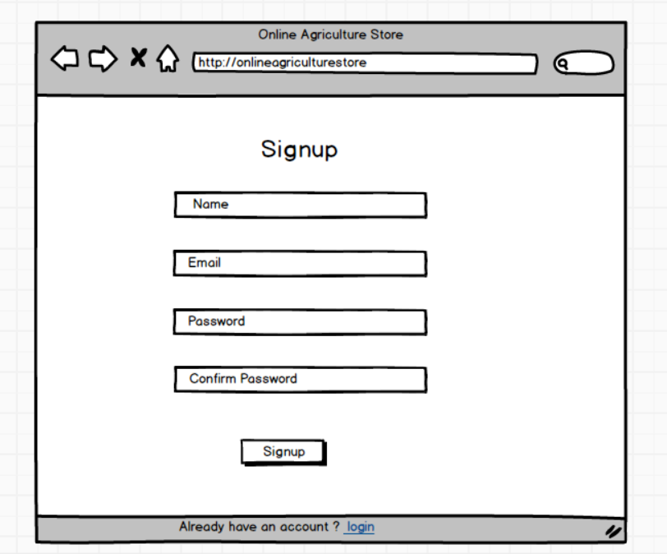

Login Page:
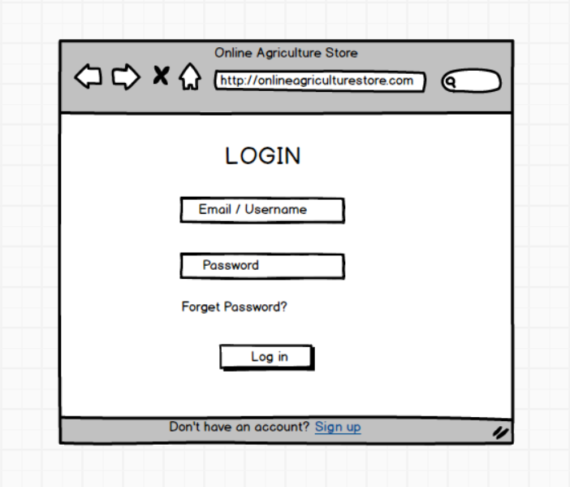

Application Page:
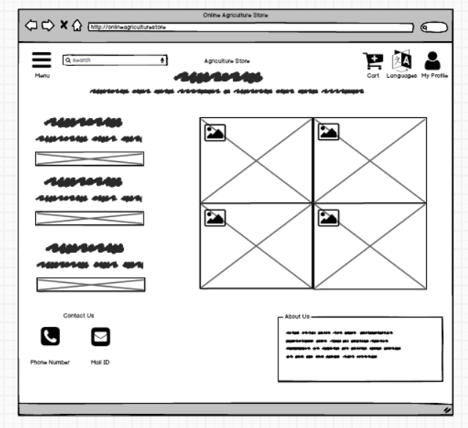
Cart Page:
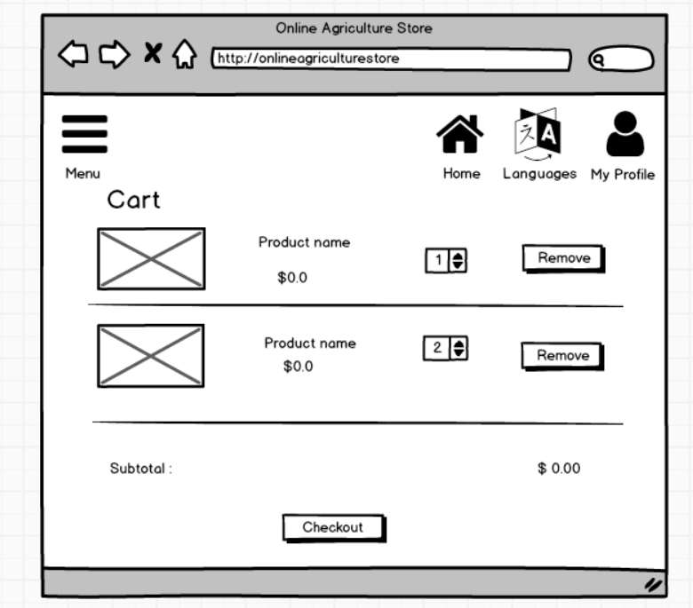

Payment Page:
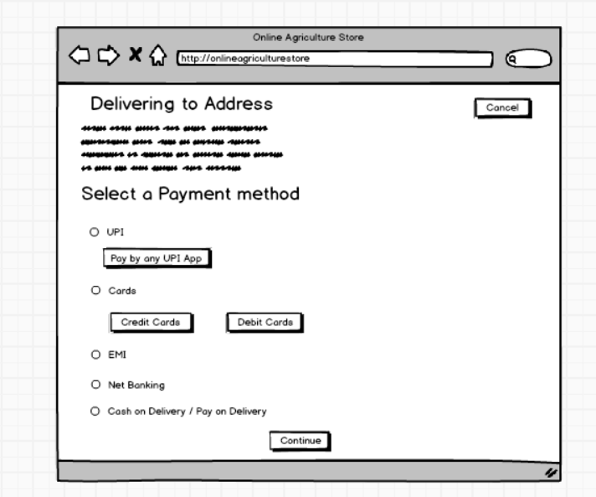

Q.no 3:
Make a note of the Tools, which you are using for above concepts.
Answers: -
Business Analysis Tools:
Business Analysis tools are the techniques to prepare a raw design, process flow diagram and prototype of an end product which will be covering all the aspects of the project requirements and represents the activity of how the process flows inside the project. In Business analysis there are tools like MS Visio, Balsamic, Axure RP which helps BA to prepare use case diagram, activity diagram, wireframes and prototype.
MS Visio:
Microsoft Visio is a powerful tool used to visually represent and communicate complex business processes, system, workflows and organizational structures. It plays a crucial role in helping business analysts model and analyse various aspects of business operations, enabling stakeholders to better understand, evaluate, and optimize processes.

Balsamiq:
Balsamiq is a rapid wireframe tool. It creates mock-ups and wireframes for websites, web apps, and desktop software. It allows us to picture ideas and concepts through a simple drag and drop interface. It’s designed to help business analysts, designers, product managers, and developers quickly sketch out the basic structure and layout of a user interface without focusing on visual design details.
Axure RP:
Axure RP stands for Axure Rapid Prototyping which is a prototyping and wireframing tool used by business analysts, designers, product managers, and developers to create interactive prototypes, and wireframes for websites, applications, and digital products.
Q.no 4:
A business analyst’s key responsibilities are to keep track of the requirements and make sure that no requirement is missed. Mr. Henry and peter have approached you regarding the current status of the project. How will you tackle this situation?
Answers: -
Requirement Traceability Matrix (RTM): -
It is a document to track the requirements throughout the project lifecycle, ensuring that they are met and that no requirements are overlooked.
Comp – Completed
WIP- Work in progress.
UAT- User acceptance testing.

Req  Id | Req Name | Req Description | Desi  gn | D1 | T1 | D2 | T2 | D3 | T3 | D4 | T4 | UAT
FR0001 | Users  registration | Users should be able to register. | Comp | Comp | Comp | Comp | Comp | Comp | Comp | Comp | Comp | Comp
FR0002 | Manufacturer’s registration | Manufacture should be able to register. | Comp | Comp | Comp | Comp | Comp | Comp | Comp | Comp | Comp | Comp
FR0003 | User login | The users should be able to login  to their accounts. | Comp | Comp | Comp | Comp | Comp | Comp | Comp | Comp | Comp | Comp
FR0004 | Uploading product details | Manufactures should be able to upload all the details of products. | Comp | WIP | Comp | Comp | Comp | Comp | Comp | Comp | Comp | WIP
FR0005 | Search products | Users should be able to search products. | Comp | Comp | Comp | Comp | Comp | Comp | Comp | Comp | Comp | Comp
FR0006 | Search filter | Users should be able to apply filter while searching products. | Comp | WIP | Comp | Comp | Comp | Comp | Comp | Comp | Comp | WIP
FR0007 | Product details | Users should be able to access all the basic details of products. | Comp | Comp | Comp | Comp | Comp | Comp | Comp | WIP | WIP | WIP
FR0008 | Adding product to cart | Users should be able to add products in the cart. | Comp | Comp | Comp | WIP | Comp | Comp | Comp | Comp | Comp | WIP
FR0009 | Cart management | Users should be able to view and manage contents of cart. | Comp | Comp | Comp | Comp | Comp | Comp | Comp | Comp | Comp | Comp
FR0010 | Payment method | The application should allow to display different payment methods. | Comp | Comp | Comp | WIP | Comp | Comp | Comp | Comp | Comp | WIP
FR0011 | Logout/checkout | The users should be able to proceed checkout from application. | Comp | Comp | Comp | Comp | Comp | Comp | Comp | Comp | Comp | Comp
FR0012 | Order confirmation | The application should send users the order confirmation via message/email once order is placed. | Comp | Comp | Comp | Comp | Comp | Comp | Comp | Comp | Comp | Comp
FR0013 | Order tracking | The users should be able to track the order status. | Comp | Comp | Comp | Comp | Comp | Comp | Comp | Comp | Comp | Comp
FR0014 | Order history | The users should be able to view past history. | Comp | Comp | Comp | Comp | Comp | Comp | Comp | Comp | Comp | Comp
FR0015 | Customer support | Users should have access to customer support. | Comp | WIP | Comp | Comp | Comp | Comp | Comp | Comp | Comp | WIP
FR0016 | User review and ratings | Users should be able to provide ratings and review for purchased products. | Comp | Comp | Comp | Comp | Comp | Comp | Comp | Comp | Comp | Comp
FR0017 | Product recommendations | The application should provide personalized product recommended on their preferences. | Comp | Comp | Comp | Comp | Comp | Comp | Comp | Comp | Comp | Comp
FR0018 | Share product | The users should be able to share the products link and experience on social media platform. | Comp | WIP | Comp | Comp | Comp | Comp | Comp | Comp | Comp | WIP
FR0019 | Secure transactions | The application should ensure secure transaction by taking secure measures. | Comp | Comp | Comp | Comp | Comp | Comp | Comp | Comp | Comp | Comp
FR0020 | Account Management | Users should be able to manage their account settings, profile, personal information etc... | Comp | Comp | Comp | Comp | Comp | Comp | Comp | WIP | Comp | WIP

Q. no 5:
Prepare 10 Test Case Documents?
Answers: -
Test Case Documents:
Test case documents are structured documents used in software testing to define and outline the specific conditions, steps, and expected results for verifying a particular feature or functionality of a software application. They are essential for ensuring that software meets its requirements and behaves as expected in different scenarios.
Test case ID | TC0001 | Test Case Name | User registration
Project ID | Agri0132 | Project Name | Online Agriculture Store Project
PM ID | 95862 | PM Name | Mr. Vandanam
Test Strategy ID | OAS001 | Tester ID | 67542
Test Plan ID | TOAS01 | Tester Name | Mr. Jason
Test Schedule ID | XXXXXX | Date of Test | 05-MAY-2025
Scenario | To register new user inside web application using email id and creating password.
Link to that page | www.onlineagriculturestore.com
Pre-conditions | Internet connectivity should be stronger enough, Website URL working.
Post-conditions | Registration successful, user able to login into system with username and password.
Input Data | Email ID, Mobile Number, Name of the user.
Expected behaviour | Once user register using name, mail id/mobile number and create password, system should show user created successfully.
Actual Behaviour | After entering mandatory fields, if user clicks on register button, then system shows pop up saying ‘User created successfully’.
Comments | NA
Results (Pass/Fail) | Pass

Test case ID | TC0002 | Test Case Name | User Login
Project ID | Agri0132 | Project Name | Online Agriculture Store Project
PM ID | 95862 | PM Name | Mr. Vandanam
Test Strategy ID | OAS001 | Tester ID | 67542
Test Plan ID | TOAS01 | Tester Name | Mr. Jason
Test Schedule ID | XXXXXX | Date of Test | 07-MAY-2025
Scenario | To login registered user using username and password.
Link to that page | www.onlineagriculturestore.com
Pre-conditions | User is already registered.
Post-conditions | Login successful, User is able to search for the required products.
Input Data | Username, Password.
Expected behaviour | User enter username and password to login and system shows login successfully.
Actual Behaviour | After entering username, password, if user clicks on ‘login’ button, then system shows pop up saying ‘login successfully’.
Comments | NA
Results (Pass/Fail) | Pass

Test case ID | TC0003 | Test Case Name | Add to cart
Project ID | Agri0132 | Project Name | Online Agriculture Store Project
PM ID | 95862 | PM Name | Mr. Vandanam
Test Strategy ID | OAS001 | Tester ID | 67542
Test Plan ID | TOAS01 | Tester Name | Mr. Jason
Test Schedule ID | XXXXXX | Date of Test | 12-MAY-2025
Scenario | User should be able to add selected products to cart.
Link to that page | www.onlineagriculturestore.com
Pre-conditions | Products are available in inventory and add to cart is enabled.
Post-conditions | Total prices will be shown, payment option would be shown
Input Data | Product ID, Product pictures, Product prices.
Expected behaviour | Once login, user will search products on the basis of requirements, and must be able to add products in the cart.
Actual Behaviour | After selecting required products, user clicks on add to cart option to add products in the cart.
Comments | NA
Results (Pass/Fail) | Pass

Test case ID | TC0004 | Test Case Name | Coupon code apply
Project ID | Agri0132 | Project Name | Online Agriculture Store Project
PM ID | 95862 | PM Name | Mr. Vandanam
Test Strategy ID | OAS001 | Tester ID | 67542
Test Plan ID | TOAS01 | Tester Name | Mr. Jason
Test Schedule ID | XXXXXX | Date of Test | 15-MAY-2025
Scenario | Users should be able to add coupon code at the checkout time to avail discount.
Link to that page | www.onlineagriculturestore.com
Pre-conditions | Coupon code must be valid.
Post-conditions | Total price will be adjusted as per coupon code applied.
Input Data | Coupon codes, Discount codes.
Expected behaviour | At the time of checkout, user must be able to enter coupon code to get discount on total bill.
Actual Behaviour | After adding to cart, user puts coupon code and gets discount on total prices of the product.
Comments | NA
Results (Pass/Fail) | Pass

Test case ID | TC0005 | Test Case Name | Payment
Project ID | Agri0132 | Project Name | Online Agriculture Store Project
PM ID | 95862 | PM Name | Mr. Vandanam
Test Strategy ID | OAS001 | Tester ID | 67542
Test Plan ID | TOAS01 | Tester Name | Mr. Jason
Test Schedule ID | XXXXXX | Date of Test | 19-MAY-2025
Scenario | User must be able to choose payments option and do payment.
Link to that page | www.onlineagriculturestore.com
Pre-conditions | Products added to cart and total price is calculated.
Post-conditions | Redirected to 3rd party apps or COD option.
Input Data | Card details, UPI details, Payment method.
Expected behaviour | User should be able to choose payment option for Net Banking, UPI or cash on delivery.
Actual Behaviour | At payments stage user is able to select options from Net Banking, Card payments, UPI or cash on delivery.
Comments | NA
Results (Pass/Fail) | Pass

Test case ID | TC0006 | Test Case Name | Payment Confirmation
Project ID | Agri0132 | Project Name | Online Agriculture Store Project
PM ID | 95862 | PM Name | Mr. Vandanam
Test Strategy ID | OAS001 | Tester ID | 67542
Test Plan ID | TOAS01 | Tester Name | Mr. Jason
Test Schedule ID | XXXXXX | Date of Test | 21-MAY-2025
Scenario | User should get payment confirmation message in phone or mail.
Link to that page | www.onlineagriculturestore.com
Pre-conditions | Payment is successful.
Post-conditions | Redirected to order confirmation page and expected delivery date.
Input Data | Payment ID, Total price.
Expected behaviour | Once payments are done and amount deducted from the users account, user should get message or mail confirmation for payment.
Actual Behaviour | After payment, user gets payment successful confirmation message or mail that payment has been successfully processed.
Comments | NA
Results (Pass/Fail) | Pass

Test case ID | TC0007 | Test Case Name | Order confirmation
Project ID | Agri0132 | Project Name | Online Agriculture Store Project
PM ID | 95862 | PM Name | Mr. Vandanam
Test Strategy ID | OAS001 | Tester ID | 67542
Test Plan ID | TOAS01 | Tester Name | Mr. Jason
Test Schedule ID | XXXXXX | Date of Test | 23-MAY-2025
Scenario | User should get text or mail for order confirmation.
Link to that page | www.onlineagriculturestore.com
Pre-conditions | Payment is successful.
Post-conditions | Tracking of order is enabled.
Input Data | Product ID, Product pictures, Product prices.
Expected behaviour | Once payments are done, User should get order confirmation containing order id, and expected delivery.
Actual Behaviour | After payment done, user should get order confirmation containing order id and expected delivery date.
Comments | NA
Results (Pass/Fail) | Pass

Test case ID | TC0008 | Test Case Name | Cancel order
Project ID | Agri0132 | Project Name | Online Agriculture Store Project
PM ID | 95862 | PM Name | Mr. Vandanam
Test Strategy ID | OAS001 | Tester ID | 67542
Test Plan ID | TOAS01 | Tester Name | Mr. Jason
Test Schedule ID | XXXXXX | Date of Test | 27-MAY-2025
Scenario | User should be able to cancel wrong order.
Link to that page | www.onlineagriculturestore.com
Pre-conditions | Product already ordered, cancel window is open now.
Post-conditions | Order status is updated, refund initiated.
Input Data | User account details, Order ID, Product ID.
Expected behaviour | User should be able to cancel the order or orders done by mistake from cancel order page.
Actual Behaviour | User is able to cancel the order from cancel order page from the menu.
Comments | NA
Results (Pass/Fail) | Pass

Test case ID | TC0009 | Test Case Name | Return order
Project ID | Agri0132 | Project Name | Online Agriculture Store Project
PM ID | 95862 | PM Name | Mr. Vandanam
Test Strategy ID | OAS001 | Tester ID | 67542
Test Plan ID | TOAS01 | Tester Name | Mr. Jason
Test Schedule ID | XXXXXX | Date of Test | 30-MAY-2025
Scenario | User should be able to return any order which they didn’t like.
Link to that page | www.onlineagriculturestore.com
Pre-conditions | Product already delivered, return window is open.
Post-conditions | Order status updated, Refund initiated.
Input Data | Product ID, Order ID, User details.
Expected behaviour | User must be able to return product from return order page.
Actual Behaviour | User can return the order from return order page with order id, product id etc…
Comments | NA
Results (Pass/Fail) | Pass

Test case ID | TC0010 | Test Case Name | Session Out timing
Project ID | Agri0132 | Project Name | Online Agriculture Store Project
PM ID | 95862 | PM Name | Mr. Vandanam
Test Strategy ID | OAS001 | Tester ID | 67542
Test Plan ID | TOAS01 | Tester Name | Mr. Jason
Test Schedule ID | XXXXXX | Date of Test | 02-JUNE-2025
Scenario | Application must be automatically session out after staying idle.
Link to that page | www.onlineagriculturestore.com
Pre-conditions | User is logged in and inactive.
Post-conditions | System should ask for re-login.
Input Data | Product ID, Order ID, User details.
Expected behaviour | Application must be session out after being idle for 30 seconds and should ask for login again.
Actual Behaviour | Application gets session out after being idle for 30 seconds and asks for login again.
Comments | NA
Results (Pass/Fail) | Pass

Q.no 6:
After the requirements are thoroughly explained to the entire project team by business analyst, the Database architects have decided to do the database design and also to represent the in-flow and out-flow of data. Draw database schema and ER diagram
Answers: -

DB Schema:
DB Schema is a blueprint that outlines the structure of the database, including its tables, fields, relationships, constraints and other characteristics.

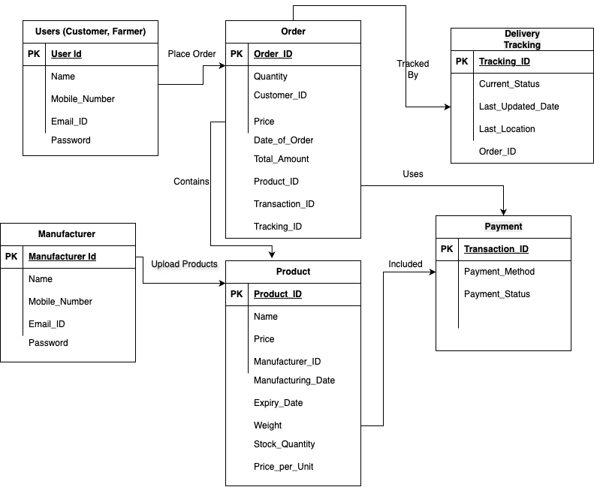

Entity Relationship Diagram:
An entity Relationship Diagram is a visual representation of the relationships between entities in a database. It depicts the entities(tables), attributes(properties/fields) and relationship between them.

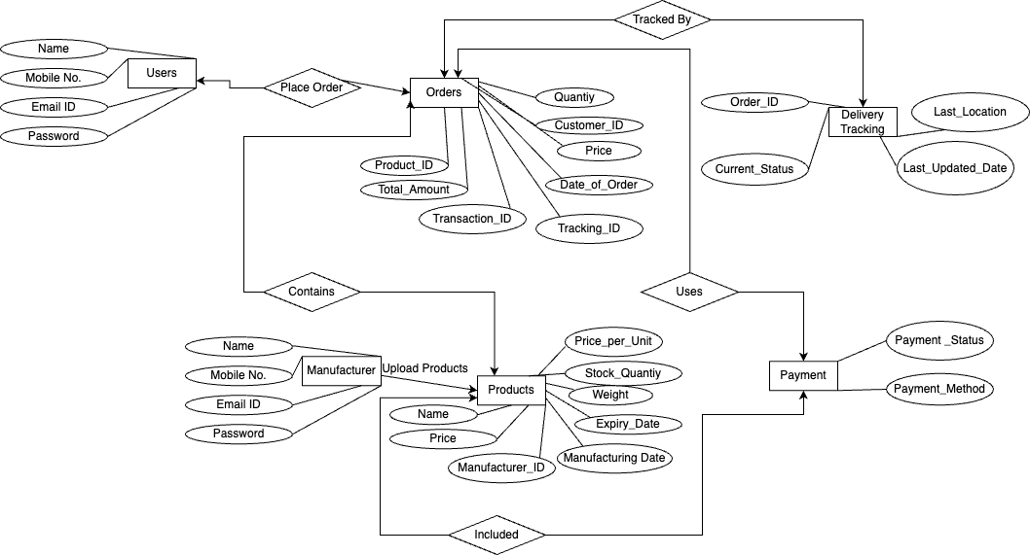

Q.no 7:
What is a data flow diagram? Draw a data flow diagram to represent the in-flow and out-flow of data when a Farmer is placing an order for the product
Answers: -

Data Flow Diagram:
A Data Flow Diagram (DFD) is a graphical representation of the flow of data within a system. It shows how data moves from one part of the system to another and how data is transformed, stored, and utilized within the system. DFDs are widely used in systems analysis and design to visualize data processes and the way information is handled, stored, and transmitted between different system components.

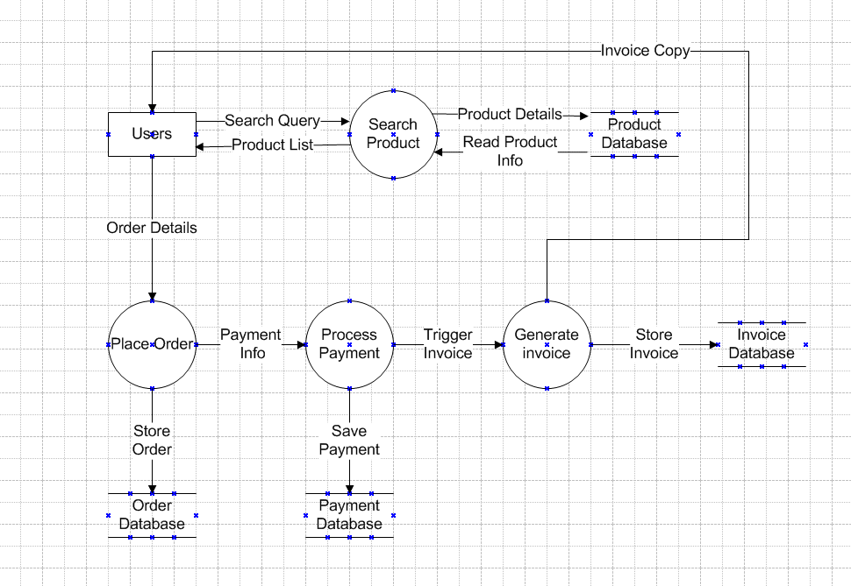

Q.no 8:
Due to change in the Government Taxation structure. we should change the Tax structure How do you handle change requests in a project?
As the project is in process, Ben and Kevin have contacted you. The reason is to inform you that they want the Farmers to sell their crop yields through this application i.e. Farmers should be able to add their crop yields or products and display to general public and should be able to sell them. They also want to introduce Auction system for their Crop yields. As a BA, what will be your response? Is this a change request or an enhancement???
Answers: -
Due to a change in the Government Taxation structure, we need to update the system's tax structure.
1. Acknowledge the Request
- I formally acknowledge the receipt of the change request from the concerned stakeholder (e.g., Regulatory team or Business Sponsor).
- The request is logged in the Change Management System (e.g., JIRA, ServiceNow) with details like:

- Requestor name
- Date of request
- Nature of change (e.g., GST updated from 12% to 18%)
2. Understand and Analyse the Request
- I conduct requirement clarification sessions with stakeholders to understand:
- Exact tax structure changes (e.g., percentage, exemptions, start date)
- Whether it applies to all products or specific categories
- Any legal/regulatory documentation supporting the change
- Clarify if the change is:
- Temporary or permanent
- Region-specific or global
- I document updated business rules:
- Example: “Effective from 1st July 2025, apply 18% GST on all farm machinery except organic fertilizers (exempted).”
3. Impact Assessment
I conduct a detailed impact analysis covering:
- Business Impact
- Product pricing logic changes
- Cart total, invoice generation, and tax summary affected
- Legal compliance updates
- System Impact
- Database: Update or add a new Tax Structure table
- Backend Logic: Change price calculation formulas in Order and Payment modules
- Frontend/UI: Display updated tax details on checkout page and invoice

- Testing Impact
- Regression testing required for:
- Discount + tax logic
- Different customer categories
- Edge cases (e.g., tax-exempt products)
- Documentation
- Update BRD, FRD, user manuals, and tax policy documents
- New use case(s) added for managing dynamic tax rates.
4. Approval from Change Control Board (CCB)
The change request document along with the impact analysis report was presented to the Change Control Board (CCB). After reviewing the necessity and scope, the CCB approved the request under compliance and legal mandate.
5. Final Conclusion
The approved change request was incorporated in the upcoming sprint/module release. Proper version control, testing, and deployment planning were ensured. Stakeholders were kept informed throughout, and updated documentation and user guides were delivered post-implementation.

Q.no 9:
As the project is in process, Ben and Kevin have contacted you. The reason is to inform you that they want the Farmers to sell their crop yields through this application i.e. Farmers should be able to add their crop yields or products and display to general public and should be able to sell them. They also want to introduce Auction system for their Crop yields. As a BA, what will be your response? Is this a change request or an enhancement???
Answers: -

Request Summary:
Ben and Kevin have proposed that:
- Farmers should be able to add and sell their crop yields directly via the application.
- An auction system should be introduced for the sale of crop yields to the general public.
My Assessment as a Business Analyst:

1. Type of Request: Enhancement
This request qualifies as an enhancement, not a simple change request.

Why is this an Enhancement and Not a Change Request?
- A change request typically involves modification of an existing feature due to external or internal factors (like tax changes, minor UI fixes, or workflow tweaks).
- This request introduces new functional capabilities — i.e.:
  - A new seller workflow for Farmers
  - A product listing interface for crops
  - An entirely new auction mechanism with bidding logic, bid history, timing, winner selection, and pricing rules

Therefore, it extends the core capabilities of the current application and adds new use cases, which classifies it as an enhancement.
My Response & Next Steps as a BA:
- Acknowledge & Capture the Request
- Thank Ben and Kevin for their input.
- Log this enhancement in the product backlog with a feature request ID.
- Requirement Elicitation
- Conduct workshops or interviews with:
    - Farmers (end-users)
    - Legal/Compliance team (to understand auction-related regulations)
    - Tech architects (for feasibility)
- Define:
    - Key features of farmer product listing
    - Auction flow (start time, end time, minimum bid, buy-now options)
- Document Functional Requirements
- Update the BRD/FRD to include:
    - Farmer Role permissions
    - New entities like Auction, Bid, Bidder
    - Auction rules, UI mock-up’s, business rules
- Impact Analysis
- Update in system architecture (e.g., backend changes for real-time bidding)
- UI changes (e.g., product listing, auction timers)
- Testing scenarios (e.g., bid conflicts, winner selection, time expiry)
- Seek Stakeholder Approval
- Review proposed enhancement with the Product Owner/Stakeholders for prioritization.
- Discuss timelines, development effort, and business value.

Conclusion:
This is an enhancement request since it introduces new functional modules like crop listing and auctioning, which extend the system’s existing capabilities.
As a Business Analyst, I will proceed by gathering detailed requirements, assessing technical and business impacts, and updating the requirement documentation accordingly.

Q.no 10:
Come up with estimations - How many Manhours required?
Answer: -
Estimation - Estimation in Software Development Life Cycle refers to the process of predicting the resources (time, cost, effort) required to complete a software development project or specific tasks within that project. Estimation is a critical part of the planning phase of SDLC, as it helps in setting realistic expectations, managing resources efficiently, and determining the project's feasibility.

Project Overview:
• Project Name: Online Agriculture Products Store
• Budget: 2 Crores INR
• Duration: 18 months (540 calendar days)
• Company: APT IT SOLUTIONS
• Team Members: 10 (Project Manager, Senior Java Developer, Java Developers, Network Admin, DB Admin, Testers, Business Analyst)
• Total Working Days: 396 (Excluding weekends and holidays)
• Daily Effort Per Resource: 8 hours
• Total Manhours (Including Buffer): 3168 Hours

Project Phase | Estimated Days | Man-Hours (Days × 8 hrs)
Requirements Gathering & Analysis | 30 | 240
System Design | 40 | 320
Development | 160 | 1280
Testing & Bug Fixing | 58 | 464
User Acceptance Testing (UAT) | 28 | 224
Deployment & Post-Go-Live Support | 24 | 192
Project Management & Coordination | 30 | 240
Total Estimated Work | 370 | 2968
Buffer Allocation | 40 | 320
Grand Total | 410 | 3168

Effort Estimation Breakdown:
• The project is categorized as a medium-scale project based on effort estimation.
• A buffer of 40 days (320 hours) is included to accommodate unforeseen challenges.
• The team is well-trained, so no additional training effort is considered.
• The auction system and order management require the most development effort due to their complexity.
Q.no 11:
Project has finally completed all the stages i.e., design, development, testing etc. Now, it is the role of a business analyst to contact the client for testing of the final product and have to successfully complete it. How are you going to handle this situation? And once it is done, what will be the process to close the project? Explain UAT Acceptance process
Answer: -

Final Stage UAT and Project Closure

User Acceptance Testing (UAT):
UAT (User Acceptance Testing) is a crucial phase in the software development life cycle where the intended users of the system validate the software by testing it in a real-world or production-like environment. The primary goal of UAT is to ensure that the software meets the business requirements, functions as expected and is ready for deployment to the end users.

1. How I Handle the Situation as a Business Analyst
As the Business Analyst, I take the lead in initiating and coordinating the User Acceptance Testing (UAT) phase with the client. Here’s how I proceed:

Step-by-Step Approach:
- Communicate with the Client
- Send a formal email to the client stating:
“The product has completed design, development, and internal testing. We are now ready for User Acceptance Testing (UAT). Kindly share your availability and nominated UAT testers.”
- Share UAT Plan and Environment Details
- Provide access credentials to the UAT environment.
- Share the UAT Test Plan, scope, and objective.
- Define roles & responsibilities (e.g., who will test, who will approve).
- Conduct UAT Kickoff Meeting
- Align client stakeholders and internal teams.
- Walk through major features.
- Provide a demo, if needed.

2. UAT Acceptance Process

Phase | Description
a. UAT Planning | Prepare and share UAT Plan, define success criteria, and test timelines.
b. Test Case Sign-Off | Review UAT test cases with client before execution.
c. UAT Execution | Client tests functionalities using real-world scenarios.
d. Defect Logging | Any bugs or mismatches are logged in a defect tracker (JIRA/Excel).
e. Fixes & Retest | Development team fixes bugs; client retests the fixed items.
f. UAT Sign-Off | Client signs off when all critical functionalities are working as per requirement.

Deliverables:
- UAT Sign-Off Document
- Issue Tracker (Closed)
- Final Change Log

3. Project Closure Process
Once UAT is signed off, I initiate the project closure phase:

Steps to Close the Project
- Prepare Closure Report
- Include final deliverables, UAT summary, approved CRs, pending issues (if any), and lessons learned.
- Conduct Closure Meeting
- With stakeholders to review:
    - Project goals vs. actual outcomes
    - Client feedback
    - Support or maintenance handover (if applicable)
- Archive Documents
- Store BRD, FRD, UAT docs, CR logs, and sign-offs in the project repository (Confluence/SharePoint).
- Release Communication
- Send final communication:
“Project successfully delivered and signed off. Handover is completed. Thanks for your collaboration.”
- Celebrate the Closure
- Acknowledge the team effort and formally release project resources.

Conclusion:
As a Business Analyst, I ensure smooth coordination with the client during UAT, facilitate clear documentation, and drive the project toward a structured closure. The UAT sign-off becomes the formal approval of deliverables and initiates the successful handover of the product.

Q.no 12:
Explain Project closure document.
Answer: -
Project Closure Document:
A Project Closure Document is a formal document that signifies the conclusion of a project. It provides a detailed summary of the project's performance, achievements, lessons learned, and any remaining tasks or issues. The purpose of this document is to ensure that the project is officially closed and that all stakeholders have agreed that the project has met its objectives. The Project Closure Document is typically prepared by the project manager or the project team and is presented to stakeholders, including the client, team members, and management.

The project closure document typically includes the following sections:
- Project Overview:
This section provides an overview of the project, including its objectives, scope, and stakeholders involved. It summarizes the project's purpose and sets the context for the closure report.

- Project Achievements:
Here, the document highlights the key achievements and deliverables of the project. It outlines the successful completion of milestones, tasks, and any significant accomplishments that were achieved.

- Project Timeline and Budget:
This section provides an overview of the project timeline, highlighting the start and end dates, major phases, and milestones. It also includes information on the project's budget, including any significant deviations or changes.

- Lessons Leamed:
The lessons learned section reflects on the project successes and challenges. It includes a comprehensive analysis of what worked well and what could have been improved. It highlights valuable insights and recommendations for future projects.

- Stakeholder Feedback:
This section gathers feedback from key stakeholders involved in the project. It includes their opinions, suggestions, and any concerns they may have expressed. The feedback helps in assessing the overall satisfaction and identifying areas for improvement.

- Risks and Issues:
The closure document discusses the risks and issues encountered throughout the project. It outlines the actions taken to mitigate these risks and resolve any issues that arose during the project's lifecycle.

- Project Performance:
This section evaluates the project's performance against the defined objectives and success criteria. It assesses factors such as scope adherence, timeline adherence, budget performance, quality of deliverables, and customer satisfaction.

- Project Sign-off:
The closure document includes formal sign-off or approval from key stakeholders, indicating their acceptance and satisfaction with the project's outcomes. This signifies the official closure of the project.

- Project Documentation:
This section provides an overview of the project documentation, including the list of documents produced, their location, and accessibility for future reference.

- Next Steps and Recommendations:
The closure document outlines any recommended actions or next steps following the project's closure. It may include suggestions for further improvements, additional tasks, or follow-up activities.
The project closure document serves as a final report that captures the project's journey, outcomes, and key learnings. It provides a reference for future projects, helps in evaluating project success, and facilitates knowledge transfer to stakeholders involved in the project.

Below is an example format,
Section | Content
Project Name | Agri e-Commerce Platform Development
Client | Ben and Kevin
Project Summary | Development of a platform for farmers to list, sell, and auction crop yields
Final Deliverables | Login module, crop listing, auction system, payment gateway
UAT Status | Successfully completed and signed off on 4 August 2025
Issues Resolved | 5 major issues resolved during UAT, 2 moved to Phase 2
Change Requests | 3 CRs accepted and implemented: Auction Module, Tax Structure Update, Notification Feature
Handover | Knowledge transfer completed, credentials and documents handed over to support team
Approval | Signed by BA, PM, and Client on 6 August 2025

