1. Audit
Ans It is inspection of work by the stakeholders to check the quality of the work and to check whether the process is going smoothly or not. As BA, we are responsible to update the progress of the project to the stakeholders.
Q1 Audit
Stage | Requirement gathering (Week 1 to week 9)
Completed | 5 weeks
Check list | BRD Document
 | Elicitation report
 | Grouping of functionalities – client signoff
 | Email communication- To, CC, BCC

Q2 Audit
Stage | Requirement Analysis (Week 10 to week 19)
Completed | 7 weeks
Check list | UML diagram
 | FS diagram
 | Documents - client signoff
 | Email communication- To, CC, BCC

Q3 Audit
Stage | Design (Week 20 to week 28)
Completed | 4 weeks
Check list | Utilization of tools
 | Stakeholder MOM
 | Email communication- To, CC, BCC

Q4
Stage | Development (Week 20 to week 28)
Completed | 8 weeks
Check list | BA and development MOM
 | Email communication- To, CC, BCC

2. BA Approach Strategy
Ans What Elicitation techniques to apply
There are many elicitation techniques used to gather requirements, they are: Brainstorming, Document analysis, reverse engineering, focus group, observation, workshop, JAD sessions, interview, prototyping, questionnaire and use case specs. As a BA, I would like to go for brainstorming session because most of the time it is physical/ live session where SMEs assemble and they will help us to how to solve the problem.

How to do stakeholder Analysis RACI/ILS
RACI is a tool used to clearly define and document the roles and responsibilities of stakeholders in a project.
R- Responsible
- Accountable
C- Consulted
I- Informed

Payment Process
RACI | Name of the resource | Designation | Details
Responsible | Mr. Henry | Manager Operations | henry@gmail.com  Ph No. 000 525 558  Available: 9AM to 1PM
Responsible | Mr. Karthik | Deliver Head | karthik@gmail.com  Ph No. 575 552 555  Available: 9AM to 1PM
Responsible | Ms. Juhi | Senior Java Developer | juhi@gmail.com  Ph No. 463 718 946  Available: 9AM to 1PM
Accountable | Mr. Vandanam | Project Manager | vandanam@gmail.com  Ph No. 663 373 292  Available: 9AM to 1PM
Accountable | Ms. Gopika | Business Analyst | gopika@gmail.com  Ph No.253 657 773  Available: 9AM to 1PM
Consultant | Mr. Teyson | Java Developer | teyson@gmail.com  Ph No. 637 845 394  Available: 9AM to 1PM
Consultant | Ms. Lucie | Java Developer | Lucie@gmail.com  Ph No.957 441 440  Available: 9AM to 1PM
Consultant | Mr. Tucker | Java Developer | Tucker@gmailcom  Ph No.394 722 775  Available: 9AM to 1PM
Consultant | Mr. Bravo | Java Developer | Bravo@gmail.com  Ph No.993 656 992  Available: 9AM to 1PM
Consultant | Mr. Mike | Network Admin | mike@gmail.com  Ph No.933 656 993  Available: 9AM to 1PM
Consultant | Mr. John | Database admin | john@gmail.com  Ph No.764 656 983  Available: 9AM to 1PM
Consultant | Mr. Jason | Tester | jason@gmail.com  Ph No.933 656 926  Available: 9AM to 1PM
Consultant | Ms. Alekya | Tester | alekya@gmail.com  Ph No.933 656 625  Available: 9AM to 1PM
Informed | Mr. Pandu | Finance Head | pandu@gmail.com  Ph No.933 656 987  Available: 9AM to 1PM
Informed | Mr. Dooku | Project Coordinator | dooku@gamil.com  Ph No.933 656 322  Available: 9AM to 1PM

What documents to write
As a BA, we need to record BRD (Business Requirement Document) to understand what the business wants, what are their Goal, resources, input, output and all.
FRD (Functional Requirement Document) here we need to record the details of how the system should function, what are its features.
SRS (Software Requirement Specification) here BA will combine FRD and non-functional requirements.
User story/ use case it is a diagram drawn by the BA, describing about how the user interacts with the system.
RTM (Requirement Trackability Matrix) this is prepared by BA. Here all the details from start to till end will be available. This is prepared to track everything and deliver everything without any miss.

What process to follow to sign off on the documents.
As a BA, we need to record BRD (Business Requirement Document) to understand what the business wants. And then we need to prepare FRD (Functional Requirement Document) in functional spec, here we need to record the details of how the system should function. And tech team will prepare non-functional requirements. And after this BA has to take signoff from the clients by using email confirmation on SRS (Software Requirement Specification) document.
So, this is the process to follow by BA to take a sign off from clients.

How to take approvals from the client
After this process, as a BA we need to establish formal meeting or we need to book the calendar. We will discussing whatever documents we have prepared we will take these documents to the clients and we will be taking the approval from them.

What communication channels to establish and implement
As a BA to communicate with the client we need to establish meetings like: Monthly meetings, Weekly status meetings, monthly stake holder updates and so on.

How to handle change requests
If a client wants few more features to add, that time to handle change request there should be change request form, we need to analysis before we change, proper approvals should be there and everything should be documented properly.

How to update the progress of the project to the stakeholders
By scheduling weekly meetings, monthly meetings with the clients BA can update the progress to stakeholders. And also, by details emails also BA can update the progress to the stakeholders.

How to take signoff on the UAT
As a BA firstly we need to UAT preparation and we will support client while they run test case, and then we need to prepare signoff document. And then we need to take approval on signoff from the client by email confirmation.

3. Tier Architecture
Ans It is a software architecture which divides an application into three layers. And each layer has its own responsibilities. They are, Presentation layer, Business logic layer, and Database layer. These three layer are built by the developer’s team.
- Presentation layer
It is a top most layer. Here, what the user can see in the screen will be visible, whatever the things the customer need they will be inputting here.
Ex: Pages, screens etc
- Business Logic Layer
It is middle layer of Architecture. It acts as an intermediatory between presentation layer and database layer. Whatever input customer will give from the presentation layer it will be taking and extracting the data from the database and it will be giving the information to the user again in the presentation layer. So whatever business logics will be there it will be available in the business logic layer
Ex: Printer, Payment gateway
- Database Layer
It is the bottom most layer. It is used to store the data and retrieve the data.
Ex: MySQL
In short, whatever input the customer will put in presentation layer, business logic layer will accept and extract the data from database layer and gives back the required information in the presentation layer. Like this the user will be getting the answers.

4. BA Approach strategy for framing questions
Ans We have many approaches to frame questions to the client and they are, 5W1H approach, SMART approach, RACI and UML.
5W1H – It is tool to gather and understand the answers from the client by questioning Who, What, When, Where, Why and How.
Who is responsible if formers cancel the order?
What are the products you are expecting to add in the application?
When you are expecting the project to finish?
Where to add payment details in the screen?
Why this online store application is prepared?
How will be benefited?
SMART – It is also one approach to question the client. This technique can help in creating questions. Specific, Measurable, Attainable, Relevant and Time bound.
Specific means it should have only one meaning.
Ex: How many online applications you want us to prepare
Measurable means it should be measurable
Ex: Which colour combination you are looking
Attainable means once we work it, we should be able to reach it
Ex: Once we prepare application, we should be able to access it properly
Relevant means it should be understandable and it should be realistic
Ex: Whatever the application we prepare, it should be understandable by all formers.
Time bound means within the given time frame, we should be able to work
RACI - It helps to understand the roles and responsibility in the team. Ex: Who is Responsible, Accountable, Consulted and Informed in the team.
UML – It is a way of diagramming and modelling software to aid in design, development and communication between team members.
So, these are the approach strategies for framing questions to the client. And the best two and commonly used approaches are 5W1H method and SMART method.

5. Elicitation Techniques
Ans Elicitation Technique means any meeting with the client with the specific objective we call it as elicitation technique. There are 11 types and they are, BDRFOWJIPQU
Brainstorming - Brainstorming sessions are aim to solve particular problem. The domain expert or SMEs assemble and for the given challenge they start giving ideas on how to solve the problem. This will be scheduled by BA before 1 week to 10 days. There will no guarantee that the problem will be solved, only the thing is we will make step forward to solve the problem.
Document Analysis - When we read any document or text and understand about the process, project or the product we call it as document analysis. Not only documents sometime it can be series of email communication or sometimes it can be MOM as well. It is an important elicitation technique which is used in any company.
Reverse engineering - Without knowing the functionality of it, still playing with it to understand the functionality of the particular process is known as reverse engineering. And generally, this approach is used in migration projects.
Focus Groups - These groups are going to use our project in future. Each professional will come on to the dais they tell what challenges they are facing with current version and they suggest what can be the solution for it and they can also suggest new features which they are looking for the next version. The team will note down these points and they will update in the next version. Such groups we call as focus groups. There are 2 types of focus groups,
- Homogenous – These people will belong to the same domain.
Ex- If I want accounting software, then I discuss with only accounting group.
- Heterogenous – These people will not belong to the same domain.
Ex- We are developing a campus management system for university, they we will be dealing with a dean, principle, staff members and etc
Observation – It means listening clearly what the domain expert or SMEs are explaining is known as observation. There are 2 types of observation,
- Active – Asking questions in between and understanding the process that has been performed is called as active observation.
- Passive – Asking questions at the end of the meeting and understanding the process that has been performed or when they give time to ask doubts if that time questions are asked then it is known as passive observation.
As a BA, we can do both active and passive observations, but preferable it will be passive observation.
Workshops – They are more practical in nature and they aim for completeness. Workshops will be 1 week, 10 days workshops. Here each department will explain what inputs they are going to take, what processing they are going to do, and what outputs they are going to generate they will be going to explain. So, by then end of the one cycle everybody in the meeting will understand the picture. And before the workshops participants won’t be knowing each other or they might be knowing only their department, but after the workshop they may be knowing not only their department but also other departments and also, they will be knowing where their department fits in the big picture.
JAD (Joint Application Development)- As a BA we may require to work on technical projects like networking projects, DB projects or testing projects and we may not be aware of that project is, in such case we will take help of technical resources and we discuss with the clients and that sessions are known as JAD session. Like this even though we are not aware about the domain and even though we are not aware about the technologies, we can drive the project.
Interview- Any interaction with the other person or understanding the other persons view is called as interview. As a BA, after gathering the requirement we are going to sort the requirements while sorting the requirement we may realise that there will be some conflicts in requirement or few requirements are contradictory in such a case we have to take appointment with the stakeholders and then we will ask them questions and they will clarify the doubts. There are 2 types of approaches to conduct an interview,
- Structured – We list out all the questions which we need to ask to the stakeholders. And once we discuss with client, we write down all the answers one after the other.
- Unstructured – We know what the problem is and once we meet the client we ask them the questions. We keep asking them the questions based on the answer is known as unstructured approach. Here we have two types of questions
- Open ended – Answers would be like explanations. Ex: Please explain me the process of doing so and so activity.
- Closed ended – Answers would be YES or NO. Ex: Do we need to follow this process.
Prototyping- Showing the sample of the working model like activity diagram, flow charts is known as prototyping.
Questionnaire- We cannot take 1000 stakeholders’ opinion and take a step, that case we choose this survey forms. Questionnaire means it will be having multiple questions and each question will be having 3 to 4 answers. And once they answer it, we will use statistical tool to measure it. So, it is used to interact with more number of stakeholders.
Use Case Specs- When the client gives the requirement, parallelly we start drawing use case, and once we start preparing use case, we start preparing use case spec. Once we start doing this, we will get lot of questions to ask stakeholders. This will be helpful for development team to develop. So, use case spec is also considered as one of the elicitation techniques.

6. Which Elicitation Technique can be used in the project? And justify your selection?
Ans As a BA, I will recommend Document Analysis technique because it is one of the important techniques which is used in all companies. It can be done by reading any document or any text or any email communication or MOM about the process. Anyone can understand the process, project easily.
And I suggest Use case spec because, When the client gives the requirement, parallelly we start drawing use case spec and once we start doing this, we will be getting lot of questions to ask stakeholders and this will also help development team to develop software at one stretch with less redo. So, I recommend Document Analysis and Use case spec techniques.

7. 10 Business Requirements
Ans- Business Requirements are the specific needs or conditions that a business must meet to achieve the objective.
10 Business Requirements are
- Formers/ manufacturers should log in with user name and password the application before they search for the products.
- If the formers/ manufacturers are logging for the first time, they should sign in first.
- Formers/ manufacturers should log in through there google or g-mail account.
- If they forget the password, there should be another option called “forgot password” from there they should reset the password and login.
- Formers should be able to browse through the product catalogue.
- Formers should have option to “add to cart” if they want to buy the items later
- Formers should have option to keep the items in the “wish list” if they liked the item.
- Formers should have access to do payment online and COD.
- Formers should get details of the particular product at the time of searching the items.
- Formers should get email confirmation for their order confirmation.
- Formers and manufacturers both should able to track the product once the order is placed.

8. Assumptions
Ans Some of the assumptions are:
- The former or manufacturer can login using google or g-mail account.
- A former should have good understanding about the seeds, pesticides, fertilizers etc.
- Manufacturers should give detailed information about the product what they wants to sell.
- The formers should prefer online shopping as the online shopping trend is increasing.
- The manufacturers should have good knowledge in what are the formers needs, in which season their demand on particular product will be more etc.
- The formers should have online account for secured payment processing.
- The formers can do COD also if they want.

9. This Project Requirement and Priority
Ans This is done by the BA by taking the help of development team that they need to complete the task on priority basis. If the no. is high, then there is a high priority to complete the particular task.
Req ID | Req Name | Req Description | Priority
BR001 | User create login | User should log in with user name and password the application before they search for the products. | 8
BR002 | User Sign in | Users are logging for the first time they should sign in first. | 10
BR003 | User Account mandatory | User should log in through there google or g-mail account. | 9
BR004 | Forgot password option | User forgets the password there should be another option called “forgot password” from there they should reset the password and login. | 6
BR005 | User browse through products | User should be able to browse through the product catalogue. | 5
BR006 | Add to cart option | User should have option to “add to cart” if they want to buy the items later | 4
BR007 | Add to wish list option | User should have option to keep the items in the “wish list” if they liked the item. | 5
BR008 | Payment gateway | User should have access to do payment online and COD | 8
BR009 | Manufacturer should add products details | User should get details of the particular product at the time of searching the items. | 6
BR010 | Email confirmation | User should get email confirmation for their order confirmation. | 4
BR011 | Product delivery tracking | User both should able to track the product once the order is placed. | 5

10. Use Case Diagram
Ans Use Case is a visual representation of interaction between User and System. This diagram helps how an end user uses the system.
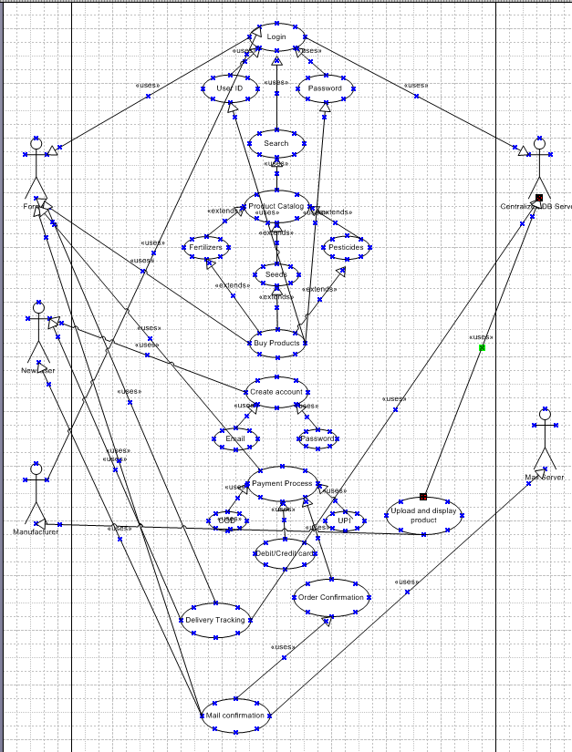

11. Use Case Spec
Ans Use case spec means Use case specification. Use case spec is a detailed description of a use case.
- Login
Use case ID | UC0001
Use case Spec | Login
Created by and date | BA, 25/09/2025
Description | Username password
Actor | Formers, Manufacturers
Pre-condition | Internet connection, Browser Compatibility
Post condition | Home page of user should be displayed
Basic Flow | Username and password are correct  Online application will open  Search for the product  User can add to wish list or add to cart  User can place order  User will get email confirmation to their email id.
Alternative Flow | Password is wrong  Username is wrong  Username and password both are wrong
Exceptional Flow | Forgot password  Forgot username
Assumption | User have computer knowledge, English
Frequency of use | High
Dependency | User should exist

- Product Catalog
Use case ID | UC0002
Use case Spec | Product Catalog
Created by and date | BA, 25/09/2025
Description | Search products
Actor | Formers
Pre-condition | Internet connection, Browser Compatibility, accurate username and password
Post condition | Home page of the application should display
Basic Flow | User can search fertilizers, seeds, pesticides  If interested to buy later, they can add the product in Buy products
Alternative Flow | Product should be available  Product should deliver to the user location  Product should be ordered like how the user wants to do payment
Exceptional Flow | Should not place to wrong address
Assumption | User have product knowledge, computer knowledge, English
Frequency of use | Medium
Dependency | User should exist

- Payment Process
Use case ID | UC0003
Use case Spec | Payment Process
Created by and date | BA, 25/09/2025
Description | Payment Details
Actor | Formers
Pre-condition | Order should be placed properly till the payment gateway, Internet connection, Browser Compatibility, accurate username and password
Post condition | Product details, date, and time of when the order will deliver should be seen at the time of making payment
Basic Flow | User can make payment through COD, UPI and net banking  If net banking, the mobile no. should be correct  User should give correct OTP at the time of placing order
Alternative Flow | Minimum amount should be there to place an order
Exceptional Flow | User should have account in bank  User should net banking  User should be installed with applications like G-pay, Phone pay etc
Assumption | User have knowledge on payment methods.
Frequency of use | High
Dependency | User should exist

- Order Confirmation
Use case ID | UC0004
Use case Spec | Order Confirmation
Created by and date | BA, 25/09/2025
Description | Order details
Actor | Formers
Pre-condition | Order should be placed properly, Internet connection,
Post condition | Once the order is placed application should show the order placed details  The same thing should be confirmed via email.
Basic Flow | Once the payment process is correct then only order will be placed
Alternative Flow | Use should have Email account to get the confirmation email.
Exceptional Flow | User should have email account and proper network connection
Assumption | User have knowledge on payment methods.
Frequency of use | Medium
Dependency | User should exist

- Search Option
Use case ID | UC0005
Use case Spec | Search
Created by and date | BA, 25/09/2025
Description | Seach option
Actor | Formers
Pre-condition | Accurate user name and password
Post condition | Home page of application should be displayed
Basic Flow | Once the login is correct the application will open  Once the search option is visible use can view product catalog  User can view seeds, fertilizers, Pesticides to book an order
Alternative Flow | Password is wrong  Username is wrong  Username and password both are wrong
Exceptional Flow | User should have sign in if he is new to the application
Assumption | User have computer knowledge, English
Frequency of use | Medium
Dependency | User should exist

12. Activity Diagram
Ans An activity diagram drawn from the systems perspective. It is drawn where a system is involved.
- Buy Product/ Add to card
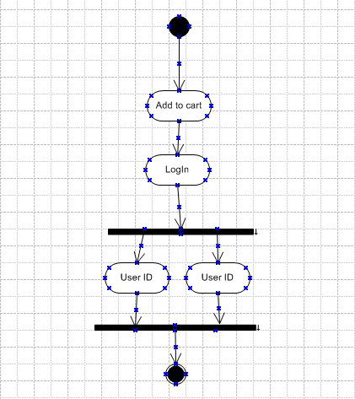
- Payment Process
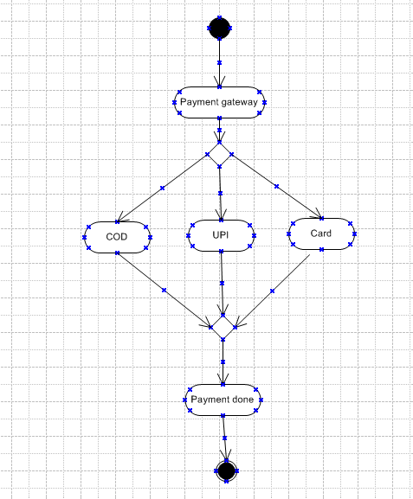

- Create account
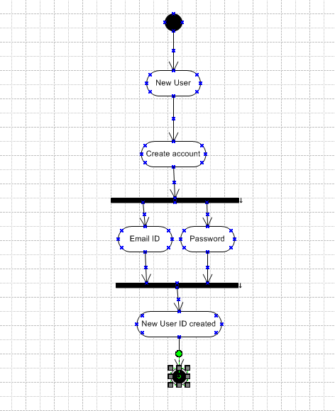

- Delivery Tracker
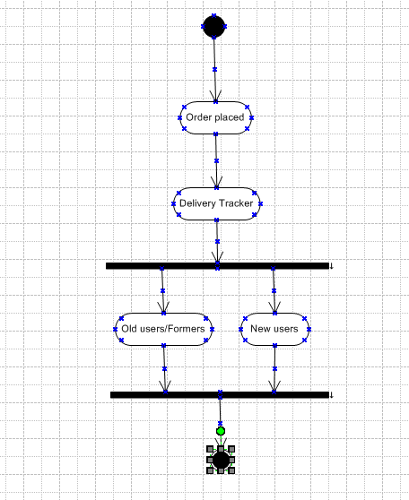

- Order Confirmation
