A company is having manufacturing plants and warehouses in various parts of the country. They
manufacture ice-cream and milk products. They want to build software to achieve two goals.
- Manage the inventory
- Quickest delivery to the customers
Assignment 1:
- Please make a BRD which can be presented to the client along with complete development and resource plan.

Project Title:
Integrated Inventory & Delivery Management System for Ice Cream and Milk Products

1. Executive Summary
The company operates multiple manufacturing plants and warehouses across the country. The objective is to develop a centralized software solution that:
- Tracks and manages inventory at all plants and warehouses in real-time.
- Optimizes deliveries to ensure quickest possible turnaround time for customers.
This project will improve supply chain efficiency, reduce wastage of perishable goods, and enhance customer satisfaction.

2. Business Objectives
- Objective 1: Provide real-time visibility into stock levels at plants & warehouses.
- Objective 2: Automate reordering based on predefined minimum stock levels.
- Objective 3: Optimize delivery routing using customer location and nearest warehouse.
- Objective 4: Reduce product spoilage by enabling FIFO (First In, First Out) stock rotation.
- Objective 5: Enable reporting and analytics for management decision-making.

3. Scope
In-Scope:
- Inventory management (stock updates, tracking, replenishment triggers)
- Delivery management (route optimization, shipment tracking)
- Integration with existing ERP for sales and finance data
- Real-time dashboard and reporting module
Out of Scope:
- Physical automation of warehouse operations (robots, conveyors)
- Manufacturing process automation (only inventory level monitoring is considered)

4. Stakeholders
Stakeholder | Responsibilities
Project Sponsor | Approve budget & final deliverables
Business Analyst | Elicit requirements, create BRD, manage scope
Development Team | Build and deploy solution
QA Team | Test the solution, ensure defect-free release
Warehouse Managers | Manage stock, receive goods, update system
Logistics Team | Plan, track, and optimize delivery

5. Functional Requirements
- Inventory Module:
  - Record goods receipt from plants
  - Record goods issue to customers
  - Automated alerts for low stock
  - FIFO-based stock rotation
- Delivery Module:
  - Assign orders to nearest warehouse
  - Auto-allocate delivery vehicle & route
  - Track delivery status (in-transit, delivered)
  - Capture proof of delivery (POD)
- Reporting Module:
  - Inventory status report (daily/weekly/monthly)
  - Delivery performance report
  - Wastage report
  - Demand forecasting (basic level)

6. Non-Functional Requirements
- Performance: System must process updates within 2 seconds.
- Scalability: Must support 100+ warehouses and 10,000 daily transactions.
- Availability: 99.9% uptime.
- Security: Role-based access control, encryption for data in transit.

7. Assumptions
- All warehouses have internet-enabled systems.
- GPS-enabled vehicles are available for delivery tracking.
- ERP system integration APIs are available.

8. Constraints
- Must be delivered within 6 months.
- Limited internal IT team — vendor support needed.

9. Risks
Risk | Mitigation
Data inconsistency across plants | Use real-time API-based data sync
Delay in ERP integration | Begin integration work in parallel with development
User adoption issues | Provide training sessions & user manuals

10. Success Criteria
- Inventory mismatch reduced by >90%.
- Delivery time reduced by 25% within first 3 months.
- User adoption > 95% by end of first quarter post go-live.

11. Development & Resource Plan
Approach: Phased development
Phase | Deliverable | Timeline | Resources Needed
1. Requirement Gathering | BRD, FRD | 4 weeks | BA (2), SME (2)
2. System Design | High-level design, DB schema | 3 weeks | Solution Architect (1), DB Designer (1)
3. Development | Inventory & delivery modules | 8 weeks | Developers (4), UI/UX Designer (1)
4. Testing | Test cases, defect resolution | 4 weeks | QA Team (3)
5. UAT | Sign-off by business users | 2 weeks | BA (1), End Users (2)
6. Deployment | Production release | 1 week | DevOps (1), IT support (1)
7. Training & Handover | User manuals, training sessions | 2 weeks | BA (1), Trainer (1)

- Prepare process flow diagram using your imagination.

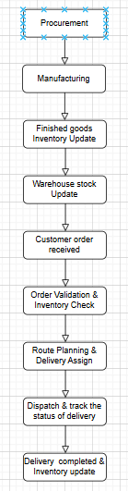s

Assignment 2:
1. Write an introduction letter to a client introducing yourself as a business analyst in charge of
working with the client and his team to start the business understanding process.
Answer:
Dear Jay,
I hope this message finds you well.
My name is Abhishek xyz, and I am pleased to introduce myself as the Business Analyst assigned to your project. I will be working closely with you and your team to initiate the business understanding process and ensure that we capture your goals, challenges, and requirements with accuracy.
As your Business Analyst, my primary responsibility will be to:
- Collaborate with you and the key stakeholders to gather and document business requirements.
- Analyze your existing processes and identify opportunities for improvement.
- Translate your requirements into clear specifications for the development team.
- Ensure alignment between your business objectives and the final solution delivered.
Our immediate next step will be to schedule a kick-off meeting where we can discuss your current inventory and delivery processes, key priorities, and success criteria for this project. This will help us set a clear direction and roadmap for the engagement.
I look forward to partnering with you and your team to deliver a solution that meets your expectations and adds significant value to your operations.
Please feel free to share your availability for the kick-off session or any initial documentation you would like us to review beforehand.
Thank you for your time and support.
Best Regards,
Abhishek xyz,
Business Analyst,
xxxxxxxxxx

2. Prepare a brief BRD and SRS for a project- Horoscope or Ticketing system or online store.
Answer:
Business Requirements Document (BRD)
Project: Support Ticketing System

1. Executive Summary
The organization aims to improve its customer service experience by implementing a Support Ticketing System that allows customers to raise and track issues, ensures timely resolution, and provides management with insights into team performance.
This system will centralize support requests, automate ticket assignment, monitor SLA compliance, and streamline communication between customers and support staff.

2. Business Objectives
- Streamline Customer Support: Provide a single platform to create, track, and resolve support requests.
- Enhance Customer Satisfaction: Enable quick response and resolution through ticket prioritization and SLA monitoring.
- Improve Team Efficiency: Automate ticket assignment to reduce manual workload and response delays.
- Provide Transparency: Track ticket status and history, offering visibility to customers and management.
- Generate Insights: Provide reports on ticket volumes, categories, resolution times, and SLA compliance for continuous improvement.

3. Scope
In-Scope
- Web-based ticket creation and management
- Role-based user access (Customer, Agent, Administrator)
- Ticket categorization and prioritization
- SLA configuration and breach alerts
- Ticket status tracking and history
- Dashboard and reporting for administrators
- Notifications (Email/SMS)
Out-of-Scope
- Chatbot integration (future phase)
- Integration with third-party CRM systems (future scope)
- Offline ticketing support

4. Stakeholders
Stakeholder | Role | Interest
Customers | End-users | Need quick resolution and visibility into ticket status
Support Agents | Operations | Require efficient ticket assignment and easy update process
Administrators | Management | Need dashboards, SLA monitoring, and reports
IT Team | Development/Support | Ensure smooth deployment and system uptime

5. Business Requirements
Req ID | Requirement Description
BR-1 | The system must allow customers to raise support tickets with category and priority.
BR-2 | The system must assign tickets to available support agents automatically.
BR-3 | The system must allow support agents to update status and resolution notes.
BR-4 | The system must track SLA compliance and send alerts on breaches.
BR-5 | The system must provide dashboards for ticket volumes, SLA adherence, and agent performance.
BR-6 | The system must notify customers of ticket updates via email/SMS.

6. Success Criteria
- 95% of tickets resolved within SLA timelines.
- Reduction of average ticket resolution time by 30% in first 6 months.
- Improved customer satisfaction scores (CSAT) by 20%.

7. Risks & Mitigation
Risk | Impact | Mitigation
Delayed adoption by support agents | Low efficiency | Conduct training sessions and provide user manuals
System downtime | High customer dissatisfaction | Use cloud-based deployment with 99.9% uptime SLA
Data security concerns | Regulatory compliance risk | Ensure encryption and access control mechanisms

8. Timeline & High-Level Plan
Phase | Deliverable | Timeline
Requirement Gathering | BRD, FRD | 4 Weeks
System Design | High-level Design, DB Schema | 3 Weeks
Development | Ticketing Module, Dashboard | 8 Weeks
Testing | Test Cases, Defect Resolution | 4 Weeks
UAT | User Sign-off | 2 Weeks
Deployment | Production Go-Live | 1 Week

9. Resource Plan
- Business Analysts: 2
- Developers: 4
- QA Testers: 3
- Solution Architect: 1
- DB Designer: 1

2. Software Requirement Specification (SRS)

Project: Support Ticketing System
1. Introduction
1.1 Purpose
The purpose of this document is to define the functional and non-functional requirements for the Support Ticketing System. The system will allow users to raise, track, and resolve support tickets efficiently, helping businesses manage customer issues and improve service delivery.
1.2 Scope
The Support Ticketing System will:
- Allow customers to create and submit support tickets.
- Automatically categorize and prioritize tickets based on severity.
- Assign tickets to available support agents.
- Enable communication between customers and support agents through comments.
- Maintain a full history of ticket status changes and updates.
- Provide administrators with dashboards and reports for monitoring ticket resolution performance.
The system will be accessible via web and mobile devices, and it will support role-based access for customers, agents, and administrators.

2. Overall Description
2.1 Product Perspective
The Ticketing System is a standalone web application integrated with the company’s authentication system. It acts as the central repository for support issues and enables tracking from ticket creation to closure.
2.2 Users and Roles
- Customer: Creates tickets, views status, adds comments or attachments.
- Support Agent: Works on assigned tickets, updates status, resolves issues.
- Administrator: Monitors tickets, manages categories, generates reports, and oversees SLAs.
2.3 Operating Environment
- Front-End: Responsive Web Application (HTML5, CSS3, JS, React/Angular)
- Back-End: REST APIs, Java/.NET/Python-based server
- Database: Relational Database (MySQL/PostgreSQL)
- Hosting: Cloud-based (AWS/Azure)
- Devices Supported: Desktop, Tablet, Mobile

3. Functional Requirements
- User Management
- Login/Logout functionality
- Role-based access control
- Profile management (update email, password)
- Ticket Management
- Create, view, edit, and close tickets
- Attach supporting files
- Add comments to tickets
- Auto-assign tickets based on category and agent availability
- Category Management
- Add, update, or delete ticket categories
- Assign default SLAs for each category
- Status Tracking
- Change ticket status (Open, In-Progress, Resolved, Closed)
- Maintain status change history
- Notifications
- Email/SMS notifications for ticket creation, updates, and closure
- Alerts for SLA breaches
- Reporting
- View ticket statistics (open vs. closed tickets, SLA compliance)
- Generate downloadable reports (CSV, PDF)

4. Non-Functional Requirements
- Performance: System must handle 500 concurrent users with response time < 2 seconds.
- Availability: 99.9% uptime guaranteed.
- Security: Enforce encryption for data in transit (HTTPS) and at rest.
- Usability: Intuitive UI for both customers and agents.
- Scalability: Support for future growth and integration with chatbots or AI-based ticket routing.

5. Constraints
- Must integrate with existing company login system (SSO).
- Must be deployable in cloud infrastructure.

6. Assumptions
- Customers will have access to the internet.
- Support team will have necessary devices to access the system.
- Company provides SMTP/notification service for email alerts.

3. Make an ERD of creating a support ticket/Ticketing life cycle.
Answer: This ERD will represent how tickets move through their lifecycle (from creation to resolution) and the entities involved.

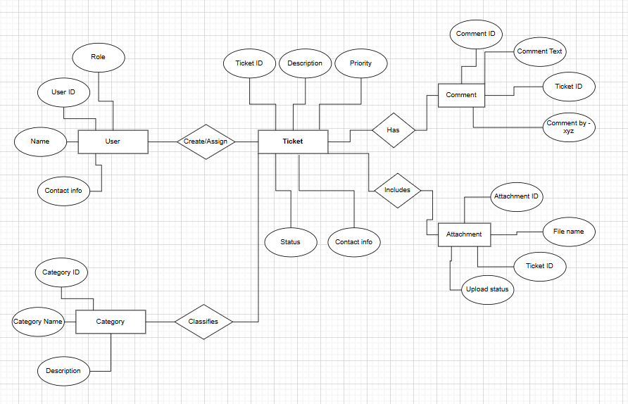

Entities
- User:
  - Attributes: User ID, Name, Email, Role (Customer, Agent, Admin)
  - Description: Represents all users interacting with the system. Customers create tickets, agents work on tickets, and admins monitor the process.
- Ticket
  - Attributes: Ticket ID, Title, Description, Priority, Status, Created Date, Closed Date
  - Description: Represents individual support issues. Each ticket is created by a user (customer) and is assigned to a support agent.
- Category
  - Attributes: Category ID, Name, Description
  - Description: Defines the classification of tickets (e.g., Technical Issue, Billing Issue, Feature Request). Helps in ticket routing and reporting.
- Comment
  - Attributes: Comment ID, Ticket ID, User ID, Comment Text, Created Date
  - Description: Represents discussion or updates posted on a ticket by users or agents.
- Attachment
  - Attributes: Attachment ID, Ticket ID, File Name, File Type, Uploaded Date
  - Description: Stores supporting files, screenshots, or documents related to a ticket.

Relationships
- User to Ticket:
  - One-to-Many: A single user can create multiple tickets, but each ticket is created by only one user.
  - Relationship: User ID to Ticket Created By
- Category to Ticket:
  - One-to-Many: Each ticket belongs to one category, but a category can contain multiple tickets.
  - Relationship: Category ID to Ticket Category ID
- Ticket to Comment:
  - One-to-Many: Each ticket can have multiple comments, but each comment belongs to only one ticket.
  - Relationship: Ticket ID to Comment Ticket ID
- Ticket to Attachment:
  - One-to-Many: A ticket can have multiple attachments, but each attachment belongs to one ticket.
  - Relationship: Ticket ID to Attachment Ticket ID

4.User story of shopping from ecommerce.

Feature 1: Product Discovery
User story no. 1 | Browse Products |  | Priority: Highest
AS A Customer
I want to browse products by category
I want to browse products by category
BV: 300 |  | CP: 05
ACCEPTANCE CRITERIA

Given I am on the homepage
When I click on a category
Then I should see all products under that category

User story no. 2 | Search products |  | Priority: Highest
As a customer
I want to search for products by name or keyword
So that I can quickly find what I am looking for

BV: 500 |  | CP: 03
Acceptance Criteria:

Given I am on the search bar
When I type a product name
Then relevant products should be displayed

Feature 2: Product Details & Cart
User story no. 3 | View Product details |  | Priority: Highest
As a customer
I want to see detailed information about a product
So that I can make an informed buying decision

BV: 300 |  | CP: 03
Acceptance Criteria:

Given I select a product
When I open the product page
Then I should see price, description, reviews, and availability

User story no. 4 | Add items to cart |  | Priority: Highest
As a customer
I want to add products to my cart
So that I can purchase multiple items in one order

BV: 500 |  | CP: 05
Acceptance Criteria:

Given I am on a product page
When I click “Add to Cart”
Then the product should appear in my cart

User story no. 5 | View and update cart |  | Priority: Highest
As a customer
I want to view my cart and update product quantities
So that I can adjust my order before checkout

BV: 100 |  | CP: 03
Acceptance Criteria:

Given I have items in my cart
When I open the cart
Then I can update quantities or remove items

Feature 3: Checkout & Payment
User story no. 6 | Enter shipping details |  | Priority: Medium
As a customer
I want to add a delivery address
So that my order can be delivered to the correct location

BV: 300 |  | CP: 01
Acceptance Criteria:

Given I proceed to checkout
When I add my address
Then it should be saved for the order

User story no. 7 | Select Payment Meythod |  | Priority: Highest
As a customer
I want to choose a payment option (COD, Card, UPI)
So that I can pay securely

BV: 500 |  | CP: 08
Acceptance Criteria:

Given I am at the payment step
When I choose a payment option
Then the payment should be processed securely

User story no. 8 | Confirm Order |  | Priority: Medium
As a customer
I want to place the final order after review
So that I can complete my purchase
BV: 300 |  | CP: 05
Acceptance Criteria:
Given I have reviewed my order
When I click confirm
Then I should see an order confirmation message

Feature 4: Order Management
User story no. 9 | Track Order Status |  | Priority: Highest
As a customer
I want to track my current order’s status
So that I know when to expect delivery
BV: 200 |  | CP: 03
Acceptance Criteria:
Given I placed an order
When I open its status page
Then I should see real-time tracking updates

