Part 2/2 Evaluation
Document 6- Please prepare a use case diagram, activity diagram, and a use case specification
document.

Ans 6.
Use Case Diagram of HRMS System
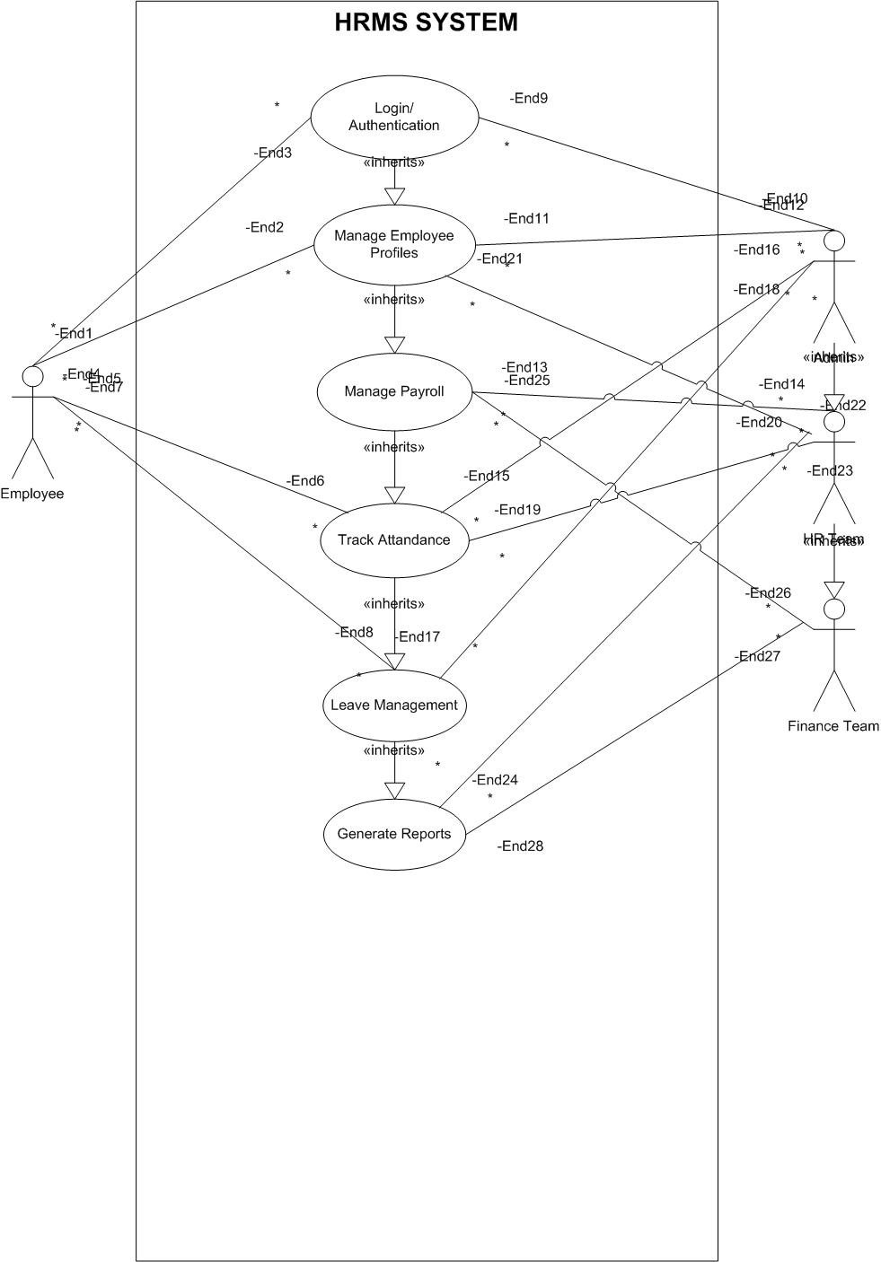
Activity Diagram
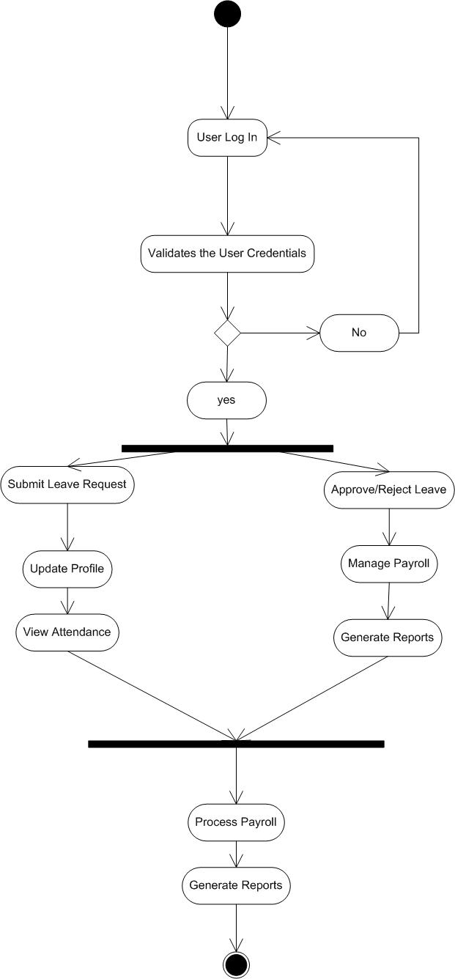

Use Case Specification Document
1. Project Information
Field | Details
Project Name | HRMS System
Customer Name | Transcend Staffing Solutions
Project Version | 1.0
Project Sponsor | Vipul Aggarwal
Project Manager | Smita Aggarwal
Date | 1-01-2025

2. Introduction
2.1 Purpose
This document provides a detailed description of each use case in the HRMS System. It outlines the actors, preconditions, main flow, alternate flows, and postconditions to ensure all requirements are met during development.
3. Use Case List
Here’s a list of key use cases included in the system:
Use Case ID | Use Case Name | Actors
UC001 | Login | Employee, Admin
UC002 | Manage Employee Profiles | Admin
UC003 | Manage Payroll | Admin, Finance Team
UC004 | Track Attendance | Employee, Admin
UC005 | Leave Management | Employee, Admin
UC006 | Generate Reports | Admin, Finance Team

4. Use Case Specifications
Use Case: UC001- Login
Attribute | Details
Use Case ID | UC001
Use Case Name | Login
Actor(s) | Employee, Admin
Description | Allows authorized users to log in and access the HRMS System.
Preconditions | 1. User must be registered in the system.  2. Valid username and password required.
Postconditions | 1. The user is logged in successfully.  2. The system grants role-based access to the user.
Normal Flow | 1. The user navigates to the login page.  2. Enter username and password.  3. System validates credentials.  4. Redirect to the respective dashboard.
Alternate Flow(s) | 1a. If credentials are incorrect, show an error message.  1b. If the account is locked, notify the user.
Exceptions | 1. Network error prevents login.  2. System maintenance
Use Case: UC002 – Manage Employee Profiles
Attribute | Details
Use Case ID | UC002
Use Case Name | Manage Employee Profiles
Actor(s) | Admin
Description | Allows Admin to add, update, and view employee profiles.
Preconditions | 1. Admin must be logged in.  2. Admin must have appropriate permissions.
Postconditions | 1. Employee profile is created/updated.  2. Changes are saved in the database.
Normal Flow | 1. Admin selects 'Manage Employee Profiles' option.  2. Adds/Updates employee information.  3. Submits the changes.  4. System confirms and updates records.
Alternate Flow(s) | 1a. If required fields are missing, system prompts for completion.  1b. If invalid data is entered, error message is shown.
Exceptions | 1. Database connectivity issues.  2. Unauthorized access attempt.

Use Case: UC003 – Manage Payroll
Attribute | Details
Use Case ID | UC003
Use Case Name | Manage Payroll
Actor(s) | Admin, Finance Team
Description | Allows Admin and Finance Team to process payroll and generate pay slips.
Preconditions | 1. User must be logged in with appropriate privileges.  2. Employee salary data must be available.
Postconditions | 1. Payroll processed successfully.  2. Payslips generated and saved.
Normal Flow | 1. Admin/Finance Team selects 'Manage Payroll'.  2. Enters data for salary processing.  3. System processes payroll.  4. Generates payslips.
Alternate Flow(s) | 1a. If salary data is missing, system prompts for corrections.  1b. If errors occur during processing, system notifies user.
Exceptions | 1. Payment gateway failure.  2. Data synchronization error.

Use Case: UC004 – Track Attendance
Attribute | Details
Use Case ID | UC004
Use Case Name | Track Attendance
Actor(s) | Employee, Admin
Description | Allows the system to track and store employee attendance using biometric devices.
Preconditions | 1. Biometric system should be configured.  2. Employee profile must be active.
Postconditions | 1. Attendance data is recorded.  2. Reports can be generated from recorded data.
Normal Flow | 1. Employee checks in/out using biometric.  2. System captures data.  3. Admin can view attendance records.
Alternate Flow(s) | 1a. If device fails, manual entry option is provided.
Exceptions | 1. Device malfunction.  2. Network failure.

Use Case: UC005 – Leave Management
Attribute | Details
Use Case ID | UC005
Use Case Name | Leave Management
Actor(s) | Employee, Admin
Description | Allows employees to apply for leave and Admin to approve/reject requests.
Preconditions | 1. Employee must be logged in.  2. Leave quota should be available.
Postconditions | 1. Leave status is updated.  2. Notifications are sent to the user.
Normal Flow | 1. Employee applies for leave.  2. Admin reviews and approves/rejects the request.  3. System updates leave status.
Alternate Flow(s) | 1. a. If the leave quota is exhausted, the system notifies the user.  1b. Admin can modify leave requests if necessary.
Exceptions | 1. Incorrect data input.  2. Leave approval delay.

Use Case: UC006 – Generate Reports
Attribute | Details
Use Case ID | UC006
Use Case Name | Generate Reports
Actor(s) | Admin, Finance Team
Description | Allows Admin and Finance Team to generate detailed HRMS reports.
Preconditions | 1. User must be logged in.  2. Data must be available for generating reports.
Postconditions | 1. Reports are generated successfully.  2. Reports can be exported or viewed.
Normal Flow | 1. User selects 'Generate Reports'.  2. System fetches relevant data.  3. Generates and displays reports.  4. User downloads/export the reports.
Alternate Flow(s) | 1a. If data is incomplete, system prompts to correct it.  1b. If report generation fails, notify the user.
Exceptions | 1. System performance issues.  2. Database query errors.

5. Assumptions & Constraints
- The system should comply with security protocols (e.g., data encryption, role-based access).
- Internet connectivity is required for real-time attendance tracking.
6. Approval
Role | Name | Signature | Date
Project Sponsor | Vipul Aggarwal |  | 1-01-2025
Project Manager | Smita Aggarwal |  | 24-01-2025
Business Owner | Deepak Sachdeva |  | 14-01-2025

Document 7- Screens and pages
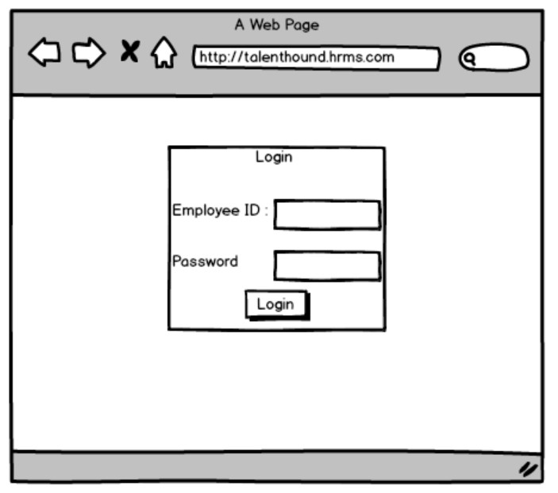

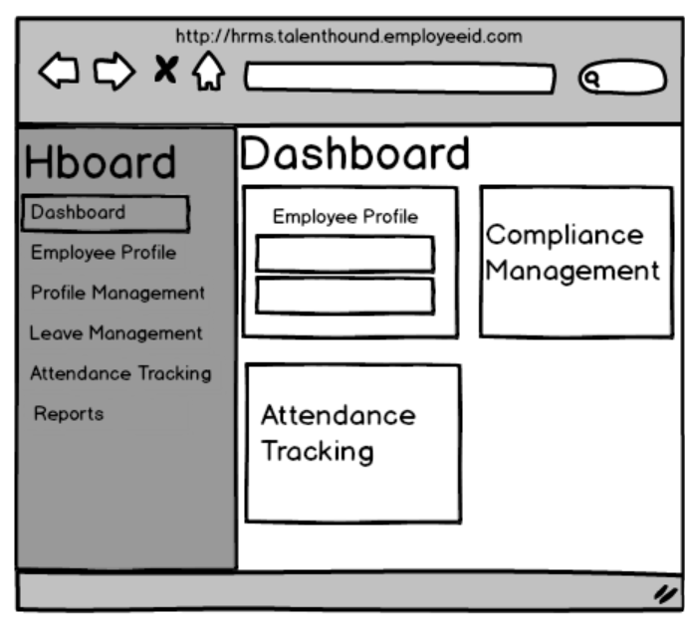

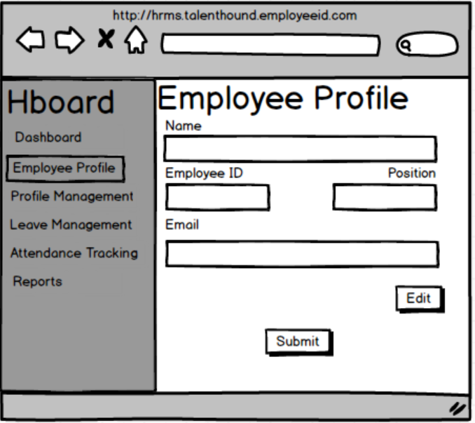

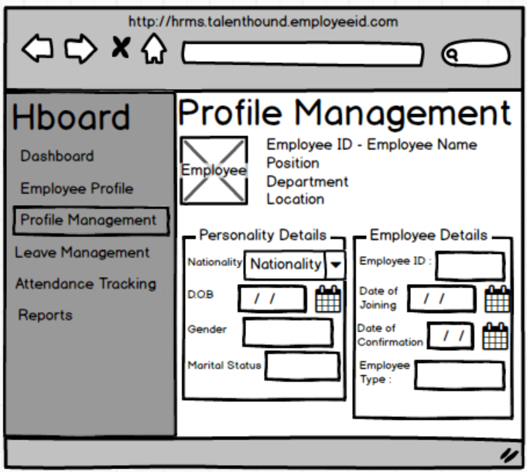

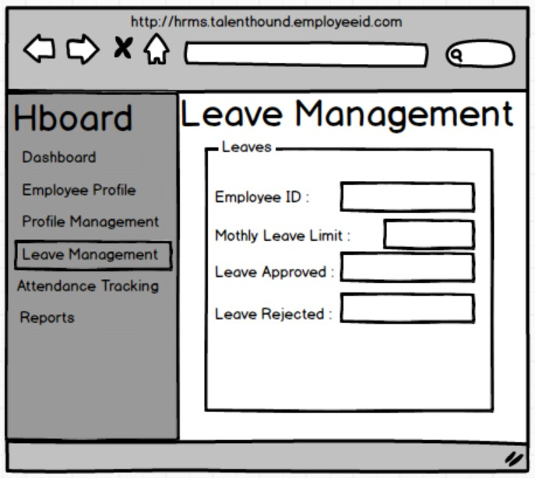

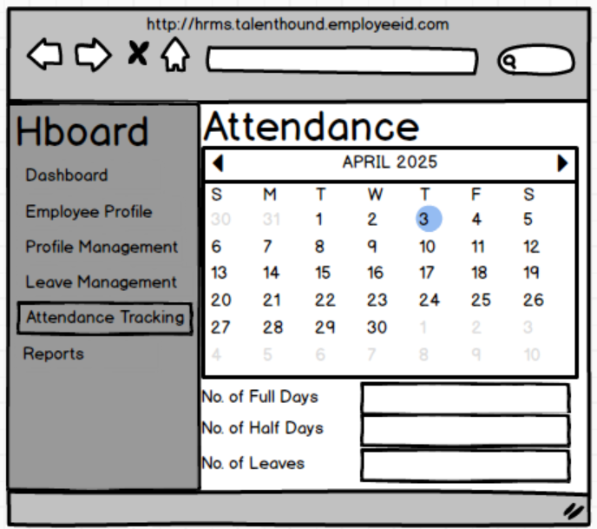

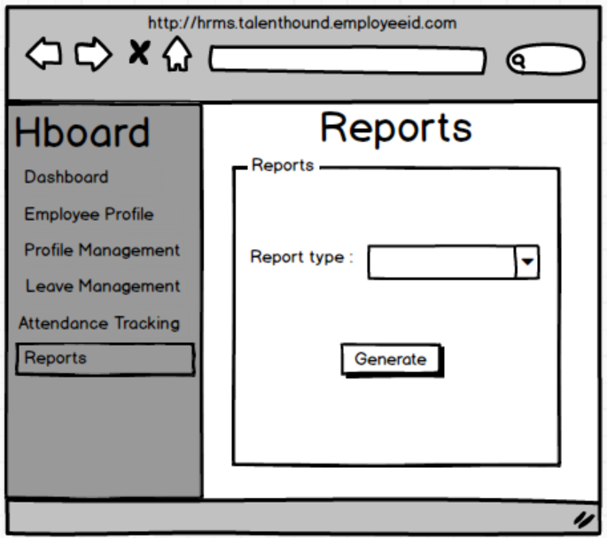

Document 8- Tools-Visio and Axure

Experience Using Visio and Axure on the HRMS Project
Microsoft Visio:
- Used Visio to create AS-IS and TO-BE process flow diagrams, swimlane diagrams, and system architecture models.
- Designed workflow charts to visually represent HRMS functionalities like onboarding, leave requests, and payroll approvals.
- Helped stakeholders easily understand complex business processes through visual representations.
- Supported design and requirement validation sessions using detailed Visio diagrams.
- Ensured process flows aligned with business goals and technical feasibility.
Axure RP:
- Created interactive wireframes and low/high-fidelity prototypes to showcase UI design concepts.
- Used Axure to simulate user interactions, helping stakeholders visualize the final product before development.
- Incorporated feedback from UI/UX sessions to refine screen designs early in the lifecycle.
- Enabled effective collaboration with design and development teams by providing click-through prototypes.
- Improved overall requirement clarity and reduced design-related rework during development.

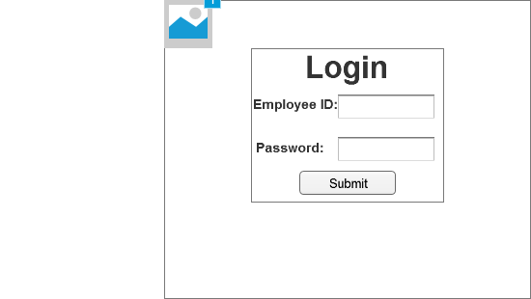

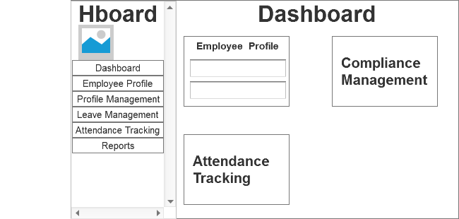

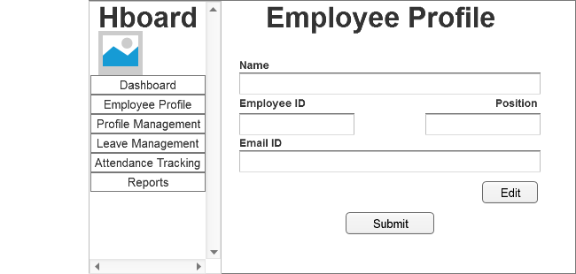
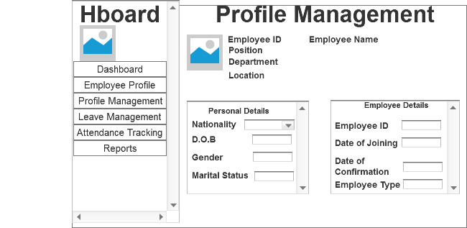

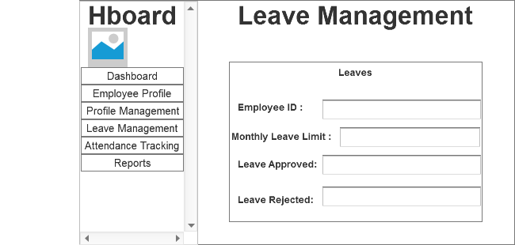
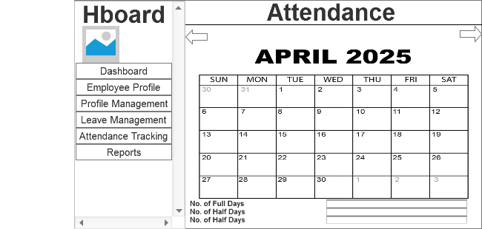

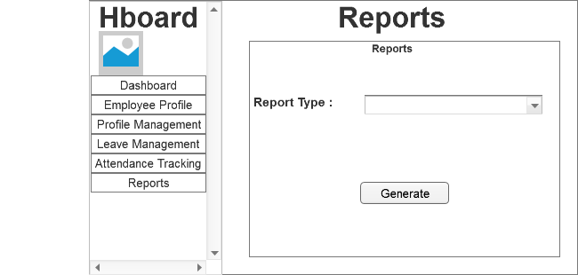

Document 9- BA experience
My experience as a BA in the following phases:
- Requirement gathering:
- Requirement Analysis:
- Design:
- Development:
- Testing:
- Deployment:
Ans 9.

My Experience as a Business Analyst Across SDLC Phases

1. Requirement Gathering
In the requirement gathering phase, I conducted interviews, workshops, and stakeholder sessions to understand business needs.
Tools I Used:
- I used Microsoft Word to document the Business Requirement Document (BRD).
- Google Forms and Excel helped me gather survey responses from users.
- I facilitated virtual meetings using Microsoft Teams and Zoom.
- To collaborate and maintain a single source of truth, I documented notes and action items in Confluence.

2. Requirement Analysis
I analyzed and validated the gathered requirements to ensure they aligned with business goals and were technically feasible.
Tools I Used:
- I created process flow diagrams and swimlane diagrams in Lucidchart and Microsoft Visio to represent the current and proposed systems.
- I maintained a Requirement Traceability Matrix (RTM) using Excel to ensure each requirement was testable and accounted for.
- I logged and refined user stories and epics in JIRA for Agile teams.

3. Design
During the design phase, I worked closely with UX/UI designers and architects to ensure the system design reflected user needs.
Tools I Used:
- I reviewed and provided feedback on wireframes and mockups using Figma and Axure.
- For visual representation of workflows, I used Draw.io to create user flow diagrams.
- I collaborated with designers via Slack and documented screen logic in Confluence.

4. Development
I liaised between stakeholders and the development team in the development phase, helping clarify requirements and track progress.
Tools I Used:
- I managed user stories and sprint tasks in JIRA and Azure DevOps.
- I responded to developer queries using Slack and Teams, ensuring timely clarifications.
- I tracked change requests using a controlled Change Request Log in Excel and facilitated impact analysis.

5. Testing
I worked with QA teams to ensure the solution met requirements through system testing and UAT.
Tools I Used:
- I created and reviewed test cases using TestRail and managed test execution status.
- I tracked bugs and issues using JIRA and ensured they were resolved in line with acceptance criteria.
- I used Excel-based RTM to verify complete test coverage.
- I conducted UAT sessions with business users and obtained sign-offs via formal UAT forms.

6. Deployment
During deployment, I supported go-live readiness, user training, and ensured a smooth handover.
Tools I Used:
- I prepared training documents and user manuals using MS PowerPoint and Word.
- I delivered training through Zoom and Microsoft Teams, and tracked attendance using Excel.
- I supported the post-deployment phase using ServiceNow for logging issues and change requests.
- I coordinated sign-off using a Project Acceptance Form signed by key stakeholders.

