Question 1 – Audits
Audit is the examination or inspection of various books of projects by an auditor followed by physical checking of inventory to make sure that all departments are following documented system of recording transactions. It is done to ascertain the accuracy of project statements provided by the organisation. Inspection of work for Quality and for progress As a BA we are responsible to update the progress of the project to the responsible stakeholders and concerning documents. A business audit is a documented evaluation of whether or not a company’s financial statements are materially correct along with the standards, evidence, and assumptions used to conduct the audit.
what is internal audit? - An internal audit may be used to assess an organization’s performance or the execution of a process against a number of standards, policies, metrics, or regulations. These audits may include examining a business’s internal controls around corporate governance, accounting, financial reporting, and IT general controls.
Following why audit will happen for BA in Q1
In the first following this auditor will check
- How the Enterprise Analysis did?
- How BA conducts stakeholder’s analysis
- What is plan of BA for approach strategy
- Check stakeholders identify and document
- Can BA prepare BRD by interacting with client
- Is properly done prioritize Requirements
Following why audit will happen for BA in Q2
the following this auditor will check
- To track records of use case and activity diagrams.
- How to prepares functional Requirements from business Requirements
- Is BA preparing RTM from SRS before Design Phase starts.
- How many test cases prepared by BA?
- What are the documents BA prepared?
- To check BA mails formats with Client
Following why audit will happen for BA in Q3
the following this auditor will check
- Is BA will initiate the preparation of end user manuals.
- To track status of updates RTM.
- Is BA properly Clarifying queries of technical team during coding.
- Is BA forward timesheet Properly to reporting manager.
- Can developers refer diagrams and transient of BA and code their unit.
Following why audit will happen for BA in Q4
the following this auditor will check
- BA prepares test cases from use cases or assists test manager to do so
- To track BA performs high level testing
- How to BA prepares client for UAT
- Is test data BA properly send to client
- Updates end user manuals.
- Is BA forwards RTM to client or the PM which should be attached to the project closure documents
- How BA plans and Organizes training sessions for end users
- Is BA forward timesheet Properly to reporting manager?
Question 2 – BA Approach Strategy
BA Approach Strategy is a structured plan that guides how the BA will understand business needs, interact with stakeholders, and deliver business solutions effectively. It explains how requirements will be gathered, analysed, documented, and managed
The steps I would need to start with to complete this project are:
Business requirement initiation (gathering stage) Identifying the stakeholders through the ILS. i.e., Identify the stakeholders, List the stakeholders and summarize the stakeholder.
Business stakeholders-Mr. Henry, Mr. Pandu and MR. Dooku Peter, Kevin, and Ben. Project stakeholders- Project Manager - Mr Vandanam Senior Java Developer - Ms. Juhi Java Developers Mr.Teyson, Ms.Lucie, Mr. Tucker, Mr. Bravo Network Admin Mr. Mike DB Admin Mr. John. Testers – Mr.Jason and Ms. Alekya BA – Shiwani 3rd party stakeholder- Peter, Kevin, and Ben
Below are some elicitations technique
Requirements Elicitation is the process of digging out the information from the stakeholders Requirements Elicitation serves the foundation in documenting the requirements. Below are some elicitation techniques which suits best for this project
Questionaries/surveys: - This is a great way to get information from a lot of people or from people with whom you don’t have a direct connection. A survey is also a great way to receive more objective information in a low intensity way. Often people will write things into surveys that they may not share personally. On the flip side, sometimes the information is unclear and difficult to interpret without more context. We use surveys here at Bridging the Gap to gather feedback from potential customers and also to get feedback from our course participants after they complete the program.
Interview: - Interviews of users and stakeholders are important in creating wonderful software. Without knowing the expectations and goal of the stakeholders and users, we are highly unlikely to satiate them. We also have to understand the perspective of every interviewee, in order to properly address and weigh their inputs. Like a good reporter, listening is a quality that assists an excellent analyst to gain better value through an interview. An interview is a systematic approach to elicit information from a person or group of people in an informal or formal setting by talking to the person the interviewee, asking relevant questions and documenting the responses.
we can list out ideas to convert BRD (business requirement documents) to FRD (Functional requirements Documents)
We will apply MOSCOW technique to prioritize the requirement from the client. So that we can reach to a mutual understanding with the stakeholder on the importance of each requirement. That will help us to gain approval and signing on the documents from client.
For better understanding we can establish Face to face communication channel and phone can and for written communication we can also for mail chain with stakeholder.
we can share time sheet of development with all stakeholder to give them update of project ongoing status.
At last, during UAT we can prepare sign off template which will show how much project has reached the desired goal or much it satisfied customer need to take sign off the project.
Question 3 – 3-Tier Architecture
3-Tier Architecture is a way to structure an application by dividing it into three separate parts: what the user sees, what processes the business rules, and where the data is stored. This separation of concerns allows each part to be developed, updated, and managed independently. Three-tier architecture is a well-established software application architecture that organizes applications into three logical and physical computing tiers:
1 -Application Layer.
2 -Business Logic layer.
3 - Data layer.
………………………… APLICATION LAYER…………………………
The application tier, which may also be referred to as the logic tier, is written in a programming language such as Java and contains the business logic that supports the application's core functions. pages, screens and validations on pages
…………………………. BUSINESS LOGIC LAYER……………………….
Acts as the engine of the application, separating business rules from presentation and database layers. All reusable components, frequently changing components, governing body rules and regulations. Ex-printer, payment gateways
…………………………DATA LAYER……………………………………….
The data layer is made of repositories that each can contain zero to many data sources.
Data base components connecting to databases.
Question 4 – BA Approach Strategy for Framing Questions
Before framing question, we should take care 5W 1H For gathering information from the stakeholder we should use the 5W1H. as bellows:
- What is this product.
- Why this project was initiated.
- who are the benefitted from this project.
- where did requirement was spotted.
- when will the project get initiated
- how we should be doing the project
Next, we should check whether the requirement collected is being SMART or not.i.e.
- SPECIFIC
- MESURABLE
- ATTAINABLE
- REALISTIC
- TIMEBOUND
Then while preparing question we need to figure out who comes under which category so we use the RACI Matrix like. responsible, accountable, consultant and informed
Then we will prepare 3tier architecture under which we will be categorizing in 3 different stages
- Application layer
- business logic layer
- data layer.
Then we will prepare to identify the requirement. Use case is prepare to know how external system is interacting with the system.
While preparing use case we will be looking at use case specifications. i.e. use case specification. under which we need to categorize the requirements gathered under basic flow and alternative flow. An activity diagram is drawn to model how the system should function in order to achieve Business Logic, Business Functionality and Business Objectives. Activity diagram is basically a flow chart to represent the flow form one activity to another activity. We will use either use case or activity to prepare the model the requirements

Question 5 – Elicitation Techniques
Elicitation is the process of working with stakeholders to understand what they want to achieve through the project or to understand how the business is organised today. A stakeholder is someone who owns or provides input on a specific aspect of the project or the organisation. Stakeholders might have a very clear picture of what they want and what they do, or they might be vague and ambiguous.
Elicitation involves bringing out the best ideas from people who see all the different aspects of the problem and includes documenting the results of what you find. So, if you sit down and observe someone do their work and then you create a work-flow document that represents the understanding you achieved through that observation, you just completed some elicitation.
- Brainstorming:
The requirements elicitation process begins with brainstorming. To facilitate focused and fruitful brainstorming sessions, business analysts should set up a team with representatives of all stakeholders for capturing new ideas. Suggestions coming out of brainstorming sessions should be properly documented in order to draft the plan of action.
- Document Analysis:
During this step of the requirements elicitation process, business analysts review existing documentation at hand, with the intent of identifying requirements for changes or improvements. Examples of document analysis sources include pre-existing project plans, system specifications, process documentation, market research dossiers, customer feedback, meeting minutes, and user manuals. Document analysis is performed before scheduling more in-depth requirements elicitation sessions or interviews with stakeholders.
- Reverse Engineering:
One of the most effective requirements elicitation techniques is reverse engineering processes. This is a great way to uncover hidden requirements, ensure valuable existing processes are not lost, and identify potential process redundancies. This method involves analysing and deconstructing existing processes to understand their underlying structure, functionality, and purpose.

- Focus Groups:
In a focus group, relevant stakeholders provide feedback to refine processes, ideas, or solutions that emerged as an outcome of earlier elicitation activities, such as brainstorming and document analysis. The feedback and comments are recorded for use in later phases of requirements elicitation.
- Observation:
Also referred to as job shadowing, observation is an excellent elicitation technique that helps understand requirements based on observations related to process flows and work environments of stakeholders. Practical insights into actual workflows serve as the basis for modifications and enhancements. The observation approach allows business analysts to elicit real-world data that other requirements elicitation methods cannot capture.
- Workshop:
For multi-stakeholder, complex projects, workshops are one of the most resource-efficient methods to elicit requirements. Intense, focused, and highly productive workshops have a key role to play in getting all parties onto the same page. Workshop events help Subject Matter Experts and Stakeholders to collaborate, resolve conflicts, and come to an agreement.
- JAD (Joint Application Development):
Joint Application Development (JAD) is an advanced elicitation technique that brings together key stakeholders, subject matter experts, and the development team to collaboratively define requirements. This interactive workshop fosters communication, consensus building, and alignment on project objectives. By leveraging JAD sessions, organizations can streamline the requirements gathering process, improve decision-making, and enhance stakeholder buy-in. The structured nature of JAD sessions enables rapid problem-solving, identification of dependencies, and mitigation of potential risks early in the project lifecycle.
- Interview:
A great way to extract critical data is via interviews. Business analysts engage in group or one-to-one interviews in an informal or formal setting to elicit project requirements through questions directed at Subject Matter Experts, stakeholders, and end-users. By exploring diverse opinions, business analysts gain in-depth knowledge of the requirements.
- Prototyping:
One of the most important phases of the requirements elicitation process, prototyping enables business owners and end-users to visualize realistic models of applications before they are finally developed. Prototyping helps generate early feedback, and it boosts stakeholder participation in requirements elicitation.
- Questionnaire (Survey)
This is a great way to get information from a lot of people or from people with whom you don’t have a direct connection. A survey is also a great way to receive more objective information in a low intensity way. Often people will write things into surveys that they may not share personally. On the flip side, sometimes the information is unclear and difficult to interpret without more context. We use surveys here at Bridging the Gap to gather feedback from potential customers and also to get feedback from our course participants after they complete the program.
Question 6 – This project Elicitation Techniques
- Interviews:
Conducted with the main decision makers Mr. Henry, Mr Pandu and Mr Dooku to understand business goals, budget and expectations clearly. This helped in defining the project scope at the initial stage.
- Questionaries/surveys:
Distributed among farmers to collect their inputs on product performance, delivery model and payment methods. This was chosen because it is cost effective and allows reaching a large number of stakeholders in less time.
- Workshops:
Organized with both management and IT team to align requirements, resolve conflicts and create a shared understanding of timelines and responsibilities.
Question 7 Business Requirements-
business requirement is what the business needs to achieve its goals. For a Business Analyst, these are the high-level problems, opportunities, and objectives that a project must address, rather than the specific features of a solution.
BR001- Everyone should be able to log in to the website as the users.
BR002- The new user should be able to create a new account by submitting their email ID and creating a secure password.
BR003– Farmers should be able to search for available products in fertilizers, seeds, pesticides.
BR004 – Manufacturers should be able to upload and display their products in the application.
BR005- A Farmer should be able to browse through the products cat-log once they visit the website.
BR006- The website should have a search option so that they can search for any product they need.
BR007- A product cat-log of fertilizers, seeds, pesticides, and a search option to search for products, payment process, and delivery tracking should be there.
BR008-Any farmer wants to buy any product or add them to buy-later list, they need to do the login first using their email id and password.
BR009-If a Farmers wants to purchase, they should have an easy-to-use payment gateway which should include cash-on-delivery (COD), Credit/Debit card and UPI options.
BR010-The user should get an email confirmation regarding their order status. A delivery tracker to track the whereabouts of their order on mobile no. and on Email address.
BR011- Farmer should be able to track the order i.e. where is the order and how much time it will take to reach.

Question 8 –Assumptions-
- Key stakeholders will be available for timely requirement discussion, approvals and audits.
- Farmers will participate in surveys and provide feedback.
- Product information will be accurate and updated regularly by the company.
- Pricing and availability pf products will be manged centrally by the company.
- Farmers will have access to mobiles phones or computers with internet connectivity to use the online platform.
- The project will be completed within the planned 18 months timeline and allocated budget.

Question 9 – This project Requirements Priority

Req ID | Req Name | Req Description | Priority
BR001 | Farmer Search for Products | Farmer should be able to search for seed fertilizer and pesticide | 9
BR002 | Manufacturers upload their Products | Manufacturer should be able to upload and display their product | 9
BR003 | Farmer browse through product | Farmer should be able to browse to all product after visiting site | 7
BR004 | Website search option | The website should have a search option for farmer so that can search according to their need | 8
BR005 | Everyone can do a login | Everyone should be able to login as a user | 5
BR006 | Product cat-log and search option | Cat-log of seed fertilizer pesticide off diff. category and their payment mode | 4
BR007 | Farmers login | Farmer should login before buying any product | 9
BR008 | For new user creating new acc. | For any new user there should be new account with their mail id and password | 8
BR009 | For purchasing order payment gateways | If a farmer wants to buy a product, then there should be different payment option such UPI, CARD, CASH ON DELIVERY | 8
BR0010 | Email confirmation regarding order status | Farmer should be able to get email confirmation and receipt after placing and order on their register email id and delivery tracking id also | 6
BR0011 | Return option | Farmer must be able to return product if order in excess or need to change | 7
BR0012 | Feed Back Option | Farmers can upload their feedback on app on the basis of product result | 5
BR0013 | Helpline number | There must be Manufacture number to solve any query of farmer | 4

Question 10 – Use Case Diagram:
- Use case diagrams are used to gather the requirements of a system including internal and external influences. These requirements are mostly design requirements. Hence, when a system is analysed to gather its functionalities, use cases are prepared and actors are identified. When the initial task is complete, use case diagrams are modelled to present the outside view.

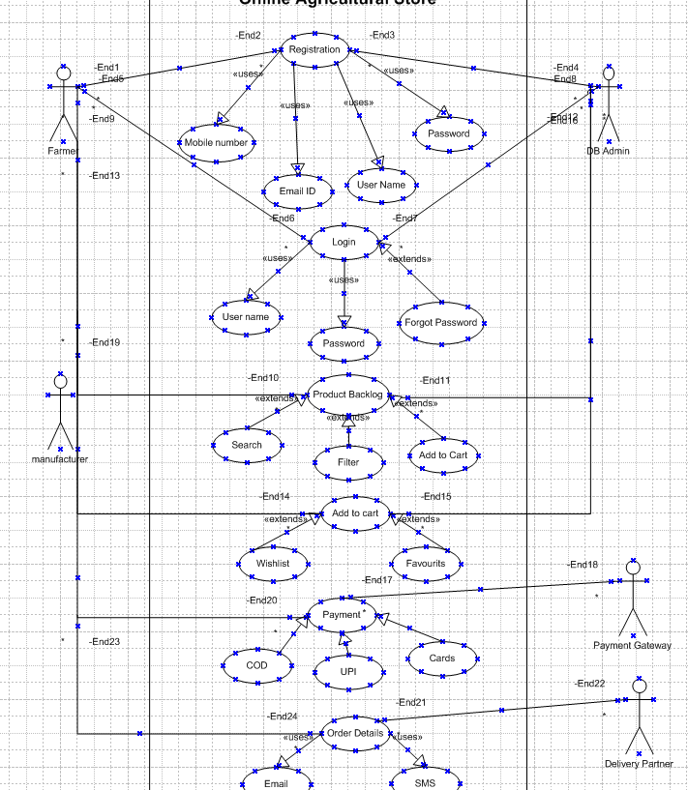

Question 11 – (minimum 5) Use Case Specs:
1
Use case spec- Registration
Description- New user registration for customers and Manufacturer
Actors-Farmers /Manufacturer
Preconditions-active internet connection,2.browser compatible
Postconditions-home page should be displayed
Basic flows: username and password are correct
Alternate flow: password is wrong User name is wrong Username and password is wrong
Exceptional flow: forget password Forget username
Assumptions: users have basic computer knowledge, English
Constraints: usernames cannot be special character
Dependents: user should exist-registration process
Inputs: Name, Email, Mobile number, Password
Output: status flag or error code.
Business rules-username should use valid mail id password should use special character
Miss information-interactive design and browser compatible.
2-
Use case spec-Login
Description- User login to access store feature
Actors: farmers, customers
Preconditions: active internet connection, registered user
Postcondition: User enters correct user name and password-redirected to home page
Basic flow: items selected are correctly captured by the system
Alternative flow: wrong password, wrong username, both incorrect.
Exceptional flow: Forgot password, account locked after 3 failed attempts
Constraints: User name cannot be blank
Dependencies: User must be registered
Input: username, password
Output: Success message or error
Business rules: Password must follow security standards
Misc info:- Browser compatible
3
New user Use case spec- Product Catalogue
Description- Display list of agricultural products
Actors-Farmers, customers
Preconditions- Product available in inventory
Postconditions- User can view product details
Basic flows: User select category- view product list-selects products
Alternate flow: No products in selected category, server delay
Exceptional flow: Network disconnected, inventory data not loaded
Assumptions: Products are already uploaded by admin
Constraints: only available products can be shown
Dependents: product database must be updated
inputs: category selection
Output: products list with details
Business rules- product displayed by relevance and stock availability
Mis information- search and filter option
4
Use case spec- Add to cart
Description-Add selected products to cart
Actors- Farmers, customers
Preconditions- user login and product available in stock
Postconditions- product successfully added to cart
Basic flows: clicks on- add to cart- item added
Alternate flow: product out of stock, quantity not available
Exceptional flow: server time out, session expired
Assumptions: users want to purchase the selected products
Constraints: maximum quantity limit per order
Dependents: stock management system active
Inputs: product id, quantity
Output: conformation or error message
Business rules- cart total auto updated
Mis information-interactive design

5
Use case spec-Payment
Description- process user payment for order
Actors-farmers, customers, payment gateway
Preconditions-the item to be in the cart
Postcondition-the farmer to be able to make payment through UPI card or cod
Basic flows: user select payment method-enters details- payment processed-success message
Alternate flow: not able to make payment
Exceptional flow: card blocked UPI not registered
Assumptions: User has valid payment method
Constraints: secure payment gateway required
Dependents: bank/payment integration active
Inputs: payment details
Output: success or error page
Business rules- payment must be secure
Mis information- supports UPI, Cards, net banking

Question 12 – (minimum 5) Activity Diagrams:
Activity Diagrams1: User Registration

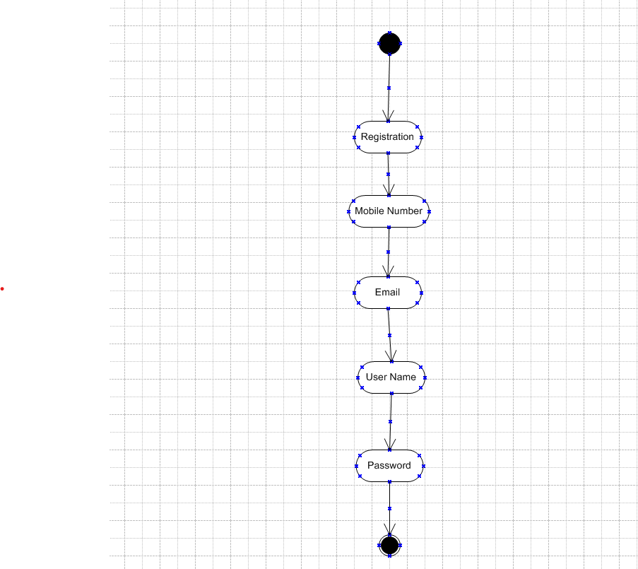

Activity Diagrams2: Login

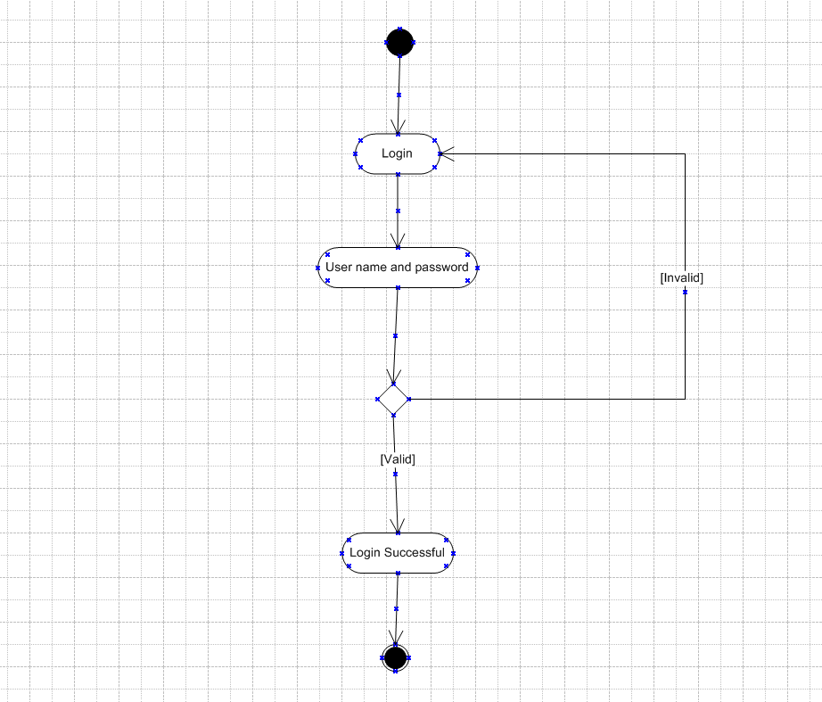

Activity Diagrams3: Search Product

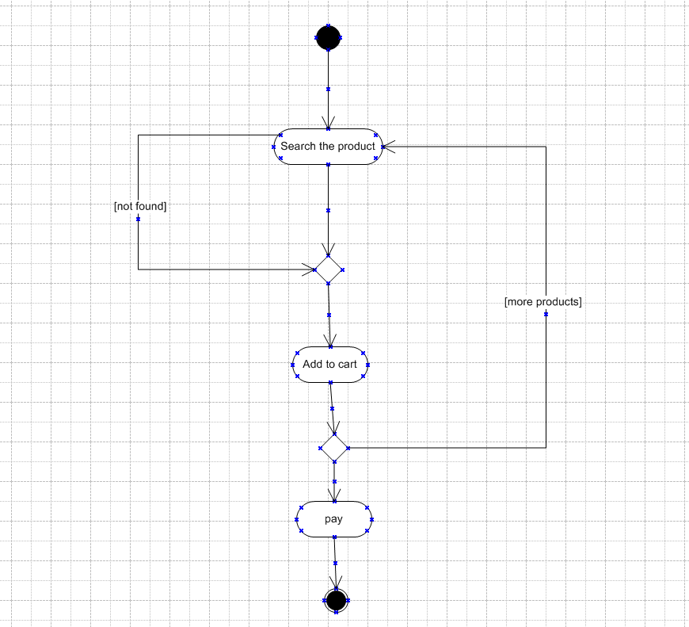

Activity Diagrams4: Payment
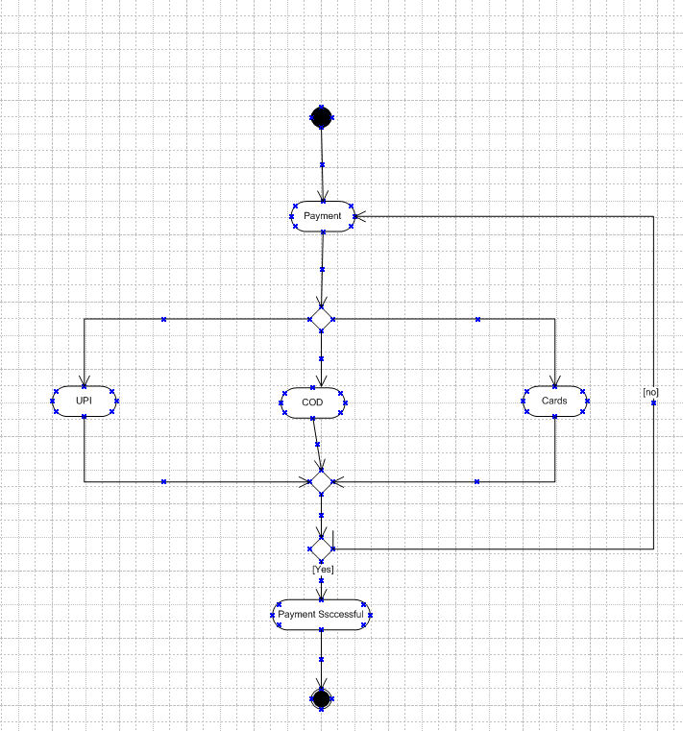

Activity Diagrams5: Order details
