WATERFALL MODEL DOCUMENT
PART 3
DOCUMENT 6

Use Case Diagram
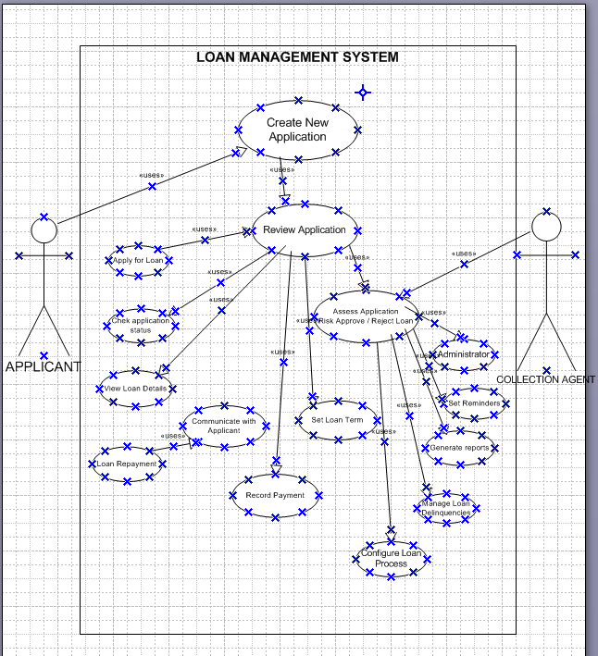

Activity Diagram
Activity 1: Apply for Loan
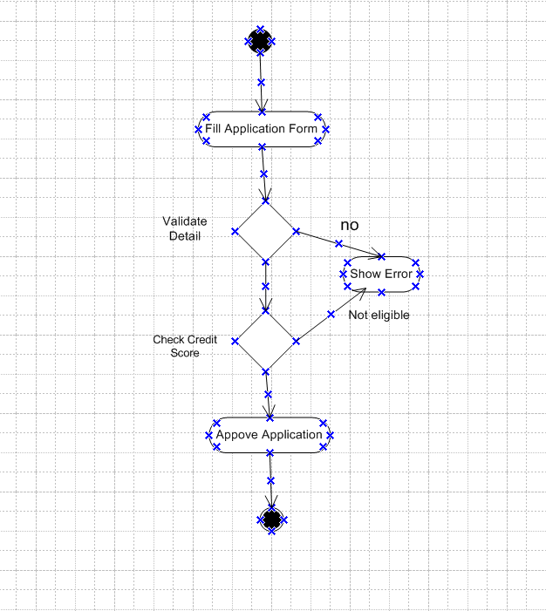
Activity 2:
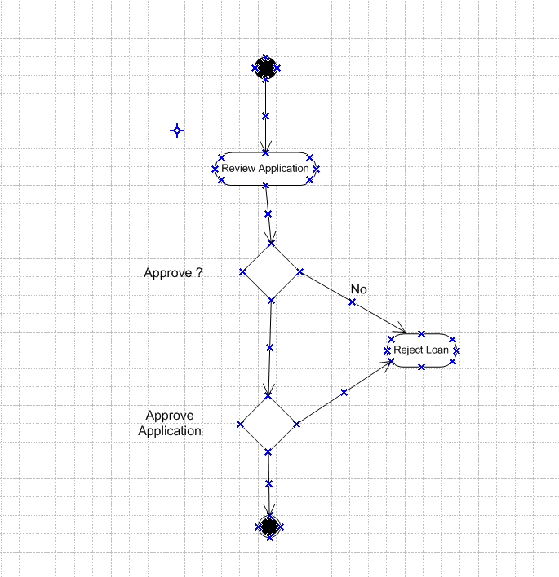
Activity 3: EMI Repayment
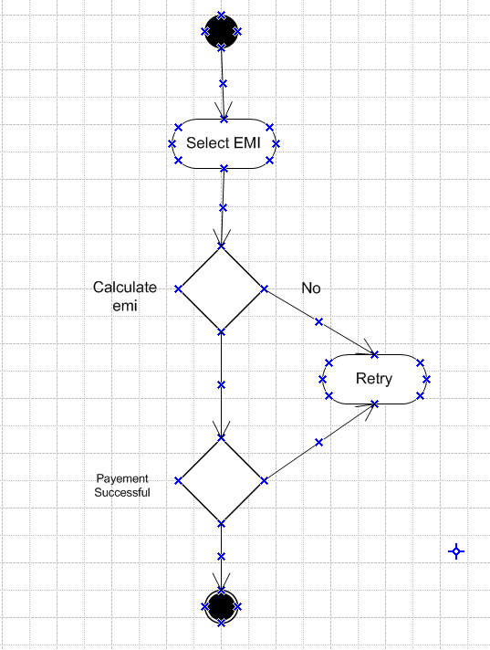
Use Case Specification
Use Case 1
Use case id | UC01
Use case name | Apply for Loan
Use case Description | Customer (or loan officer on behalf of customer) submits a loan application with required personal, financial and document details. The system validates inputs, performs KYC and credit checks, evaluates eligibility, and routes the application for approval.
Actors | - Primary Actor: Customer / Loan Applicant  - Secondary Actors: Loan Officer, Credit Bureau (external), System (LMS)
Basic Flow | - Customer opens loan application form.  - Customer enters personal, employment and financial details.  - Customer uploads required documents (KYC, income proof).  - System validates mandatory fields.  - System calls KYC and Credit Bureau APIs to validate identity and credit score.  - System evaluates eligibility via business rules.  - If eligible, system assigns application ID and submits to loan officer/manager for approval.  - System notifies customer that application is submitted.
Alternate Flow | - If mandatory fields missing → system prompts user to complete fields.  - If auto-evaluation indicates manual review required → application flagged and sent to loan officer for manual checks.
Exceptional flows | - External API failure (KYC/credit bureau) → system logs error, notifies user of temporary issue, allows re-try or manual verification.  - Document upload fails → system displays error and allows re-upload.
Pre- Conditions | - Customer has access to internet and LMS portal.  - Customer possesses required documents.
Post-conditions | Application saved with unique ID; status = Submitted / Pending Verification.
Assumptions | - Credit bureau API credentials and endpoints are available and stable.  - Minimum eligibility rules are defined and approved.
Constraints | - Maximum upload file size and allowed formats.  - API rate limits for external services.
Dependencies | Credit Bureau API, KYC service, Document storage service, Notification service (SMS/Email).
Inputs and Outputs | - Inputs: Applicant data, uploaded documents, selected loan product & amount.  - Outputs: Application ID, validation results, notifications, eligibility decision flag.
Business Rules | - Mandatory KYC documents required.  - Minimum credit score threshold per product.  - Age and income validation rules apply.
Miscellaneous Information | - UI must show progress indicators; save-as-draft available.  - Time-stamp all transactions for audit.

Use Case 2
Use case id | UC02
Use case name | Approve Loan
Use case Description | Loan Officer / Manager reviews verified applications and approves, rejects, or places them on hold based on eligibility and risk rules. Approved applications move to disbursement.
Actors | - Primary Actor: Loan Officer / Manager  - Secondary Actors: Credit Risk System, Finance (for limits), Customer
Basic Flow | - Loan Officer opens pending application from dashboard.  - Reviews verification results, credit score, and attached documents.  - Applies business/risk rules; may modify terms (tenure, rate) within policy limits.  - Chooses Approve / Reject / Hold.  - If approved → system creates loan account and sends to Disbursement.  - System notifies customer of decision.
Alternate Flow | - If additional documents required → request documents from customer; change status to Pending Documents.  - If Manager escalation required → route to manager for final approval.
Exceptional flows | - Policy violation detected → system rejects automatically or flags for review.  - Duplicate application detected → merge or reject based on rules.
Pre- Conditions | Application is Verified and in Pending Approval status.
Post-conditions | Application status updated to Approved / Rejected / On Hold; loan account created if approved.
Assumptions | Approval limits and authorities defined.
Constraints | Approver cannot exceed authorization limit without escalation.
Dependencies | Risk rules engine, finance approval, audit logging, notification service.
Inputs and Outputs | - Inputs: Application file, verification logs, credit score.  - Outputs: Approval decision, loan account number, notification to customer.
Business Rules | - Approvals must follow configured authority matrix.  - All approvals require audit log and digital signature.
Miscellaneous Information | - Support bulk approvals for low-risk standard products.  - SLA: decision within defined TAT

Use Case 3
Use case id | UC03
Use case name | Record Repayment / Payment Processing
Use case Description | System records EMI payments from customers via integrated payment gateways or manual entry by staff and updates loan balance, sends receipts, and updates delinquency status.
Actors | - Primary Actor: Customer / Payment Gateway / Collections Agent  - Secondary Actors: Finance System, Notification Service, Bank Gateway
Basic Flow | - Customer initiates EMI payment via portal or payment channel.  - Payment gateway processes transaction and returns success/failure.  - System records payment, updates loan balance, and posts ledger entry.  - System generates receipt and notifies customer.  - If payment satisfies closure conditions → mark loan as Closed.
Alternate Flow | - Payment fails → system notifies customer with failure reason and retry options.  - Partial payment → update outstanding balance and reschedule next EMI.
Exceptional flows | - Reconciliation mismatch with bank → flag for manual reconciliation and temporary hold on balance.  - Fraud detection alert → block transaction and notify fraud team.
Pre- Conditions | Loan account is active and not closed.
Post-conditions | Payment recorded; balance updated; receipt issued.
Assumptions | Payment gateway integration available and tested.
Constraints | Cut-off times for same-day posting; settlement delays for bank transfers.
Dependencies | Payment gateway, core accounting/ledger system, notification service.
Inputs and Outputs | - Inputs: Payment amount, transaction ID, payment method.  - Outputs: Updated loan balance, receipt, ledger entries, notifications.
Business Rules | - Apply penalty interest for late payments per policy.  - Accept only allowed payment methods; validate minimum payment amounts.
Miscellaneous Information | - Support bulk file upload for branch collections.  - Provide reconciliation report for finance team.

DOCUMENT 7

Prototype 1
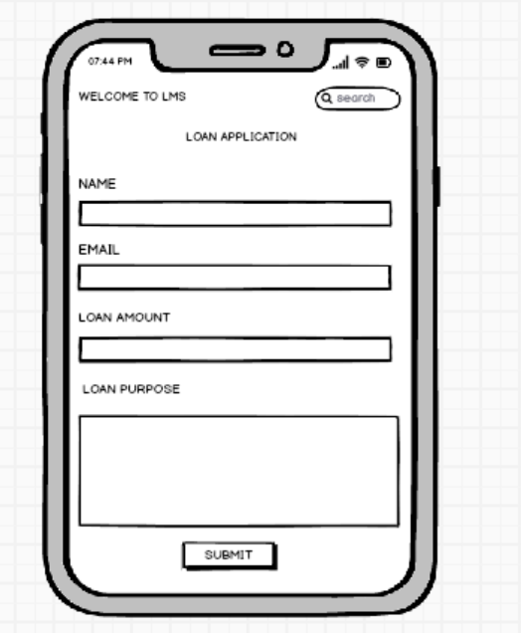

Prototype 2
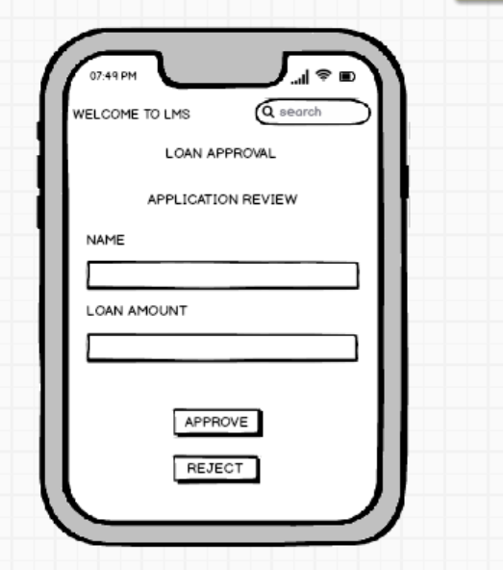

Prototype 3
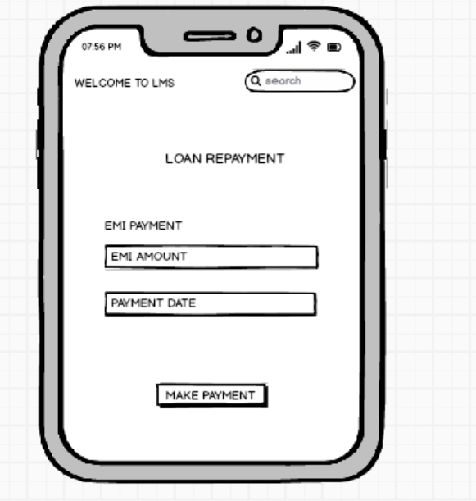

DOCUMENT 8

Experience Using Visio and Balsamiq
In this project, I extensively used Microsoft Visio and Balsamiq to support requirements visualization and solution design. Using Visio, I created detailed process flow diagrams, activity diagrams, UML use case diagrams, and system architecture models to clearly illustrate end-to-end business workflows and system interactions. These visuals helped stakeholders understand complex processes and ensured alignment during requirement reviews. With Balsamiq, I developed low-fidelity wireframes and screen mockups to represent the user interface for various loan management modules, including loan application, approval, and repayment screens. These prototypes enabled quick feedback cycles, improved clarity during design discussions, and served as an effective communication bridge between business stakeholders, UX designers, and developers. Overall, both tools played a critical role in improving requirement accuracy, reducing design ambiguities, and accelerating project delivery.

DOCUMENT 9

My experience as BA in following phases:
- Requirement gathering
- Conducted stakeholder interviews, workshops, JAD sessions, and surveys to capture business needs.
- Collected functional, non-functional, regulatory, and reporting requirements from various business units.
- Analysed existing systems, workflows, and pain points to define clear business problems.
- Prepared BRD/FSD, user stories, and process documentation with complete clarity.
- Requirement Analysis
- Performed feasibility study, impact analysis, and gap analysis for proposed solutions.
- Collaborated with technical, QA, and business teams to refine requirements and resolve ambiguities.
- Prioritized requirements using Moscow, value–complexity scoring, and stakeholder inputs.
- Created use cases, process flows, and data models for detailed understanding.
- Design
- Translated business needs into high-level and detailed functional designs.
- Supported UI/UX team with wireframes, screen flow diagrams, and design validations.
- Ensured integration points, data flows, and system interactions were well documented.
- Reviewed solution design documents to ensure alignment with business objectives.
- Development
- Acted as liaison between development team and business stakeholders.
- Clarified requirements, provided acceptance criteria, and resolved requirement-related queries.
- Conducted periodic walkthroughs and sprint reviews with developers and stakeholders.
- Ensured traceability of requirements through RTM for smooth development execution.
- Testing
- Developed test scenarios, test cases, and UAT scripts based on functional requirements.
- Conducted functional testing, regression testing validations, and supported SIT & UAT.
- Logged defects, tracked resolutions, and validated fixes to ensure high-quality output.
- Signed off deliverables after ensuring alignment with business requirements.
- Deployment
- Coordinated release readiness activities between development, QA, and operations teams.
- Supported migration, data validation, and deployment activities.
- Ensured training materials, user manuals, and release notes were prepared and delivered.
- Provided post-deployment support, monitored system behaviour, and facilitated issue resolution.

