Question 1 – write Agile Manifesto -
Answer - Agile Manifesto – 4 Core Values:
1. Individuals and interactions over processes and tools
2. Working software over comprehensive documentation
3. Customer collaboration over contract negotiation
4. Responding to change over following a plan

Agile Manifesto – 12 Principles:
1. Customer satisfaction through early and continuous delivery of valuable software.
2. Welcome changing requirements, even late in development.
3. Deliver working software frequently, from a couple of weeks to a couple of months.
4. Close, daily cooperation between business people and developers.
5. Build projects around motivated individuals. Give them the environment and support they need, and trust them.
6. Face-to-face conversation is the best form of communication.
7. Working software is the primary measure of progress.
8. Sustainable development – able to maintain a constant pace indefinitely.
9. Continuous attention to technical excellence and good design enhances agility.
10. Simplicity – the art of maximizing the amount of work not done – is essential.
11. Self-organizing teams produce the best architectures, requirements, and designs.
12. Regularly reflect on how to become more effective, then tune and adjust behavior accordingly.

Question 2 – User Stories- Acceptance Criteria-BV-CP
Answer -
User Story No. | User Story | Acceptance Criteria | BV | CP
1 | AS A DELIVERY BOY, I WANT TO REGISTER IN SCRUM FOODS, SO THAT I CAN DELIVER ORDERS | Registration screen with text boxes for username, password, nation ID, mobile no, email, address, phone number. Click on register button. Send success notification. | 500 | 2
2 | AS A RESTAURANT OWNER, I WANT TO VIEW ORDERS, SO THAT I CAN VIEW THE LIST OF ORDERS | View orders, display list of orders in tabular form. | 500 | 2
3 | AS A CUSTOMER, I WANT TO ADD THE ADDRESS, SO THAT I CAN GET THE ORDER TO MY ADDRESS | Text box to enter address. Business rule: within 5km radius. | 500 | 2
4 | AS A CUSTOMER, I WANT TO SELECT THE PAYMENT MODE, SO THAT I CAN MAKE PAYMENT OF MY CHOICE | Display payment modes with radio buttons, payment button. Business rule: select only one mode. | 500 | 3
5 | AS AN ADMIN, I WANT TO VIEW THE RESTAURANTS, SO THAT I CAN APPROVE THEIR REGISTRATION | List of restaurants, select restaurant, verify details, approve/reject buttons, send notification. | 500 | 2
6 | AS A CUSTOMER, I WANT TO VIEW THE PRICE, SO THAT I CAN ORDER THE FOOD | Display price in the list of menu items. | 50 | 1
7 | AS A CUSTOMER, I WANT TO VIEW THE CONTACT NUMBER OF DELIVERY BOY, SO THAT I CAN CONTACT DELIVERY BOY FOR THE STATUS | Display delivery boy mobile number, name in tracking, picture. | 50 | 1
8 | AS A RESTAURANT OWNER, I WANT TO PROVIDE TIME SLOTS, SO THAT CUSTOMER CAN CHECK OPENING AND CLOSING HOURS | Restaurant dashboard, add from/to time, submit, success message. | 100 | 2
9 | AS A BUSINESS OWNER, I WANT TO VIEW RESTAURANT REVENUE REPORT, SO THAT I CAN VIEW THE RESTAURANT’S REVENUE | Select report, choose date and region, generate, download Excel. | 200 | 3
10 | AS A REGIONAL ADMIN, I WANT TO MANAGE REGIONAL RESTAURANTS, SO THAT I CAN TRACK THEIR PERFORMANCE | Click on performance of restaurants, select date, generate report, download Excel. | 200 | 3
11 | AS AN ADMIN, I WANT TO SEE THE REGIONAL REVENUE REPORTS, SO THAT I CAN VIEW THE REGIONAL PERFORMANCE | Select regional dropdown, tabular performance view, download Excel or PDF. | 100 | 3
12 | AS A CUSTOMER, I WANT TO CHAT WITH REG ADMIN, SO THAT I CAN REQUEST FOR REFUND | All mandatory fields, order ID, description, submit, generate issue ID, success message. | 200 | 2
User Story No. | User Story | Acceptance Criteria | BV | CP
13 | AS A CUSTOMER, I WANT TO LOGIN, SO THAT I CAN ACCESS MY ACCOUNT | Login page, username/password, login button, success/failure message | 500 | 2
14 | AS A CUSTOMER, I WANT TO SEARCH RESTAURANTS BY CUISINE, SO THAT I CAN FIND MY PREFERENCE | Search bar, filters, show relevant restaurants | 300 | 3
15 | AS A CUSTOMER, I WANT TO ADD FOOD ITEMS TO CART, SO THAT I CAN PLACE AN ORDER | Add to cart button, display updated cart | 300 | 3
16 | AS A CUSTOMER, I WANT TO VIEW MY ORDER HISTORY, SO THAT I CAN REORDER PREVIOUS ITEMS | List past orders with reorder button | 200 | 2
17 | AS A CUSTOMER, I WANT TO CANCEL AN ORDER, SO THAT I CAN STOP DELIVERY IF NEEDED | Cancel button available for first 5 mins, confirmation popup | 300 | 3
18 | AS A CUSTOMER, I WANT TO GIVE FEEDBACK, SO THAT I CAN RATE MY EXPERIENCE | Rating stars, comment box, submit feedback | 100 | 2
19 | AS A CUSTOMER, I WANT TO SELECT MULTIPLE ITEMS FROM MENU, SO THAT I CAN ORDER A COMBO | Checkbox or + sign, dynamic cart update | 200 | 2
20 | AS A CUSTOMER, I WANT TO SEE ESTIMATED DELIVERY TIME, SO THAT I CAN PLAN ACCORDINGLY | Display ETA based on distance | 100 | 2
21 | AS A CUSTOMER, I WANT TO RECEIVE NOTIFICATIONS, SO THAT I STAY UPDATED ON ORDER STATUS | Notification alerts (placed, dispatched, delivered) | 200 | 3
22 | AS A DELIVERY BOY, I WANT TO VIEW AVAILABLE ORDERS, SO THAT I CAN ACCEPT ONE | List view, accept/reject option | 300 | 3
23 | AS A DELIVERY BOY, I WANT TO UPDATE ORDER STATUS, SO THAT CUSTOMER CAN TRACK IT | Status dropdown (picked, en route, delivered) | 300 | 2
24 | AS A DELIVERY BOY, I WANT TO VIEW MY EARNINGS, SO THAT I CAN CHECK MY INCOME | Show revenue by date, export option | 200 | 2
25 | AS A DELIVERY BOY, I WANT TO RAISE AN ISSUE, SO THAT I CAN REPORT A PROBLEM | Issue form, submit button, ticket ID | 100 | 2
26 | AS A RESTAURANT, I WANT TO ADD/EDIT MY MENU, SO THAT CUSTOMERS SEE CORRECT ITEMS | Add/edit form for food items | 300 | 3
27 | AS A RESTAURANT, I WANT TO VERIFY DELIVERY BOY DETAILS, SO THAT ONLY VERIFIED BOYS ARE USED | View profile, verify or reject | 200 | 2
28 | AS A RESTAURANT, I WANT TO RESPOND TO CUSTOMER FEEDBACK, SO THAT I CAN IMPROVE SERVICE | View feedback, comment box | 100 | 2
29 | AS A RESTAURANT, I WANT TO VIEW TOTAL ORDERS PER DAY, SO THAT I CAN TRACK SALES | Date filter, order count, export report | 200 | 2
30 | AS AN ADMIN, I WANT TO MANAGE USER ACCOUNTS, SO THAT I CAN HANDLE COMPLAINTS | View all users, activate/deactivate account | 300 | 3
31 | AS AN ADMIN, I WANT TO MANAGE DELIVERY BOY REQUESTS, SO THAT ONLY VERIFIED BOYS ARE ACTIVE | View request, approve/reject | 300 | 2
32 | AS AN ADMIN, I WANT TO VIEW CUSTOMER FEEDBACK, SO THAT I CAN ANALYZE SERVICE QUALITY | Feedback list by region, downloadable | 100 | 2
33 | AS A REGIONAL ADMIN, I WANT TO ASSIGN DELIVERY BOYS TO ORDERS, SO THAT ORDERS ARE HANDLED QUICKLY | Assign option, dropdown list of delivery boys | 200 | 2
34 | AS A REGIONAL ADMIN, I WANT TO APPROVE NEW RESTAURANTS, SO THAT I EXPAND THE NETWORK | Restaurant details, approve button, status update | 200 | 2
35 | AS A REGIONAL ADMIN, I WANT TO VIEW CITY-WISE PERFORMANCE, SO THAT I CAN ANALYZE REGIONAL SALES | Region dropdown, report with graphs and numbers | 100 | 2
36 | AS A BUSINESS OWNER, I WANT TO LOGIN TO THE SYSTEM, SO THAT I CAN MANAGE COMPANY DATA | Login credentials, secure access | 100 | 1
37 | AS A BUSINESS OWNER, I WANT TO VIEW OVERALL REPORTS, SO THAT I CAN MONITOR BUSINESS HEALTH | Dashboard with all modules’ summary | 300 | 3
38 | AS A BUSINESS OWNER, I WANT TO RELEASE PAYMENTS TO RESTAURANTS, SO THAT THEY ARE SETTLED TIMELY | Select restaurant, enter amount, confirm payment | 300 | 3
39 | AS A BUSINESS OWNER, I WANT TO VIEW REFUND REQUESTS, SO THAT I CAN AUDIT CUSTOMER SERVICE | List refunds, reason, amount, status | 200 | 2
40 | AS A BUSINESS OWNER, I WANT TO MANAGE APP PROMOTIONS, SO THAT WE ATTRACT MORE USERS | Add promo, set date, set discount, publish | 100 | 2

Question 3– What is epic -
Answer - An Epic is a large user story that cannot be completed in a single sprint. It represents a significant feature or business requirement that is broken down into smaller, more manageable user stories to be implemented over multiple sprints.

Epic 1: Online Food Ordering & Checkout System

Description:
As a Customer, I want to search for restaurants, add food items to the cart, and place orders so that I can easily get food delivered to my location.

User Stories under this Epic:
• Search and view restaurants by cuisine
• View restaurant menu and prices
• Add food items to cart
• Select address and delivery location
• Choose payment method
• Confirm and place order

Business Value (BV): ₹1000
Complexity Points (CP): 13

Epic 2: Delivery Partner Management System

Description:
As a Delivery Boy, I want to register, view and accept orders, update delivery status, and view earnings so that I can manage my delivery operations efficiently.

User Stories under this Epic:
• Register as a delivery boy
• Login to the app
• View and accept available orders
• Update order status (picked, on the way, delivered)
• Raise delivery-related issues
• View delivery reports and earnings

Business Value (BV): ₹1000
Complexity Points (CP): 13
Question 4 –What is the difference between BV and CP
Answer -
Aspect | Business Value (BV) | Complexity Points (CP)
Definition | Indicates how valuable a feature is to the business or user. | Represents how complex or difficult it is to implement a feature.
Purpose | Helps prioritize features based on business impact. | Helps estimate effort and plan development tasks.
Driven by | Stakeholders, product owners, or business goals. | Development team, architects, or technical leads.
Range | Typically rated from 1 (Low Value) to 10 (High Value). | Typically rated from 1 (Simple) to 10 (Highly Complex).

Question 5 –Explain about Sprint
Answer - A Sprint is a fixed timebox (iteration) in Agile Scrum during which a usable and potentially shippable product increment is created. It allows the Scrum team to focus on completing a set of prioritized Product Backlog Items (PBIs) within a defined time frame.
• Your Sprint Duration: 2 Weeks
• Each sprint includes: Planning → Development → Testing → Review → Retrospective.

What is Scrum?

Scrum is a daily 15-minute meeting held during the sprint. It helps the team inspect progress and adapt daily to ensure sprint goals are met.
• Your Scrum Duration: 1 Day (15 minutes each day)
• It includes 3 questions:
1. What did you do yesterday?
2. What will you do today?
3. Are there any blockers?

Key Terms in a Sprint

Term Definition
PBI Product Backlog Item – a feature, bug fix, or requirement selected for Sprint.
Task Smallest unit of work derived from a PBI. Completed by one developer in one day.
WIP Work In Progress – Tasks that are started but not yet finished.
Sprint Backlog The set of PBIs and tasks the team commits to deliver in the Sprint.

Question 6 – Explain Product backlog and sprint back log -
Answer - Product Backlog

The Product Backlog is a master list of all features, enhancements, bug fixes, technical work, and requirements for the product. It is owned and prioritized by the Product Owner.
• It contains Product Backlog Items (PBIs) such as:
• User stories
• Epics
• Tasks or enhancements
• The items are prioritized by Business Value (BV) and estimated using Complexity Points (CP).

Sprint Backlog

The Sprint Backlog is a subset of the Product Backlog that the development team commits to complete during a single sprint (e.g., 2 weeks).
• It is created during the Sprint Planning Meeting.
• The Scrum Team selects PBIs based on their velocity (capacity).
• Each PBI is broken into tasks that can be completed in a single Scrum (day).

Question 7 – What is impediments log? write 2 impediments
Answer - An Impediments Log is a document or tracker used in Agile Scrum to record all challenges, blockers, or obstacles faced by the Scrum team during the Sprint.
• It helps the Scrum Master to track, prioritize, and remove the impediments as early as possible.
• It improves team productivity by ensuring that issues are not ignored or repeated.

Purpose of the Impediments Log:
• Ensure transparency of problems
• Keep a record of how issues were resolved
• Helps in Sprint Retrospective for continuous improvement
• Enables the Scrum Master to take action quickly

2 Sample Impediments:

ID | Impediment | Raised By | Date | Status | Resolution
1 | API for payment gateway not available in staging. | Developer | 12-Jun-2025 | Open | Pending with DevOps team.
2 | Product images failing to upload for large file size. | QA Tester | 13-Jun-2025 | Resolved | File size limit increased.

Question 8 – Explain Velocity of the Team
Answer - Velocity is the total number of Complexity Points (CP) completed by the Scrum Team in a single sprint.

It indicates the team’s capacity and helps in forecasting how many user stories the team can complete in future sprints.

Question 9 – Draw Sprint Burn Charts n Product Burn Down Charts
Answer - 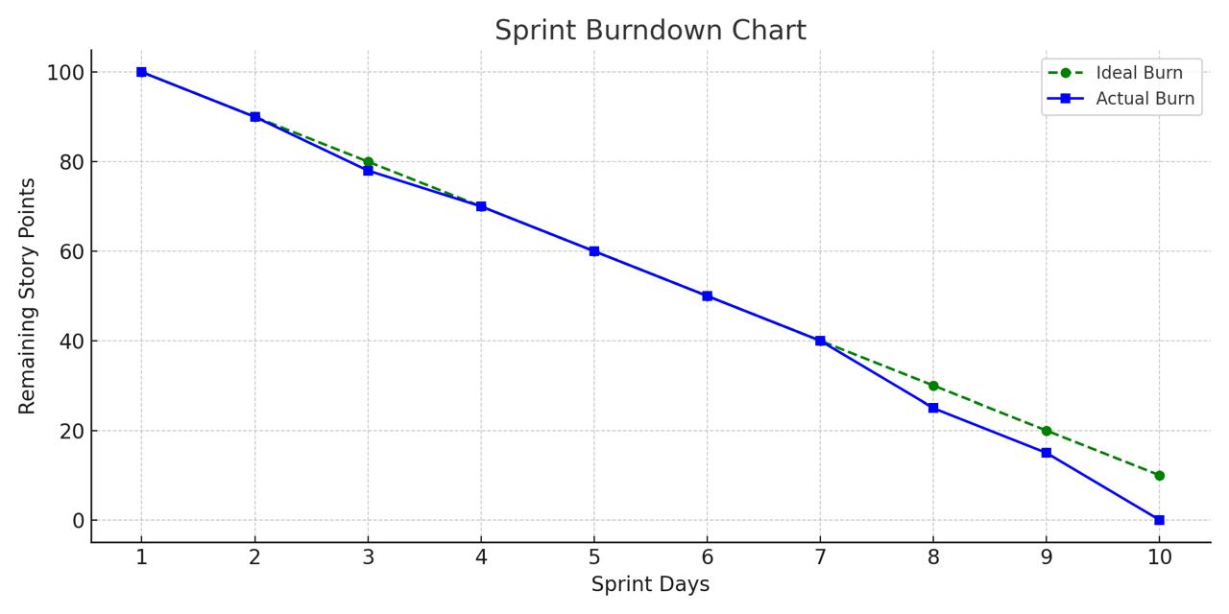

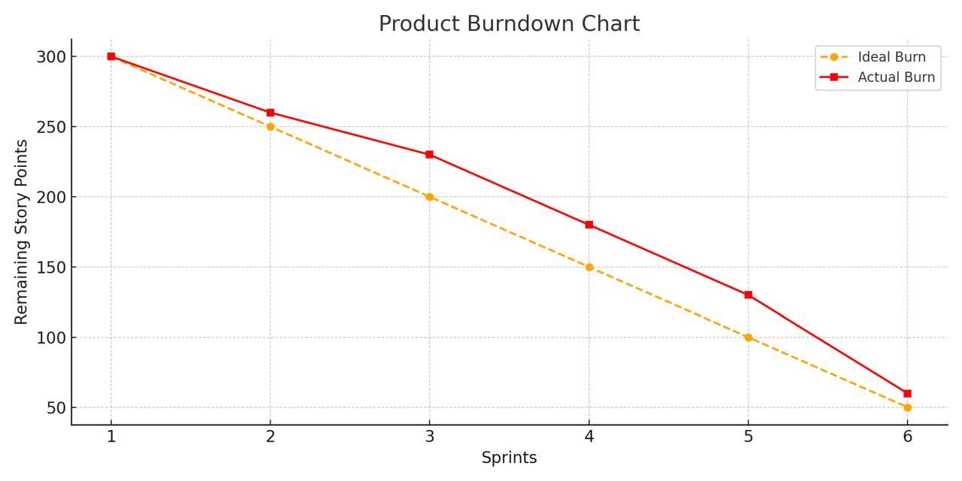
Question 10 – Explain about Product Grooming
Answer - What is Product Grooming?

Product Grooming, also known as Backlog Refinement, is the process of reviewing, updating, and prioritizing items in the Product Backlog to ensure that the Scrum Team is ready for upcoming sprints.

Key Activities in Product Grooming:
1. Clarifying User Stories – Ensure stories are clearly defined, understandable, and testable.
2. Adding Acceptance Criteria – To define what qualifies a story as “done”.
3. Estimating Complexity Points (CP) – Developers assign CP using Planning Poker.
4. Prioritizing PBIs by Business Value (BV) – Done by the Product Owner.
5. Splitting Epics into User Stories – Large features are broken down for easier sprint planning.

Question 11 – Explain the roles of Scrum Master and Product Owner

Answer - Roles of Scrum Master vs. Product Owner
🔹 Aspect | 🔵 Scrum Master | 🟠 Product Owner
Primary Focus | Scrum Process & Team Efficiency | Product Vision & Business Value
Main Role | Facilitator and Coach | Customer Representative & Backlog Owner
Key Responsibilities | - Facilitate Scrum events  - Remove impediments  - Coach the team  - Ensure Scrum adoption  - Protect team from disruptions | - Define product vision  - Manage and prioritize backlog  - Gather stakeholder input  - Ensure value delivery  - Accept/reject work
Interaction With | Development Team, Product Owner | Stakeholders, Customers, Development Team
Decision-Making Power | No product decision-making authority | Has decision-making authority over product features
Success Measured By | Team productivity, process improvement | Product value, customer satisfaction, ROI
Example Scenario | Helps team resolve technical roadblock during sprint | Prioritizes feature request from client for next sprint

Question 12 – Explain all Meetings Conducted in Scrum Project
Answer - 1. Sprint Planning Meeting
• Purpose: Decide what work will be done in the sprint.
• Attendees: Product Owner, Scrum Master, Scrum Team
• Output: Sprint Goal and Sprint Backlog
• Example in Scrum Foods: You (Product Owner) selected high-priority user stories like registration, order view, and payment mode, based on Business Value and Complexity Points.

2. Daily Scrum (Stand-up Meeting)
• Purpose: Track daily progress and highlight blockers.
• Duration: 15 minutes daily
• Attendees: Scrum Team and Scrum Master
• Each developer answers:
1. What did I do yesterday?
2. What will I do today?
3. Any impediments?
• Example in Scrum Foods: Developers shared their updates on modules like customer address input and delivery status tracking.

3. Sprint Review Meeting
• Purpose: Demonstrate the working product increment to stakeholders.
• Attendees: Scrum Team, Product Owner, Stakeholders
• Outcome: Feedback is collected for future improvement.
• Example in Scrum Foods: Delivery Boy registration and Customer order flow were shown to stakeholders for feedback.

4. Sprint Retrospective Meeting
• Purpose: Reflect on the sprint to improve future performance.
• Attendees: Scrum Team and Scrum Master
• Focus:
• What went well?
• What didn’t go well?
• What can we improve?
• Example in Scrum Foods: Team suggested reducing task overload and improving collaboration tools.

5. Backlog Refinement (Product Grooming)
• Purpose: Keep the Product Backlog updated and prioritized.
• Led by: Product Owner
• Includes: Adding new stories, estimating CP, updating Acceptance Criteria
• Example in Scrum Foods: You refined stories like “viewing revenue reports” and split epics into manageable stories for upcoming sprints.

Question 13 – Explain Sprint Size and Scrum Size
Answer - Sprint Size:
• Sprint Size refers to the duration of a Sprint, which is a time-boxed period in which a Scrum team delivers a potentially shippable product increment.
• Typically, the Sprint size is 1 to 4 weeks, most commonly 2 weeks.
• The size is decided based on project complexity, team experience, and delivery expectations.
• It helps in planning, reviewing, and improving work in a predictable rhythm.

Scrum Size:
• Scrum Size refers to the ideal number of members in a Scrum Team.
• As per Scrum guidelines, the ideal Scrum Team size is 10 or fewer people, including:
• Product Owner
• Scrum Master
• Developers/Team Members
• A small, cross-functional, and self-organizing team ensures better collaboration and quicker decision-making.

Question 14 – Explain DOR and DOD
Answer - DOR (Definition of Ready):
• DOR means a user story or task is fully prepared to be taken into a Sprint.
• It ensures that the backlog item is clear, well-defined, and actionable by the development team.
• A user story is considered “Ready” when:
• It has clear acceptance criteria
• Dependencies are identified and resolved
• Proper estimation is done
• Prioritized in the product backlog

Purpose: To avoid ambiguity and ensure the team starts work only on fully understood items.

DOD (Definition of Done):
• DOD means the criteria that must be met for a user story to be considered complete.
• It ensures that work meets the quality standards and is potentially shippable.
• A task is “Done” when:
• Code is written and reviewed
• Testing is completed
• Documentation is updated
• Product Owner has accepted it

Purpose: To ensure quality, consistency, and delivery of a usable product increment.

Question 15 – Explain Prioritization Techniques and MVP
Answer - Prioritization techniques help the Product Owner and stakeholders decide which features or tasks to deliver first based on business value, urgency, and impact.

Here are some commonly used techniques:
1. MoSCoW Method:
• Must Have – Essential requirements
• Should Have – Important but not critical
• Could Have – Desirable but optional
• Won’t Have (now) – Not included in this release
2. Kano Model:
• Focuses on customer satisfaction.
• Categories: Must-Have, Performance, and Delighters.
3. Value vs Effort Matrix:
• Plots features on a graph based on business value and effort to implement.
• Helps in quick decision-making – prefer high value, low effort items.
4. 100 Dollar Test:
• Stakeholders are given $100 to distribute among features based on their perceived value.

MVP (Minimum Viable Product):
• MVP refers to the smallest version of a product that can be released with enough features to satisfy early adopters and gather feedback.
• It includes only core functionalities necessary for users to use the product.
• Helps in:
• Reducing time-to-market
• Saving development costs
• Validating product ideas early

Question 16 – Difference between Business Analyst n Product Owner
Answer -
🔹 Criteria | 🧩 Business Analyst (BA) | 🎯 Product Owner (PO)
Primary Focus | Understanding and analyzing business needs | Delivering business value through the product
Main Responsibility | Elicit, document, and manage requirements | Own and prioritize the product backlog
Reports To | Project Manager or Business Stakeholders | Often reports to Product Management or Business Leadership
Backlog Ownership | May help maintain or refine backlog but does not own it | Fully owns and manages the product backlog
Decision-Making Power | Suggests solutions but may not have authority to take final calls | Makes final decisions about feature priority and product scope
Customer Interaction | Indirect; via research and interviews | Direct; engages with customers and stakeholders regularly
Role in Agile Team | Acts as a bridge between stakeholders and the team | Represents the customer voice within the Scrum team
Documentation Focus | High – Prepares BRDs, FRDs, Use Case Specs | Moderate – Focuses on user stories and acceptance criteria
Goal | Ensure complete and correct requirements | Ensure maximum value delivery per Sprint
Presence in Scrum | Not a formal Scrum role, but often works with PO and team | One of the three core Scrum roles

Question 17 – Prepare a sample Resume of 3yrs exp Product Owner
Answer -

