Document 6- Please prepare a use case diagram, activity diagram and a use case specification document.

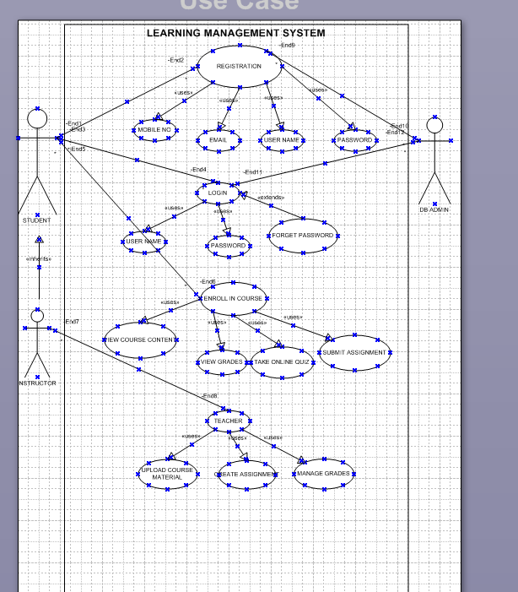

- Actors: The Student (Primary) and the Instructor (Secondary) are directly interacting with the use case. The System Administrator is a supporting actor who ensures the system is running but doesn't interact directly with this specific function.
- Use Case: The core action is "Submit Assignment."
- Associations: The Student initiates the use case. The Instructor receives a notification and can grade the submission. The system sends a confirmation email to the student.

Activity Diagram

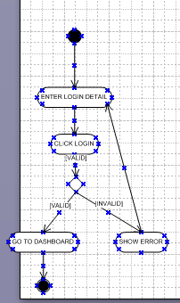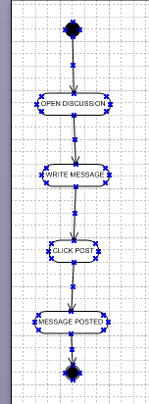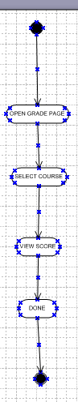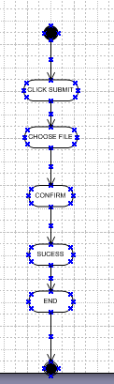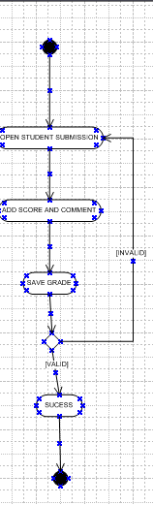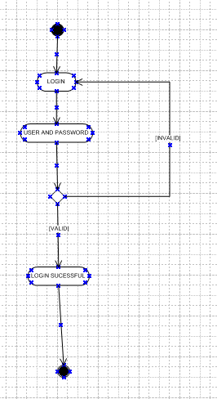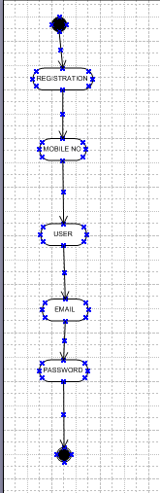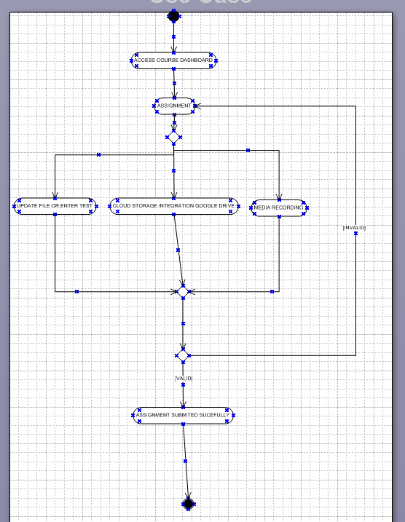

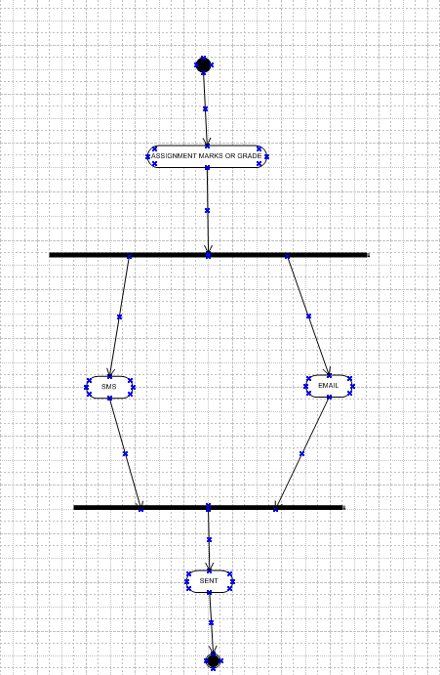

3. Use Case Specification Document
1. Use Case Name: Submit Assignment
2. Use Case Description:
This use case allows a Student to upload and submit their completed assignment work to the LMS for a specific course before a defined deadline. The system records the submission, confirms it, and notifies the instructor.
3. Actors:
- Primary Actor: Student
- Secondary Actors: Instructor (receives notification), Email Server (sends automated emails)
4. Basic Flow (Happy Path):
- The Student navigates to the specific assignment page in their course.
- The system displays the assignment details, including the deadline.
- The Student clicks the "Submit Assignment" button.
- The system presents a dialog to upload a file.
- The Student selects the correct file from their computer and confirms the upload.
- The system validates that the file type and size are acceptable.
- The system saves the file to a secure server.
- The system records the submission time and date, and updates the assignment status to "Submitted."
- The system displays a success message: "Assignment Submitted Successfully."
- The system automatically sends a confirmation email to the Student.
- The system generates a notification for the Instructor indicating a new submission is ready for grading.
- The use case ends successfully.
5. Alternate Flow:
- 5a. Resubmit Assignment:
  - If the assignment allows resubmissions and the deadline has not passed, the Student can submit a new file.
  - The system automatically archives the previous submission and replaces it with the new one, logging the action.
  - The flow rejoins the basic flow at step 8.
6. Exceptional Flows:
- 6a. Assignment Deadline Passed:
  - If the Student tries to submit after the deadline, the system displays an error: "The assignment deadline has passed. Submission is closed."
  - The use case ends in failure.
- 6b. Invalid File Type/Size:
  - If the uploaded file is not of an allowed type (e.g., .exe, .bat) or exceeds the maximum size limit (e.g., 100MB), the system displays an error: "Invalid file type or file too large. Please check the requirements."
  - The system returns the user to the upload dialog (Basic Flow step 5).
- 6c. Network Failure During Upload:
  - If the connection is lost during file upload, the system displays an error: "Upload Failed. Please check your connection and try again."
  - The use case ends in failure, and no submission is recorded.
7. Pre-Conditions:
- The Student must be registered and enrolled in the course.
- The Student must be logged into the LMS.
- The Instructor must have created and published the assignment.
- The assignment must be active and available for submission (i.e., the current date/time is before the set deadline).
8. Post-Conditions:
- Success: The assignment file is stored on the server. The submission timestamp is recorded. The assignment status for the student is set to "Submitted." A confirmation email is sent.
- Failure: No file is saved. The database remains unchanged. No email is sent.
9. Assumptions:
- The Student has a stable internet connection.
- The Student has the completed assignment file saved on their device.
- The Student knows how to navigate the LMS interface.
- The LMS and file servers are operational and have enough storage space.
10. Constraints:
- File size is limited to a maximum of 100MB per submission.
- Only specific file types are allowed (e.g., .pdf, .docx, .pptx, .zip).
- Submissions are final once the deadline passes (unless the Instructor manually re-opens it).
- The system must be accessible via a web browser on both desktop and mobile devices.
11. Dependencies:
- The use case is dependent on the "Create Assignment" use case (performed by the Instructor) as an assignment must exist to be submitted.
- Relies on the correct functioning of the file storage server and the email notification system.
12. Inputs and Outputs:
- Inputs:
  - Student ID (from logged-in session)
  - Assignment ID
  - Digital file from Student's device
- Outputs:
  - Success/Error message on the user interface.
  - Confirmation email (output to Student).
  - Notification alert (output to Instructor's dashboard).
  - Database record update (submission time, file path, status).
13. Business Rules:
- BR1: A student cannot submit an assignment after the deadline without special permission from the Instructor.
- BR2: The system must maintain an audit trail of all submission attempts for academic integrity purposes.
- BR3: The file upload must be scanned for malware before being stored.
- BR4: The confirmation email must include the file name, submission time, assignment name, and course name.
14. Miscellaneous Information:
- The user interface should clearly show the time remaining until the deadline.
- A preview feature for common file types (like PDFs) before final submission would be a valuable enhancement.
- The system should handle multiple file submissions if the assignment requires it.
- Performance: The upload process should provide a progress bar and should not timeout for large files on slow connections.

Document 7- Screens and pages

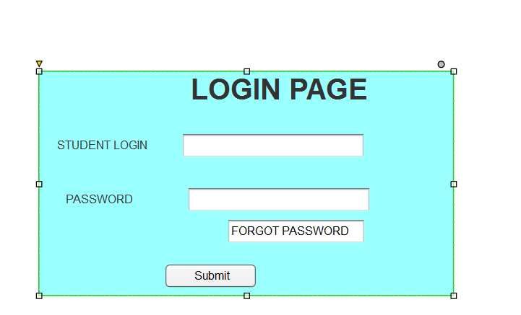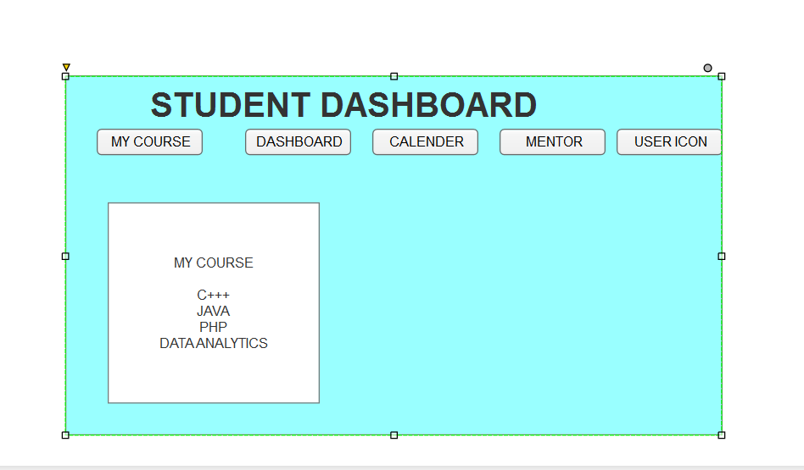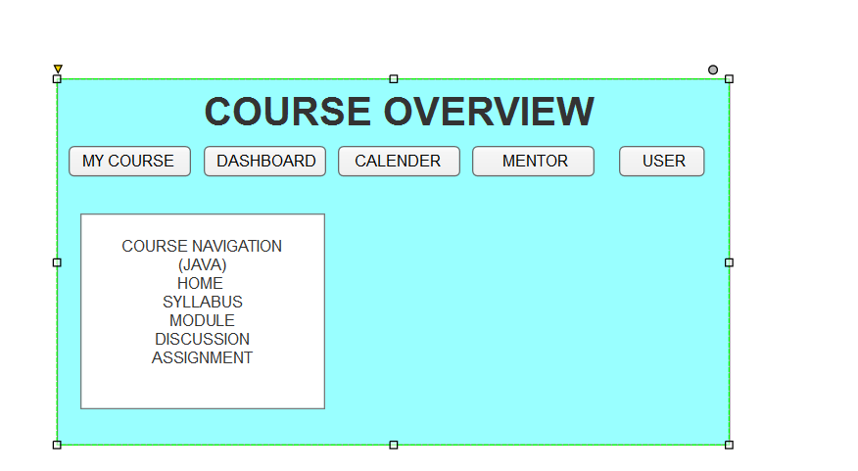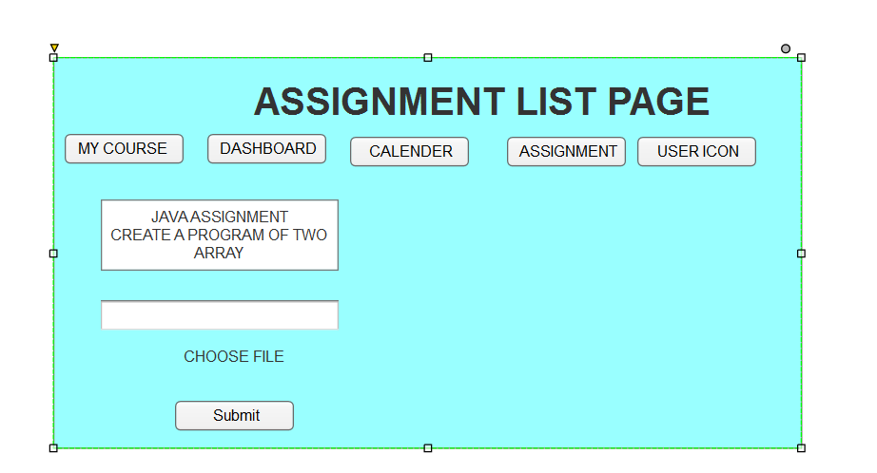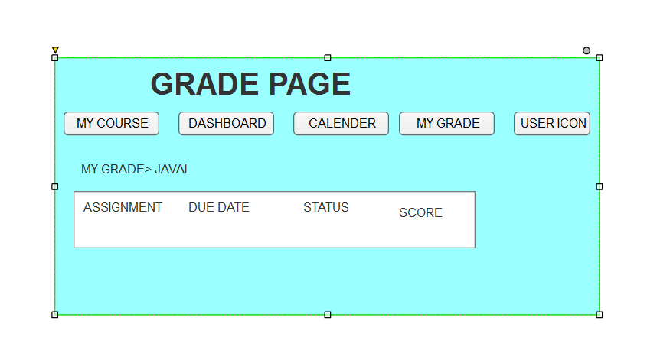

Document 8- Tools-Visio and Axure

Using Microsoft Visio in the LMS Project
Within the LMS project, Microsoft Visio was the definitive tool for engineering the system's backbone, serving as the blueprint for developers and database architects. Its primary application was in rigorously defining complex, multi-actor workflows and data relationships that are central to an LMS. For example, we used Visio to meticulously map the entire data flow for a critical path like "Course Enrollment," creating detailed swimlane diagrams that visualized the interaction between the Student, the System, and the Registrar's database, ensuring all exception flows (like pre-requisite checks or seat capacity) were logically accounted for. Furthermore, its database modeling features were crucial for designing the schema, allowing us to visually construct the relationships between entities like Users, Courses, Enrollments, Assignments, and Submissions, ensuring referential integrity and efficient data structure from the outset. This precision was invaluable for creating a shared technical understanding, but its static diagrams could not effectively communicate the student's journey through a micro-learning module or the instructor's experience of using a real-time collaborative grading tool, which required a more experiential representation.

Using Axure RP in the LMS Project
Axure RP was employed to prototype and validate the user-centric front-end of the LMS, focusing squarely on the pedagogical experience and administrative efficiency. Its power was unleashed in simulating the rich, context-dependent interactions that define a modern LMS. We created a fully functional prototype of the student's learning path, complete with dynamic panels that simulated video playback, quiz completion with immediate feedback, and the unlocking of subsequent modules based on completion rules. For administrators and instructors, we built complex, data-driven interfaces like the dashboard widget configuration tool and the gradebook, using Axure's repeater widgets to show how they could sort, filter, and manage large sets of student data. This allowed us to conduct usability testing that revealed critical insights, such as the need for a more intuitive bulk-grading interface for instructors, before any code was written. By generating a live, interactive prototype, Axure moved the conversation with stakeholders from "what it does" to "how it feels," ensuring the final LMS was not only functionally robust but also intuitive and engaging for all its users.

Document 9- BA experience

BA Experience in a Learning Management System (LMS) Project
The role of a Business Analyst is critical in a complex software project like an LMS, which involves multiple stakeholders (students, instructors, administrators, IT) and intricate functionalities. Here’s a breakdown of the BA's experience across each phase for an LMS implementation.

1. Requirement Gathering
- MOSCOW Technique: For an LMS, this is essential to manage scope.
  - MUST HAVE: Core functionalities without which the LMS fails (e.g., user login, course enrollment, content viewing, assignment submission, basic gradebook).
  - SHOULD HAVE: Important but not vital for launch (e.g., discussion forums, calendar integration, gamification badges).
  - COULD HAVE: Desirable but with less impact (e.g., advanced analytics dashboards, custom certificate generation).
  - WON'T HAVE (This time): Explicitly deferred features (e.g., a mobile app, complex LTI tool integrations, AI-based proctoring).
- Client Unavailability: A common challenge. The BA must be proactive.
  - Action: Identify and source alternative Points of Contact (POCs) from the client's side—e.g., a Head of Training, a Lead Instructor, or a IT manager—to get answers on requirements like "What are the acceptable file types for assignment submissions?" or "What is the process for a student to withdraw from a course?"
- FURPS Validation: This technique ensures requirements are holistic.
  - Functionality (Core features): "The system must allow instructors to create quizzes with multiple-choice questions."
  - Usability: "The interface for students to submit assignments must be completed in less than 3 clicks."
  - Reliability: "The system must have 99.9% uptime during final exam weeks."
  - Performance: "The platform must support 500 concurrent users streaming video lectures."
  - Supportability: "The system must be easily deployable on our cloud infrastructure."
- Removing Duplicates: Crucial for an LMS where requirements like "track progress" or "send notifications" can be repeated across different user stories. Consolidating these prevents development redundancy.
- Prototyping: Invaluable for visualizing the LMS. A clickable prototype (e.g., in Axure) of the instructor's course creation wizard or the student's learning dashboard helps stakeholders give specific feedback, preventing misunderstandings later.

2. Requirement Analysis
- UML Diagrams: These translate textual requirements into a universal visual language for the technical team.
  - Use Case Diagram: Shows all functionalities (e.g., Enroll in Course, Grade Assignment, Generate Report) and which actor (Student, Instructor, Admin) performs them.
  - Activity Diagram: Details the step-by-step flow of a process, like the "Submit Assignment" flow, including all decision points (e.g., "Is the submission before the deadline?").
  - Sequence Diagram: Illustrates the real-time interaction between objects for a specific scenario, such as the message exchange between the Student browser, LMS server, and database when loading a course page.
- Team Communication & Modifications: The BA presents these diagrams in meetings. A developer might point out that a proposed workflow for "Course Approval" is inefficient and suggest a better technical approach. A good BA incorporates this feedback, ensuring the solution is both functionally correct and technically sound.
- BRS & SRS:
  - Business Requirements Specification (BRS): High-level business goals. Example: "The LMS must reduce the administrative overhead of managing training by 20%."
  - System Requirements Specification (SRS): Detailed functional and non-functional requirements. Example: "The system shall allow an administrator to bulk upload users via a CSV file with columns: Email, First Name, Last Name, Role."

3. Design
- Test Cases from Use Cases: Each use case generates multiple test cases.
  - Use Case: Submit Assignment
  - Positive Test Case: Student submits a valid PDF file before the deadline -> System accepts it and sends confirmation.
  - Negative Test Case: Student submits an .exe file -> System rejects it with an appropriate error message.
- Client Communication: The BA walks the client through solution design documents to ensure the proposed technical design meets their business needs.
- Importance of Test Cases: Missing a negative test case for "password reset" (e.g., handling an invalid token) could leave a critical security vulnerability in the LMS.
- Test Data: The BA requests or creates realistic data for testing (e.g., sample student accounts, sample courses, sample assignments).
- Update RTM (Requirements Traceability Matrix): This is a live document. The BA ensures every requirement in the BRS/SRS has a corresponding design element and test case. This guarantees nothing is missed and provides full visibility into coverage.

4. Development
- JAD Sessions: Organized Joint Application Development (JAD) sessions are crucial. The BA brings together developers, testers, and a client representative to collaboratively solve complex issues, like designing the logic for calculating final grades based on weighted categories (quizzes, assignments, participation).
- Clarifying Queries: The tech team will have detailed questions during coding. Example: "If a student is enrolled in a course and the course is deleted by an admin, should we soft-delete the enrollment or hard-delete it?" The BA must provide the answer based on business rules.
- Handling Conflict: The BA acts as a facilitator. If a developer is uncooperative, a one-on-one discussion to explain the business impact of their actions (e.g., "If we don't implement this accessibility feature, we are excluding users with disabilities, which is a legal risk") is more effective than a public confrontation.
- Meeting Challenges: Coordinating between busy technical teams and clients is difficult. Recording meetings and following up with absent key individuals is a critical BA skill to keep the project on track.

5. Testing
- High-Level Testing: The BA performs smoke testing and sanity checks on new builds to ensure core LMS workflows (login -> open course -> view content) work before the build is passed to the QA team for full regression testing.
- Test Data from Client: For UAT, the BA requests realistic data from the client (e.g., actual training content, a list of real user roles) to create a testing environment that mirrors production.
- UAT Preparation: The BA prepares the client for User Acceptance Testing (UAT) by creating clear UAT scripts (e.g., "Log in as an instructor and attempt to create a new announcement") and training the client's testers on how to use the system and report bugs.

6. Deployment
- Project Closure: The finalized RTM is a key part of the project closure document, proving that all agreed-upon requirements have been delivered and tested.
- End-User Manuals: The BA coordinates with technical writers or creates simple guides themselves—e.g., "Quick Start Guide for Students," "Instructor Manual."
- Training Sessions: The BA plans and organizes training sessions for the end-users (instructors, administrators, students). This is a final knowledge transfer to ensure the client can use the LMS effectively.

