Assignment 1.1.

Business Requirements Document (BRD)
Project Name: Inventory & Delivery Management System (IDMS)
Version: 1.0
Prepared By: [Bhumika Sahu]
Date: [12-08-2025]

1. Executive Summary
The company operates multiple manufacturing plants and warehouses across the country, producing ice-cream and milk products. The current operations face challenges in managing stock levels efficiently and ensuring the quickest delivery to customers. This project aims to develop a centralized software solution to:
- Manage the inventory across all plants and warehouses in real time.
- Enable quickest delivery by optimally allocating orders to the nearest and best-stocked location.
The solution will integrate inventory management, order routing, logistics tracking, and reporting dashboards to streamline operations, reduce wastage, and improve customer satisfaction.

2. Objectives
- Provide a real-time inventory view across all manufacturing and warehouse locations.
- Automate stock replenishment alerts based on threshold levels.
- Enable dynamic delivery routing for fastest fulfilment.
- Integrate with existing ERP and accounting systems.
- Provide role-based dashboards for management, warehouse operators, and delivery partners.

3. Scope

In Scope
- Inventory tracking at SKU level (ice-cream flavors, milk variants, pack sizes).
- Order allocation based on inventory levels and geographic proximity.
- Delivery route optimization using mapping APIs (e.g., Google Maps API).
- Automated alerts for stock shortages, expirations, and replenishment needs.
- Mobile app for warehouse staff to scan and update stock.
- Reporting & analytics (sales trends, wastage reports, delivery performance).

Out of Scope
- Manufacturing process automation.
- Third-party vendor management outside delivery partners.

4. Stakeholders
Role | Stakeholder | Responsibility
Sponsor | CEO | Approve funding and project direction
Business Owner | Operations Manager | Define business rules & KPIs
End Users | Warehouse Staff | Daily inventory updates
End Users | Delivery Managers | Route and dispatch management
Technical Team | Developers, QA, DevOps | Build, test, deploy software

5. High-Level Requirements
ID | Requirement Description | Priority
R1 | Centralized inventory database accessible in real-time | High
R2 | Barcode/QR code scanning for stock updates | High
R3 | Geo-location-based order routing | High
R4 | Expiry date tracking for perishable goods | High
R5 | Mobile and web portals for staff and management | High
R6 | Role-based access control | Medium
R7 | Integration with ERP & accounting systems | Medium
R8 | Automated stock alerts and replenishment requests | High
R9 | Analytics dashboard for performance monitoring | Medium

6. Assumptions & Constraints
Assumptions:
- Internet connectivity is available at all locations.
- All warehouses have barcode scanners or compatible smartphones.
- Delivery partners share live location data.
Constraints:
- Budget: ₹[Specify budget]
- Delivery timeline: [e.g., 6 months]
- Must comply with food safety & transport regulations.

7. Risks & Mitigation
Risk | Impact | Mitigation
Data inaccuracy during stock update | High | Training staff and automating scanning
Delayed delivery due to weather | Medium | Route re-optimization and buffer stock
Integration challenges with ERP | High | API-based modular integration

8. Development Plan

8.1 Phases & Timeline (Example – 6 Months Total)
Phase | Duration | Activities
Requirement Gathering | 2 weeks | Workshops, interviews, process mapping
Design | 3 weeks | UI/UX, architecture, database design
Development (Backend + Frontend) | 8 weeks | Inventory module, delivery routing module
Integration & Testing | 4 weeks | SIT, UAT
Deployment | 1 week | Production release
Post-Go-Live Support | 2 weeks | Bug fixes, enhancements

9. Resource Plan
Role | No. of Resources | Duration | Responsibility
Business Analyst | 1 | Full Project | Requirement gathering, BRD, UAT support
UI/UX Designer | 1 | 3 weeks | Wireframes, prototypes
Backend Developer | 2 | 8 weeks | API & database
Frontend Developer | 2 | 8 weeks | Web & mobile UI
QA Engineer | 2 | 4 weeks | Test cases, SIT/UAT
DevOps Engineer | 1 | 2 weeks | Deployment, CI/CD setup
Project Manager | 1 | Full Project | Planning, tracking, client communication

10. Deliverables
- BRD & Functional Requirement Document (FRD)
- UI/UX mockups and wireframes
- Backend and frontend modules
- Integration APIs
- Test cases & UAT reports
- Training manuals for staff
- Go-live deployment & support plan

11. Success Metrics
- 100% inventory accuracy across all locations
- 20% reduction in delivery time
- 15% reduction in wastage due to expiry
- Positive customer feedback on delivery speed

Assignment 1.2.

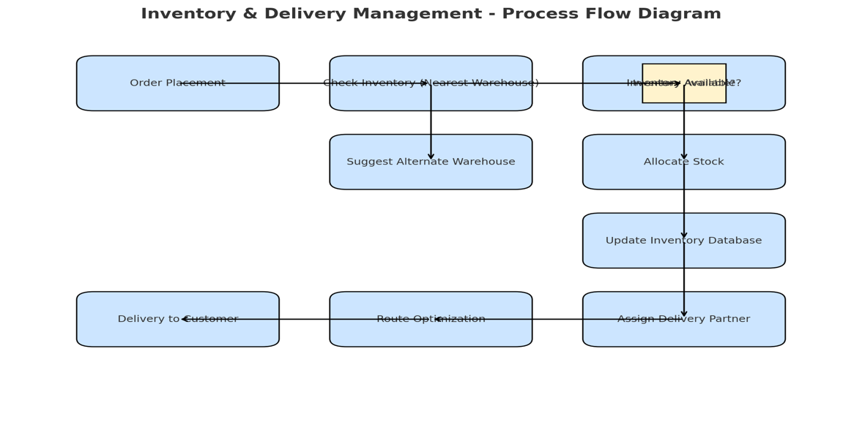
Assignment 2.1

Dear ABC company,
I hope this message finds you well.
My name is Bhumika Sahu, and I will be serving as the Business Analyst for your project. I will be working closely with you and your team to initiate the business understanding process, ensuring we capture your goals, requirements, and expectations accurately.
My role will involve facilitating discussions, gathering and analysing requirements, and translating them into clear, actionable documentation for our development team. I will also act as a bridge between your business objectives and the technical implementation, ensuring that the solution aligns with your vision.
Over the next few days, I will be scheduling requirement workshops and discovery sessions to understand your current processes, challenges, and success metrics. This will help us lay a strong foundation for the project.
I look forward to collaborating with you and your team to make this initiative a success. Please feel free to reach out to me directly for any clarifications or inputs.
Best regards,
Bhumika Sahu
Business Analyst
Cognizant Technology Services
Assignment 2.2

1. Business Requirements Document (BRD) – Online Ticketing System
Project Name: SmartTicket – Online Ticket Booking Platform
Version: 1.0
Prepared By: Bhumika Sahu
Date: [Insert Date]

1. Executive Summary
SmartTicket is a web and mobile-based platform designed to allow customers to browse events, book tickets, make payments, and receive e-tickets instantly. The system aims to provide a seamless user experience, reduce manual booking errors, and offer real-time seat availability.

2. Objectives
- Provide a centralized ticket booking portal for concerts, movies, sports, and other events.
- Enable real-time seat selection and instant booking confirmation.
- Facilitate secure online payments and e-ticket generation.
- Offer admin dashboards for event organizers to track sales.

3. Scope
In Scope:
- User registration/login.
- Event search and filtering.
- Seat selection and booking.
- Payment integration with multiple gateways.
- E-ticket generation and email/SMS confirmation.
- Admin panel for event management and sales reporting.
Out of Scope:
- Event hosting or streaming.
- Cash-on-delivery payment method.

4. Stakeholders
- Sponsor: Company CEO
- Business Owner: Event Operations Manager
- End Users: Customers booking tickets, Event organizers
- Technical Team: Developers, QA, UI/UX designers

5. High-Level Requirements

ID | Requirement | Priority
R1 | Users can search and filter events by date, location, category | High
R2 | Seat map view with real-time availability | High
R3 | Secure online payment processing | High
R4 | Generate e-tickets with QR codes | High
R5 | Admin can create/edit events | Medium
R6 | Reporting dashboard for organizers | Medium

2. Software Requirements Specification (SRS) – Online Ticketing System
Project Name: SmartTicket – Online Ticket Booking Platform
Version: 1.0
Prepared By: Bhumika Sahu
Date: [Insert Date]

1. Introduction

1.1 Purpose
This document specifies the functional and non-functional requirements for SmartTicket. It is intended for the development, testing, and deployment teams.

1.2 Product Scope
SmartTicket will provide users the ability to browse events, book tickets, make secure payments, and receive instant booking confirmations.

2. Functional Requirements
FR1 – User Registration/Login
- Users can register with email/phone and password or via social logins.
FR2 – Event Search & Filter
- Search by event name, location, date, category.
FR3 – Seat Selection
- Interactive seat map with availability status.
FR4 – Payment Integration
- Integration with Stripe, Razorpay, PayPal, etc.
FR5 – E-Ticket Generation
- System generates a QR-coded ticket sent to email/SMS.
FR6 – Admin Management
- Admin can create, edit, or delete events.
- Admin dashboard to view ticket sales and revenue.

3. Non-Functional Requirements

NFR ID | Requirement | Priority
NFR1 | The system should handle up to 10,000 concurrent users | High
NFR2 | Booking confirmation should be completed within 5 seconds | High
NFR3 | The system should maintain 99.9% uptime | High
NFR4 | Data should be encrypted using HTTPS/TLS | High

4. Assumptions & Constraints
Assumptions:
- Users have internet access.
- Events are managed by verified organizers.
Constraints:
- Limited budget for payment gateway fees.
- Compliance with data protection laws (e.g., GDPR).

Assignment 2.3 ER Diagram

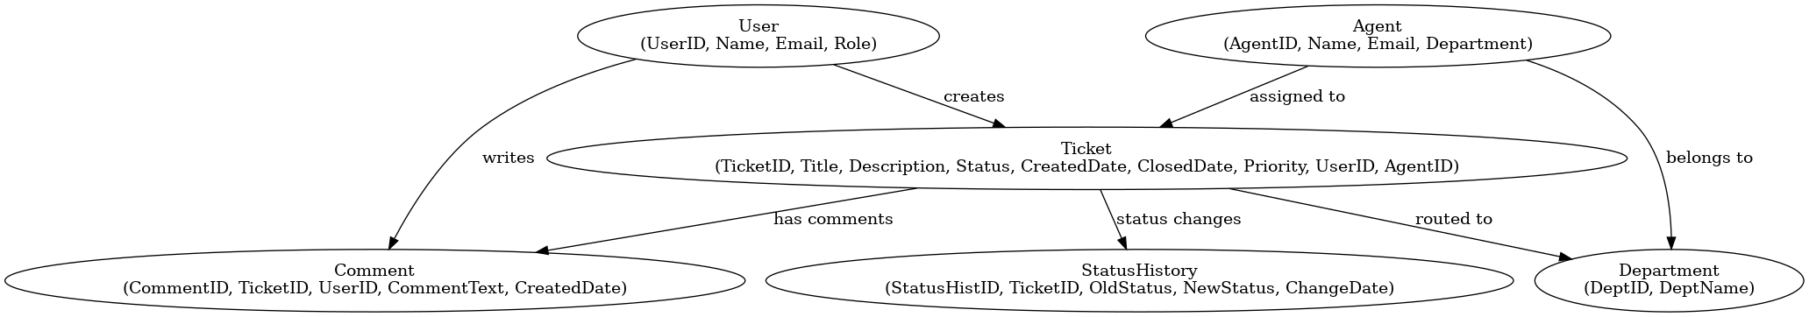

Assignment 2.4

US ID | User Story | Acceptance Criteria | BV | CP
US-001 | As a visitor, I want to create an account so that I can shop and track my orders. | • Registration form with email/phone.  • OTP verification before activation. | 100 | 5
US-002 | As a registered user, I want to log in so that I can access my account. | • Login with email/password. • Social login options available. | 200 | 3
US-003 | As a logged-in user, I want to log out so that my account remains secure. | • Logout button available.  • Session ends immediately. | 500 | 2
US-004 | As a user, I want to edit my profile details so that my personal information is up to date. | • Editable profile page.  • Changes saved successfully. | 200 | 3
US-005 | As a user, I want to change my password so that my account stays secure. | • Old password validation.  • Confirmation before update. | 100 | 3
US-006 | As a user, I want to reset my password if I forget it so that I can regain account access. | • Password reset email/OTP.  • Secure update process. | 200 | 5
US-007 | As a user, I want to search products by keyword so that I can quickly find what I need. | • Search bar present.  • Results show relevant products. | 500 | 5
US-008 | As a user, I want to filter products by price, brand, and category so that I can refine my choices. | • Multiple filter options available.  • Filters can be combined. | 100 | 5
US-009 | As a user, I want to sort products by price, rating, and popularity so that I can view them in my preferred order. | • Sort dropdown available.  • Sorting applies instantly. | 200 | 3
US-010 | As a user, I want to see detailed product descriptions, specifications, and reviews so that I can make an informed purchase. | • Product details page includes description, price, reviews. | 200 | 5
US-011 | As a user, I want to view multiple product images so that I can examine the product closely. | • Image carousel available.  • Zoom function works. | 100 | 3
US-012 | As a user, I want to check if a product is available in my region so that I know if I can order it. | • Pincode checker.  • Availability displayed clearly. | 100 | 5
US-013 | As a user, I want to add items to my cart so that I can purchase them later. | • "Add to Cart" button available.  • Confirmation message shown. | 200 | 3
US-014 | As a user, I want to change the quantity of items in my cart so that I can adjust my purchase. | • Quantity selector available. • Cart total updates automatically. | 200 | 3
US-015 | As a user, I want to remove an item from my cart so that I can finalize my purchase list. | • Remove option available.  • Cart updates instantly. | 100 | 3
US-016 | As a user, I want to view all the items in my cart so that I can review before checkout. | • Cart page lists items, prices, totals. | 100 | 3
US-017 | As a user, I want to move items to a wishlist so that I can purchase them in the future. | • "Save for Later" option.  • Items move to Wishlist. | 200 | 3
US-018 | As a user, I want to save my favourite products in a wishlist so that I can easily find them later. | • Wishlist accessible from profile. | 100 | 3
US-019 | As a user, I want to add a shipping address so that my orders are delivered to the correct location. | • Address form with validation. | 200 | 5
US-020 | As a user, I want to choose from multiple payment methods so that I can pay in my preferred way. | • Credit/debit card, UPI, wallets available. | 200 | 8
US-021 | As a user, I want to apply coupon codes so that I can get discounts. | • Coupon code field at checkout.  • Validation applied. | 500 | 3
US-022 | As a user, I want to review my order details before payment so that I can confirm accuracy. | • Order summary shown before payment. | 500 | 3
US-023 | As a user, I want to make a secure payment so that I can complete my purchase. | • Secure gateway integration (SSL/TLS). | 200 | 8
US-024 | As a user, I want to receive an order confirmation via email/SMS so that I know my purchase was successful. | • Order ID generated.  • Confirmation message sent. | 200 | 5
US-025 | As a user, I want to track my order status so that I know when it will arrive. | • Real-time tracking page. | 100 | 5
US-026 | As a user, I want to cancel my order so that I can stop it before it ships. | • Cancel button available until shipment. | 100 | 5
US-027 | As a user, I want to request a return or replacement so that I can resolve issues with the product. | • Return form with reason.  • Status tracking. | 100 | 5
US-028 | As a user, I want to view my past orders so that I can reorder or reference them. | • Order history list with filters. | 200 | 3
US-029 | As a user, I want to download my order invoice so that I have proof of purchase. | • PDF invoice downloadable. | 100 | 3
US-030 | As a user, I want to leave feedback on products so that I can share my experience. | • Review form with text & rating. | 100 | 3
US-031 | As a user, I want to rate products so that I can help other buyers. | • Star rating system available. | 200 | 3
US-032 | As a user, I want to read other customer reviews so that I can make a better purchase decision. | • Review section visible on product page. | 100 | 2
US-033 | As a user, I want to report inappropriate reviews so that the platform remains trustworthy. | • Report option on each review. | 100 | 3
US-034 | As a user, I want to receive order updates via push notifications, email, or SMS so that I’m informed in real-time. | • Notifications triggered at each status change. | 200 | 5
US-035 | As a user, I want to receive promotions and deals so that I don’t miss offers. | • Promotional notification system. | 500 | 3
US-036 | As a user, I want to contact support via chat, email, or call so that I can get help with my orders. | • Chatbot/live chat integration. | 500 | 8
US-037 | As a user, I want to browse FAQs so that I can find solutions to common issues. | • Searchable help center. | 200 | 3
US-038 | As an admin, I want to add or update products so that customers see accurate information. | • Product management panel. | 100 | 8
US-039 | As an admin, I want to update order statuses so that customers are informed about progress. | • Order management dashboard. | 100 | 5
US-040 | As an admin, I want to view reports on sales, revenue, and product performance so that I can make business decisions. | • Reports exportable to Excel/PDF. | 200 | 8

