Capstone Project 1 (Part 2)

Question1

4 Quarterly Audits are planned Q1 , Q2, Q3, Q4 for this Project What is your knowledge on how these Audits will happen for a BA ?

Answer

In a Business Analyst’s role, audits are conducted quarterly (Q1, Q2, Q3, Q4) to ensure that BA deliverables, processes, and documentation align with project objectives, standards, and stakeholder expectations.
The audits are as follows :
Quarter 1 Audit Report (Requirement Gathering Phase)
Completed: 10 weeks (Week 1 to Week 10)
Checklist:
- BRD Template
- Elicitation Results Report
- Duplicate Requirements Report
- Grouping of Functionalities/Features – Client Sign-off
- Email Communication – To, CC, BCC

Quarter 2 Audit Report (Requirement Analysis Phase
Completed: 8 weeks (Week 16 to Week 24)
Checklist:
- UML Diagrams
- Business to Functional Requirements Mapping
- Client Sign-off Documents
- RTM Document Version Control
- Email Communication – To, CC, BCC

Quarter 3 Audit Report (Design Phase
Completed: 8 weeks (Week 30 to Week 38)
Checklist:
- Utilization of Tools
- Documented Evidence on Client Communication
- Stakeholder MOM
- Email Communication – To, CC, BCC

Quarter 4 Audit Report (Testing & Implementation Phase)
Completed: 40 weeks (Week 42 to Week 82)
Checklist:
- Test Case Documents and Test Execution Reports
- Test case summary
- End user manual preparation document
- Implementation & Deployment Checklist
- Lessons Learned document
- Training report to end users
- Email Communication

Question 2

Before the Project is going to Kick Start, The Committee asked Mr Karthik to submit BA Approach Strategy Write BA Approach strategy (As a business analyst, what are the steps that you would need to follow to complete a project – What Elicitation Techniques to apply, how to do Stakeholder Analysis RACI/ILS, What Documents to Write, What process to follow to Sign off on the Documents, How to take Approvals from the Client, What Communication Channels to establish n implement, How to Handle Change Requests, How to update the progress of the project to the Stakeholders, How to take signoff on the UAT- Client Project Acceptance Form )

Answer
For the Online Agriculture Product Store project at APT IT Solutions, the following approach will be followed:
1. Elicitation Techniques
To capture business and functional needs effectively, the BA will use a combination of:
- Interviews: with Mr. Henry (Owner) and farmers (Peter, Kevin, Ben) to understand challenges.
- Brainstorming: sessions with the SOONY Committee to discuss features like payment, tracking, and delivery.
- Document Analysis: reviewing existing purchase and procurement records for context.
- Focus groups : creating a group having multiple stakeholder then getting insights from them.
- Reverse Engineering : Analyze similar existing agriculture or e-commerce applications to identify hidden or implied requirements and best practices.

2. Stakeholder Analysis
Identify and analyze all stakeholders for influence, interest, and role in the project.
RACI Matrix:
Activity | Mr. Henry  (Sponsor) | Mr. Pandu  (Finance) | Mr. Dooku  (Coordinator) | Mr. Karthik  (Delivery Head) | Vandanam  (PM) | BA | Developers | Testers | Farmers
Requirement  Gathering | I | I | C | A | C | R |  |  | C
Budget  Approval | A | R | C | C | I | I |  |  | I
Design and Development | I | I | I | I | A | C | R | C | I
Testing | I | I | I | C | A | C | C | R | C
Deployment | I | I | I | C | A | C | C | R | A
Feedback and Improvement | I | I | I | C | C | R | C | C | A

ILS (Influence–Interest–Support) :
Stakeholder | Influence | Interest | Support
Mr. Henry (Owner) | High | High | High
Mr. Pandu (Finance Head) | Medium | High | Medium
Mr. Dooku (Project Coordinator) | High | High | High
Peter / Kevin / Ben (Farmers) | Low | High | Medium
Mr. Vandanam (Project Manager) | High | High | High
Dev & QA Team | Medium | Medium | Medium
3.Documents to Write
The BA will prepare and maintain the following artifacts throughout the project:
- BRD – Business Requirements Document
- FRD – Functional Requirements Document
- Use Case document
- Test case document
4.Process of Document Sign-off
- Conduct internal document walkthrough sessions with project team and stakeholders.
- Take sign off on SRS as it is an important document.
- Share document for formal approval through email by client.
- Maintain control with clear version numbers and approval date.
- Store signed-off documents in the shared spaces for audit readiness.
5.Taking Approval from the Client
- Obtain formal email confirmation from Mr. Henry (Client Owner) and Mr. Dooku (Project Coordinator).
- Establish a formal meeting with the clients to keep them informed and get continuous feedback.
6.Communication Channels to be Established & Implemented
- Regular meetings – weekly status meetings
- MS Teams / Zoom: for weekly review and discussion calls.
- Jira / Trello: to track tasks, issues, and progress updates.
- Shared Drive : for document storage and version control.
- Monthly Stakeholders update: to summarize project progress for the committee.
7.Handling Change Requests
- Record each CR in the Change Request Log with details of requestor, date, and description.
- Perform Impact Analysis on timeline, cost, and scope.
- Present analysis to Project Manager and Client Committee.
- Implement only after written approval from Mr. Henry / Mr. Dooku.
- Update RTM and relevant documents with revised version number.
8.Updating the Progress of the Project to Stakeholders
- Conduct weekly progress meetings with the Project Manager and Committee.
- Conduct monthly review meetings
9.Taking Sign-off on the UAT – Client Project Acceptance Form
- Prepare UAT Scenarios based on signed-off requirements .
- Coordinate UAT execution with Testers (Ms. Alekya & Mr. Jason).
- Capture UAT results, issues, and resolutions.
- Obtain Client sign-off on the UAT – Project Acceptance Form confirming successful delivery.
- Final review meeting

Question 3

Explain and illustrate 3-tier architecture?

Answer

The 3-Tier Architecture is a client-server architectural model that divides an application into three logical layers — Presentation Layer, Application/Business Logic Layer, and Data Layer.
This structure improves scalability, security, maintainability, and reusability of the system.

Presentation Layer (Client Tier)
- Purpose: This layer handles user interaction and the front-end interface of the application.
- Technology Examples: HTML, CSS, JavaScript, React, or Angular.
- Responsibilities:
  - Displays the product catalog to farmers and manufacturers.
  - Accepts inputs like login credentials, search keywords, and order details.
  - Sends user requests to the business layer and displays responses.
In our project:
Farmers and manufacturers will interact through the website or mobile app interface.

Application / Business Logic Layer (Middle Tier)
- Purpose: Acts as a bridge between the user interface and the database.
- Technology Examples: Java, Spring Boot, Python, or .NET.
- Responsibilities:
  - Processes user requests and executes business rules.
  - Validates inputs, applies pricing or discounts, and manages transactions.
  - Communicates between the presentation and data layers via APIs.
In our project:
This layer handles login authentication, payment processing, and order tracking.

Data Layer (Database Tier)
- Purpose: Responsible for storing and retrieving data from the database.
- Technology Examples: MySQL, Oracle, PostgreSQL, MongoDB.
- Responsibilities:
  - Stores product details, user profiles, orders, and payment information.
  - Responds to queries from the business layer.
  - Ensures data integrity, backup, and security.
In our project:
This layer will store information about farmers, manufacturers, and product inventory.

Benefits of 3-Tier Architecture
- Scalability: Each layer can be scaled independently.
- Security: Database is isolated from direct user access.
- Maintainability: Easier to debug or enhance specific layers.
- Reusability: Business logic can be reused for different interfaces (web/mobile).
- Performance Optimization: Data and application layers can be optimized separately.

Question 4
Business Analyst should keep What points in his/her mind before he frames a Question to ask to the Stakeholder ( 5W 1H – SMART – RACI – 3 Tier Architecture – Use Cases, Use case Specs, Activity Diagrams, Models, Page designs)

Answer

A Business Analyst should keep in mind the following points:
The 5W + 1H Framework
These six dimensions guide logical and complete questioning:
Dimension | Description | Example (for this project)
Who | Identify the actor or stakeholder involved | Who will upload product details — manufacturers or admin?
What | Understand what needs to be done | What information should be displayed to farmers?
When | Identify timing or sequence | When should payment confirmation be triggered?
Where | Identify where the process happens | Where will order tracking data be displayed?
Why | Clarify purpose or motivation | Why is COD option critical for farmers?
How | Understand process or approach | How should a farmer create a new account?

Keep Questions SMART
Every question should be:
- Specific – Avoid vague questions.
- Measurable – Responses should produce quantifiable or testable requirements.
- Achievable – Ensure questions align with business feasibility.
- Relevant – Connect to project goals (ease of use for farmers).
- Time-bound – Consider project deadlines and deliverables.
Example:
“Can we enable farmers to search products by category within 2 clicks?”
→ Specific, measurable, relevant, and time-bound.

Align Questions with RACI Analysis
- Responsible: Ask how the development or testing team will handle requirements.
- Accountable: Confirm approvals or sign-offs (Project Manager or Mr. Henry).
- Consulted: Gather feedback from stakeholders like Peter, Kevin, Ben.
- Informed: Prepare updates for the Committee or Delivery Head.
This ensures roles and responsibilities are clear during discussions.

Leverage 3-Tier Architecture Understanding
While framing technical questions, the BA should keep the architecture layers in mind:
- Presentation Layer: Questions about UI and user experience.
- Business Layer: Questions about rules, validations, and workflows.
- Data Layer: Questions about data fields, relationships, and reporting.
Example:
“How should the application validate login credentials before accessing the catalog?”

Use Models and Diagrams to Guide Questions
Visuals help stakeholders express needs clearly.
- Use Case Diagrams: Identify actor-system interactions.
- Activity Diagrams: Clarify workflow or sequence.
- Mock-ups / Page Designs: Trigger visual discussion.
Example:
Showing a login page mock-up helps ask, “Would you like social login options or only email/password?”

Create Use Case-Based Question Sets
Frame questions around specific scenarios such as:
- “How does a manufacturer upload a new product?”
- “What happens if payment fails during checkout?”
- “How should farmers receive order confirmation?”
This technique ensures each use case is validated.

Prepare Before the Meeting
- Study business background and goals.
- Review previous documents or meeting minutes.
- Define the purpose of each session — discovery, validation, or clarification.
- Prepare open-ended and closed-ended questions accordingly.

Document and Validate Responses
- Record all responses in elicitation notes.
- Summarize key decisions and share Meeting Minutes (MoM).
- Validate with stakeholders before finalizing requirements.

Question 5

As a Business Analyst, What Elicitation Techniques you are aware of? ( BDRFOWJIPQU)

Answer

The elicitation techniques are as follows:
Brainstorming (B)
- Conducted with stakeholders or subject-matter experts to generate ideas quickly.
- Encourages open discussion and innovation when defining new features or solving problems.
- Example: Brainstorming with farmers and manufacturers to decide on convenient delivery modes.

Document Analysis (D)
- Review existing business process documents, reports, and manuals to identify current workflows and gaps.
- Saves time by using existing validated data.
- Example: Studying current fertilizer procurement records before proposing online modules.

Requirements Workshops (R)
- A structured group meeting involving stakeholders, BA, developers, and testers to define, refine, and prioritize requirements.
- Useful for reaching consensus.
- Example: Conducting a joint workshop with the SOONY Committee and APT IT Solutions team.

Focus Groups (F)
- Gathering a small representative group of end users to discuss expectations and usability.
- Ideal for capturing user experience and emotional perspectives.
- Example: Inviting a few farmers to review early prototypes and share feedback.

Observation (O)
- The BA observes how end users currently perform their tasks to uncover implicit or unspoken requirements.
- Example: Watching how farmers select and pay for products at local stores to design an intuitive online process.

Workshops (W)
- Similar to requirements workshops but can include collaborative design sessions.
- Helps quickly clarify ambiguous requirements through real-time interaction.

JAD (Joint Application Development) Sessions (J)
- A formal, time-boxed session combining business and technical teams to define system requirements and design collaboratively.
- Example: JAD session to finalize login, catalog, and payment modules.

Interviews (I)
- One-on-one or group discussions to gather in-depth requirements and stakeholder perspectives.
- Example: Interviewing Mr. Henry, Peter, Kevin, and Ben individually to capture their unique needs.

Prototyping (P)
- Creating early mock-ups or wireframes to visualize features and validate understanding.
- Reduces rework by confirming expectations early.
- Example: Presenting UI prototypes for the product catalog and checkout process.

Questionnaires (Q)
- Distribute structured question forms to gather data from a large number of users efficiently.
- Example: Circulating a survey among multiple farmers to identify preferred payment modes.

User Story (U)
- Visual or narrative description of how users interact with the system.
- Helps the team understand real-life scenarios and value from a user’s perspective.

Question 6

Which Elicitation Techniques can be used in this Project and Justify your selection of Elicitation Techniques?
Prototyping
Use case Specs
Document Analysis
Brainstorming

Answer

As a Business Analyst for the Online Agriculture Products Store project, the following elicitation techniques are most suitable:

Document Analysis
- Purpose: To understand existing procurement processes and identify business gaps.
- Application in this project:
Review existing offline purchase records, product catalogs, and supplier documents used by farmers and manufacturers.
- Justification:
Helps in understanding the current system and reduces duplication of requirements.

Brainstorming
- Purpose: To generate a broad range of ideas and potential solutions.
- Application in this project:
Conduct brainstorming sessions with the SOONY committee (Mr. Henry, Mr. Pandu, and Mr. Dooku) and farmers (Peter, Kevin, and Ben) to explore possible features such as payment options, product filtering, and delivery tracking.
- Justification:
Encourages creative thinking and uncovers new ideas that may not arise during formal interviews.

Prototyping
- Purpose: To visualize requirements through mock-ups or wireframes.
- Application in this project:
Build early prototypes of login screens, product search pages, and payment pages to confirm user expectations before development begins.
- Justification:
Helps farmers and manufacturers—who may not be technically skilled—easily understand the system and provide feedback.

Use Case Specifications
- Purpose: To define how users will interact with the system.
- Application in this project:
Prepare use case specs for processes like “Login,” “Search Products,” “Place Order,” and “Track Delivery.”
- Justification:
Ensures functional requirements are well understood by both business and technical teams.

Question 7

Make suitable Assumptions and identify at least 10 Business Requirements

Answer

The business requirements are as follows:

Req. ID | Requirement Name | Requirement Description
BR001 | Product Search Functionality | Farmers should be able to search and filter available fertilizers, seeds, and pesticides.
BR002 | Manufacturer Product Upload | Manufacturers should be able to upload and display product details, prices, and stock quantity.
BR003 | User Registration & Login | System must allow new farmers and manufacturers to register, log in securely, and manage their accounts.
BR004 | Product Catalog Display | The system should provide a structured catalog grouped by product type, brand, and price range.
BR005 | Shopping Cart & Buy-Later Feature | Farmers should be able to add products to a shopping cart or “buy later” list before checkout.
BR006 | Secure Payment Gateway | The system should enable multiple payment modes — UPI, Credit/Debit Card, and COD.
BR007 | Order Confirmation & Notifications | Once an order is placed, the system must send email/SMS confirmations and order status updates.
BR008 | Order Tracking | Farmers should be able to track real-time delivery status of their orders.
BR009 | Admin Monitoring & Reporting | The Admin should be able to monitor all transactions, generate sales and stock reports, and manage users.
BR010 | Feedback & Rating System | Farmers should be able to rate products and provide feedback to manufacturers for quality improvement.

Question 8

List your assumptions

Answer

The assumptions are as follows:

- All users will have basic internet access and can use smartphones or computers to access the application.
- The application will be available in English, and regional language support will be considered in later phases.
- Only registered users can purchase or upload products.
- The product categories will be limited to fertilizers, seeds, and pesticides in the initial phase.
- Payment gateway integration (UPI, Card, COD) will be handled by a certified third-party service provider for security.
- The project will be developed using 3-Tier Architecture (Presentation, Business, and Data Layers).
- The database server will be centrally hosted and accessible to both web and mobile applications.
- The system will be compatible with major web browsers (Chrome, Edge, Safari).
- The data backup and recovery process will be handled by the IT infrastructure team at APT IT Solutions.
- The budget of ₹2 crores and 18-month timeline approved by SOONY committee will remain unchanged.
- Stakeholders will be available for periodic requirement reviews and UAT sessions.
- The project will follow traditional SDLC (Waterfall) methodology unless otherwise approved by management.
- All BA documents (BRD, SRS, FRD, RTM, Use Cases) will be reviewed and signed off through formal email approvals.
- There will be no integration with external e-commerce platforms (e.g., Amazon, Flipkart) in Phase 1.

Question 9

Give Priority 1 to 10 numbers ( 1 being low priority – 10 being high priority) to these Requirements after discussions with the stakeholders

Answer

After multiple discussions with key stakeholders — Mr. Henry, Mr. Pandu, Mr. Dooku, Peter, Kevin, and Ben — the following priorities were assigned to the business requirements.
Prioritization was based on business value, impact on users, technical dependency, and implementation effort.

Req. ID | Requirement Name | Requirement Description | Priority (1 = Low → 10 = High) | Justification for Priority
BR001 | Farmer Search for Products | Farmers should be able to search for available products (fertilizers, seeds, pesticides). | 10 | Core feature enabling farmers to find products — the main purpose of the portal.
BR002 | Manufacturers Upload Products | Manufacturers should be able to upload and display their products in the application. | 9 | Without manufacturer listings, the platform has no data to display to farmers.
BR003 | User Registration & Login | Secure login and registration for both farmers and manufacturers. | 8 | Mandatory for authentication and personalized operations.
BR004 | Product Catalog Display | Display of categorized product catalog for easy browsing. | 7 | Enhances user experience and supports core business flow.
BR005 | Shopping Cart / Buy-Later Feature | Farmers can add products to a cart or save them for later purchase. | 6 | Important for usability but secondary after search and upload features.
BR006 | Secure Payment Gateway | Enable UPI, Credit/Debit Card, and COD options for payment. | 10 | Directly tied to transaction success and project revenue flow.
BR007 | Order Confirmation & Notifications | Automatic email/SMS alerts on order placement and updates. | 8 | Boosts customer satisfaction and transparency.
BR008 | Order Tracking | Real-time order status visibility for farmers. | 8 | High-impact usability feature that builds trust and reliability.
BR009 | Admin Monitoring & Reporting | Admin can monitor all transactions and generate reports. | 5 | Needed for control and analytics but can come after core functions.
BR010 | Feedback & Rating System | Farmers can rate products and share feedback with manufacturers. | 1 | Useful for long-term improvement; not critical in Phase 1.

Question 10

Draw use case diagram

Answer

A Use Case Diagram visually represents how users interact with the system and what major functions the system provides.
For the Online Agriculture Products Store project, the primary actors are:
1) Farmer : End-user who browses and purchases agricultural products.
2) Manufacturer : Vendor who uploads and manages products.
3) Admin : System controller who monitors users, products, and orders.
Use Cases
- Register / Login
- Search Products
- Add to Cart
- Make Payment
- Track Order
- Upload Product (Manufacturer)
- Update/Delete Product
- Approve Users (Admin)
- Generate Reports
- Provide Feedback

Use Case Diagram
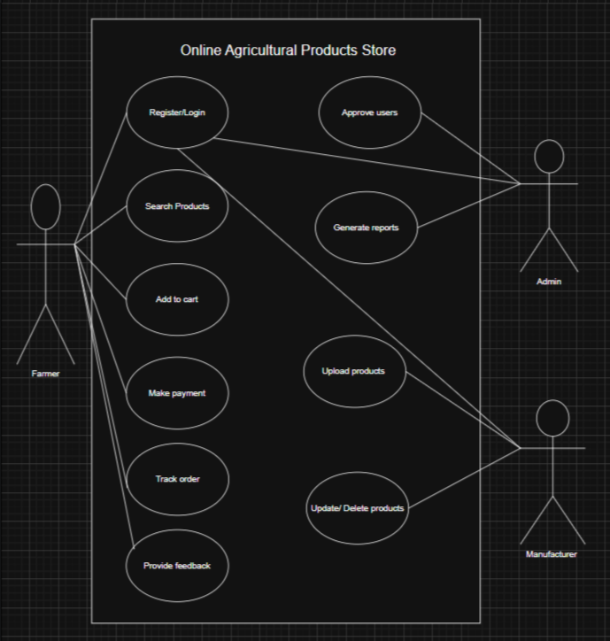

Question 11

Prepare use case specs for all use cases

Answer

The Use Case Specifications for key functionalities in the Online Agriculture Product Store System are

Heading | Details
Use Case ID | UC-001
Use Case Name | Register / Login
Created By | Business Analyst
Date Created | 13-Oct-2025
Actor | Farmer / Manufacturer / Admin
Description | Enables new users to create an account and existing users to authenticate securely.
Pre Condition | User has access to web/app; registration page available; no active session.
Post Condition | Validated user session created; profile initialized; audit trail captured.
Normal Flow of Events | 1. User opens Register/Login page. 2. User selects Register or Login. 3. For Register, user enters name, mobile/email, role, password; accepts T&C. 4. System validates inputs and sends OTP/email verification. 5. User verifies OTP/link. 6. System creates account, sets default role permissions. 7. For Login, user enters credentials (or SSO/OTP). 8. System authenticates and starts session; redirects to dashboard.
Alternative Flow | A1. Social/OTP Login: User selects OTP; gateway sends OTP; login without password. A2. Forgot Password: User requests reset link; system enforces password policy on reset.
Exceptions | E1. Duplicate email/phone; registration blocked. E2. OTP expired/incorrect; retry or resend. E3. Account locked due to failed attempts; cooldown.
Frequency of Use | High (daily)
Assumption | KYC may be required for Manufacturers before listing; secure password policy enforced.

Heading | Details
Use Case ID | UC-002
Use Case Name | Search Products
Created By | Business Analyst
Date Created | 13-Oct-2025
Actor | Farmer
Description | Farmer discovers products via keyword, category, filters (price, brand, rating, availability).
Pre Condition | Farmer is logged in (search allowed for guests as read-only).
Post Condition | Search results list displayed; filters/sorts persisted in session.
Normal Flow of Events | 1. Farmer opens Search. 2. Enters keyword/applies filters. 3. System queries catalog and scoring index. 4. System displays paginated, sortable results. 5. Farmer views product details.
Alternative Flow | A1. Voice Search/Barcode: Farmer uses mic or scans QR/barcode to search. A2. Saved Searches: Farmer loads saved filters.
Exceptions | E1. No results; show suggestions and broadened filters. E2. Catalog service timeout; show friendly error with retry.
Frequency of Use | High (daily)
Assumption | Search index updated near real time; synonyms configured for agri terms.

Heading | Details
Use Case ID | UC-003
Use Case Name | Add to Cart
Created By | Business Analyst
Date Created | 13-Oct-2025
Actor | Farmer
Description | Adds selected SKU with quantity to cart; validates stock and pricing.
Pre Condition | Product detail available; Farmer identified (guest cart allowed).
Post Condition | Cart updated with line item; totals recalculated; promotions applied.
Normal Flow of Events | 1. Farmer selects quantity/variant. 2. Clicks Add to Cart. 3. System checks inventory & price. 4. System adds item; updates totals and promo badges. 5. System confirms addition (mini-cart/snackbar).
Alternative Flow | A1. Wishlist to Cart: Item moved from wishlist. A2. Bulk Add: CSV or multi-select add for recurring orders.
Exceptions | E1. Out of stock; suggest substitutes/notify when available. E2. Price changed since view; prompt to accept new price.
Frequency of Use | High (daily)
Assumption | Real-time stock checks; cart persisted server-side and across devices.

Heading | Details
Use Case ID | UC-004
Use Case Name | Make Payment
Created By | Business Analyst
Date Created | 13-Oct-2025
Actor | Farmer; External Payment Gateway
Description | Completes checkout using UPI, card, net banking, or CoD per policy.
Pre Condition | Valid cart; shipping address and delivery slot captured; order summary confirmed.
Post Condition | Payment authorized/captured; order created; invoice generated; confirmation sent.
Normal Flow of Events | 1. Farmer chooses payment method. 2. System redirects to Payment Gateway. 3. Farmer authorizes payment. 4. Gateway returns status (success). 5. System creates order, captures payment, emails invoice/SMS.
Alternative Flow | A1. UPI Intent/QR: Opens UPI app; returns success. A2. Partial Fail → Retain Cart: Payment fails; cart retained; retry enabled.
Exceptions | E1. Gateway timeout/webhook mismatch; system reconciles via callback/retry queue. E2. Payment success but order not created; auto-recovery job creates order and alerts Ops.
Frequency of Use | High (daily)
Assumption | PCI-DSS handled by gateway; webhook signing & idempotency keys implemented.

Heading | Details
Use Case ID | UC-005
Use Case Name | Track Order
Created By | Business Analyst
Date Created | 13-Oct-2025
Actor | Farmer
Description | Provides real-time order status from confirmation to delivery with ETAs.
Pre Condition | Order placed; tracking ID available.
Post Condition | Latest status displayed; optional notifications updated.
Normal Flow of Events | 1. Farmer opens My Orders. 2. Selects order to track. 3. System fetches status from OMS/logistics. 4. Timeline/ETA displayed; delivery contact shown.
Alternative Flow | A1. Guest Tracking: Track via order ID + phone OTP. A2. Subscribe: Farmer enables push/SMS for updates.
Exceptions | E1. Status stale; show last known state and escalate to support. E2. Delivery missed; reschedule/refund options shown.
Frequency of Use | Medium (per order)
Assumption | OMS exposes status API; SLAs and cut-offs defined.

Question 12

Activity diagrams

Answer
1) User registration
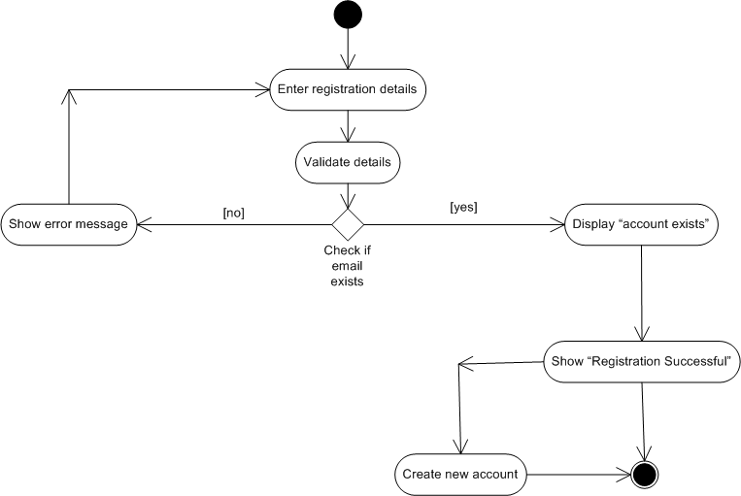

2) Search products
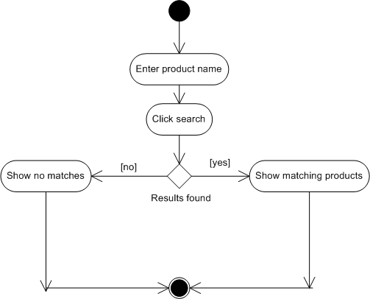

3)Add products to cart
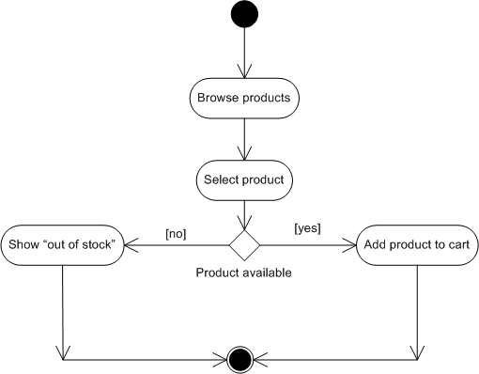

4)Making a payment
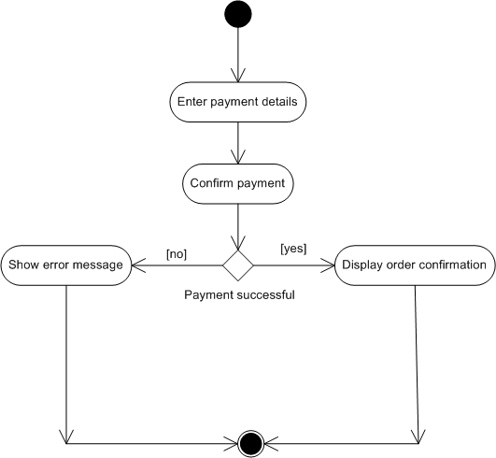

5) Delivery
