Use Case Diagram
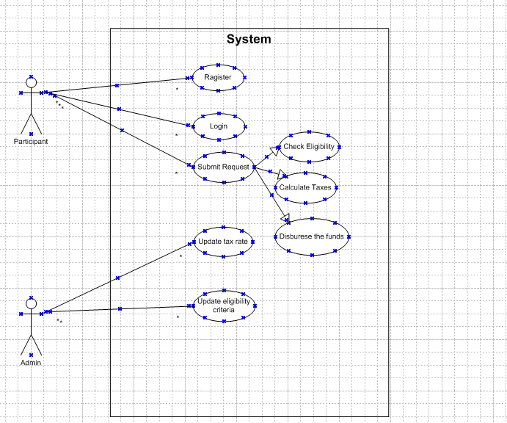

Activity Diagram for Use Registration
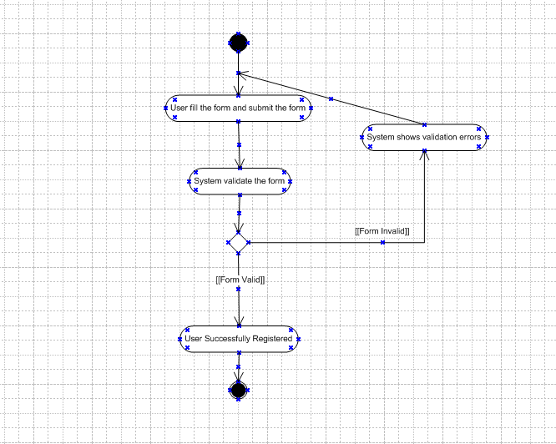
Activity Diagram for Login
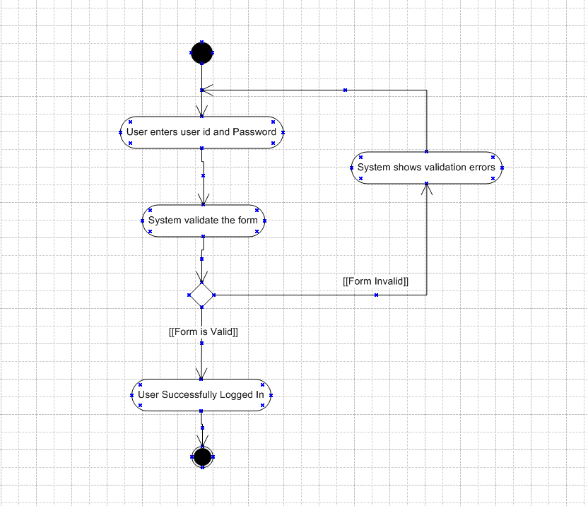

Activity Diagram for submit request
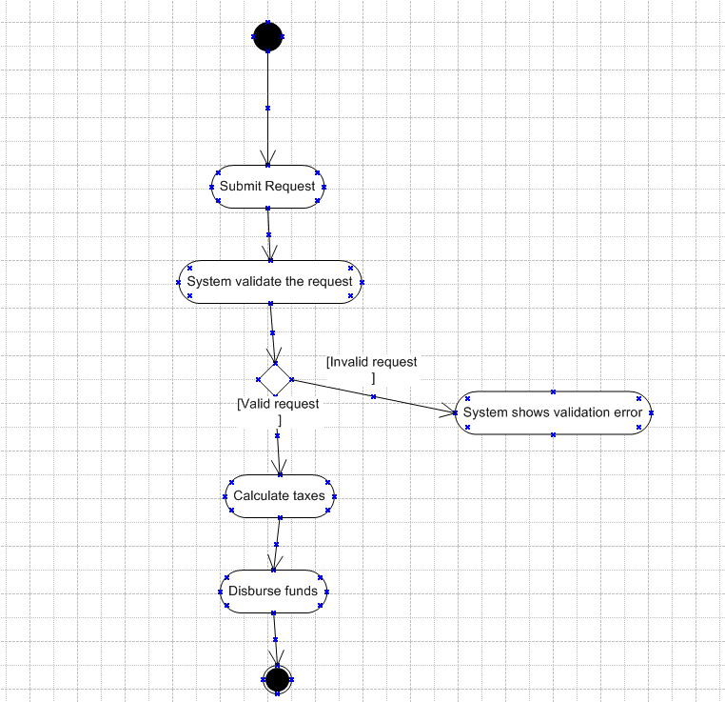

Use case specification
Use Case ID | UC002
Use Case Name | Submit the request
Created By | Shahzad Ahmed Mahagami
Date Created | 15-05-2025
Last Updated By | Shahzad Ahmed Mahagami
Last Updated On | 15-05-2025
Actor | Participant
Description | This use case describes how the user can submit the withdrawal/distribution request
Pre condition | Participant has an active account and access to the portal.Withdrawal option is available in the plan
Post condition | Withdrawal request is submitted and logged. Process moves to eligibility validation.
Basic Flow | Step 1: Participant logs into the online portal.  Step 2: Navigates to the “Submit Request” section.  Step 3: Enters withdrawal amount, reason, and required information.  Step 4: Submits the request. Step 5: System stores the request and triggers eligibility check
Alternative Flow | If participant saves the request as a draft instead of submitting, system saves it for later completion
Exceptions | If internet connectivity is lost while doing this use case,system displays "Check your internet connectivity"
Frequency of Use | High
Assumption | Participant understands withdrawal policies. Network connectivity is stable.
Use Case ID | UC003
Use Case Name | Check Eligibility
Created By | Shahzad Ahmed Mahagami
Date Created | 15-05-2025
Last Updated By | Shahzad Ahmed Mahagami
Last Updated On | 15-05-2025
Actor | Participant
Description | This use case allows the system to automatically verify if a participant is eligible to make a withdrawal request based on integrated plan and payroll data.
Pre condition | Valid withdrawal request submitted. Participant data is available in the integrated systems.
Post condition | Eligibility is determined (Approved or Flagged for Review).System updates request status.
Basic Flow | Step 1: System retrieves participant data from payroll and plan management systems.  Step 2: Checks withdrawal eligibility rules (e.g., employment status, plan type, age).  Step 3: If eligible, the request moves to the next processing step.  Step 4: If ineligible, the request is flagged for manual review..
Alternative Flow | If eligibility can’t be confirmed due to missing data, the system sends a notification to Admin for manual review.
Exceptions | If integrated systems are down, the check fails, and the request is held.Data mismatch or corruption flags the request.
Frequency of Use | High
Assumption | Eligibility criteria are already configured in the system. System has real-time access to payroll/plan databases.
Use Case ID | UC004
Use Case Name | Calculate Federal and StateTax
Created By | Shahzad Ahmed Mahagami
Date Created | 15-05-2025
Last Updated By | Shahzad Ahmed Mahagami
Last Updated On | 15-05-2025
Actor | Participant
Description | This use case allows the system to automatically calculate the mandatory 20% federal tax on the taxable portion of the participant’s withdrawal.
Pre condition | Participant is eligible. Taxable amount has been determined.
Post condition | Federal tax amount is calculated and recorded. Net withdrawal amount is adjusted.
Basic Flow | Step 1: System retrieves the taxable withdrawal amount.  Step 2: Applies a fixed 20% federal tax rate.  Step 3: Calculates the tax amount.  Step 4: Stores the tax amount with the transaction record.  Step 5: Updates the net withdrawal amount.
Alternative Flow | If the withdrawal is non-taxable (e.g., rollover), federal tax is skipped.
Exceptions | If the taxable amount is missing or invalid, calculation is halted, and an error is logged. If tax rate configuration is corrupted or not found, flag the transaction for review.
Frequency of Use | High
Assumption | The taxable amount is correctly identified prior to this use case.
Use Case ID | UC001
Use Case Name | Online User Registration
Created By | Shahzad Ahmed Mahagami
Date Created | 15-05-2025
Last Updated By | Shahzad Ahmed Mahagami
Last Updated On | 15-05-2025
Actor | Participant
Description | This use case describes how the user can register in the system
Pre condition | The user’s device connected to the Internet when user register a new account.
Post condition | User account is created successfully
Basic Flow | Step 1: The user clicks on the “Sign up” button.  Step 2. System asks the user to fill the Registration form consisting of name, email id, Date of hire, beneficiary name, mobile no, password, password confirmation.  Step 3. The user enters the form details an clicks on “Sign Up” button.  Step 4. System asks the user for verification code sent by SMS to the mobile number and sent to email. id  Step 5. The user enters verification code.  Step 6. System verifies the verification code. It is ok.  Step 7. User account is created successfully.
Alternative Flow | If user enters invalid mobile no, system will prompt message  If user enters invalid email id, system will prompt message  If the password and confirm password don’t match, system will prompt message  If user enters wrong OTP, error message is displayed to enter correct OTP
Frequency of Use | High
Use Case ID | UC005
Use Case Name | Process Transaction
Created By | Shahzad Ahmed Mahagami
Date Created | 15-05-2025
Last Updated By | Shahzad Ahmed Mahagami
Last Updated On | 15-05-2025
Actor | Participant
Description | This use case handles the automated processing of the withdrawal transaction, ensuring correct application of tax withholdings and updating of participant account balances.
Pre condition | All validation and calculation steps are complete. Participant has sufficient funds in the eligible account.
Post condition | Account balances are updated. Withdrawal transaction is marked as completed in the system.
Basic Flow | Step 1: System validates that all prior steps (eligibility, tax, penalties, data population) are complete.  Step 2: Confirms available balance in the participant’s retirement account.  Step 3: Deducts applicable taxes and penalties.Deducts applicable taxes and penalties.  Step 4: Deducts net amount from the retirement account. Step 5: Updates internal records with transaction details. Step 6: Marks transaction as “Processed” and prepares for fund disbursement.
Alternative Flow | If participant has multiple retirement accounts, the system prompts or selects the default account for withdrawal
Exceptions | If insufficient funds are available, the transaction is cancelled, and the participant is notified. If the internal ledger fails to update, the transaction is flagged for manual correction.
Frequency of Use | High
Assumption | The system has up-to-date balance information. Transaction processing adheres to financial regulations.

Tools-Visio and Axure
1. Microsoft Visio
What it is:
Visio is a diagramming tool by Microsoft.
What it's used for:
You use it to create professional diagrams like:
- Flowcharts
- Organizational charts
- Network diagrams
- UML diagrams (used in software design)
- Process diagrams
Why it's useful:
It helps teams visualize systems, workflows, and processes clearly. For example, a Business Analyst can draw how a user moves through a process or how systems connect.
Easy example:
If you want to show the steps a customer follows to place an online order, you can create a flowchart in Visio.

2. Axure RP
What it is:
Axure is a wireframing and prototyping tool.
What it's used for:
You use it to design interactive mockups of websites or applications before the real coding begins. It’s great for:
- Wireframes (basic layout of pages)
- Prototypes (clickable versions of screens)
- User flow simulations
Why it's useful:
It helps stakeholders, designers, and developers see how the app will work — including clickable buttons, menus, and navigation — even before a single line of code is written.

My experience as BA in following phases:
- Requirement gathering:
  - To gather requirements, we used MOSCOW technique.
  - Client is not available for some period of time during this phase. So as a BA i need to source out point of contacts from his side and get the information ASAP.
  - There are many requirements which are duplicated or repeated. We need to remove them immediately
  - Prototyping is used to give more specific requirements

- Requirement Analysis:
  - We need to draw UML diagrams to visually describe the requirements
  - Activity diagrams also used to describe the process flow
  - Communicate the diagrams to team. Some team members might not agree with them and might make changes. As a BA we need to consider the points and make modifications
  - Prepare BRS and SRS
- Design:
  - From the use case diagrams, we prepare test cases
  - Communicate with client on design and solution documents ● Write negative test cases as well along with positive test cases.
  - Do not miss a single test case. It might have huge impact on project development in later stages
  - Prepare test data for testing
  - Update RTM. This is just as we need to make sure that all the requirements are met
- Development:
  - Organized JAD sessions
  - Clarifying queries of tech team during coding
  - There might be some team members who doesn't agree with the concept or who doesn’t cooperate during JAD sessions. As a BA i handle the situation gently and had one on one discussion with them. Explained how their actions are going to affect the project. Setup healthy environment within the team.
  - Referred diagrams to code the Unit
  - Conduct regular meetings with technical team and client which is challenging. Some team members might not be available for the meeting. Recording the session and providing that to missed one and having one to one discussion later with that missed person is all i need to do
- Testing:
  - Prepare test cases from use cases
  - Perform high level testing
  - Test data is requested by BA from client
  - Updated RTM
  - Take signoff from client
  - Prepare client for UAT

- Deployment:
  - Forwarded RTM to client which should be attached to project closure document
  - Coordinates to complete and share end user manuals
  - Plans and organizes training sessions
  - Make sure all the candidates attend the meeting

