Document 6- Please prepare a use case diagram, activity diagram and a use case specification document.
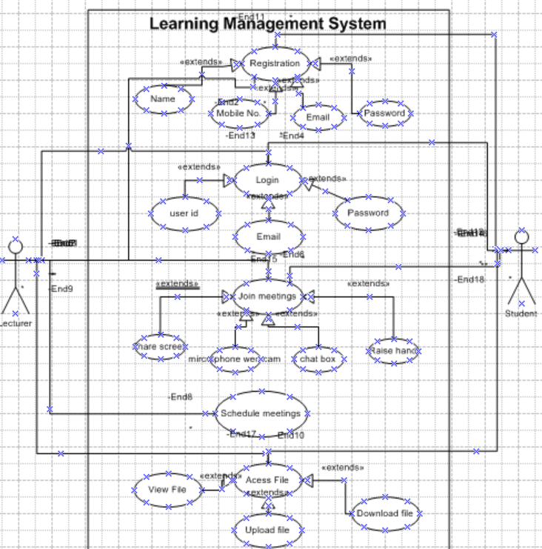

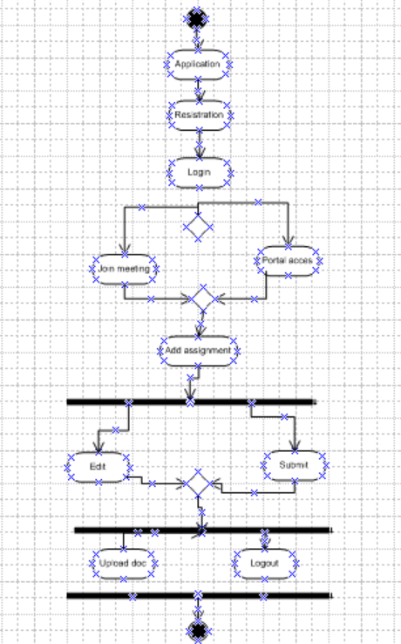

1. Use Case Name
Manage Course Enrollment
2. Use Case Description
This use case describes how a student logs into the LMS, searches for a course, enrolls in it, makes payment (if required), and accesses the course content.
3. Actors
- Primary Actor: Student
- Secondary Actors:
  - Instructor (approves/reviews enrollment if needed)
  - Payment Gateway (if course is paid)
  - Admin (manages backend rules, course availability)
4. Basic Flow
- Student logs into the LMS.
- Searches for a course.
- Views course details (syllabus, instructor, schedule).
- Enrolls in course.
- If paid course → redirects to payment gateway.
- On success, course enrollment confirmed.
- Student gets access to course materials and dashboard.
5. Alternate Flow
- If student is already enrolled, system shows “Already Enrolled” status.
- If course is free → skips payment step.
- If enrollment requires approval → pending until instructor/admin approves.
6. Exceptional Flows
- Invalid login credentials.
- Course not found.
- Payment failure.
- Enrollment quota full (course capacity reached).
7. Pre-Conditions
- Student has a valid LMS account.
- Internet connection is available.
- Course is available for enrollment.
8. Post-Conditions
- Student successfully enrolled OR
- System displays failure message (with retry option).
9. Assumptions
- All course data (content, schedule) is already published.
- Payment gateway integration is functional.
- Student has necessary prerequisites.
10. Constraints
- Course access limited to active enrollment period.
- Payment only through supported methods.
- Limited number of seats per course.
11. Dependencies
- Database of students, instructors, and courses.
- Payment gateway (for paid courses).
- Instructor/Admin approval (if required).
12. Inputs and Outputs
- Inputs: Login credentials, course search query, enrollment request, payment details.
- Outputs: Enrollment confirmation, course access, payment receipt.
13. Business Rules
- Only registered students can enroll.
- One student cannot enroll in the same course multiple times.
- Payment must be completed before enrollment is confirmed (for paid courses).
- Course access expires after defined period.
14. Miscellaneous Information
- Notifications sent to student via email/app after successful enrollment.
- LMS logs enrollment activity for auditing.
- Admin can revoke enrollment if policy violated.

Use Case Diagram
Document 7- Screens and pages Please follow the following steps to create the mock-ups 1. Kindly use balsamic or Axure. 2. Always start with a home page of an application. 3. Take a feature and follow it to the end a. Eg: Home page of SCRUM Foods b. Select Login- Create a login page c. Let’s assume, you want to search a restaurant d. Search page- Type the restaurant name and select the dish e. Add to cart page f. Payment page g. Logout page

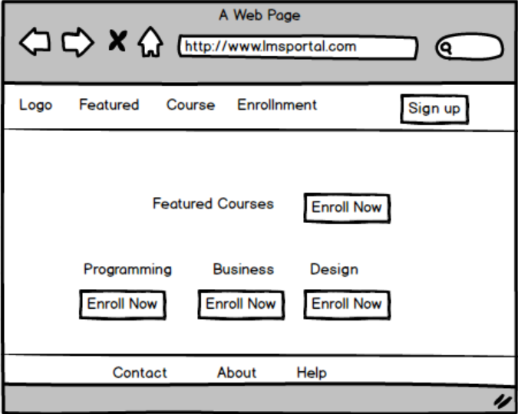
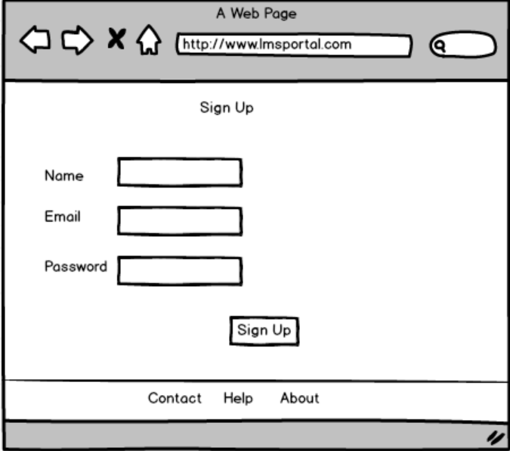
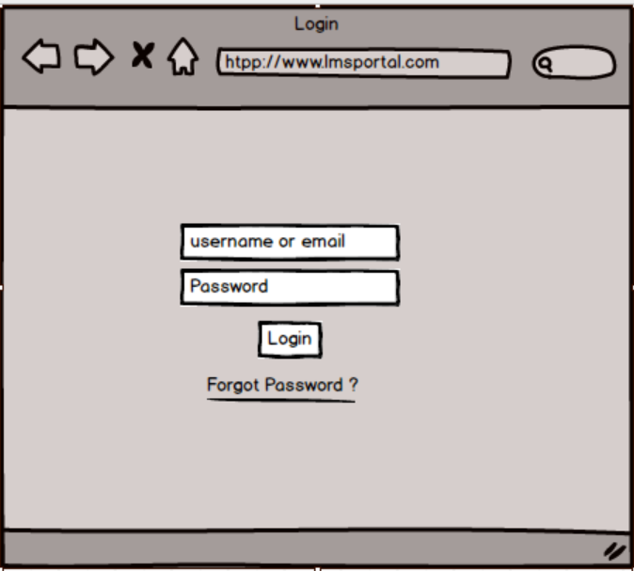

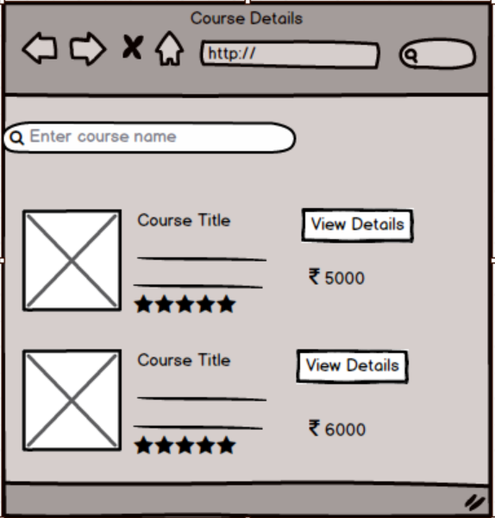

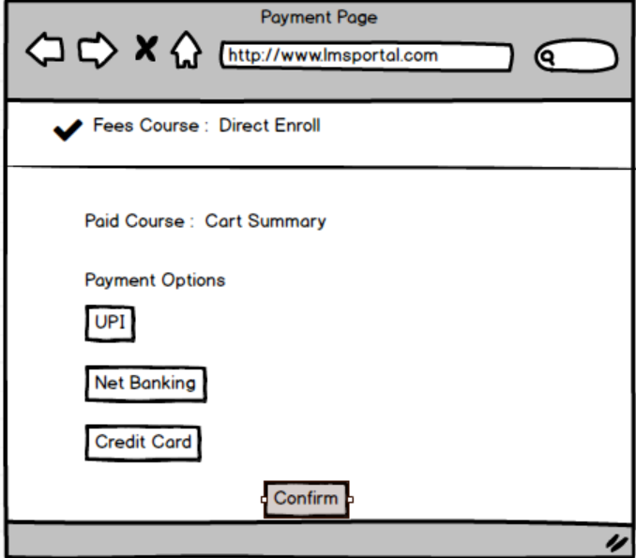

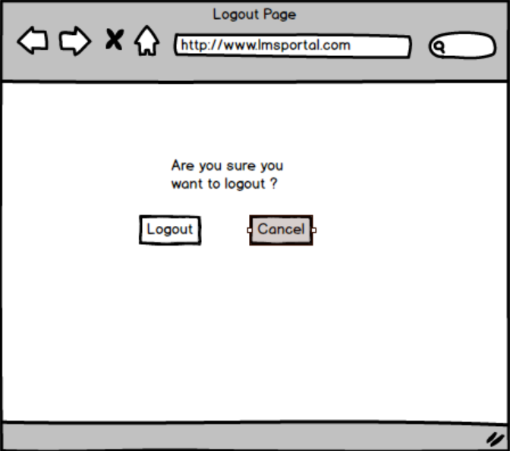
Document 8 – Tools: Visio and Axure
During the project, I used MS Visio to design various diagrams such as Use Case Diagrams, Activity Diagrams, and Process Flowcharts. Visio made it easy to represent both the AS-IS and TO-BE processes clearly, with professional-quality visuals that improved stakeholder understanding. It also helped in maintaining consistency across all workflow diagrams.
For prototyping, I used Axure, which allowed me to create interactive wireframes and mock-ups of the portal. This gave stakeholders a real-time experience of how the system would look and function before development. Axure’s drag-and-drop components, linking, and interactive features were useful in demonstrating user navigation and validating requirements early in the lifecycle.
Both tools together helped bridge the gap between business requirements and technical design, ensuring clarity, accuracy, and alignment throughout the project.
Document 9- BA experience
My experience as BA in following phases:
- Requirement gathering:
- Requirement Analysis:
- Design:
- Development:
- Testing:
- Deployment:

Answer : . Requirement Gathering
- Conducted stakeholder interviews, brainstorming sessions, and workshops.
- Prepared questionnaires and documented business needs.
- Created AS-IS process flow diagrams and identified gaps.
2. Requirement Analysis
- Analyzed collected requirements for feasibility and alignment with project goals.
- Classified them into functional and non-functional requirements.
- Maintained a requirement traceability matrix (RTM) for tracking.
3. Design
- Collaborated with UI/UX designers and technical architects.
- Prepared use case diagrams, activity diagrams, wireframes, and mock-ups.
- Ensured design matched both user expectations and business goals.
4. Development
- Acted as a bridge between developers and stakeholders.
- Clarified doubts and explained requirements to the development team.
- Participated in sprint planning and daily stand-ups (Agile methodology).
5. Testing
- Prepared test scenarios and UAT cases.
- Coordinated User Acceptance Testing with stakeholders.
- Validated that the final product met the TO-BE process and requirements.
6. Deployment
- Ensured smooth transition from legacy system (AS-IS) to new system (TO-BE).
- Supported the deployment team in production release.
- Provided training, user manuals, and post-deployment support.

