COEPD
Capstone Project 5

Submitted by – Annu Singh

A customer can make a payment either by Card or by Wallet or by Cash or by Net banking.
Question No.1. Draw a Use Case Diagram - 4 Marks
Answer:

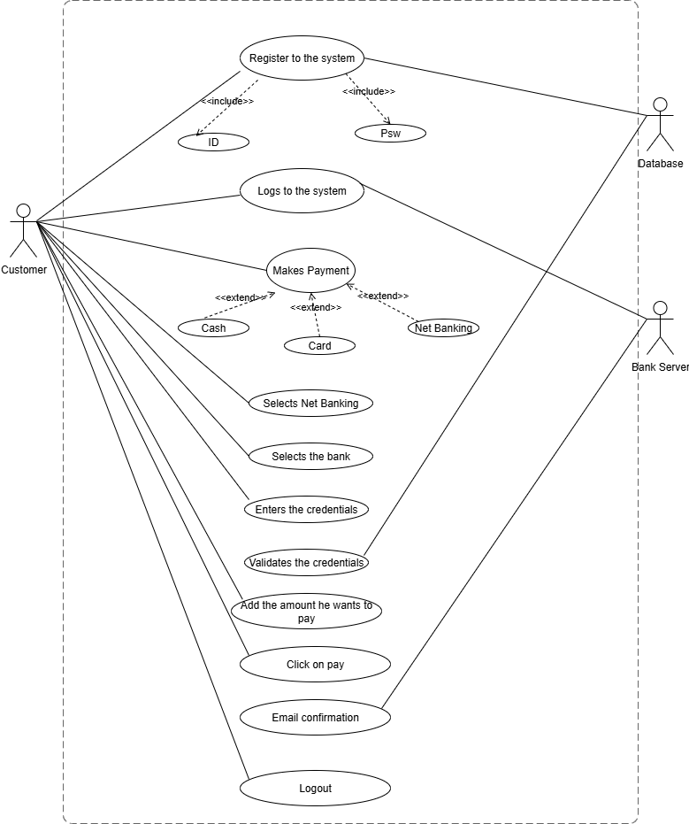

Question No.2. Derive Boundary Classes, Controller Classes, Entity Classes (4 Marks)
Answer:
In Object-Oriented Analysis, the classes are divided into three categories:
1. Boundary Classes (Interface Classes):
These are the classes that interact with external users or systems.
They define the “entry and exit points” of the system.

For this payment case:
Payment Screen (UI) – where the customer chooses Card, Wallet, Cash, or Net Banking.
Card Gateway Interface – interacts with external bank/card processor.
Wallet Interface – interacts with wallet provider.
Net Banking Interface – connects with banking server.
Cash Receipt Screen – used by cashier/admin for cash handling.

2. Controller Classes (Logic/Process Handling Classes):
These classes handle the workflow, validations, and process coordination.

For this case:
Payment Controller – manages the payment request and coordinates between UI and entities.
Transaction Manager – handles transaction creation, verification, and confirmation.
Authentication Controller – validates user credentials, OTP, and authorization.

3. Entity Classes (Business/Data Classes):
Represent the business objects and persist in the database.

For this case:
Customer – details like name, ID, account info.
Payment – payment details like amount, method, status.
Transaction – transaction record (date, time, reference number).
Account – customer’s bank/wallet account details.
Wallet – stores balance and wallet ID.

Question No.3. Place these classes on a Three-Tier Architecture (4 Marks)
Answer:
The system can be placed in three layers as follows:
1. Presentation Tier (UI Layer – user interaction):
Payment Screen (UI)
Card Gateway Interface
Wallet Interface
Net Banking Interface
Cash Receipt Screen

2. Application Tier (Business Logic Layer – handles process and rules):
Payment Controller
Transaction Manager
Authentication Controller
3. Data Tier (Database Layer – stores information permanently):
Customer (master data of user)
Payment (payment records)
Transaction (transaction logs)
Account (bank account info)
Wallet (wallet account info)
Question No.4. Explain Domain Model for Customer making payment through Net Banking (4 Marks)
Answer:
A Domain Model shows how the objects in the system interact with each other for a business process.
For Net Banking Payment:
1. Customer initiates the payment request.
2. A Payment object is created with details (amount, method = Net Banking, date).
3. The Payment Controller validates the request and routes it to the Net Banking Interface.
4. The Bank Account entity is checked for sufficient balance.
5. If valid, a Transaction object is created (with status = Success).
6. The System updates the Customer account and stores the Payment record.
7. A Confirmation/Receipt is generated and shown to the Customer.

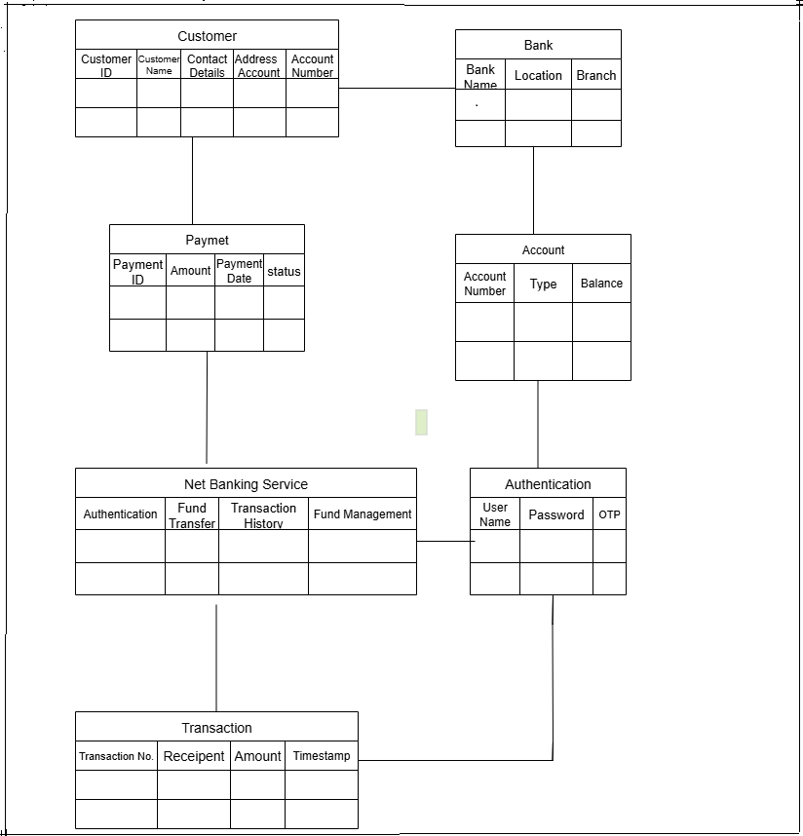

Q5. Draw a sequence diagram for payment done by Customer Net Banking - 4 Marks
Answer:
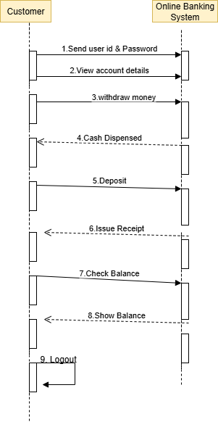

Question No.6. Explain Conceptual Model for this Case (4 Marks)
Answer:
The Conceptual Model explains the overall idea of the system without technical implementation details. It focuses on “what happens” instead of “how it happens”.
For this Payment Case Study:
1. Actors:
Customer (initiates the payment).
System (handles payment).
2. Payment Options (Use Cases):
Pay by Card
Pay by Wallet
Pay by Cash
Pay by Net Banking

3. Process Flow (Conceptual):
Customer selects a payment method.
System validates details.
Payment request is processed through the chosen channel.
System records transaction details.
Customer receives success/failure confirmation.
4. Relationships:
Customer → Payment Method → Transaction → Confirmation.
Q7. What is MVC architecture? Explain MVC rules to derive classes from use case diagram and guidelines to place classes in 3-tier architecture - 8 Marks
Answer:
MVC Architecture:
MVC (Model–View–Controller) is a design pattern in which an application is divided into three logical parts: Model, View, and Controller. Each part has a specific responsibility:

1. Model
Represents the data and business logic of the application.
Manages application data, performs validation, implements business rules, and handles data access operations.
Independent of how data is presented or how the user interacts with it.
Interacts with the database and returns requested data.
Model classes are represented as Entity Classes.
2. View
Responsible for presenting the data to the user and handling the user interface.
Can be a web page, desktop window, or any user interface component.
Receives input from the user and passes it to the Controller.
Renders the data received from the Model in a user-friendly format.
View classes are represented as Boundary Classes.
3. Controller
Acts as an intermediary between Model and View.
Receives input from the user (via View), processes it by invoking methods in the Model, and updates the View.
Handles user interactions and coordinates the flow of data.
Controller classes represent Use Cases.
Advantages of MVC:
Provides scalability and helps in growth of the application.
Components are easy to maintain.
Promotes reusability of code, as a single Model can support multiple Views.
Applications become more manageable since all three layers are independent.
Rules to Derive Classes from Use Case Diagram:
1. Combination of one Actor + one Use Case → results in one Boundary Class.
Example: 2 actors + 1 use case → 2 boundary classes.
2. Each Use Case → results in one Controller Class.
3. Each Actor → results in one Entity Class.
Example: Online Shopping Application
Model Classes (Entity): Customer, Payment, NetBanking, Card, Cash
View Classes (Boundary): LoginView, PaymentOptionView, NetBankingView, BankSelectionView, CredentialsView, PaymentAmountView, PaymentConfirmationView, LogoutView
Controller Classes (Use Case): LoginController, PaymentOptionController, NetBankingController, BankSelectionController, CredentialsController, PaymentAmountController, PaymentConfirmationController, LogoutController
Guidelines to Place Classes in 3-Tier Architecture:
1. Presentation Layer:
User interface layer.
Contains View classes for displaying and receiving input from the user.
2. Application Layer (Business Logic):
Contains Model and Controller classes.
Controller processes user input, invokes Model, and manages interaction between Model and View.
Model handles the business rules and logic.
3. Data Layer:
Handles data access and storage.
Contains classes interacting with the database, files, or other data sources.

Q8. Explain BA contributions in project (Waterfall Model – all Stages) – 8 Marks
Answer:
The Business Analyst (BA) plays a vital role in each phase of a project. BA ensures that requirements are clear, documented, and properly translated into solutions that meet stakeholder needs. BA contributions can be explained along the Waterfall model phases as follows:
1. Requirements Gathering
Stakeholders are identified.
All requirements are collected from stakeholders.
BA and Project Manager participate in this phase.
After completion, the BRD (Business Requirement Document) is generated.
2. Requirements Analysis
Requirements are analyzed to understand the project scope.
BA checks for conflicting or ambiguous requirements.
BA communicates with stakeholders to clarify and finalize requirements.

3. Functional & Non-Functional Requirements
BA prepares Functional Requirements (FRS – Functional Requirement Specification).
Technical team prepares Non-Functional Requirements (SSD – Supplementary Support Document).
BA combines FRS and SSD to form the SRS (Software Requirement Specification).
BA also prepares the RTM (Requirements Traceability Matrix) by referring to SRS.

4. Design Phase
Starts once requirements are cleared.
BA collaborates with designers, architects, and developers to translate requirements into system design.
BA ensures design aligns with documented requirements and stakeholder needs.
Produces High-Level Design Documents (HDD/ADD) and solution design documents.

5. Development Phase
Includes implementation and coding as per design.
BA acts as a mediator between development team and stakeholders.
Clarifies requirements and ensures development is on track.
BA participates in Scrum meetings.

6. Testing Phase
BA works with testing team to ensure solution meets requirements.
BA facilitates UAT (User Acceptance Testing).
Helps users understand system functionality.
Test documents are generated.

7. Deployment Phase
Once software is tested and approved, it is deployed to production.
BA ensures smooth transition from development to production.

8. Implementation Phase
Final stage of Waterfall model.
Involves running the system code for the first time in production.
Handled by Release Manager.
BA updates documentation and requirements to reflect changes over time.

9. Maintenance Phase
Running the code again in production is considered maintenance.
Handled by the support team.
BA ensures updated documentation and monitors requirement changes.

Q9. What is conflict management? Explain using Thomas – Kilmann technique – 6 Marks
Answer:
Conflicts can occur due to various reasons, such as differences in goals, values, personalities, resources, or communication breakdowns.
Conflict is an inevitable part of any workplace.
So it is important to resolve it to promote learning and growth.
Conflict management is nothing but the process of identifying and addressing conflicts in a healthy and constructive manner.
It consists of strategies and techniques aimed at resolving disputes, disagreements, or differing perspectives among individuals or groups.
By identifying the conflicts efficiently, it will in turn be helpful to reduce negative impact and increase positive impact.
It is a process or skill to find creative ways to handle the disagreement.
Thomas – Kilmann approach is widely used to recognize the approaches for conflict management.

Y axis – assertiveness, X axis – cooperativeness
1. High Assertiveness and High Cooperativeness – Collaboration: working together to find solution.
2. High Assertiveness and Low Cooperativeness – Competition: defensive, standing for your individual beliefs and trying to win.
3. Low Assertiveness and High Cooperativeness – Accommodation: stakeholder will prioritize their needs over others.
4. Low Assertiveness and Low Cooperativeness – Avoidance: means ignoring the conflict.
Assertiveness: the extent to which the person attempts to satisfy his own concerns.
Cooperativeness: the extent to which the person attempts to satisfy the other person’s concerns.

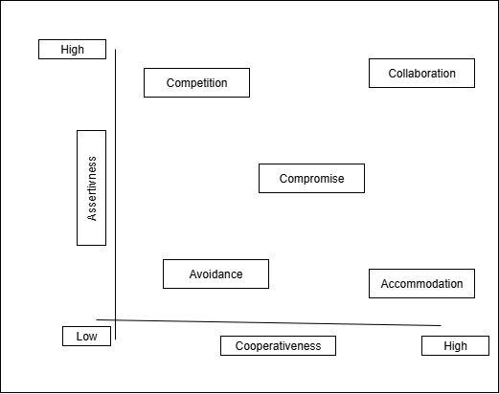

Q10. List down the reasons for project failure – 6 Marks
Answer:
Reasons for project failure are:
1. Improper requirement gathering –
If the requirements of the project are not gathered correctly, then this can lead to project failure.

2. Lack of stakeholder involvement –
A project can fail if the stakeholders are not participating in the process.
Stakeholders’ input and feedback play a very important role in meeting the goals.
3. Ineffective or less communication –
If there are communication issues between stakeholders or team members, this can lead to misunderstandings, delays, or even project failure.
4. Continuous change in the requirements –
If the requirements keep changing frequently, it can lead to project failure.
The project scope also keeps changing, which affects progress.
5. Poor risk management –
Failure to identify and mitigate risks can cause unexpected challenges or delays, leading to project failure.
6. Lack of user involvement / Lack of executive support –
Without proper user participation and executive backing, project success is difficult.
7. Unrealistic expectations –
Setting goals that are unachievable or out of scope can result in project failure.
8. Improper planning –
If planning is not done properly, milestones and goals may not be achieved, causing project delays or failure.
9. Insufficient resources –
Lack of resources (finance, skilled manpower, or technology) can also lead to project failure.

Q11. List the Challenges faced in projects for BA – 6 Marks
Answer:
Lack of training.
2. Obtaining sign-off on the requirement.
3. Change management.
4. Co-ordination between developers and testers.
5. Conducting meetings.
6. Making sure status report is effective.
7. Driving clients for UAT completion.
8. Making sure that the project is going on the right track and delivered as per the timelines without any issues.
9. Gathering clear and unambiguous requirements can be challenging.
10. Unable to understand what stakeholder is trying to convey.
11. Scope creep – change in requirement or scope of the project during the project lifecycle can lead to scope creep.
12. Managing stakeholders with conflicting interests can be a difficult task for BA.
13. BA may face difficulties in understanding the requirements if the domain is not familiar to him.
14. Poor communication between stakeholder and BA can affect the process of gathering the information.
15. Technical complexity.

Q12. Write about Document Naming Standards – 4 Marks
Answer:
Document naming standards define a consistent way to name project documents so that they are easily identifiable and traceable.
The standard format is:
[ProjectID][Document Type]V[x]D[y].extension
ProjectID → Unique identifier of the project.
Document Type → Type of document (e.g., FRS – Functional Requirement Specification, BRD – Business Requirement Document).
V[x] → Version number of the document.
D[y] → Draft or revision number.

Extension → File extension such as .docx, .pdf, etc.
[ProjectID][Document Type]V[x]D[y].extention
Example – [PQ777FRDV1D1.docx] or [PQ777FRD1.1.docx]

Q13. What are the Do’s and Don’ts of a Business analyst – 6 Marks
Answer:
The primary responsibility of a business analyst is to assess business needs, provide solutions, and ensure they align with the company’s objectives. As a business analyst, you evaluate current business processes, identify areas of improvement, and facilitate the implementation of organizational changes. This requires a balance of technical knowledge, interpersonal skills, and strategic thinking.
Dos of Effective Business Analysis
1. Do Conduct Thorough Research
Successful business analysis starts with comprehensive research. Understand customers, market conditions, and business operations through various data sources and methodologies. Utilize analytics tools and feedback loops to gather relevant information.
2. Do Engage Key Stakeholders
Involve key stakeholders early in the analysis process. Their insights and cooperation are crucial in obtaining accurate data and ensuring commitment to the proposed changes. Maintaining open communication with all involved parties is essential for success.
3. Do Use Appropriate Analysis Tools
Equip yourself with diverse analytical tools that provide meaningful insights. From SWOT analysis to PESTLE and use case modelling, choose tools that best fit your business context and project goals.
4. Do Develop Clear and Measurable Objectives
Avoid vague goals by outlining clear, specific, and measurable objectives. When objectives are well-defined, they serve as a roadmap for implementing successful business strategies.
5. Do Prioritize Continuous Learning
The business landscape and technology are constantly evolving. Stay updated with industry trends, new methodologies, and emerging technologies. Engage in continuous learning through workshops, seminars, and professional courses.
Don'ts of Effective Business Analysis
1. Don't Ignore the Human Element
Technology and data are powerful tools, but they must be integrated with the human element. Empathize with end-users, considering their experiences and feedback when suggesting solutions.
2. Don't Overlook Communication
Effective communication is critical in business analysis. Ensure that all communications are clear, concise, and directed at the right audience. Miscommunication can lead to project misalignment and unmet expectations.
3. Don't Resist Process Improvement
Do not become complacent with the status quo. Be open to questioning existing processes and suggesting improvements that add value to the organization.
4. Don't Make Decisions in Isolation
Collaboration ensures diverse viewpoints and better decision-making. Avoid working in silos; always seek input from team members and other departments to validate your findings and proposals.
5. Don't Underestimate the Power of Documentation
Proper documentation is crucial in maintaining project clarity and continuity. Keep detailed records of each phase of the analysis process, findings, and decisions for future reference.
Question No14. Write the difference between packages and sub-systems – 4 Marks
Answer:
In UML models and Object-Oriented Analysis,
PACKAGE
- A package is a organised group of elements.
- It can be termed as the UML mechanism for grouping things.
- It may contain many structural things like classes, components and other packages in it.
- It can be used to: Group semantically related elements.
- Define a semantic boundary in the model.
- Provide units for parallel working and configuration management.
- It is used to provide encapsulated namespace within which all names must be unique.
SUBSYSTEM
- In UML models, subsystems are a type of stereotyped components that represent independent, behavioural units of a system.
- They are widely used in class, component, use case diagrams to represent large-scale components that are to be modelled.
- An entire system can be modelled by a hierarchy of subsystems.
- The behaviour of each subsystem can be defined by specifying the interfaces and operations that support interfaces in accordance with subsystems.

Key differences between Package and Subsystems:
PACKAGE | SUBSYSTEMS
A package can be termed as a container which tends to organise, group elements present in the system into a more manageable unit. | A subsystem is a stereotyped components which represents individual behavioural units in a system hierarcy
Package can be termed as a collection of components which are not reusable in nature. | Subsytem can be termed as a collection of components which are reusable in nature.
Application development companies work on packages. | Product development companies work on subsystems
Package is represented as a rectangle with tab in upper left corner. the rectangle contains name of the package and icon, | Subsytem is displayed as a rectangle that contains the name of the subsystem and icon along with<<subsystem>> keyword
Packages are smaller and more focused in scope. | Subsystems are larger and encompass multiple packages or modules.
They manage dependencies at class and component level. | They manage dependencies at a higher level, defining boundaries and interfaces between different parts of the system.

Question No15. What is camel-casing and explain where it will be used- 6 Marks
Answer:
Camel-casing refers to the naming convention of variable, parameters or properties.
Here, multiple words are combined together.
In camel-casing, the starting letter of first word starts with small letter and other words first letter starts with capital letters.
Ex- firstName, lastName
In BA, camel-casing is used in requirements documentation.
In requirement documentation, BA often use camel-casing to name the entities like use case, features, user stories like validateCustomerDetails, calculateInterestRate, etc.
Business rules, which should be satisfied by the system use camel-casing.
While documenting business process or workflows, camel-casing can be used to individual in steps. This will help maintain consistency in the document.
The database tables name also uses camel-casing.
Requirement naming – camel-casing is used in requirement document also, to name the functional and non-functional requirements.
By using camel-casing in the documents, it helps to maintain consistency in the entire document and also increases readability.

Q16. Illustrate Development server and what are the accesses does business analyst has? -6 Marks
Answer:
A Development Server is an environment where software applications are built, tested, and modified before moving to testing or production. It allows developers to write and debug code without affecting the live system.
Accesses a Business Analyst (BA) has in a Development Server:
1. Read-only access to review application behavior and verify requirements.
2. Access to logs and error reports to understand issues raised during development.
3. Database access (limited) for validating data models and mappings.
4. Access to test the functionality of new features against business requirements.
5. Ability to raise issues/defects and communicate with developers for fixes.

Question No17. What is Data Mapping 6 Marks
Answer:
In simple words, data mapping is the process of mapping data fields from a source file to their related target fields.
For example, in Figure 1, ‘Name,’ ‘Email,’ and ‘Phone’ fields from an Excel source are mapped to the relevant fields in a Delimited file, which is our destination.
Mapping tasks vary in complexity, depending on the hierarchy of the data being mapped, as well as the disparity between the structure of the source and the target. Every business application, whether on-premise or cloud, uses metadata to explain the data fields and attributes that constitute the data, as well as semantic rules that govern how data is stored within that application or repository.
For example, Microsoft Dynamics CRM contains several data sets which comprise of different objects, such as Leads, Opportunities, and Competitors. Each of these data sets has several fields like Name, Account Owner, City, Country, Job Title, and more. The application also has a defined schema along with attributes, enumerations, and mapping rules. Therefore, if a new record is to be added to the schema of a data object, a data map needs to be created from the data source to the Microsoft Dynamics CRM account.
Depending on the number, schema, and primary keys and foreign keys of the relational databases data sources, database mappings can have a varying degree of complexity.

Question No18. What is API? Explain how you would use API integration in the case of your application Date format is dd-mm-yyyy and it is accepting some data from Other Application from US whose Date Format is mm-dd-yyyy – 10 Marks

Answer:
API (Application Programming Interface) is a set of rules that allows two applications to communicate and exchange data securely. APIs enable integration between systems without needing to understand each other’s internal logic.
Using API Integration in Date Format Scenario:
1. My application accepts dd-mm-yyyy format, but the US application provides dates in mm-dd-yyyy format.
2. Through API integration, the incoming data will be received as JSON/XML.
3. Before saving or using the data, a data transformation/mapping logic will be applied:
Extract month, day, year separately.
Re-arrange into my required format (dd-mm-yyyy).
Example: US API sends 09-25-2025 (mm-dd-yyyy).
→ My application converts and stores it as 25-09-2025 (dd-mm-yyyy).
4. This ensures consistency across applications and prevents data errors.
5. APIs thus act as a bridge, handling differences in data formats, structures, and standards.

