Case Study (Q1-Q7)

A customer can make a payment either by Card or by Wallet or by Cash or by Net banking.

Q1: Draw a Use Case Diagram

Ans: 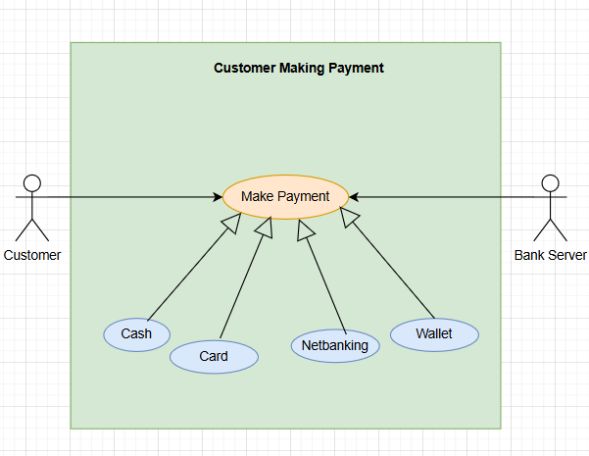

Q2: Derive Boundary Classes, Controller classes, Entity Classes

Ans: There is an approach to derive Boundary, Controller and Entity Classes from the UseCase Diagram i.e MVC (Model, View, Controller) Architecture.

Model - All Entities, Actors Tables, databases comes under Entity Classes
Entity Classes are represented by 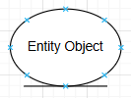

View - What we view from the outside comes under Boundary Class
Boundary Classes are represented by 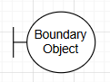

Controller - All Use Cases comes from Controller Class

Controller Classes are represented by 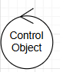

For the given case study

Entity Class | Boundary Class | Controller Class
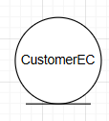 | 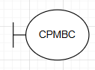 | 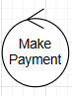
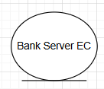 | 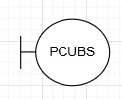
 | 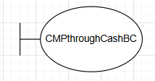
 | 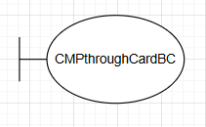
 | 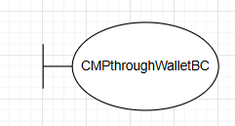
 | 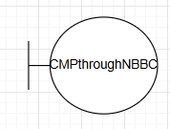

Q3: Place these classes on a three tier Architecture.

Ans: 3 tier Architecture: The 3 layered approach is known as 3 Tier Architecture

- Application Layer - All Screens, pages, company specific logics and functionally are placed in Application Layer
- Business Logic Layer - All reusable components, governing body rules & regulations are placed in Business Logic Layer
- Data Base Layer - Database components connecting to Database are placed in Database layer

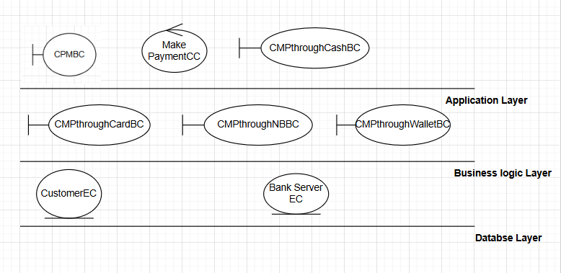

Q4: Explain Domain Model for Customer making payment through Net Banking

Ans: Domain Model: Each participating class will do an action part. All these classes doing action parts put together to achieve a task or functionality is known as the Domain Model.

For the given case study:

- Customer initiates a payment for an Order.
- The Order is linked to a Payment entity which captures the payment method, status, and amount.
- When the Customer chooses Net Banking, they select a Bank from the NetBankingDetails.
- The PaymentGateway redirects the Customer to the Bank’s system where an AuthenticationSession is created to verify credentials.
- After successful authentication, the Customer selects a BankAccount.
- The Bank then initiates a Transaction, debits the amount, and sends the response back to the PaymentGateway.
- The Payment status is recorded, and finally, a Receipt is generated and linked to the Payment.

Q5: Draw a sequence diagram for payment done by Customer Net Banking

Ans: 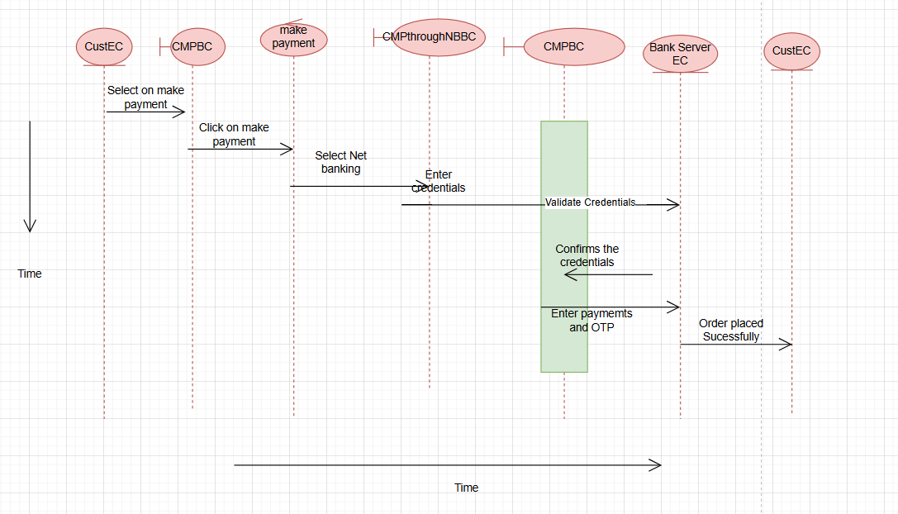

Q6: Explain Conceptual Model for this Case

Ans:

Conceptual Model: It is that we have all the possibilities of doing the transactions (volumes, geographical distractions etc). If we have all the information then we can call it a Conceptual model.

For the given case study:

- A Customer can perform multiple Payments.
- Payment is modeled as a supertype entity.
- Payment can be made through four modes: Card, Wallet, Cash, Net Banking.
- These modes are represented as subtype entities: CardPayment, WalletPayment, CashPayment, NetBankingPayment.
- Only one subtype is associated with each Payment.
- This design supports flexibility, clarity, and eliminates redundancy.

Explanation
- The Customer entity stores details of customers.
- The Payment entity captures common attributes such as PaymentID, Date, Amount, and PaymentType.
- Since a payment can be made in different ways, four subtype entities are created:
  - CardPayment (stores card details)
  - WalletPayment (stores wallet provider and wallet ID)
  - CashPayment (stores handler details)
  - NetBankingPayment (stores bank name and transaction number)
- A Customer–Payment relationship is one-to-many, meaning a single customer may make multiple payments.

Q7: What is MVC architecture? Explain MVC rules to derive classes from use case diagram and guidelines to place classes in 3-tier architecture

Ans: MVC Architecture: MVC divides an application into Model (data), View (UI), and Controller (controller handler).

To identify classes from a use case diagram there are few rules that we need to follow, which also helps to derive the classes.

- Combination of one actor and a usecase result in one boundary class.
- Combination of two actors and a usecase result in two boundary class.
- Combination of two actors and a usecase result in two boundary class and son on…
NOTE: Only one primary actor is to be associated with a use case
- Use Case wil result in a Controller Class
- Each actor will result in an Entitty Calss.

Instructions while identify

- Write classes column wise
- All Boundary Classes in one colum
- All Controller Classes in one colum
- All Entity Classes in one colum
- Write meaningful names

Guidelines to place identifies classes in 3 Tier

- Place all entity Classes to DB layer
- Place primary actor initiating Boundar Class and Controller Class in Application layer
- Remaining Boundary Classes - if they are reusablke then in Business Logic layerelse place them in Application layer
If we have to write code for the complete functionality then place in Application Layer, if we have to write the code to connect to 3rd party plugin then place in Business Logic layer

Q8: . Explain BA contributions in project (Waterfall Model – all Stages)

Ans:

BA Contributions in Waterfall Model

The Business Analyst (BA) plays a critical role across all phases of the Waterfall SDLC.
Each phase produces specific artifacts (documents) that ensure clarity and traceability.
1. Requirements Gathering & Analysis Stage
BA Contributions
- Identify stakeholders and conduct interviews, workshops, surveys, etc.
- Elicit business needs, goals, rules, constraints.
- Analyze and prioritize requirements.
- Document functional and non-functional requirements.
- Model business processes (AS-IS and TO-BE).
- Create requirement traceability (RTM).
- Get stakeholder approval and sign-off.
BA Artifacts
- BRD (Business Requirements Document)
- SRS (Software Requirements Specification)
- FRD (Functional Requirements Document) – sometimes part of SRS
- NFR document (Non-functional requirements)
- Use Case Diagrams / Use Case Specifications
- Process Flow Diagrams (DFD, BPMN, Flowcharts)
- User Stories (if at hybrid approach)
- Glossary / Business Rules Document
- RTM (Requirements Traceability Matrix)
- Change Request Document (if needed)
2. System Design Stage
BA Contributions
- Clarify requirements for designers and architects.
- Review design documents for alignment with business needs.
- Validate UX/UI design from a business perspective.
- Participate in design walkthroughs.
BA Artifacts
- Updated SRS / Updated RTM
- Wireframes / Mockups / UI prototypes
- Use Case Realization diagrams
- Business Rules refinement
- Gap Analysis Document
- Design Review Notes
(Although design artifacts are owned by architects/UX, the BA reviews and contributes.)
3. Implementation / Development Stage
BA Contributions
- Answer developer queries regarding requirements.
- Provide business logic clarifications.
- Assist in test data creation for developers.
- Validate requirement coverage through RTM.
- Manage and document any changes.
BA Artifacts
- Updated SRS / Updated BRD
- Updated RTM
- Requirement Clarification Log
- Change Request Documentation
- Business Logic Explanation Notes
- Test Data Inputs (if required)
4. Testing Stage
BA Contributions
- Help QA understand the requirements.
- Ensure test cases cover all business flows.
- Validate test scenarios & test coverage.
- Participate in SIT (System Integration Testing).
- Conduct or support UAT (User Acceptance Testing).
- Log defects and help with prioritization.
BA Artifacts
- UAT Test Plan
- UAT Test Cases / Scenarios
- UAT Execution Report
- Defect Log / Defect Triage Summary
- Requirements Validation Report
- Test Coverage Matrix
- Updated RTM
5. Deployment / Implementation Stage
BA Contributions
- Verify that deployed solution meets requirements.
- Support deployment planning.
- Conduct end-user training sessions.
- Prepare training and support materials.
- Ensure all requirements are fulfilled.
BA Artifacts
- User Manuals / User Training Guides
- Release Notes (BA-reviewed)
- Deployment Checklist Support
- FAQ Document
- Business Go-Live Readiness Document
6. Maintenance Stage
BA Contributions
- Gather post-launch feedback.
- Analyze issues and enhancement requests.
- Conduct impact analysis for new changes.
- Update requirement documents as system evolves.
- Help resolve production defects by providing business insight.
BA Artifacts
- Change Request / Enhancement Request Forms
- Impact Analysis Document
- Updated SRS / Updated RTM
- Root Cause Analysis Report
- Support Documentation

Waterfall Phase | BA Contributions | BA Artifacts
Requirements | Elicit, analyze, document, validate | BRD, SRS/FRD, Use Cases, DFDs/BPMN, NFR, RTM
Design | Requirement clarification, design review, UI review | Wireframes, Mockups, Updated SRS/RTM, Gap Analysis
Development | Clarify requirements, manage changes, support dev team | Requirement Clarification Log, Updated RTM, Change Request Docs
Testing | Support QA, review test cases, conduct UAT | UAT Test Cases, Test Coverage Matrix, Defect Log, UAT Report
Deployment | Training, go-live support | Training Manuals, Release Notes, Go-Live Checklist
Maintenance | Handle enhancements, analyze changes, support fixes | CR Forms, Impact Analysis, Updated SRS/RTM, RCA Document

Q9: What is conflict management? Explain using Thomas – Kilmann technique

Ans: Conflict Management refers to the process of identifying, addressing, and resolving disagreements or disputes between individuals or groups in an effective and constructive manner.
Purpose of Conflict Management
- Maintain healthy relationships
- Improve communication
- Ensure smooth workflow
- Increase productivity
- Prevent escalation of disputes
A BA, manager, or team member uses conflict management to ensure the project runs smoothly by reducing misunderstandings and interpersonal issues.
Thomas–Kilmann Conflict Management Technique (TKI)
The Thomas–Kilmann Instrument (TKI) is a widely used model that identifies five conflict-handling modes based on two dimensions:
1. Assertiveness
- How much a person tries to satisfy their own concerns.
2. Cooperativeness
- How much a person tries to satisfy others’ concerns.
The five styles are determined by the combination of assertiveness and cooperativeness.
Five Conflict Management Styles (Thomas-Kilmann Model)

1. Competing (High Assertiveness, Low Cooperativeness)
- Also known as “forcing” or “dominating.”
- One party pursues their own concerns at the other party’s expense.
- Power-oriented and assertive.
When to Use
- When quick decisions are needed
- In emergencies
- When standing up for important rights or principles
2. Collaborating (High Assertiveness, High Cooperativeness)
- Also known as “problem-solving.”
- Both parties work together to find a win-win solution.
- Requires time, communication, and mutual trust.
When to Use
- When both sides’ needs are important
- For complex issues requiring creative solutions
- To build long-term relationships
3. Compromising (Medium Assertiveness, Medium Cooperativeness)
- Both sides give up something to reach a mutually acceptable solution.
- A “middle-ground” or “give and take” approach.
When to Use
- When quick, fair solutions are needed
- When both sides have equal power
- When collaboration is not possible due to time constraints
4. Avoiding (Low Assertiveness, Low Cooperativeness)
- Also known as “withdrawing.”
- The conflict is ignored or postponed.
When to Use
- When the issue is trivial
- When emotions are high and a cooling-off period is needed
- When gathering more information is necessary
- When the cost of confrontation is higher than the benefit
5. Accommodating (Low Assertiveness, High Cooperativeness)
- Also known as “yielding.”
- One party puts aside their own needs to satisfy the other person.
When to Use
- To preserve relationships
- When the issue is more important to the other party
- When you realize you may be wrong
- To maintain harmony
Style | Assertiveness | Cooperativeness | Key Idea | Result
Competing | High | Low | "I win, you lose" | Quick solution, may damage relationship
Collaborating | High | High | "Win-Win" | Best long-term outcome
Compromising | Medium | Medium | "Split the difference" | Partial win for both
Avoiding | Low | Low | "Ignore/Delay" | No immediate resolution
Accommodating | Low | High | "You win" | Maintains relationship

Q10: List down the reasons for project failure

Ans:

Reasons for Project Failure

1. Poor Requirements Gathering
- Incomplete, unclear, or incorrect requirements
- Frequent requirement changes
- Lack of stakeholder involvement
2. Lack of Proper Planning
- No realistic schedule or budget
- Poor estimation of effort, cost, or resources
- Inadequate risk assessment and mitigation
3. Weak Project Management
- Ineffective monitoring and control
- Poor task allocation and prioritization
- Lack of leadership or decision-making
4. Scope Creep
- Continuous addition of new features
- Uncontrolled changes without impact analysis
- No proper change management process
5. Poor Communication
- Misunderstanding between team members
- Insufficient stakeholder communication
- Lack of updates or documentation
6. Inadequate Resources
- Shortage of skilled personnel
- Insufficient budget, tools, or infrastructure
- Overloaded team members
7. Technical Failures
- Using outdated or incompatible technology
- Lack of technical expertise
- Poor system design or architecture
8. Lack of Stakeholder Involvement
- Stakeholders not providing timely feedback
- Limited user engagement
- Conflict between stakeholders
9. Unrealistic Deadlines
- Overly aggressive timelines
- Pressure to deliver faster than possible
- Not considering project complexity
10. Poor Risk Management
- Risks not identified early
- No contingency plans
- Ignoring potential threats
11. Quality Issues
- Inadequate testing
- Defective deliverables
- Not following QA processes
12. Team Issues
- Lack of motivation
- Internal conflicts
- High employee turnover
13. Poor Change Management
- Resistance to change
- No structured approval process
- Failure to evaluate impacts of changes
14. External Factors
- Market changes
- Legal/regulatory issues
- Vendor-related problems
Q11: List the Challenges faced in projects for BA

Ans:

Challenges Faced by a BA in Projects
1. Unclear or Changing Requirements
- Stakeholders are unsure about what they need.
- Frequent requirement changes without proper justification.
2. Limited Stakeholder Engagement
- Stakeholders not available on time.
- Conflicting expectations among different user groups.
3. Communication Gaps
- Misunderstandings between technical teams and business users.
- Difficulty translating business language into technical terms.
4. Scope Creep
- New features continuously added.
- No proper change control process.
5. Time Constraints
- Tight deadlines for requirement gathering, analysis, and documentation.
- Pressure to deliver quickly.
6. Managing Conflicts
- Conflicts between stakeholders or within teams.
- Difficulty achieving consensus.
7. Lack of Domain Knowledge
- Working in unfamiliar industries.
- Requires extra learning to understand business processes.
8. Inadequate Tools or Resources
- No proper BA tools for modeling, documentation, or analysis.
- Insufficient access to data or SMEs (Subject Matter Experts).
9. Technical Limitations
- Requirements may not fit within the system’s technical constraints.
- Need to balance business needs with feasibility.
10. Poor Documentation Standards
- Lack of templates or guidelines.
- Expectations differ across stakeholders.
11. Risk & Change Management Issues
- Difficulty analyzing impact of changes.
- Hidden risks due to incomplete information.
12. Cultural and Communication Differences (in global teams)
- Different working styles.
- Time zone challenges.
Q12: Write about Document Naming Standards

Ans:
Document Naming Standards are predefined rules used to name project documents in a consistent, clear, and organized way. These standards ensure that all team members can easily identify, search, and retrieve documents without confusion.
Purpose of Naming Standards
- Maintain consistency across project documentation
- Improve version control and avoid duplication
- Make documents easy to organize and locate
- Facilitate collaboration among teams
- Reduce errors caused by unclear or ambiguous names
Key Components of Document Naming Standards
1. Document Type Prefix
Indicates what kind of document it is.
Example:
- BRD – Business Requirements Document
- SRS – Software Requirements Specification
- UAT – User Acceptance Testing Document
2. Project or Module Name
Identifies the project or specific module.
Example: HRMS, Billing, LoginModule
3. Description of Content
A short, meaningful title describing what the document contains.
Example: UserOnboardingProcess, PaymentWorkflow
4. Version Number
Shows document revision and helps track updates.
Examples:
- V1.0 (initial version)
- V1.1 (minor update)
- V2.0 (major revision)
5. Author or Department (Optional)
Useful in large teams or enterprises.
Example: IT, PMO, BA
6. Date Format (Optional)
Indicates when the document was created or updated.
Example: 2025-01-15
Example of Standard Document Names
- BRD_HRMS_EmployeeOnboarding_V1.0
- SRS_BillingModule_InvoiceGeneration_V2.1
- UAT_InventoryManagement_TestScenarios_V1.0
- FRD_PaymentGateway_Integration_V3.0
Benefits of Document Naming Standards
- Ensures professional and organized documentation
- Helps in version tracking and change management
- Saves time when searching for documents
- Avoids duplication and confusion
- Supports audit and compliance processes
Conclusion
Document Naming Standards help maintain clarity, consistency, and control over project artifacts. They are essential for effective documentation management and smooth project execution.
Q13: What are the Do’s and Don’ts of a Business analyst

Ans:
Do’s (Best Practices)
1. Communicate Clearly
- Use simple, unambiguous language
- Actively listen to stakeholders
2. Understand the Business Domain
- Gain domain knowledge
- Study existing processes (AS-IS)
3. Ask the Right Questions
- Use interviews, workshops, surveys, etc.
- Clarify assumptions and unknowns
4. Document Requirements Properly
- Create clear, complete, and accurate BRDs/SRS
- Maintain an updated RTM
5. Manage Stakeholders Effectively
- Identify stakeholders early
- Keep them engaged and informed
6. Perform Requirements Validation
- Confirm requirements with users
- Align requirements with business goals
7. Support Cross-Functional Teams
- Bridge communication between business and technical teams
- Ensure developers and QA understand requirements
8. Handle Conflicts Professionally
- Use conflict resolution techniques (e.g., T.K.I)
- Stay neutral and focus on facts
9. Apply Analytical Thinking
- Use diagrams, flows, models to simplify complexity
- Evaluate feasibility, risks, and impacts
10. Keep Learning
- Update skills in tools, domains, and BA techniques
Don’ts (What a BA Should Avoid)
1. Don’t Make Assumptions
- Never assume requirements without validation
- Avoid guessing solutions
2. Don’t Ignore Stakeholder Inputs
- All voices matter, especially end users
- Avoid taking requirements from only one stakeholder
3. Don’t Use Technical Jargon with Business Users
- Communicate in business-friendly terms
- Avoid confusing or overly complex language
4. Don’t Skip Documentation
- Avoid undocumented requirements
- Never rely only on verbal discussions
5. Don’t Overpromise
- Avoid committing to unrealistic timelines or features
- Always check feasibility before agreeing
6. Don’t Resist Change
- Change is part of the project lifecycle
- Use a structured change management process
7. Don’t Take Sides in Conflicts
- Remain objective and neutral
- Base decisions on facts and data
8. Don’t Ignore Risks
- Identify risks early
- Communicate potential impacts upfront
9. Don’t Neglect Testing Support
- Never assume the system works as expected
- Participate actively in UAT and requirement validation
10. Don’t Stop Learning
- Avoid becoming outdated in tools, techniques, and trends
Q14: Write the difference between packages and sub-systems

Ans:

1. Packages
Definition:

Package:
A Package is a grouping of related elements in a system, such as classes, interfaces, or other packages. It is used to organize and manage complexity in large models.
Key Points:
- Primarily a structural organization tool.
- Helps manage large UML models.
- Can contain classes, interfaces, or even other packages.
- Does not provide business functionality on its own.
- Supports modularity and reusability.
Example:
- Package UserManagement containing classes User, Role, Permission.
- Package BillingHelpers containing utility classes for billing.
2. Sub-systems
Definition:
A Sub-system is a self-contained functional module of a system that performs a major business function. It is a higher-level grouping of functionality, which may include multiple packages, components, or classes.
Key Points:
- Represents a complete functional module.
- Provides business-level services or functionality.
- Can interact with other sub-systems through well-defined interfaces.
- Helps in breaking a large system into manageable parts.
Example:
- Sub-system Billing System containing packages like InvoiceProcessing, PaymentGateway, ReportGeneration.
- Sub-system Inventory Management managing stock, orders, and warehouse functions.

Q15: What is camel-casing and explain where it will be used

Ans:
Camel-Casing
Definition:
Camel-casing is a naming convention in which compound words or phrases are written without spaces, and each word after the first starts with a capital letter. The first letter of the first word may be lowercase (lower camel case) or uppercase (upper camel case).
The name comes from the “humps” created by the capital letters in the middle of the word, like a camel’s humps.
Types of Camel-Casing
- Lower Camel Case (common in programming variables & methods)
  - First letter is lowercase, subsequent words start with uppercase.
  - Example: employeeName, calculateSalary, userLoginStatus
- Upper Camel Case (common in class names, types)
  - First letter is uppercase, subsequent words start with uppercase.
  - Example: EmployeeDetails, InvoiceGenerator, PaymentGateway
Where Camel-Casing is Used
1. Programming and Software Development
- Variable Names: totalAmount, userAge
- Method/Function Names: getUserDetails(), calculateInvoice()
- Class Names: CustomerAccount, OrderProcessor (usually upper camel case)
- Object Names: customerOrder, billingDetails
2. Databases
- Column names in some coding standards: firstName, orderDate
3. Documentation & Requirements
- Use in diagrams, models, and reports for naming elements consistently:
  - Use case names: createInvoice, updateProfile
  - Class names: ProductCatalog, InventoryItem
Why Use Camel-Casing
- Improves readability in multi-word names
- Avoids spaces or special characters in identifiers
- Standardizes naming across code, diagrams, and documents
- Helps in distinguishing variables, classes, and methods
Short Exam-Friendly Example
- Lower camel case: calculateSalary, userLoginStatus
- Upper camel case: EmployeeDetails, InvoiceGenerator
Q16: Illustrate Development server and what are the accesses does business analyst has

Ans:

Definition:
A Development Server is an environment where software developers and the project team build, test, and experiment with new features before releasing them to testing or production environments. It mimics the actual system but is not accessible to end-users.
Key Points:
- Used for coding, development, and unit testing.
- Isolated from the Production Server to prevent disruptions.
- Can host partial or complete versions of the application.
- May include dummy or sample data instead of real user data.
Purpose:
- Test new functionalities without affecting real users.
- Debug and fix errors early in the development lifecycle.
- Validate designs, workflows, and integrations.
Accesses a Business Analyst (BA) Typically Has
While a BA is not a developer, they often need access to the development environment to understand the system, validate requirements, and support testing.
Typical BA Accesses:
- View-Only Access to Development Server
  - Explore system functionalities, screens, and workflows.
  - Review data, forms, and reports without making changes.
- Access to Test Data
  - Use sample data to verify business processes.
  - Check if requirements are implemented correctly.
- Read Access to Logs or Reports
  - Review system logs or error reports to understand issues.
- Access to Test Environments
  - Participate in User Acceptance Testing (UAT).
  - Validate that features meet business requirements.
- Documentation Access
  - Access functional specifications, workflows, and requirement traceability matrices stored on the server.
- Optional (Limited Edit Access)
  - In some projects, BAs may have permission to update requirements documents or test scripts on the development server.

Aspect | Development Server | BA Access
Purpose | For developers to build & test features | To validate, review, and test business requirements
User Type | Developers, testers | Business Analysts, testers, stakeholders
Data | Sample/test data | View-only or test data access
Changes | Full editing allowed | Mostly read-only, sometimes limited editing
Impact | Safe to experiment | No risk to production environment

Q17: What is Data Mapping

Ans: Data Mapping is the process of matching data fields from one system (source) to another system (target). It ensures that data flows accurately and consistently between systems, applications, or databases during integration, migration, or transformation.

Key Points:
- Used in data migration, ETL (Extract, Transform, Load) processes, and system integration.
- Ensures that each piece of data in the source corresponds correctly to a field in the target system
- Can include transformation rules (e.g., converting formats, units, or applying business logic).
- Helps maintain data consistency, integrity, and accuracy.
Components of Data Mapping:
- Source Data – Original data from an existing system.
  - Example: CustomerName, OrderDate in the old database.
- Target Data – Fields in the destination system where data will be stored.
  - Example: Cust_Name, Order_Date in the new system.
- Mapping Rules – Rules for converting or transforming data if necessary.
  - Example: Date format change from MM/DD/YYYY → YYYY-MM-DD.
- Transformation Logic – Optional formulas or business rules applied during mapping.
  - Example: Calculating TotalPrice = Quantity × UnitPrice.

Example of Data Mapping Table

Source Field | Target Field | Transformation/Rules
FirstName | Cust_First_Name | None
LastName | Cust_Last_Name | None
DOB (MM/DD/YYYY) | DateOfBirth (YYYY-MM-DD) | Change date format
PhoneNumber | ContactNo | Remove dashes
Quantity × UnitPrice | TotalPrice | Calculate total price

Where Data Mapping is Used:
- System Migration – Moving data from legacy systems to new systems.
- Integration Projects – Connecting multiple applications with different data structures.
- ETL Processes – Extracting, transforming, and loading data into data warehouses.
- Reporting & Analytics – Ensuring consistent data across reports and dashboards.
Benefits of Data Mapping:
- Ensures data accuracy and consistency across systems.
- Reduces errors during migration or integration.
- Saves time and effort by clearly defining field relationships.
- Helps in compliance and auditing by maintaining traceable mappings.
Q18: What is API. Explain how you would use API integration in the case of your application Date format is dd-mm-yyyy and it is accepting some data from Other Application from US whose Date Format is mm-dd-yyyy

Ans: An API (Application Programming Interface) is a set of rules and protocols that allows one software application to communicate and exchange data with another. APIs define how requests and responses should be structured so that different systems can work together seamlessly.
Key Points:
- Enables integration between different applications.
- Can be RESTful (HTTP-based), SOAP (XML-based), or others.
- Handles data exchange, authentication, and error handling.
Example:
- Your application can get user details from a third-party service using an API call:
GET https://api.example.com/users/123
API Integration Scenario
Problem:
- Your application expects date format: dd-mm-yyyy
- Another application (US-based) sends data with date format: mm-dd-yyyy
- You want to integrate their data using an API.
Steps to Handle API Integration with Date Format Conversion
- Receive Data via API
  - Make an API request to the US application to fetch the data.
  - Example response:
{
"userId": 101,
"registrationDate": "11-18-2025" // mm-dd-yyyy
}
- Identify the Date Format
  - Check that the incoming date is in mm-dd-yyyy.
  - Your system expects dd-mm-yyyy.
- Convert Date Format
  - Use a date parsing and formatting function in your programming language.
  - Example in Python:
from datetime import datetime

us_date = "11-18-2025" # mm-dd-yyyy
converted_date = datetime.strptime(us_date, "%m-%d-%Y").strftime("%d-%m-%Y")
print(converted_date) # Output: 18-11-2025

- Map Data to Your System
  - After conversion, store the date in your application in the expected format.
  - Ensure other fields are mapped correctly as per your data model.
- Send Acknowledgment or Process Data
  - Process the converted data, update your database, or return a response to the API call.
Summary Table
Step | Action
1 | Fetch data from external API
2 | Identify data format (mm-dd-yyyy)
3 | Convert to system format (dd-mm-yyyy)
4 | Map fields and update your database
5 | Process data or send acknowledgment

Benefits of Using API Integration
- Enables real-time data exchange between systems.
- Ensures data consistency with proper transformations.
- Reduces manual entry and errors.
- Makes your application interoperable with external systems.

