Document 1- Business case document template Document 2: BA Strategy
Document 3- Functional Specifications Document 4- Requirement Traceability Matrix Document 5- BRD Template

Document 1- Business case document template
  - Why is this project initiated?
This project is initiated to respond to a clear business or technological need, satisfy stakeholder demands, fulfill legal or regulatory requirements, or improve or create products and services. These forces drive organizations to identify business problems or opportunities and develop solutions, leading to a project's formal launch. The initiation phase ensures the project's purpose is understood and feasible, securing buy-in and resources before significant time and money are committed.

  - What are the current problems?
Common project problems include scope creep, unclear goals, budget constraints, and poor communication. Other frequent issues are unrealistic deadlines, team conflicts, lack of accountability, resource allocation problems, and inadequate planning or risk management.

  - With this project how many problems could be solved?
Problems solved:
  - Reduced commute times: By optimizing traffic lights and providing drivers with alternative route suggestions.
  - Improved driver satisfaction: By giving commuters a sense of control and foresight, reducing their frustration.
  - Better resource allocation for city planners: Providing data to help them make decisions on road maintenance and development.

  - What are the resources required?
- The Team consists of 10 Tech support Agents.
- Two Project leads and one Project Manager.
- Budget:50 lakhs
- Time:Should be completed within adhered time limits for a span of 5 years.
- Resources are allocated as per knowledge and experience.

  - How much organizational change is required to adopt this technology?
Key Areas of Organizational Change:
- Strategy and Planning:
  - Develop a clear adoption strategy: Align the technology with overall business goals and outline specific objectives for its implementation.
  - Perform a cost-benefit analysis: Assess both the immediate costs and the long-term financial implications and benefits of the new technology.
- People and Culture:
  - Invest in change management: Implement effective communication, training, and incentive programs to foster employee acceptance and overcome resistance.
  - Promote a culture of innovation: Create an environment that rewards experimentation, encourages lifelong learning, and supports cross-functional cooperation.
  - Prioritize user experience: Ensure new technology is intuitive and user-friendly, and provide ongoing support to help employees integrate it into their daily routines.
- Processes and Operations:
  - Update workflows: Integrate the new technology and methods into existing procedures to improve efficiency and streamline operations.
  - Provide necessary skills and capabilities: Implement training and upskilling programs to equip employees with the new knowledge and skills required to use the technology effectively.
- Leadership and Alignment:
  - Secure leadership buy-in: Ensure that management and leadership are aligned with the change initiative and can effectively champion the new technology.
  - Monitor progress: Track key performance indicators to measure adoption rates and identify areas for ongoing improvement and support.

  - Time frame to recover ROI?
Five years time is given to recover ROI.

  - How to identify Stakeholders?

To identify stakeholders, brainstorm by asking who is affected, who has an interest, or who has power to influence your project or organization, then use methods like document reviews, team discussions, expert interviews, and past project analysis to create a comprehensive list. Tools like stakeholder registers and mapping techniques can help you organize and analyze the identified individuals and groups to understand their roles and importance.

Document 2: BA Strategy

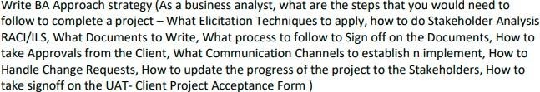

A BA strategy, or business analysis strategy, is a high-level plan to achieve a future state by understanding the current situation, identifying business needs, and developing solutions to address those needs. It involves analyzing current processes, defining desired outcomes, assessing risks, and collaborating with stakeholders to develop a transition strategy for organizational change.
Key Components of a BA Strategy
- Understanding the Current State:
BAs analyze existing processes, policies, and capabilities to identify problems, gaps, and inefficiencies.
- Defining the Future State:
This involves setting clear, achievable goals and objectives for the desired future state of the organization.
- Identifying Business Needs:
BAs work with stakeholders to pinpoint the core business problems or opportunities that necessitate a change.
- Assessing Risks and Constraints:
Potential risks, benefits, and limitations are evaluated to ensure the proposed solutions are viable and effective.
- Developing a Change Strategy:
A comprehensive plan is created to guide the transition from the current state to the desired future state, detailing the steps, methods, and stakeholders involved.
- Defining Value and Viability:
The BA evaluates the potential value of the proposed change, ensuring it aligns with business goals and is sustainable.
How a BA Strategy is Developed
- Initiate with a Business Need:
The process begins when a new business need or problem is identified.
- Collaborate with Stakeholders:
BAs work with various stakeholders to gather information, define goals, and gain a shared understanding of the problem and potential solutions.
- Analyze and Document:
The BA analyzes the collected information, identifies requirements, and documents key aspects of the current and future states.
- Develop Transition Plans:
Based on the analysis, the BA outlines a strategy for how the organization will transition to the new state, which may involve changes to technology, processes, or organizational structures.
Why a BA Strategy is Important
- Aligns with Business Goals:
It ensures that proposed changes are aligned with the overall strategic objectives of the organization.
- Facilitates Organizational Change:
A clear strategy helps organizations navigate complex changes, reducing confusion and increasing the likelihood of success.
- Enhances Decision-Making:
By providing a solid foundation of analysis and planning, a BA strategy enables more informed and effective decision-making.
- Drives Value:
The focus on defining outcomes and potential value helps ensure that projects deliver tangible benefits to the organization.
To effectively elicit information, consider using a combination of techniques like interviews, brainstorming, observation, document analysis, and prototyping, adapting your approach based on the project's complexity and stakeholder availability.
Some of the elicitation techniques are as follows:-
Common Elicitation Techniques:
- Brainstorming:
A group technique where participants generate ideas and solutions collaboratively, often used to discover a wide range of potential requirements.
- Observation:
Observing how people interact with systems or perform tasks to identify potential problems and hidden requirements.
- Prototyping:
Creating a working model or design of a solution to test with stakeholders and gather feedback, helping to validate requirements and refine the design.
- Document Analysis:
Reviewing existing documentation (e.g., reports, policies, procedures) to understand current processes and identify potential requirements.
- Surveys and Questionnaires:
Distributing surveys or questionnaires to a wider audience to gather opinions and gather data on requirements.
- Stakeholder Analysis:
Identifying and understanding the different stakeholders involved in a project, their roles, interests, and expectations, to ensure their needs are met.
- Interviews:
Conducting structured or unstructured interviews with stakeholders to gather information and clarify requirements.
- Joint Application Development (JAD):
A collaborative workshop involving stakeholders, business analysts, and developers to elicit and refine requirements in a structured and interactive environment.
- Reverse Engineering:
Analyzing existing systems or processes to understand their functionality and identify potential requirements, particularly useful in migration projects.
- Document Research:
Researching existing documents to understand the current market scenario and business needs.
- Use Case:
A technique used to elicit, specify, and refine solution requirements.

How to do stakeholder analysis:RACI Matrix
To perform stakeholder analysis using a RACI matrix, first identify all stakeholders and project tasks, then create a RACI matrix table, assigning roles (Responsible, Accountable, Consulted, Informed) for each task and stakeholder to clarify responsibilities and communication needs.

What documents to write:-
BRD ,FRD,Use case documentation,Test case documentation

What process to follow to sign off on the documents:-
Sign off to be taken on SRS.Sign off can be taken by using email confirmation from client.
To sign off on documents, identify the required signatories, ensure the document is complete and accurate, and then follow the designated process for electronic or physical signatures, often involving review and approval steps.

How to take approvals from the client:-
To effectively obtain client approvals, clearly present your work, solicit feedback early, establish a streamlined process, and maintain open communication throughout the process.
Establish a formal meeting with client and inform about continuos feedback.

What communication channels to establish and implement:-

To effectively communicate, establish and implement a mix of channels including email, instant messaging (like Slack or Microsoft Teams), video conferencing (like Zoom or Google Meet), social media (if relevant), and potentially live chat for customer service, ensuring each is used strategically for different purposes.
Bi weekly Sprint review meetings,weekly status meetings,monthly stakeholder updates.

How to handle change requests:-
To effectively handle change requests, establish a clear process, involve relevant stakeholders, assess the impact, and communicate decisions transparently.
Change request form,Do impact Analysis,approval process,documentation

How to update the progress of project to stakeholders

To effectively update project progress to stakeholders, establish a clear communication plan, use project management tools, provide regular updates, and be proactive in addressing concerns and managing expectations.
Weekly status reports,monthly Review meetings.

How to take sign off on UAT (Client project acceptance form)

To take sign-off on UAT, ensure all testing is complete, issues are resolved, and then formally document the client's acceptance with a project acceptance form, including details like project name, recipient, and a summary of results.
Conduct UAT
Fix Issues
Acceptance form
Final review meeting
Obtain sign off

Document 3- Functional Specifications

Project name | Online Ticketing System
Customer name | AMAZON UK customers
Project Version | 1.12.1
Project Sponsor | AMAZON
Project Manager | RITIKA PANDEY
Project Initiation date | 22 APRIL 2023

Functional Requirement specifications:

Req ID | Req Name | Req Description | Priority
FR0001 | Login | User should be able to login to the application to do inventory operations | 10

Document 4- Requirement Traceability Matrix

Req ID | Req Name | Req description | Design | D1 | T1 | D2 | T2 | UAT
FR0001 | login | User must be able to login to access the application | Yes | Pending | No | Yes | Yes | YES



Document 5- BRD Template
V2D2 August 2024

Page 5 of 12

admin
www.coepd.com nurtureba@coepd.com CONFIDENTIAL

<Project Name >
<Project ID>
<Version ID>
<Author>

Contents
- Document Revisions 8
- Approvals 8
- RASCI Chart for This Document 8
Codes Used in RASCI Chart 9
RASCI Chart 9
- Introduction 9
  - Business Goals 9
  - Business Objectives 9
  - Business Rules 10
  - Background 10
  - Project Objective 10
  - Project Scope 10
    - In Scope Functionality 10
    - Out Scope Functionality 10
- Assumptions 10
- Constraints 10
- Risks 10
Technological Risks 11
Skills Risks 11
Political Risks 11
Business Risks 11
Requirements Risks 11
Other Risks 11
- Business Process Overview 11
  - Legacy System (AS-IS) 11
  - Proposed Recommendations (TO-BE) 11
- Business Requirements 11
- Appendices 12
  - List of Acronyms 12
  - Glossary of Terms 12
  - Related Documents 12

- Document Revisions

Date | Version Number | Document Changes
05/02/2025 | 0.1 | Initial Draft
06/02/2025 | 1.1 | Changing font of text
07/2/25 | 1.2 | Changing requirements
09/2/25 | 1.3 | Changing color of login buttons
- Approvals

Role | Name | Title | Signature | Date
Project Sponsor | RITU | AMAZON HEAD | RITU | 05/02/25
Business Owner | ROHAN | AMAZON HEAD 2 | ROHAN | 04.02.25
Project Manager | RITIKA PANDEY | AMAZON SUPPORT ENGINEER | RITIKA | 07/02/25
System Architect | KALPIT | AMAZON ARCHITECT | KALPIT | 08/02/25
Development Lead | RISHU | DEVELOPMENT LEAD | RISHU | 09/02/25
User Experience Lead | SHOMU | USER SUPPORT LEAD | SHOMU | 10/02/25
Quality Lead | SHONIT | QUALITY ENGINEER | SHONIT | 11/02/25
Content Lead | MONICA | PROJECT LEAD | MONICA | 11/02/25

- RACI Chart for This Document
The RACI chart identifies the persons who need to be contacted whenever changes are made to this document. RACI stands for responsible, accountable, consulted, and informed. These are the main codes that appear in a RACI chart, used here to describe the roles played by team members and stakeholders in the production of the BRD. They are adapted from charts used to assign roles and responsibilities during a project.( RACI Can be made for IT side[Project stakeholder] as mentioned above, apart from that Can also Be made for Client side[Business Stakeholder]).
The following describes the full list of codes used in the table:

Codes Used in RACI Chart
* Authorize Has ultimate signing authority for any changes to the document.
- Responsible Responsible for creating this document.
A Accountable Accountable for accuracy of this document (for example, the project manager)
- Supports Provides supporting services in the production of this document

C | Consulted | Provides input (such as an interviewee).
I | Informed | Must be informed of any changes.
RACI Chart
RACI MATRIX | Name | Designation | Details
Responsible | Mr Dooku  Ms Juhie  Teysen  Tucker  Bravo  Lucie | Manager operations  Technical SME  Software Developers | Name:-Dooku  Email:-Dooku@gmail.com  Contact number:-  88000000  Name:-Juhie  Email:-juhie@gmail.com  Contact number:-  8600000  Name:-Teysen  Email:-teysen@gmail.com  Contact number:-  8700000  Name:-Tukcer  Email:-Tukcer@gmail.com  Contact number:-890000  Name:-Lucie  Email:-lucie@gmail.com  Contact number:-  8100000  Name:-Bravo  bravo@gmail.com  Email:-  Contact number:-  8500000
Accountable | Mr Vadnam  Miss Ritika Pandey  Mr Dooku | Project Manager  Business Analyst  Client SPOC | Name:-Vadnam  Email :-Vadnam@gmail.com  Contact number:-8400000  Name:Ritika  Email:-ritika@gmail.com  Contact number:-8200000  Name :-Dooku  Email:-  Dooku@gmail.com  Contact number:-830000
Consulted | Mr X  Mr Karthik  Mr Mike | HR Head  Process Manager  Network Admin | Name:-X  Email :-x@gmail.com  Contact number:-  8220000  Name :-Mike  Email:-mike@gmail.com  Contact number:-  84400000
Informed | Mr HENRY  Mr Y  Mr Dooku | Sponsor  Client BA  Project Head | Name:-Mr henry  Email :-henry@gmail.com  Contact number:-900000  Name :-Y  Email:-Y@gmail.com  Contact number:-1100000  Name :-Dooku  Email :-dooku@gmail.com  Contact number:-100000

- Introduction

  - Business Goals
Need:This project is needed for widening the Amazon UK customer support business.To solve Techincal Issues of AMAZON UK customers.

  - Business Objectives To provide an IT solution for:
The functionalities are going to develop in software Mobile application for android and for ios
E LEARNING MANAGEMENT SYSTEM.

HRMS

  - Business Rules
Organization Policies:-The policy is to Implement an query resolving system.

Procedures:-The procedure for this is
A query is received and it is taken by an agent.Agent looks into the query and replies by mail ,phone and chat.
Performs DART operations.
Query is resolved.
Rules& Regulations:-
The SLA’s should be met.
Tech support Agents should follow the guidelines.
KPIs should be met by agent.

  - Background

The project came to be proposed and initiated Amazon UK customer support
After user complained about the service provided by help desk support for Amazon UKL customers.
  - Project Objective
Handle DART operations like replace,modify product and ensure no delays in product delivery.
- Maintain SLA’s and adhere Timelines.
- Handle exceptions and escalations.
- This project works better because it ensures Timely resolution of Customer’s Issues.

  - Project Scope
We will develop a online query resolving system to cater to the needs of Amazon Uk customers.
    - In Scope Functionality
The functionalities we are going to do:-
1)Resolving query using chat,phone and email
2)Perform DART operations
3)Do exception handling and handle escalations.
4)login register add to cart and product delivery.

    - Out Scope Functionality
Maintability and scalability.

- Assumptions
The login page opens properly
The internet connection is proper.

- Constraints
The constraints are like that online query resolving system is not scalable and lacks implementing continuous user feedback.
- Risks
User maintabilty and scability Issue.
Timely resolution of customer queries
Maintaining system down time and response time.
SLA adherence
KPI’s mandatory Adherence for Team.
Scalability Issue
Risk of changing requirements.

Technological Risks
This subsection of “Risk Analysis” specifies new technology issues that could affect the project.
The software is implemented in JAVA and not able to transfer in any other technology.
Skills Risks
This subsection of “Risk Analysis” specifies the risk of not getting staff with the required expertise for the project.
The software and agents require rigorous traning and difficult to achieve such standards.
Political Risks
This subsection of “Risk Analysis” identifies political forces that could derail or affect the project.
Few politician might not like the Idea of it.They might want to oppose and create problems for the Project and its not good for competitors.
Business Risks
This subsection of “Risk Analysis” describes the business implications if the project is canceled.
If project is cancelled then it will have an large impact on service.
Requirements Risks
This subsection of “Risk Analysis” describes the risk that you have not correctly described the requirements. List areas whose requirements were most likely to have been incorrectly captured.
Areas like:-
Technical troubleshooting
DART operations
Non time delivery and delay in delivery of products.

Other Risks
In this subsection of “Risk Analysis,” document any other risks not covered in the prior subsections.
Usuability ,reliability risks:-
Software is reliable but needs maintenance.
Usuabilty of software is good but requires capturing of data at intervals and user must be technolically advanced,

- Business Process Overview
[This describes the overall process flow from each phase]
  - Legacy System (AS-IS)

Process is legal and robust.
  - Proposed Recommendations (TO-BE)

Legal changes can be dealt by legal Team.

  - 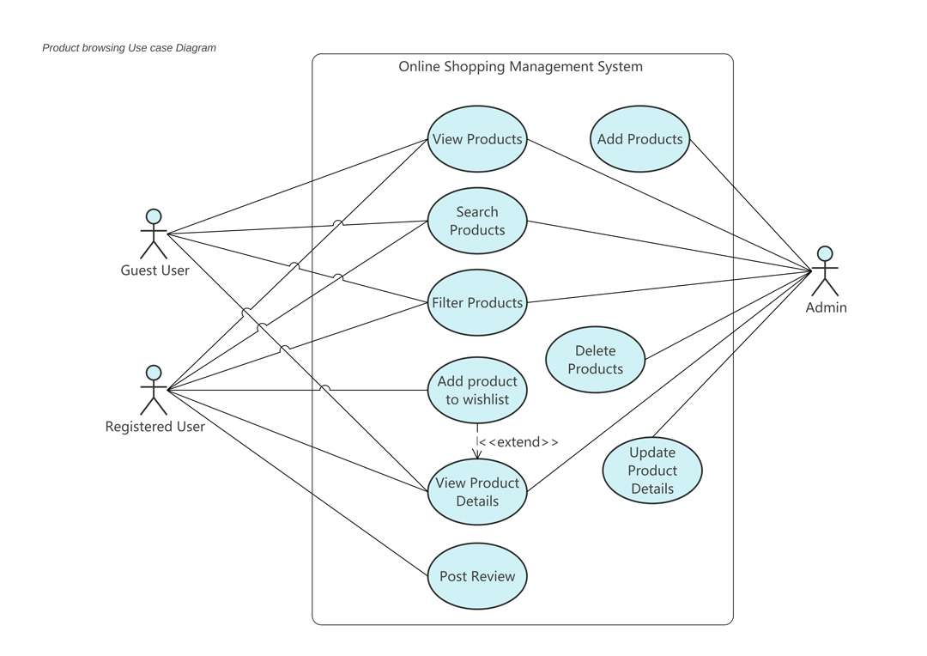

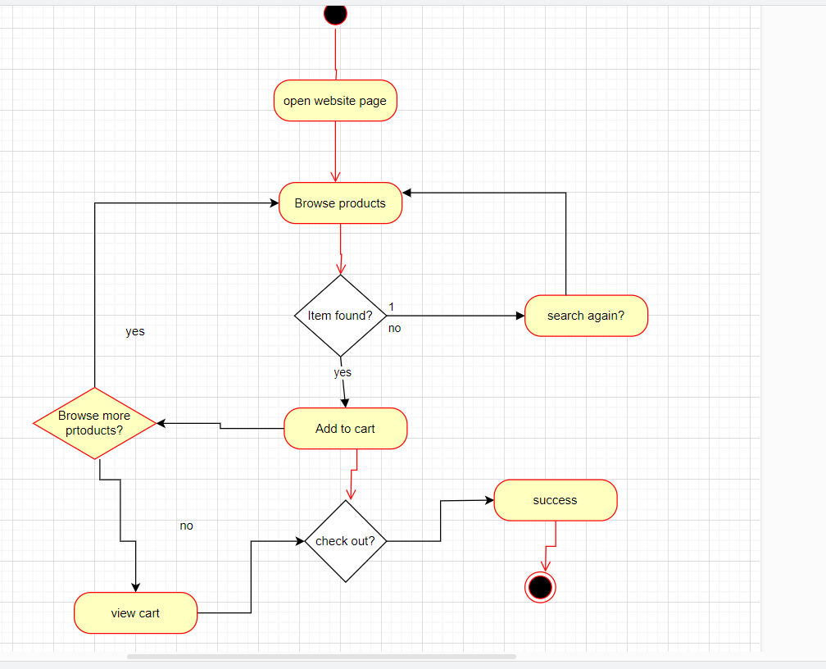

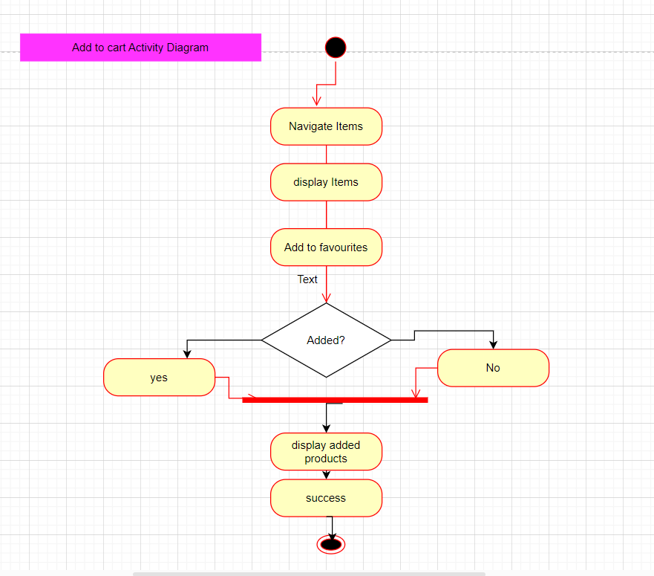
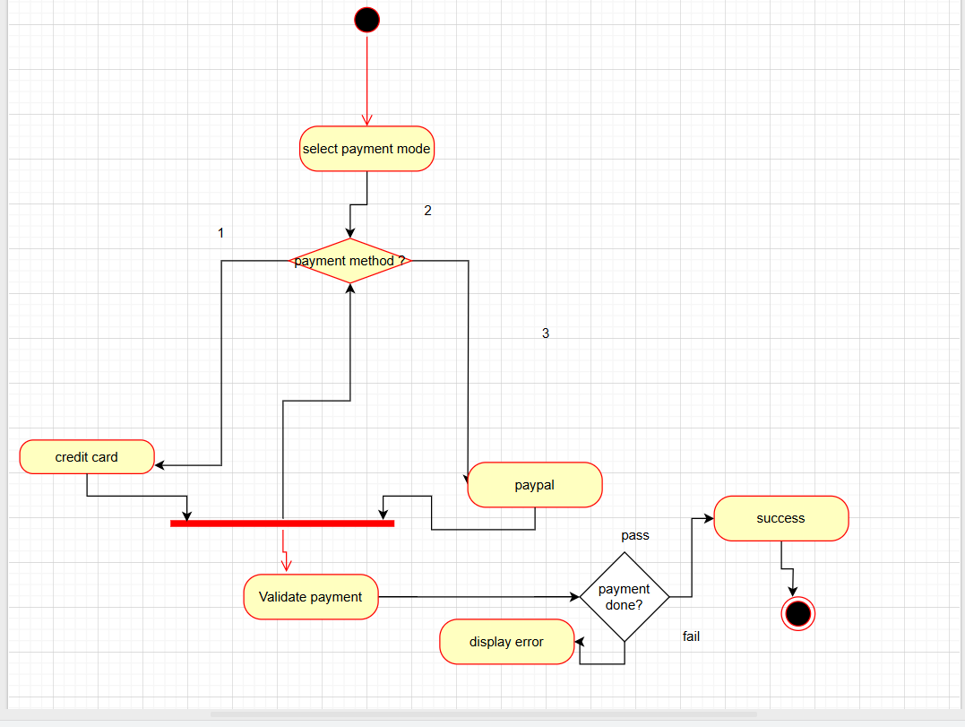

- Business Requirements
The specific business requirements elicited from stakeholders are listed, categorized by both priority and area of functionality to smooth the process of reading and tracking them. Include links to use case documentation, and other key reference material as needed to make the requirements as complete and

understandable as possible. We wish to incorporate the functional and non- functional requirements into a traceability matrix that can be followed throughout the project
Login ,Register add to cart and product delivery functionalities are there.

Req ID | Req Name | Req description | Priority
BR001 | User search for products | User should be able to search for available products | 3
BR002 | User browse products | User should be able to browse for available products | 2
BR003 | User create login | User should be able to login with username and password | 1
BR004 | Email confirmation | User should get a email confirmation for their order | 4
BR005 | Payment gateway | User should be able to make payment in COD,Credit card,debit card | 5
BR006 | Manufacturer can add product in catalog | Manufacturer should be able to add products and display products on menu | 8

- Appendices

  - List of Acronyms
BRD SRS FRD
  - Glossary of Terms
BRD SRS FRD use case
Requirement gathering
Elicitation
Design
Development
Testing

  - Related Documents

BRD FRD SRS FAQS

