Project Title: Travel and Compliance Hub

Document 1: Business Case Document Template
Project Initiation:
The Travel and Compliance Hub project was initiated to address operational inefficiencies in handling travel requests and compliance documentation within the organization. The current manual system using emails and spreadsheets is prone to errors, lacks transparency, and poses compliance risks.

Current Problems:
- Manual travel request submissions and approvals
- Lack of real-time visibility into approval status
- No centralized system for storing passport/visa documents
- No alerts for document expiries
- Redundant follow-ups and miscommunication

Problem Solution:
This project is expected to solve multiple issues by:
- Automating the travel request and approval process
- Digitizing the document submission and tracking system
- Providing timely alerts for expiry
- Reducing manual work and increasing transparency

Required Resources:
- Team: Project Manager, Developer, Tester, HR/Admin support, BA
- Tools: MS Visio, Balsamiq, Axure RP, Power BI, Excel
- Infrastructure: Hosting service, SSL certification
- Budget: ₹75,000 for development, hosting, and training

Organizational Change:
Moderate. Teams will need training on using the new system, and some process adjustments are required, but core operations remain aligned.

ROI Timeframe:
Expected within 6 months post-implementation, due to cost and time savings in administrative tasks and reduced compliance penalties.

Stakeholder Identification:
Stakeholders were identified through their roles in the travel process: HR team, Admin staff, Line Managers, Employees, and IT Support. They were engaged through meetings and feedback sessions.

Document 2: BA Approach Strategy

1. Project Initiation:
- Define the business need: automate travel and compliance workflows.
- Identify project sponsor (Amit D. Chordia) and assign PM (Vickykumar Sancheti).
- Prepare initial Business Case outlining problems, goals, and benefits.
- Identify stakeholders across HR, Admin, IT, and employee levels.
- Set up initial meetings to align on scope, timelines, and responsibilities.
- Finalize project charter and secure formal go-ahead.

2. Elicitation Techniques:
- Interviews with HR/Admin for detailed process flow
- Workshops with end users (employees/managers)
- Observation of current workflow and tools (email, Excel)
- Document analysis of travel forms, visa/passport records

3. Stakeholder Analysis:
- Identify primary, secondary, and sponsor-level stakeholders
- Categorize by influence, interest, and involvement
- Use a Stakeholder Matrix and ILS (Identify–List–Summary) model

4. RACI / ILS Preparation:
Create RACI Matrix:
- R – Business Analyst, Developer
- A – Project Manager
- C – HR/Admin
- I – Sponsor, Employees
Use ILS to assess stakeholder authority and engagement need

5. Documents to be Written:
- Business Case Document
- BA Strategy Document
- Functional Specification Document
- Use Case Documents
- User Stories
- Requirement Traceability Matrix (RTM)
- Business Requirements Document (BRD)
- UAT Plan and Client Acceptance Form
- Change Request Log and Meeting Minutes

6. Document Sign-off Process:
- Share finalized documents with relevant stakeholders
- Collect review feedback and revise drafts accordingly
- Obtain sign-off via email or e-signature from PM and Sponsor
- Archive signed documents in shared project folder

7. Taking Approvals from Client:
- Present deliverables with summary and impact
- Use structured formats (PDF, PPT, checklists) for clarity
- Collect approvals on milestone documents like UAT, Go-Live, etc.
- Use the Client Acceptance Form for final sign-off

8. Communication Channels:
- Weekly email updates on progress and blockers
- Bi-weekly stakeholder meetings via video call
- Internal coordination via WhatsApp or Slack
- Document repository shared via Google Drive or OneDrive

9. Change Request Handling:
- Maintain a Change Request Register
- Assess impact on time, cost, scope, and resources
- Review and approve changes in PM/Sponsor meetings
- Update BRD, RTM, and schedules post-approval

10. Progress Updates to Stakeholders:
- Weekly reports including:
- Completed work
- Upcoming tasks
- Identified risks
- Action items
- Visual status through Power BI dashboards
- Escalate issues immediately to avoid delays

11. UAT Sign-off Process:
- Prepare a UAT plan with scenarios and users
- Conduct UAT with selected employees, HR, and Admin
- Log bugs, get feedback, and resolve issues
- Obtain UAT Sign-off using the Client Acceptance Form
- Proceed to final deployment and handover

Document 3: Functional Specifications Document
Project Name: | Travel and Compliance Hub
Customer Name: | World Foods LLP
Project Version: | 1.0
Project Sponsor: | Amit Dhanyakumar Chordia
Project Manager: | Vickykumar Rameshlalji Sancheti
Project Initiation Date: | 20/05/2025

Functional Requirement Specifications
Req ID | Req Name | Req Description | Priority
FR001 | Login | Role-based user login (Employee, Manager, Admin) | 10
FR002 | Travel Request Submission | Form to raise and submit travel request | 10
FR003 | Approval Workflow | Approval path based on hierarchy | 10
FR004 | Document Upload | Upload and manage passport/visa copies | 9
FR005 | Expiry Alert Notification | Auto-email alerts 30 days before document expiry | 9
FR006 | Dashboard View | Visual display of pending/completed requests and document status | 8
FR007 | Reports Export | Export compliance and travel reports in Excel/PDF | 7

Document 4: Requirement Traceability Matrix
Req ID | Req Name | Req Description | Design | D1 | T1 | D2 | T2 | UAT | Priority
FR001 | Login | User login by role | Yes | ✓ | ✓ | ✓ | ✓ | Yes | 10
FR002 | Travel Request | Submit travel request with details | Yes | ✓ | ✓ | ✓ | ✓ | Yes | 10
FR003 | Approval Workflow | Route request to respective manager | Yes | ✓ | ✓ | ✓ | ✓ | Yes | 10
FR004 | Document Upload | Upload and view passport/visa | Yes | ✓ | ✓ | ✓ | ✓ | Yes | 9
FR005 | Expiry Notification | Auto-alert 30 days before expiry | Yes | ✓ | ✓ | ✓ | ✓ | Yes | 9
FR006 | Dashboard | Compliance and status overview | Yes | ✓ | ✓ | ✓ | ✓ | Yes | 8
FR007 | Reports Export | Generate Excel/PDF reports | Yes | ✓ | ✓ | ✓ | ✓ | Yes | 7

Document 5: BRD Template
Project Name: Travel and Compliance Hub
Project ID: TCH-001
Version ID: 1.0
Author: Kunal Kadambande

1. Document Revisions

Date | Version Number | Document Changes
20/05/2025 | 0.1 | Initial Draft created with high-level objectives and problem outline
22/05/2025 | 0.2 | Added detailed ROI analysis and stakeholder identification methodology
24/05/2025 | 0.3 | Refined the problem and opportunity statements after Admin/HR feedback
26/05/2025 | 0.4 | Integrated organizational change and timeline estimates from PM’s review
28/05/2025 | 0.5 | Final formatting and consistency check across all points for submission

2. Approvals
Role | Name | Title | Signature | Date
Project Sponsor | Amit D. Chordia | Director | TBD | 22/05/2025
Business Owner | Nikhil Sharma | HR Head | TBD | 24/05/2025
Project Manager | Vickykumar R. Sancheti | Project Manager | TBD | 25/05/2025
System Architect | Neha Kulkarni | Solution Architect | TBD | 25/05/2025
Development Lead | Saurabh Patil | Lead Developer | TBD | 26/05/2025
User Experience Lead | Rucha Mehta | UI/UX Designer | TBD | 26/05/2025
Quality Lead | Arvind Rao | QA Lead | TBD | 27/05/2025
Content Lead | Pooja Iyer | Documentation Specialist | TBD | 27/05/2025

3. RASCI Chart for This Document
Codes Used in RASCI Chart:
- R: Responsible
- A: Accountable
- S: Support
- C: Consulted
- I: Informed
RASCI Chart:
Name | Position | R | A | S | C | I
Kunal Kadambande | Business Analyst | X |  |  | X
Vickykumar Sancheti | Project Manager |  | X | X | X | X
Amit D. Chordia | Project Sponsor |  |  |  |  | X
Saurabh Patil | Development Lead | X |  |  | X
Arvind Rao | QA Lead |  |  | X | X
Nikhil Sharma | HR/Admin Representative |  |  |  | X | X

In this RASCI Chart:
- Vickykumar Sancheti (PM): Accountable for all documents; has final authority to approve changes.
- Kunal Kadambande (BA): Responsible for requirement gathering and BRD; consulted in design and QA.
- Amit D. Chordia (Sponsor): Informed on progress and final outcomes.
- Saurabh Patil (Dev Lead): Responsible for development; consulted in design and analysis.
- Arvind Rao (QA Lead): Responsible for testing; supports UAT and consulted in quality checks.
- Nikhil Sharma (HR/Admin): Consulted for compliance inputs; informed on system changes.

4. Business Goals
Need:
To digitize and streamline the travel request and compliance process within the organization.
4.1. Goals:
- Reduce manual work involved in handling employee travel approvals and document tracking.
- Improve transparency and accountability through automated workflows and notifications.
- Ensure timely renewal of passport and visa documents via system-generated alerts.
- Provide real-time dashboards and reports for decision-makers.
- Enhance security and confidentiality of sensitive employee travel data.
- Integrate the solution seamlessly with existing HR tools and processes.

4.2. Business Objectives
To provide an IT solution for:
- Automating travel request initiation, routing, and approvals
- Centralized storage and tracking of employee travel documents
- Role-based access for Employees, Managers, Admin
- Notification engine for document expiry alerts
- Dashboards and analytics for management
- Integration (if required) with HRMS tools like attendance or employee records
Modules:
- Travel Request Workflow (Web Interface)
- Document Upload & Tracking (Passport/Visa)
- Alerts & Notification Engine
- Manager/Admin Dashboards
- Reports Export Module

4.3. Business Rules
- Travel requests must be submitted at least 7 days prior to travel.
- Document expiry alerts must be generated 30 days in advance.
- Only Admin and Manager roles have approval authority.
- Employees can view only their own travel status and documents.
- System access is governed by RBAC (Role-Based Access Control).
- All records must be archived for 3 years for audit purposes.

4.4. Background
This project was proposed due to recurring issues in manual handling of employee travel and document tracking. Approvals often got delayed due to lack of visibility and over-dependence on email threads. Passport and visa documents were being tracked in Excel, often resulting in expiry oversight and compliance issues. The admin team had to chase approvals manually, leading to inefficiencies and escalations.
The proposed centralized Travel and Compliance Hub is aimed at eliminating these challenges and improving end-to-end coordination, compliance, and administrative efficiency.

4.5. Project Objective
The objective is to develop a secure, user-friendly application that:
- Allows employees to raise travel requests with full traceability
- Let us managers/admin review and approve/reject requests in real time
- Notifies stakeholders about document expiry, pending approvals
- Stores all travel and compliance documents digitally in one place
- Generates reports and dashboards for leadership and audit readiness
The product is aligned with business objectives to reduce operational overhead and ensure policy compliance. Future integration with HRMS is considered.

4.6. Project Scope
We are going to develop: A web-based application that streamlines employee travel and document compliance workflows, equipped with user access control, real-time alerts, analytics, and document storage.
4.6.1. In Scope Functionality
- Travel request form submission with approval routing
- Upload and manage travel documents (passport/visa)
- Automated notification system for document expiry
- Role-based access (Employee, Manager, Admin)
- Admin and Manager dashboards
- Report generation (PDF/Excel)
- User authentication and profile management
4.6.2. Out Scope Functionality
- Flight/hotel booking integration
- Payroll or reimbursement tracking
- Mobile offline access
- Third-party document verification
- Integration with external visa consultants

5. Assumptions
- All users will have access to internet and browser-based systems.
- Admin team will provide all historical data in Excel format for migration.
- HR/Admin will be available for periodic reviews and testing.
- End users will cooperate during UAT and training phases.
- Access credentials and email IDs for all users are available.

6. Constraints
- Fixed budget of ₹75,000 for development, testing, and deployment.
- Completion timeline is limited to 4 months.
- Only 1 developer and 1 tester are available.
- Integration with external APIs is not allowed in this phase.
- Mobile application is not part of initial release.

7. Risks
This section identifies risks that could affect the success of the project and strategies to address them.
Risk Handling Strategies:
- Avoid: Eliminate risks by altering project scope or design.
- Mitigate: Take actions to reduce the likelihood or impact.
- Transfer: Shift the risk to a third party.
- Accept: Acknowledge the risk and plan to manage consequences.
Technological Risks
- Integration issues with server or hosting environment.
- Unfamiliarity with some components of the tech stack.
- Strategy: Mitigate by using proven technologies and ensuring dev team is trained.
Skills Risks
- Limited technical staff with overlapping responsibilities.
- Strategy: Accept and balance workload carefully with buffer time.
Political Risks
- Internal resistance to system changes by staff used to manual methods.
- Strategy: Mitigate via awareness sessions and stakeholder buy-in.
Business Risks
- Delay in project delivery could result in continued compliance lapses.
- Strategy: Mitigate with clear milestone-based tracking and weekly reporting.
Requirements Risks
- Stakeholders may not have expressed all expectations clearly.
- Strategy: Mitigate by validating each requirement via workshops and approvals.
Other Risks
- Power outages or internet issues during UAT.
- Strategy: Accept but plan for multiple UAT time slots or fallback systems.

8. Business Process Overview
This section explains the current and proposed business processes.
8.1. Legacy System (AS-IS)
- Employees manually fill travel request forms and email them to Admin.
- Admin forwards the request to respective managers for approval.
- Status tracking is done via Excel sheets.
- Document expiry tracking is manual and error-prone.
- Lack of real-time visibility, causing delays and non-compliance.
8.2. Proposed Recommendations (TO-BE)
- Employees submit travel requests directly in the system.
- System auto-routes requests to the appropriate approvers.
- Admin and Managers get real-time dashboards of pending actions.
- Employees upload documents into the system and receive expiry alerts.
- Approval status and compliance reports are available instantly.
- All actions are logged for audit and traceability.

9. Business Requirements
This table outlines the business requirements gathered from stakeholders for the Travel and Compliance Hub project. The requirements are categorized by type, priority, and source.
Req ID | Requirement Description | Type | Priority | Source
BR001 | System must allow role-based login for Employees, Admins, and Managers | Functional | High | Stakeholder Workshop
BR002 | Users must be able to raise travel requests via web interface | Functional | High | Admin Feedback
BR003 | Requests must follow a multi-level approval workflow | Functional | High | HR Interviews
BR004 | Employees should upload passport and visa documents | Functional | Medium | Process Review
BR005 | System should trigger expiry alerts 30 days in advance | Functional | High | Compliance Policy
BR006 | Admin/Managers should access dashboards for pending approvals | Functional | Medium | Review Meeting
BR007 | Export reports in PDF and Excel formats | Functional | Low | Management Feedback
BR008 | System access must be secure using RBAC | Non-Functional | High | IT Security
BR009 | System should support concurrent users | Non-Functional | Medium | Development Team
BR010 | Data should be backed up weekly | Non-Functional | Medium | Risk Planning

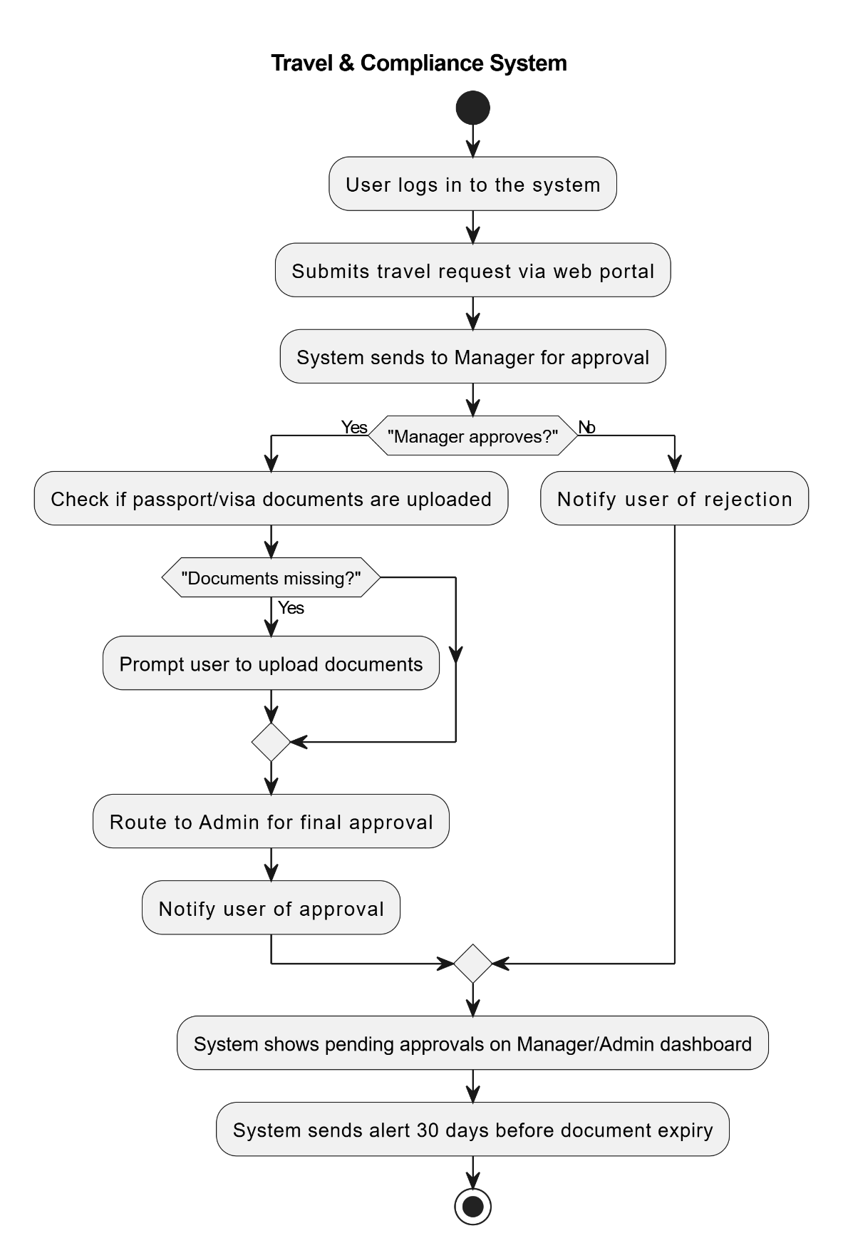

10. Appendices
10.1. List of Acronyms
- HR: Human Resources
- UAT: User Acceptance Testing
- RTM: Requirement Traceability Matrix
- BRD: Business Requirement Document
- RBAC: Role-Based Access Control
10.2. Glossary of Terms
- Compliance: Adhering to internal travel policy and documentation standards.
- Dashboard: A summary view showing status, metrics, and KPIs.
- Approval Workflow: The sequence in which travel requests are reviewed and approved.
10.3. Related Documents
- Functional Specification Document
- Requirement Traceability Matrix (RTM)
- Change Request Log
- UAT Plan & Client Sign-off Document This section identifies risks that could affect the success of the project and strategies to address them.

