CAPSTONE PROJECT – PREP 2.
SUBMITTED BY – AISHWARYA AJIT KHULE
BATCH – 10TH AUGUST, 2024.
SUBMISSION DATE – 21ST SEPT, 2024.

Online Agriculture Products Store :-
Mr. Henry, after being successful as a businessman and has become one of the wealthiest persons in the city. Now, Mr. Henry wants to help others to fulfil their dreams. One day, Mr. Henry went to meet his childhood friends Peter, Kevin and Ben. They live in a remote village and do farming. Mr. Henry asked his friends if they are facing any difficulties in their day-to-day work. Peter told Mr. Henry that he is facing difficulties in procuring fertilizers which are very important for farm. Kevin said that he is also facing the same problem in-case of buying seeds for farming certain crops. Ben raised his concern on lack of pesticides which could help in greatly reducing pests in crops. After listening to all his friends’ problems, Mr. Henry thought that this is a crucial problem faced not only by his friends but also by so many other farmers. So, Mr. Henry decided to make an online agriculture product store to facilitate remote area farmers to buy agriculture products. Through this Online Web / mobile Application, Farmers and Companies (Fertilizers, seeds and pesticides manufacturing Companies) can communicate directly with each other. The main purpose to build this online store is to facilitate farmers to buy seeds, pesticides, and fertilizers from anywhere through internet connectivity. Since new users are involved, Application should be user friendly. This new application should be able to accept the product (fertilizers, seeds, pesticides) details from the manufacturers and should be able to display them to the Farmers. Farmers will browse through these products and select the products what they need and request to buy them and deliver them to farmers location. Mr. Henry has given this project through his Company SOONY. In SOONY Company, Mr Pandu is Financial Head and Mr Dooku is Project Coordinator. Mr. Henry , Mr Pandu , and Mr Dooku formed one Committee and gave this project to APT IT SOLUTIONS company for Budget 2 Crores INR and 18 months Duration under CSR initiative. Peter, Kevin and Ben are helping the Committee and can be considered as Stakeholders share requirements for the Project. Mr Karthik is the Delivery Head in APT IT SOLUTIONS company and he reached out to Mr Henry through his connects and Bagged this project. APT IT SOLUTIONS company have Talent pool Available for this Project. Mr Vandanam is project Manager, Ms. Juhi is Senior Java Developer, Mr Teyson, Ms Lucie, Mr Tucker, Mr Bravo are Java Developers. Network Admin is Mr Mike and DB Admin is John. Mr Jason and Ms Alekya are the Tester. And you joined this team as a BA.
YOUR TEAM.
Project Manager - Mr Vandanam Senior Java Developer - Ms. Juhi.
Java Developers - Mr Teyson, Ms Lucie, Mr Tucker, Mr Bravo Network Admin - Mr Mike.
DB Admin - Mr John
Testers - Mr Jason and Ms Alekya.
BA – You.

Fertilizers, seeds, pesticides details from the manufacturers and should be able to display them to the Farmers. To gather the business requirements from the client, you went to SOONY and met Mr. Henry. When Mr. Henry was asked about the project and what are they expecting from the project, Mr. Henry stated that he is expecting to have a login for all its users (fertilizers, seeds, pesticides manufacturers and Farmers) , a product catalogue of fertilizers, seeds, pesticides, a search option to search for products, payment process, and delivery tracking. After doing the stakeholder analysis, you have found out that Peter, Kevin, Ben are the key stakeholders and you have scheduled an appointment to meet them. After meeting with them and trying to gather the stakeholder requirements, Kevin said that, a Farmer should be able to browse through the products catalogue once they visit the website and need to have a search option so that they can search for any product they need. Peter said that, if a farmer wants to buy any product or add them to buy-later list, they need to login first using their email id and password. If it is a new user, then they can create a new account by submitting their email ID and creating a secure password. Ben added saying that, Farmers needs to have an easy-to-use payment gateway which should include cash-on-delivery (COD), Credit/Debit card and UPI options so that the user’s experience should be better. Kevin mentioned that, a user gets an email confirmation regarding their order status. A delivery tracker to track the whereabouts of their order.
Identify Business Requirements (which includes Stakeholder Requirements)
BR001 – Farmers should be able to search for available products in fertilizers, seeds.
BR002 – Manufacturers should be able to upload and display their products in the application.
Make suitable Assumptions and identify at least 10 Business Requirements.
List your assumptions.
Give Priority 1 to 10 numbers ( 1 being low priority – 10 being high priority) to these Requirements after discussions with the stakeholder.

REQ ID | REQ NAME. | REQ DESCRIPTION. | PRIORITY.
BR0101 | Farmers search for product. | Farmers should be able to search for available products in fertilizers, seeds, pesticides. | 8
BR0102 | Manufacturers upload their products. | Manufacturers should be able to upload and display their products in the application. | 8

Once the requirements are finalized, as a business analyst, one of the major roles is to act as a liaison between the client and the project team. To gather the requirements correctly from the client side and then to deliver those requirements to the project team in a way they understand.
To make the project team understand the requirements, you need to convert those requirements into UML diagrams and screen mock-ups.
You will draw use case diagram.
Prepare use case specs for all use cases.
And you will all Activity diagrams required.

Question 1.
Identify minimum 20 functional requirements Example : Functional requirement: When an order is fulfilled, the local printer shall print a packing slip. Non-Functional Requirement: Packing slips shall be printed on both sides of 4”x 6” white paper, the standard size for packing slips used by local printers.
Answer 1.
Req. ID | Req. Name | Req. Description
FR001 | User Registration and Authentication | The application must allow farmers and manufacturers to create accounts securely and authenticate their identities.
FR002 | User Login | The system shall allow users (farmers and manufacturers) to log in using their credentials.
FR003 | Product Catalogue Management | The system must enable manufacturers to upload and manage product listings, including fertilizers, seeds, and pesticides.
FR004 | Search and Filter Functionality | Farmers must be able to search for products and filter results based on categories, such as type (fertilizer, seed, pesticide), price range, and manufacturer.
FR005 | Product Details and Information | Each product listing must include detailed descriptions, usage instructions, pricing, and availability status.
FR006 | Shopping Cart and Order Management | The application must allow farmers to add products to a shopping cart and manage their orders, including viewing order history and tracking deliveries.
FR007 | Place Order | The system shall allow farmers to place an order for products in the cart.
FR008 | Payment Processing | The system should support multiple payment methods, including credit/debit cards, mobile wallets, and cash on delivery.
FR009 | Delivery Scheduling | Farmers should be able to choose preferred delivery times, and the system must manage logistics to ensure timely delivery to remote areas.
FR010 | Product Categories. | The system shall categorize products into sections such as fertilizers, seeds, and pesticides.
FR011 | Notifications | The system shall send notifications to users for order updates, new product listings, and payment status.
FR012 | User Reviews and Ratings | The application must include a feature for farmers to review and rate products, providing feedback to both manufacturers and other users.
FR013 | Customer Support | The application should offer customer support options, such as FAQs, chat support, or contact forms for users facing issues.
FR014 | Return and Refund Policy | There should be a set refund and return or exchange policy on the goods that are displayed on the website. And, the system must provide all the necessary details
FR015 | Manage User Profile | The system shall allow users (farmers and manufacturers) to view and update their profile information.
FR016 | Communication Channel | The system shall provide a communication feature for farmers to ask questions directly to manufacturers.
FR017 | Reporting and Analytics | The system must provide reporting tools for manufacturers to track sales performance, inventory levels, and user engagement metrics
FR018 | Manage Admin user | The system shall allow the admin (SOONY) to manage user roles, permissions, and access control.
FR019 | Usability | The user interface should be intuitive and easy to navigate, with a satisfaction rating of at least 80% in user testing.
FR020 | Authentication. | The system must implement multi-factor authentication for user accounts, especially for transactions over a certain amount.
Req ID. | Req Name. | Req Description.
NFR001 | Response Time | The system should load within 2 seconds for users on a standard broadband connection
NFR002 | Error Rate | The application should have a failure rate of less than 1% for transactions.
NFR003 | Availability. | The system should be available 24/7, allowing users to browse and purchase products at any time.
NFR004 | Data Protection | User data (including payment information) must be encrypted both in transit and at rest.
NFR005 | Backup and Recovery | The system should implement daily backups of all data and have a recovery plan to restore operations within 4 hours in case of data loss.
NFR006 | Accessibility | The system should meet Web Content Accessibility Guidelines 2.1 AA standards to ensure it is accessible to users with disabilities.
NFR007 | Data Backup | The system must perform daily automatic backups to ensure data can be restored in case of failure.
NFR008 | Mobile Responsiveness | The system must be fully responsive and optimized for use on mobile devices of various screen sizes.
NFR009 | Load Handling | The system should handle up to 10,000 product uploads per hour without failure or performance issues.
NFR010 | Interoperability | The system should be able to integrate with popular payment gateways and logistics service providers.
NFR011 | Data Retention | User transaction data should be retained for a minimum of 5 years for regulatory and reporting purposes.
NFR012 | Localization | The system must support multiple languages (e.g., English, Hindi) to cater to farmers in different regions.
NFR013 | Legal Compliance | The system must comply with all relevant data privacy laws (e.g., GDPR, Indian IT Act) for handling user data.
NFR014 | Maintainability | The system should allow easy updates and maintenance by the IT team without downtime.
NFR015 | Error Handling | The system must provide user-friendly error messages and error logging for critical failures.
NFR016 | Transaction Processing | The system must process payments securely, ensuring that no transaction takes longer than 5 seconds.
NFR017 | Audit Logging | The system should keep a complete audit log of user actions, including order placements and product uploads.
NFR018 | Session Timeout | User sessions should automatically log out after 15 minutes of inactivity to ensure security.
NFR019 | Disaster Recovery | The system must have a disaster recovery plan in place to restore operations within 4 hours after a major failure.
NFR020 | Database Performance | The database should support up to 1 million records without performance degradation during queries.

QUESTION 2.
Make wireframe and prototype.
ANSWER 2.
The wireframes and prototypes have been created using Balsamiq tool, by me.
The prototypes are of-
- Login Page.
(Computer Interface) -

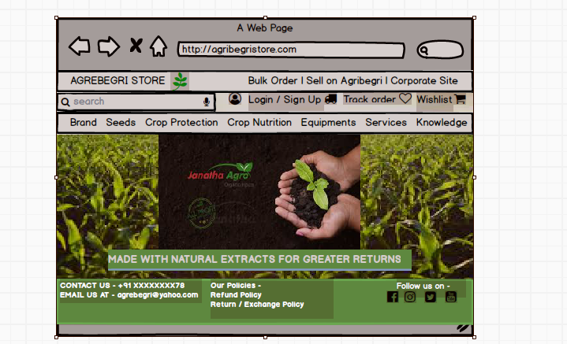

(Mobile Interface.)

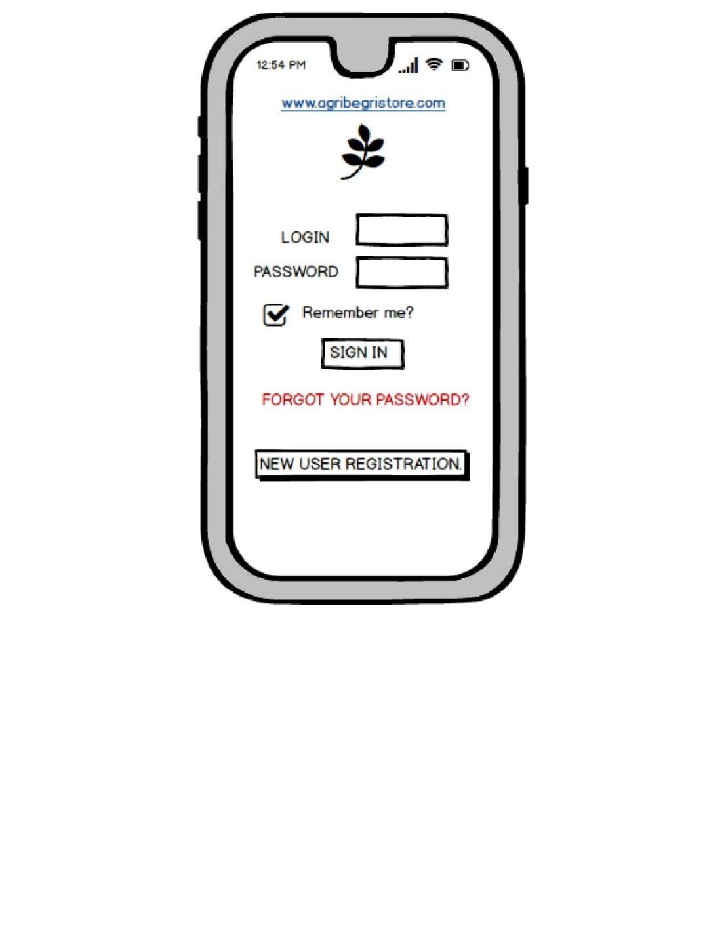

- Order Tracking Page
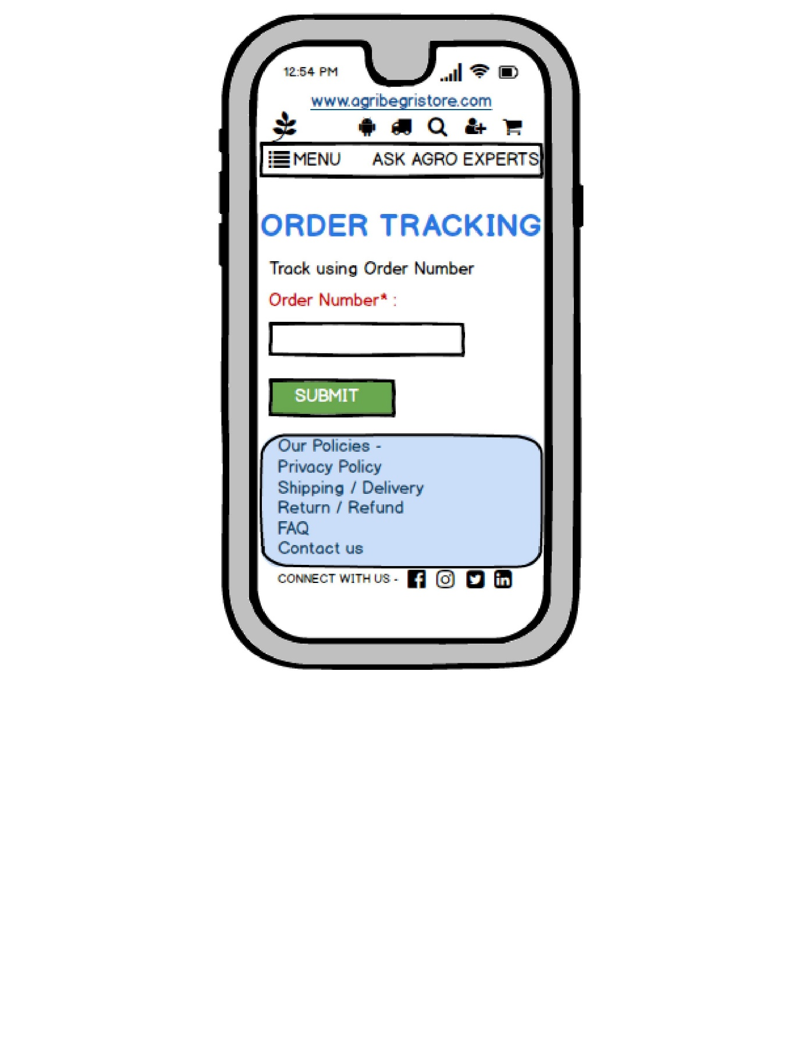

- Search Page.

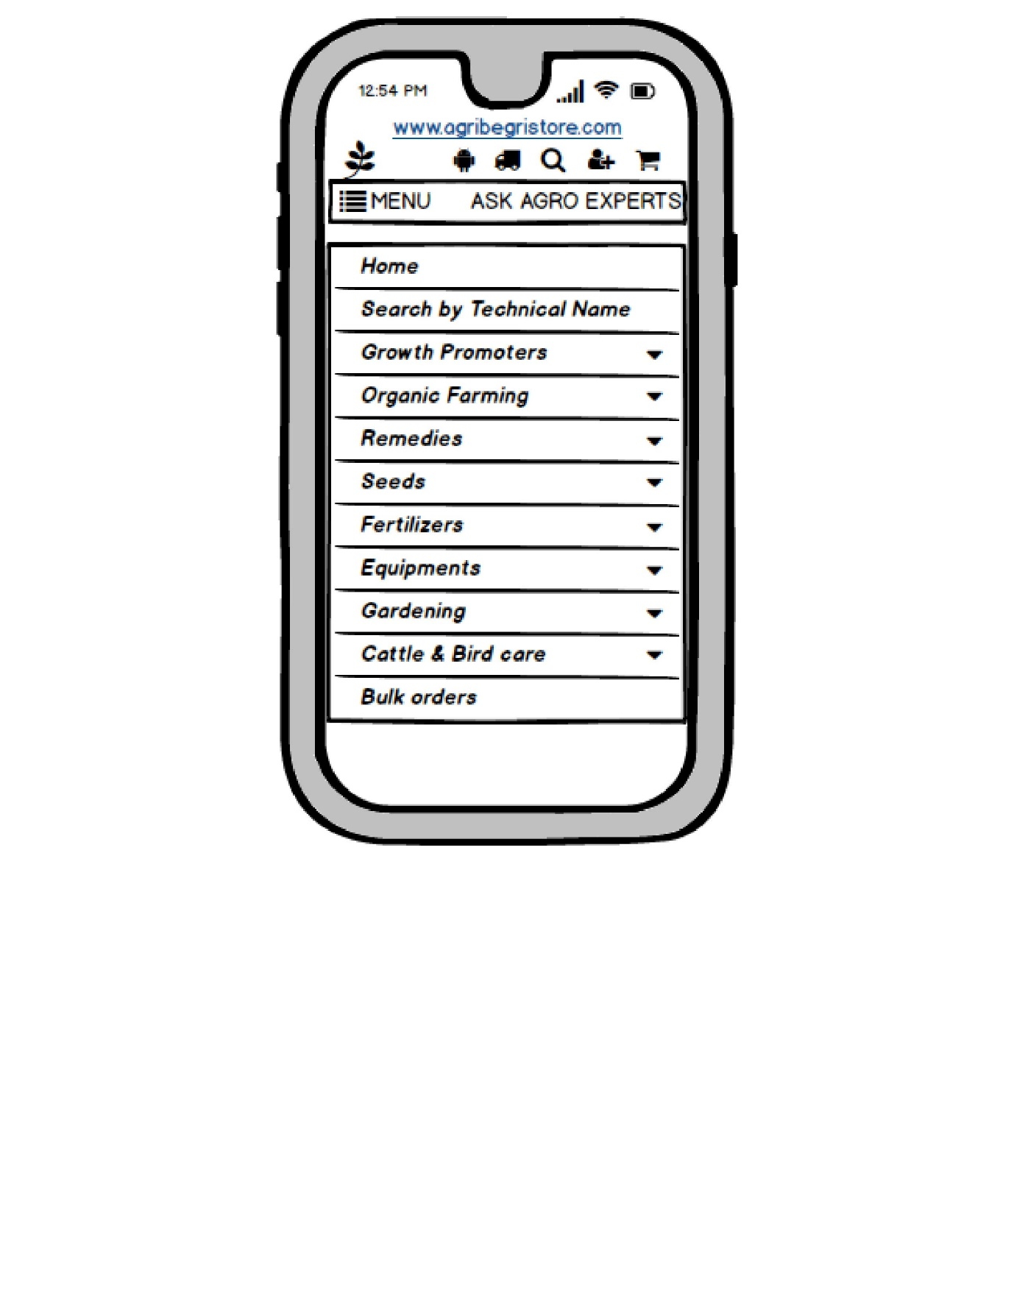

- Product Page.

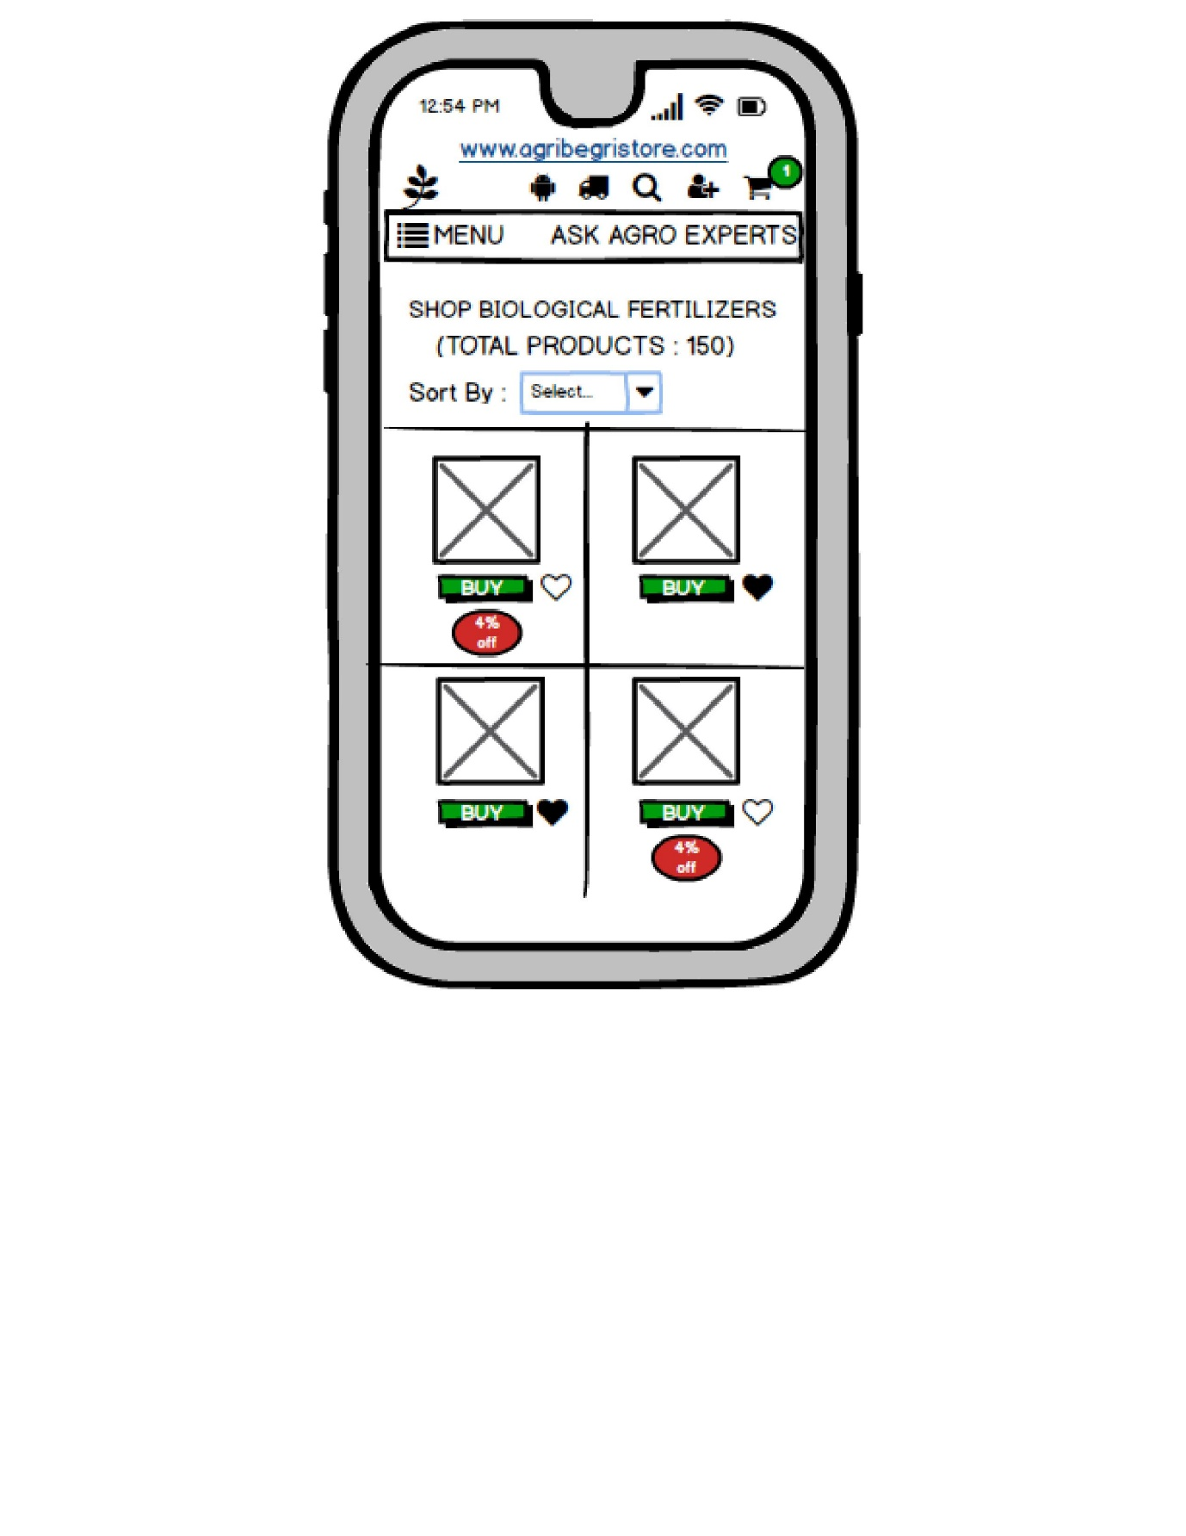

- Shopping Cart Page.

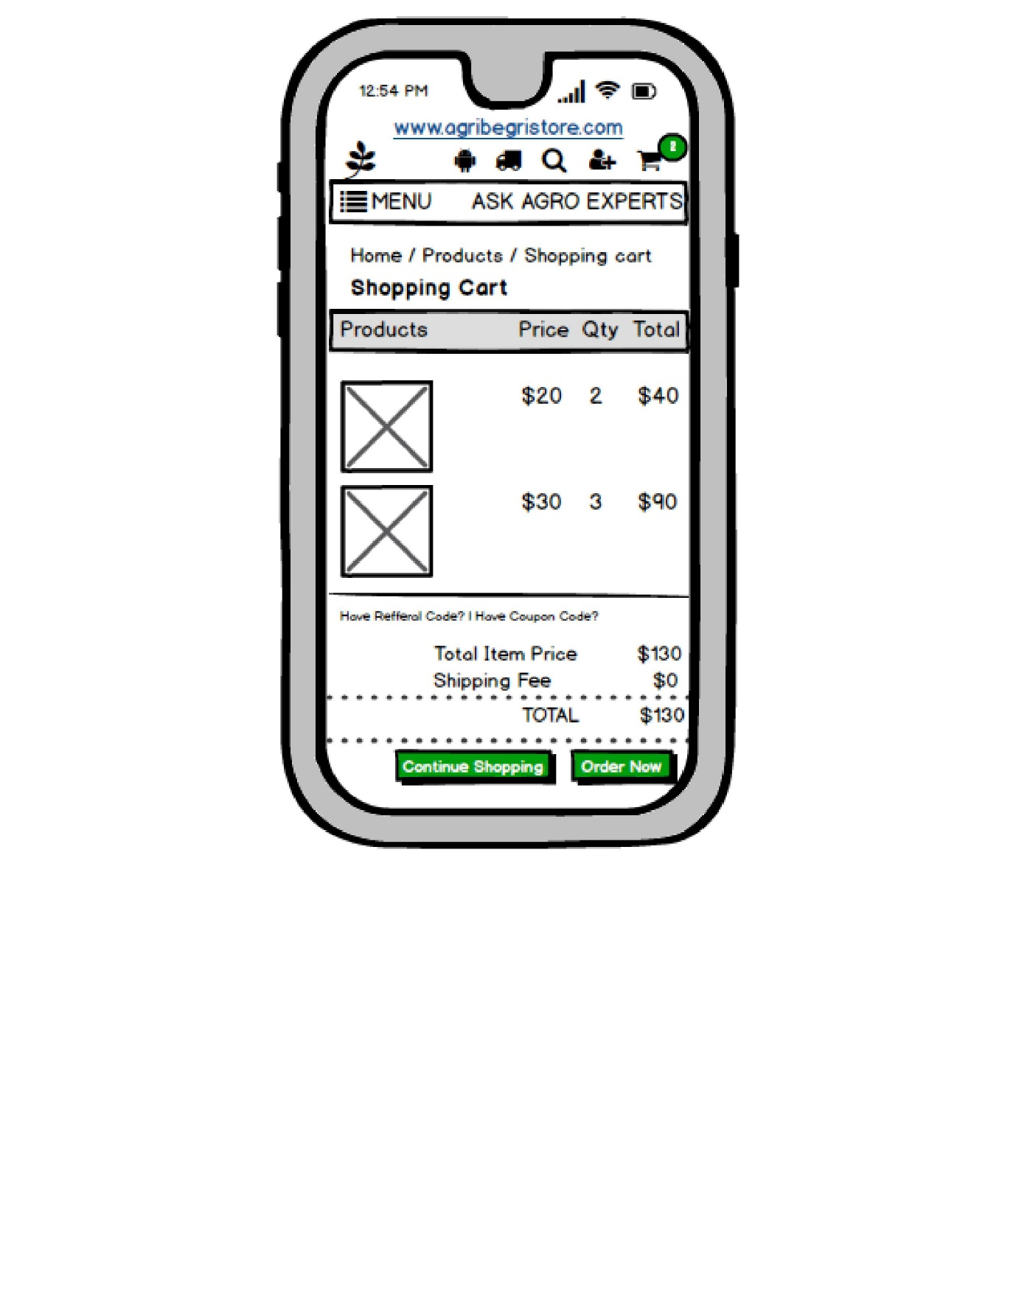

QUESTION 3.
Make a note of the Tools, which you are using for above concepts
ANSWER 3.
For the above given question, I have used Balsamiq to design all my prototypes. I decided to use Balsamiq specifically for its given detailed information below-
Balsamiq is a wireframing tool designed to facilitate the early stages of product design. It helps designers and product teams create low-fidelity mock-up’s of user interfaces, focusing on functionality and layout rather than visual aesthetics. Its sketch-like interface encourages quick iteration and brainstorming, making it an excellent tool for gathering feedback.
- Key Features-
- Low-Fidelity Wireframing: Balsamiq emphasizes simplicity. The designs resemble hand-drawn sketches, which helps stakeholders focus on structure and user experience rather than getting distracted by colour schemes and detailed graphics.
- Drag-and-Drop Interface: Users can easily drag and drop UI components from a library, speeding up the design process. The library includes common elements like buttons, text fields, icons, and more.
- Collaboration: Balsamiq allows multiple team members to collaborate on wireframes. You can share designs via a web link, enabling others to leave comments and feedback directly on the mock-up’s.
- Commenting and Feedback: Stakeholders can add comments on specific areas of the wireframe, facilitating constructive feedback and discussions.
- Version Control: Balsamiq supports version history, allowing users to track changes and revert to previous versions if necessary.
- Export Options: Users can export their wireframes as PNG or PDF files, making it easy to share with non-Balsamiq users or stakeholders.
- Integration: Balsamiq integrates with various project management and collaboration tools like Jira, Confluence, and Trello, allowing seamless workflow integration.
- Accessibility: It is available both as a cloud-based app (Balsamiq Cloud) and a desktop application (Balsamiq Mock-ups), catering to different user preferences.
- Use Cases
- Brainstorming and Ideation: Designers can quickly sketch ideas and concepts, making it easier to explore various solutions.
- User Testing: Low-fidelity wireframes can be used in user testing to gather early feedback on functionality and navigation without the distraction of detailed design.
- Stakeholder Engagement: Presenting wireframes to stakeholders allows teams to align on concepts and requirements early in the design process.
- Agile Development: Balsamiq fits well within agile workflows, enabling rapid iterations and adjustments based on team and user feedback.
- Pros and Cons
Pros:
- Fast and intuitive interface.
- Encourages rapid prototyping and iteration.
- Focuses on user experience rather than aesthetics.
- Strong collaboration features.
Cons:
- Limited to low-fidelity designs; may not be suitable for high-fidelity prototypes.
- The sketch-like style may not appeal to all stakeholders, especially those looking for polished designs.
Microsoft Visio is a popular tool for creating diagrams, flowcharts, and wireframes. It offers a wide
range of templates and shapes to create visual representations of processes and systems. It is also commonly used for
scenarios such as Process Mapping and Visual Collaboration. The latest version of Visio also has data visualization that
allows users to create diagrams from Excel data and also embed Visio diagrams in Power Dashboards
2. Balsamiq: Balsamiq is a wireframing tool that allows you to create low-fidelity wireframes quickly. It has a simple
and intuitive interface, making it easy to sketch out ideas and concepts3. Axure RP: Axure RP is a powerful
prototyping and wireframing tool that enables you to create interactive and dynamic prototypes. It offers advanced
features for creating complex interactions and user flows.
4. Mock-ups: - Mock-ups is a web-based design tool that provides a comprehensive set of features for wireframing
and prototyping. It allows you to create interactive wireframes and prototypes with a user-friendly interface. These
tools can assist you in visualizing and prototyping your design concepts effectively. It's important to explore their
features and determine which tool best fits your specific needs and preferences.
These tools can assist you in visualizing and prototyping your design concepts effectively. It's important to
explore their features and determine which tool best fits your specific needs and preferences.
Microsoft Visio is a popular tool for creating diagrams, flowcharts, and wireframes. It offers a wide
range of templates and shapes to create visual representations of processes and systems. It is also commonly used for
scenarios such as Process Mapping and Visual Collaboration. The latest version of Visio also has data visualization that
allows users to create diagrams from Excel data and also embed Visio diagrams in Power Dashboards
2. Balsamiq: Balsamiq is a wireframing tool that allows you to create low-fidelity wireframes quickly. It has a simple
and intuitive interface, making it easy to sketch out ideas and concepts3. Axure RP: Axure RP is a powerful
prototyping and wireframing tool that enables you to create interactive and dynamic prototypes. It offers advanced
features for creating complex interactions and user flows.
4. Mock-ups: - Mock-ups is a web-based design tool that provides a comprehensive set of features for wireframing
and prototyping. It allows you to create interactive wireframes and prototypes with a user-friendly interface. These
tools can assist you in visualizing and prototyping your design concepts effectively. It's important to explore their
features and determine which tool best fits your specific needs and preferences.
These tools can assist you in visualizing and prototyping your design concepts effectively. It's important to
explore their features and determine which tool best fits your specific needs and preferences.
Microsoft Visio is a popular tool for creating diagrams, flowcharts, and wireframes. It offers a wide
range of templates and shapes to create visual representations of processes and systems. It is also commonly used for
scenarios such as Process Mapping and Visual Collaboration. The latest version of Visio also has data visualization that
allows users to create diagrams from Excel data and also embed Visio diagrams in Power Dashboards
2. Balsamiq: Balsamiq is a wireframing tool that allows you to create low-fidelity wireframes quickly. It has a simple
and intuitive interface, making it easy to sketch out ideas and concepts3. Axure RP: Axure RP is a powerful
prototyping and wireframing tool that enables you to create interactive and dynamic prototypes. It offers advanced
features for creating complex interactions and user flows.
4. Mock-ups: - Mock-ups is a web-based design tool that provides a comprehensive set of features for wireframing
and prototyping. It allows you to create interactive wireframes and prototypes with a user-friendly interface. These
tools can assist you in visualizing and prototyping your design concepts effectively. It's important to explore their
features and determine which tool best fits your specific needs and preferences.
These tools can assist you in visualizing and prototyping your design concepts effectively. It's important to
explore their features and determine which tool best fits your specific needs and preferences.
Microsoft Visio is a popular tool for creating diagrams, flowcharts, and wireframes. It offers a wide
range of templates and shapes to create visual representations of processes and systems. It is also commonly used for
scenarios such as Process Mapping and Visual Collaboration. The latest version of Visio also has data visualization that
allows users to create diagrams from Excel data and also embed Visio diagrams in Power Dashboards
2. Balsamiq: Balsamiq is a wireframing tool that allows you to create low-fidelity wireframes quickly. It has a simple
and intuitive interface, making it easy to sketch out ideas and concepts3. Axure RP: Axure RP is a powerful
prototyping and wireframing tool that enables you to create interactive and dynamic prototypes. It offers advanced
features for creating complex interactions and user flows.
4. Mock-ups: - Mock-ups is a web-based design tool that provides a comprehensive set of features for wireframing
and prototyping. It allows you to create interactive wireframes and prototypes with a user-friendly interface. These
tools can assist you in visualizing and prototyping your design concepts effectively. It's important to explore their
features and determine which tool best fits your specific needs and preferences.
These tools can assist you in visualizing and prototyping your design concepts effectively. It's important to
explore their features and determine which tool best fits your specific needs and preferences.
As a business analyst, I would also consider using the below mentioned tools for wireframing and prototyping-
- MS Visio- Microsoft Visio is used for creating diagrams and flowcharts. It’s often employed in business contexts for visualizing processes, organizational structures, and data flow. It has extensive templates and shapes for various industries. It is software for drawing a variety of diagrams. These include flowcharts, org charts, building plans, floor plans, data flow diagrams, process flow diagrams, business process modelling, swim lane diagrams, 3D maps, and many more.

- Lucid Chart- Lucidchart is a cloud-based diagramming tool that can be used for a variety of purposes. It can be used for brainstorming, creating product roadmaps, designing wireframes, and modelling workflows. Lucidchart can also be used to build project management timelines, create customer journey maps, and build user flow diagrams.

- Sketch- Sketch is a vector-based design tool primarily used for web and mobile app design. It offers a wide range of plugins and has strong collaboration features. It's popular among designers for creating high-fidelity prototypes and interface designs. Sketch is used mainly for designing the UI and UX of mobile apps and web. The files designed in Sketch are saved in its own. sketch file format, though the files can also be opened in Adobe Illustrator, Adobe Photoshop, and other programs.

- Figma- Figma's prototyping tools make it easy to build and share high-fidelity, no-code, interactive prototypes, Design and prototype. With Figma's prototyping tools, we can turn sketches into a series of interconnected screens, so you can see how a user can navigate through an experience, without having to write any code.

- Jira- Microsoft Visio is used for creating diagrams and flowcharts. It’s often employed in business contexts for visualizing processes, organizational structures, and data flow. It has extensive templates and shapes for various industries.

- Adobe XD- Adobe XD is a vector-based design tool for creating user interfaces and experiences. It supports wireframing, prototyping, and collaboration. Its integration with other Adobe products makes it appealing for designers familiar with the Adobe ecosystem.

QUESTION 4.
A business analyst’s key responsibilities are to keep track of the requirements and make sure that no requirement is missed. Mr. Henry and peter have approached you regarding the current status of the project. How will you tackle this situation? Prepare RTM.
ANSWER 4.
Req. ID | Req. Name | Req. Description | Design | Code | UT  (Unit Testing) | CT  (Component Testing) | ST  (System Testing) | SIT  (System Integration Testing) | UAT  (User Acceptance Testing)
FR001 | User Registration and authentication. | The application must allow farmers and manufacturers to create accounts securely and authenticate their identities. | Complete | Complete | Complete | Complete | Complete | Complete | Incomplete
FR002 | User Login | Users log in with credentials. | Complete | Complete | Complete | Complete | Complete | Incomplete | Incomplete
FR003 | Product Catalogue Management | The system must enable manufacturers to upload and manage product listings, including fertilizers, seeds, and pesticides.
FR004 | Search & Filter Functionality | Farmers must be able to search for products and apply filter. | Complete | Complete | Complete | Complete | Complete | Incomplete | Incomplete
FR005 | Product details & Information. | Each product listing must include detailed descriptions, usage instructions, pricing, and availability status. | Complete | Complete | Complete | Complete | Complete | Incomplete | Incomplete
FR006 | Shopping Cart and Order Management | The application must allow farmers to add products to a shopping cart and manage their orders, including viewing order history and tracking deliveries. | Complete | Complete | Complete | Complete | Complete | Incomplete | Incomplete
FR007 | Place Order | The system shall allow farmers to place an order for products in the cart. | Complete | Complete | Complete | Complete | Complete | Complete | Complete
FR008 | Payment Processing | The system should support multiple payment methods, including credit/debit cards, mobile wallets, and cash on delivery. | Complete | Complete | Complete | Complete | Complete | Incomplete | Incomplete
FR009 | Delivery Scheduling | Farmers should be able to choose preferred delivery times, and the system must manage logistics to ensure timely delivery to remote areas. | Complete | Complete | Complete | Complete | Complete | Incomplete | Incomplete
FR010 | Product Categories. | The system shall categorize products into sections such as fertilizers, seeds, and pesticides. | Complete | Complete | Complete | Complete | Complete | Incomplete | Incomplete
FR011 | Notifications | The system shall send notifications to users for order updates, new product listings, and payment status. | Complete | Complete | Complete | Complete | Complete | Incomplete | Incomplete
FR012 | User Reviews and Ratings | The application must include a feature for farmers to review and rate products, providing feedback to both manufacturers and other users. | Complete | Complete | Complete | Complete | Complete | Incomplete | Incomplete
FR013 | Customer Support | The application should offer customer support options, such as FAQs, chat support, or contact forms for users facing issues. | Complete | Complete | Complete | Complete | Complete | Incomplete | Incomplete
FR014 | Return and Refund Policy | There should be a set refund and return or exchange policy on the goods that are displayed on the website. And, the system must provide all the necessary details | Complete | Complete | Complete | Complete | Complete | Incomplete | Incomplete
FR015 | Manage User Profile | The system shall allow users (farmers and manufacturers) to view and update their profile information. | Complete | Complete | Complete | Complete | Complete | Incomplete | Incomplete
FR016 | Communication Channel | The system shall provide a communication feature for farmers to ask questions directly to manufacturers. | Complete | Complete | Complete | Complete | Complete | Incomplete | Incomplete
FR017 | Reporting and Analytics | The system must provide reporting tools for manufacturers to track sales performance, inventory levels, and user engagement metrics | Complete | Complete | Complete | Complete | Complete | Incomplete | Incomplete
FR018 | Manage Admin user | The system shall allow the admin (SOONY) to manage user roles, permissions, and access control. | Complete | Complete | Complete | Complete | Complete | Incomplete | Incomplete
FR019 | Usability | The user interface should be intuitive and easy to navigate, with a satisfaction rating of at least 80% in user testing. | Complete | Complete | Complete | Complete | Complete | Incomplete | Incomplete
FR020 | Authentication. | The system must implement multi-factor authentication for user accounts, especially for transactions over a certain amount. | Complete | Complete | Complete | Complete | Complete | Incomplete | Incomplete

RTM For Non Functional Requirements :-

Req. ID | Req. Name | Req. Description | Design | Code | UT  (Unit Testing) | CT  (Component Testing) | ST  (System Testing) | SIT  (System Integration Testing) | UAT  (User Acceptance Testing)
NFR001 | Response Time | The system should load within 2 seconds for users on a standard broadband connection | Complete | Complete | Complete | Complete | Incomplete | Incomplete | Incomplete
NFR002 | Error Rate | The application should have a failure rate of less than 1% for transactions. | Complete | Complete | Complete | Complete | Incomplete | Incomplete | Incomplete
NFR003 | Availability. | The system should be available 24/7, allowing users to browse and purchase products at any time. | Complete | Complete | Complete | Complete | Incomplete | Incomplete | Incomplete
NFR004 | Data Protection | User data (including payment information) must be encrypted both in transit and at rest. | Complete | Complete | Complete | Complete | Incomplete | Incomplete | Incomplete
NFR005 | Backup and Recovery | The system should implement daily backups of all data and have a recovery plan to restore operations within 4 hours in case of data loss. | Complete | Complete | Complete | Complete | Incomplete | Incomplete | Incomplete
NFR006 | Accessibility | The system should meet WCAG 2.1 AA standards to ensure it is accessible to users with disabilities. | Complete | Complete | Complete | Complete | Incomplete | Incomplete | Incomplete
NFR007 | Data Backup | The system must perform daily automatic backups to ensure data can be restored in case of failure. | Complete | Complete | Complete | Complete | Incomplete | Incomplete | Incomplete
NFR008 | Mobile Responsiveness | The system must be fully responsive and optimized for use on mobile devices of various screen sizes. | Complete | Complete | Complete | Complete | Incomplete | Incomplete | Incomplete
NFR009 | Load Handling | The system should handle up to 10,000 product uploads per hour without failure or performance issues. | Complete | Complete | Complete | Complete | Incomplete | Incomplete | Incomplete
NFR010 | Interoperability | The system should be able to integrate with popular payment gateways and logistics service providers. | Complete | Complete | Complete | Complete | Incomplete | Incomplete | Incomplete
NFR011 | Data Retention | User transaction data should be retained for a minimum of 5 years for regulatory and reporting purposes. | Complete | Complete | Complete | Complete | Incomplete | Incomplete | Incomplete
NFR012 | Localization | The system must support multiple languages (e.g., English, Hindi) to cater to farmers in different regions. | Complete | Complete | Complete | Complete | Incomplete | Incomplete | Incomplete
NFR013 | Legal Compliance | The system must comply with all relevant data privacy laws (e.g., GDPR, Indian IT Act) for handling user data. | Complete | Complete | Complete | Complete | Incomplete | Incomplete | Incomplete
NFR014 | Maintainability | The system should allow easy updates and maintenance by the IT team without downtime. | Complete | Complete | Complete | Complete | Incomplete | Incomplete | Incomplete
NFR015 | Error Handling | The system must provide user-friendly error messages and error logging for critical failures. | Complete | Complete | Complete | Complete | Incomplete | Incomplete | Incomplete
NFR016 | Transaction Processing | The system must process payments securely, ensuring that no transaction takes longer than 5 seconds. | Complete | Complete | Complete | Complete | Incomplete | Incomplete | Incomplete
NFR017 | Audit Logging | The system should keep a complete audit log of user actions, including order placements and product uploads. | Complete | Complete | Complete | Complete | Incomplete | Incomplete | Incomplete
NFR018 | Session Timeout | User sessions should automatically log out after 15 minutes of inactivity to ensure security. | Complete | Complete | Complete | Complete | Incomplete | Incomplete | Incomplete
NFR019 | Disaster Recovery | The system must have a disaster recovery plan in place to restore operations within 4 hours after a major failure. | Complete | Complete | Complete | Complete | Incomplete | Incomplete | Incomplete
NFR020 | Database Performance | The database should support up to 1 million records without performance degradation during queries. | Complete | Complete | Complete | Complete | Incomplete | Incomplete | Incomplete

QUESTION 5.
Prepare 10 Test Case Documents.
ANSWER 5.
TEST CASE 1-
Test Case ID | TC001 | Test Case Name | User Authentication.
Project ID | OAS4599 | Project Name | Online agriculture product store
PM ID | BA245 | PM Name | Mr. Vandanam
Test Strategy ID | TS001 | Tester ID | TE034J
Test Plan ID | TP001 | Tester Name | Mr. Jason
Test Schedule ID | TSC001 | Date of Test | 01-Oct-24

Scenario | To authentic a successful user login on Gmail.com
Link to that page

Input Data | Name, Contact number, Email ID
Expected Behaviour | Once username and password are entered, the web page redirects to the users inbox, displaying and highlighting new emails at the top.
Actual Behaviour | As expected.
Comments | NA
Results (Pass/Fail) | Pass.

TEST CASE 2-
Test Case ID | TC002 | Test Case Name | Product authentication.
Project ID | OAS4599 | Project Name | Online agriculture product store
PM ID | BA245 | PM Name | Mr. Vandanam
Test Strategy ID | TS002 | Tester ID | TE012A
Test Plan ID | TP002 | Tester Name | Miss Alekya.
Test Schedule ID | TSC002 | Date of Test | 02-Oct-24

Scenario | Seller Product Creation.
Link to that page

Input Data | Product ID, Product pictures, Product prices, Inventory details.
Expected Behaviour | Authenticated sellers can access, authorised product creation panels under authorised categories.
Actual Behaviour | As expected.
Comments | NA.
Results (Pass/Fail) | Pass.

TEST CASE 3-
Test Case ID | TC003 | Test Case Name | Filter Results.
Project ID | OAS4599 | Project Name | Online Agriculture Product Store.
PM ID | PM245 | PM Name | Mr. Vandanam.
Test Strategy ID | TS003 | Tester ID | TE034J
Test Plan ID | TP003 | Tester Name | Mr. Jason
Test Schedule ID | TSC003 | Date of Test | 03-Oct-24

Scenario | Filter Results.
Link to that page

Input Data | Product key names, product alternative names.
Expected Behaviour | The user should be able to see results with default search criteria when at least one of the filter parameters isn’t mandatory.
Actual Behaviour | As expected.
Comments | NA
Results (Pass/Fail) | Pass.

TEST CASE 4-
Test Case ID | TC004 | Test Case Name | Product authentication.
Project ID | OAS4599 | Project Name | Online agriculture product store
PM ID | BA245 | PM Name | Mr. Vandanam
Test Strategy ID | TS004 | Tester ID | TE012A
Test Plan ID | TP004 | Tester Name | Miss Alekya.
Test Schedule ID | TSC004 | Date of Test | 04-Oct-24

Scenario | Product Details.
Link to that page

Input Data | Product Colour alternatives, product quantity, product quality.
Expected Behaviour | Test that all the product details are displayed correctly and that no empty/ invalid details are displayed.
Actual Behaviour | As expected.
Comments | NA
Results (Pass/Fail) | Pass.

TEST CASE 5-
Test Case ID | TC003 | Test Case Name | Product Pricing.
Project ID | OAS4599 | Project Name | Online Agriculture Product Store.
PM ID | BA245 | PM Name | Mr. Vandanam.
Test Strategy ID | TS005 | Tester ID | TE034J
Test Plan ID | TP005 | Tester Name | Mr. Jason
Test Schedule ID | TSC005 | Date of Test | 05-Oct-24

Scenario | Shopping cart.
Link to that page

Input Data | Item pricing, item quantity.
Expected Behaviour | Test that all the listed products have pricing, quantity and delete option related to it.
Actual Behaviour | As Expected.
Comments | NA
Results (Pass/Fail) | Pass.

TEST CASE 6-
Test Case ID | TC003 | Test Case Name | Checkout Page.
Project ID | OAS4599 | Project Name | Online Agriculture Product Store.
PM ID | BA245 | PM Name | Mr. Vandanam.
Test Strategy ID | TS006 | Tester ID | TE034J
Test Plan ID | TP006 | Tester Name | Mr. Jason
Test Schedule ID | TSC006 | Date of Test | 06-Oct-24

Scenario | Checkout Page.
Link to that page

Input Data | Item price, coupon details, price breakup.
Expected Behaviour | User should be shown the total amount with the necessary breakup as applicable.
Actual Behaviour | Not satisfactory.
Comments | User feedback received that total amount not shown with perfect breakup.
Results (Pass/Fail) | FAIL.

TEST CASE 7-
Test Case ID | TC007 | Test Case Name
Project ID | OAS4599 | Project Name | Online agriculture product store
PM ID | BA245 | PM Name | Mr. Vandanam
Test Strategy ID | TS007 | Tester ID | TE012A
Test Plan ID | TP007 | Tester Name | Miss Alekya.
Test Schedule ID | TSC007 | Date of Test | 07-Oct-24

Scenario | Payment page.
Link to that page

Input Data | Saved payment method, card numbers, UPI, Customer ID of net banking.
Expected Behaviour | For returning customers, they should be redirected to log in for checkout.
Actual Behaviour | As expected, but can be better.
Comments | The saved card numbers and details should be displayed immediately without any option.
Results (Pass/Fail) | Fail.

TEST CASE 8-
Test Case ID | TC008 | Test Case Name | Session logout.
Project ID | OAS4599 | Project Name | Online Agriculture Product Store.
PM ID | BA245 | PM Name | Mr. Vandanam.
Test Strategy ID | TS008 | Tester ID | TE034J
Test Plan ID | TP008 | Tester Name | Mr. Jason
Test Schedule ID | TSC008 | Date of Test | 08-Oct-24

Scenario | Session logout if page left idle for mora than 10 mins.
Link to that page

Input Data | Timer for page loading.
Expected Behaviour | Maintain session for each user and test verify the session timeout after a while.
Actual Behaviour | As expected.
Comments | NA.
Results (Pass/Fail) | Pass.

TEST CASE 9-
Test Case ID | TC009 | Test Case Name | Manufacturer registration form.
Project ID | OAS4599 | Project Name | Online agriculture store.
PM ID | BA245 | PM Name | Mr. Vandanam.
Test Strategy ID | TS009 | Tester ID | TE012A
Test Plan ID | TP009 | Tester Name | Miss Alekya.
Test Schedule ID | TSC009 | Date of Test | 09-Oct-24

Scenario | Manufacturer can register with all details to the website.
Link to that page

Input Data | Manufacturer details like, email, phone, name and password.
Expected Behaviour | Every new registration of manufacturer should happen successfully with correct data being stored database.
Actual Behaviour | As expected.
Comments | NA.
Results (Pass/Fail) | Pass.
TEST CASE 10-
Test Case ID | TC010 | Test Case Name | App install/ uninstall
Project ID | OAS4599 | Project Name | Online agriculture product store.
PM ID | BA245 | PM Name | Mr. Vandanam.
Test Strategy ID | TS010 | Tester ID | TE034J
Test Plan ID | TP010 | Tester Name | Mr. Jason.
Test Schedule ID | TSC010 | Date of Test | 10-Oct-24

Scenario | App Installation/ uninstallation.
Link to that page

Input Data | Device details, auto-fillup, contact number
Expected Behaviour | The app should be successfully installed and works correctly. The application when uninstalled, the icon app should not be displayed in mobiles OS.
Actual Behaviour | As expected.
Comments | NA.
Results (Pass/Fail) | Pass.

QUESTION 6.
After the requirements are thoroughly explained to the entire project team by business analyst, the Database architects have decided to do the database design and also to represent the in-flow and out-flow of data.
Draw database schema and ER diagram
ANSWER 6.

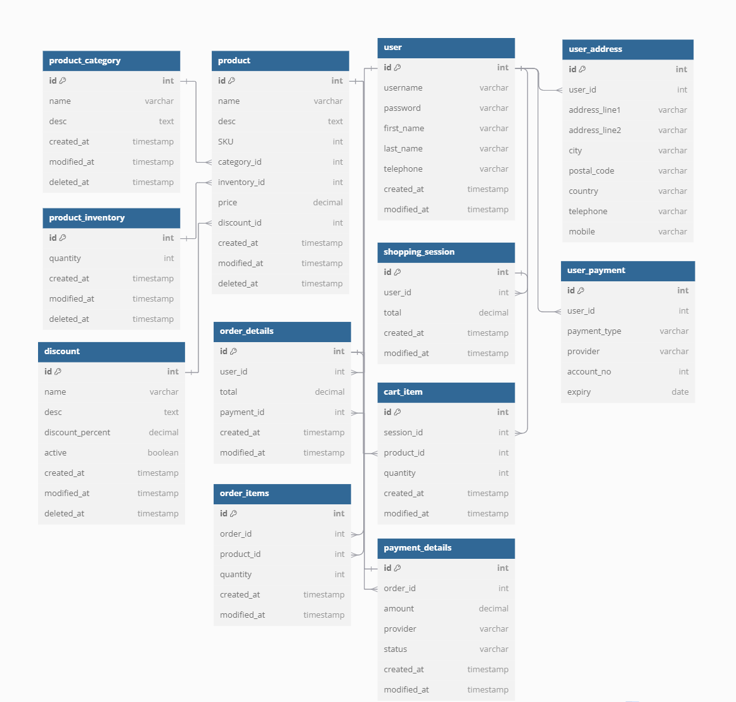

QUESTION 7.
What is a data flow diagram? Draw a data flow diagram to represent the in-flow and out-flow of data when a Farmer is placing an order for the product
ANSWER 7.

QUESTION 8.
Due to change in the Government Taxation structure. we should change the Tax structure
How do you handle change requests in a project?
ANSWER 8.
- Understand the Scope of the Change Request and Document It
- Scope Clarification: Identify the specific changes in the government taxation structure and how it will impact the online agriculture product store.
- Documentation: Use a formal change request document to capture details like the reason for the change, urgency, and impact areas (taxes on fertilizers, seeds, pesticides).
- Do the Impact Analysis
- Project Scope Impact: Understand how this tax change will affect the current functionality of the application (e.g., how prices are displayed to farmers).
- Schedule: Determine whether the change will delay any project milestones or deliverables.
- Budget: Assess any additional costs involved in making these changes.
- Resources: Check if you need additional development or testing resources for this change.
- Risks: Identify risks
- Prioritize the Change Request
- Evaluate the urgency and importance of the change based on regulatory deadlines.
- Discuss with the committee (Mr. Henry, Mr. Pandu, and Mr. Dooku) and stakeholders (Peter, Kevin, Ben) to understand how critical this change is for project success.
- Seek Approval from the Project Sponsor (Committee)
- Submit the impact analysis to the change control board
- Obtain their approval before moving forward with the change.
- Communicate the Change Request
- Share the change details with all relevant stakeholders, including the development and testing teams (Ms. Juhi, Mr. Jason, Ms. Alekya).
- Ensure everyone understands how this will impact the system and the timeline.

QUESTION 9.
As the project is in process, Ben and Kevin have contacted you. The reason is to inform you that they want the Farmers to sell their crop yields through this application i.e. Farmers should be able to add their crop yields or products and display to general public and should be able to sell them. They also want to introduce Auction system for their Crop yields. As a BA, what will be your response?
Is this a change request or an enhancement?
ANSWER 9.
Response as a BA:
- Acknowledge the Request: Recognize that the addition of selling crop yields and an auction system is a valuable idea that can benefit the farmers and the platform.
- Impact Analysis: As a next step, perform an impact analysis on how these new features will affect the project in terms of:
- Scope: How much additional work is needed to implement the selling and auction systems.
- Timeline: Whether the current 18-month timeline can accommodate these features.
- Budget: Assess if the 2 Crore INR budget can cover these new features or if additional funding is needed.
- Resources: Determine if more development, testing, or design work is required to handle these new functionalities.
- Consult Stakeholders: Discuss the request with key stakeholders, including Mr. Henry, Mr. Pandu, Mr. Dooku, and the development team to Prioritize the new features.
- Decide whether to include these features in the current phase or defer them to a later stage.
This is an enhancement.
- This request introduces new features and functionalities that were not part of the original project scope.
- It enhances the platform by expanding its use case from a buying platform to a marketplace for both buying and selling, as well as adding a completely new auction system.
- It does not modify the existing features but adds additional value and complexity to the system.

QUESTION 10.
Come up with estimations – How many Manhours required
ANSWER 10.
Estimation of Manhours:
- Number of Working Days in 18 Months:
18 months * 20 working days per month = 360 working days
- Total Hours for One Team Member in 18 Months:
360 working days * 8 hours per day = 2,880 hours
Team Roles and Estimated Allocation:
The roles and team composition provided include the following people:
- Business Analyst (you) – 1 person
- Project Manager – 1 person
- Senior Java Developer – 1 person
- Java Developers (4 people: Mr. Teyson, Ms. Lucie, Mr. Tucker, Mr. Bravo) – 4 people
- Network Admin – 1 person
- DB Admin – 1 person
- Testers (2 people: Mr. Jason, Ms. Alekya) – 2 people
Estimating Manhours for Each Role:
- Business Analyst (BA): Likely to be involved full-time in the initial stages and intermittently afterward for change management, user acceptance testing, etc.
Estimation: Full-time for 6 months, part-time (50%) for the rest.
Manhours: (6 months * 160 hours) + (12 months * 80 hours) = 960 manhours
- Project Manager: Involved throughout the project lifecycle, but generally part-time.
Estimation: 50% involvement for the full 18 months.
Manhours: 18 months * 80 hours = 1,440 manhours
- Senior Java Developer: Lead on development activities, full-time for the project duration.
Manhours: 18 months * 160 hours = 2,880 manhours
- Java Developers (4): Full-time throughout the development phase.
Manhours per developer: 18 months * 160 hours = 2,880 hours
Total for 4 developers: 4 * 2,880 = 11,520 manhours
- Network Admin: Primarily involved during deployment and setup phases, likely part-time.
Estimation: 25% of the project duration.
Manhours: 18 months * 40 hours = 720 manhours
- DB Admin: Involved for database setup, management, and support, part-time.
Estimation: 25% of the project duration.
Manhours: 18 months * 40 hours = 720 manhours
- Testers (2): Full-time during the testing phase, likely part-time during early development.
Estimation: Full-time for 6 months, 25% involvement for the rest.
Manhours per tester: (6 months * 160 hours) + (12 months * 40 hours) = 1,680 manhours
Total for 2 testers: 2 * 1,680 = 3,360 manhours
Total Manhour Estimation:
Role | Number of people | Manhours per person | Total Manhours
Business Analyst | 1 | 960 | 960
Project Manager | 1 | 1440 | 1440
Senior Java Developer | 1 | 2880 | 2880
Java Developers | 4 | 2880 | 11520
Network Admin | 1 | 720 | 720
DB Admin | 1 | 720 | 720
Testers | 2 | 1680 | 3360
Total | 11 |  | 21600 manhours

For the full duration of 18 months, the estimated total manhours required for the project would be 21,600 manhours based on the team's structure and involvement levels.

QUESTION 11.
Project has finally completed all the stages i.e., design, development, testing etc. Now, it is the role of a business analyst to contact the client for testing of the final product and have to successfully complete it. How are you going to handle this situation? And once it is done, what will be the process to close the project?
Explain UAT Acceptance process
ANSWER 11.
- Contact the Client for Testing:
- Initial Communication: Reach out to Mr. Henry and the other stakeholders (Peter, Kevin, and Ben) to schedule a meeting. Explain the purpose of the UAT and how their feedback will be invaluable in ensuring the final product meets their requirements.
- Set Expectations: Clearly outline what UAT entails, including timelines, objectives, and the importance of their involvement. Provide a brief overview of the application’s features.
- Planning:
- Define Objectives: Clearly specify what you aim to achieve during UAT. This includes verifying that the application functions as intended and meets the user’s needs.
- Create a UAT Plan: Develop a detailed UAT plan that includes:
- Scope: Define which functionalities will be tested.
- Timeline: Establish a timeline for UAT, including start and end dates.
- Resources: Identify who will participate in the testing (stakeholders, end-users).

- Designing:
- Test Cases: Collaborate with stakeholders to design test cases based on user stories and requirements gathered during the project. Each test case should outline:
- Test Scenario: Describe what will be tested.
- Expected Outcome: Define the expected results for each test scenario.
- User Documentation: Prepare user manuals or guides to assist stakeholders during testing.
- UAT Tester:
- Select Testers: Confirm who will be participating in the UAT. This typically includes stakeholders and end-users who can provide valuable feedback.
- Conduct Training: If necessary, provide training for testers on how to use the application and execute the test cases effectively.
- Bug Fixing:
- Gather Feedback: During the UAT phase, collect feedback and any issues encountered by testers. This could be done through:
- Feedback Forms: Use structured forms to gather insights.
- Regular Check-ins: Schedule daily or weekly check-ins to address any immediate concerns.
- Prioritize Bugs: Categorize and prioritize bugs based on severity. Ensure the development team is prepared to fix these bugs in a timely manner.
- Retesting: After bugs are fixed, conduct retesting to ensure that the issues have been resolved and that no new issues were introduced.
- Sign Off:
- Final Review Meeting: Organize a meeting with the stakeholders to review the UAT results, discuss any remaining concerns, and demonstrate how the feedback has been implemented.
- Obtain Approval: Once all issues have been addressed and stakeholders are satisfied with the application, obtain formal sign-off. This can be in the form of an email confirmation or a signed document indicating that the product meets their requirements and is ready for deployment.

QUESTION 12.
Explain Project closure document
ANSWER 12.
- A project closure document, also known as a project closure report - is a formal document that summarizes the key outcomes, lessons learned, and final details of a completed project.
- It serves as a comprehensive record of the project's accomplishments, challenges, and overall performance, providing valuable insights for stakeholders and future projects
Points to be included in the Project closure document are:
- Project Overview- A summary of the project's objectives, scope, and overall timeline.
- Achievements- Key successes and milestones achieved during the project.
- Lessons Learned- Insights and knowledge gained from both positive and negative experiences throughout the project.
- Quality Assurance- A report on how the project met its quality standards and benchmarks.
- Resource Utilization- An analysis of how resources (time, personnel, budget) were used and managed.
- Risk Management- A review of how potential risks were identified, mitigated, and addressed.
- Challenges- Difficulties and obstacles encountered during the project, and how they were overcome.
PROJECT CLOSURE DOCUMENT-
Sr. No. | Points to include | Details | Reference link
1 | Did the client sign off on the UAT Testing?
 | Date of the sign-off:
 | Name of the resource: | Mr. Henry
2 | Objectives of the project
 | User-friendliness | Achieved
 | Customer satisfaction | ROI in 6 months
 | More categories | Achieved
3 | Functionalities worked on
 | Secure payment processing | Achieved
 | Categories | Achieved
4 | Infrastructure
 | Software installed | Achieved
 | Laptops purchased | Achieved
5 | Funding
 | Amount approved | 2 Crore
 | Amount used | 2 Crore
6. | Overall project information
 | Escalations | 25
 | Customer satisfaction | High
7. | Value to the company.
 | Positive / Negative | Positive 95%. Company has successfully made an application to help remote farmer to get the product on door step

