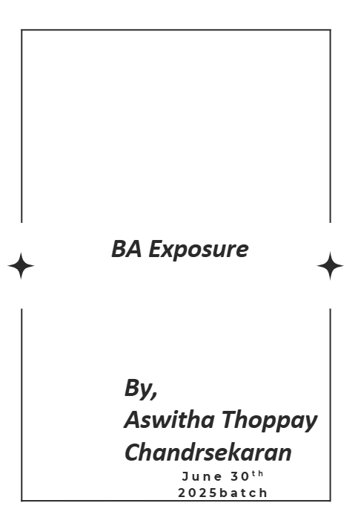

1. Who is a Business Analyst?
As a BA, I act as the link between business stakeholders and technical teams. My role goes beyond just passing messages—I ensure that requirements are understood, documented, and tracked. I am accountable for aligning business needs with IT solutions. In many ways, I am both translator and problem-solver.

2. What is a Requirement?
A requirement is essentially a client’s need expressed in a form that can be acted upon. It serves as the backbone of any system or solution being built. Requirements may describe functionality, constraints, or conditions that must be met. Without them, projects lack direction and purpose.

3. Types of Requirements
As a BA, I categorize requirements into business, stakeholder, solution, functional, non-functional, and transitional. Each type provides clarity at different stages of the project. For instance, functional tells us what the system should do, while non-functional tells us how it should perform. Managing these types ensures complete coverage.

4. Stakeholders
Stakeholders are anyone affected by the solution, directly or indirectly. They may include business sponsors, users, vendors, or even critics of the project. Each group brings unique expectations, risks, and perspectives. As a BA, my job is to balance these voices into a unified direction.

5. Business Process Modeling
Business process modeling helps me capture how things actually work today. It highlights inputs, outputs, workflows, and areas where value is created or lost. With models, I can show stakeholders inefficiencies and opportunities clearly. It is the blueprint that ensures we improve processes, not just automate them.

6. SDLC Models
I work with models like waterfall, iterative, spiral, and agile depending on project context. Each brings strengths and limitations that affect timelines and deliverables. My role is to adapt requirements management to the chosen model. Understanding SDLC is critical for smooth collaboration with technical teams.

7. Agile and Scrum
Agile has transformed the BA role from document-heavy to collaboration-focused. Instead of one large requirement set, I now deliver user stories iteratively. I partner with product owners to refine backlogs and join daily scrums. This flexibility ensures evolving needs are addressed quickly.

8. Use Case Diagrams
Use case diagrams are one of my favorite tools to explain system interactions. They show actors, goals, and how the system responds to users. I’ve found stakeholders grasp concepts faster when visuals are used. These diagrams also become a strong basis for test case design.

9. Activity Diagrams
Activity diagrams are useful to illustrate the flow of tasks, decisions, and parallel processes. They help stakeholders validate whether steps reflect reality. I often use them to uncover gaps between “assumed” versus “actual” workflows. The clarity they bring prevents future misunderstandings.

10. Requirements Elicitation Techniques
Elicitation isn’t about one method but choosing the right mix. I use interviews for depth, workshops for collaboration, and prototyping for visualization. Sometimes observation reveals more than what stakeholders say. A BA’s strength lies in tailoring techniques to each situation.

11. Prioritizing Requirements
Not all requirements hold equal weight, and prioritization ensures the most valuable are delivered first. I often use MoSCoW, ranking them as must-have, should-have, could-have, and won’t-have. Tools like the $100 test also help stakeholders make trade-offs. Prioritization aligns limited resources with maximum business impact.

12. Validating Requirements
Validation confirms that what we captured truly meets business needs. I rely on walkthroughs, prototypes, and frameworks like SMART or FURPS. It’s not about perfection but alignment with stakeholder intent. Strong validation avoids costly rework later in development.

13. Business Solution Evaluation
As a BA, I don’t just define problems; I also evaluate proposed solutions. This involves checking feasibility, assessing readiness, and ensuring the solution adds measurable value. It’s a balancing act between what is desirable, viable, and achievable. Ultimately, I aim to recommend the best-fit option.

14. Risk Analysis and Management
Every project carries risks in cost, time, scope, or quality. My role is to identify these early, assess their impact, and propose mitigation plans. Risks can’t always be eliminated, but they can be managed. Anticipating challenges helps projects stay on track.

15. Root Cause Analysis
I use techniques like the 5 Whys and Fishbone diagrams to get to the heart of business issues. Too often, organizations treat symptoms instead of causes. By digging deeper, we uncover the real blockers to success. This ensures our solutions address the problem at its core.

16. Strategy Analysis
Strategy analysis connects requirements to the bigger organizational picture. I use tools like SWOT or PESTLE to understand the environment and align goals. This ensures projects don’t just deliver systems—they deliver competitive advantage. A BA must always think beyond the immediate task.

17. Business Analyst Competencies
BA success is shaped as much by soft skills as by technical ones. Communication, negotiation, leadership, and critical thinking are key. These skills help me influence stakeholders and resolve conflicts. They also ensure I can adapt to changing project dynamics.

18. UML and OOA Concepts
Concepts like abstraction, encapsulation, inheritance, and polymorphism may sound technical. But they give me a way to model systems in ways developers understand. UML diagrams bridge business intent and technical design. Mastery of these concepts makes collaboration seamless.

19. Contribution of BA in Projects
My role extends from gathering requirements to supporting UAT and handling change requests. I’m there through initiation, development, and delivery. In essence, I safeguard the client’s vision while enabling the technical team. This contribution often determines the project’s success.

20. Dos and Don’ts of a BA
Through experience, I’ve learned the importance of listening carefully and avoiding assumptions. A BA should never say “by default” or dismiss a stakeholder’s input. Respect and curiosity open doors to deeper insights. Building trust is as important as building requirements.

