Live Waterfall Project – Part – 2
Document 6 – Please prepare a use case diagram, activity diagram and a use case specification document.
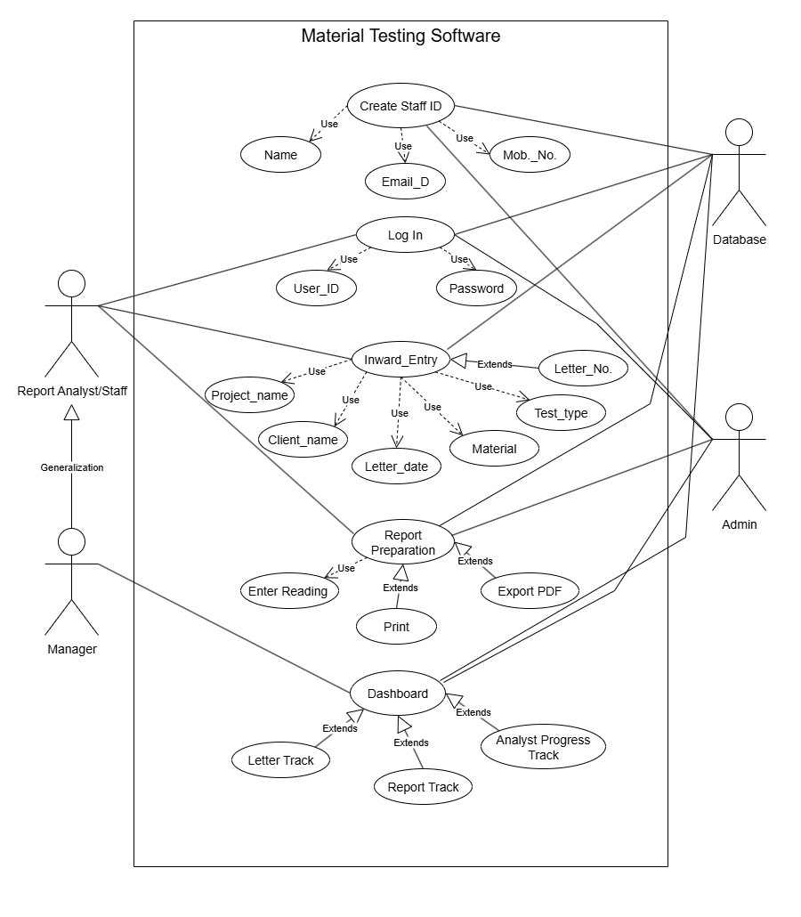
Answer: Use Case Diagram
Use Case Specification:
Use Case ID | UC001
Use Case Name | Create Staff ID
Use Case Description | This use case allows the Admin to create a new staff profile in the Material Testing Software. While creating the staff ID, details such as Name, Mobile Number, Email ID, and unique Staff ID are captured. Initially, the Admin sets a default password for the staff, which the staff can later change after first login. All information is securely stored in the database.
Actors | Primary Actors – Admin Secondary Actors – Database
Basic Flow | - Admin logs into the system.  - Admin selects the option “Create Staff ID”.  - System displays staff registration form.  - Admin enters details (Name, Mobile No., and Email ID).  - System generates a unique Staff ID.  - Admin sets a temporary password for the staff.  - The details are validated and saved into the database.  - Confirmation message is displayed to Admin.  - Staff can now log in using newly created Staff ID and the given password.
Alternate Flow | - If email ID already exists, system prompts Admin to use a different one.  - If mobile number is invalid, system requests correct format.  - If Staff ID duplication occurs, system regenerates a new unique ID.
Exceptional Flow | - Database connection fails → Staff ID creation unsuccessful.  - Mandatory fields left blank → Error message displayed.  - System crash during saving → Staff ID not created, Admin must retry.
Pre-Conditions | - Admin must be logged in with valid credentials.  - System should be connected to the database.
Post-Conditions | - New Staff ID is created and stored in the system.  - Staff can log in with given credentials and later change password.
Assumptions | - Admin has authority to create staff IDs and set passwords.  - Staff will change password after first login for security.
Constraints | - Staff ID must be unique across the system.  - Password should meet minimum security standards (e.g., 8 characters, alphanumeric).  - Mobile number must be 10 digits and Email ID should be valid format.
Dependencies | - Depends on database for storing new staff details.  - Depends on password validation rules.
Input and Output | - Inputs: Name, Mobile Number, Email ID, Password  - Outputs: Unique Staff ID, Confirmation message
Business Rules | - Only Admin can create staff IDs and assign initial passwords.  - Staff must change password on first login.
Miscellaneous Information | Staff details and passwords should be encrypted in the database.

Use Case ID | UC002
Use Case Name | Log In
Use Case Description | This use case allows Staff, Manager, and Admin to access the Material Testing Software by entering their Staff ID and Password. The system verifies credentials from the database. If valid, the user is granted access based on their role. Staff can later change their password if required.
Actors | Primary Actors – Report staff, Manager, Admin Secondary Actors – Database
Basic Flow | - User opens the Material Testing Software.  - User selects “Log In” option.  - System displays login screen.  - User enters Staff ID and Password.  - System verifies credentials against the database.  - If valid, system grants access to the application dashboard according to the user role.
Alternate Flow | - If password expired, system asks user to reset password.  - If staff is logging in for the first time, system forces a password change.  - If Caps Lock is ON while entering password, system shows a warning message.
Exceptional Flow | - Incorrect Staff ID or Password → System shows “Invalid credentials” error.  - Account locked due to multiple failed attempts → User must contact Admin.  - Database connection failure → Login unavailable, system shows error.
Pre-Conditions | - User must already have a valid Staff ID created by Admin.  - Password must be set either by Admin or changed by user earlier.
Post-Conditions | - User is logged into the system and redirected to dashboard according to role.  - Failed login attempts are recorded in the system logs.
Assumptions | - User remembers correct Staff ID and Password.  - Admin has provided initial password for first-time users.
Constraints | - Login session expires automatically after a defined idle period (e.g., 15 minutes).  - Password must follow security policy (minimum 8 characters, alphanumeric, special character).  - Maximum 3–5 invalid attempts allowed before account lock.
Dependencies | - Dependent on Staff ID created in “Create Staff ID” use case.  - Dependent on database authentication service.
Input and Output | - Inputs: Staff ID, Password  - Outputs: Successful login → Dashboard, Failed login → Error message
Business Rules | - Only valid users (Staff/Manager/Admin) can log in.  - First login requires password change.  - Admin can unlock locked accounts.
Miscellaneous Information | Option for “Forgot Password” should be available to reset via Admin approval.

Use Case ID | UC003
Use Case Name | Inward Entry
Use Case Description | This use case allows Report Analyst/Staff to enter details of incoming letters and testing requests. The details include Project Name, Client Name, Letter Number, Letter Date, Material, and Test Type. These entries are stored in the database and form the base for report preparation.
Actors | Primary Actors – Report Analyst/Staff Secondary Actors – Database, Manager (review), Admin (for oversight)
Basic Flow | - Analyst logs into the system.  - Analyst selects “Inward Entry” option.  - System displays entry form with required fields.  - Analyst enters details (Project Name, Client Name, Letter No., Letter Date, Material and Test Type).  - System validates mandatory fields and unique Letter Number.  - Data is saved into the database.  - Confirmation message is displayed.
Alternate Flow | - If Letter Number already exists, system prompts to enter a different number.  - Analyst can save entry as a draft and update later.  - If Manager approval is required, system routes entry for review before finalizing.
Exceptional Flow | - Missing mandatory fields → System shows error message.  - Invalid data format (e.g., incorrect date format, special characters in project name) → Error displayed.  - Database connection failure → Entry cannot be saved.
Pre-Conditions | - Analyst must be logged into the system.  - Staff ID must already exist in the database.  - Database should be active and connected.
Post-Conditions | - A new inward entry record is created and stored.  - Entry is available for report preparation and tracking.
Assumptions | - Analyst has authority to make inward entries.  - All required details are provided by client or letter.
Constraints | - Date format should follow system standard (e.g., DD/MM/YYYY).  - Entry form should not accept blank mandatory fields.
Dependencies | - Depends on “Log In” use case for authentication.  - Depends on database for saving entries.
Input and Output | - Inputs: Project Name, Client Name, Letter Number, Letter Date, Material, Test Type  - Outputs: Confirmation message, Saved inward entry record
Business Rules | - Only authorized staff can perform inward entry.
Miscellaneous Information | - System should maintain log of who created/updated inward entry.  - Inward entries can be searched or filtered later by project, client, or letter number.

Use Case ID | UC004
Use Case Name | Report Preparation
Use Case Description | This use case allows Report Analyst/Staff to prepare a material testing report based on inward entry details. The system fetches required data (Project, Client, Test Type and Material) and allows staff to enter test readings. After validation, the system generates a standardized report in PDF format, which can be saved, printed, or shared with clients.
Actors | Primary Actors – Report Analyst Secondary Actors – Database, Manager (review), Admin (for oversight)
Basic Flow | - Analyst logs into the system.  - Analyst selects “Report Preparation” from dashboard.  - System displays inward entries available for report preparation.  - Analyst selects an inward entry.  - System fetches client and project details automatically.  - Analyst enters test readings and observations.  - System validates the data entered.  - System generates a draft report using the standard template.  - Analyst reviews and finalizes the report.  - Final report is saved into the database and made available for printing/export.
Alternate Flow | - If analyst selects “Save as Draft,” report is stored but not finalized.  - If data is partially available, analyst can update readings later.  - If manager review is enabled, the report is routed for manager approval before finalization.
Exceptional Flow | - Invalid or incomplete data → System shows error message.  - Database connection failure → Report cannot be generated.  - Standard template missing → Report creation halted, error logged.
Pre-Conditions | - Analyst must be logged into the system.  - Inward entry must exist in the database.  - Standard report template must be available.
Post-Conditions | - A final report is generated and stored in the system.  - Report can be exported, printed, or shared with client.
Assumptions | - Analyst has valid permissions to prepare reports.  - All inward details are already entered correctly.  - Required formulas/calculations for test readings are pre-defined.
Constraints | - Reports must follow organization’s standard format (font, header, footer).  - Report should be generated within 2–3 seconds after validation.
Dependencies | - Depends on inward entry details.  - Depends on system templates and formulas.
Input and Output | - Inputs: Test Readings, Observations  - Outputs: Draft Report, Final Report PDF, Confirmation message
Business Rules | - Only staff with report preparation rights can create reports.  - Manager approval may be required before sending report to client.  - Report must follow the approved template; customization not allowed.
Miscellaneous Information | Notifications (email/SMS) may be sent to client when report is ready.

Use Case ID | UC005
Use Case Name | Dashboard
Use Case Description | The Dashboard is the central screen of the Material Testing Software that provides role-based access and overall tracking information.  - Total Letters Received (daily, monthly, overall)  - Reports Prepared (daily, monthly, overall)  - Reports Prepared by Each Analyst (performance tracking)  - Pending Reports vs Completed Reports  This helps Admin and Manager monitor overall system activity and staff performance.
Actors | Primary Actors – Manager, Admin Secondary Actors – Database (fetching real-time counts and summaries)
Basic Flow | - User logs into the system.  - System verifies user role.  - Dashboard loads with the following data:  - Number of inward letters received today, this month, and overall.  - Number of reports prepared today, this month, and overall.  - List of report analysts with the count of reports each has prepared.  - Pending vs finalized reports.  - User can filter the dashboard data by daily, weekly, monthly, or custom date range.
Alternate Flow | - If no letters or reports exist for the selected period, system shows “No records available.”
Exceptional Flow | - Database error → Summary counts not displayed.  - Dashboard refresh fails → Old data shown with warning message.
Pre-Conditions | - User must be logged into the system.  - Inward entries and reports must exist in the database.
Post-Conditions | - User gets clear visibility of system activities and performance.  - Admin/Manager can analyze workload and efficiency of report analysts.
Assumptions | - All inward entries and reports are updated in real time.  - Every report is linked with the respective analyst ID.
Constraints | - Dashboard should refresh automatically (e.g., every 1–5 minutes).  - Graphs and counts must load within 3 seconds.
Dependencies | - Dependent on inward entry module for letter details.  - Dependent on report preparation module for report counts.
Input and Output | - Inputs: Database records of letters and reports.  - Outputs: Dashboard with counts, graphs, and performance statistics.
Business Rules | - Admin and Manager can see full dashboard with all staff performance.  - Staff can only see their own activity summary.  - Dashboard statistics must match reports stored in the database.
Miscellaneous Information | - Dashboard may include graphs/charts for better visualization.  - Monthly reports can be exported from dashboard as PDF/Excel.

Activity Diagram
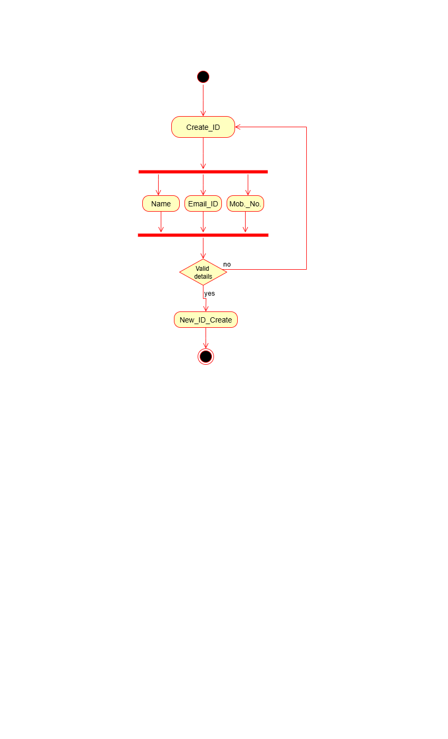
- Create ID
- Inward Letter
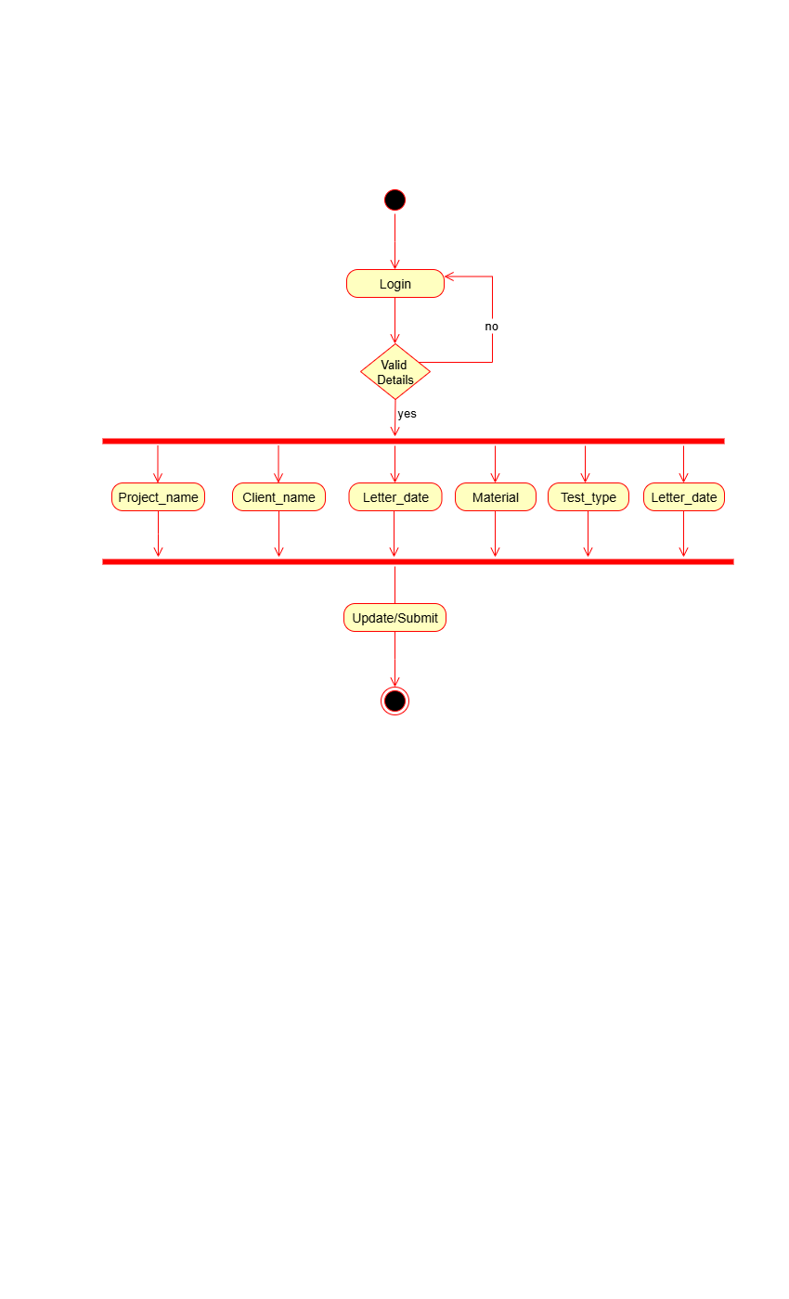
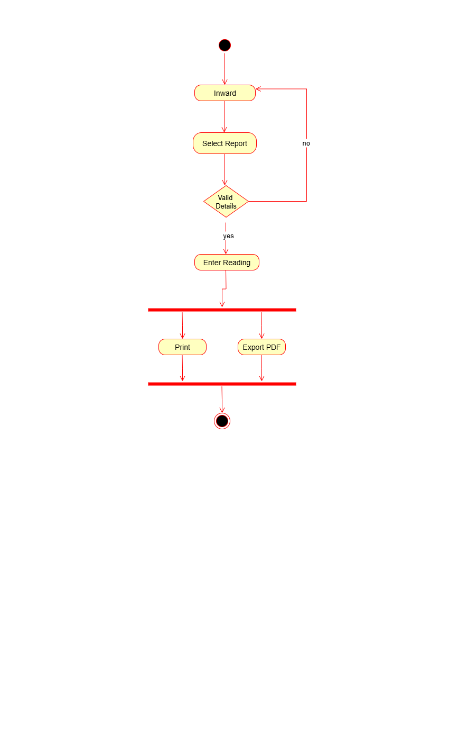
- Report & Print

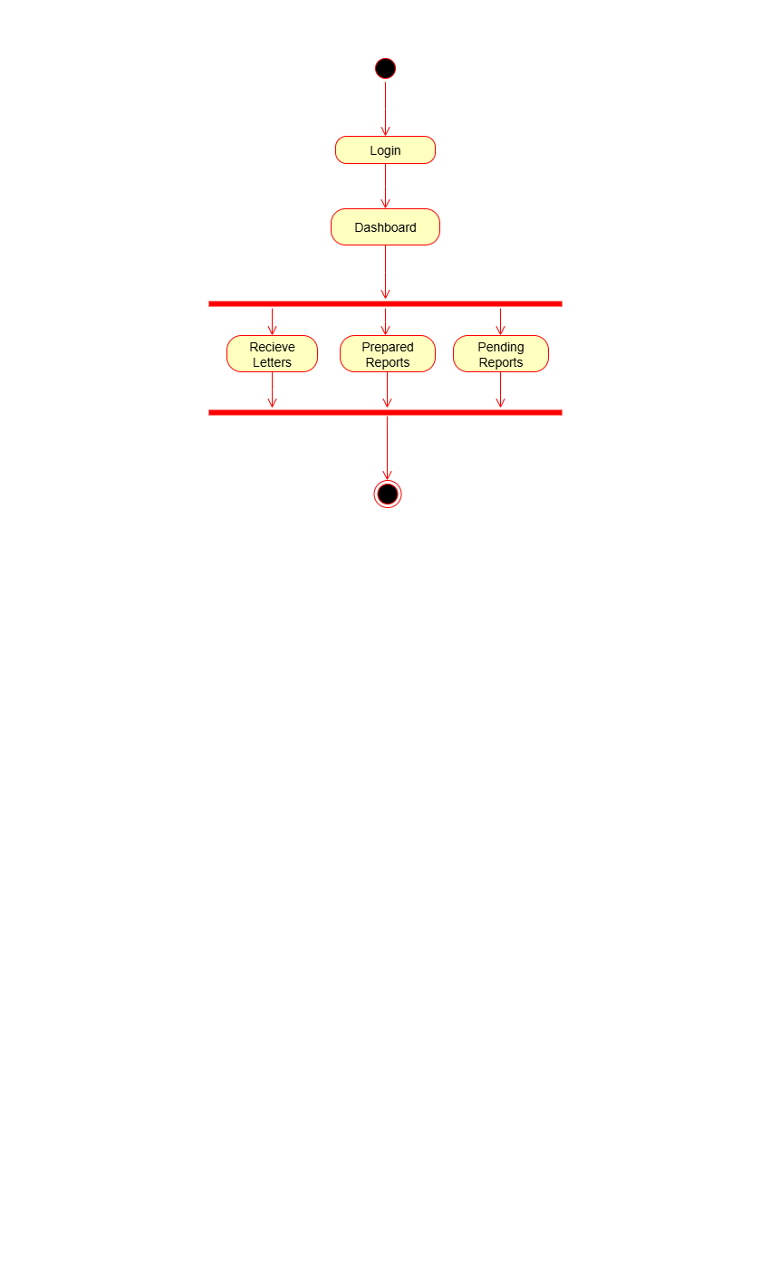
- Dashboard
Document 7 – Screens and pages

