Question 1:
4 Quarterly Audits are planned Q1 , Q2, Q3, Q4 for this Project What is your knowledge on how these Audits will happen for a BA ?
Ans:
Audit is inspection of various books of different departments by an auditor followed by physical checking of inventory, financial statement and serval other documents to make sure that all departments are following documents system of recording transitions

What is a Project Audit: A project management audit is a formal review that seeks to evaluate a given project based on specific criteria. Examples of these can include project quality, performance, and adherence to the statement of work.
While doing the Audit of a BA, the auditor needs to check the following details.
In Q1 Auditor will check the following details:
- Understanding of company goals does the BA has.
- Work is Planned and Tracked.
- Understood the Current as is process.
- BA’s understanding of Business Requirements
- BA conducted the Stakeholder Analysis
- Requirement gathering and analysis was done correctly.
- What Elicitation techniques has been used to gather requirements.

In Q2 Auditor will check the following details:
- Documents have been prepared by the BA.
- Has the BA prepared all the required documents like RTM, BPM to understand the requirement correctly.
- How is BA prepared the Use case and Activity diagram.
- Was all these documents signed and agreed by the Stakeholders, before the start of the development stage.
In Q3 Auditor will check the following details:
- Requirements were correctly explained to the development team.
- BA tracking the status of the project.
- JAD session organized by the BA.
- Timesheets sent to the reporting manager.
- BA keeping the Stakeholders updated on the status of the project.
In Q4 Auditor will check the following details:
- BA tracking the Testing of the product.
- BA assisting the Testing team for Testing the product.
- BA sending the Test data to the client.
- BA preparing the End user manual.
- BA preparing the client for UAT.
In Q5 Auditor will check the following details:
- BA assisting the Delivery manager to implement the product.
- BA helping the client to do the UAT.
- BA organizing the training sessions for the users.
- BA taking signoff document from the client.
- BA sending the complete timesheet to the reporting manager.

Question 2:
Before the Project is going to Kick Start, The Committee asked Mr Karthik to submit BA Approach Strategy Write BA Approach strategy (As a business analyst, what are the steps that you would need to follow to complete a project – What Elicitation Techniques to apply, how to do Stakeholder Analysis RACI/ILS, What Documents to Write, What process to follow to Sign off on the Documents, How to take Approvals from the Client, What Communication Channels to establish n implement, How to Handle Change Requests, How to update the progress of the project to the Stakeholders, How to take signoff on the UAT- Client Project Acceptance Form.
Technical Team have assembled to discuss on the Project approach and have finalised to follow 3-tier architecture for this project.
Ans:
BA Approach Strategy: The Business Analysis Approach is the plan that the senior or lead business analyst on a project would create describing the way that all the Business Analysis activities will be executed. This could include:

- Business Analysis resources and their Roles & Responsibilities,
- Requirements Gathering Approach for the project (techniques to be used, high level planning),
- Stakeholder Engagement,
- Requirements Review Process and Approval Cycles,
- Change Management approach to requirements and agreed deliverables.
- Other elements such as team structure, assumptions and constraints could also be included.
As a Business Analyst, following are the steps which needs to be followed to complete a Project.
- Elicitation Techniques to apply – There are several Elicitation techniques to be used to elicit the requirement, however for this project, we are going to use the below Elicitation techniques.
a) Brainstorming – We are going to arrange sessions, where participants are allowed to provide inputs without criticism, discussion, or evaluation. The goal is to be creative and gather as many ideas as possible in a short period of time.
b) Interviews – We will be interviewing every Stakeholder to elicit the requirements needed to complete the project.
c) Workshops – Key Stakeholders and SMEs are expected to attend the targeted seminars that we are planning. Planning, analysis, design, scoping, requirements elicitation, modeling, or a combination of these will be the focus of these workshops. This elicitation process will also be used to analyze requirements and design, come to an agreement on an issue, and generate suggestions for new features of the goods.
d) Surveys or Questionnaire – There will be Surveys or Questionnaires sent to all the Stakeholders and SMEs, which will include multiple range of open and closed ended questions, which will extract the information about the desired product, work practices and behavioural attitudes etc.
- Stakeholder Analysis – Stakeholder Analysis involves Identifying the Stakeholders who will be directly or indirectly impacted by the change and analyzing the information once collected.
a) Identifying Stakeholders:
- Internal Stakeholders –
● Project Manager – Mr. Vandanam
● Senior Java Developer – Ms. Juhi
● Java Developers – Mr. Teyson, Ms. Lucie, Mr. Tucker, Mr. Bravo
● Network Admin – Mr. Mike
● DB Admin – Mr. John
● Testers – Mr. Jason and Ms. Alekya
● BA – Mr. Sourabh Bhattacharya
- External Stakeholders –
● Sponsor – Mr. Henry
● Financial Head – Mr. Pandu
● Project Coordinator – Mr. Dooku
● Key stakeholders – Peter, Kevin and Ben
- b) Prioritizing Stakeholders: RACI Matrix –

Tasks | Mr Henry – Project Sponsor | Peter, Kevin, Ben – Key Stakeholders | Mr. Karthik – DH | Mr. Vandanam – PM | Ms. Juhi – Sr Java Dev | Teyson, Lucie, Bravo & Tucker – Java Dev | Mr. Jason & Ms. Alekya – Testers | Sourabh Bhattacharya – BA
Requirement Gathering | A* | C | NA | A/I | NA | A | NA | R
Requirement Analysis | NA | NA | NA | I | NA | NA | NA | R
Development | A* | NA | NA | R/A | C/A | R | NA | C
Testing | NA | NA | NA | R/A | I | NA | R | I
Implementation | NA | NA | R | I | I | NA | NA | A
UAT | I | NA | NA | R/A | NA | NA | NA | C

Key Understanding:
The Project Manager (Mr. Vanadanam) plays a central role—being Accountable or Responsible in almost all tasks.
The Business Analyst (Sourabh Bhattacharya) is Responsible for gathering and analyzing requirements, and Consulted/Informed during later stages.
Developers and Testers are Responsible for their specific stages.
Sponsor (Mr. Henry) has approval (Authorize) authority on key phases like Requirement Gathering and Development.

Documents to Write –
a) Project vision Document
b) Business Analysis Plan – Stakeholder Analysis Document (RACI)
c) Business Requirements Document.
d) Functional requirement specification (FRS)/ Functional Specification Document (FSD)
e) System requirement specification (SRS)/ System Requirement Document (SRD)
Signing off on the Documents – Once the above-mentioned documents are prepared, as a BA, I will take the sign off on the above documents via Emails and Physical sign off as well from the respective Stakeholders.
a) Project Vision Document – Email to – Project Sponsor and CC – Financial Head, Project Coordinator and Project Manager.
b) Business Requirement Document – Project Sponsor (Email and Physical)
c) FRS/FSD & SRS/SRD – Email to – Project Sponsor and CC – Financial Head, Project Coordinator and Project Manager.
Taking Approvals – While taking approval for all the above documents, I will call the respective Stakeholders and send them an Email with the details.

Communication Channels to establish and implement – As a BA, I would prefer the below communication channels:
a) Face to Face communication – for Requirement Gathering stage. For example, Interviews with Stakeholders.
b) Video conferencing & Phone calls – This communication is also used when the Stakeholder is at a different location adding setting up meeting with stakeholders for approvals.
c) Emails – This communication is used for setting up meetings with Stakeholders and for taking approvals.
How to handle Change request –
As a BA I would handle the Change request by understanding the below steps.
(a) Understanding the Scope of Change.
(b) Determining the Scope of Incorporating the Change request.
(c) Understanding the Feasibility of the Change request.
(d) Taking the approval for the Change.
(e) Communicating and Implementing the Change.
Question 3: 3-Tier Architecture
Level 1 Level 2 Level 3

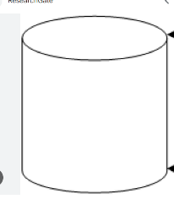
Sending SQL Query

Request

Sending
Replies

Client Application Database
Server Server

Presentation tier: also called as client layer and is responsible for accepting inputs or request from the user and displaying data for user in user friendly format.
It accepts input and sends input or request to business logic layer.

Business Tier: this layer also called business logic layer and helps define solution to complex business problems. It acts as middle layer between client and database server which are used to exchange partially processed data.

Database layer: In this layer, information is stored. This layer performs operations like insert, update or delete to connect with database.

Question 4: Business Analyst should keep What points in his/her mind before he frames a Question to ask to the Stakeholder

5W1H - As a BA, the followings points should be kept in mind before framing questions to ask a Stakeholder.
- What is the Project and what are the objectives?
- What is the Timeline for the project?
- Who is the Client and Who are the users?
- Who will benefit from this project?
- Where will the product be deployed?
- How much is the Budget?
- Why are the clients developing this product?

SMART - Confirm the requirement is SMART before accepting it for development.
- Specific - Narrowing the questions, so let every signal question only include one element you can get.
- Measurable - The questions are better to be quantified and countable. Ex. Multiple Choice questions.
- Action Oriented - Does the question influence creation of different or new feature packages.
- Relevant - Does the question identify which features are most required from the customer.
- Timebound - It can let you or your customer decide priority in a specific time frame.

RACI Matrix
Responsible - The person who does the work to achieve the task. They have responsibility for getting the work done or decision made. The persons responsible are typically working-level project team members, such as the project manager, business analyst and developers.
Accountable - The person who is responsible for the correct and through completion of the task. They are responsible for ensuring the work is complete and suitable.
Consulted - People from whom feedback and input should be solicited. They are going to provide information for the project and with whom there can be two-way communication.
Informed- People keep them informed about the progress by keeping them in loop, these individuals do not have to be consulted or be a part of decision making.

3 Tier Architecture
- Presentation layer - This layer display screens, pages, validation on page, company specific logic, functionally.
- Business logic layer - In a business logic layer all reusable components, frequently changing components, governing body rules, regulation, compliance.
- Data layer - In this layer the data or information is stored. This layer performs operations like insert, update and delete to connect with the database.
Use Cases
- What type of product we will deliver?
- Where is the location we will deliver the application?
- When should be the process be completed?
- Who all are responsible for doing this?
- Why this product will be used?
- How will we deliver this project?

Use Case Specs
o Who are the Primary and Secondary actors?
o What are the Actor Goals?
o What are the main task or functions that are performed by the actor.
Activity Diagrams: are visual representation of a series of actions or flow of control in a system similar to a Data flow diagram. It is basically a flowchart to represent the flow from one activity.
Purpose of activity diagram can be described as
Draw the activity flow of a system
Describe the sequence from one activity to another.
Describe the parallel, branched and concurrent flow of the system.
Models: conceptual, Data Model and Physical model.
Question 5
As a Business Analyst, What Elicitation Techniques you are aware of? ( BDRFOWJIPQU)
1.Brainstorming: This method is utilized to come up with fresh concepts and resolve a particular problem. Subject matter and domain specialists may be among the participants in the brainstorming session. We can choose from a variety of concepts and facts, which provides us with a wealth of knowledge.
2.Document Analysis: Business analysts examine the current documentation in order to determine what needs to be changed or improved at this phase of the requirements elicitation process. Pre-existing project plans, system specifications, process documentation, market research dossiers, customer feedback, meeting minutes, and user manuals are a few examples of document analysis sources. Prior to setting up more in-depth requirements elicitation sessions or stakeholder interviews, document analysis is completed.
3.Reverse Engineering: The inner workings of the system are studied (analyzing and understanding the software code.
- Focus Group: By using a focus group, you can get information about a product, service from a group. The Focus group includes subject matter experts. The objective of this group is to discuss the topic and provide information. A moderator manages this session.
- Observations: Observation is an excellent elicitation technique that helps understand requirements based on observations related to process flows and work environments of stakeholders. Observation requires a business analyst to go and look at the work—for example, observing the business processes in scope of the project. The elicitation technique observation is an effective means of understanding how a user does their job by assessing their work environment.
- Workshops: Workshops comprise a group of users or stakeholders working together to identify requirements. A requirement workshop is a structured way to capture requirements. Workshops are used to scope, discover, define, and prioritize requirements for the proposed system.
- JAD (Joint Application Development): This technique is more process-oriented and formal as compared to other techniques. These are structured meetings involving end-users, PMs, SMEs. This is used to define, clarify, and complete requirements.
- Interviews: An interview is a systematic approach to elicit information from a person or group of people. This is the most common technique used for requirement elicitation. Interview techniques should be used for building strong relationships between business analysts and stakeholders. In this technique, the interviewer directs the question to stakeholders to obtain information. One to one interview is the most commonly used technique.

- Prototyping: Prototyping is used to identify missing or unspecified requirements. In this technique, frequent demos are given to the client by creating the prototypes so that client can get an idea of how the product will look like. Prototypes can be used to create a mock-up of sites, and describe the process using diagrams.

- Questionnaire & Surveys: For Survey/Questionnaire, a set of questions is given to stakeholders to quantify their thoughts. After collecting the responses from stakeholders, data is analyzed to identify the area of interest of stakeholders. Questions should be based on high priority risks. Questions
- Use case Specs : they are effective and widely used technique for eliciting software requirements. The use case approach focuses on goals that users have with a system, rather than emphasizing system functionality. The text combines text and pictures to provide a better understanding of requirements. The use case describe ‘what’ of a system and not ‘how’. Hence they only give functional view of a system.

Question 6
Which Elicitation Techniques can be used in this Project and Justify your selection of Elicitation Techniques? Prototyping Use case Specs Document Analysis Brainstorming

This project Elicitation Techniques: For this Project, I would prefer to use the below Elicitation techniques.
- Brainstorming: By using this Technique, we can extract several ideas to make the Online store more useful for farmers and other users. Once we have these ideas, we can analyze and select the best ideas to implement. Brainstorming is effective with group of 8 to 12 people it helps to get the good number of ideas from user and stakeholders.
- Prototype: Prototyping is a visual technique, where we can create a representation of any ideas and allow us to test our ideas directly with the users before developing into a fully-fledged product. For this project, I would draw down the idea in a paper and share it with the stakeholders. Being a completely new project in the market, for which there are no details or documents available, I would use this technique to find the feasibility of the project, before spending money on the project.
- Use case specs: This technique is a combination of text and pictures which will provide me a better understanding of the requirements. This technique shows the behavior of the system and help to capture the requirement of the system. These diagrams also identify the interactions between the system and its actors.

Identify Business Requirements (which includes Stakeholder Requirements) BR001 – Farmers should be able to search for available products in fertilizers, seeds, pesticides

Question 7: Make suitable Assumptions and identify at least 10 Business Requirements.
Identify Business Requirements (which includes Stakeholder Requirements)
Req ID | Business Requirement
BR001 | Farmer should be able to see the fertilizers and pesticides details from the manufacturers
BR002 | They should be able to search specific required product
BR003 | Farmers should be able to buy or Wishlist
BR004 | They should be able to make payment online
BR005 | Customers should be informed once order is placed successfully
BR006 | Customers should know the whereabouts of the order
BR007 | Customers should be able to check their keep-aside products they want to buy later
BR008 | Customers’ queries should be addressed for better customer service
BR009 | Customers should be able to share the products with other people too
BR010 | Customers should be able to know the experience of other users with the product they buy from the manufacturer

Question 8: List your assumptions
Ans:
- Users should either have Laptops or Desktops or mobile.
- They should have an active email address.
- They should have an active bank account with active payment models like Credit/ Debit card, UPI payments or net banking facility.
- They also should have an active registered mobile number to receive OTPs to pay for the product and accept delivery.
- Does the application have price comparison option for multiple products.
- How much competitive the price of the products is going to be.
- The application should have the Product stock notification.
- The application should have Chat facility to speak to any customer service querying for any product, they want to buy.
- The application should have a delivery tracking facility

Question 9
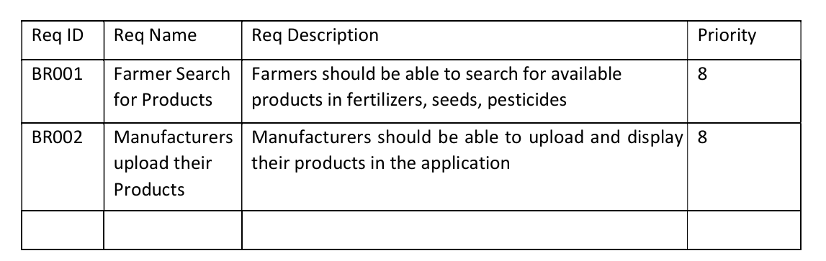
Give Priority 1 to 10 numbers ( 1 being low priority – 10 being high priority) to these Requirements after discussions with the stakeholders

Once the requirements are finalized, as a business analyst, one of the major roles is to act as a liaison between the client and the project team. To gather the requirements correctly from the client side and then to deliver those requirements to the project team in a way they understand.
To make the project team understand the requirements, you need to convert those requirements into UML diagrams and screen mock-ups.
Business Requirements Table
Req ID | Business Requirement | Req Description | Priority
BR001 | Product availability | Farmers should be able to see the fertilizers and pesticides details from the manufacturers | 1
BR002 | Product visibility | They should be able to search specific required product | 2
BR003 | Wishlist box | Farmers should be able to buy or wishlist | 2
BR004 | Methods of online payment | They should be able to make payment online via different type of payment | 3
BR005 | Order placed notification to customer | Customers should be informed once order is placed successfully | 4
BR006 | Customer should be able to track product | Customers should know the whereabouts of the order | 5
BR007 | Customers Wishlist cart | Customers should be able to check their keep aside products they want to buy later | 6
BR008 | Customer service | Customers' queries should be addressed for better customer service | 7

Req ID | Business Requirement | Req Description | Priority
BR009 | Product sharing option | Customer should be able to share the products with other people too | 9
BR010 | Public reviews would be helpful for new customer | Customer should be able to know the experience of other users with the product they buy from the manufacturer | 10

Question 10:
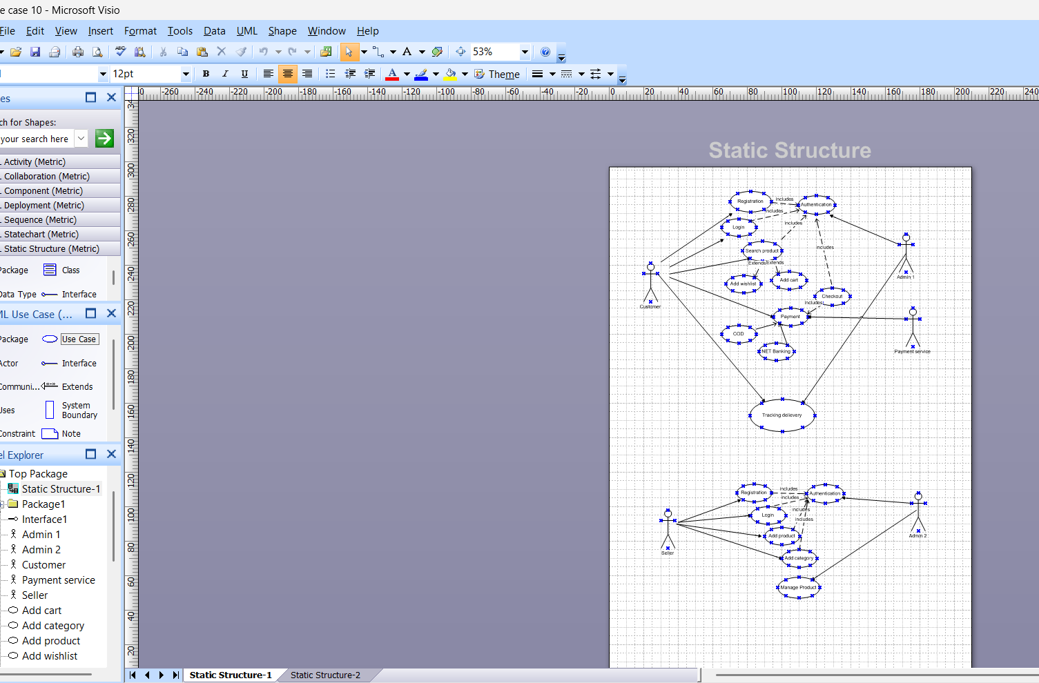
Draw use case diagram

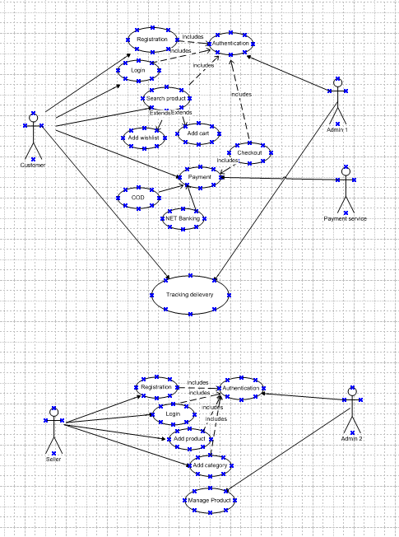
Zoom version of Activity Diagram (from Microsoft Viso)

Mr. Henry wants to build a platform for farmers to order agricultural products online.
Farmers (Customers) are users performing the top-level actions.
Admins represent the product management team or backend staff from APT IT SOLUTIONS.
Payment service is an external system used to complete transactions.
Tracking delivery connects both customer and admin sides, showing interaction through logistics or fulfilment.

- Admin 1: Handles customer-side authentication and validation.
- Admin 2: Handles seller-side authentication and approval
Payment Service (External system to process payments)
This Use Case Diagram models the core functionalities of an Online Agriculture Product Store, where:
- Customers can register, search products, add to cart/Wishlist, checkout using various payment methods, and track deliveries.
- Sellers can register, log in, add/manage products and categories.
- Admins handle authentication and backend validation.
- An external Payment Service processes the transaction securely

Include Relationship (<<include>>):
- Used between Checkout → Payment, meaning payment is a required part of the checkout process.
Directed Arrows:
- Show the direction of interaction or initiation (i.e., which actor or use case initiates another).

Question 11: Prepare Use case specs (minimum 5)
1) Use case: User can buy agricultural product from online application:

Use Case Specification : 1 case
Field | Details
Use Case ID | UC001
Use Case Name | This use case shows how the user can buy agriculture product from this application.
Created by | MR ABC
Last Updated by | 04-Apr-23
Date Created | 25-Mar-23
Last Revision Date | 01-Apr-23
Actor | Customers/Farmers
Description | Describing how page should respond if there is no internet
Pre-condition | Farmers are having an active internet connection
Post-condition | Success – Farmers can place the order successfully.  Failure – Farmers unable to login / logs are updated accordingly.
Normal Flow of events / Basic Flow / Happy Path | • The use case starts when Farmers do the registration with valid email ID and then login with ID and password.  • Use case validates the user.  • Then farmers can view products; add to cart and place the order.
Alternative Flow | Invalid User; Wrong account ID; Wrong password; No successful authentication via mobile number or email ID
Exceptions | If internet connection is lost during activity, then display "Check your internet connection"
Assumptions | It is assumed that customer is registered and has a computer knowledge.

Case2 : How farmers can register on the app
Field | Details
Use Case ID | UC002
Use Case Name | This use case shows how farmers can register on the app.
Created by | MR ABC
Last Updated by | 05-Apr-23
Date Created | 26-Mar-23
Last Revision Date | 02-Apr-23
Actor | Customers/Farmers
Description | Describing how page should respond if they do not put OTP for registration
Pre-condition | Farmers are having an active internet connection
Post-condition | Success – Farmers can register successfully.  Failure – Farmers unable to register are updated accordingly.
Normal Flow of Events / Basic Flow / Happy Path | • The use case starts when Farmers do the registration with valid email ID and then login with ID and password.  • Then farmers can register using OTP.
Alternative Flow | Incorrect OTP; No successful authentication via mobile number or email ID
Exceptions | If internet connection is lost during activity, then display  "Check your internet connection"
Frequency of Use | High
Assumptions | It is assumed that the customer has an email ID and mobile phone for authentication.

Case 3: Sellers can upload new products on app
Use Case ID | UC003
Use Case Name | This use case shows how sellers can upload new products on the app.
Created by | Mr. ABC
Date Created | 27-Mar-23
Last Updated by | 06-Apr-23
Last Revision Date | 03-Apr-23
Actor | Sellers / Dealers
Description | Describes how to upload new product details.
Pre-condition | Sellers have basic technical knowledge & an internet connection.
Post-condition | Success – Sellers can upload product description successfully.  Failure – Sellers are unable to upload product description accordingly.

Flow Type | Description
Normal Flow / Basic Flow / Happy Path | 1. Seller logs in using a valid email ID and password.  2. Alternatively, seller can log in using OTP.  3. Seller uploads the products.
Alternative Flow | - Sellers can log in using OTP.  - Sellers can upload products using history details.
Exceptions | - If internet connection is lost during the activity, display: "Check your internet connection".
Frequency of Use | High
Assumptions | It is assumed that sellers have details about their products.

Case 4: How farmers can add products to cart
Use Case: Add Products to Cart (UC004)
Use Case ID | UC004
Use Case Name | This use case shows how farmers can add products to cart.
Created by | MR ABC
Last Updated by | 07-Apr-23
Date Created | 28-Mar-23
Last Revision Date | 04-Apr-23
Actor | Farmers / Customers
Description | Describing how to purchase products.
Pre-condition | Farmers have basic technical knowledge & internet connection.
Post-condition | Success – Farmers can add products to cart successfully.  Failure – Farmers are unable to add products to cart.

Flow Type | Description
Normal Flow / Basic Flow / Happy Path | 1. Farmers search for desired products and browse the catalogue.  2. They select quantity and number of items.  3. Farmers add product to cart.
Alternative Flow | - Farmers can Wishlist the product and later add it to cart.  - Farmers can directly add products from past purchase and make similar purchase.
Exceptions | - If internet connection is lost during activity, display: "Check your internet connection".
Frequency of Use | High
Assumptions | It is assumed that farmers have basic browsing knowledge of products.

Case 5: Use Case: Initiate Return and Refund (UC005)
Use Case ID | UC005
Use Case Name | This use case shows how farmers can initiate return and refund.
Created by | MR ABC
Last Updated by | 08-Apr-23
Date Created | 29-Mar-23
Last Revision Date | 05-Apr-23
Actor | Farmers / Customers

Use Case Description
Attribute | Details
Description | Describing how to initiate refund and return.
Pre-condition | Farmers have basic technical knowledge & internet connection.
Post-condition | Success – Farmers can initiate return & refund.  Failure – Farmers unable to initiate return and refund.

Flow Type | Description
Normal Flow / Happy Path | 1. Farmers go to purchase history and initiate return.  2. Select reason for return and agree to terms and conditions.  3. Select mode and medium of refund.
Alternative Flow | Farmers can get refund added to their account wallet.
Exceptions | If internet connection is lost during the activity, display: "Check your internet connection".
Frequency of Use | High
Assumptions | It is assumed that Farmers have basic browsing knowledge of products.

Question 12 – (minimum 5) Activity Diagrams
Activity diagram are one of the 5 diagram in the UML for modelling the dynamic aspects of the system. An activity is essentially a flowchart showing the flow of control from activity to activity.
1.In the above online case study , we use certain elements for the use case model.
2Control flow an arrow showing the direction of the workflow 3.Activity indicates a step in the process it is a unit of work done by the system or a consistent achieved. 4.Connector is a trigger attached to control flow when the guard condition is true.

Activity 1: user workflow for a basic login system
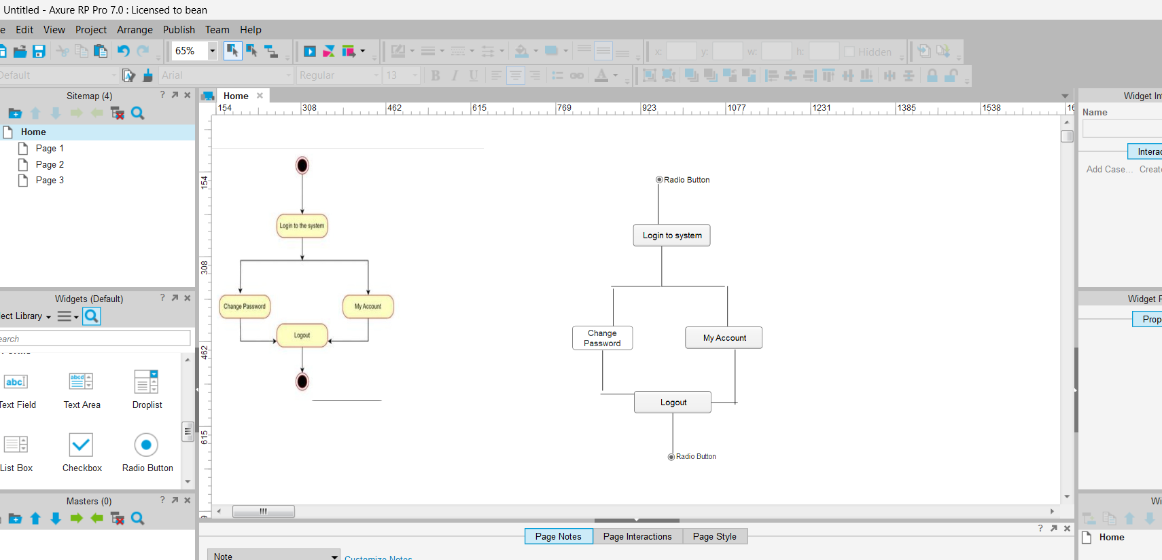

Start Node (solid black circle at the top):
Indicates the starting point of the process.
Activities (rounded rectangles):
These are actions performed by the user.
Arrows:
Show the direction of the flow from one activity to another.
End Node (black circle with a surrounding ring at the bottom):
Indicates the end of the process.
This activity diagram describes a simple system login flow where:
- The user logs into the system.
- After login, they can either change their password or manage account settings.
- Finally, the user logs out, ending the session.

user interaction flow for adding items to a cart in an online shopping system.
Activity 2:
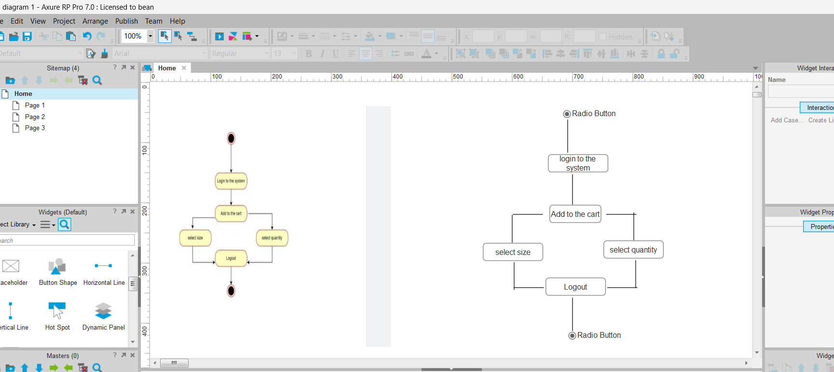

This activity diagram outlines a basic e-commerce cart interaction, where:
- A user logs in,
- Adds a product to the cart,
- Selects the size and quantity of the item,
- And finally logs out.
This diagram is useful for showing user flow for shopping cart operations, especially in online retail or agriculture product apps.
payment and order confirmation process
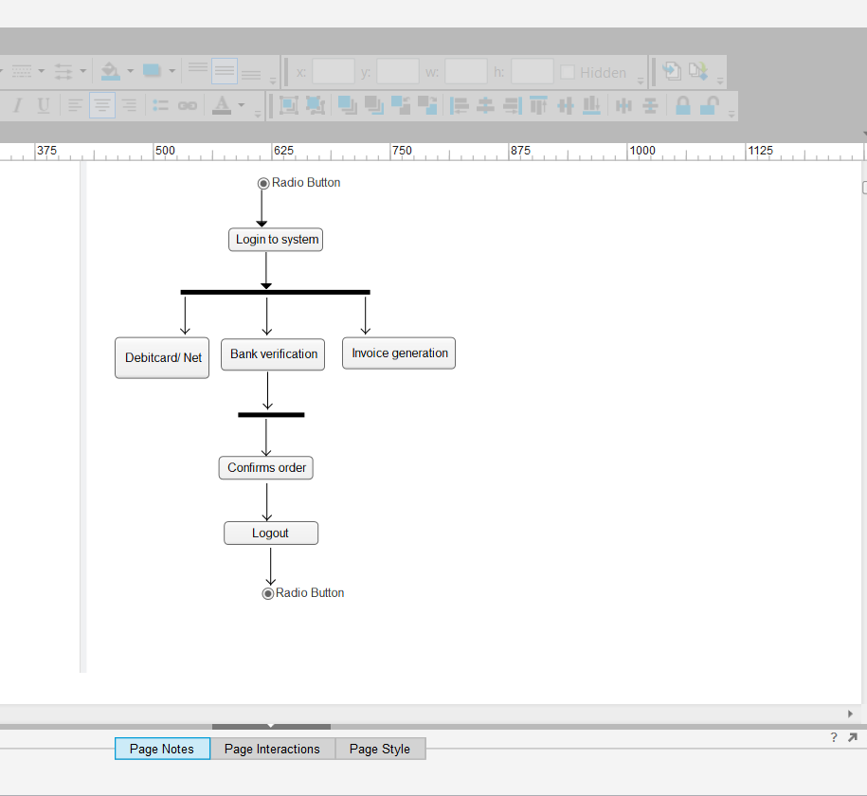
Activity 3:

Parallel Activities (Fork Node):
- After choosing to make a payment, three activities happen in parallel (represented by the horizontal black bar)
- Debit card/net banking
User selects a payment method.
- Bank verification
The system verifies the bank/payment details.
- Invoice generation
A transaction invoice is prepared simultaneously.

This activity diagram models the order completion process:
- Starts with login and payment initiation.
- Multiple processes (payment mode, verification, invoice) happen in parallel.
- System waits for all processes to complete.
- Order gets confirmed, followed by user logout.

Activity 4:
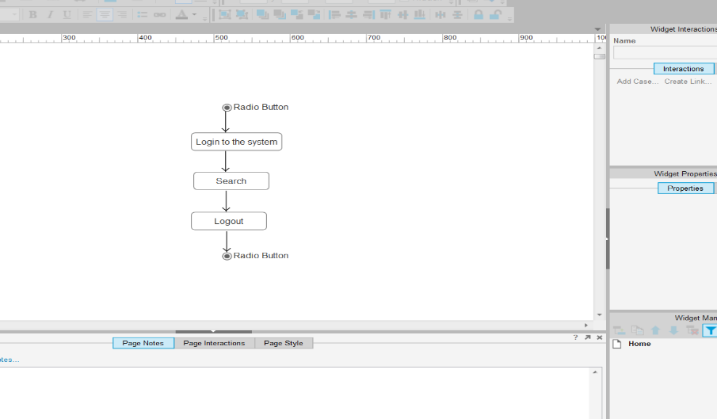

This activity diagram outlines a simple user workflow for interacting with an online agriculture system:
- Login → Perform Search → Logout
- It reflects a sequential flow ideal for systems with basic user needs such as information lookup or browsing agriculture-related content.
After logging in, the user accesses the search functionality.
In an agriculture context, the user might search for:
- Available crops
- Farming tools
- Suppliers
- Market prices
- Fertilizers or pesticides
- Government schemes or subsidie
Activity 5: Order cancellation:

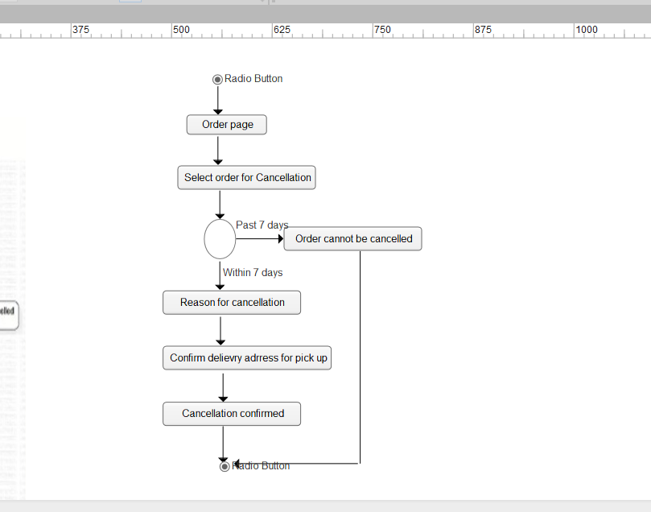

1. Order Page
- The user accesses the Order Page where their previous orders are listed.
2. Select Order for Cancellation – Return
- The user selects a specific order they wish to cancel or return.
3. Decision: Check Time Frame
- The system checks if the cancellation request is within 7 days of the order date.
➤ If Past 7 days:
- The system redirects to “Order cannot be cancelled”, ending the process.
➤ If Within 7 days:
- The process proceeds to gather cancellation details.
4. Reason for Cancellation
- The user is prompted to select or input a reason for cancellation (e.g., wrong product, damaged, not needed, etc.).

5. Confirm Delivery Address for Pick-up
- The user provides or confirms the pickup address so the delivery service can collect the returned item.
6. Cancellation Confirmed
- The system finalizes the cancellation process.

