Online Agriculture Products Store
1) 4 Quarterly Audits are planned, Q1, Q2, Q3, Q4, for this Project. What is your knowledge of how these Audits will happen for a BA?
As a Business Analyst (BA), I understand that Quarterly Audits (Q1, Q2, Q3, Q4) are formal review checkpoints conducted to assess the project’s progress, quality, compliance, documentation, and deliverables. These audits ensure that the project is aligned with the approved scope, budget, and timeline, and that BA activities are traceable, approved, and consistent with business needs.
Q1 Audit – Initiation & Requirements Phase Audit
BA Audit Areas:
- Verification of Business Requirements Document (BRD) approval by stakeholders.
- Validating that the Stakeholder Register and Requirement Traceability Matrix (RTM) are created.
- Review of elicitation techniques, meeting minutes, and version control.
- Ensuring sign-offs from Mr. Henry’s committee (Henry, Pandu, Dooku) and farmer stakeholders (Peter, Kevin, Ben).
- Audit team ensures that requirements align with the CSR initiative’s objectives.
Q2 Audit – Design & Analysis Phase Audit
BA Audit Areas:
- Review of Functional Requirement Specification (FRS) and Use Case Diagrams prepared by the BA.
- Ensuring requirements are properly translated into design artifacts by developers.
- Cross-verification of change requests and requirement updates.
- Validation of traceability from BRD → FRS → Design.
- Check if BA reviewed wireframes, data flow diagrams, and mockups with users for approval.
Q3 Audit – Testing & UAT Phase Audit
BA Audit Areas:
- Review of Test Scenarios and Test Cases to confirm full coverage of requirements.
- Validation of RTM updates to ensure every requirement is linked to at least one test case.
- Verification of UAT Plan, UAT Scripts, and Defect Traceability.
- Ensure sign-off from end users (farmers and company reps) after UAT.
- Audit team checks that all requirement changes are updated and approved formally.
Q4 Audit – Deployment & Closure Phase Audit
BA Audit Areas:
- Review of BA Closure Report and confirmation that all deliverables are signed off.
- Verification of post-implementation review, lessons learned, and benefits realization report.
- Ensure knowledge transfer documents and support materials are completed.
- Check if all versions of BRD, FRS, and RTM are archived properly.
2) Before the Project kicks going to Kick Start, the Committee asked Mr Karthik to submit the BA Approach Strategy
Write BA Approach strategy (As a business analyst, what are the steps that you would need to follow to complete a project – What Elicitation Techniques to apply, how to do Stakeholder Analysis RACI/ILS, What Documents to Write, What process to follow to Sign off on the Documents, How to take Approvals from the Client, What Communication Channels to establish n implement, How to Handle Change Requests, How to update the progress of the project to the Stakeholders, How to take signoff on the UAT- Client Project Acceptance Form )
Your Team Project Manager - Mr Vandanam, Senior Java Developer - Ms. Juhi, Java Developers - Mr Teyson, Ms Lucie, Mr Tucker, Mr Bravo, Network Admin - Mr Mike, DB Admin - Mr John. Testers - Mr Jason and Ms Alekya BA - You Technical Team have assembled to discuss on the Project approach and have finalised to follow 3-tier architecture for this project.
Ans: BA Approach Strategy for the Online Agriculture Products Store Project
Before the project kick-off, the Committee, comprising Mr. Henry, Mr. Pandu, and Mr. Dooku requested the Business Analyst (BA) approach strategy from APT IT Solutions. As the assigned BA, my goal is to ensure that the project is executed efficiently by clearly understanding stakeholder needs, documenting them accurately, obtaining approvals, and supporting the team throughout the SDLC. The project will follow a 3-tier architecture consisting of the Presentation Layer (UI), Business Logic Layer, and Database Layer.
1. Understanding Project Scope and Objectives
- Conduct a Project Inception Meeting with the Committee to confirm project objectives, CSR expectations, budget, and timeline (2 Crores INR, 18 months).
- Review the initial high-level scope to define the problem statement, key goals, and deliverables.
- Identify the success criteria — enabling farmers to easily buy seeds, fertilizers, and pesticides online.
2. Stakeholder Analysis (RACI / ILS)
- Identify and categorize stakeholders:
  - Internal: Mr. Vandanam (PM), Ms. Juhi (Senior Developer), Development Team (Teyson, Lucie, Tucker, Bravo), Mr. Mike (Network Admin), Mr. John (DBA), Mr. Jason and Ms. Alekya (Testers).
  - External: Mr. Henry, Mr. Pandu, Mr. Dooku (Committee), and farmers (Peter, Kevin, Ben).
- Prepare a RACI Matrix (Responsible, Accountable, Consulted, Informed) for key project activities.
- Conduct Influence-Interest (ILS) Analysis to plan stakeholder engagement frequency and communication style.
3. Requirement Elicitation Techniques
Apply multiple elicitation techniques to gather accurate requirements:
- Interviews with Committee members and farmers to understand business and operational needs.
- Workshops and Brainstorming Sessions with developers and testers to capture system-level expectations.
- Observation and Document Analysis to study existing offline purchase processes.
- Questionnaires/Surveys to gather feedback from potential farmer users.
- Prototyping and Wireframing sessions to validate user interface expectations.

4. BA Documentation to be Prepared

Phase | Document | Purpose
Initiation | Business Requirement Document (BRD) | Captures high-level business goals and needs.
Analysis | Functional Requirement Specification (FRS) | Defines detailed functionality of the system.
Design | Use Case Diagrams, Process Flows | Visualize interactions between users and system.
Development | Requirement Traceability Matrix (RTM) | Ensures traceability from BRD → FRS → Test Cases.
Testing | UAT Plan, UAT Scenarios, Test Case Mapping | Guides testing and validation activities.
Closure | BA Closure Report, Lessons Learned | Summarizes delivery and outcomes.

All documents will maintain version control and be reviewed by the PM before submission to the client.
5. Review and Sign-off Process
- Conduct walkthrough meetings with the Committee after each major deliverable (BRD, FRS, RTM).
- Obtain formal email or digital signature-based sign-offs from Mr. Henry (as primary approver) and Mr. Pandu / Mr. Dooku (as reviewers).
- Maintain a Sign-off Tracker for traceability.
6. Client Approval and Communication Channels
- Establish clear communication channels:
  - Weekly progress meetings with the Committee via video conference.
  - Daily Scrum meetings within the technical team.
  - Monthly status reports to Mr. Henry’s committee.
- Tools used: MS Teams for meetings, JIRA for tracking, and Email for official communication and approvals.
- All communication will be documented in the Project Communication Plan.
7. Change Request Management
- Any new or modified requirement will follow a formal Change Request (CR) process.
- The BA will document the CR, analyze its impact on scope, cost, and timeline, and present it to the Committee.
- Upon approval, the BA updates the RTM, BRD, and FRS, and the PM adjusts the project plan accordingly.
8. Progress Monitoring and Reporting
- Provide Weekly Progress Reports to Mr. Vandanam and the Committee.
- Highlight completed BA deliverables, pending items, risks, and mitigation plans.
- Use RTM updates to show progress on requirement fulfillment and test coverage.
9. User Acceptance Testing (UAT) and Client Sign-off
- Prepare the UAT Plan and Scripts aligned with business scenarios.
- Coordinate UAT sessions with the farmers and Committee members.
- Capture UAT feedback, resolve issues, and ensure all test cases are passed.
- Obtain final Client Project Acceptance Sign-off from Mr. Henry upon successful completion.
10. Project Closure and Handover
- Conduct a BA Closure Meeting summarizing deliverables, sign-offs, and lessons learned.
- Archive all approved versions of BRD, FRS, RTM, and Change Requests.
- Support the PM in preparing the Project Closure Report.

3) Explain and illustrate the 3-tier architecture?
Explain and Illustrate 3-Tier Architecture
The 3-Tier Architecture is a well-structured software design model that separates an application into three logical layers — Presentation Layer, Application (Business Logic) Layer, and Data Layer. This separation improves scalability, maintainability, and security by isolating responsibilities within the system. It is widely used in web-based applications such as the Online Agriculture Products Store Project.
1. Presentation Layer (Client Tier)
- Also called the User Interface (UI) Layer.
- It is the topmost layer through which users interact with the system.
- This layer consists of web pages, mobile screens, forms, and dashboards.
- In this project, farmers and company users will use this layer to browse products, place orders, and view delivery updates.
- Technologies: HTML, CSS, JavaScript, Angular/React, etc.
2. Application Layer (Business Logic Tier)
- Also known as the Middle Tier or Service Layer.
- It handles the core business rules and data processing.
- This layer processes user requests from the presentation layer, interacts with the database, and sends back the results.
- For example, when a farmer places an order, this layer validates product availability, calculates the price, and initiates the delivery process.
- Technologies: Java, Spring Boot, .NET, or other server-side frameworks.
3. Data Layer (Database Tier)
- This is the bottom layer where all data is stored, managed, and retrieved.
- It consists of databases, tables, and data access mechanisms.
- The Application Layer communicates with this layer using SQL queries or APIs.
- In this project, product details, user profiles, transaction records, and order histories are stored here.
- Technologies: MySQL, Oracle, PostgreSQL, etc.
Advantages of 3-Tier Architecture:
- Scalability: Each layer can be scaled independently.
- Maintainability: Easier to update or modify one layer without affecting others.
- Security: Data access can be restricted to the middle layer only.
- Reusability: Business logic can be reused by multiple interfaces (web, mobile).
4) Business Analyst should keep What points in his/her mind before he frames a Question to ask to the Stakeholder (5W 1H – SMART – RACI – 3 Tier Architecture – Use Cases, Use case Specs, Activity Diagrams, Models, Page designs)
Ans: Before framing any question to a stakeholder, a Business Analyst (BA) must ensure that the questions are clear, purposeful, and structured so that they extract the right information needed for requirement understanding and documentation. To achieve this, the BA should keep the following key points in mind:
1. Apply the 5W1H Technique
Before asking a question, the BA should validate whether it answers one or more of the following:
- What – What is the stakeholder expecting from the system?
- Why – Why is this requirement important to the business?
- Who – Who will use this feature (farmers, company, admin)?
- Where – Where will it be implemented (web, mobile, both)?
- When – When should this feature or process occur?
- How – How should it function or interact with other modules?
Using 5W1H ensures the BA covers all business, functional, and operational angles before finalizing requirements.
2. Ensure Questions Follow the SMART Principle
Each question or requirement elicitation objective should be:
- Specific – Focused and clear (e.g., “What payment modes should be enabled for farmers?”)
- Measurable – Expected output or metric is known.
- Achievable – Within system and resource capabilities.
- Relevant – Aligned with the project’s CSR goals.
- Time-bound – Within project timelines or defined release phases.
This helps the BA gather precise and actionable information from stakeholders.
3. Consider RACI Roles Before Asking
Before framing a question, the BA must identify who to ask:
- R (Responsible): Who executes the task (developers/testers)?
- A (Accountable): Who approves or signs off (Mr. Henry / Mr. Pandu)?
- C (Consulted): Whose inputs are valuable (farmers Peter, Kevin, Ben)?
- I (Informed): Who just needs to be kept updated (network/DB admins)?
This prevents asking irrelevant questions to the wrong stakeholder and ensures focused communication.
4. Align Questions with 3-Tier Architecture Understanding
A BA should visualize the project’s 3-Tier Architecture (Presentation, Application, Data) before questioning:
- For Presentation Layer – Ask about UI expectations, usability, language options, accessibility.
- For Application Layer – Ask about rules, workflows, and validations (e.g., how discounts or delivery charges apply).
- For Data Layer – Ask about what data needs to be stored, updated, or reported (e.g., farmer registration, product catalog).
This ensures questions are technically relevant to each layer of the system.
5. Refer to Use Cases and Models
Before elicitation meetings, the BA should prepare Use Case diagrams, Use Case Specifications, and Activity Diagrams to:
- Visualize how the user will interact with the system.
- Identify missing scenarios or alternate flows.
- Frame detailed, scenario-based questions
(e.g., “What should happen if the product is out of stock?”).
- Discuss page designs or mockups with stakeholders to validate workflow and UI requirements visually.
This helps stakeholders understand the system flow better and provide concrete feedback.
6. Keep Documentation and Validation in Mind
Each question should aim to:
- Clarify a business rule or assumption for inclusion in BRD or FRS.
- Be validated through prototypes or walkthroughs.
- Be traceable in the Requirement Traceability Matrix (RTM).
5) As a Business Analyst, What Elicitation Techniques are you aware of? (BDRFOWJIPQU)
Answer:
As a Business Analyst, I must be aware of several requirement elicitation techniques that help in gathering, clarifying, and validating information from stakeholders. These techniques are remembered by the acronym BDRFOWJIPQU, which stands for:
B – Brainstorming
Used to generate a wide range of ideas or solutions in a group discussion involving stakeholders, developers, and users.
Example: Brainstorming with farmers and product companies to identify challenges in ordering and delivery.
D – Document Analysis
Reviewing existing documents, reports, and process manuals to understand the current system and business rules.
Example: Studying existing fertilizer purchase processes before designing the online system.
R – Reverse Engineering
Analyzing an existing or competitor’s system to identify functionalities and requirements.
Example: Studying an existing agricultural e-commerce platform to identify useful features.
F – Focus Group
Gathering opinions from a selected group of stakeholders to discuss specific topics or features.
Example: Conducting focus groups with farmers to get feedback on proposed mobile app screens.
O – Observation
Watching users perform their daily tasks to understand real-world challenges and workflows.
Example: Observing how farmers currently procure seeds or pesticides offline.

W – Workshop
Interactive sessions where stakeholders and technical teams work together to define and refine requirements.
Example: Conducting a joint workshop with Mr. Henry’s committee and APT IT Solutions team.
J – JAD (Joint Application Development) Sessions
Structured meetings involving business users, developers, and testers to finalize system requirements quickly.
Example: JAD sessions to finalize key modules like Product Catalog, Order, and Delivery Tracking.
I – Interview
One-on-one or group discussions with stakeholders to gather detailed requirements and expectations.
Example: Interviewing Mr. Henry and farmers (Peter, Kevin, Ben) to understand their individual needs.
P – Prototyping
Creating visual models or mock-ups of the system to help stakeholders visualize features and provide feedback.
Example: Showing UI wireframes of the online store for usability validation.
Q – Questionnaire / Survey
Distributing structured questions to a larger group of users to collect quantitative data.
Example: Using surveys to gather input from farmers in different regions on product preferences.
U – Use Case / Scenario Analysis
Describing how users will interact with the system to perform specific tasks.
Example: Defining use cases such as “Place Order”, “Track Delivery”, and “Update Inventory”.
The BDRFOWJIPQU elicitation techniques collectively ensure that the Business Analyst gathers complete, accurate, and validated requirements by engaging all stakeholders effectively. Selecting the right combination of techniques depends on project scope, stakeholder availability, and system complexity.

6 Which Elicitation Techniques can be used in this Project and Justify your selection of Elicitation Techniques? Prototyping Use case Specs Document Analysis Brainstorming Fertilizers, seeds, pesticides details from the manufacturers and should be able to display them to the Farmers. To gather the business requirements from the client, you went to SOONY and met Mr. Henry. When Mr. Henry was asked about the project and what are they expecting from the project, Mr. Henry stated that he is expecting to have a login for all its users (fertilizers, seeds, pesticides manufacturers and Farmers), a product catalog of fertilizers, seeds, pesticides, a search option to search for products, payment process, and delivery tracking. After doing the stakeholder analysis, you have found out that Peter, Kevin, Ben are the key stakeholders and you have scheduled an appointment to meet them. After meeting with them and trying to gather the stakeholder requirements, Kevin said that, a Farmer should be able to browse through the products catalog once they visit the website and need to have a search option so that they can search for any product they need. Peter said that, if a farmer wants to buy any product or add them to buy-later list, they need to login
first using their email id and password. If it is a new user, then they can create a new account by submitting their email ID and creating a secure password. Ben added saying that, Farmers needs to have an easy-to-use payment gateway which should include cash-on-delivery (COD), Credit/Debit card and UPI options so that the user’s experience should be better. Kevin mentioned that, a user gets an email confirmation regarding their order status. A delivery tracker to track the whereabouts of their order. Identify Business Requirements (which includes Stakeholder Requirements) BR001 – Farmers should be able to search for available products in fertilizers, seeds, pesticides BR002 – Manufacturers should be able to upload and display their products in the application.
Ans:
As a Business Analyst for the Online Agriculture Products Store Project, my goal is to use suitable elicitation techniques to gather accurate and complete requirements from the client (SOONY Committee) and stakeholders (Farmers and Manufacturers). Based on the project’s nature, user diversity, and requirements shared by Mr. Henry and the farmers (Peter, Kevin, Ben), the following elicitation techniques are most appropriate:
1. Prototyping
Justification:
Since Mr. Henry and the farmers are new to digital systems, visualizing the application through prototypes and wireframes will help them understand how the website and mobile app will look and function.
Using low-fidelity screen mockups for Login, Product Catalog, Search, Payment, and Delivery.
Only preparing screen mockups will cause misunderstanding or miscommunication. So need to combine the prototype with written description about the functionality of the screen.
Tracking modules allows stakeholders to give visual feedback before development begins.
Outcome: Confirms user interface expectations and simplifies requirement validation for both farmers and manufacturers.
2. Use Case Specification
Justification:
Use Case diagrams and specifications help illustrate how each user interacts with the system.
For example:
- Use Case 1: “Search Product” (Farmer browses or searches items).
- Use Case 2: “Add Product” (Manufacturer uploads fertilizer, seed, pesticide details).
Use Case 3: “Make Payment” (Farmer completes purchase through COD, Card, or UPI).
By defining these scenarios, both business and technical teams get a clear understanding of required functionalities and user flows.
Outcome: Ensures that every requirement is aligned to a specific user action.
3. Document Analysis
Justification:
Analyzing existing documents like product catalogs, invoices, delivery records, and payment formats from the manufacturers will help identify what product data and attributes need to be captured (e.g., product type, brand, quantity, expiry date, price).
Document analysis also ensures system data structures are aligned with current business practices.
Outcome: Provides factual input for database design and system data validation.
4. Brainstorming
Justification:
Conducting brainstorming sessions with Mr. Henry’s committee and farmer stakeholders (Peter, Kevin, Ben) helps generate and prioritize ideas for system features and improvements.
For example, discussions helped identify requirements like login creation, search function, buy-later list, payment gateway, and delivery tracking.
Outcome: Encourages creative thinking, ensures all pain points are covered, and helps finalize the Business Requirements (BRs) list.

ID | Business Requirement | Stakeholder
BR001 | Farmers should be able to search for available products in fertilizers, seeds, and pesticides. | Kevin
BR002 | Manufacturers should be able to upload and display their products in the application. | Peter / Manufacturer
BR003 | Farmers should be able to create a new account or login securely before purchasing. | Peter
BR004 | Farmers should be able to make payments using COD, Credit/Debit cards, or UPI. | Ben
BR005 | Farmers should receive order confirmation emails and have a delivery tracker for their orders. | Kevin

The selected elicitation techniques — Prototyping, Use Case Specification, Document Analysis, and Brainstorming — are the most effective for this project.
They help visualize requirements for non-technical stakeholders, validate process flows, and ensure the BA captures clear, complete, and stakeholder-approved business requirements, aligning with SOONY’s CSR initiative to support farmers.
7) Make suitable Assumptions and identify at least 10 Business Requirements.
Answer:
Assumptions:
- The Store Online Agriculture Products will be a web and mobile-based application accessible in both English and local languages.
- There will be three main user roles — Farmers, Manufacturers (fertilizers, seeds, pesticides), and System Admin.
- All users will have unique login credentials to access their dashboards.
- The platform will integrate a secure payment gateway supporting multiple payment modes (COD, Credit/Debit Card, UPI).
- The application will display product categories, pricing, and availability in real-time.
- Farmers should receive email/SMS notifications on order placement and delivery updates.
- Manufacturers will manage their own product listings, stock levels, and order dispatch details.
- The Admin will oversee user registrations, product approvals, and transaction reports.
- The system will maintain a delivery tracking mechanism linked with courier partners.
- The platform will be scalable to include future modules like government schemes or subsidies for farmers.
Business requirements:
BR001: Farmers should be able to register and login securely using their email ID and password.
BR002: Manufacturers should be able to create accounts and upload their product details (fertilizers, seeds, pesticides).
BR003: Farmers should be able to browse and search products based on category, name, or brand.
BR004: The system should display a product catalog with product details (price, description, availability).
BR005: Farmers should be able to add products to the cart or buy later list for future purchases.
BR006: Farmers should be able to make payments online using COD, Credit/Debit card, or UPI.
BR007: The system should send email/SMS notifications on successful registration, order placements, and delivery updates.
BR008: Manufacturers should be able to update stock and pricing information whenever required.
BR009: The system should provide a delivery tracking feature for farmers to check order status.
BR0010: Admin should be able to approve new manufacturers, monitor transactions, and generate reports.
BR0011: The system should maintain data security and privacy compliance for all information.
BR0012: The platform should have a feedback and rating system for farmers to rate products.
By making these assumptions and identifying 10+ clear Business Requirements, the Business Analyst ensures that all functional and stakeholder needs are captured. These BRs will later be refined into Functional Requirements and Use Case Specifications during the Requirements Analysis phase.
8. List your assumptions
Assumptions for the Project: Online Agriculture Products Store
- The application will be developed as a web and mobile-based platform to allow access from remote areas.
- The application will have three major user roles — Farmers, Manufacturers (Fertilizers, Seeds, Pesticides), and System Administrator.
- Each user must register and login securely with a valid email ID and password.
- The system will include multi-factor authentication for data security.
- The application will display product categories (fertilizers, seeds, pesticides) with full details including price, stock, and description.
- The payment gateway will support multiple payment modes — Cash on Delivery (COD), Credit/Debit Card, and UPI.
- Farmers will receive order confirmation and delivery status notifications through email and SMS.
- The delivery tracking feature will be integrated with a third-party logistics partner.
- Manufacturers will be able to add, update, or delete their product details and manage inventory levels.
- The Admin will verify and approve new manufacturer registrations before their products go live.
- The application will follow a 3-Tier Architecture (Presentation, Application/Business Logic, and Database Layers).
- The project will be completed within the approved budget of ₹2 Crores and 18 months timeline.
- The system will maintain data backups and recovery mechanisms for uninterrupted service.
- The user interface (UI) will be simple, intuitive, and multilingual (English and local language support).
9. This project Requirements Priority - 8 Marks
Give Priority 1 to 10 numbers (1 being low priority – 10 being high priority) to these Requirements after discussions with the stakeholders
Req ID | Req Name | Req Description | Priority
BR001 | Farmer Search for Products | Farmers should be able to search for available products in fertilizers, seeds, pesticides | 8
BR002 | Manufacturers upload their Products | Manufacturers should be able to upload and display their products in the application | 8

Once the requirements are finalized, as a business analyst, one of the major roles is to act as a liaison between the client and the project team. To gather the requirements correctly from the client side and then to deliver those requirements to the project team in a way they understand.
To make the project team understand the requirements, you need to convert those requirements into UML diagrams and screen mock-ups.
Answer:
UML diagrams:

1.Use case diagram.
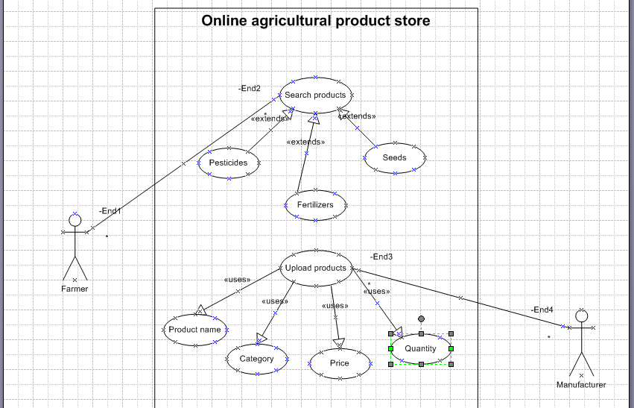

  - Activity diagram (Search products)
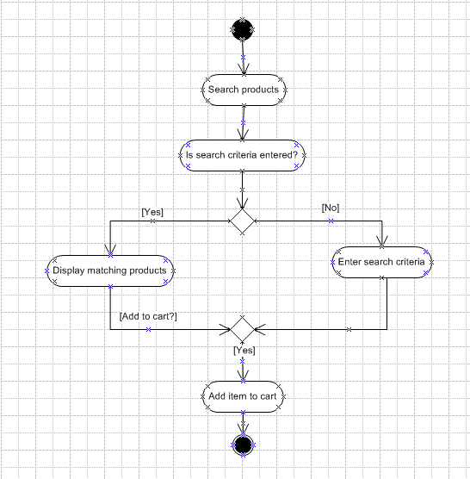

  - Activity diagram (Upload products)
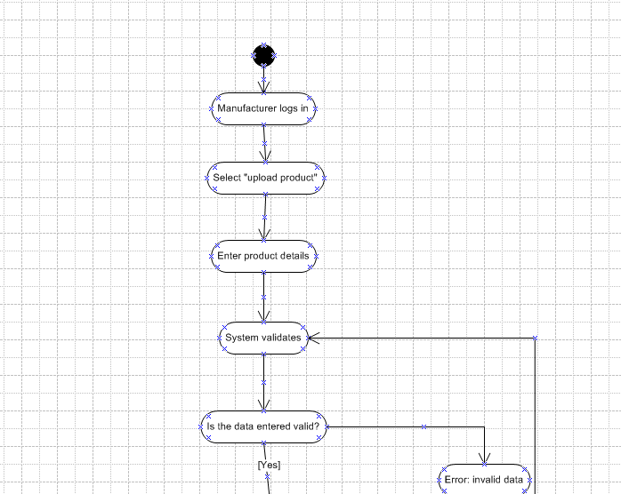
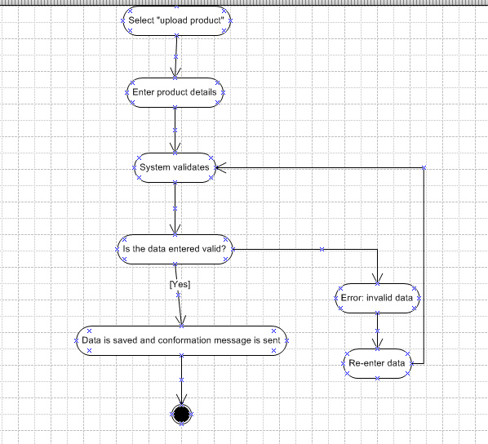

Screen mockup of BR001
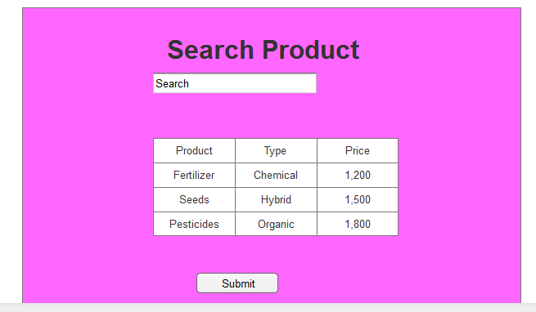
Screen mockup for BR002
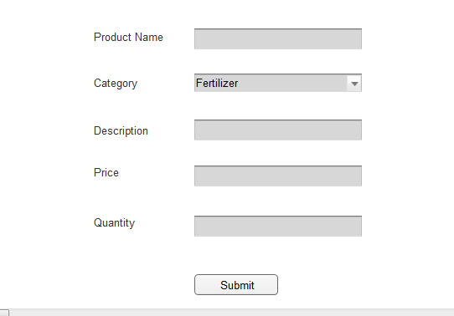

Question 10 – Use Case Diagram - 10 Marks
Draw use case diagram
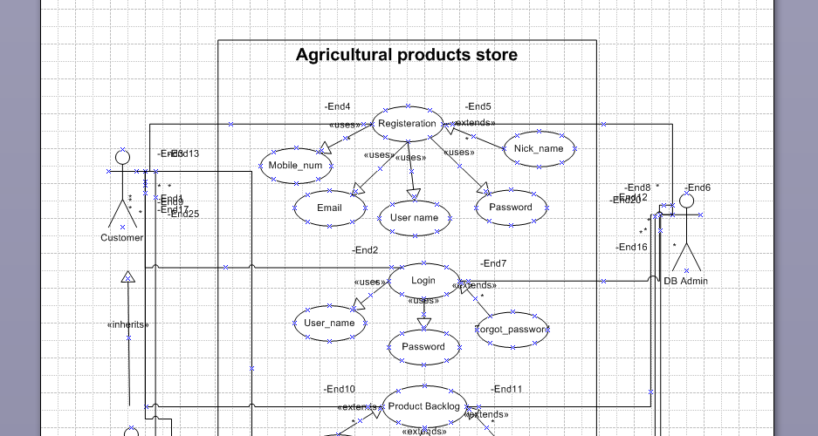
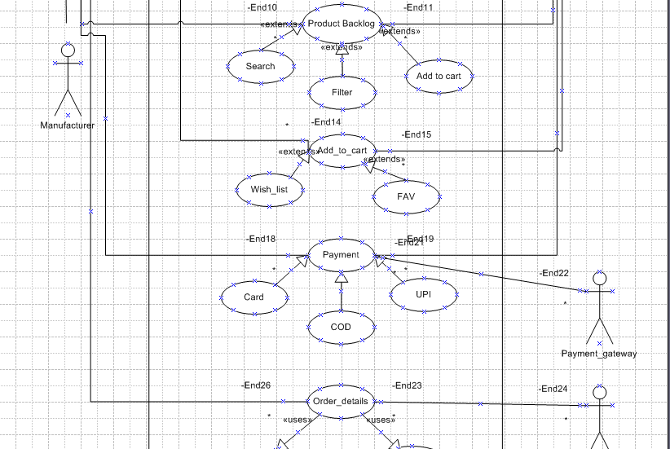
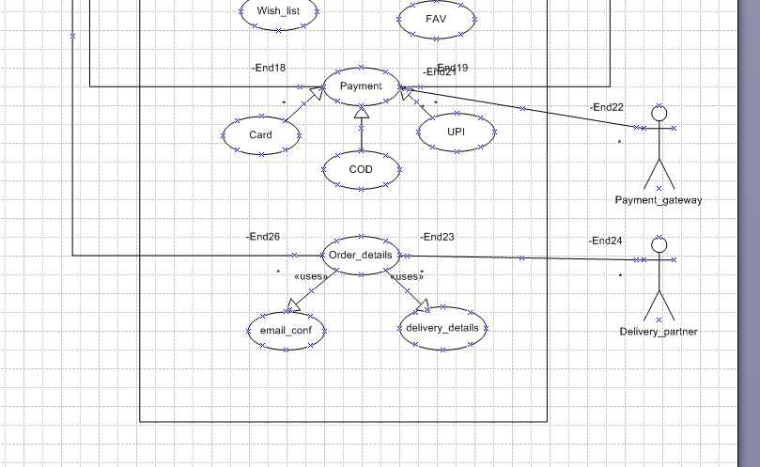
11. Prepare use case specs for all use cases
Use Case ID: BR001
Use Case Name: Farmer Registration
Primary Actor: Farmer
Goal: To allow new farmers to register in the system.
Preconditions:
- Farmer has a valid mobile number and ID proof.
Postconditions:
- Farmer account created successfully and credentials sent via SMS/email.
Main Flow:
- Farmer opens registration page.
- Enters personal and contact details.
- Uploads ID proof (if required).
- System validates details and creates a new account.
- Confirmation message sent to farmer.
Alternative Flow:
- Invalid data: system prompts to re-enter information.
Use Case ID: BR002
Use Case Name: Product Management (Vendor/Admin)
Primary Actor: Vendor / Admin
Goal: To add, update, or delete products in the system.
Preconditions:
- Vendor/Admin is authenticated.
Postconditions:
- Product list updated in the database.
Main Flow:
- Vendor/Admin logs into the system.
- Selects “Manage Products.”
- Adds or updates product details (name, category, price, quantity).
- Saves the product record.
- System confirms update.
Alternative Flow:
- Invalid data: system displays an error message.

Use Case ID: BR003
Use Case Name: Place Order
Primary Actor: Farmer
Goal: To allow farmers to place orders for desired products.
Preconditions:
- Farmer must be logged in.
- Product must be available in stock.
Postconditions:
- Order successfully placed and confirmation sent.
Main Flow:
- Farmer searches and selects product.
- Clicks “Buy Now.”
- Enters quantity and confirms purchase.
- System verifies stock and processes payment.
- Confirmation message displayed with order details.
Alternative Flow:
- Payment failed: order not processed; farmer notified.
Use Case ID: BR004
Use Case Name: Payment Processing
Primary Actor: Farmer
Goal: To process online payment securely for the order.
Preconditions:
- Valid order initiated.
- Payment gateway is active.
Postconditions:
- Payment status recorded.
- Order status updated accordingly.
Main Flow:
- Farmer selects payment option (UPI, Card, NetBanking).
- Enters payment details.
- System redirects to payment gateway.
- Payment processed and confirmation received.
- System updates payment and order records.
Alternative Flow:
- Payment declined: farmer prompted to retry or cancel.
Use Case ID: BR005
Use Case Name: View Order History
Primary Actor: Farmer
Goal: To enable farmers to view details of past and current orders.
Preconditions:
- Farmer is logged in.
Postconditions:
- Order list displayed to farmer.
Main Flow:
- Farmer logs in.
- Selects “My Orders.”
- System retrieves and displays list of all past and current orders.
- Farmer can click any order to view details.
Alternative Flow:
- If no orders: system displays “No orders found.”
Use case ID: BR006
Use Case Name: Farmer Search for Products
Primary Actor: Farmer
Goal: To enable farmers to search and view available agricultural products such as fertilizers, seeds, and pesticides.
Preconditions:
- Farmer must be registered and logged into the system.
- Product database must be available and updated.
Postconditions:
- Farmer successfully views list of products matching search criteria.
Main Flow:
- Farmer logs into the system.
- Farmer navigates to the “Search Products” page.
- Farmer enters product name, type, or category.
- System retrieves and displays matching products.
- Farmer views product details (price, supplier, stock).
Alternative Flow:
- If no products are found, the system displays “No products available” message.
Exceptions:
- Database not accessible: system displays “Service temporarily unavailable.
Question 12 – (minimum 5) Activity Diagrams - 15 Marks
Activity diagrams
Registration:
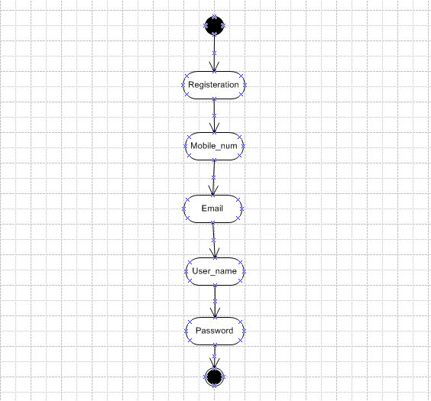
Login:
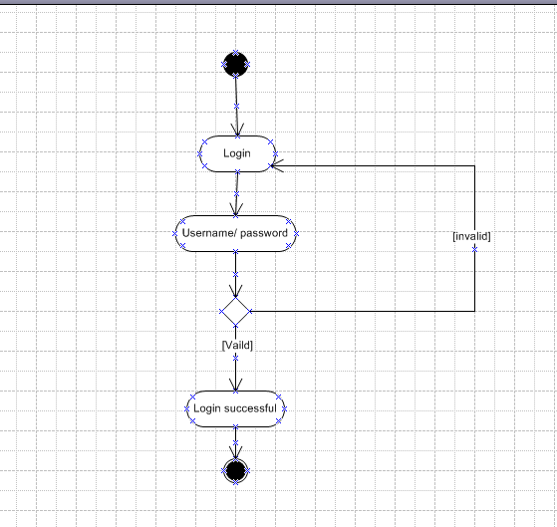
Payment:
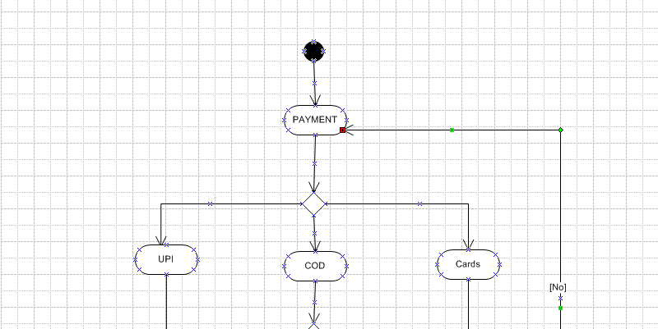

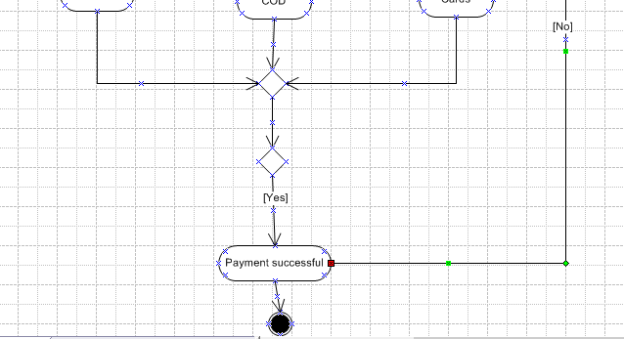
Order details:
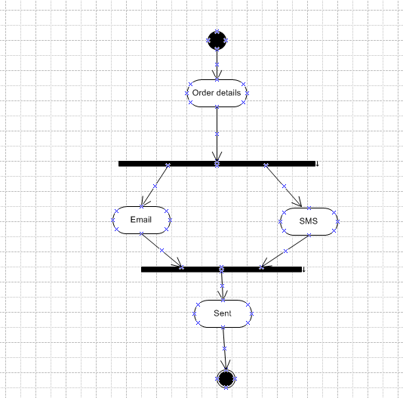
Search product:
