A company is having manufacturing plants and warehouses in various parts of the country. They manufacture ice-cream and milk products. They want to build software to achieve two goals.
- Manage the inventory
- Quickest delivery to the customers

Assignment 1:
- Please make a BRD which can be presented to the client along with complete development and resource plan.

Business Requirements Document –

Executive Summary –

The client manufactures ice-cream and milk products with multiple plants and warehouses across the country. The business needs a software solution to: 1) manage inventory effectively across manufacturing plants and warehouses; and 2) ensure quickest delivery to customers while maintaining product freshness and minimizing waste.

Project objectives:
- Centralized inventory visibility (real-time stock levels by SKU, location, batch/lot, expiry).
- Automated replenishment & production triggers.
- Route-optimized deliveries (shortest time plus cold-chain compliance).
- Integrations with POS, existing ERP, and third-party logistics (3PL).
- Reporting, alerts, and compliance (expiry, recalls, temperature excursions).

Business Goals:
- Enhance visibility of stock across plants and warehouses.
- Minimize wastage of perishable goods.
- Ensure fastest delivery to customers.
- Enable data-driven decision making through analytics.

Business Objectives
- Automate manual inventory tracking.
- Integrate order management, logistics, and warehouse systems.
- Reduce stock-outs and overproduction by 20%.
- Improve delivery time by 25%.
- Support scalability for future plants and outlets.

Business Rules
- All products must be assigned a unique SKU.
- Inventory updates in real-time after dispatch or receipt.
- Orders above ₹10,000 require approval from the regional manager.
- Expiry dates must be tracked to prioritize dispatches (FIFO).
- Delivery routes must be optimized based on distance and temperature requirements.

Background
Currently, the organization uses manual logs and spreadsheets to monitor stock and dispatch schedules. Communication between manufacturing units and warehouses is delayed, resulting in inefficiencies, spoilage, and customer dissatisfaction

Business Rules
- All products must be assigned a unique SKU.
- Inventory updates in real-time after dispatch or receipt.
- Orders above ₹10,000 require approval from the regional manager.
- Expiry dates must be tracked to prioritize dispatches (FIFO).
- Delivery routes must be optimized based on distance and temperature requirements.

Success metrics:
- Reduce stockouts by 60% within 6 months.
- Reduce per-delivery transit time by 20% in first year.
- Reduce spoilage/wastage by 30% in first year.

Stakeholders
- Executive Sponsor: Head of Supply Chain
- Product Owner: Operations Manager
- Operations: Plant Managers, Warehouse Managers, Fleet Manager
- IT: Infrastructure & Integration Team
- Sales & Customer Support
- Third-Party Logistics Providers (3PL)
- End Customers

Scope (In-scope)
- Inventory module: SKU master, batch & expiry tracking, stock ledger, FIFO/FEFO support
- Warehouse management: receiving, put away, picking, packing, mobile scanning
- Manufacturing interface: production orders, yields, ingredient usage
- Order management: order intake, allocation, backorder management
- Delivery optimization: route planning, delivery windows, vehicle capacity, temperature constraints
- Mobile app for drivers: manifests, POD (proof of delivery), temperature logging, returns
- Integrations: ERP, POS, payment gateway (if retail), GPS telematics, weather API
- Reporting & dashboards: inventory KPIs, deliveries, SLA, spoilage

Out of scope
- New manufacturing equipment controls
- Direct-to-consumer marketing platform (beyond order capture)

Assumptions
- Each warehouse will have stable internet connectivity.
- All users will have access to basic training on the system.
- Required hardware and infrastructure will be available.

Constraints
- Budget limitations for IoT sensor integration.
- Project timeline of 6 months.
- Dependency on accurate data migration from legacy systems.

Functional Requirements
- FR1: Maintain SKU master with attributes (perishable flag, shelf-life, storage temp).
- FR2: Capture batch/lot number and expiry on receipt.
- FR3: Real-time stock view across all locations.
- FR4: Support automated replenishment rules (min/max, safety stock, EOQ suggestions).
- FR5: Allocate inventory to orders using FEFO.
- FR6: Create pick lists and packing lists; support barcode scanning.
- FR7: Integrate with route optimization engine to produce driver manifests.
- FR8: Mobile app for drivers to capture POD (photo/signature) and log temperature/time.
- FR9: Alerts for near-expiry, temperature excursions, low stock, delayed delivery.

Non-functional Requirements
- NFR1: Availability: 99.9% SLA for core modules.
- NFR2: Performance: Orders allocation <= 2s; inventory query <= 300ms.
- NFR3: Security: Role-based access, encrypted data at-rest/in-transit, audit logs.
- NFR4: Scalability: Support growth to 100+ warehouses and 1,000+ SKUs initial, extendable.
- NFR5: Compliance: Data retention and food-safety traceability.

Risks
Technological Risks
- Integration challenges with existing ERP systems.
- Potential downtime during migration.
Skills Risks
- Limited technical expertise in warehouse staff.
Political Risks
- Delay in approvals from regional authorities.
Business Risks
- Inaccurate demand forecasting leading to excess production.
Requirements Risks
- Changes in business processes during implementation.
Other Risks
- External factors like power failures or transport strikes.

Business Process Overview
- Raw materials received and logged into system.
- Products manufactured, labeled, and stored in cold storage.
- Warehouses monitor stock levels via central dashboard.
- Orders received from customers/distributors.
- Route optimization algorithm assigns best delivery route.
- Delivery executed and tracked until completion.

Legacy System (AS-IS)
- Manual tracking through Excel sheets.
- Delayed communication between manufacturing and warehouse.
- No centralized visibility of stock or expiry dates.

Proposed Recommendations (TO-BE)
- Implement real-time cloud-based inventory system.
- Automate stock and delivery notifications.
- Integrate route optimization and analytics dashboards.

Development & Resource Plan
Delivery approach
Agile delivery using 2-week sprints. Phased rollout:
- Phase 0 (2 wks): Discovery, data collection & environment setup
- Phase 1 (8 wks): Core Inventory & Warehouse Management (WMS) MVP
- Phase 2 (8 wks): Order Management + Allocation + FEFO
- Phase 3 (6 wks): Delivery Optimization & Driver Mobile App
- Phase 4 (4 wks): Integrations (ERP, POS, GPS) & Reporting
- Phase 5 (4 wks): UAT, training, pilot rollout
- Phase 6 (ongoing): Production hardening, handover, support
Total estimated delivery: ~6 months to pilot (assuming timely inputs).

Team & roles
- Product Owner (Client-side): 0.5 FTE
- Business Analyst (Sulu / Implementation BA): 1 FTE
- Scrum Master/Delivery Manager: 1 FTE
- Solution Architect: 0.5–1 FTE during design and integrations
- Backend Developers (API, integration): 3 FTE
- Frontend Developers (web + dashboards): 2 FTE
- Mobile Developers (Android/iOS or cross-platform): 2 FTE
- QA/Test Engineers: 2 FTE
- DevOps/Cloud Engineer: 1 FTE
- Data Engineer (ETL & reporting): 1 FTE
- UX Designer: 0.5 FTE (early design)
- Technical Writer / Training: 0.5 FTE

Tooling & tech stack
- Cloud: AWS / Azure
- Backend: Node.js / Java Spring Boot
- Database: PostgreSQL (primary), Redis (cache)
- Message Bus: Kafka / RabbitMQ for events
- Mobile: React Native or Flutter
- Route Optimization: integrate Google OR-Tools or commercial TMS
- CI/CD: GitHub Actions / Azure DevOps
- Monitoring: Prometheus + Grafana / Cloud native

Estimated effort (story points / person-months)
A rough estimate: 20–25 person-months for initial 6-month delivery (team ramping up). Detailed estimation will follow after discovery.

Budget considerations
- Implementation labour: depends on location/rates — provide options: in-house vs offshore. Detailed costing to be provided after scoping.
- Licensing: route optimizer, maps, telematics, optional WMS modules.
- Hardware: barcode scanners, mobile devices, possible temperature sensors.

Deployment & Rollout Plan
- Sandbox & QA environments provisioned in cloud.
- Pilot rollout at one plant + one warehouse for 4 weeks.
- Phased rollouts to other locations in 2–4 week waves.
- Training: super-user workshops + SOP documentation + recorded e-learning.

2. Prepare process flow diagram using your imagination.
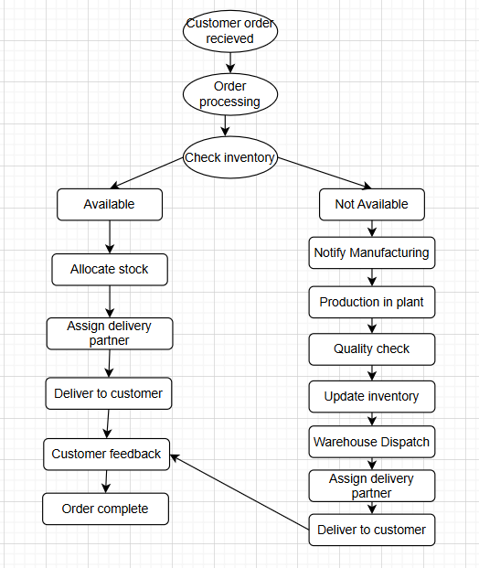

Assignment 2:
1. Write an introduction letter to a client introducing yourself as a business analyst in charge of working with the client and his team to start the business understanding process.
Subject: Introduction — Business Analyst (Nahid) for Inventory & Delivery Project
Dear Sachin,
My name is Nahid Anjum and I will be the Business Analyst assigned to work with you and your team on the Inventory Management & Quick Delivery initiative. I appreciate the opportunity to partner with you on this important transformation that will help reduce spoilage, improve delivery times, and bring centralized visibility to your operations.
Over the next weeks I will:
1) lead the business-understanding workshops with stakeholders
2) document requirements (BRD/SRS) and process flows
3) help prioritize features for a pragmatic MVP
4) coordinate user acceptance testing and training. I bring experience in supply-chain implementations, WMS, and logistics integrations and will act as the bridge between operations and the technical team.
To start, I propose we schedule a 90-minute discovery workshop with Operations, IT, and Sales to review current processes, data sources, and pain points. Please let me know your available times next week. I look forward to collaborating closely with you and your team.
Warm regards,
Nahidd Anjum
Business Analyst

2. Prepare a brief BRD and SRS for a project- Horoscope or Ticketing system or online store.
BRD
Introduction
The Customer Support Ticketing and Resolution System (CSTRS) will streamline the way customer complaints, service requests, and queries are handled for the company’s milk and ice-cream distribution network.
It will provide a centralized platform for logging, tracking, and resolving tickets raised by customers, distributors, or internal departments, ensuring faster resolution and improved customer satisfaction.

Business Goals
- Provide a unified platform for managing all support queries.
- Improve customer satisfaction through quick resolution.
- Enhance transparency in ticket progress and accountability.
- Enable management to analyze recurring issues and prevent future ones.

Business Objectives
- Reduce average ticket resolution time by 40%.
- Increase customer satisfaction scores by 30%.
- Provide complete traceability of each issue’s lifecycle.
- Enable data-driven analysis of product or service issues.

Business Rules
- Each ticket must have a unique Ticket ID.
- Tickets are automatically assigned based on issue category or region.
- Tickets unresolved beyond SLA automatically escalate to higher authority.
- Users must be authenticated before raising a ticket.
- Closed tickets cannot be modified.

Background
The organization currently handles customer complaints via emails and phone calls without a structured system. This leads to delayed responses, lack of tracking, and loss of accountability.
A digital system is needed to log, assign, track, and resolve customer complaints effectively.

Project Objective
To implement an automated, web-based ticket management solution that ensures faster resolution, better accountability, and real-time performance monitoring of customer service operations.

Project Scope
The system will handle customer complaints, product quality issues, service delays, and requests for refunds/replacements.
It will be integrated with the existing ERP and CRM modules.

In-Scope Functionality
- Ticket creation and tracking
- Ticket assignment and escalation
- SLA management and notifications
- Status updates and audit trail
- Customer and agent dashboards
- Reporting and analytics
- Integration with email and SMS alerts

Out-of-Scope Functionality
- AI chatbot or predictive resolution suggestions
- Integration with third-party CRMs
- Offline ticket creation

Assumptions
- All customer interactions will be recorded through this system.
- Users will have access to internet and valid credentials.
- Email/SMS integration services will be available.

Constraints
- SLA timing and escalation levels must be defined by the client.
- Limited IT infrastructure at regional warehouses.
- Multi-language support planned for later phases.

Risks
Technological Risks
- System downtime affecting ticket updates.
- Integration delays with CRM.
Skills Risks
- Support staff may require training.
Political Risks
- Resistance to adoption from certain departments.
Business Risks
- Poor SLA compliance could affect brand image.
Requirements Risks
- Evolving workflow needs may affect scope.
Other Risks
- Data privacy concerns if improperly secured.

Business Process Overview
- Customer submits a complaint online or via helpline.
- Ticket generated and categorized (product, delivery, service).
- System assigns ticket to appropriate support agent.
- Agent investigates and resolves issue.
- Customer receives notification and rates service.
- Ticket closed and archived for reporting.

Legacy System (AS-IS)
- Complaints via email, WhatsApp, or phone.
- No tracking or escalation mechanism.
- Inconsistent response time and missing follow-up.

Proposed Recommendations (TO-BE)
- Introduce unified web-based ticketing platform.
- Automate ticket routing and escalation.
- Enable dashboards for managers to track SLA compliance.

Business Requirements

ID | Requirement | Priority | Type | Remarks
BR-01 | User should raise a ticket online | High | Functional | Must-have
BR-02 | Auto ticket ID generation | High | Functional | Unique identifier
BR-03 | Ticket assignment by category | High | Functional | Logic-based routing
BR-04 | SLA monitoring with alerts | High | Functional | Escalation triggers
BR-05 | Dashboard for users & agents | Medium | Functional | Role-based
BR-06 | Reports and analytics | Medium | Non-Functional | Trends and patterns
BR-07 | Email/SMS notifications | Medium | Functional | Acknowledgement & updates
BR-08 | Data encryption | High | Non-Functional | Security compliance

SRS
Functional Requirements
- User registration & authentication (email, mobile OTP).
- Product catalog with categories, SKU details, images, nutrition info.
- Search with autocomplete, filters (flavour, pack-size, expiry window).
- Cart management and checkout with address validation.
- Payment gateway integration (card, UPI, wallets), and COD support.
- Order confirmation, status updates, and live tracking.
- Returns & refunds (perishable-specific rules).
- Admin portal: product management, price & promo management, order management.

Non-functional
- Page load <= 2s on mobile 4G.
- Support 10k concurrent users (scalable cloud).
- PCI-DSS adherence for payment.

Data model : Users, Addresses, Products, SKUs, Inventory by Location, Orders, Order Items, Payments, Deliveries, Returns.
Acceptance Criteria (example):
- Customer can place an order and receive confirmation within 2 minutes.
- Inventory allocated at order placement and reflected in warehouse picking queue.

3. Make an ERD of creating a support ticket/Ticketing life cycle.

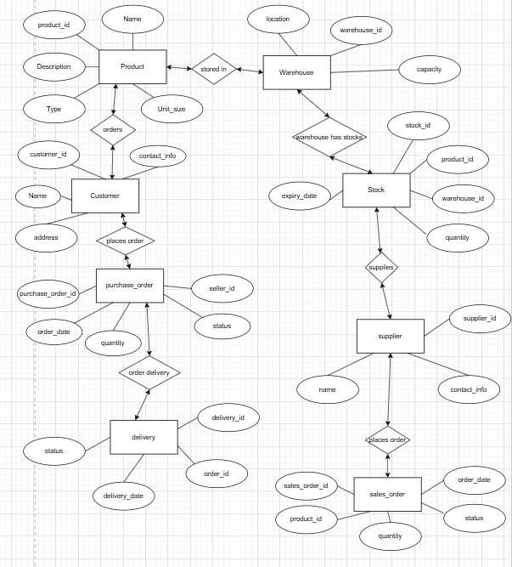

4. User story of shopping from ecommerce.

User Story: 1 | Tasks: User Registration |  | Priority: High
Value statement: As a new user, I want to register using my email or phone number so that I can securely log in to the store.
BV: 100 |  | CP: 5
Acceptance criteria:
- User can register with valid email/phone.
- Verification link/OTP must be sent.
- Registration is confirmed upon successful validation.

User Story: 2 | Tasks: User Login |  | Priority: High
Value statement: As a registered user, I want to log in using my credentials so that I can access my account.
BV: 100 |  | CP: 5
Acceptance criteria:
- Valid credentials allow access.
- Invalid login shows error message.
- Session should be created after login.

User Story: 3 | Tasks: Product Browsing |  | Priority: High
Value statement: As a shopper, I want to browse products by category so that I can easily find what I need.
BV: 200 |  | CP: 8
Acceptance criteria:
- Products are displayed by selected category.
- Page numbers and filters available.
- Product images and prices are visible.

User Story: 4 | Tasks: Product Search |  | Priority: High
Value statement: As a user, I want to search for products by name or keyword so that I can quickly find specific items.
BV: 200 |  | CP: 8
Acceptance criteria:
- Search returns relevant results.
- Handles spelling variations

User Story: 5 | Tasks: Product Details View |  | Priority: High
Value statement: As a user, I want to see detailed product information so that I can make informed decisions.
BV: 100 |  | CP: 6
Acceptance criteria:
- Shows product images, price, specs, reviews.
- “Add to Cart” button visible.

User Story: 6 | Tasks: Add to Cart |  | Priority: High
Value statement: As a user, I want to add products to my cart so that I can purchase them later.
BV: 100 |  | CP: 7
Acceptance criteria:
- Product added successfully.
- Cart updates instantly.

User Story: 7 | Tasks: Update or Remove Cart Items |  | Priority: High
Value statement: As a user, I want to modify or remove items in my cart so that I can control my purchase list.
BV: 500 |  | CP: 10
Acceptance criteria:
- Quantities can be changed.
- Items can be deleted.
- Total cost updates correctly.

User Story: 8 | Tasks: Apply Discount Code |  | Priority: Medium
Value statement: As a user, I want to apply coupon code to my order so that I can avail discounts.
BV: 50 |  | CP: 4
Acceptance criteria:
- Valid coupon reduces total amount.
- Invalid code shows error.

User Story: 9 | Tasks: Checkout |  | Priority: High
Value statement: As a user, I want to check out my cart items so that I can make a purchase.
BV: 500 |  | CP: 12
Acceptance criteria:
- Checkout collects address and payment.
- Order confirmation shown after success.

User Story: 10 | Tasks: Multiple Payment Options |  | Priority: High
Value statement: As a buyer, I want to choose from multiple payment methods so that I can pay conveniently.
BV: 200 |  | CP: 8
Acceptance criteria:
- Support credit card, UPI, COD.
- Show success/failure messages.

User Story: 11 | Tasks: Order Confirmation |  | Priority: High
Value statement: As a user, I want to receive order confirmation so that I know my order was successful.
BV: 100 |  | CP: 7
Acceptance criteria:
- Confirmation screen + email/SMS notification.

User Story: 12 | Tasks: Order Tracking |  | Priority: High
Value statement: As a user, I want to track my orders so that I know the delivery status.
BV: 100 |  | CP: 6
Acceptance criteria:
- Order tracking page displays status and estimated delivery.

User Story: 13 | Tasks: Product Reviews |  | Priority: Medium
Value statement: As a user, I want to rate and review products so that others can see my feedback.
BV: 200 |  | CP: 9
Acceptance criteria:
- Users can post, edit, and delete reviews.

User Story: 14 | Tasks: Wishlist Management |  | Priority: Medium
Value statement: As a user, I want to save products to my wishlist so that I can purchase them later.
BV: 200 |  | CP: 9
Acceptance criteria:
- User can add/remove wishlist items.

User Story: 15 | Tasks: Profile Management |  | Priority: Medium
Value statement: As a user, I want to manage my profile details so that I can keep my account updated.
BV: 50 |  | CP: 5
Acceptance criteria:
- Users can edit name, address, password.

User Story: 16 | Tasks: Notification Alerts |  | Priority: Medium
Value statement: As a user, I want to receive notifications for order updates so that I stay informed.
BV: 50 |  | CP: 4
Acceptance criteria:
- Notifications for shipping, cancellation, delivery.

User Story: 17 | Tasks: Admin Product Management |  | Priority: High
Value statement: As an admin, I want to add, update, or remove products so that the catalog remains current.
BV: 200 |  | CP: 10
Acceptance criteria:
- Admin can CRUD products.

User Story: 18 | Tasks: Inventory Management |  | Priority: High
Value statement: As an admin, I want to monitor stock levels so that I can avoid out-of-stock issues.
BV: 100 |  | CP: 6
Acceptance criteria:
- Low stock alerts generated.
- Inventory auto-decreases after sale.

User Story: 19 | Tasks: Return/Refund Process |  | Priority: Medium
Value statement: As a customer, I want to request returns or refunds so that I can resolve order issues.
BV: 50 |  | CP: 5
Acceptance criteria:
- Returns allowed within 7 days.
- Refund confirmation notification sent.

User Story: 20 | Tasks: Customer Support Chat |  | Priority: Medium
Value statement: As a user, I want to chat with support for order help so that my queries are quickly resolved.
BV: 500 |  | CP: 12
Acceptance criteria:
- Real-time chat between user and support agent.
- Chat history saved in ticket system.

