Document 6- Please prepare a use case diagram, activity diagram and a use case specification document.
Use case Diagram
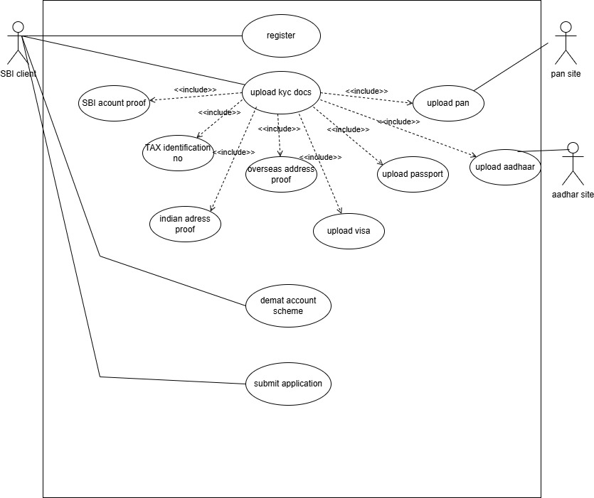

ACTIVITY DIAGRAM
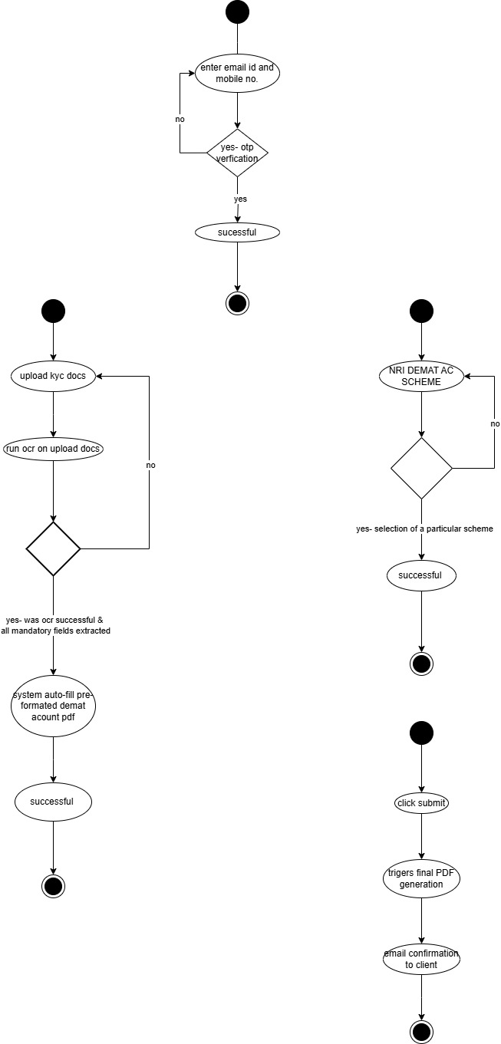
Use Case Specific Document
Use case name | Client registration
Use case description | Verification of email-id and mobile no. via OTP
Actors | NRI Clients
Pre-condition | - Active internet,  - availability of valid email id, and mobile no.
Post-condition | Mobile no and email id are verified successfully
Basic flow | - Clients enter email id and mobile no.  - System sends OTP to both email id and phone no.  - Client inputs receive OTP  - System verifies OTP  - If OTP is valid within the time, verification successful
Alternate flow | Invalid email id and mobile no.- Show error and prompt re-entry
Exceptional flow | OTP not received- option to resend OTP  System failure in sending OTP- Display error message and suggest retry later
Assumptions | SMS and email APIs are responsive
Constraints | OTP valid for 10 mins
Dependencies | SMS and email services  OTP verification logic
Input and output | Input- email id and mobile no  Output- verified status or error flag
Business rule | OTP is valid only for 10 mins for the time it sent
MIS | - Error codes should be user-friendly  - OTP format should be numeric (6 digits)

Use case name | Upload KYC documents
Use case description | Allow SBI NRI clients to upload documents for digital demat account processing. Each document will be scanned using OCR and verified through respective system
Actors | NRI clients
Pre-condition | - Clients must be registered  - Clients should possess all the valid KYC docs
Post-condition | - Document is uploaded successfully, extracted and verified
Basic flow | - Client selects document type to upload  - Upload images/PDF of the selected document  - System runs OCR to extract data  - PAN and Aadhaar will be validated through NSDL AND UIDAI respectively.  - Extracted data auto fills the mandatory field in the system  - Extracted data simultaneously filled the pre-defined DEMAT form in the backend  - Success message shown with each document status.
Alternate flow | - Client uploads incorrect documents or unreadable document- system throws ORC error  - API call falls( NASDL/UIDAI)  - System prompts retry or fallback to manual fill  - Optional manual data entry if OCR fails.
Exceptional flow | - No document selected  - Unsupported flow  - Upload timeout or system crash
Assumptions | - Uploaded images are clear, valid and within the size limit  - System has integration with OCR and relevant APIs
Constraints | - Max file size – 2MB  - Only jpg.phg,pdf formats  - Each document must be uploaded
Dependencies | - OCR engines  - APIs- NSDL/UIDAI  - SMS service for OTP
Input and output | INPUT- Upload kyc docs  Output-verified and uploaded doc confirmation
Business rule | - Each client must all the mentioned document  - OCR extracted data must be 90% higher or higher for auto-fill to be accepted
MIS | - Uploaded documents are stored in encrypted format.  - Document status and verification logs are shown to the client on dashboard.

Use case name | NRI demat account scheme selection
Use case description | Scheme1- NRO wealth demat account  Scheme2- NRO non wealth demat account.  Every scheme will have the charges defined
Actors | NRI clients
Pre-condition | Client must have an SBI NRO account  Must have completed prior KYC submission
Post-condition | Successful selection of Scheme by client  Summary of selected scheme is displayed to client
Basic flow | - Client select scheme  - System should display the scheme charges  - System confirms the selected scheme and records
Alternate flow | - Client does not make a selection and times run out- system redirects
Exceptional flow | System fails to fetch scheme data- show error msg
Assumptions | - Client aware about the difference between the scheme  - Scheme and charges are preconfigured by admin
Constraints | - Only one scheme can be selected per client  - Change of scheme after selection requires manual intervention
Dependencies | SBI Core Banking system for verifying NRO wealth/non wealth account
Input and output | Input: Client login, scheme selection  Output: Confirmation message, selected scheme, charges
Business rule | - Only NRO account holders can select schemes  - Selection must be saved with timestamp.  - Each scheme must show T&C before confirmation
MIS | - Reports on total scheme selections  - Data available for business & audit teams

Use case name | Submit
Use case description | This use case allows the client to submit all the filled information and uploaded KYC documents as a complete form for processing. Upon submission, a unique form number is generated and sent to the client’s registered email ID.
Actors | NRI clients
Pre-condition | • All mandatory KYC documents have been uploaded  • Scheme selection is completed  • Valid email ID is verified
Post-condition | Form submission is successful  • Unique Form Number is generated  • Confirmation sent to client’s email  • Form enters the backend processing workflow
Basic flow | 1.Client clicks on “Submit”  2. System validates all inputs  3. On successful validation, a unique form number is generated  4. Confirmation screen is shown to the client  5. Email with submitted form and form number is sent to the client
Alternate flow | • If form validation fails, system highlights the missing/incomplete fields  • Client can correct and resubmit
Exceptional flow | • Server timeout during submission → show error message and allow retry  • Email server down → form submitted but email fails; system retries in background or alerts admin
Assumptions | • All prior steps (document upload, verification, and selection) are completed  • Client is ready to finalize submission
Constraints | • No further edits allowed after submission unless re-opened by admin  • Submission window may be time-limited
Dependencies | - Email service for sending confirmation  - Backend storage/database for saving the form and generating form ID
Input and output | Input: Trigger from client clicking Submit  Output: Form ID, confirmation email, submitted form record
Business rule | - Submission only allowed after all mandatory fields are validated  - Form ID must be unique and timestamped  - PDF form is generated for archival and audit
MIS | - Number of submissions per day/week  - Submission success/failure rate  - Time from registration to submission  - Audit reports with form status

Document 7- Screens and Pages
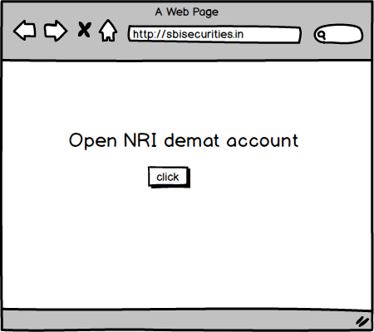
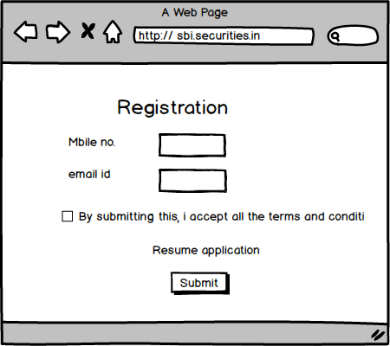
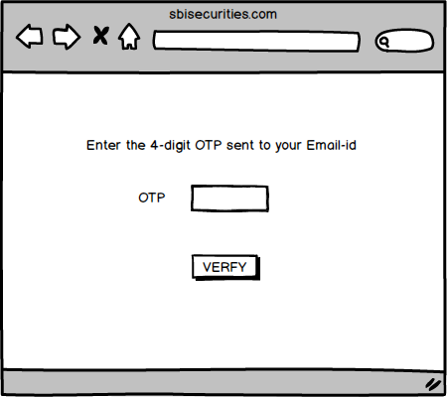
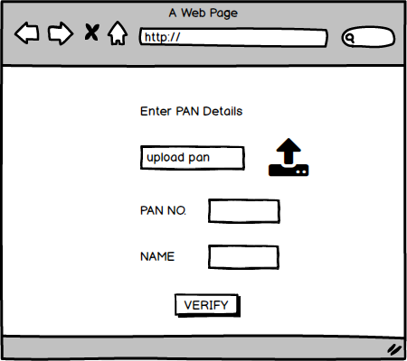
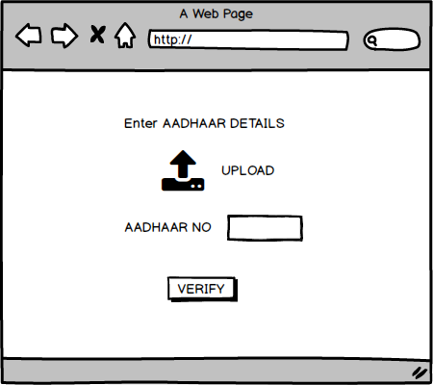
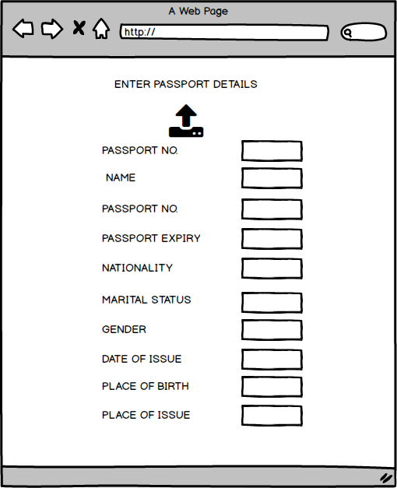
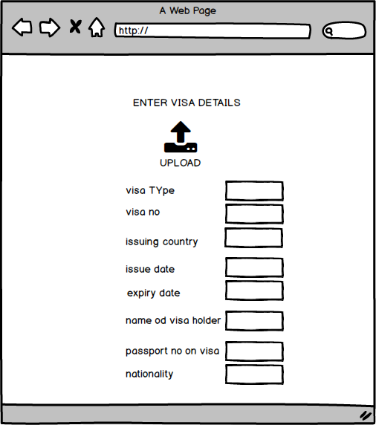
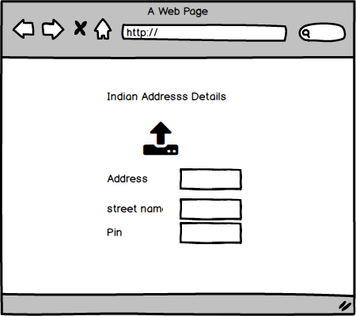
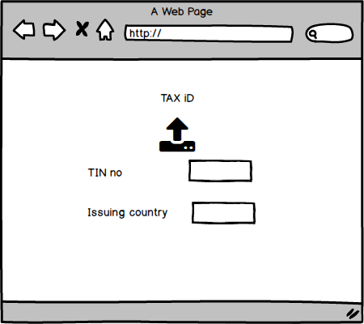
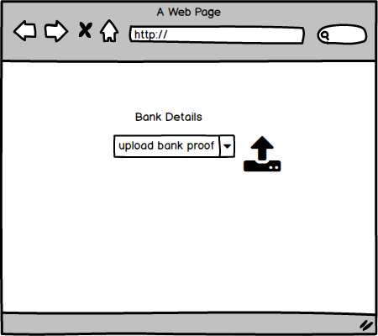
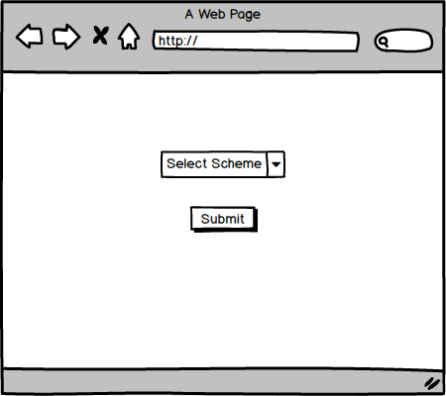
Document 8- Tools-Visio and Axure
Write a paragraph on your experience using Visio and Axure for the project.
During the project, I utilized Draw.io extensively for creating structured diagrams such as use case diagrams, activity diagrams, and process flows to visually represent the system’s behavior and the end-to-end KYC journey. DRAW.io helped in simplifying complex workflows and was particularly useful in stakeholder discussions, as the visuals made technical flows easier to understand. Additionally, I used Axure RP for designing low-fidelity wireframes and interactive prototypes of the screens involved in the NRI digital KYC platform. Axure allowed me to map out user interactions, validate screen layouts, and receive early feedback from stakeholders and testers before development began. These tools significantly improved communication, minimized rework, and ensured better alignment between business expectations and the technical team’s execution.
Document 9- BA experience
My experience as BA in following phases:
1. Requirement gathering:
● To gather requirements, we used MOSCOW technique.
● Client is not available for some period of time during this phase. So as a BA i need to source out point of contacts from his side and get the information ASAP.
● I validate the requirements using FURPS technique
● There are many requirements which are duplicated or repeated. We need to remove them immediately.
● Prototyping is used to give more specific requirements
2. Requirement Analysis:
● We need to draw UML diagrams to visually describe the requirements.
● Activity diagrams also used to describe the process flow
● Communicate the diagrams to team. Some team members might not agree with them and might make changes. As a BA we need to consider the points and make modifications
● Prepare BRS and SRS.
3. Design:
● From the use case diagrams, we prepare test cases
● Communicate with client on design and solution documents
● Write negative test cases as well along with positive test cases.
● Do not miss a single test case. It might have huge impact on project development in later stages
● Prepare test data for testing
● Update RTM. This is just as we need to make sure that all the requirements are met

4. Development:
● Organized JAD sessions
● Clarifying queries of tech team during coding
● There might be some team members who doesn't agree with the concept or who doesn’t cooperate during JAD sessions. As a BA i handle the situation gently and had one on one discussion with them. Explained how their actions are going to affect the project. Setup healthy environment within the team. ● Referred diagrams to code the Unit
● Conduct regular meetings with technical team and client which is challenging. Some team members might not be available for the meeting. Recording the session and providing that to missed one and having one to one discussion later with that missed person is all i need to do

5. Testing:
● Prepare test cases from use cases
● Perform high level testing
● Test data is requested by BA from client
● Updated RTM
● Take signoff from client
● Prepare client for UAT

6. Deployment:
● Forwarded RTM to client which should be attached to project closure document
● Coordinates to complete and share end user manuals
● Plans and organizes training sessions
● Make sure all the candidates attend the meeting

