Q1. What is the difference between Brainstorming and JAD Sessions?
Brainstorming
- It can be done either individually or in groups
- Ideas collected are then reviewed analysed and if relevant included within the system requirements
- Ideas can come from what users/ stakeholders have seen or experienced elsewhere.
- Most effective with group of 8-12 people
- Should be performed in relaxed environment
- It is used to identify all the possible solutions to the problem
- Steps involved are
  - Prepare for Brainstorming
  - Conduct Brainstorming
  - Wrap up Brainstorming
Joint Application Development (JAD)
- It is an extended and facilitated workshop
- It involves collaboration between stakeholders and system analysts to identify requirements
- Efforts required should be more concentrated and focused
- It allows simultaneous gathering and consolidating of requirements
- High quality requirements are produced in shorter period of time
- Dependencies can be resolved immediately with the help of facilitator
- Significant planning required
- Steps involved in JAD are
  - Define session
  - Research Product
  - Prepare
Q 2. Why Document Analysis is one of the compulsory technique we use in a Project? Justify
Document analysis is one of the compulsory elicitation techniques for any project because evaluating the documentation of a present system can assist when making AS-IS process documents and also when performing the GAP analysis for scoping of the migration projects. It could be a lot of information and easy to transfer to a new system requirements document.
Q3. In Which Context we will use Reverse Engineering?
Reverse engineering is elicitation technique that can extract the implemented requirements from the software code. It is used in situations where the software of an existing system has little or outdated documentation and it is necessary to understand what the system actually does.
It is of two types
- Black Box Reverse Engineering: System is studied without examining internal structure
- White Box Reverse Engineering: The inner workings of the system are studied
Q4. What is the difference between Brainstorming and Focus Groups?
Brainstorming | Focus Group
Main purpose is to generate all possible ideas or solution to a problem | Main purpose is to improve existing ideas with the expertise of the participants on the respective topic
A Facilitator is there to guide the session | A Moderator is there to guide the session
Session can be conducted either in a group or individually as well | Session is conducted only in an interactive group environment
Participants can be from different departments | Participants should be from same department

Q5. Observation Technique – Explain both Active and Passive approaches
Observation is an elicitation technique used to gather information or requirements from existing processes, inputs and outputs. This technique is useful when user is not able to explain what they do or their requirements.
There are two types of observation technique:
- Passive Approach: Also known as invisible approach, here BA observes the user throughout the business routine but do not ask questions in between. BA writes notes and wait until the entire process is completed before asking questions.
- Active Approach: Also known as visible approach, here BA while observing the user throughout the business routine can conversate with the user while taking notes and ask questions in between also.
Q6. How do you conduct the Requirements Workshop?
Requirements Workshop is a structured way of capturing requirements.
Steps to conduct requirements workshop are:
- Prepare for requirements workshop:
  - Clarify the stakeholder’s needs and the purpose of the workshop
  - Identify critical stakeholders who should participate in the workshop
  - Define the agenda of the workshop
  - Communicate the attendees in advance and seek acknowledgement
  - Determine what means will be used to document the output of the workshop
  - Schedule the workshop
  - Finalize the venue
  - Send materials in advance to the attendees to prepare which will increase the productivity of the workshop
  - Conduct pre-workshop interviews with the attendees
- Conduct/Execute the workshop:
  - Explain the agenda of the workshop
  - Explain project objective and scope
  - Run the workshop
  - Make sure there are no conflicts
  - Ensure the discussions are on the direction towards the agenda
  - Capture the requirements, open issues and action items
- Wrap-up workshop
  - Create minutes of meeting (MOM), it should contain the list of attendees. Discussed items, attach documents, action items, open issues, follow up meeting
  - Send the MOM to the workshop attendees and the sponsor
Q7. In which context, Interview Technique can be conducted by a BA? How may approaches are there in conducting Interviews? (Structured – Unstructured) Explain them. Explain the difference between Open Ended Questions and Closed ended Questions
Interview is an important elicitation technique to elicit information for a stakeholder or a group of stakeholders in an informal or formal setting by talking to the interviewee and asking relevant questions and documenting the responses.
This technique is important because it helps you understand the expectations and goals of the stakeholders.
There are two type of interview techniques:
- Structured Interview: In this the interviewer will be asking specific questions in order to gather the requirements from the interviewee. In this the questions are predetermined and prepared by the interviewer in advance.
- Unstructured Interview: It refers to an interview wherein questions asked by the interviewer are not set in advance.
Open Ended Questions: User or stakeholder can answer in their own words
Close Ended Questions: User or stakeholder needs to choose from a predefined set of answers. Questions can be multiple choice or can be ranked from not important to very important
Q8. Questionnaire Technique – Where we will use? Give one example
Questionnaire technique also known as survey can be used for obtaining limited system requirement details from the users or stakeholders having a minor input or geographically scattered. Design of questionnaire and types of question are important and care should be taken because it can influence the answers.
Two types of questions can be asked
Open ended: User or stakeholder can answer in their own words
Close Ended: User or stakeholder needs to choose from a predefined set of answers. Questions can be multiple choice or can be ranked from not important to very important
Example of open-ended question:
What are the main reasons you chose our product?
What are the payment modes you want in your application?
Example of close-ended question:
Would you recommend net banking as a payment option?
Would you recommend OTP for logging in the application?
Q9. How to Sort the Requirements – Where we will use? Give one example
Sorting requirements is the process in which scattered requirements are put together, redundancies are removed and the interrelated requirements are linked.
Process of sorting requirements:
- Define the stakeholder needs
- Identify business needs and divide them into functional and non-functional requirements
- Create a group of similar requirements
- Create supporting artefacts
Example:
Suppose I have following requests to be processed in a bank
- 1 savings account opening form
- 1 current account opening form
- 5 RTGS requests
- 2 NEFT requests
- 2 FD booking requests
- 5 RD booking requests
Here both savings account current account opening documents will be put together as they belong to the account opening depart, similarly NEFT and RTGS request will be put together as these requests belong to transfer of funds and FD and RD booking requests will be put together as these belongs to time deposit booking.
Q10. Prioritise the Requirements – –Where we will use? Give one example
Prioritising requirements is the technique of queuing requirements for the development process on the basis of different factors such as importance, risk, cost, benefit, time and strategy.
There are various techniques for prioritising requirements:
MoSCoW technique, 100 Dollars Test, Top 10 requirements.
Most commonly used technique is MoSCoW:
M- Must have this requirement to meet the business needs.
S- Should have this requirement if possible, but the project success does not depend on it.
C- Could have this requirement if it does not affect anything else in the project.
W- Would have this requirement later, but it won’t be delivered this time.
Example:
Let’s consider a web application for attendance marking wherein the user can do the following
- User can signup
- User can login
- User can reset password
- User can mark attendance
- User can download mobile application
- User can change background theme of the home page
Using MoSCoW technique we can prioritize the requirements as follows:
- User must signup
- User must login
- User must reset password
- User should mark attendance
- User could download the mobile application
- User would change the background theme of the home page
Q11. Weekly status reporting – How we will drive?
Weekly status reporting is the process of reviewing the work that the team has done towards the project completion in comparison to the milestone set. It covers the work that has been completed, work that is still in progress and the plans for the upcoming week.
Weekly status report should contain
- Milestone decided for the week
- Work completed during the week
- Work in progress
- Impediments or challenge areas
- Learning for the upcoming weeks
Steps to drive
1. Gather Inputs | Collect updates from developers, testers, product owners, SMEs, etc.
2. Analyze Data | Identify trends, blockers, risks, and alignment with project plan
3. Prepare Report | Fill in a clear, concise status format (email, slide, or dashboard)
4. Share With Stakeholders | Send weekly (typically Friday or Monday AM) to PM, Sponsor, etc.
5. Review in Weekly Meeting | Present and walk through the report, take notes, update actions

Q12. Meeting Minutes Document – prepare one Sample
Meeting minutes document is used to capture the key data or discussion point of the meeting.
Meeting Minutes Document Sample:
Date & Time of Meeting
10/07/2025
11:00 AM

Name of the Participants
• Rohan Mehta – Project Manager
• Neha Kulkarni – IT Lead
• Arvind Rao – QA Lead
• Priya Desai – Business Analyst

Agenda/Topic of the Meeting
• Review of project progress
• Feedback on UI designs
• Finalizing Sprint 2 scope

Agenda Items and Topics Discussed
• Sprint 1 successfully completed with minor delays in testing
• UI design approved with a few layout changes requested
• Sprint 2 to include user management and email notifications

Action Items
• Update Reports tab UI design – Assigned to UI/UX Team – Due by 11/07/2025
• Follow up with external vendor for API documentation – Assigned to Priya Desai – Due by 12/07/2025
• Prepare Sprint 2 kick-off plan – Assigned to Project Manager – Due by 12/07/2025

Open Issues
• Pending API documentation from vendor
• Need confirmation on UAT environment readiness
• Awaiting sign-off on updated business rules

Follow-Up Meeting
17/07/2025

Attach Documents

Q13. Change Tracker – Document - – prepare one Sample
A Change Tracker is a structured document or log used to track changes in business requirements, project scope, deliverables, or any related documentation. It captures the details of the change, the reason behind it, who requested and approved it, and its impact on the project.
Change ID | Date | Change Description | Requested By | Reason for Change | Impact Analysis | Approved By | Status
CT-001 | 01-07-2025 | Add mobile responsiveness to website | Client (Mr. Patel) | End users use mobile heavily | Minor delay in timeline; No cost impact | Product Owner | Approved
CT-002 | 02-07-2025 | Replace payment gateway API | Dev Lead | Current API deprecated | Testing required, 2-day delay | BA & PM | Approved
CT-003 | 04-07-2025 | Add OTP for login process | Security Team | Compliance requirement | Medium dev effort, extra test cases | Tech Lead | In Progress
CT-004 | 06-07-2025 | Remove “Contact Us” form | Marketing | Collected data unused | Minimal impact | Project Manager | Approved
CT-005 | 08-07-2025 | Update user roles and permissions | BA (self) | Align with updated business rules | Needs UAT update | Business Owner | Pending

Q14. Difference between Traditional Development Model and Agile Development Models
Aspect | Traditional Development Model (e.g., Waterfall) | Agile Development Model
Approach | Linear and sequential | Iterative and incremental
Phases | Phases like requirements, design, development, testing happen once and in order | Phases are repeated in short cycles (sprints)
Flexibility | Less flexible — changes are hard and costly once the project has started | Highly flexible — changes can be made anytime during the project
Customer Involvement | Limited customer involvement after requirement phase | Continuous involvement of customer throughout the project
Delivery | Entire product delivered at the end | Working software delivered at the end of each sprint (2–4 weeks)
Documentation | Heavy documentation required | Light documentation, focus on working software
Testing | Testing is done only after development is complete | Testing is done in every iteration (continuous testing)
Risk Handling | High risk — errors found late in the process | Low risk — issues are identified and fixed early in each sprint

Q15. Explain Brainstorming Technique – Where to use?
Brainstorming is a group creativity technique used to generate a large number of ideas or solutions for a specific problem, challenge, or requirement in a short amount of time.
It encourages free thinking, open sharing, and collaboration, often without immediate judgment or criticism of ideas.

Where to Use Brainstorming Technique:
Use Case |  |  |  | Purpose
Requirement Gathering |  |  |  | To explore various business needs and user expectations
Problem Solving |  |  |  | To identify possible solutions for technical or business issues
Process Improvement |  |  |  | To find ways to improve efficiency or reduce errors
Product/Feature Design |  |  |  | To generate creative ideas for new features or enhancements
Risk Identification |  |  |  | To uncover potential risks in a project or process

Brainstorming Technique
- It is used to identify all the possible solutions to the problem
- It can be done either individually or in groups
- Ideas collected are then reviewed analysed and if relevant included within the system requirements
- Ideas can come from what users/ stakeholders have seen or experienced elsewhere.
- Most effective with group of 8-12 people
- Should be performed in relaxed environment
Q16. What reports Accounts Departments will generate (minimum 5 reports)
Following are the reports generated by the accounts department:
1. Loan Disbursement Report
This report shows all loans that have been approved and disbursed to employees. It includes details like employee name, ID, loan amount, disbursement date, and department.
Purpose: To monitor total funds disbursed and ensure accurate record-keeping.
2. Loan Repayment Report
This report tracks the monthly EMI (Equated Monthly Installment) deductions from employee salaries. It lists how much has been repaid and how much is pending.
Purpose: To ensure timely loan recovery and detect missed or delayed payments.
3. Outstanding Loans Report
This report displays the list of employees who have ongoing loans and their outstanding balances. It includes details like total loan amount, amount repaid, and remaining balance.
Purpose: Helps the company manage financial liabilities and forecast future deductions.
4. Loan Approval & Rejection Summary
This report summarizes the number of loan applications received, approved, and rejected over a specific period. It also includes reasons for rejection.
Purpose: Useful for analysing trends, improving loan policies, and understanding common rejection causes.
5. Interest Income Report
This report calculates the total interest earned from employee loans (if interest is applicable). It includes the interest per employee and the total income generated.
Purpose: Important for financial reporting, tax filing, and audit purposes.
Q17. What is the structure of the message/mail communicated from the HR department to the employee in case the Loan is rejected?

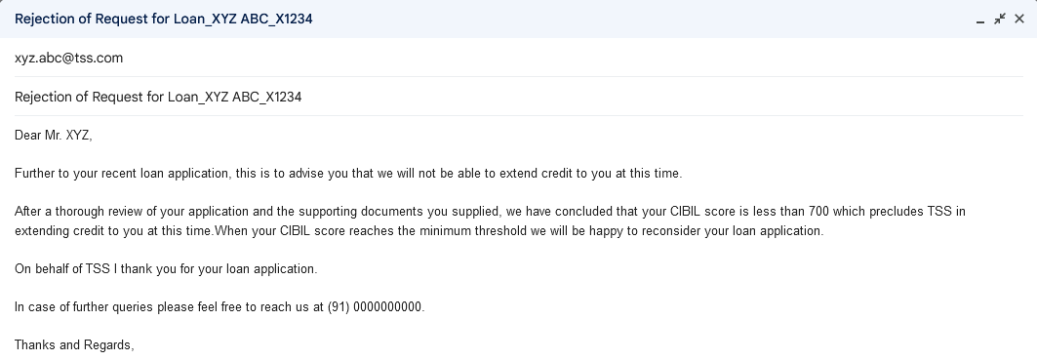
Q18. What is the structure of the message/mail communicated from the HR department to the employee in case the Loan is approved?

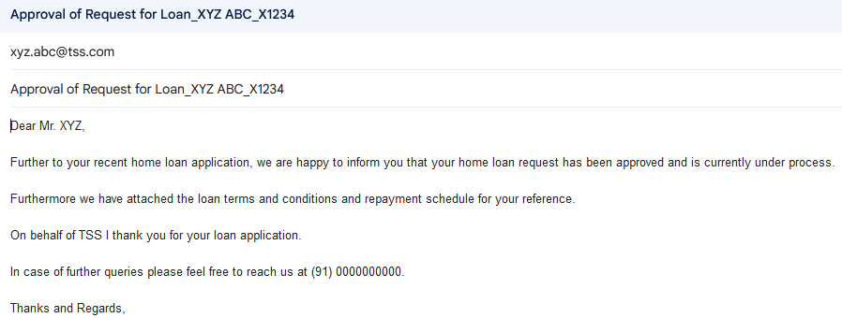

Q19. Design a sample report on the Loans applications Received by the accounts department

Employee ID | Employee Name | Requested Loan Type | Requested Loan Amount (Lakh) | Requested Tenor (Years) | Status
R2341 | Rajat Sharma | Home Loan | 35 | 15 | Document upload pending
S1261 | Sonakshi Jain | Auto loan | 15 | 7 | Quotation pending
S5271 | Sunidhi Singh | Personal Loan | 7 | 5 | Approved
A9812 | Amit Rastogi | Two-Wheeler Loan | 1 | 3 | Approved

Q20. Which reporting Tools we will use for generating reports.
Mostly we use two reporting tools for generating reports
- Power BI
- Tableau
Power BI
- It is a business intelligence tool that allows you to connect to various data sources, visualize the data in reports and dashboards to take the right decisions in the organizations.
- There are three types
  - Power BI Desktop
  - Power BI Service
  - Power BI Mobile Apps
Tableau
- It is a business intelligence and data visualization tool to get insights from data, find hidden trends and make business decisions.
- It helps in simplifying raw data in a very easily understandable format.
- It helps to create the data that is understood by both professional users and non-technical users.
- Data analysis is very fast with tableau tool and visualizations created are in the form of dashboards and worksheets.

