Question1. Identify minimum 20 functional requirements.
Example: Functional requirement: When an order is fulfilled, the local printer shall print a packing slip.
Non-Functional Requirement: Packing slips shall be printed on both sides of 4”x 6” white paper, the standard size for packing slips used by local printers.
Answer: Functional Requirements (FR): These are the features and functions that a system must perform. They define what the system should do.
"What should the application do?"
Non-Functional Requirements (NFR)
Definition:
These define how the system should behave. They are quality attributes and constraints of the system, like performance, usability, security, etc.
"How should the system behave?"
Req ID | Req Name | Req Description | Priority
FR0001 | Farmer Registration | Farmers should be able to register using email and password | 10
FR0002 | Farmer Login | Registered farmers must be able to log in securely | 10
FR0003 | Manufacturer Registration | Manufacturers must be able to register and log in | 9
FR0004 | Product Catalog View | Farmers should view a categorized list of products | 9
FR0005 | Product Search | Farmers should search products by name, category, or brand | 10
FR0006 | Add to Cart | Farmers should add products to their shopping cart | 9
FR0007 | Add to Buy Later | Farmers should add products to a "Buy Later" list | 8
FR0008 | Product Upload by Manufacturers | Manufacturers can upload product details (image, description, price, quantity) | 9
FR0009 | Product Edit/Delete | Manufacturers can edit or delete uploaded products | 7
FR0010 | Place Order | Farmers can place an order for selected products | 10
FR0011 | Payment Gateway Integration | System should accept COD, UPI, and Credit/Debit card payments | 10
FR0012 | Email Confirmation | Email must be sent on successful order placement | 8
FR0013 | Delivery Tracking | Farmers can track the order status from dispatch to delivery | 8
FR0014 | Password Reset | Users can reset password through email verification | 7
FR0015 | User Profile Management | Farmers/Manufacturers can update profile details | 7
FR0016 | Order History | Farmers can view past orders and invoices | 7
FR0017 | Admin Product Approval | Admin must approve manufacturer products before displaying | 8
FR0018 | Product Rating & Feedback | Farmers can rate and review products | 6
FR0019 | Notification System | Users get notifications for order updates and offers | 6
FR0020 | Multi-language Support | Application must support multiple regional languages | 5

Question 2. Make wireframes and prototypes.

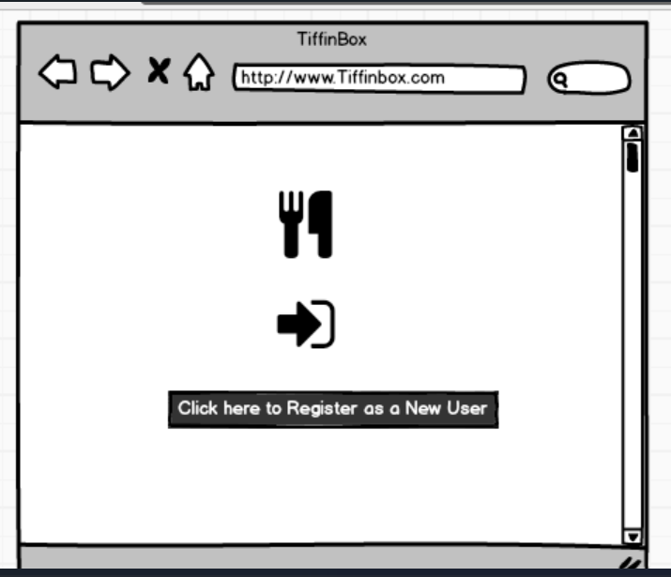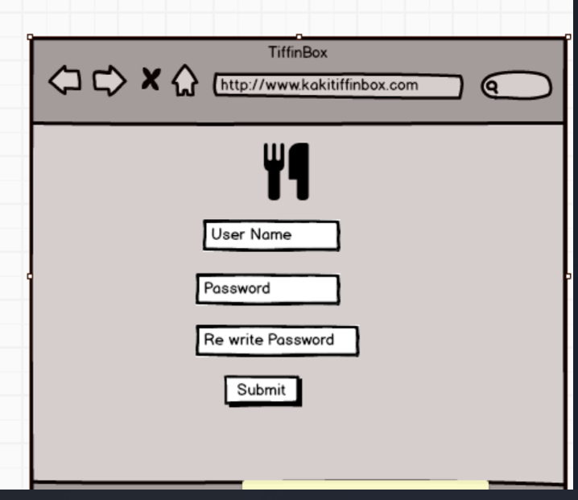
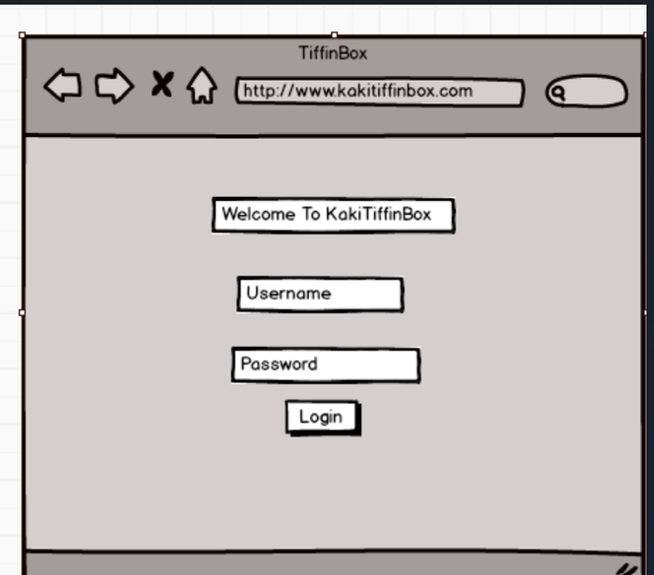
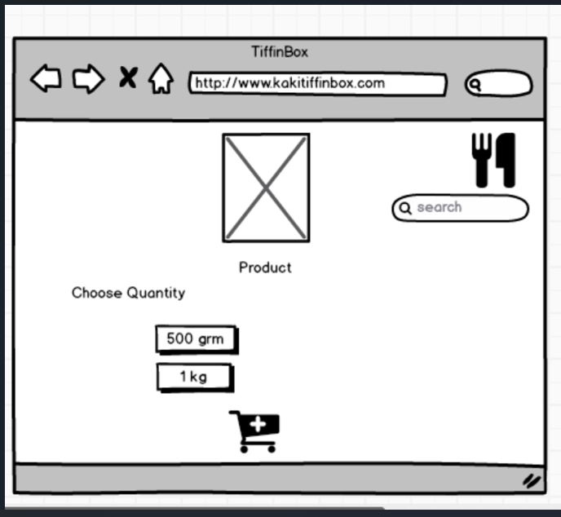
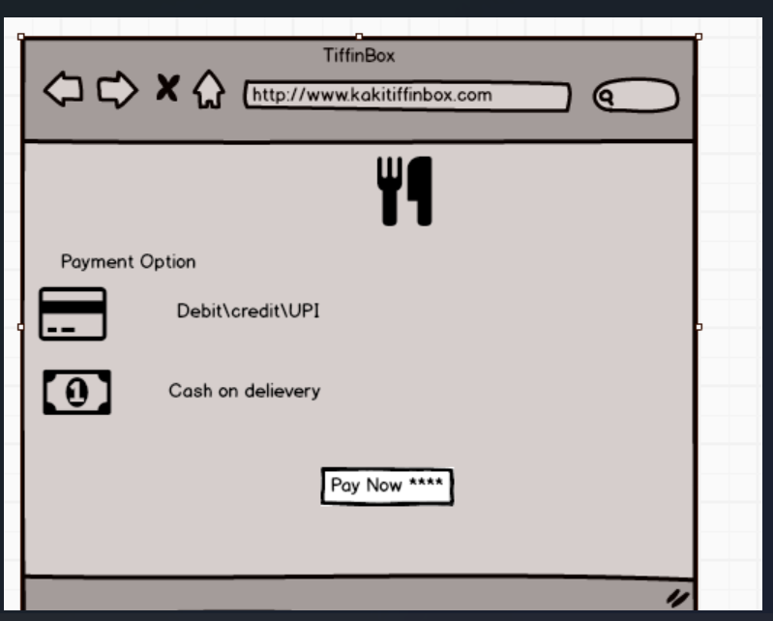
Question 3. Make a note of the Tools which you are using for the above concepts.
Answer: As a Business Analyst, selecting the right tools is essential for clear communication, proper documentation, and effective collaboration with stakeholders and the development team. Below is a list of tools used for completing different parts of this project.
Wireframe and Prototype Design Tools

- Balsamiq- Used for creating low-fidelity wireframes for screens like login, home, product catalog, etc. It's easy to use and helps quickly visualize ideas.
- Microsoft Visio- Used to design UML diagrams such as Use Case Diagrams and Activity Diagrams, which help in visualizing system interactions and process flows.
- AxureRP- It is a powerful prototyping and wireframing tool that enables you to create interactive and dynamic prototypes. It offers advanced features for creating complex interactions and user flows.

Question 4. A business analyst’s key responsibilities are to keep track of the requirements and make sure that no requirement is missed. Mr. Henry and peter have approached you regarding the current status of the project. How will you tackle this situation?
Answer: Requirements Traceability Matrix (RTM) is a document used in project management and software development to ensure that all requirements are accounted for and properly addressed.
Req ID | Req Name | Req Description | Design | Code | Unit Testing | System Testing | Component Testing | SIT | UAT
FR0001 | Farmer Registration | Farmers should be able to register with the application | Complete | Complete | Complete | Complete | Complete | Complete | Complete
FR0002 | Farmer Search for Products | Farmers should be able to search for available products in fertilizers, seeds, pesticides | Complete | Complete | Complete | Complete | Complete | Complete | Complete
FR0003 | Product Catalog Display | Products should be listed under proper categories for easy browsing | Complete | Complete | Complete | Complete | Complete | Complete | Complete
FR0004 | Login/Signup | Users should be able to log in/sign up using email and password | Complete | Complete | Complete | Complete | Complete | Complete | Complete
FR0005 | Add to Buy Later List | Users can add products to a wishlist for future purchases | Complete | Complete | Complete | Complete | Complete | Complete | Complete
FR0006 | Place Order | Users can place an order for selected products | Complete | Complete | Complete | Complete | Complete | Complete | Complete
FR0007 | Payment Gateway Integration | System must allow COD, UPI, Credit/Debit Card options | Complete | Complete | Complete | Complete | Complete | Complete | Complete
FR0008 | Order Confirmation Email | System sends confirmation email after order placement | Complete | Complete | Complete | Complete | Complete | Complete | Complete
FR0009 | Delivery Tracker | Users can track delivery status of their order | Complete | Complete | Complete | Complete | Complete | Complete | Complete
FR0010 | Product Upload (Manufacturer) | Manufacturers can upload products with description and pricing | Complete | Complete | Complete | Complete | Complete | Complete | Complete
NFR0101 | Page Loading Time | Each page must load within 2 seconds | Complete | Complete | Complete | Complete | Complete | Complete | Complete
NFR0102 | WCAG 2.1 Compliance | Application must comply with accessibility standards WCAG 2.1 | Complete | Complete | Complete | Complete | Complete | Complete | Complete

Question 5. Prepare 10 Test Case Documents.
Test Case ID | Test Case Description | Pre-Conditions | Test Steps | Expected Result
TC001 | Farmer Registration with valid data | Registration page is accessible | Enter valid name, email, password and Click "Register" | Farmer account is created successfully and redirected to login page
TC002 | Farmer Registration with existing email | Email already exists in database | Enter existing email and Click "Register" | Error message shown: "Email already registered"
TC003 | Login with valid credentials | User already registered | Enter correct email & password and Click "Login" | Dashboard is displayed after login
TC004 | Login with invalid password | User already registered | Enter correct email & wrong password and Click "Login" | Error message shown: "Invalid credentials"
TC005 | Search for a product (e.g., fertilizer) | User is logged in | Enter product name in search bar and Click "Search" | Product list page shows relevant search results
TC006 | Manufacturer uploads a new product | Manufacturer logged in | Navigate to "Add Product" and Fill form and submit | Product is added and appears in catalog
TC007 | Add product to cart | User logged in, product catalog available | Click "Add to Cart" button next to a product | Product added to cart successfully
TC008 | Payment using UPI | Cart has items | Go to checkout then Select "UPI" , Enter details and Confirm | Payment successful message and order placed
TC009 | View Order Confirmation Email | Order placed | Check registered email | Email received with order ID, summary, and tracking info
TC010 | Track Delivery | Order shipped | Login → Go to "My Orders" → Click "Track Order" | Delivery status and tracking details shown

Question6: After the requirements are thoroughly explained to the entire project team by business analyst, the Database architects have decided to do the database design and also to represent the in-flow and out-flow of data.
Answer: A Database Schema is the blueprint or structure of a database. It includes:
- What tables the database contains
- What columns (fields) are in each table
- The data types of each column (e.g., text, integer, date)
- Relationships between tables (e.g., one-to-many, many-to-many)
- Primary Keys (unique identifiers for records)
- Foreign Keys (to link records between tables)

ER Diagram (Entity-Relationship Diagram)
An ER Diagram is a visual representation of your database schema. It shows:
- Entities (tables like Farmers, Products, Orders)
- Attributes
- Relationships between entities (e.g., one farmer can place many orders)
- 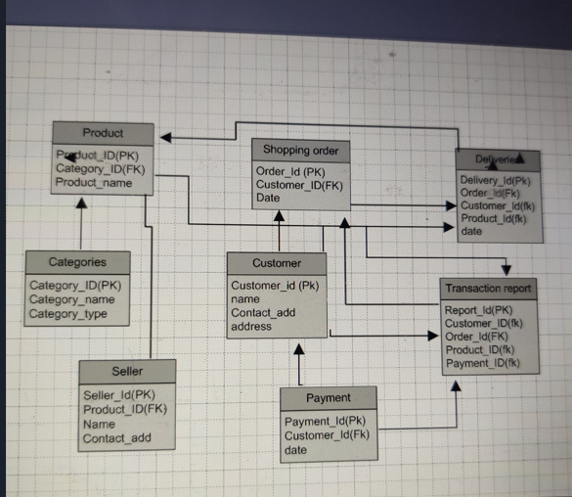

Question 7. What is a data flow diagram? Draw a data flow diagram to represent the in-flow and out-flow of data when a Farmer is placing an order for the product.
Answer: A Data flow diagram is a graphical representation of the flow of data within a system. It visually shows how data moves from one place to another. How it stored and where it ends up.
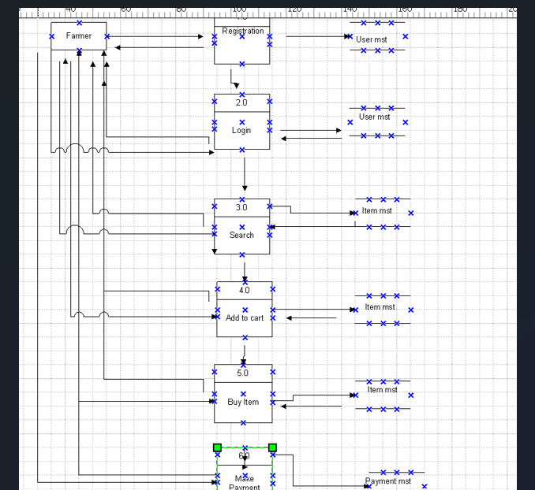

Question: Due to changes in the Government Taxation structure. We wshould change the Tax structure. How do you handle change requests in a project?
Answer: As a Business Analyst, handling a change request is a structured and traceable process to ensure project alignment with new business needs or regulatory changes. Below are the steps I would follow:

1. Change Request Initiation
- The change request (CR) is raised by the concerned stakeholder (in this case, due to government taxation structure change).
- A formal Change Request Form is submitted, which includes:
  - Change description
  - Reason for the change (regulatory compliance)
  - Requested timeline for implementation
  - Impacted modules (Billing, Invoice generation, Order Summary)

2. Impact Analysis
- Conduct an Impact Assessment with the help of:
  - Development Team (to analyze code changes)
  - DB Admin (to check for schema updates)
  - QA Team (to estimate regression testing scope)
  - Project Manager (to assess time and budget impact)
- Document the analysis in terms of:
  - Scope Impact
  - Timeline impact
  - Cost impact
  - Risk analysis

3. Approval Process
- Present the impact analysis to the Change Control Board (CCB) which may include:
  - Mr. Henry (Client)
  - Mr. Pandu (Finance Head)
  - Mr. Dooku (Project Coordinator)
  - Mr. Vandanam (Project Manager)
- After discussion, the CCB either approves, rejects, or defers the change.
- If approved, the CR is logged into the Change Log Register.

4. Update Project Artifacts
- Update relevant project documents:
  - BRD (Business Requirement Document)
  - FRD (Functional Requirement Document)
  - RTM
  - Test Plans and Cases
  - Design and Architecture Diagrams
- Communicate the approved change to all team members.

5. Implementation
- Developers implement changes as per revised specifications.
- QA team performs functional and regression testing.

6. UAT & Deployment
- Present the updated module to the client for User Acceptance Testing (UAT).
- Upon client approval, deploy the change to production.

7. Post-Implementation Review
- Conduct a review meeting to ensure the change was successfully integrated without side effects.
- Document lessons learned for future reference.

Conclusion:
A structured change request process ensures transparency, minimizes risk, and maintains project stability while accommodating necessary changes like tax structure updates.

Question 9. As the project is in process, Ben and Kevin have contacted you. The reason is to inform you that they want the Farmers to sell their crop yields through this application i.e. Farmers should be able to add their crop yields or products and display to general public and should be able to sell them. They also want to introduce Auction system for their Crop yields. As a BA, what will be your response? Is this a change request or an enhancement??
Answer: As a business Analyst my response to Ben and Kevins request would be to classify it as an enhancement rather than a change request. A change request typically involves modification to the existing functionality and requirements, while enhancement introduces new features or capabilities, that were not initially specified.
In this case the Request to allow Farmers to add their Crop yields and display them to the general Public and enable selling through the application an enhancement because it introduces the new functionality that goes beyond the initial scope of the Project.
Additionally, the introduction of the auction system for crop yields adds another layer of the functionality of the application.
To address this enhancement request, I would follow the standard process for handling the Requirements.
  - Requirement gathering- I would meet Ben and Kevin to gather detailed requirements for the next functionality. This would involve understanding the specific- Features they envision, such as the Process for Farmers to add and manage their crop yields, the display of products to the public and the implementation of the auction system.
  - Impact Analysis- I would analyze the impact of these enhancements on the existing project scope, timeline budget and resources. This assessment would help determine the feasibility and potential implications of incorporating the requested features.
  - Stakeholder Analysis- I would Identify and involve relevant stakeholders such as the Project sponsor, development team and other key personnel, to assess their perspectives and gather their input on the potential enhancements.
  - Documentation and communication- I would document the detailed requirements and changes in the Project scope and communicate them to the Project team, stakeholders and any other parties involved. This would ensure everyone is aware of the proposed enhancement and their implications.
  - Evaluation and Prioritization: I would work with the Project team and stakeholders to evaluate the value and priority of the requested enhancement. This evaluation would consider Factors such as the potential benefits, impact on project goals with business objectives and available resources.
  - Planning and Execution- If the enhancements are deemed feasible and approved. I would update the Project plan, schedule and resources accordingly. I would collaborate with the development team and stakeholders to incorporate the same new feature into the application, ensuring proper testing.
- By treating the request as enhancement, the Project can effectively manage the additional requirements and deliver the desired functionality while considering the impact on the ongoing Project.

Question 10. Come up with estimations – How many Manhours required.
Answer: Estimating the number of man-hours required for the enhancements in the Online Agriculture Products Store—such as adding crop yield listings, public visibility, and implementing an auction system—depends on multiple factors. These include the complexity of the features, size and structure of the existing system, technology stack, and team expertise. Based on standard industry practices and experience, we can provide a general estimate broken down by project phase.
The first phase is requirement gathering and analysis, which involves stakeholder meetings, documenting user stories, analyzing system impact, and preparing requirement specifications. This phase is estimated to take around 10 to 20 man-hours. Once the requirements are clear, the next phase is design and architecture, which focuses on structuring the system components, updating the database schema, and designing the user interface for the new modules. This step is expected to take approximately 20 to 40 man-hours.
The development and coding phase involves actual implementation of features such as crop listing, bidding mechanism, integration with payment and delivery modules, and backend/frontend changes. This phase typically consumes the most effort, estimated at 40 to 80 man-hours. Following this, the testing and quality assurance phase involves writing test cases, performing unit, integration, and system testing to ensure functionality and reliability. This is expected to require 20 to 40 man-hours.
After internal QA, the system is moved to User Acceptance Testing (UAT) and deployment. This includes preparing the UAT environment, coordinating with the client for testing, addressing feedback, and finalizing the release. This stage is estimated at 10 to 20 man-hours. Finally, the documentation and training phase involves creating user manuals, updating system documentation, and providing training materials for end users, especially farmers. This too is estimated at 10 to 20 man-hours.
In total, the project would require approximately 110 to 220 man-hours, depending on the complexity and actual implementation path. It’s important to note that these are rough estimates and may vary based on team productivity, tool availability, and change in scope during development. In practice, the development team should always be consulted for refining these estimates.
Question 11. Project has finally completed all the stages i.e., design, development, testing etc. Now, it is the roleof a business analyst to contact the client for testing of the final product and have to successfully complete it. How are you going to handle this situation? And once it is done, what will be the process to close the project? Explain UAT Acceptance process.
Answer: To handle the situation of testing the final product and successfully completing it, the business analyst can follow these steps:
- UAT Planning:
Prepare a plan for User Acceptance Testing (UAT) in consultation with the client. This plan should include the scope of testing, test scenarios, test cases, and timelines for the same.
- Environment Setup:
Ensure that the required test environment is set up and available before starting testing. This may involve providing access to the testing environment, necessary test data, and any additional resources needed for testing.
- Test Execution:
Coordinate with the client to execute the planned test scenarios. Monitor the testing progress, provide support for any questions or issues that arise, and track the test results.
- Defect Management:
If any issues or defects are identified during UAT, work closely with the development and QA teams to address the reported defects and verify the fixes.
- UAT Sign-Off:
Once the client has completed testing and is satisfied with the product’s functionality, obtain their formal sign-off or approval. This indicates that the client has accepted the final product and is ready to move forward with its deployment.
Regarding the process to close the project, it typically involves the following steps:
- Final Documentation:
Ensure that all project-related documentation is complete, including user manuals, design documents, test cases, and user guides. Review the documentation to ensure it reflects the final product accurately.
- Review and Deliverables:
Conduct a review meeting with stakeholders. Present the final deliverables and confirm that all requirements have been met as agreed.
- Project Closure Report:
Prepare a detailed project closure report summarizing the work completed. Include project milestones, lessons learned, success factors, and improvement recommendations.
- Client Confirmation:
Provide the client with the closure report and obtain confirmation. This is essential to formally end the engagement.
- Post-Project Evaluation:
After the product is deployed and operational, conduct a post-project evaluation. It helps in performance analysis, user feedback, and identifying areas for future improvement.

UAT Acceptance Process:
The User Acceptance Testing (UAT) process involves the following steps:
- Test Planning:
Define the scope of UAT and identify the key features or functionalities to be tested. Prepare test scenarios and test cases based on user requirements.
- Test Execution:
Perform the planned test scenarios, following the test cases provided. Validate the system’s behavior against the expected outcomes and verify that it meets the user’s acceptance criteria.
- Defect Reporting:
If any issues are identified during UAT, document them in structured manner. Include detailed steps to reproduce the problem. Communicate the issues to the development team for resolution.
- Defect Resolution:
Coordinate with the development team to address the reported defects. Verify the fixes provided by the development team and retest as needed.
- Sign-Off:
Once all test scenarios have been executed, defects have been resolved, and the client is satisfied with the outcome, obtain formal sign-off. This signifies that the client accepts the product to meet their requirements.
- UAT Closure:
Document the UAT results, including the test execution summary, any outstanding issues, and the overall assessment of the product.
Communicate the closure of UAT to all stakeholders involved in the testing process.
The UAT Acceptance process ensures that the final product meets the client’s expectations and is ready for deployment. It serves as a final validation before the project is considered complete and ready for closure.
Question 12. Explain Project closure document.
Answer: A project closure document is a comprehensive report that summarizes the entire project’s objectives, outcomes, and lessons learned. It serves as a formal record of the project’s completion and provides important information for future reference.
The project closure document typically includes the following sections:

1. Project Overview:
This section provides an overview of the project, including its objectives, scope, and deliverables. It outlines the purpose of the project, major milestones, and the context in which it occurred.

2. Project Achievements:
Here, the document highlights the key achievements and successes of the project. It outlines the successful completion of milestones, goals, and any significant benefits realized.

3. Project Timeline and Budget:
This section provides an overview of the project timeline, including major phases and dates. It also covers the project’s budget utilization and any variances between planned and actual values.

4. Lessons Learned:
The lessons learned section reflects on the project’s successes and challenges. It includes comprehensive analysis on what worked well and what could have been improved. Highlighting valuable insights and recommendations for future projects.

5. Stakeholder Feedback:
This section gathers feedback from key stakeholders involved in the project. The section captures suggestions, issues, and any concerns raised during the lifecycle of the project. This helps in identifying new ideas for future enhancements.

6. Risks and Issues:
The document discusses the risks and issues encountered throughout the project. It outlines the mitigating steps taken to resolve these risks and how they were handled during the project’s lifecycle.

7. Project Performance:
This section evaluates the project’s performance against the defined objectives and success criteria. It assesses factors such as scope adherence, timeline adherence, budget performance, quality of deliverables, and customer satisfaction.

8. Project Sign-Off:
The closure document includes formal sign-off or approval from key stakeholders. This confirms that all project-related activities have been completed, and the deliverables are in alignment with the project’s requirements.
Obtaining final client approval signifies the official acceptance of the product.

9. Closure Documentation:
This section provides the list of closure deliverables, including the list of documents produced, final issues, and outstanding items (if any).

10. Storage and Archival:
The closure document outlines any future recommendations or specific storage instructions for project artifacts. It includes achieving important documents for auditing or future reference.
The project closure document serves as a final record that captures the project’s journey, achievements, and key learnings. It provides a reference for future projects, helps with organizational knowledge, and facilitates knowledge transfer to stakeholders involved in the project.

