Question 1. 4 Quarterly Audits are planned Q1 , Q2, Q3, Q4 for this Project What is your knowledge on how these Audits will happen for a BA ?
Answer:
An audit is a systematic inspection of each project phase to ensure tasks, documents, and deliverables. For a Business Analyst, audits validate whether requirement processes and documentation are accurate and traceable.
Quarterly Breakdown:
- Q1 – Requirement Gathering Audit
  - Duration: 8–10 weeks
  - Activities: Stakeholder identification, Elicitation, Documentation (BRD, FRS, Traceability).
  - Checklist: PRD template completion, Elicitation Techniques Results Report, Duplicate Requirements Report.
- Q2 – Analysis & Design Audit
  - Duration: 6–8 weeks
  - Activities: UML models (Use Case & Activity Diagrams), Prototypes, Approval from client.
  - Checklist: BRD sign-off, RACI validation, UML diagram verification.
- Q3 – Development & Test Audit
  - Duration: 8–10 weeks
  - Activities: Requirements traceability to test cases, CR log review, version control check.
  - Checklist: Traceability Matrix, Test case linkage, Change Request log.
- Q4 – UAT & Closure Audit
  - Duration: 4–6 weeks
  - Activities: Validate UAT test results, acceptance criteria met, post-deployment documentation ready.
  - Checklist: UAT Sign-off form, Client Acceptance Form, Closure Report.
Audit Deliverables:
Audit reports, checklists, RACI approvals, and minutes of audit meetings. The BA ensures transparency and consistency in requirement handling across all quarters.

Question 2. Before the Project is going to Kick Start, The Committee asked Mr Karthik to submit BA Approach Strategy Write BA Approach strategy (As a business analyst, what are the steps that you would need to follow to complete a project – What Elicitation Techniques to apply, how to do Stakeholder Analysis RACI/ILS, What Documents to Write, What process to follow to Sign off on the Documents, How to take Approvals from the Client, What Communication Channels to establish n implement, How to Handle Change Requests, How to update the progress of the project to the Stakeholders, How to take signoff on the UAT- Client Project Acceptance Form )
Your Team
Project Manager - Mr Vandanam Senior Java Developer - Ms. Juhi Java Developers - Mr Teyson, Ms Lucie, Mr Tucker, Mr Bravo Network Admin - Mr Mike DB Admin - Mr John.
Testers - Mr Jason and Ms Alekya BA - You
Technical Team have assembled to discuss on the Project approach and have finalised to follow 3-tier architecture for this project.
Answer:
The Business Analyst Approach Strategy defines how requirements will be gathered, analysed, documented, validated, and approved throughout the project lifecycle.
1. Planning & Stakeholder Analysis:
- Identify key stakeholders: Mr. Henry (Sponsor), Mr. Pandu (Finance Head), Mr. Dooku (Coordinator), Peter/Kevin/Ben (Farmers).
- Prepare Stakeholder Register and perform Power-Interest Grid Analysis.
2. Define BA Deliverables & Plan:
- BA Work Plan → includes timeline, scope, communication plan, and deliverables.
- Establish RACI (Responsible, Accountable, Consulted, Informed).
  - R: BA, A: Client Sponsor, C: Tech Leads/Testers, I: Project Manager.
3. Elicitation Phase:
Use combination of Elicitation Techniques (BDRFOWJIPQU):
Brainstorming, Document Analysis, Reverse Engineering, Focus Group, Observation, Workshop, JAD, Interview, Prototype, Questionnaire, Use Case Specification.
- Conduct interviews with client, workshops with stakeholders, create prototypes.
4. Documentation Phase:
Documents prepared:
- BRD – Business Requirement Document
- FRS – Functional Requirement Specification
- Use Case Specs & UML Diagrams
- Test Case Document
- Requirement Traceability Matrix (RTM)
5. Review & Sign-off:
- Conduct document walkthroughs with client and internal team.
- Obtain formal sign-off using Sign-off Sheet and version control.
6. Change Request (CR) Management:
- Maintain Change Request Log.
- Conduct impact analysis, estimate timeline/budget, and obtain client approval before development.
7. Communication Channels:
- Weekly status meetings, bi-weekly sprint reviews, monthly stakeholder updates.
- Tools: MS Teams, JIRA, Confluence.
8. Progress Reporting:
- Send progress summary emails weekly to client & PM.
- Update CR status and deliverable tracker.
9. UAT & Client Acceptance:
- Facilitate UAT Testing. Capture feedback and defects.
- On successful completion, get Client Project Acceptance Form signed.
Outcome: A structured approach ensuring quality, transparency, and traceable BA deliverables.

Question 3. Explain and illustrate 3-tier architecture?
Answer:
The 3-tier architecture separates an application into three layers to ensure scalability, security, and ease of maintenance.
Layers Explained:
- Presentation Layer (UI Layer):
  - Interface seen by users (web pages, mobile screens).
  - Example: Farmer login, product search page.
  - Handles data input and user validation.
- Business Logic Layer (Application Layer):
  - Contains business rules and application logic.
  - Example: Payment process, order management, authentication, stock validation.
- Data Layer (Database Layer):
  - Stores all persistent data (user accounts, products, orders).
  - Example: MySQL or Oracle Database storing product details.
Flow:
User → Presentation Layer → Application Layer → Database Layer → Response Back to User
Purpose: Enhances modular development and simplifies testing, deployment, and scalability.

Question 4. Business Analyst should keep What points in his/her mind before he frames a Question to ask to the Stakeholder ( 5W 1H – SMART – RACI – 3 Tier Architecture – Use Cases, Use case Specs, Activity Diagrams, Models, Page designs)
Answer:
When framing questions, a Business Analyst must ensure that every question is relevant, clear, and aligned to the project’s objectives.
Techniques Used:
- 5W 1H – Who, What, When, Where, Why, How
  - Who uses the feature?
  - What does it achieve?
  - When is it used?
  - Where is it accessed from?
  - Why is it needed?
  - How should it work?
- SMART Approach – Specific, Measurable, Achievable, Relevant, Time-bound
  - Ensure questions gather measurable and realistic requirements.
- RACI Awareness – Clarify stakeholder roles.
  - Who approves, who develops, who tests.
- Architecture Awareness – Ask in context of 3-tier design.
  - UI-related vs. Backend vs. Data queries.
- UML & Use Cases – Prepare question sets aligned with user flows, activity diagrams, and prototypes.
Example Questions:
- “What are the main product categories farmers should see first?”
- “How should payment failures be handled?”
- “Who will update product stock details?”

Question 5. As a Business Analyst, What Elicitation Techniques you are aware of? ( BDRFOWJIPQU)
Answer:
11 commonly used elicitation techniques (BDRFOWJIPQU) are:
- Brainstorming
- Document Analysis
- Reverse Engineering
- Focus Group
- Observation
- Workshops
- JAD (Joint Application Development)
- Interviews
- Prototyping
- Questionnaires
- Use Case Specifications
Each technique is used during requirement gathering to ensure stakeholder needs are captured correctly.

Question 6. Which Elicitation Techniques can be used in this Project and Justify your selection of Elicitation Techniques? Prototyping Use case Specs Document Analysis Brainstorming Fertilizers, seeds, pesticides details from the manufacturers and should be able to display them to the Farmers. To gather the business requirements from the client, you went to SOONY and met Mr. Henry. When Mr. Henry was asked about the project and what are they expecting from the project, Mr. Henry stated that he is expecting to have a login for all its users (fertilizers, seeds, pesticides manufacturers and Farmers) , a product catalog of fertilizers, seeds, pesticides, a search option to search for products, payment process, and delivery tracking. After doing the stakeholder analysis, you have found out that Peter, Kevin, Ben are the key stakeholders and you have scheduled an appointment to meet them. After meeting with them and trying to gather the stakeholder requirements, Kevin said that, a Farmer should be able to browse through the products catalog once they visit the website and need to have a search option so that they can search for any product they need. Peter said that, if a farmer wants to buy any product or add them to buy-later list, they need to login irst using their email id and password. If it is a new user, then they can create a new account by submitting their email ID and creating a secure password. Ben added saying that, Farmers needs to have an easy-to-use payment gateway which should include cash-on-delivery (COD), Credit/Debit card and UPI options so that the user’s experience should be better. Kevin mentioned that, a user gets an email confirmation regarding their order status. A delivery tracker to track the whereabouts of their order. Identify Business Requirements (which includes Stakeholder Requirements) BR001 – Farmers should be able to search for available products in fertilizers, seeds, pesticides BR002 – Manufacturers should be able to upload and display their products in the application

Answer:
For the Online Agriculture Product Store project, the following techniques are used:
- Prototyping: Helps visualize the app interface and gather feedback from farmers.
- Document Analysis: Reviews existing fertilizer catalogs and vendor data.
- Brainstorming: With farmers and stakeholders to identify must-have features.
- Use Case Specification: Structures functional interactions and flows.
Justification: These techniques cover visual, analytical, and collaborative aspects required for this project.

Question 7. Make suitable Assumptions and identify at least 10 Business Requirements.

Answer:
BR001 – Farmers can search for products (fertilizers, seeds, pesticides).
BR002 – Manufacturers can upload products to the platform.
BR003 – Farmers can register/login securely.
BR004 – Farmers can add products to cart and purchase.
BR005 – Payment gateway supports UPI, card, COD.
BR006 – System sends order confirmations & status updates.
BR007 – Farmers can track delivery via order ID.
BR008 – Manufacturers have dashboards for stock & orders.
BR009 – System provides multilingual support for farmers.
BR010 – Platform should load within 3 seconds for 95% users.

Question 8. List your assumptions
Answer:
- Farmers use smartphones with internet.
- Manufacturers have digital product catalogs.
- Payment gateway integration available.
- Logistics partners provide API for tracking.
- Project delivered within 18 months under ₹2 Cr budget.
- Farmers may prefer local languages.
- Data protection & GST compliance will be handled.

Question 9. Give Priority 1 to 10 numbers ( 1 being low priority – 10 being high priority) to these Requirements after discussions with the stakeholders
Req ID Req Name Req Description BR001 Farmer Search for Products Priority Farmers should be able to search for available products in fertilizers, seeds, pesticides 8 BR002 Manufacturers upload their Products Manufacturers should be able to upload and display their products in the application 8
Once the requirements are finalized, as a business analyst, one of the major roles is to act as a liaison between the client and the project team. To gather the requirements correctly from the client side and then to deliver those requirements to the project team in a way they understand. To make the project team understand the requirements, you need to convert those requirements into UML diagrams and screen mock-ups.

Req ID | Requirement | Priority (1–10) | Remarks / Justification
BR001 | Product Search | 10 | Most critical feature for farmers; core to application usability and purpose.
BR002 | Product Upload | 9 | Enables manufacturers to publish products; essential for platform functionality.
BR003 | Registration / Login | 8 | Mandatory for secure access and user tracking.
BR004 | Cart & Checkout | 7 | Important for completing the purchase flow.
BR005 | Payment Gateway | 6 | Business-critical but dependent on checkout implementation.
BR006 | Order Notifications | 5 | Enhances user communication; medium priority.
BR007 | Order Tracking | 4 | Convenience feature, can be added after launch.
BR008 | Manufacturer Dashboard | 3 | Analytical / management function, secondary priority.
BR009 | Multilingual Support | 2 | Regional enhancement; can be delivered in later phase.
BR010 | System Performance & Scalability | 1 | Important for long-term improvement; will be ongoing post-launch optimization.

Question 10 Draw use case diagram
Answer:
Actors: Farmer, Manufacturer, Admin, Payment Gateway, Delivery Partner
Use Cases: Register/Login, Search Product, Upload Product, Add to Cart, Checkout, Payment, Track Order, Manage Dashboard.
Diagram (Text Representation):
Farmer ----> (Register/Login)
Farmer ----> (Search Products)
Farmer ----> (Add to Cart & Checkout)
Farmer ----> (Track Order)
Manufacturer ----> (Upload Products)
Manufacturer ----> (Manage Orders)
Admin ----> (Monitor Platform)
Farmer --> (Make Payment) --> Payment Gateway
Farmer <-- (Track Delivery) <-- Delivery Partner

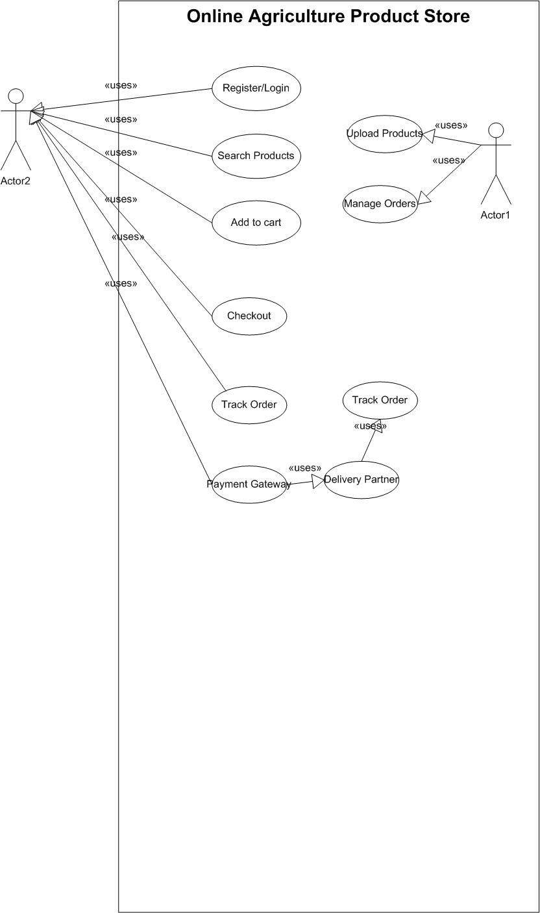

Question 11. Prepare use case specs for all use cases
Answer:
UC-01: Register/Login
Actor: Farmer/Manufacturer
Precondition: User has valid credentials.
Main Flow: Enter details → Validate → Create/Authenticate Account → Redirect to Dashboard.
Alternate Flow: Invalid credentials → Show error.
UC-02: Search Product
Actor: Farmer
Precondition: Catalog available.
Main Flow: Enter keyword → Fetch results → Select item.
Alternate Flow: No results → Suggest alternatives.
UC-03: Upload Product
Actor: Manufacturer
Main Flow: Fill details → Validate → Save → Display in catalog.
Alternate Flow: Invalid data → Show error.
UC-04: Checkout & Payment
Actor: Farmer
Main Flow: Add to cart → Select payment method → Confirm → Get receipt.
Alternate Flow: Payment failure → Retry.
UC-05: Track Order
Actor: Farmer
Main Flow: Enter order ID → Fetch status from courier → Show delivery info.

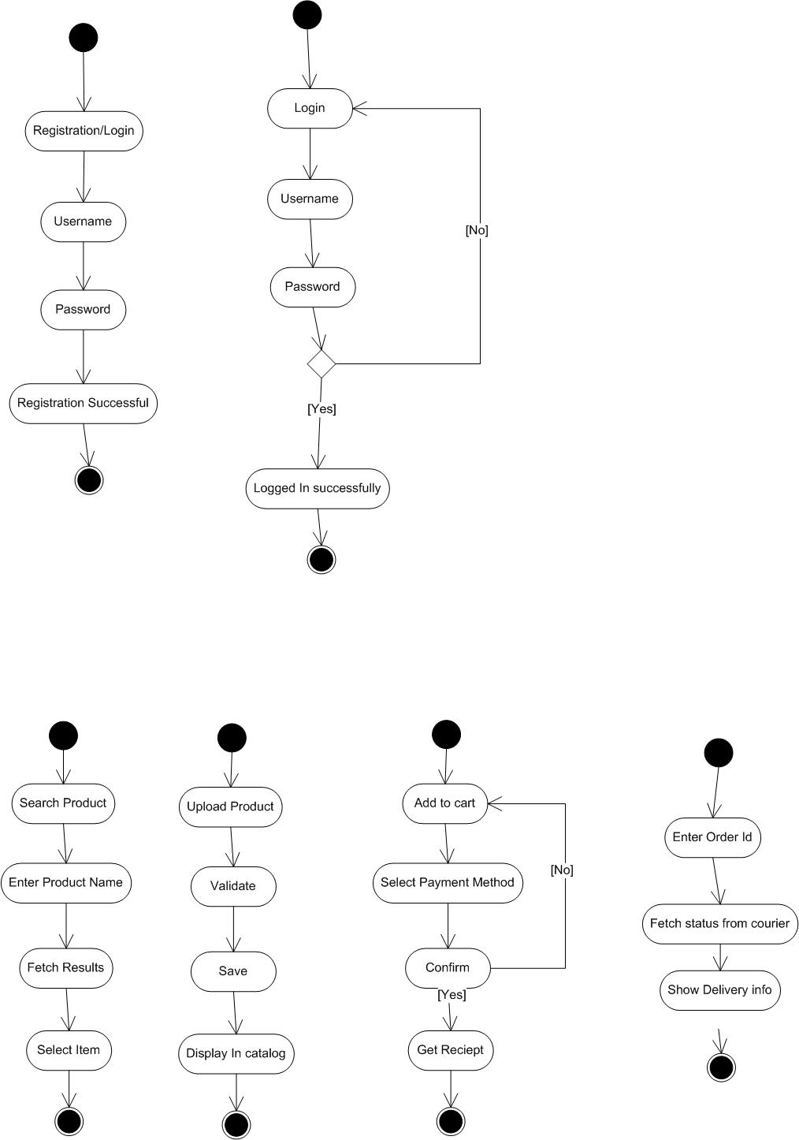

Question 12. Activity diagrams
Answer:
A1: User Registration
Start → Enter Details → Validate → Create Account → Confirmation → End
A2: Search Product
Start → Enter Query → Retrieve Results → Select Product → End
A3: Upload Product
Start → Enter Product Info → Validate Fields → Save Record → End
A4: Checkout & Payment
Start → Add Items → Select Payment → Confirm Order → Generate Receipt → End
A5: Order Tracking
Start → Enter Order ID → Query Partner API → Show Status → End

