RCRMS (AN ATS) – Agile Deliverables

Document 1 – Definition Of Done (DOD)
Definition of Done is a technique where the team agrees on, and prominently displays, a list of criteria which must be met before a backlog item is considered done.
That is the team must create a well-defined, unambiguous, measurable, agreed-upon, and shared Definition of Done between all team members.
The best form of Definition of Done representation is a checklist of activities that has to demonstrate the agreed value and quality of a user story.
So, this checklist should include:
- acceptance criteria (to satisfy customer requirements for a product)
- quality criteria (to satisfy quality requirements for a product)
Definition of Done may be defined for different levels of project work. For example, in Agile / Scrum framework these levels of work could be user story, sprint, and release.

Checklist for DoD:
- Code for functionalities written and committed
- User story assumptions validated
- Project builds successfully without errors
- Unit tests written and passed
- Code deployed to staging/test environment
- Cross-browser/device compatibility verified
- UX sign-off received
- QA validation completed
- Feature tested against acceptance criteria
- Product Owner approval obtained
- Refactoring and optimization done
- Configuration changes documented
- Documentation updated (functional/user docs)
- Peer review conducted and passed

Document 2 – Product Vision
Product Vision is a high-level, future-oriented statement that explains what the product aims to achieve, who it serves, and how it creates value, aligning with the organization's strategic goals.
Scrum Project Name: | RCRMS – An Application tracking System
Venue | Bhopal
Date | 01-AUG-2023
Start Time | 10:00 AM
End Time | 12:00 PM
Duration | 2 hours
Stakeholders | - Project Sponsor (Mr. Vir Nayak)  - IT Lead  - HR Head  - Hiring Managers  - Recruiters  - Compliance and Risk Manager
Scrum Team | - Scrum Master (Mr. Ravi Kumar)  - Product Owner (Mr. Piyush Chaudhary)  - Scrum Developers:  - Developer 1 – Rajiv Pandey  - Developer 2 – Kratika Jain  - Developer 3 – Rahul Gandhi  - Developer 4 – Ritika Sharma  - Developer 5 – Patricia Jorge
Vision | To build a centralized, intelligent, and scalable Recruitment Compliance and Reporting Management System (RCRMS) that transforms GDKN Corporation's recruitment operations by automating workflows, ensuring regulatory compliance, and delivering real-time insights to support faster, smarter, and more transparent hiring decisions.
Target Group | Which market segment does the product address?  The RCRMS (Recruitment Compliance and Reporting Management System) product addresses the Human Resources Technology (HR Tech) market segment  Who are the target users and customers?  The target users of the RCRMS project at GDKN Corporation include HR managers, recruiters, hiring managers, compliance officers, and IT administrators who will use the system to manage recruitment workflows, ensure regulatory compliance, and generate reports. The primary customers are GDKN’s internal business units and executive leadership, who seek to streamline hiring processes, reduce manual efforts, and gain visibility into recruitment performance through a centralized and scalable solution.
Needs | What problem does the product solve?  The RCRMS product solves the problem of fragmented, manual, and inefficient recruitment processes at GDKN Corporation. It addresses issues such as delayed hiring cycles, poor collaboration between HR and hiring managers, lack of real-time visibility, inconsistent data tracking, and non-compliance with regulatory requirements.  Which benefit does it provide?  The RCRMS product provides several key benefits, including streamlined and automated recruitment workflows, reduced time-to-hire, improved collaboration between HR and hiring managers, and enhanced visibility through real-time dashboards and reports. It ensures regulatory compliance with audit-ready documentation and reduces manual errors, ultimately leading to more efficient, transparent, and scalable hiring operations
Product | What product is it?  The RCRMS is a Recruitment Compliance and Reporting Management System—a centralized, web-based Applicant Tracking System (ATS) designed to streamline GDKN Corporation’s end-to-end recruitment processes.  What makes it desirable and special?  The RCRMS is desirable and special because it combines end-to-end recruitment automation with built-in compliance and reporting features tailored to GDKN Corporation’s specific needs. Unlike generic ATS platforms, RCRMS not only streamlines hiring workflows but also ensures regulatory adherence through audit-ready records, real-time dashboards, and customizable approval flows.  Is it feasible to develop the product?  Yes, it is feasible to develop the RCRMS product, provided that the project is backed by proper planning, resources, and stakeholder alignment. GDKN Corporation has the required organizational structure, access to skilled technical teams or vendors, and a clear understanding of recruitment challenges and goals.
Value | How is the product going to benefit the company?  The RCRMS product will benefit GDKN Corporation by significantly improving recruitment efficiency, reducing time-to-hire, and enhancing compliance with regulatory standards. It will centralize and automate the entire hiring process, leading to better coordination between HR and hiring managers, fewer manual errors, and quicker decision-making through real-time dashboards and reports.  What are the business goals?  The business goals of the RCRMS project at GDKN Corporation are to streamline and automate recruitment processes, reduce time-to-hire, and ensure regulatory compliance through standardized, audit-ready workflows.  What is the business model?  The business model for the RCRMS project at GDKN Corporation is internal process optimization. It is not a commercial product for external sale but a strategic internal tool designed to enhance the efficiency, compliance, and scalability of the company’s recruitment operations.
Document 3 – User Stories
A User Story is a brief, value-focused requirement expressed from the user’s point of view that guides the development and its features in Agile projects.
User Story 1: Job Requisition Creation
User Story No: 1 | Tasks: 1 |  | Priority: High
Value Statement: As an HR manager, I want to create and submit job requisitions with required details, so that I can initiate the hiring process efficiently.
BV: 200 |  | CP: 5
Acceptance Criteria:
A form is available to enter job title, department, location, job description, and budget
Mandatory fields are validated
Requisition is saved and submitted to the appropriate approver
Confirmation message is displayed upon successful submission

User Story 2: Requisition Approval Workflow
User Story No: 2 | Tasks: 1 |  | Priority: High
Value Statement: As a hiring manager, I want to receive and approve job requisitions, so that I can authorize the recruitment process.
BV: 200 |  | CP: 5
Acceptance Criteria:
Requisitions appear in the hiring manager’s dashboard.
Approve or reject option is available with comments
Approval status is updated and logged with timestamps
Notification sent to HR after approval/rejection

User Story 3: Candidate Profile Tracking
User Story No: 3 | Tasks: 1 |  | Priority: High
Value Statement: As a recruiter, I want to track all candidate profiles through different stages, so that I can monitor progress and act when needed.
BV: 200 |  | CP: 8
Acceptance Criteria:
Candidates are displayed with status (e.g., Applied, Interview Scheduled, Offer Sent)
Status can be updated with comments
Filters available for stage, job title, or recruiter
Changes are audit-logged

User Story 4: Interview Scheduling
User Story No: 4 | Tasks: 1 |  | Priority: Medium
Value Statement: As a recruiter, I want to schedule interviews with candidates and panel members, so that everyone is notified and aligned.
BV: 50 |  | CP: 3
Acceptance Criteria:
Calendar integration with availability view
Ability to send invites and reminders to all participants
Scheduled interviews are listed in the system
Candidates receive confirmation with date, time, and meeting link

User Story 5: Compliance and Audit Trail
User Story No: 5 | Tasks: 1 |  | Priority: High
Value Statement: As a compliance officer, I want every recruitment action to be audit-logged, so that we can maintain regulatory readiness.
BV: 200 |  | CP: 5
Acceptance Criteria:
All user actions (e.g., requisition submission, approvals, status changes) are logged
Logs include user ID, action, timestamp, and context
Logs are searchable and exportable
Access to logs is permission-based

User Story 6: Dashboard and Reporting
User Story No: 6 | Tasks: 1 |  | Priority: Medium
Value Statement: As an HR executive, I want to view real-time recruitment metrics in a dashboard, so that I can monitor performance and make data-driven decisions.
BV: 100 |  | CP: 3
Acceptance Criteria:
Dashboard displays metrics like open positions, time-to-hire, candidate drop-offs
Filters by department, recruiter, or date range
Export options available
Data refreshes in near real-time

Document 4 – Agile PO Experience
Key responsibility handled as a Product owner.
- Market Analysis-
- GDKN’s RCRMS is well aligned with current market trends—it combines core ATS functionality with compliance, auditability, and potentially AI-powered workflows.
- Positioned for a market that values automation, regulatory readiness, and scalable cloud solutions—especially in fast-growing regions like India—it has strong relevance and potential.
- To stand out, emphasizing data privacy controls and bias mitigation features will be key.

- Enterprise Analysis –
- RCRMS fits well within an enterprise architecture strategy: it consolidates recruitment workflows, integrates with core business systems, enforces data governance, and scales across the organization.
- By anchoring its design within proven architecture frameworks, coupled with strong training and compliance processes, the system enables GDKN to modernize talent acquisition while managing organizational risk and complexity effectively.

- Product Vision and Roadmap –
- The vision is to eliminate manual inefficiencies, reduce compliance risks, and provide a seamless hiring experience for all users—HR teams, hiring managers, and candidates—while supporting GDKN’s long-term growth and digital transformation goals.
- Product Roadmap
- Establish the core infrastructure and launch MVP with basic functionalities
- Improve collaboration, automation, and compliance readiness
- Add intelligent features and optimize user experience
- Scale system organization-wide and integrate with external platforms

- Managing Product Features –
- Managing product features for RCRMS is a continuous, agile, and value-driven process, ensuring that every feature delivered enhances recruitment efficiency, compliance, and user experience. Managing product feature involved:
- Feature Identification
- Feature Prioritization
- Backlog Management
- Feature Definition and Documentation
- Stakeholder Collaboration
- Release Planning and Tracking
- Post-Release Feedback and Continuous Improvement

- Managing Product Backlog –
- Managing the product backlog in the RCRMS project is a continuous, evolving process that balances stakeholder needs, technical feasibility, and business value.
- As Product Owner, I ensure the backlog remains a transparent, prioritized, and actionable source of truth that guides the development team to deliver high-impact features sprint after sprint.

- Managing Iteration Progress –
- Led Sprint Planning to define sprint scope with clear, achievable goals.
- Participated in Daily Stand-ups to address blockers and progress updates.
- Conducted Sprint Reviews to demonstrate completed functionalities.
- Facilitated Sprint Retrospectives with Business Analyst to implement process improvements.
User Story Management –
Developed well-structured user stories including:
- Story No. and Title
- Tasks and Dependencies
- Priority Level (High, Medium, Low)
- Acceptance Criteria
- Business Value (BV) and Complexity Points (CP)
This structure ensured that all user stories were clear, testable, and aligned with stakeholder needs.
PO as Liaison Between Business & Scrum Team -
- Acted as a bridge between business stakeholders and the Scrum team.
- Translated customer needs and regulatory requirements into technical specifications.
- Ensured that product development remained aligned with business goals throughout the sprints.

Learning Outcomes from This Project -
- Gained hands-on experience in managing all types of Scrum ceremonies:
  - Sprint Planning
  - Daily Standups
  - Sprint Reviews
  - Sprint Retrospectives
  - Backlog Grooming/Refinement
- Improved backlog prioritization skills and stakeholder communication.
Learned how to measure sprint progress and re-prioritize quickly based on feedback.

Document 5 - Product and sprint backlog and product and sprint burndown charts
Product Backlog:
User Story ID | User Story | Tasks | Priority | BV | CP | Sprint
US001 | As an HR manager, I want to create and submit job requisitions with required details, so that I can initiate the hiring process efficiently | Design UI, Implement Form Validation, create database schema, Integrate Role-Based Access Control | High | 200 | 5 | Sprint 1
US002 | As a hiring manager, I want to receive and approve job requisitions, so that I can authorize the recruitment process | Design UI, Build Notification Trigger, develop workflow logic, Implement Approve/Reject Actions | High | 200 | 5 | Sprint 1
US003 | As a recruiter, I want to track all candidate profiles through different stages, so that I can monitor progress and act when needed | Design UI, define candidate workflow, create API, develop candidate status functionality | High | 200 | 8 | Sprint 2
US004 | As a recruiter, I want to schedule interviews with candidates and panel members, so that everyone is notified and aligned. | Design UI, Integrate Calendar, Build Backend API, Enable Rescheduling and Cancellation Option | Medium | 50 | 3 | Sprint 2
US005 | As a compliance officer, I want every recruitment action to be audit-logged, so that we can maintain regulatory readiness | Identify Key Recruitment Actions, Design Audit Log Schema, Develop Audit Logging Middleware | High | 200 | 5 | Sprint 3
US006 | As an HR executive, I want to view real-time recruitment metrics in a dashboard, so that I can monitor performance and make data-driven decisions. | Identify Key Metrics, Design Dashboard UI, Set Up Backend API, Integrate with Data Visualization, Implement Role-Based Access | Medium | 100 | 3 | Sprint 3

Sprint Backlog –
User Story ID | User Story | Tasks | Owner | Status | Estimated Effort
US001 | As an HR manager, I want to create and submit job requisitions with required details, so that I can initiate the hiring process efficiently | Design UI, Implement Form Validation, create database schema, Integrate Role-Based Access Control | Developer 1 & 3 | In Progress | 56 hours
US002 | As a recruiter, I want to track all candidate profiles through different stages, so that I can monitor progress and act when needed | Design UI, define candidate workflow, create API, develop candidate status functionality | Developer 2,4 & 5 | Done | 72 hours

Sprint Burndown Chart –
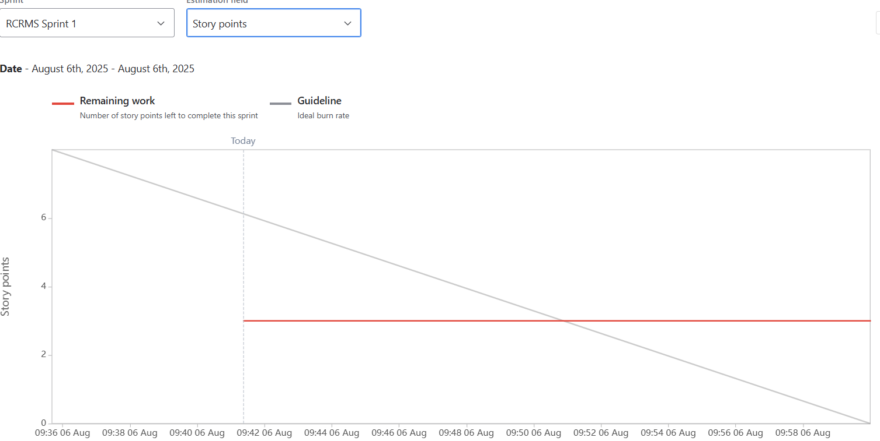
Sprint Burnup Chart –
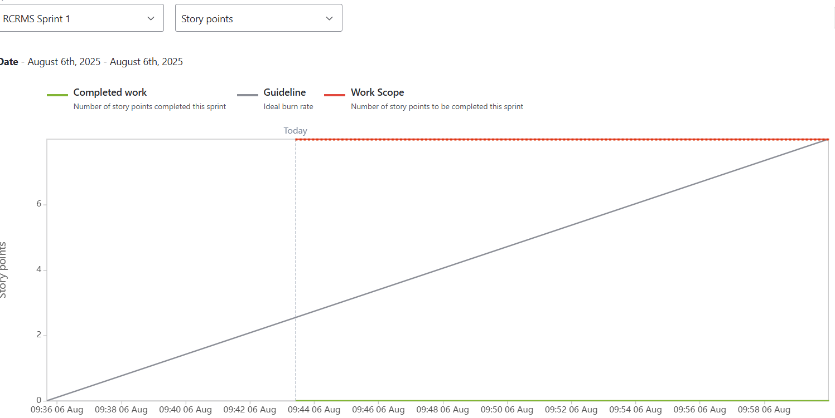

Document 6 - Sprint meetings
Meeting 1 – Sprint Planning Meeting
Date | 12-07-2025
Time | 10:00 AM to 11:30 AM
Location | Conference Room/MS teams
Prepared By | Product Owner (Piyush Chaudhary)
Attendees | Scrum Master, Product Owner, Scrum Developers (1–5), QA Analyst, UX Designer

Agenda Topics: Planning Of Sprint 1
Topic | Presenter | Time Allotted
Welcome & Objective | Scrum Master | 5 min
Product Backlog Overview | Product Owner | 10 min
Sprint Goal Discussion | Product Owner | 10 min
User Story Breakdown & Estimates | Scrum Developers | 30 min
Capacity Planning | Scrum Master | 10 min
Sprint Commitment & Finalization | Team | 15 min
Q&A / Closing | Scrum Master | 10 min

Other Information –
- Observers: QA Manager
- Resources: Jira board, Product backlog
- Special Notes: Team committed to 2 user stories for Sprint 1

Meeting 2 – Sprint Review Meting
Date | 22-07-2025
Time | 4:00 PM to 5:00 PM
Location | Conference Room/MS teams
Prepared By | Scrum Master
Attendees | Scrum Team, Product Owner, Business Stakeholders

Sprint Status
- Completed User Stories: 1 of 2 committed
- Pending Items: 1 story partially done, moved to next sprint

Things TO Demo
- Job Requisition Approval Page
- Action Buttons – Approve / Reject
- Audit Trail Logging
- Email Notification Integration
- Approval Status Tracking

Quick Updates
- Reason for incompletion
- Unanticipated delays in backend API integration
- Resource shift to fix urgent UI bugs in approval workflow

What’s Next
- Remaining story added to Sprint 2
- Integration module planned for next sprint

Meeting 3 – Sprint Retrospective Meeting
Date | 22-07-2025
Time | 5:30 PM to 6:15 PM
Location | Conference Room/MS teams
Prepared By | Scrum Master
Attendees | Scrum Team only

Agenda
- Welcome and Sprint Recap
- What Went Well
- What Didn’t Go Well
- Questions and Observations
- Action Items for Next Sprint

What went Well
- Successfully implemented and demoed the job requisition approval feature
- Effective collaboration between frontend and backend teams for the approval workflow
- Early stakeholder involvement helped clarify expectations

What did not go well
- The candidate tracking feature was only partially completed.
- Delay in backend API readiness impacted the recruiter story.
- UI bugs required unplanned attention, consuming dev capacity
Questions
- Can we break large user stories into smaller, independently testable stories?
- Do we need better alignment between backend readiness and frontend planning?

Reference
- Sprint board on Jira: Sprint #1 – RCRMS
- Completed User Story: [US-002] Job Requisition Approval
- Incomplete User Story: [US-001] Candidate Tracking by Recruiter

Meeting 4 – Daily stand-up meeting

Question | Name/Role | Mon | Tue | Wed | Thu | Fri | Sat | Sun
What did you do yesterday? | Dev 1 | Finalized job requisition form UI | Integrated approval buttons | Fixed COD issue | NA | NA | NA | NA
What did you do yesterday? | Dev 2 | Built API for requisition approval | Completed unit tests | Helped UI integration
What did you do yesterday? | Dev 3 | Designed recruiter dashboard layout | Shared recruiter dashboard wireframes | Began candidate card UI
What will you do today? | Dev 1 | Start integrating approval button | Connect UI to API | Work on error messages and form validation | NA | NA | NA | NA
What will you do today? | Dev 2 | Start writing unit tests for API | Assist in API-UI integration | Start next API (candidate stage updates)
What will you do today? | Dev 3 | Share UI wireframe with team | Start candidate card UI | Complete UI for status tracking
What (if any) is blocking your progress? | Dev 1 | None | Minor COD issue | None | NA | NA | NA | NA
What (if any) is blocking your progress? | Dev 2 | Waiting for DB schema confirmation | None | None
What (if any) is blocking your progress? | Dev 3 | None | Feedback pending | Feedback still awaited

