Q1.Functional Requirements
Functional requirements = what the system must do.
They cover user activities (buy/sell/manage) and system features (authentication, payments, logistics, communication).

Req ID | Req Name | Req Description | Priority
FR001 | User Registration | The system shall allow new users to register for an account. | 9
FR002 | Login | The system shall allow registered users (Farmers and Manufacturers) to log in using their email ID and password. | 9
FR003 | Validation of Login Credentials | The system shall validate user login credentials against the database. | 9
FR004 | Search for product | The system shall allow users to search for agricultural products, including fertilizers, seeds, and pesticides. | 8
FR005 | List of Products | The system shall display a list of products that match a user's search query. | 8
FR006 | Upload Product details | The system shall allow manufacturers to upload and display their product details. | 8
FR007 | Display Product Catalog | The system shall display a product catalog for farmers to browse. | 8
FR008 | Add Product to Cart | The system shall allow a farmer to add a product to a "buy-later" list or cart. | 8
FR009 | Select Product to buy | The system shall allow farmers to select a product and request to buy it. | 8
FR010 | Checkout Process | The system shall facilitate the checkout process for products in a user's cart. | 8
FR011 | Payment Options | The system shall offer different payment options, including Cash on Delivery (COD), Credit/Debit Card, and UPI. | 8
FR012 | Payment Gateway | The system shall process secure transactions through a payment gateway. | 8
FR013 | Confirm Payment | The system shall confirm an order once payment is successfully processed. | 9
FR014 | Email Confirmation | The system shall send an email confirmation to a user regarding their order status. | 9
FR015 | Delivery Tracker | The system shall provide a delivery tracker for users to track the status and location of their order. | 8
FR016 | Reset Password | The system shall allow a user to reset their password. | 9
FR017 | Display an error message | The system shall display an error message for invalid login credentials. | 8
FR018 | Display a message if no products found | The system shall display a message if no products are found during a search. | 8
FR019 | System shall display an error message if an email ID already exists | The system shall display an error message if an email ID already exists during new user registration. | 8
FR020 | Navigate to a registration page | The system shall allow users to navigate to a registration page from the login page if they are a new user. | 8

NFRs (Non-Functional Requirements) ensure not just functionality, but also performance, reliability, usability, and future readiness of the Agriculture Product Store app

Req ID | Req Name | Req Description | Priority
NFR001 | Response Time | All user requests (search, product load, checkout) should be processed within 2–3 seconds. | 8
NFR002 | Scalability | The system must support up to 1 million concurrent users during peak seasons. | 8
NFR003 | Throughput | App should handle at least 5000 transactions per minute smoothly. | 8
NFR004 | Availability | The platform must maintain 99.9% uptime annually. | 8
NFR005 | Authentication & Authorization | Secure login with multi-factor authentication (farmers, companies, admins). | 8
NFR006 | Data Encryption | Sensitive data (user info, payment details) encrypted using AES-256. | 8
NFR007 | Compliance | Must comply with IT Act (India), GDPR (where applicable), and RBI digital payment guidelines. | 9
NFR008 | Audit Trails | All transactions and administrative actions must be logged for traceability. | 8
NFR009 | Multi-Language Support | Interface available in English + 10 major Indian languages for inclusivity. | 8
NFR010 | Accessibility | Must comply with WCAG 2.1 standards for differently-abled users. | 8
NFR011 | Mobile Responsiveness | App must function seamlessly across mobile devices, tablets, and desktops | 8
NFR012 | Fault Tolerance | System must continue functioning in case of server failures using load balancers. | 8
NFR013 | Disaster Recovery | Recovery Point Objective (RPO) ≤ 15 minutes, Recovery Time Objective (RTO) ≤ 1 hour. | 8
NFR014 | Backup | Daily automated backups with retention for at least 90 days. | 8
NFR015 | Modular Architecture | Should support future expansion (adding new products like tools, irrigation equipment). | 8
NFR016 | API Integration | Must allow integration with UPI, payment gateways, govt. agri schemes APIs. | 8
NFR017 | Code Maintainability | Maintain 80%+ unit test coverage to ensure stability during updates | 8
NFR018 | Monitoring & Alerts | Real-time monitoring of app health with alerts on downtime, errors, or performance degradation. | 8
NFR019 | Version Control & Deployment | CI/CD pipeline with rollback support in case of failed updates | 8
NFR020 | Support Window | Provide 24x7 customer support with escalation matrix for critical issues. | 8

Question 2: Minimum 5 Page Designs
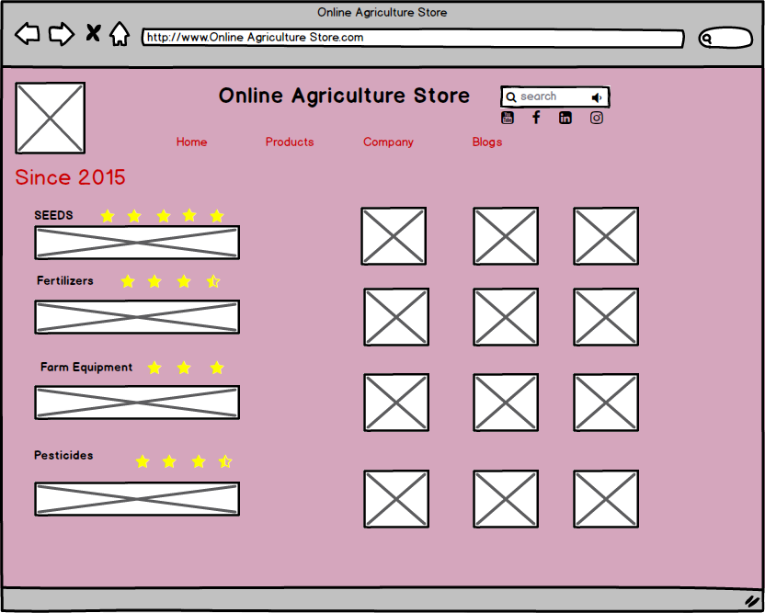

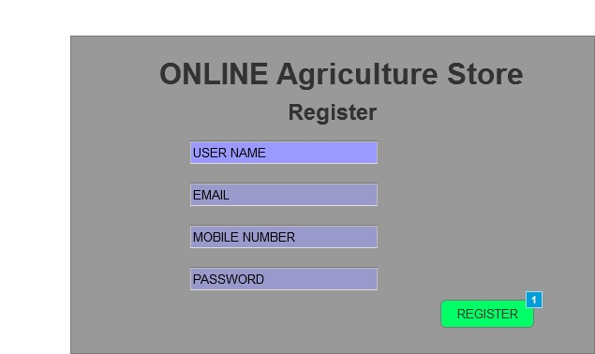

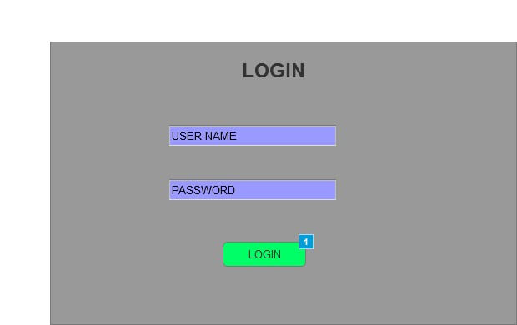
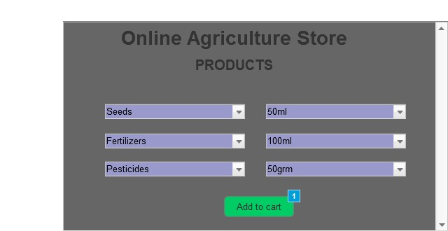

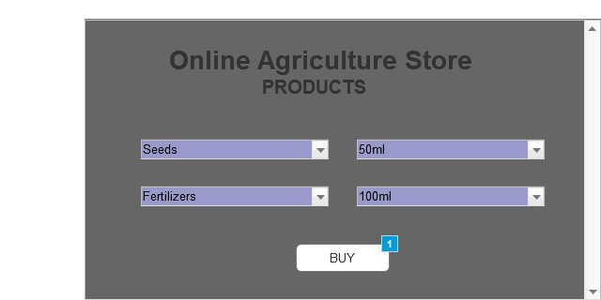
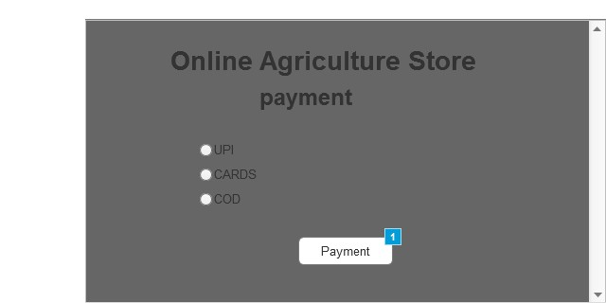

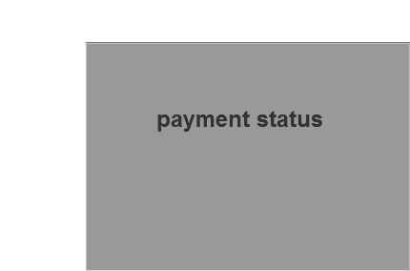

Question 3: Tools

1. Balsamiq for Prototyping and Wireframing
Balsamiq is a low-fidelity wireframing and mock-up tool that excels at creating quick, hand-sketched-style visuals. For a business analyst, its primary value lies in its ability to facilitate communication and rapid iteration without getting bogged down in design details.
How a Business Analyst uses Balsamiq for an Agriculture Product Store:
- User Interface (UI) Wireframes: The BA can use Balsamiq's drag-and-drop components to create skeletal wireframes for all the application's screens. For an agriculture store, this would include:
  - Homepage: A layout showing a search bar for products, categories (e.g., "Seeds," "Fertilizers," "Tools"), featured products, and a call-to-action for vendors to join.
  - Product Listing Page: A grid view of products with images, names, prices, and an option to filter by crop type or location.
  - Product Detail Page: A detailed view of a single item, including a high-resolution image, a description from the farmer or vendor, price, stock availability, and a button to "Add to Cart."
  - Shopping Cart and Checkout: A multi-step flow showing the items in the cart, shipping details, and a secure payment process.
  - Vendor Dashboard: A separate set of screens for farmers and suppliers to manage their product listings, view sales reports, and handle orders.
- User Flows and Prototypes: Balsamiq allows the BA to link these wireframes together to create an interactive prototype. This is a powerful way to demonstrate the user journey. For example, a BA can create a prototype where a user clicks a "Buy" button on a product page, which then navigates them to the shopping cart screen. This prototype can be shared with stakeholders—from farmers who will be selling on the platform to investors—to get early feedback and validate the design before any code is written.
- Requirements Elicitation: Presenting a visual prototype is far more effective than a lengthy text document. When a BA shows a wireframe to a farmer, the farmer might immediately suggest, "I need a field on my product page to specify if the product is organic," or a logistic partner might point out a missing step in the delivery process. This visual approach uncovers requirements that might have been missed during initial interviews.
2. Microsoft Visio for Process Modeling
Microsoft Visio is a professional diagramming and vector graphics application used to create flowcharts, network diagrams, and other detailed business process models. Unlike Balsamiq, which focuses on the user interface, Visio is used to model the business processes that the application will support.
How a Business Analyst uses Visio for an Agriculture Product Store:
- "As-Is" Process Maps: Before designing the new system, a BA must understand the current state. They can use Visio to create a flowchart that maps the existing, manual process. This could show a farmer receiving an order via a phone call, manually updating an inventory ledger, physically packing the order, and then calling a local courier to arrange a pickup. This diagram helps to pinpoint inefficiencies, like a lack of real-time inventory tracking or the time-consuming manual order process.
- "To-Be" Process Maps (BPMN): The BA can then use Visio to create a "To-Be" process model using Business Process Model and Notation (BPMN). This diagram shows the new, automated process enabled by the online store. It would depict:
  - A customer placing an order on the website (an automated "event").
  - The system automatically checking inventory and marking the item as sold (an automated "task").
  - An email notification being sent to the vendor (a "message flow").
  - The vendor receiving the notification, confirming the order, and preparing it for delivery.
  - The system automatically generating a shipping label and tracking number.
  - The payment being processed automatically through a payment gateway.
- Use Case Diagrams: Visio can also be used to create UML (Unified Modeling Language) diagrams, such as a Use Case diagram. This diagram visually represents the different types of users (actors) and their interactions with the system. For the agriculture store, actors might include a "Farmer," a "Customer," a "Delivery Driver," and an "Administrator." The diagram would show how each actor interacts with the system to perform a specific function, such as a "Farmer" actor using the system to "Manage Product Listings" or a "Customer" actor using it to "Place an Order."
3. Assure for Requirements Management and Traceability
While "Assure" is a broad term often associated with "business assurance," in a business analysis context, it refers to tools and processes that ensure requirements are well-defined, managed, and traceable throughout the development lifecycle. A tool that embodies this concept is Jira, often used in conjunction with a requirements management platform or a robust documentation tool like Confluence. We will describe the functionality of "Assure" as a concept and illustrate it with Jira.
How "Assure" (represented by Jira) is used by a Business Analyst:
- Requirements and User Story Management: The BA uses a tool like Jira to create and manage all functional and non-functional requirements for the agriculture store. These requirements are often written as user stories, such as: "As a farmer, I want to be able to upload high-quality pictures of my produce so that customers can see what they are buying." Each user story is a ticket in Jira, which contains a clear description, acceptance criteria, and is linked to the relevant project.
- Traceability and Linking: A key part of "assuring" the project's success is traceability. The BA uses Jira to link requirements to different artifacts. For example, a user story about "secure payments" can be linked to:
  - The wireframe in Balsamiq that shows the payment page.
  - The BPMN diagram in Visio that models the payment process.
  - Specific tasks or sub-tasks assigned to developers and testers.
  - Test cases that verify the security of the payment system. This end-to-end traceability ensures that every requirement is accounted for and that the final product aligns with stakeholder expectations.
- Collaboration and Version Control: Tools like Jira and Confluence provide a central, collaborative space for all project documentation. The BA can create detailed requirements documents, user guides, and business rules in Confluence, and link them to the active development tickets in Jira. This ensures that the entire team—from developers and testers to product managers and stakeholders—is working from a single, up-to-date source of truth. It also provides a history of changes, which is crucial for auditing and for understanding why a requirement was modified.

Question 4: RTM (Requirements Traceability Matrix)
An RTM is a key responsibility for a business analyst to ensure no requirement is missed. It helps track requirements and their status. Given the provided template, here is a populated RTM for the given requirements:
Req ID | Req Name | Req Description | Design | D1 | T1 | T4 | UAT
FR0001 | Farmer Registration | Farmers should be able to register with the application. | completed | completed | completed | completed | completed
FR0002 | Farmer Search for Products | Farmers should be able to search for available products in fertilizers, seeds, pesticides. | completed | completed | completed | completed | completed
NFR0101 | Page Loading Time | Each Page should load within 2 seconds time. | completed | completed | completed | completed | completed
NFR0102 | WCAG 2.1. | The system must meet Web Content Accessibility Guidelines WCAG 2.1. | completed | completed | completed | completed | completed
Question 5: 10 Test Case Documents
Test Case 1 | User Registration
Test Case ID | TC_AGRO_001
Project ID | AGRO_001
Module | Authentication
Scenario | Verify that a new user can register successfully.
Preconditions | User is not logged in
Input data | Step 1:Navigate to the registration page.  Step 2: Enter valid name, email, phone, password.  Step 3:Click on “Register”.
Expected behaviour | User account is created, confirmation message/email sent
Actual behaviour | User account is created, confirmation message/email sent
Comment | NIL
Result (Pass/Fail) | Pass

Test Case 2 | User Login
Test Case ID | TC_AGRO_002
Project ID | AGRO_002
Module | Authentication
Scenario | Verify login with valid credentials
Preconditions | User is already registered
Input data | Step 1:Navigate to the registration page.  Step 2: Enter valid name, email, phone, password.  Step 3:Click on “Register”.
Expected behaviour | User is logged in and redirected to the homepage.
Actual behaviour | User is logged in and redirected to the homepage.
Comment | NIL
Result (Pass/Fail) | Pass

Test Case 3 | Browse Products by Category
Test Case ID | TC_AGRO_003
Project ID | AGRO_003
Module | Product Catalog
Scenario | Verify that users can browse products category-wise (e.g., seeds, fertilizers, equipment).
Preconditions | User is logged in.
Input data | Step 1:Select “Seeds” category.  Step 2: Observe displayed products
Expected behaviour | Only seed-related products are displayed with proper images and pricing.
Actual behaviour | Only seed-related products are displayed with proper images and pricing.
Comment | NIL
Result (Pass/Fail) | Pass

Test Case 4 | Search Product
Test Case ID | TC_AGRO_004
Project ID | AGRO_004
Module | Product Catalog
Scenario | Verify product search functionality
Preconditions | At least one product matching search exists.
Input data | Step 1:Enter “Organic Fertilizer” in search bar.  Step 2:Click on search.
Expected behaviour | Relevant fertilizers appear in search results
Actual behaviour | Relevant fertilizers appear in search results
Comment | NIL
Result (Pass/Fail) | Pass

Test Case 5 | Add to Cart
Test Case ID | TC_AGRO_005
Project ID | AGRO_005
Module | Shopping Cart
Scenario | Verify that users can add a product to the cart
Preconditions | User logged in, products available.
Input data | Step 1:Select any product.  Step 2: Click on “Add to Cart”.
Expected behaviour | Product is added successfully, cart updated
Actual behaviour | Product is added successfully, cart updated
Comment | NIL
Result (Pass/Fail) | Pass

Test Case 6 | Update Cart Quantity
Test Case ID | TC_AGRO_006
Project ID | AGRO_006
Module | Shopping Cart
Scenario | Verify the ability to update product quantity in the cart
Preconditions | Product available in cart.
Input data | Step 1:Go to cart.  Step 2:Change quantity from 1 to 3.  Step 3:Save/update.
Expected behaviour | Total price recalculated and updated.
Actual behaviour | Total price recalculated and updated.
Comment | NIL
Result (Pass/Fail) | Pass

Test Case 7 | Place Order with COD Payment
Test Case ID | TC_AGRO_007
Project ID | AGRO_007
Module | Order & Payment
Scenario | Verify placing an order using Cash on Delivery.
Preconditions | Cart has at least one product.
Input data | Step 1:Go to checkout page.  Step 2:Select delivery address.  Step 3:Choose "Cash on Delivery".  Step 4:Place order.
Expected behaviour | Order placed successfully, order ID generated
Actual behaviour | Order placed successfully, order ID generated
Comment | NIL
Result (Pass/Fail) | Pass

Test Case 8 | Place Order with Online Payment
Test Case ID | TC_AGRO_008
Project ID | AGRO_008
Module | Order & Payment
Scenario | Verify placing an order using online payment (Card/UPI).
Preconditions | Valid payment method available.
Input data | Step 1:Add product to cart.  Step 2:Select checkout.  Step 3:Choose Online Payment.  Step 4:Enter valid card/UPI details.
Expected behaviour | Payment successful, order confirmed.
Actual behaviour | Payment successful, order confirmed.
Comment | NIL
Result (Pass/Fail) | Pass

Test Case 9 | Order Tracking
Test Case ID | TC_AGRO_009
Project ID | AGRO_009
Module | Order Management
Scenario | Verify that user can track order status.
Preconditions | User has a pending order.
Input data | Step 1:Login and open "My Orders".  Step 2:Select placed order.
Expected behaviour | Status displayed (Processing/Dispatched/Delivered).
Actual behaviour | Status displayed (Processing/Dispatched/Delivered).
Comment | NIL
Result (Pass/Fail) | Pass

Test Case 10 | User Profile Update
Test Case ID | TC_AGRO_010
Project ID | AGRO_010
Module | Profile Management
Scenario | Verify user can update profile details like address and phone
Preconditions | User logged in.
Input data | Step 1:Go to profile page.  Step 2:Update phone number and delivery address.  Step 3:Save changes.
Expected behaviour | Profile updated successfully with confirmation message
Actual behaviour | Profile updated successfully with confirmation message
Comment | NIL
Result (Pass/Fail) | Pass

Question 6: DB Design

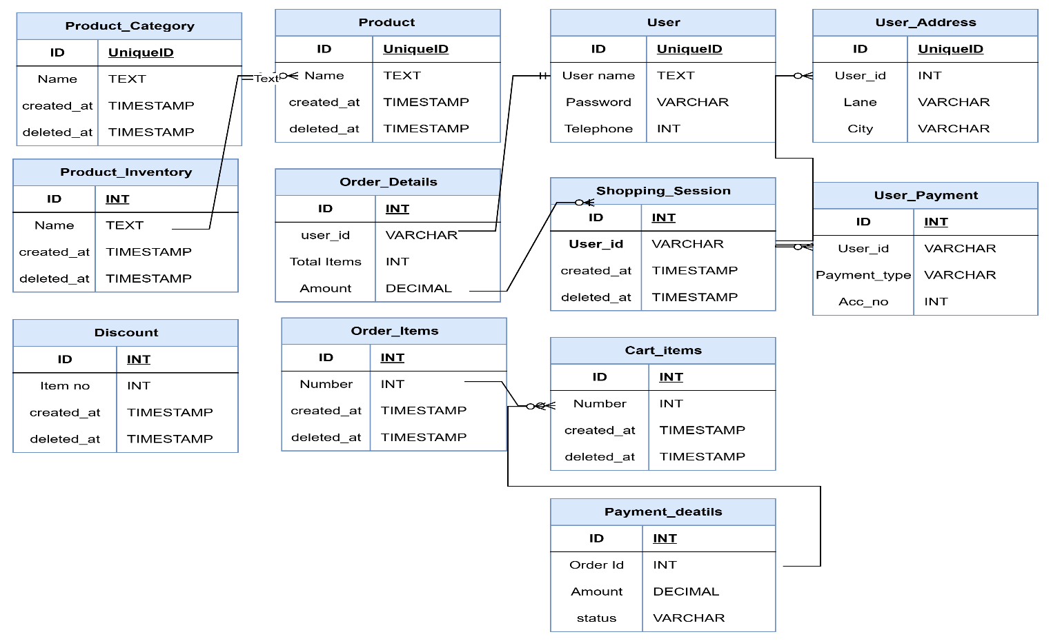

Question 7: Data Flow Diagram
A Data Flow Diagram (DFD) is a graphical representation of how data moves through a system. It shows how input data is transformed into output through a series of processes, and how that data is stored and interacted with by external entities.

It help analysts and designers understand the flow of data within a system,identify potential bottlenecks or inefficiencies, and communicate system requirements to stake -holders.

Question 8: Change Request
When a change in the government taxation structure requires a change to the tax structure within the project, a formal change request process should be followed.
How to handle change requests:
- Document the Change: The business analyst should document the new tax requirements due to the government's change in taxation structure.
- Analyze the Impact: Analyze the impact of the change on the project's scope, budget, timeline, and resources. This includes determining which parts of the system, such as the payment gateway and product pricing, will be affected.
- Submit the Change Request: A formal change request form should be submitted to the project manager or a designated change control board. This document should detail the proposed change, its justification, and the estimated impact.
- Review and Approve: The change control board (including stakeholders like Mr. Henry, Mr. Pandu, and Mr. Dooku ) must review the request. They will decide whether to approve or reject the change based on the project's priorities and constraints.
- Update Project Documents: If approved, all relevant project documents, such as requirements, design specifications, and the RTM, must be updated to reflect the new tax structure.
- Communicate the Change: The approved change and its impact must be communicated to the entire project team, including developers and testers, to ensure everyone is working with the most current information.
- Implement and Test: The development team will implement the change, and the testing team will verify that the new tax structure is correctly applied without introducing new defects.
Question 9: Change Request vs. Enhancement
Ben and Kevin have requested that farmers be able to sell their crop yields and that an auction system be introduced.
Response as a BA: This is a significant change in the project's scope. These new features are not part of the original business requirements gathered from Mr. Henry, Kevin, Peter, and Ben. The original goal was for farmers to buy products, not sell them or participate in auctions.
Change Request vs. Enhancement: This would be classified as an
enhancement. An enhancement adds new functionality that was not part of the initial scope, while a change request typically modifies existing functionality. The ability for farmers to sell their products and to have an auction system is a new business goal that requires new features, new user roles (farmers as sellers), and new system processes (listing, selling, and auctioning) that were not previously defined or budgeted for.
As a BA, my response would be to formally document these new requirements from Ben and Kevin and treat them as a new set of project requirements, subject to a new round of analysis, prioritization, and estimation. They would need to be approved by the project committee (Mr. Henry, Mr. Pandu, and Mr. Dooku).
Question 10: Estimations
How many Manhours are required for the project?
Come up with number and justify your analysis
Man efforts are the required resources to complete the project.They are three types of project
Small: up to 500 hours
Medium : up to 1000 hours
Large : up to 1500 hours
As per the time sheet designed by me (BA) 287 manhours are required hence this project is a small project therefore trained resoruces and advanced infrastrcture is not required.Project estimation is for 10 weeks with 287 man hours.
Question 11: UAT
When a project is ready for User Acceptance Testing (UAT), the business analyst needs to contact the client to test the final product.
How to handle UAT:
- Prepare UAT Plan: Create a UAT plan that outlines the test scope, objectives, schedule, test cases, roles and responsibilities, and acceptance criteria.
- Communicate with Stakeholders: Contact the key stakeholders (Peter, Kevin, and Ben ) to schedule the UAT sessions. Explain the process and what is expected of them.
- Conduct UAT Sessions: Guide the stakeholders through the test cases to ensure the system meets the original business requirements.
- Document Findings: Record any issues or bugs found during UAT, classifying them by severity.
- Obtain Sign-off: Once UAT is successfully completed and the stakeholders are satisfied that the solution meets their needs, they must provide a formal sign-off. This UAT acceptance process signifies that the product is ready for deployment.
UAT Acceptance Process: The UAT acceptance process is the formal procedure to get client approval on the final product. It involves:
- Execution of UAT Test Cases: The client or end-users execute the pre-defined test cases.
- Defect Management: Any defects found are logged, assigned to the development team, and re-tested once fixed.
- Acceptance Criteria Review: The client verifies that all acceptance criteria have been met.
- Sign-off: Once the system is deemed satisfactory, the client provides a formal sign-off, typically in a UAT sign-off document, which marks the completion of the UAT phase and allows the project to move to the next stage (e.g., deployment).

Question 12: Project Closure Document
A Project Closure Document is a formal document created at the end of a project to finalize all project activities and confirm the project's completion.
What it includes:
- Final Project Scope: A summary of the final scope, including any approved changes.
- Project Outcome: A description of whether the project objectives were met.
- Financial Summary: A final financial report that compares the actual costs to the planned budget.
- Lessons Learned: A review of what went well and what could be improved in future projects.
- Team Performance Review: A final assessment of the project team's performance.
- Stakeholder Sign-off: Final signatures from key stakeholders confirming their acceptance of the project's deliverables.
- Archiving: Details on where to archive project documentation and deliverables for future reference.

