CAPSTONE PREP – 2

QUESTION – 1
WRITE AGILE MANIFESTO

-AGILE MANIFESTO
Four main values –
- Individuals and interactions over process and tools
- Working software over comprehensive documentation
- Customer collaboration over contract negotiation
- Responding to change over following plan.
Twelve principles of Agile software –
- Satisfy the customer through early and continuous delivery of valuable software.
- Welcome changing requirements, even late in development. Agile process harness change for the customer’s competitive advantage.
- Deliver working software frequently , from a couple of weeks to a couple of months with preference to the shorter timescale.
- Business people and developers must work together daily through out the project.
- Build projects around motivated individuals. Give them the environment and support they need, and trust them to get the job done.
- The most efficient and effective method of conveying information to and within a development team is face-to-face conversation.
- Working software is the primary measure of progress.
- Agile process promote sustainable development. The sponsors, developers and users should be able to maintain a constant pace indefinitely.
- Continuous attention to technical excellence and good design enhances agility.
(10)Simplicity …the art of maximizing the amount of work not done ..is essential.
(11) The best architectures, requirements and designs emerge from self organizing teams
(12) At regular intervals, the team reflects on how to become more effective, then tunes and adjust its behaviour accordingly.

QUESTION-2
Write minimum 40 user stories and their Acceptance criteria along with their BV and CP ?
User Story NO: 1 | Tasks: 2 |  | Priority: high
AS A CUSTOMER
I WANT TO REGISTER AN ACCOUNT WITH MY EMAIL ID AND PASSWORD
SO THAT I CAN SAVE MY ORDER HISTORY
BV: 500 |  | CP:04
Acceptance Criteria :
Registration screen
Text boxes for email id and password
Click on Register button
Send registered successfully notification to customer

User Story NO: 2 | Tasks:2 |  | Priority: medium
AS A CUSTOMER
I WANT TO LOGIN AND OUT OF MY ACCOUNT
SO THAT I CAN SECURELY ACCESS MY INFORMATION
BV: 400 |  | CP:03
Acceptance Criteria :
Click on login button
Click on logout button
Get to enter credentials screen after logout.

User Story NO: 3 | Tasks:2 |  | Priority: High
AS A CUSTOMER
I WANT TO BROWSE THE RESTAUARNTS
SO THAT I CAN EASILY FIND THE KIND OF FOOD I AM LOOKING FOR
BV: 300 |  | CP: 03
Acceptance Criteria :
System should display the list of restaurants.
User should able to sort the restaurants.

User Story NO: 4 | Tasks: 2 |  | Priority:
AS A CUSTOMER
I WANT TO VIEW RESTAURANT MENU WITH PRICES WITH DESCRIPTIONS
SO THAT I CAN MAKE INFORMATED DECISION ABOUT MY ORDER
BV: 300 |  | CP:02
Acceptance Criteria :
System should display the menu and description of restaurant
User can able to select the item from menu

User Story NO:05 | Tasks:02 |  | Priority: high
AS A CUSTOMER
I WANT TO ADD MY ADDRESS
SO THAT I CAN GET MY ORDER TO MY ADDRESS
BV: 400 |  | CP:04
Acceptance Criteria :
Text box to enter the address
Business rules. within the 4 km radius

User Story NO:06 | Tasks:2 |  | Priority: High
AS A CUSTOMER
I WANT TO SELECT PAYMENT MODE
SO THAT I CAN MAKE PAYMENT OF MY CHOICE
BV: 500 |  | CP:04
Acceptance Criteria :
Display payment modes
Radio buttons for payment modes
Payment submit button, payment successful notification
Business Rule: can select only one payment mode .

User Story NO:07 | Tasks:02 |  | Priority: Medium
AS A CUSTOMER
I WANT TO SEE HIGH QUALITY PHOTOS OF DISHES
SO THAT I CAN VISUALIZE WHAT I AM ORDERING
BV: 300 |  | CP:02
Acceptance Criteria :
DISPLAY THE DISHES IMAGES
ZOOM OPTION FOR IMAGES

User Story NO:08 | Tasks:02 |  | Priority: Medium
AS A CUSTOMER
I WANT TO TRACK THE ORDER
SO THAT I CAN KNOW WHERE THE DELVERY BOY IS
BV: 400 |  | CP:04
Acceptance Criteria :
Display the tracking id and link
By clicking on link display the delivery boy status.

User Story NO:09 | Tasks:02 |  | Priority: medium
AS A CUSTOMER
I WANT TO VIEW MY PAST ORDER HISTORY
SO THAT I CAN REORDER MY FAVORITE MEALS
BV: 200 |  | CP:02
Acceptance Criteria :
Click on history
Display the order list of past dates

User Story NO: 10 | Tasks: 02 |  | Priority: medium
AS A CUSTOMER
I WANT TO TRACK THE REAL TIME STATUS OF MY ORDER
SO THAT I KNOW WHEN TO EXPECT MY FOOD
BV: 300 |  | CP:03
Acceptance Criteria :
Click on order status button
Show order status as order places, preparing, out for delivery.

User Story NO:11 | Tasks:02 |  | Priority: Medium
AS A CUSTOMER
I WANT TO RECIVE NOTIFICATIONS FOR ORDER UPADTES
SO THAT IAM ALWAYS INFORMED
BV: 300 |  | CP:04
Acceptance Criteria :
Click on notification button
show notifications to customer

User Story NO:12 | Tasks:02 |  | Priority: medium
AS A CUSTOMER
I WANT TO CONTACT CUSTOMER CARE OF APPLICATION
SO THAT I CAN GET HELP WITH ANY ISSUES
BV: 500 |  | CP:04
Acceptance Criteria :
Display help option on screen
Click on contact us button
Clear the issue .

User Story NO: 13 | Tasks:02 |  | Priority: Medium
AS A CUSTOMER
I WANT TO RATE AND REVIEW RESTAURANT AND DELIVERY DRIVERS
SO THAT I CAN GICE FEEDBACK AND HELP OTHER USERS
BV: 300 |  | CP:04
Acceptance Criteria :
Display rating and review option on screen
Text box for rating
Click on submit button
Rating gets uploaded

User Story NO: 14 | Tasks:02 |  | Priority: Medium
AS A RESTAURANT OWNER
I WANT TO ADD, EDIT AND REMOVE MENU ITEMS
SO THAT I CAN KEEP MY OFFERINGS UP TO DATE
BV: 400 |  | CP:04
Acceptance Criteria :
Click on add button, edit button and remove items
System should able to perform activities

User Story NO:15 | Tasks:3 |  | Priority: Medium
AS A RESTAURANT OWNER
I WANT TO VIEW ORDES
SO THAT I CAN VIEW THE LIST OF ORDERS

BV: 400 |  | CP:03
Acceptance Criteria :
View orders
Display the list of orders in the tabular form

User Story NO:16 | Tasks:03 |  | Priority: medium
AS A RESTAURANT OWNER
I WANT TO UPLOAD HIGH QUALITY IMAGES OF DISHES
SO THAT CUSTOMERS CAN SEE WHAT THEY ARE ORDERING
BV: 300 |  | CP:04
Acceptance Criteria :
Can able to upload hd images
Display the images of dishes

User Story NO:17 | Tasks:03 |  | Priority:medium
AS A RESTAURANT OWNER
I WANT TO MARK ITEMS AS OUT OF STOCK
SO THAT CUSTOMER DON’T ORDER UNAVAILABLE DISHES
BV: 200 |  | CP:02
Acceptance Criteria :
Click on update item status
Select available or not available
Shoe status on display

User Story NO:18 | Tasks:03 |  | Priority: Medium
AS A RESTAURANT OWNER
I WANT TO PROVIDE TIME SLOTS
SO THAT CUSTOMER CAN CHECK OPENINGS AND CLOSING HOURS OF RESTAURANT
BV: 400 |  | CP:04
Acceptance Criteria :
Click on restaurant dashboard
Add from time to time
Click submit button

User Story NO:19 | Tasks:3 |  | Priority: Medium
AS A RESTURANT OWNER
I WANT TO KNOW FEEDBACK FROM CUSTOMERS
SO THAT I CAN IMPROVE MY SERVICES
BV: 400 |  | CP:04
Acceptance Criteria :
Click on ratings
Display ratings and reviews uploaded by customers

User Story NO:20 | Tasks:03 |  | Priority:Medium
AS A RESTAURANT OWNER
I WANT TO RECIVE INSTANT NOTIFICATIONS FOR NEW ORDERS
SO THAT I CAN START PREPARE THE ORDER
BV: 500 |  | CP:05
Acceptance Criteria :
Click on new order button
Display the new order
Click on accept button

User Story NO:21 | Tasks:02 |  | Priority:medium
AS A RESTAURANT OWNER
I WANT TO ACCEPT OR REJECT ORDERS
SO THAT I CAN MANAGE MY CAPACITY
BV: 300 |  | CP:03
Acceptance Criteria :
Display on view orders
Select accept or reject option
Click submit

User Story NO:22 | Tasks:03 |  | Priority: Medium
AS A RESTAURANT OWNER
I WANT TO PRINT ORDER RECEIPTS
SO THAT I CAN KEEP PHYSICAL RECORDS
BV: 400 |  | CP:05
Acceptance Criteria :
Display order accepted
Click on print option
Take the print

User Story NO:23 | Tasks:03 |  | Priority: Medium
AS A RESTAURANT OWNER
I WANT TO VIEW MY ORDER HISTORY AND SALES REPORT
SO THAT I CAN TRACK MY PERFORMANCE
BV: |  | CP:
Acceptance Criteria :
Click on sold items
Display the sold item list with prices

User Story NO: 24 | Tasks: 03 |  | Priority: Medium
AS A RESTAURANT OWNER
I WANT TO COMMUNICATE WITH CUSTOMERS
SO THAT I CAN RESLOVE PROBLEMS EASILY
BV: 200 |  | CP:02
Acceptance Criteria :
Click on customer complains
Display notifications list from the customers

User Story NO:25 | Tasks:03 |  | Priority: Medium
AS A RESTAURANT OWNER
I WANT TO OFFER DISCOUNTS AND COUPONS
SO THAT I CAN GET MORE SALE
BV: 400 |  | CP: 04
Acceptance Criteria :
Click on upload
Select discounts or coupons and upload in application.
Display coupons and discounts to customers

User Story NO:26 | Tasks:4 |  | Priority: high
AS A DELIVERY BOY
I WANT TO REGISTER IN SCRUM FOOD APPLICATION
SO THAT I CAN DELIVER ORDERS
BV: 500 |  | CP:02
Acceptance Criteria :
Register screen
Text box for user name and password ,mobile number, bike RC , Bike images etc..
Verification
Click on register button
Send successful notification to user

User Story NO: 27 | Tasks:04 |  | Priority:High
AS A DELIVERY BOY
I WANT TO LOGIN APPLICATION BY USER NAME AND PASSWORD
SO THAT I CAN DELIVER MY ORDERS
BV: 300 |  | CP:02
Acceptance Criteria :
Click on login button
Text box for user name and password
Show login successful in display

User Story NO:28 | Tasks:04 |  | Priority: High
AS A DELIVERY BOY
I WANT TO RECIVE NOTIFICATIONS FOR DELIVERY REQUEST
SO THAT I CAN ACCEPT THEM
BV: 500 |  | CP:04
Acceptance Criteria :
Show the notifications in app
Select accept or reject button
Display Accepted successfully

User Story NO:29 | Tasks:4 |  | Priority:High
AS A DELIVERY BOY
I WANT TO VEIW PICK UP LOCATION AND DELIVERY LOCATION ON A MAP
SO THAT I CAN PLAN MY ROUTE
BV: 500 |  | CP:05
Acceptance Criteria :
Click on view location
Display route on map
Click on start option in map for route.

User Story NO:30 | Tasks:04 |  | Priority:Medium
AS A DELIVERY BOY
I WANT TO VIEW CUSTOMER DELIVERY INSTEUCTIONS
SO THAT I CAN DELIVER ACCORDING TO THEIR OPTIONS
BV: 400 |  | CP:03
Acceptance Criteria :
Click on customer instructions
Display the selected option 1: GIVE NEAR DOOR STEP, 2 HANDOVER IT TO WATCH MAN etc..
Click on Deliver successful button

User Story NO:31 | Tasks:04 |  | Priority: Medium
AS A DELIVERY BOY
I WANT TO CONTACT THE CUSTOMER FOR ANY ISSUES WITH DELIVERY
SO THAT I CAN RESLOVE THEM
BV: 400 |  | CP:04
Acceptance Criteria :
Display the customer contact option
Select call or chat option
Communicate with them .

User Story NO:32 | Tasks:4 |  | Priority: medium
AS A DELIVERY BOY
I WANT TO MARK AN ORDER AS DELIVERED WITH PROOF BY IMAGE
SO THAT THERE IS A RECORD
BV: 300 |  | CP:3
Acceptance Criteria :
Click on upload delivery items image
Click image and upload
Click on delivery completed

User Story NO:33 | Tasks:4 |  | Priority:high
AS A DELIVERY BOY
I WANT TO VEIW THE PAYMENT MODE
SO THAT I CAN COLLECT MONEY IF IT IS COD
BV: 500 |  | CP:5
Acceptance Criteria :
Click on payment option
If it is COD collect the money .

User Story NO:34 | Tasks:4 |  | Priority: hidh
AS A DELIVERY BOY
I WANT TO VIEW FEEDBACK
SO THAT I CAN IMPROVE MY PERFORMANCE ACCORDINLLY
BV: 400 |  | CP:04
Acceptance Criteria :
Click on my rating option
Display the customer rating on delivery driver

User Story NO:35 | Tasks:4 |  | Priority:medium
AS A DELIVERY BOY
I WANT TO VIEW MY EARNINGS FOR EACH DELIVERY
SO THAT I CAN TRACK MY INCOME
BV: 400 |  | CP:03
Acceptance Criteria :
Click on my trips
Display the successfully delivered items with earnings

User Story NO:36 | Tasks:5 |  | Priority:high
AS AN ADMIN
I WANT TO VEIW THE RESTAURANT
SO THAT I CAN APPROVE RESTAURANT REGISTRATION
BV: 500 |  | CP:04
Acceptance Criteria :
Click on restaurant list option.
Display the restaurant list ,verify restaurant ,approve button , reject button
Notification to restaurant.

User Story NO: 37 | Tasks:05 |  | Priority:medium
AS AN ADMIN
I WANT TO MONITOR AVERAGE DELIVERY TIMES AND DELAYS IN MY REGION
SO THAT I CAN TAKE CORRECTIVE ACTIONS FOR BETTER SERVICE QUALITY
BV: 300 |  | CP:02
Acceptance Criteria :
Tracking orders button
Display delivery time and delays with location
Display the customers feedbacks

User Story NO:38 | Tasks:5 |  | Priority:m
AS A BUSSINESS OWNER
I WANT TO VIEW RESTAURANT REVENUE REPORT
SO THAT I CAN VIEW THE RESTAURANT’S REVENUE
BV: 300 |  | CP:2
Acceptance Criteria :
Reports button
Display revenue reports in options
Select revenue report in list
Download report in excel

User Story NO: 39 | Tasks:5 |  | Priority:m
AS A BUSSINESS OWNER
I WANT TO TRACK CUSTOMER RATINGS AND REVIEWS
SO THAT I CAN IDENTIFY SERVICE ISSUES .
BV: 300 |  | CP:4
Acceptance Criteria :
Click on customer feedback
Display review and ratings

User Story NO:40 | Tasks:2 |  | Priority:m
AS AN BUSSINESS OWNER
I WANT TO OFFER DISCOUNTS AND COUPONS
SO THAT I CAN ATTRACT NEW CUSTOMERS
BV: 400 |  | CP:03
Acceptance Criteria :
Create discounts and coupons
Release option
Approve coupons and discounts.

Question – 3
WHAT IS EPIC ? WRITE 2 EPICS
An epic is a set of related user stories they can also consider a really big user story in another words its like a large body of work that can be broke down into smaller , manageable user stories .
It represents a significant feature ,functionality or business goal that usually takes multiple sprints to complete.

SCRUM FOODS
(1)
The epic is scrum foods a food delivery applications will charge of this epic and this application should ensure that all the user stories should complete to satisfy the customers and the user stories include from the customer side is
. User should register by the email id and password and he should get logged in by entering the credentials
. user should browse the restaurant and select the specific dishes from the restaurant
. He should able to see the high quality images so that he can visualize what he wants to order
. He should able to contact the restaurant and the delivery boy about the order he placed.
. he should have many option for the payment by debit cards,credit cards , COD options to make the payments in the applications
. He need option like review and ratings in the application so that he can give the feedback and help the other customers

(2) Epic of an scrum foods from the application side
.Scrum food application wants to provide fast , reliable online food delivery application targeting customer of all age group offering any time service
. customers and delivery boy should able to contact the restaurant for ant issues
.Every individual how participate in the application should registered in the application
. application should show the performance of the delivery boy and restaurant what types of service the are performing to satisfying the customer
.Communication between the customer,restaurant and delivery boy should be happened by the application.
.Payment options should be display to the delivery rider so that he can collect the payment and update in the application
.Every one hoe got registered in the application should get satisfied by the performance of the application

Question -4
WHAT IS THE DIFFERENCE BETWEEN BV AND CP?
BUSINESS VALUE | COMPLEXITY POINTS
- Measures the benefit or impact a feature brings to the business or end user  - It is seen by the customer and stakeholder perspective  - It helps to prioritize work based on the impact  - This is estimated by the scrum currency notes for (ex-Rs 10,20,50,100,500,1000)  - Higher value items are usually prioritized first.  - Based on customer impact, revenue potential, cost savings. | - It estimates the efforts ,difficulty or time required to implement the feature.  - It is seen by the development team’s perspective.  - It Helps plan and estimate workload and team capacity.  - This is estimated by scrum developer by using poker cards with values 1,2,3,5,8,13,20.40..Big  - It Help determine if a high-value item is worth the effort  - It is Based on technical difficulty, unknowns, risks, and effort.

QUESTION – 5
EXPLAIN ABOUT SPRINT ?
. A sprint is a scrum based agile methodology concept similar to an iteration and it is a timeboxed to deliver a specific set of user stories and produce working features within a set of time period .
. During the sprint planning the business customer or the product owner specifies the user story priority and the development team commits to the scope for a given sprint.
. During a print , user stories can be removed from the sprint scope but new stories can’t be added . this allows project team to focus on the goals of the sprint and deliver rapidly.
. A sprint is short,fixed period of time usually 1 to 4 weeks where the software development team willwork to complete a specific set of tasks .
. Its like a focused work cycle with the clear goal.
. in anther words a sprint is like a mini project inside a bigger project ,the team picks few important things to build like creating the feature,fixing bugs,testing something etc..
And they commit to finishing those tasks within the sprint’s timeframe
. At the end of the sprint , the team shows what they have completed and gets the feedback and then plans to the next sprint
. in this way progress is made step by step and the product keeps improving .
KEY POINTS
- TIME BOXED : Has a set of duration (e.g. 2 weeks )
- GOAL ORIENTED : Focuses on delivery something valuable and usable
- TEAM COMMITMENT : Every one will agrees on what will be delivered during the sprint
- CONTINUOUS FEEDBACK: Ends with a review to gather feedback and improve

Question – 6
Explain product backlog and sprint backlog ?

PRODUCT BACKLOG
The product backlog is a master list of everything that needs to be done for a product.it is includes all the features, improvements, bugs fixes, technical tasks and ideas its like any work that could add value to the product.

KEY POINTS :

- Owned and maintained by the product owner
- Continuously updated as new ideas or requirements come in.
- Items are typically written as user stories
- Prioritized based on business value and urgency
- Not every thing in the product backlog will be done only the most valuable items rise to the top
SPRINT BACKLOG –
The sprint backlog is a subset of the product back log. it includes the specific items the team commits to delivering in the current sprin , its like sprint backlog is a smaller list taken from the product backlog,
The team will plan to finish the task during the current sprint usually (1to 2 weeks)
Its like saying : From the big to-do list , here is what we are focusing on right now .
The team chooses these items during the sprint planning meeting and breaks them down into smaller tasks so they know what exactly needs to be done .

KEY POINTS :
- Created during sprint planning
- Owned by the development team
- Contains selected product back log items and plan for complete them
- Can include tasks that break user stories into manageable steps
- Changes during the sprint are discouraged unless absolutely necessary

Question – 7
What is impediments log? write 2 impediments.

An impediments log is a list of problems or blockers that are slowing down or stopping the team from getting there work done
These type of problems are called impediments and they can be anything like technical issue , missing information, unclear requirements , delays from other teams or even broken tools .
The scrum master or team lead usually keeps track of the issues In the log and work to get them resolved as quickly as possible .
- A description of the problem, the date it was identified and who reported it is included in an impediments log
Impediment #1

- DESCRIPTION: The payment gateway integration is failing in the staging environment due to missing API keys

- Impact : Blocks testing and deployment of the new “ADD TO CART & PAY” feature.

- Raised by: Developer

- STATUS: Open

- ACTION: Waiting for API credentials from the payment provider, scrum master following up with the vendor

- OWNER: Scrum master

IMPEDIMENT #2

- DESCRIPTION: Restaurant owner have not provided updated menus , which are required for the dynamic pricing feature.

- IMPACT: User story for “MENU & PRICE UPDATES” cannot be started.

- RAISED BY : Product owner

- STATUS: In progress

- ACTION: Reminder sent to restaurants . sales team asked to escalate to key accounts

- OWNER: Product owner

Question – 8
Explain velocity of the team?
Velocity is measured as how much work a team can finish in a sprint ,it helps the team to understand their speed and capacity over time.
. It is usually measured in the story points .
. It helps to plan future sprints more accurately
. It shows how the team is progressing over time
. It helps in predicting delivery timelines .
As per my assumption
13 story points in sprint 1
14 story points in sprint 2
15 story points in sprint 3
So the average velocity is about 13.6 points per sprint .

Question-9
Draw a sprint burn charts and product burnt down charts
Sprint 1
LOGIN
Sprint 1 BURNDOWN CHART
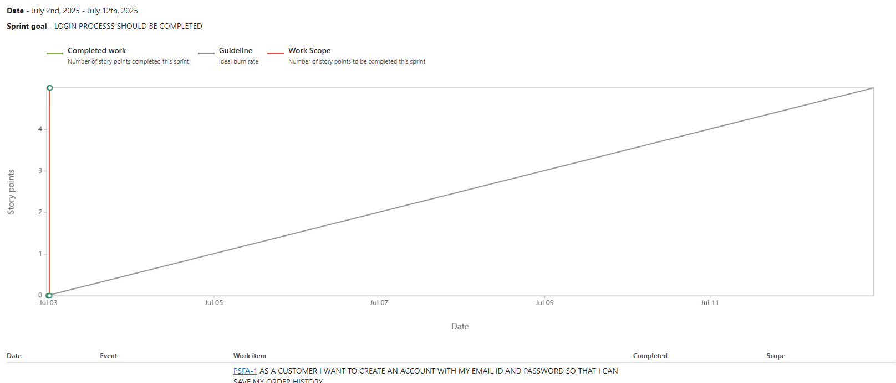

Sprint burndown chart -

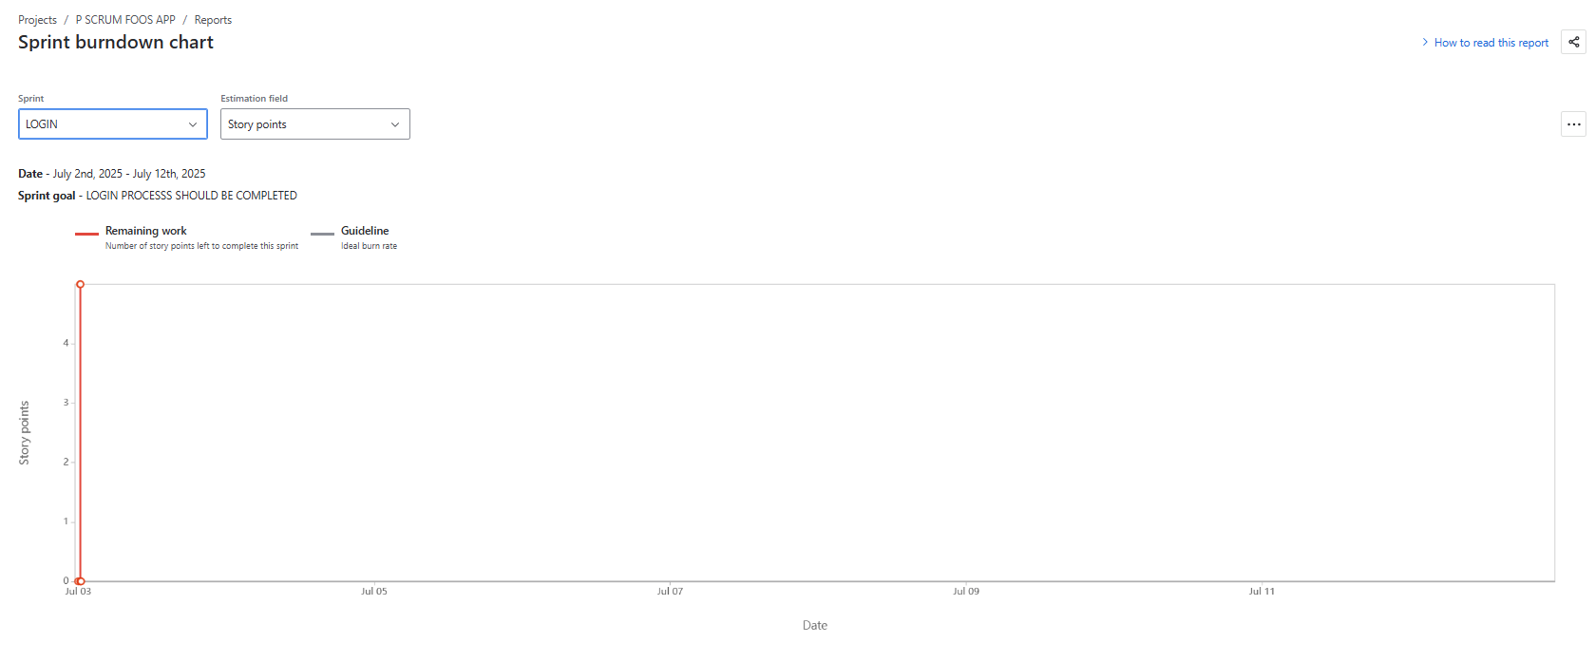

Sprint 2
TRACKING-
BURNUP CHART

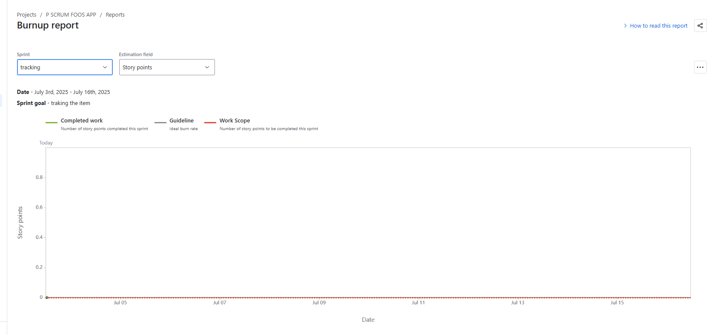

Sprint burndown chart
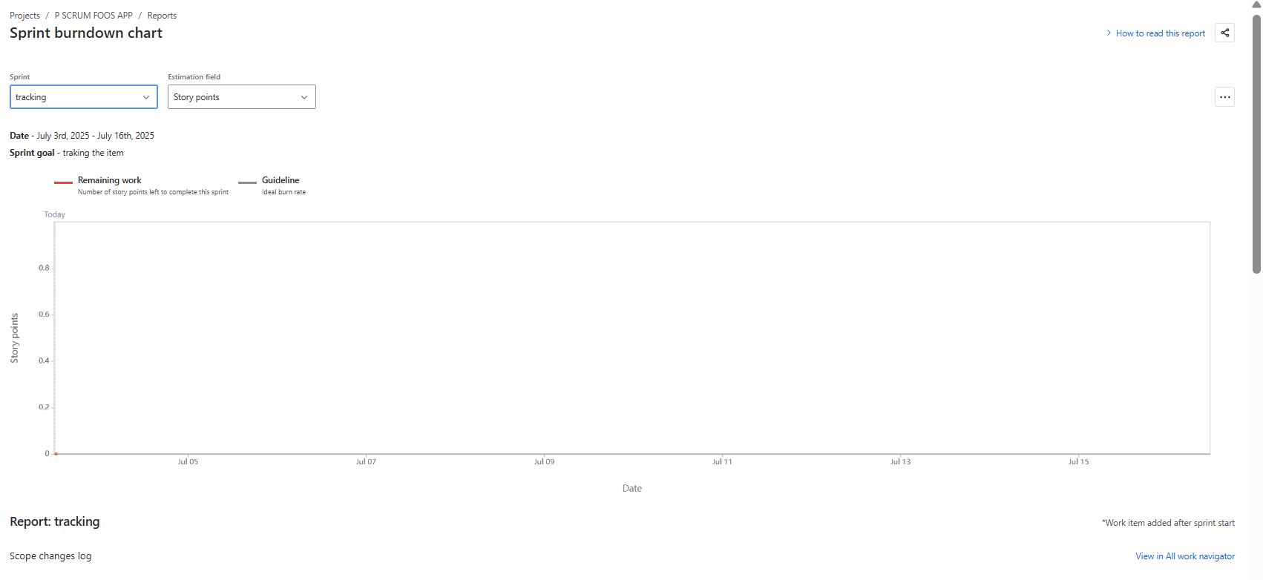

QUESTION – 10
Explain about Product Grooming?
Product grooming in scrum is a key ongoing activity that ensures the product backlog is well organized, clear and prioritized so the team can efficiently plan and deliver work in upcoming springs
Product grooming is the process of
- Reviewing items in the product backlog
- Clarifying requirements or user stories
- Breaking down large items into smaller, actionable tasks like epics into stories
- Prioritizing based on value,risk and dependencies
- Estimating efforts
- Ensuring readiness of item for future sprint planning
The benefits of product grooming is keeping the backlog clean and actionable, it prevents last minute confusion during sprint planning, it improves team alignment and shared understanding, it leads to better sprint forecasts and delivery predictability.

QUESTION 11
Explain role of the scrum master and product owner
SCRUM MASTER-
The scrum master is responsible for ensuring that the scrum process is understood and followed, he is like servant leader who helps the team to work efficiently by removing the obstacles and fostering a productive environment
KEY REPONSIBILITIES :
- He will facilitate scrum process by
. Sprint planning
. Daily scrum meeting (stand up meeting)
. Sprint review
. Sprint Retrospective meeting

- Remove impediments
Helps resolve blockers or issues that slows down project

- Coach the team
.Teach scrum principles
.Guide the team towards self-organization and continuous improvement
- Shield the team
. Protect team from outside interruptions or distractions
- Work with product owner
. Help to manage the backlog
. Ensure backlog items are clear and ready for sprint planning
- Foster collaboration
. encourage healthy communication between team members and stakeholders

PRODUCT OWNER
The product owner is responsible for maximizing the value of the product by managing the product backlog , he acts as a bridge between the business needs and the development team.
Key responsibilities
- Define and prioritize work
. create and maintain the product backlog
. prioritize items basd on the business value , risk and need.

- Clarify requirements
. provide clear and detailed user stories or backlog items
. Be available to answers team questions

- Represents stakeholders
. Acts as the voice of the customers
. gather feedback and requirements from stakeholders and also consider stake holders interest.

- Accept work
. accept or reject completed stories in sprint review
. Continue or discontinue the development.
.whether to ship the product or not.

- Set product vision
. define goals and long term strategy for the product.

QUESTION – 12
Explain all meetings conducted in the scrum project
-Sprint planning meeting
This happens at the beginning of the each sprint and team decides on what they will deliver in this sprint ( sprint goal) and how will we do the work ( plan the tasks)
The output of the meeting is sprint goal and sprint backlog items and plan.
The participants are Scrum master , Product owner, Development team
-DAILY SCRUM MEETING (STAND-UP)
This happens daily usually at the same time and place to inspect progress and team activities
The participants are scrum master, product owner, development team.
The team will just answer this three questions
- What did you do today ?
- What will you do tomorrow?
- Is there any impediments that slowing or stopping you ?

SPRINT REVIEW MEETING-
This meeting happens at the end of the sprint
The participants are scrum team , product owner , scrum master , development team and key stakehoders
In this meeting the team will demo the completed stories to product owner and get it cleared.

SPRINT RETROSPECTIVE MEETING
This meeting happens after the sprint review meeting and before the next sprint planning meeting
This participate in this meeting are only the scrum team
This is to reflect on the sprint nad identify improvements for the next sprint
In this the team will answers this three questions
- What went well in the sprint?
- What did not go well?
- What are the required areas of improvements in next sprint?

QUESTION – 13
Explain sprint size and scrum size?

- Sprint size
The sprint size refers to the duration of the sprint that is how long each iteration lasts
The duration of the sprint would be for
.1week, 2 weeks the most common, 3 week and maximum 4 weeks not more than that allowed in scrum
The duration of the sprint size is decided by Team maturity and experience, project complexity and risk and stake holders availability.

- Scrum size
The scrum size is refers to the size of the scrum team, project resources are grouped as the scrum teams. which is made up of:
. Product owner
. Scrum master
. Developers (development team)
Each team size will on average be 7-8 members . if team is larger than 10, scrum recommends splitting into multiple scrum teams each working on the same product but focus different areas.
The reason why the scrum team size been smaller is easy communication and quicker decision.

QUESTION – 14
EXPLAIN DOR AND DOD?
In the scrum the DOR stand for Definition of Ready and DOD stands for Definition of Done are important agreements that ensure clarity and quality during the product development process.
- Definition of Ready
It is a check list or a set of criteria that a product backlog item like user story or tasks must meet before the development team can work on it , like is this work item is ready to be picked up in the sprint.
Example –
. The story is clearly defined and understood by the team
. It has acceptance criteria
. Dependencies are identified and resolved
. No blockers

- Definition of done
It is a shared understanding of what it means for work to be complete like can we say this is 100 percent done and potentially shippable
Example –
. Documentation is completed
. Code is unit tested
. Bug free
. Feature is functionally tested

Question – 15
- Explain Prioritization techniques and MVP?

In the scrum the prioritization techniques helps the product owner and it is used in business analysis and software development to reach a common understanding with the stake holders on the importance they place on the delivery of each requirement also known as MOSCOW prioritization or MOSCOW analysis
The Moscow stands for must, should, could and would
- Must have this requirement to meet the business needs.
- Should have this requirement if possible, but project success does not rely on it.
- Could have this requirement if it does not affect anything else in the project
- Would like to have this requirement later, but it wont be delivered this time.

MVP
The MVP stands for Minimum Viable Product in the scrum it is s smallest possible version od a product that :
. Delivers enough value to early adopters
. Can be shipped at the end of one or few sprints
. Allows the team to validates assumptions with real feedback
The MVP will aligned with the product goal and it is delivered and reviewed through sprint reviews

QUESTION 16
Difference between product owner and business analyst ?
The difference between the product owner and business analyst
PRODUCT OWNER | BUSINESS ANALYST
- Owns the product vision and the product backlog  - Official role in scrum  - He prioritize the backlog  - He will accept or reject work  - He is like driver of car | - Gathers, analyses and documents the business requirements  - Not an official role but he can work within  - He will gather the requirements  - He will translate needs into user stories  - He is like navigator

Question – 17
Prepare a sample resume of 3years experience of product owner ?

RESUME

Name : RALLABANDI PRADEEP CHARY
Phone : 9963501487
Email : rallabandipradeep004@gmail.com
Location: Hyderabad, India.

Professional summary
Results – driven owner with 3 years of experience driving product strategy and development in Agile environments, Skilled in defining product roadmaps, gathering the user requirements, prioritizing features and collaborating with cross functional teams to deliver high impact digital solutions. Proven success in launching scalable products that improve customer experience and meet business goals.

Core Competences
. Product Road mapping & Strategy
. Agile & Scrum Methodology
. User Story Writing
. Stake holder Communication
. Sprint Planning & Review
. Data -Driven Decision Making.

Professional Experience

Associate Product owner
X4Z Technology Pvt. Ltd – Hyderabad, India
June 2022 – Present
Domain: E- commerce

. Assisted the senior PO in managing the backlog of a high-traffic e-commerce web application
. Coordinated with cross-functional teams to refine requirements and ensure timely feature delivery.
. Wrote detailed user stories and acceptance criteria , supporting multiple product releases.
. Supported UAT efforts and ensured alignment between development output and stakeholder expectations

Education

Bachelor of Commerce (B.Com)- computers
Osmania university Hyderabad.
Graduated – 2020

Certifications:

Certified Scrum Product Owner (CSPO)- Scrum Alliance .

Tools & Technologies

Microsoft excel, JIRA, Powe Bi, Tableau, SQL (basic).

Languages

English (Fluent)
Telugu (Native)
Hindi (Conversational)

Declaration

I here by declare that the information mentioned above is true to the best of my knowledge

Place: Hyderabad
Date:
(R. PRADEEP CHARY)

