Q1. Draw a Use Case Diagram
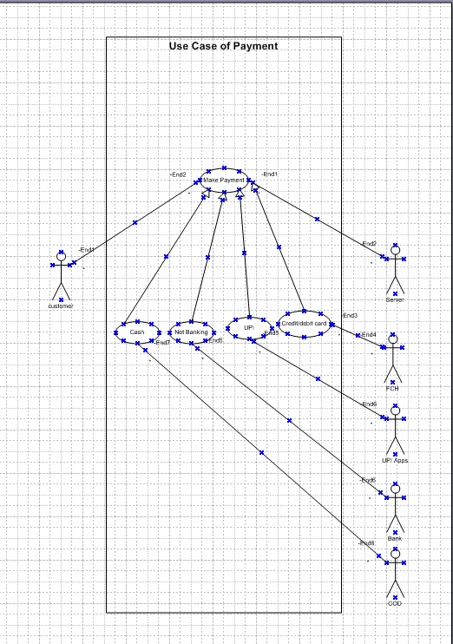

Q2. Derive Boundary Classes, Controller classes, Entity Classes.
Boundary Classes:
The Boundary class is a class that is the boundary of the system and other system or user (which is actor in the use case diagram).
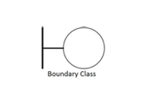
Customer Payment BC()
Server payment BC

Cod by payment cashBC()
FCH by Credit/debit BC()

Apps by UPI BC()

bank by NB BC()

Controller Class:
This class is a class to achieves use cases in the Use case diagram.

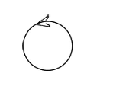
Payment CC()

Entity Classes:
The Entity class is a class that has data.

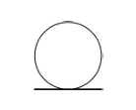
Cust EC()

Server EC()

FCH EC()

Bank EC()

UPI App EC()

COD EC()
Q3. Place these classes on a three tier Architecture
Application layer:
Customer Payment BC()

Payment CC()
Server payment BC

Cod by payment cashBC()

Business Logic layer:

FCH by Credit/debit BC()

Apps by UPI BC()

bank by NB BC()
Data Layer:

Cust EC()

Server EC()

FCH EC()

Bank EC()

UPI App EC()

COD EC()

Q4. Explain Domain Model for Customer making payment through Net Banking
Domain Model
Each Participating Class will do an action part.
All these Classes and their Action Parts together will achieve one task or Functionality.

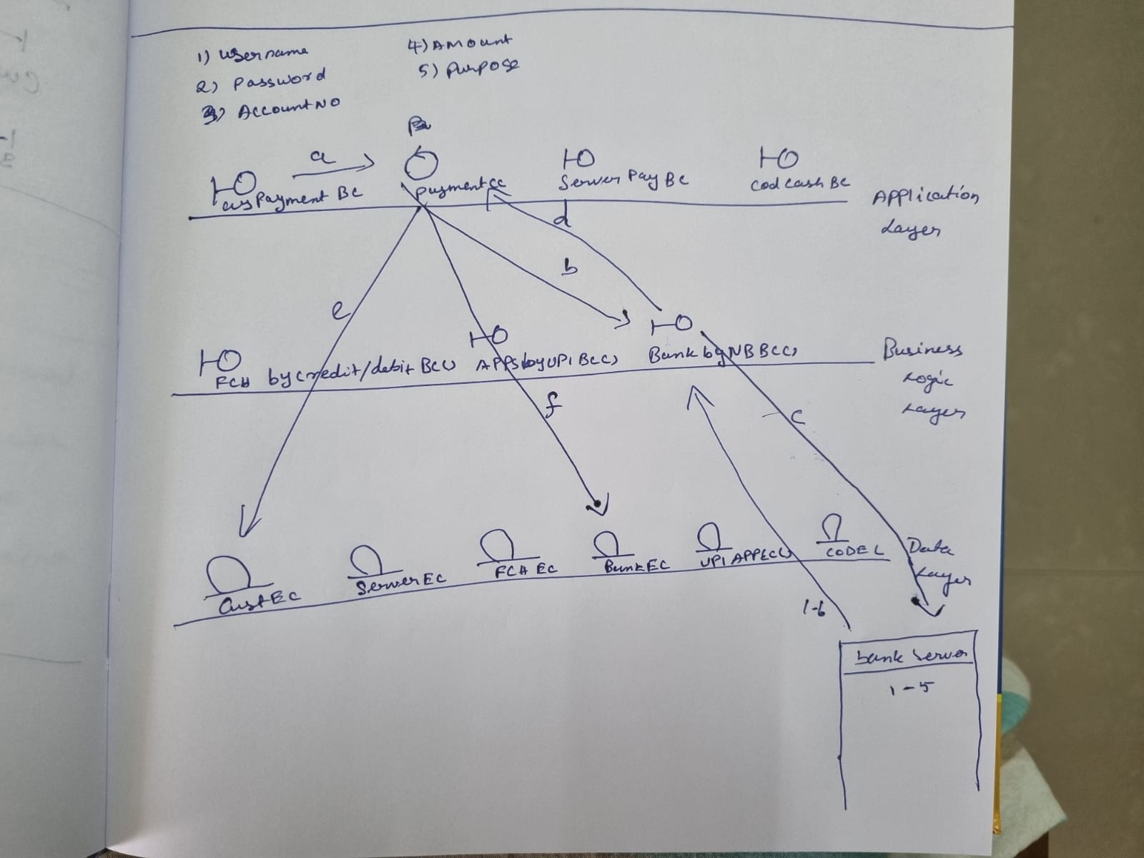

Q5. Draw a sequence diagram for payment done by Customer Net Banking

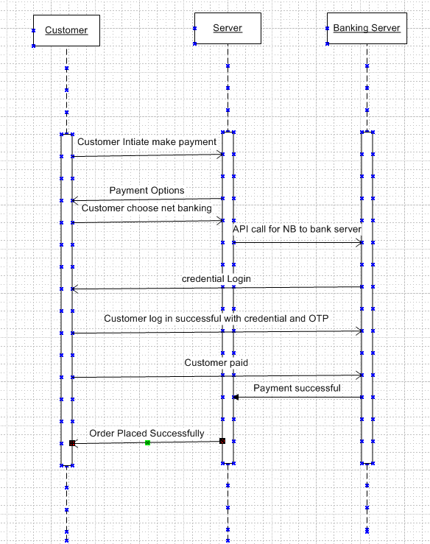

Q6. Explain Conceptual Model for this Case
Conceptual Model
CustomerMaking Payment
Card, NB, UPI, Cash
all possibilities of doing these transactions
Frequency
Volumes
Value
Geographical distribution
Entire Information together
we call it as Conceptual Model

Q7. What is MVC architecture? Explain MVC rules to derive classes from use case diagram and guidelines to place classes in 3-tier architecture
- The Model-View-Controller (MVC) framework is an architectural pattern that separates an application into three main logical components Model, View, and Controller.
- View - Represents the presentation layer of the application.
- Model - Represents the data and the business logic of the application.
- Controller - Acts as an intermediary between Model and View.
MVC architecture
Entity Class
Data base classes ,
Persistent class ( Back end designers)

Controller Class
Transient Class (Given to Front end designers)

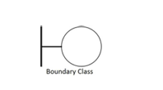
Boundary Class
(or) FORM Class

MVC Architecture Rules
1. Combination of One Actor and an use case results in one Boundary class
2. Combination of Two Actors and an use case results in two Boundary classes
3. Combination of Three Actors and an use case results in Three Boundary classes and so on....
Note: only one primary actor is to be considered with a use case.
4. Use case will result in a controller class
5. Each Actor will result in one entity class

Guidelines to place identified MVC Classes in a 3 Tier Architecture
➢Place all Entity Classes in DB Layer
➢Place Primary Actor associated Boundary Class in Application Layer
➢Place Controller Class in Application Layer
➢If governing Body influence or Reusability is there with any of remaining Boundary Classes , place them in Business Logic Layer else place them in Application Layer

Classes in 3-tier architecture:

Application layer:
Customer Payment BC()

Payment CC()
Server payment BC

Cod by payment cashBC()

Business Logic layer:

FCH by Credit/debit BC()

Apps by UPI BC()

bank by NB BC()
Data Layer:

Cust EC()

Server EC()

FCH EC()

Bank EC()

UPI App EC()

COD EC()

Q8. Explain BA contributions in project (Waterfall Model – all Stages)
Stages | Activities | Artifacts & Resources
Requirements Gathering | 1. Stakeholders identify and document  2. Client gives BRD or BA prepares BRD by interacting with Client –Brainstorming , Document Analysis, Reverse engineering, Interviews, workshops, Focus Groups, Observation, Questionnaires .  3. Prototyping can be used by BA to make the Client to give more specific requirements | BRD  (Business Requirements  Document)
Requirement s Analysis | 1. Draws UML Diagrams ( Usecaseand Activity Diagrams)  2. Prepares Functional Requirements from Business  Requirements  3. All Architects comes up with Technical Requirements  (SSD)  4. SRS will have Functional Requirements and Technical  Requirements  5. BA prepared RTM from SRS before Design phase starts.  (BA is the owner of RTM). | Functional Requirements  Specification  SSD(Supplementary  Support Document)  SRS (Software  Requirements  Specification)  RTM (Requirements  Traceability Matrix)
Design | 1. From UsecaseDiagram , Test Manager or BA will prepare  Test Cases  2. Communicates with Client on the design and Solution  documents (updates Status to Client and make them  understand how the solution would look like to prepare  them to drive UAT)  3. BA will initiate the preparation of End user manuals  4. updates RTM  5. From Use case Diagram Solution-Architect recommends  Architecture of the IT solution  6. DB Architect uses Persistence Classes (Entity Classes) and  comes up with ER Diagrams or DB Schema. | Solution Document  Design Document –HDD –ADD
Coding | 1.BA organizes JAD Sessions  2. BA clarifies queries of Technical Team during Coding  3. Developers refer Diagrams and Transient  (Controller Classes) of BA and code their unit  4. Update End user manuals  5. Update RTM | LDD –CDD  Application
Testing & UAT | 1.BA-Prepares Test Cases from Use Cases or assists  Test Manager to do so  2. BA performs high level testing  3. BA prepares Client for UAT  4. Test Data is requested by BA from Client  5. Updates End User Manuals  6. Updates RTM | Test Concerning  Documents  Application with less  errors
Deployment  and  Implementati  on | 1.Forwards RTM to Client or the PM which should be  attached to the Project Closure Document  2. Coordinates to complete and share End User  Manuals  3. Plans and Organizes Training Sessions for End Users  4. Prepares Lessons learned from this project (to take  precautions for coming projects) | Project closure Document

Q9. What is conflict management? Explain using Thomas – Kilmann technique

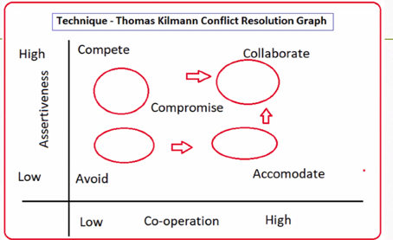

X Axis- Co-operation, Y Axis- Assertiveness
5 Options of Conflict Management
➢ Competing: When the co-operation is low and the assertiveness is high conflict will be competing.
➢ Avoiding: When the co-operation is low and assertiveness is low the conflict is Avoid
➢ Accommodating: The assertiveness is low and the co-operation is high the conflict is accommodating
➢ Collaborating: The assertiveness is high and the co-operation is high the conflict is collaborating
➢ Compromising: When the co-operation is average and assertiveness is average the conflict is Compromising.
Q10. List down the reasons for project failure
Reasons for Project Failures
➢Improper requirement gathering
➢Continuous change in requirements
➢Lack of user involvement
➢Lack of executive support
➢Unrealistic expectation
➢Improper planning
Q11. List the Challenges faced in projects for BA
The Challenges faced
• Obtaining sign-off on requirement
• Change Management- with respect to cost and timelines
• Coordination between developers & testers
• Conducting meetings
• Driving client for UAT completion
• People Management (coordinating with different people and different teams)
Q12. Write about Document Naming Standards
Document Naming Standards All documents will be named using some standards like [ProjectID][Document Type]V[X]D[Y].ext
Example:
PQ786-BRD-V1-D1.docx 1.1.
PQ786-BRD-V1-D2.docx 1.2.
PQ786-BRD-V1-D3.docx 1.3.
PQ786-BRD-V2-D1.docx 2.1.

Q13. What are the Do’s and Don’ts of a Business analyst
Sr. No. | DO’S | DON’TS
1 | Consult an SME for clarifications in requirements. | Never say NO to the client.
2 | Go to the client with a plain mind with no assumptions. Listen carefully and completely until the client is done, and then you can ask queries. | There is no word as “By default”.
3 | Try to extract maximum leads to the solution from the client himself. | Never imagine anything in terms of GUI.
4 | Concentrate on the important requirements. | Don’t interrupt the client when he is giving you the problem.
5 | Question the existence of existence./ Question everything. | Never try to give solutions to the client straight away with your previous experience and assumptions.

Q14. Write the difference between packages and sub-systems
Packages | Subsystems
Collection of components which are not reusable in nature. | Collection of components which are reusable in nature.
Ex : Application development companies work on Packages. | Ex: Product development companies work on Sub systems.

Q15. What is camel-casing and explain where it will be used-
- Camel-casing is a naming convention used in computer programming.
- It is used for naming variables, functions, and identifiers.
Example:
- CamelCase: camelCaseExample
In Camel casing, the first words starts with a lower case letter and each subsequent word begins with an uppercase letter.

Q16. Illustrate Development server and what are the accesses does business analyst has?

- A development server refers to a dedicated environment or server that is used during the software development process.
- It provides a platform for developers and testers to build, test and debug applications before they are deployed to a production environment.
- As a BA, we have only limited access only.

Q17. What is Data Mapping
- Data mapping is the process of matching fields from one database to another.
- Data mapping bridges the differences between two systems, or data models.
- Data mapping has been a common business function for some time.
- Data mapping is an essential part of many data management processes.
- Data mapping is an essential part of ensuring that in the process of moving data from a source to a destination.
Q18. What is API. Explain how you would use API integration in the case of your application Date format is dd-mm-yyyy and it is accepting some data from Other Application from US whose Date Format is mm-dd-yyyy
- An API, or Application Programming Interface, is a set of rules and tools that allows different software applications to communicate with each other.
- It defines the methods and data formats that applications can use to request and exchange information.
