Mock 4

Assignment 1
- Please make a BRD which can be presented to the client along with a complete development and resource plan.
Business Requirement Document (BRD)
Project Name: Inventory Management and Delivery Optimization System
Project Name: Inventory Management and Delivery Optimization system
Project ID: IDOS-XXX-2025
Version ID: 1.0
Author: Business Analyst – Piyush Chaudhary
Approvals -
ROLE | NAME | TITLE | SIGNATURE | DATE
Project Sponsor |  | Head of Inventory
Business Owner |  | Director of Operations
Project Manager |  | Project Manager
System Architect |  | System Architect
Development  Lead |  | Lead Developer
User Experience  Lead |  | UX Designer
Quality Lead |  | QA Manager
Content Lead |  | Content Strategist

RACI chart -
Activity | Project Manager | BA | Developer | QA | Client
Requirements Gathering | A | R | C | C | I
Design | A | R | C | I | C
Development | A | C | R | I | I
Testing | A | I | C | R | I
Deployment | A | C | R | C | I
Approval & Sign-Off | R | C | I | I | A

- Introduction
The purpose of this document is to outline the requirements for developing a software system that manages inventory across multiple manufacturing plants and warehouses while optimizing delivery routes for ice-cream and milk products.
2. Business Goals
- Improve operational efficiency through accurate inventory management.
- Enhance customer satisfaction by ensuring timely delivery of products.
3. Business Objectives
- Real-time visibility into stock levels across locations.
- Reduce order processing and delivery time.
- Minimize inventory holding and transportation costs
4. Business Rules
- Inventory must be updated in real-time for every transaction.
- Orders must be routed to the nearest warehouse with sufficient stock.
- Delivery must prioritize perishable items.
5. Background
The company operates multiple manufacturing plants and warehouses across the country to produce and distribute ice cream and milk products. However, the current processes and systems face several challenges, including:
- Inefficient Inventory Management:
  - Lack of real-time stock updates across warehouses leads to overstocking in some locations and stockouts in others.
  - Manual tracking processes result in data discrepancies and delays in identifying inventory levels.

- Delivery Delays:
  - Delivery routes are manually determined without optimization, causing increased transit times and higher logistics costs.
  - Perishable items often fail to reach customers in time, leading to spoilage and customer dissatisfaction.
- Limited Visibility:
  - Decision-makers lack access to detailed, real-time reports on stock movements and delivery performance.
  - Poor integration between inventory and logistics systems hinders coordination.
- High Operational Costs:
  - Inefficient inventory distribution and unoptimized delivery routes increase fuel and storage expenses.
  - Lack of predictive insights leads to last-minute decisions, increasing operational inefficiencies.

6.Project Objective
The primary objective of this project is to design and implement a centralized software solution that efficiently manages inventory and optimizes delivery operations for the company’s ice cream and milk product distribution network. The system will align with the business objectives of improving operational efficiency, reducing costs, and enhancing customer satisfaction.
High-Level Product Goals:
- Comprehensive Inventory Management:
  - Provide real-time tracking of stock levels across manufacturing plants and warehouses.
  - Enable automated alerts for low stock levels, expirations, and reorder requirements.
- Delivery Optimization:
  - Implement a route optimization engine to minimize delivery times and costs.
  - Ensure timely delivery of perishable products to prevent spoilage and customer dissatisfaction.
- Integrated Reporting and Analytics:
  - Generate insights into stock movements, sales trends, and delivery performance.
  - Enable data-driven decision-making through interactive dashboards and reports.

Alignment with Business Objectives:
- Objective 1: Operational Efficiency:
Streamline inventory processes and minimize manual interventions to reduce errors and waste.
- Objective 2: Cost Reduction:
Optimize delivery routes and reduce transportation costs.
- Objective 3: Customer Satisfaction:
Enhance delivery speed and reliability, improving overall service quality and brand reputation.
Requirements for Interaction with Other Systems:
- ERP Integration:
  - Seamless integration with the company’s existing ERP system to sync financial, procurement, and production data.
- Logistics Partner Systems:
  - Connect with third-party logistics systems for vehicle tracking and delivery status updates.
- Notification and Alert Systems:
  - Integration with email and SMS gateways for automated alerts to stakeholders.

7.Project Scope
In-Scope Functionality
The following functionalities will be included in the current project:
- Real-time tracking of inventory across manufacturing plants and warehouses.
- Automated alerts for low stock levels and expiration of perishable goods.
- Delivery route optimization for faster and more cost-effective logistics.
- Integration with third-party logistics systems for real-time delivery tracking.
- Centralized dashboard for reporting and analytics (stock levels, delivery efficiency).
- Role-based access for administrators, logistics teams, and warehouse staff.

Out-of-Scope Functionality
The following functionalities are excluded from the current project:
- Mobile application for end customers.
- Integration with external e-commerce platforms.
- Advanced AI-based demand forecasting.
- Vendor management and supplier tracking.

Assumptions
- All warehouses and manufacturing plants will have stable internet connectivity.
- Accurate initial data migration will be provided for inventory levels.
- The existing ERP system supports integration through APIs.
- Users will receive adequate training to use the new system.

8. Constraints
- Budget limitations may restrict the addition of certain advanced features.
- The project must be completed within six months.
- The system must be compatible with existing legacy infrastructure.
- Limited time for stakeholder availability during the requirement gathering phase

9. Risks
Technological Risks
- Risk: Integration challenges with legacy systems.
- Impact: High
- Strategy: Mitigate by conducting a technical feasibility study and building a robust integration layer.
- Risk: System downtime during migration or deployment.
- Impact: High
- Strategy: Mitigate by scheduling migration during non-peak hours and maintaining a backup plan.
Skills Risks
- Risk: Shortage of skilled developers for new technology implementation.
- Impact: Medium
- Strategy: Mitigate by hiring consultants or upskilling existing team members.
Political Risks
- Risk: Resistance to change from internal stakeholders.
- Impact: Medium
- Strategy: Mitigate through stakeholder engagement and change management practices.
Business Risks
- Risk: Failure to meet delivery timelines, affecting customer satisfaction.
- Impact: High
- Strategy: Mitigate by setting realistic milestones and contingency planning.
Requirements Risks
- Risk: Misinterpretation of business requirements during the initial phase.
- Impact: High
- Strategy: Avoid by conducting multiple requirement validation workshops.

Other Risks
- Risk: Vendor delays in providing necessary software licenses.
- Impact: Medium
- Strategy: Mitigate by procuring licenses in advance and having alternate vendors.

10.Business Process Overview
The Inventory and Delivery Management System is designed to streamline and optimize the company's operations, addressing the challenges faced in inventory tracking and delivery logistics. Below is an overview of the current business process (AS-IS) and the proposed system (TO-BE).

Legacy System (AS-IS)

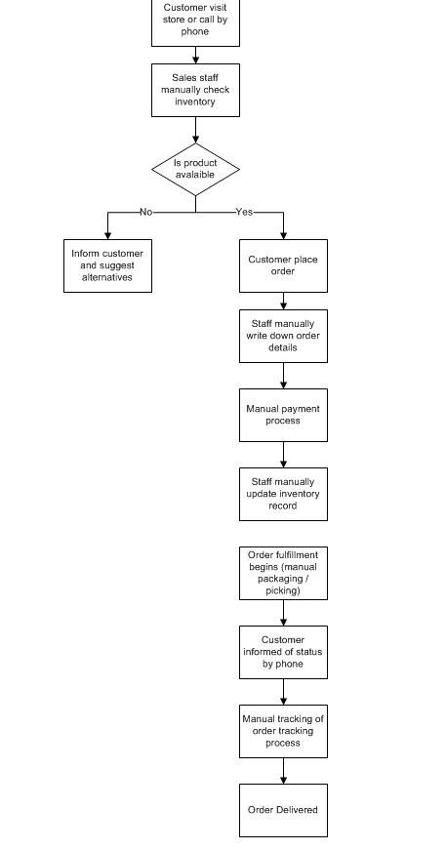

Proposed Recommendations (TO-BE)
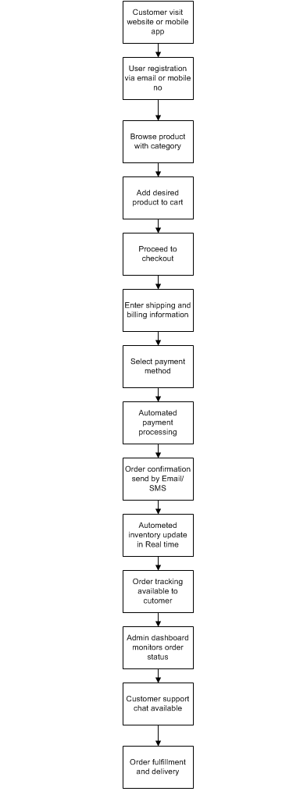

Challenges in AS-IS Process:
- Lack of real-time inventory visibility.
- Inefficient delivery route planning.
- High operational costs due to overstocking or understocking.
- Poor coordination between manufacturing plants and warehouses

Benefits of TO-BE Process:
- Improved accuracy in inventory tracking.
- Faster, more reliable delivery of products.
- Reduced spoilage and logistics costs.
- Enhanced decision-making through actionable insights.

Business Requirements
Req Id | Req name | Req Description | Priority
BR001 | Real-Time Inventory Tracking | Enable real-time tracking of inventory levels across manufacturing plants and warehouses. | 10
BR002 | Automated Reorder Alerts | Generate automated alerts for low stock levels, impending expirations, and reorder points. | 9
 | Delivery Route Optimization | Use an AI-based route optimization tool to minimize delivery times and costs while considering real-time traffic data. | 9
  BR003
BR004 | Integration with Logistics Systems | Integrate the system with third-party logistics tools to enable real-time delivery vehicle tracking and status updates. | 8
BR005 | Centralized Reporting Dashboard | Provide a dashboard for real-time visibility into inventory levels, delivery metrics, and sales trends. | 9
BR006 | Demand Forecasting | Use predictive analytics to forecast inventory demand based on historical sales and seasonal trends. | 8
BR007 | User Role Management | Implement role-based access control for administrators, warehouse staff, and delivery teams. | 9
BR008 | Compliance Tracking | Ensure the system adheres to food safety and industry compliance standards for inventory and delivery operations. | 7
BR009 | Order Allocation Automation | Automate order allocation by identifying the nearest warehouse with sufficient stock for quicker processing. | 6
BR010 | Scalability and Future Readiness | Ensure the system can scale to accommodate additional warehouses, delivery routes, and users as the business grows. | 8

- Prepare process flow diagram using your imagination

Inventory management –

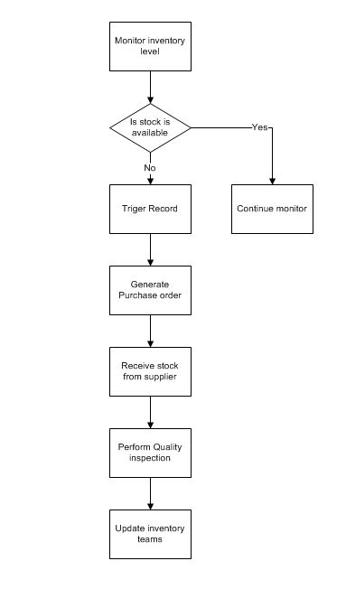

Delivery management –
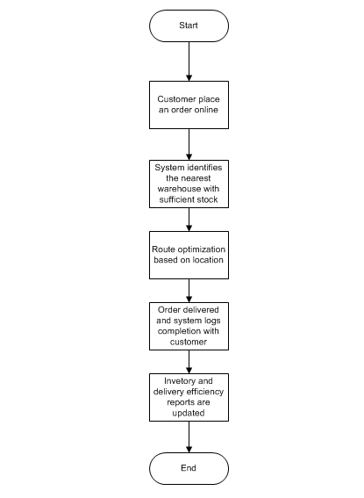

Assignment 2:

1. Write an introduction letter to a client introducing yourself as a business analyst in charge of working with the client and his team to start the business understanding process.

Answer: Introduction Letter to Client

To,
The Client,

Subject: Introduction as Business Analyst for Inventory and Delivery Optimization System (IDOS)

Dear Client,

I hope this message finds you well.
My name is Piyush Chaudhary, and I have recently been assigned as the Business Analyst for your project. I will be your primary point of contact for understanding your business requirements, gathering functional details, and ensuring that our solution aligns with your organization’s goals and expectations. As part of the business understanding phase, I’ll be working closely with you and your team to:
- Gain a detailed understanding of your current processes and challenges.
- Identify key objectives and success metrics for the proposed solution.
- Document and validate requirements to form the foundation of a clear, actionable roadmap for the project.

I look forward to collaborating with you and your stakeholders to ensure we capture every critical aspect of your operations and deliver a solution that meets your strategic needs.

Please let me know a convenient time for our discovery meeting so we can initiate this process together.

Thank you for your time and cooperation. I’m excited to begin this engagement and contribute to the success of your project.

Warm regards,
Piyush Chaudhary
Business Analyst
Piyushchaudhary013@gmail.com
Contact No - 8435877136

2. Prepare a brief BRD and SRS for a project- Horoscope or Ticketing system or online store.
Project Name: Online Store Development
Project Name: Online Store Development
Project ID: OSD-XXX-2025
Version ID: 1.0
Author: Business Analyst – Piyush Chaudhary

Approvals -
ROLE | NAME | TITLE | SIGNATURE | DATE
Project Sponsor |  | Head of Project
Business Owner |  | Director of Operations
Project Manager |  | Project Manager
System Architect |  | System Architect
Development  Lead |  | Lead Developer
User Experience  Lead |  | UX Designer
Quality Lead |  | QA Manager
Content Lead |  | Content Strategist

RACI chart -
Activity | Project Manager | BA | Developer | QA | Client
Requirements Gathering | A | R | C | C | I
Design | A | R | C | I | C
Development | A | C | R | I | I
Testing | A | I | C | R | I
Deployment | A | C | R | C | I
Approval & Sign-Off | R | C | I | I | A

1. Introduction
The Online Store Development Project aims to build a robust e-commerce platform to enable customers to browse, search, purchase, and track orders seamlessly. The system will also empower the business to manage inventory, sales, and customer data effectively.
2. Business Goals
- Establish a scalable e-commerce platform to increase online sales revenue.
- Provide customers with an engaging and intuitive shopping experience.
- Streamline inventory management and order processing.

3. Business Objectives
- Enable secure online transactions and order tracking.
- Provide personalized product recommendations to customers.
- Ensure seamless integration with payment gateways and logistics partners.

4. Background
Current Issues/Problems:
- Lack of an online presence limits customer reach.
- Manual order handling is prone to errors and inefficiencies.
- Inventory management challenges lead to stockouts or overstocking.
- Difficulty in tracking customer preferences and generating actionable insights.

5. Project Objective
The objective of this project is to develop a user-friendly online store that aligns with the company's goals of expanding market reach, improving operational efficiency, and enhancing the overall customer experience. The system will interact seamlessly with existing inventory, logistics, and CRM tools.

6. Project Scope
6.1. In-Scope Functionality:
- Product browsing, search, and filtering features.
- Secure customer registration and login.
- Online payment integration with multiple gateways.
- Real-time inventory updates and stock availability.
- Order placement, tracking, and management.
- Personalized product recommendations using AI.
- Analytics dashboards for sales and inventory.
6.2. Out-of-Scope Functionality:
- Offline retail operations.
- Custom mobile app (optional in the current phase).
- Integration with third-party loyalty programs.
7. Assumptions
- Internet connectivity will be available to customers and the business.
- Existing product data is accurate and up-to-date for initial system setup.
- All necessary APIs from payment and logistics partners are functional and accessible.
8. Constraints
- The project must be completed within a six-month timeline.
- Budget limitations restrict the inclusion of certain advanced features.
- The system must be scalable but start with a defined inventory size and customer base.

9. Risks
Technological Risks
- Risk: Integration with payment gateways or third-party logistics APIs may fail.
    - Impact: High
    - Mitigation: Conduct integration testing early in the development cycle; ensure APIs have robust documentation.

- Risk: Performance issues with the online store under high traffic.
    - Impact: Medium
    - Mitigation: Implement load testing and scalable infrastructure during development.

Skills Risks
- Risk: Lack of expertise in AI-based recommendation system development.
    - Impact: Medium
    - Mitigation: Provide training or hire external consultants for specialized tasks.
- Risk: Resource unavailability during critical project phases.
    - Impact: High
    - Mitigation: Ensure resource allocation is secured and cross-train team members.

Political Risks
- Risk: Changes in business priorities or leadership decisions.
    - Impact: High
    - Mitigation: Align project goals with long-term business strategies and secure executive sponsorship.
- Risk: Regulatory changes affecting online sales.
    - Impact: Medium
    - Mitigation: Monitor regulatory updates and adjust compliance strategies as needed.

Business Risks
- Risk: Low adoption of the online store by customers.
    - Impact: High
    - Mitigation: Conduct market research and usability testing to ensure customer satisfaction.
- Risk: Project delay due to extended decision-making cycles.
    - Impact: High
    - Mitigation: Establish clear approval workflows and timelines.

Requirements Risks
- Risk: Misalignment between business goals and documented requirements.
    - Impact: High
    - Mitigation: Conduct regular stakeholder reviews and maintain a requirements traceability matrix.

- Risk: Incomplete requirement captures during discovery phase.
    - Impact: High
    - Mitigation: Use comprehensive elicitation techniques like workshops and interviews.

Other Risks
- Risk: Vendor delays in providing tools or software dependencies.
    - Impact: Medium
    - Mitigation: Establish contracts with clear deadlines and penalties for delays.

10. Business Process Overview
AS-IS Process Flow Diagram

Proposed Recommendations (TO-BE):
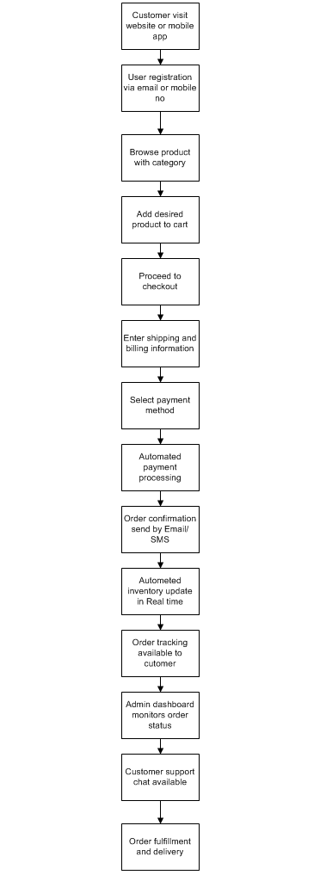

Business Requirements
Req Id | Req name | Req Description | Priority
BR001 | User Registration | The system must allow users to register and create personalized accounts with secure authentication methods. | 10
BR002 | Product Catalog | The system must display all available products with details such as price, description, and stock availability. | 9
 | Search and Filter | Users must be able to search for products using keywords and apply filters (e.g., category, price range, brand). | 9
  BR003
BR004 | Cart Management | The system must allow users to add, remove, or update items in their cart before checkout. | 8
BR005 | Order Placement | Users must be able to place orders, with the system validating stock availability and providing an estimated delivery date. | 9
BR006 | Payment Integration | The system must support multiple secure payment options, including credit/debit cards, wallets, and UPI. | 8
BR007 | Real-Time Inventory Update | The system must update inventory levels in real-time as orders are placed or cancelled. | 9
BR008 | Delivery Tracking | Customers must be able to track their orders in real-time with updates on estimated delivery times. | 7
BR009 | Customer Feedback and Support | The system must provide a ticketing mechanism for customers to report issues, give feedback, or request support. | 6
BR010 | Discounts and Promotions | The system must allow the application of discount codes or promotional offers during checkout. | 8

Software Requirement Specifications (SRS)
1. Introduction
The Online Store Development Project aims to build a robust e-commerce platform to enable customers to browse, search, purchase, and track orders seamlessly. The system will also empower the business to manage inventory, sales, and customer data effectively.
2. Business Goals
- Establish a scalable e-commerce platform to increase online sales revenue.
- Provide customers with an engaging and intuitive shopping experience.
- Streamline inventory management and order processing.

3. Business Objectives
- Enable secure online transactions and order tracking.
- Provide personalized product recommendations to customers.
- Ensure seamless integration with payment gateways and logistics partners.

Use Case Diagram –
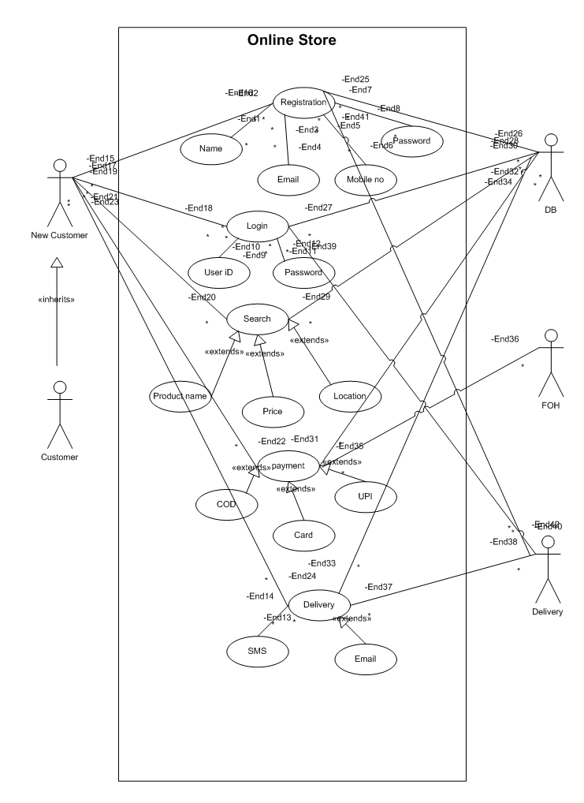

Activity Diagram –
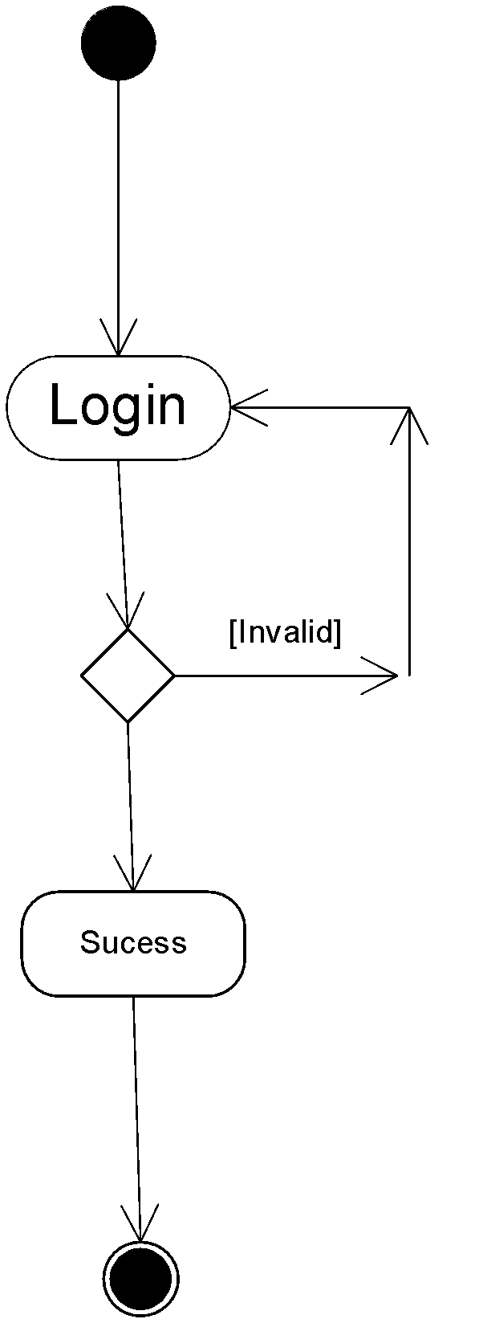

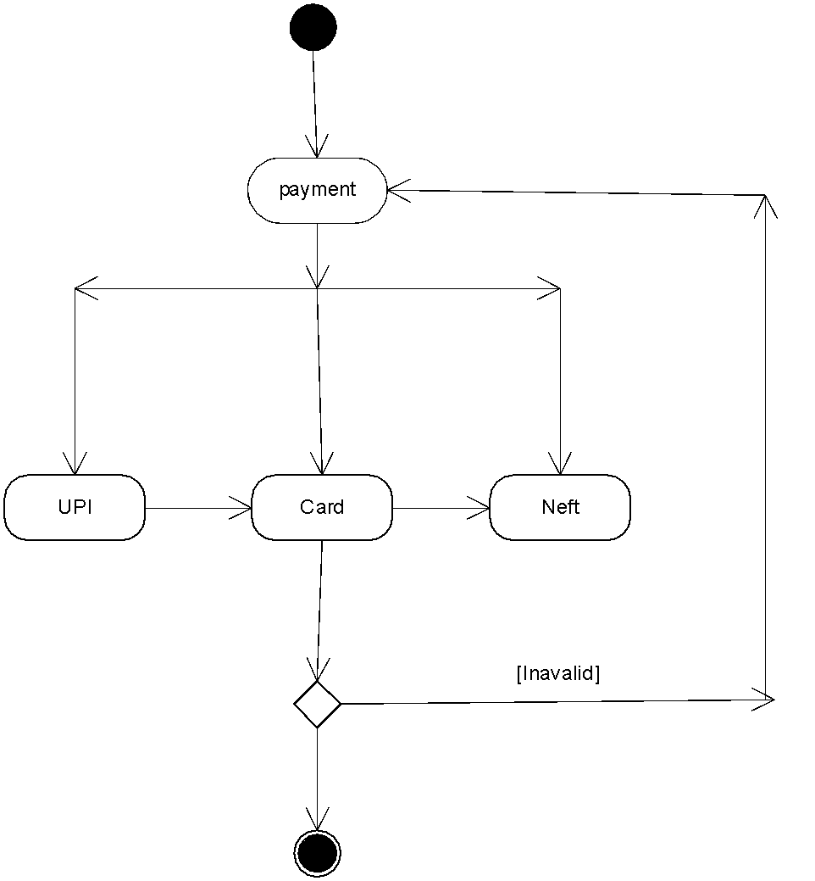

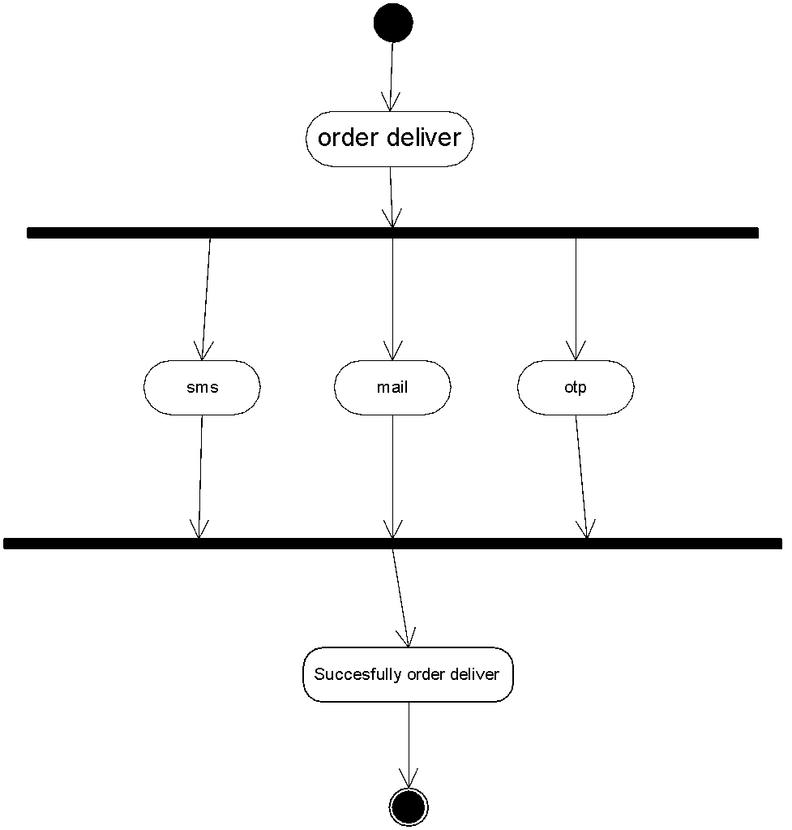

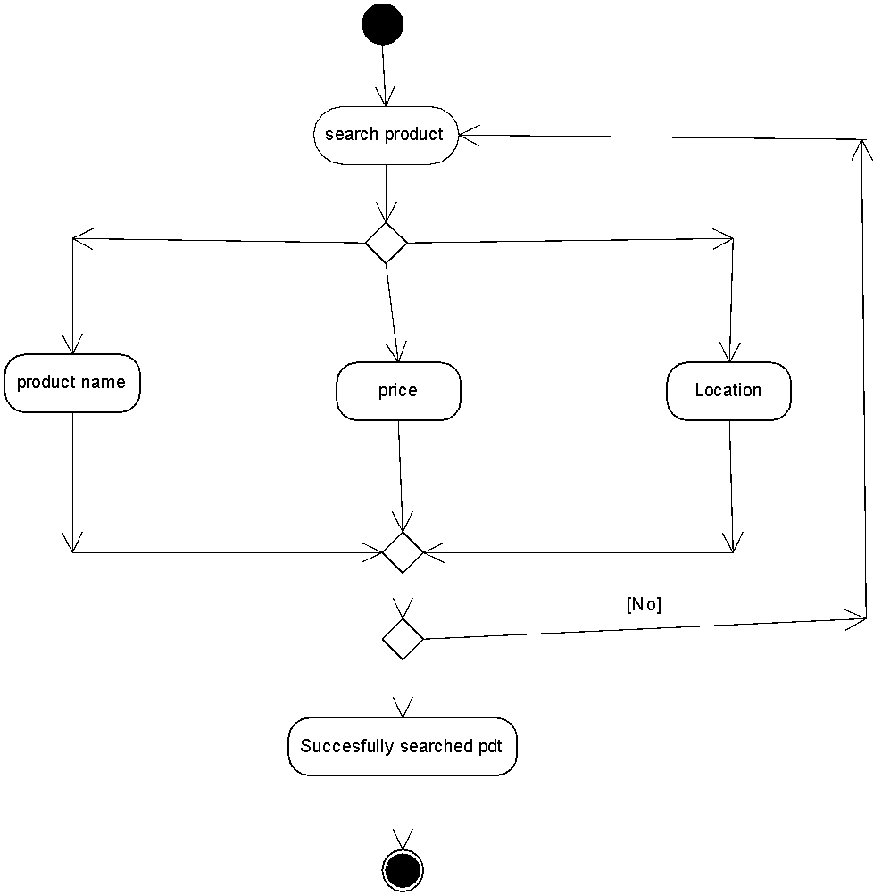
Use Case Spec – 1. Registration
Use case Name | User Registration
Use case Description | This use case describes how a new user creates an account in the online store management system by providing personal details, contact information, and login credentials. The system validates the inputs, verifies the email/phone number, and creates a new user profile to enable login and online shopping.
Actors | Primary Actors - New User / Customer  Secondary Actor - Online Store System & Email/SMS Service
Basic Flow | - User clicks on the “Register” or “Create Account” button.  - System displays the registration form.  - User enters personal details (name, email, mobile number).  - User creates a password and confirms it.  - User agrees to Terms & Conditions and Privacy Policy.  - User clicks on “Register / Sign Up”.  - System validates all inputs.  - System sends OTP or verification link to the provided email/mobile.  - User enters OTP or clicks verification link.  - System verifies the OTP/link successfully.  - System creates a new user account.  - System sends a confirmation message.  - User can now log in.  - Use case ends.
ALTERNATE FLOW | - user selects “Register with Google/Facebook/Apple”.  - System fetches verified email/profile info.  - System auto-creates account based on social data.
Exceptional flows | system detects invalid input.  Error message shown.  User corrects input.
Pre- Conditions | User must have access to a valid email address or mobile number.  Registration module must be active and functional.
post-conditions | A new user account is created in the system.  User receives a confirmation message via email/SMS.
Assumptions | The user has a stable internet connection.  User understands basic form-filling processes.
Constraints | Password must follow system-defined complexity rules.  Email and mobile number must be unique per user.
Dependencies | Email gateway for verification link.  SMS service provider for OTP.
Inputs and Outputs | Input – User id and Password  Output - Registration success message
Business Rules | All mandatory fields must be filled before submission.  Email/mobile must be unique and verified.
Miscellaneous Information | System should support multi-language forms.  Captcha may be required for security to prevent bots.
Use Case Spec – 2. Login
Use case Name | User Login
Use case Description | This use case describes how a registered user (customer/admin/seller) logs into the online store system using valid credentials such as email/mobile number and password. The system validates the credentials, authenticates the user, and grants access to their account.
Actors | Primary Actors - Registered User (Customer / Admin / Seller)  Secondary Actor - Online Store System, Authentication Service & Email/SMS Service
Basic Flow | - User opens the application and clicks on “Login”.  - System displays the login page.  - User enters email/mobile number.  - User enters password.  - User clicks on “Login” button.  - System validates input formats.  - System checks credentials against the stored database.  - System authenticates the user.  - System creates and stores a session/token.  - User is redirected to the dashboard.  - Use case ends.
ALTERNATE FLOW | - user selects “Login with Google/Facebook/Apple”.  - System fetches verified identity from provider.  - System authenticates user.
Exceptional flows | After multiple failed attempts account is locked.  System shows “Your account is locked. Reset password or contact support”.  Flow ends.
Pre- Conditions | User must be registered in the system.  User account must be active  Login page must be accessible
post-conditions | User is authenticated successfully  System starts a new session for the user.
Assumptions | User remembers their credentials.  Authentication system is available 24/7.
Constraints | Password must meet minimum complexity requirements.  Maximum login attempts allowed before account lock.
Dependencies | User registration module.  Database storing user credentials and session information.
Inputs and Outputs | Input – User id and Password  Output - Login success or failure message, User session/token
Business Rules | Only registered and active users may log in.  Email/mobile must be unique for each user.
Miscellaneous Information | Multi-language error messages may be supported.  CAPTCHA may be shown after multiple failed attempts.

Use Case Spec – 3. Search product
Use case Name | Search Products
Use case Description | This use case describes how a user searches for products in the online store by entering keywords, applying filters, or browsing categories. The system retrieves matching products from the catalog and displays the results. The use case includes flows for no results, invalid keywords, and advanced search options.
Actors | Primary Actors - User (Customer / Guest / Admin)  Secondary Actor - Product Catalog System & Search Engine / Indexing Service
Basic Flow | - User navigates to the website/app.  - User enters a keyword into the search bar (e.g., “shoes”, “laptop”).  - User clicks on the “Search” button or presses Enter.  - System validates the keyword input.  - System queries the product catalog/search index.  - System retrieves the list of matching products.  - System displays product results with price, image, rating, and availability.  - System displays applicable filters (brand, price range, categories).  - User optionally applies filters or sorting (e.g., price low to high).  - System updates the result list based on filter selection.  - User selects a product for more details (optional).  - Use case ends.
ALTERNATE FLOW | - User selects filters (brand, category) without entering keywords.  - System retrieves products based on filters.
Exceptional flows | User enters invalid characters or leaves search box empty.  System shows “Please enter a valid keyword”.
Pre- Conditions | User is on the website/app (login optional).  Product catalog is available and synced.  Search function is enabled.
post-conditions | System displays product search results.  Filters and sorting options are updated based on the result set.
Assumptions | User knows basic search behaviour.  Product catalog is kept up to date
Constraints | Search results must load within acceptable performance limits  Search queries may be rate-limited to prevent abuse
Dependencies | Product catalog database.  Search indexing service.
Inputs and Outputs | Input – Search keyword(s) and Category selection  Output - List of matching products, Filters and sort options
Business Rules | Search should consider product name, description, category, brand, and tags.  Autosuggestions should display high-demand or trending products.
Miscellaneous Information | Search should support spelling correction.  Mobile and desktop layouts should be consistent.

Use Case Spec – 4. Payment
Use case Name | Payment Process
Use case Description | This use case describes how a user completes the payment for their online order. It covers selecting a payment method, processing the transaction through a payment gateway, validating payment success or failure, and updating the order status accordingly. It also covers alternate payment methods like COD and exceptional situations like declined payments, timeouts, and gateway errors.
Actors | Primary Actors - Customer/User  Secondary Actor - Product Catalog System & Payment Gateway / Bank & Admin/Seller
Basic Flow | - Customer proceeds to checkout.  - Customer reviews the order summary (items, price, tax, shipping).  - Customer selects a payment method (card/UPI/net banking/wallet/COD).  - User clicks “Proceed to Pay”.  - System sends payment request to the payment gateway.  - Payment gateway prompts customer to authenticate (OTP, PIN, UPI approval).  - Customer completes authentication.  - Payment gateway validates and authorizes the transaction.  - Payment gateway sends success response to the system.  - System updates order status to Paid.  - System generates invoice and sends confirmation (SMS/email/app).  - Order is forwarded to warehouse for fulfilment.  - Use case ends.
ALTERNATE FLOW | - Customer selects wallet balance.  - System checks if wallet has enough balance.  - System deducts amount without contacting payment gateway.
Exceptional flows | Payment gateway returns “Declined” or “Insufficient Balance”.  System marks status as Payment Failed  System shows error message and allows retry.  Flow ends or returns to payment scree
Pre- Conditions | Customer must have items in the cart and order summary ready.  Customer must be logged in (unless guest checkout is allowed).  Payment gateway integration must be active and functional.
post-conditions | Payment is successfully authorized.  Order status changes to be Paid
Assumptions | User has stable internet connectivity during payment.  Payment gateway and banking systems are operational
Constraints | Session timeout limit applies during payment steps.  Maximum transaction amount may be capped by the store or gateway
Dependencies | Payment Gateway APIs.  Bank networks and UPI service providers
Inputs and Outputs | Input – Payment method selection and Card details (number, expiry, CVV)  Output - Payment confirmation or failure message, Updated order status
Business Rules | Order cannot be marked as “Paid” without gateway authorization.  COD can be restricted based on location or user history (fraud control
Miscellaneous Information | System should show a secure payment icon to build trust.  Saved cards must be tokenized as per RBI guidelines

Use Case Spec – 5. Delivery
Use case Name | Delivery Management
Use case Description | This use case describes the process of managing the delivery of customer orders after successful payment. It includes order dispatch, shipment tracking, delivery updates, and final confirmation of delivery. The system coordinates with logistics partners, updates shipment status, and notifies customers at each stage.
Actors | Primary Actors - Delivery Personnel / Logistics Partner  Secondary Actor – Customer & Order Management System & Warehouse Staff
Basic Flow | - System receives the packed order details from the warehouse.  - System assigns a delivery partner and generates a shipment ID.  - Delivery partner picks up the package.  - System updates order status to “Out for Delivery”.  - Customer receives shipment tracking updates.  - Delivery personnel reaches customer’s address.  - Customer receives the order.  - Delivery personnel updates status to “Delivered”.  - System stores proof of delivery and sends confirmation to customer.
ALTERNATE FLOW | - Delivery partner attempts delivery.  - Customer not available.  - Delivery personnel marks “Customer Not Available”.  - System schedules a re-delivery attempt.  - Customer receives a notification to reschedule.
Exceptional flows | Delivery partner reaches the location but finds an incorrect or incomplete address.  Delivery personnel updates status to “Address Not Found”.  System notifies customer to update address.  If address not updated within allowed time, system initiates cancellation and return
Pre- Conditions | The customer has placed an order.  Payment has been successfully completed and verified.  Inventory is available and order is packed.
post-conditions | Order is delivered successfully and marked as Delivered in the system.  Customer receives delivery confirmation notification.  Proof of delivery (POD) is stored in the system.
Assumptions | Customer’s address is valid and reachable.  Delivery partner systems integrate successfully with the store platform.
Constraints | Delivery partner availability may vary by region.  Delivery cannot occur during restricted hours
Dependencies | Order Management System for order details.  Payment Gateway for payment confirmation
Inputs and Outputs | Input – Order ID and Customer address, Delivery partner details  Output - Delivery status updates, Delivery confirmation, Proof of Delivery (POD)
Business Rules | Delivery can only proceed after successful payment verification.  Attempted deliveries must be updated in real time.
Miscellaneous Information | Delivery tracking must follow standard logistics formats  Delivery time estimates must be updated dynamically based on partner API.

Functional Requirements
Req ID | Req Name | Req Description | Priority
FR001 | Customer Registration | Application should allow to register with and login to the application. | 8
FR002 | Product Catalogue | Customers should be able to search for the products available (Fertilizers, seeds, pesticides) | 8
FR003 | Shopping cart | Should allow Customers after logging in to add the products to the shopping cart (buy now /buy later) | 9
FR004 | Payment Processing | Application should be able to manage multiple payment gateways to facilitate secure and convenient transactions. | 10
FR005 | Order History | Should allow to view the past history including the orders list, and status of the order. | 9
FR006 | Order confirmation | Users should get confirmation details like order quality, colour, delivery timeline on the specified ordered products. | 9
FR007 | Tracking details | Users get email confirmation with a delivery tracker to track the status of the order in real time. | 5
FR008 | Customer service | Should allow customer support to either chat, phone, call option. | 9
FR009 | Return and refund Policy | Should allow users to avail for a refund or a return if the product is damaged or doesn’t meet the criteria. | 8
FR010 | Manufacturer registration | Allow manufacturers to register and login | 9

Non-Functional Requirements
Req ID | Req Name | Req Description | Priority
NFR001 | Page loading time | Each Page should load within 2 seconds time. | 9
NFR002 | WCAG 2.1 | The system must meet Web Content Accessibility Guidelines WCAG 2.1 | 8
NFR003 | Internet speed | Required internet speed to run the application | 7
NFR004 | Maintenance | Maintenance of the application | 8
NFR005 | Compliance | Adherence of law, regulations, industry standards etc | 8
NFR006 | Security | The system must ensure secure data transmission using SSL/TLS encryption and protect user credentials through encryption and hashing techniques. | 10
NFR007 | Scalability | The system should efficiently handle increased loads, users, and transactions without impacting performance. | 9
NFR008 | Reliability | The system should maintain a minimum uptime of 99.9% to ensure continuous service availability. | 9
NFR009 | Usability | The application interface should be intuitive, easy to navigate, and require minimal user training. | 8
NFR010 | Data Backup and Recovery | The system should automatically back up data daily and allow for quick recovery in case of system failures. | 9

- Make an ERD of creating a support ticket/Ticketing life cycle.

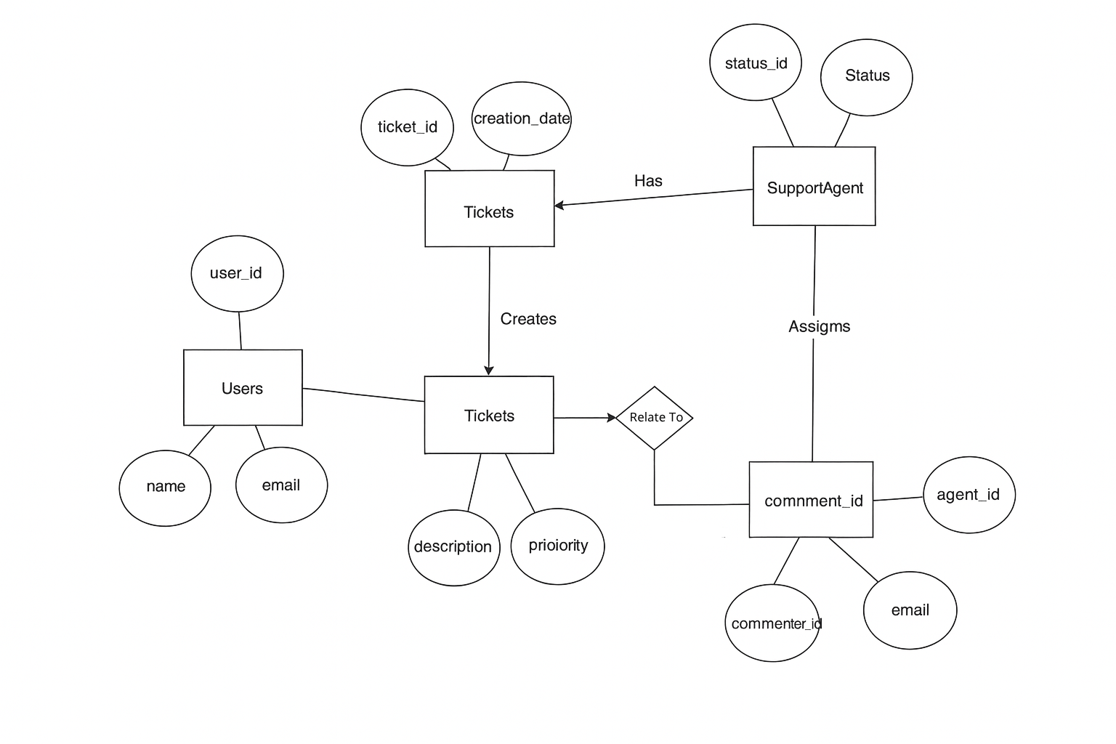
4. User story of shopping from ecommerce.

User Story no: 1 | Tasks:3 |  | Priority: Highest
As a user,
I want to register an account,
so that I can securely log in and shop.
BV:50 |  | CP:05
Acceptance criteria:
- The registration form includes name, email, password, and phone number.
- A verification email is sent and must be confirmed before login.
- Password must meet complexity rules (min 8 chars, 1 special char)

User Story no: 2 | Tasks:2 |  | Priority: Highest
As a user,
I want to log in with my credentials,
so that I can access my account.
BV:50 |  | CP:02
Acceptance criteria:
- Login is successful with a valid email and password.
- Error message is displayed for invalid credentials.

User Story no: 3 | Tasks:3 |  | Priority: Highest
As a user,
I want to search for products by name,
so that I can find what I am looking for quickly.
BV:20 |  | CP:08
Acceptance criteria:
- Search results display relevant products.
- Results update within 1 second of user input.
- No results message appears if no matches are found.

User Story no: 4 | Tasks:3 |  | Priority: Medium
As a user,
I want to filter products by price, category, and rating,
so that I can narrow down my choices.
BV:50 |  | CP:08
Acceptance criteria:
- Filters must dynamically update product lists.
- Selected filters should be highlighted.

User Story no: 5 | Tasks:3 |  | Priority: Medium
As a user,
I want to view product details,
so that I can decide whether to purchase them.
BV:50 |  | CP:03
Acceptance criteria:
- Product page includes name, description, images, price, and reviews.
- Users can zoom product images.
- Similar products are suggested below.
User Story no: 6 | Tasks:2 |  | Priority: Highest
As a user,
I want to add products to my cart,
so that I can purchase them later.
BV:100 |  | CP:03
Acceptance criteria:
- Items are added to the cart with a quantity selector.
- Confirmation message appears after adding.

User Story no: 7 | Tasks:2 |  | Priority: Highest
As a user,
I want to view my cart,
so that I can review the items before purchasing.
BV:100 |  | CP:05
Acceptance criteria:
- Cart displays product name, price, quantity, and total.
- Users can edit or remove items.

User Story no: 8 | Tasks:2 |  | Priority: Highest
As a user,
I want to update quantities in the cart,
so that I can buy the exact amount I need.
BV:20 |  | CP:03
Acceptance criteria:
- Cart updates automatically with quantity changes.
- Subtotal adjusts with quantity changes.

User Story no: 9 | Tasks:2 |  | Priority: Medium
As a user,
I want to remove items from the cart,
so that I can manage my purchases.
BV:10 |  | CP:02
Acceptance criteria:
- Items are removed when delete is clicked.
- Total is recalculated after removal.

User Story no: 10 | Tasks:2 |  | Priority: Highest
As a user,
I want to proceed to checkout,
so that I can complete my purchase.
BV:100 |  | CP:08
Acceptance criteria:
- Clicking “Checkout” redirects to secure payment page.
- Cart summary and delivery address appear on checkout screen.
- Total amount includes taxes and shipping.

User Story no: 11 | Tasks:3 |  | Priority: Highest
As a user,
I want to add multiple delivery addresses,
so that I can choose where my orders are sent.
BV:50 |  | CP:08
Acceptance criteria:
- Address book allows adding, editing, and deleting addresses.
- Selected address is highlighted during checkout.

User Story no: 12 | Tasks:2 |  | Priority: Medium
As a user,
I want to choose a delivery method,
so that I can decide between standard or express shipping.
BV:20 |  | CP:05
Acceptance criteria:
- Delivery charges update based on the selected method.
- Estimated delivery dates are shown.

User Story no: 13 | Tasks:2 |  | Priority: Highest
As a user,
I want to apply coupon codes,
so that I can get discounts.
BV:50 |  | CP:08
Acceptance criteria:
- Valid coupon reduces the order total.
- Error message for expired or invalid coupons.

User Story no: 14 | Tasks:3 |  | Priority: Highest
As a user,
I want to pay online securely,
so that I can complete my order.
BV:100 |  | CP:13
Acceptance criteria:
- Supports multiple payment methods (credit card, UPI, wallets).
- Payment gateway is secure and encrypted.
- Users receive a confirmation email upon payment.

User Story no: 15 | Tasks:2 |  | Priority: Highest
As a user,
I want to track my order,
so that I know the delivery status.
BV:50 |  | CP:05
Acceptance criteria:
- Order status updates include “Processing,” “Shipped,” and “Delivered.”
- Tracking link redirects to courier service.

User Story no: 16 | Tasks:2 |  | Priority: Medium
As a user,
I want to cancel an order,
so that I can avoid receiving items I don’t need.
BV:20 |  | CP:05
Acceptance criteria:
- Orders can be cancelled if not yet shipped.
- Refund confirmation is sent for prepaid orders.

User Story no: 17 | Tasks:2 |  | Priority: Medium
As a user,
I want to view my order history,
so that I can see past purchases.
BV:10 |  | CP:03
Acceptance criteria:
- Order history includes product name, order date, and status.
- Clicking an order shows its detailed invoice.

User Story no: 18 | Tasks:2 |  | Priority: Highest
As a user,
I want to add products to a Wishlist,
so that I can save them for future purchases.
BV:20 |  | CP:05
Acceptance Criteria:
- Wishlist persists even after logging out.
- Items can be added to the cart from the Wishlist.

User Story no: 19 | Tasks:2 |  | Priority: Medium
As a user,
I want to write reviews,
so that I can share feedback on products.
BV:10 |  | CP:08
Acceptance criteria:
- Reviews include ratings (stars) and comments.
- Only verified buyers can leave reviews.

User Story no: 20 | Tasks:3 |  | Priority: Medium
As a user,
I want to receive order notifications,
so that I am updated about my purchases.
BV:20 |  | CP:05
Acceptance criteria:
- Notifications are sent for order confirmation, shipping, and delivery.
- Notifications are sent via email and SMS.

