Waterfall Model Documents ---Project –Part 2/2
Document 6---Please prepare a use case diagram, activity diagram and a use case specification a
1.Use case Name: Login
2.Use case Description: This use case describes how a branch staff member logs into the E-Call Back portal to verify and digitally sign off on branch reports that were previously verified in physical format.
3.Actor: Who are using particular system
Primary Actor: Branch Staff
Secondary actors (Supporting Actor): System Admin, Core Banking System (for reports generation)
4.Basic Flow: Sequence of sets to follow to perform use case
1. Staff logs into E-Call Back Portal
2.System authenticates the credentials
3.System grants access and shows the main dashboard

5.ALTERNATE FLOW: When the End user get stuck to execute his/her basic flow of events then he/she will come into this alternative flows
Login Failure: If credentials are invalid, system shows error message.
Reports Error: If reports are not in proper format/updating error
Network Timeout: If the session times out, user is redirected to login page.
6.Exceptional Flows: System Failures /ID Block
Server Down/Power down
When the End user is unable to execute his/her basic flow of events and Alternatives flows then he/she will be getting into this Exceptional Flows
7.Pre-Conditions: Prerequired/precondition to perform the use cases (all this condition to be satisfied)
*Active Internet and System should be up and running
* Staff must have valid login credentials and access rights to the portal.
*Reports must be uploaded or auto-synced from the Core Banking System
8.Post-Condition: Ends Results either Positive or Negative
8a) Successful execution: *User is logged in and redirected to the dashboard. *Audit trail is recorded
8b) Unsuccessful Execution: Alternative flow & Exceptional not executive
9.Assumptions: Which are considering True at this moment but later on it might be true or false.
- All user will have ADID credentials for authentication
- Branch users will have required hardware (computer, internet access)
- Staff will be trained before the rollout
- Reports will be assigned in system as per standard compliance process 10.Contstrains: Which are limitations to improve the efficiency of the functionally or system
- Internet dependency across all branches
- Limited tech-savvy staff at some branches may delay adoption

11.Dependencies: The dependent use cases to perform your current use cases
- Staff Login Id /Password
- Transaction in Branch
12.Inputs and Outputs: Values entering into systems are considered as Inputs
Inputs: User Name, Password, Report Name, Report Updating
Outputs: Reports verified
13.Business Rules: Which are influencing your Current Use case
1.Reports must be verified same day during office hr.
2.Only authorized staff can approve/reject
3.System logs every action with timestamp and user ID

Use Case: Select Branch Transaction Report
1.Use Case Name: Select Branch Transaction Report
2.Use Case Description: This uses case describes the process of select branch transaction report.
3.Actors: Primary Actor: User
Secondary Actor: System
4.Basic Flow: * User navigate to reports section *User selects the required branch and transaction reports
5.Alternate Flow: When the End user get stuck to execute his/her basic flow of events then he/she will come into this alternative flows
Reports Error: If reports are not in proper format/updating error
Network Timeout: If the session times out, user is redirected to login page
6.Exceptional Flow: System Failures /ID Block
Server Down/Power down
When the End user is unable to execute his/her basic flow of events and Alternatives flows then he/she will be getting into this Exceptional Flows
7.Pre-Condition: System must be available; user must have valid credentials (for login0
8. Post Condition: Successful completion of select branch transaction report
9.Assumptions: User has required permission to perform this action.
10.Constraints: System performance, security policies, data availability.
11.Dependencies: Dependent on prior successful steps (e.g. login before report upload)
12.Inputs and Outputs: Inputs required and system outputs after select branch transaction report
13.Bussiness Rule: Relevant rules or validations for select branch transaction report.

Use Case: Upload Report
1.Use case Name: Upload Reports
2.Use Case Description: This uses case describes the process of upload reports
3.Actors: Primary Actor: User Secondary Actor: System
4.Basic Flow: *User upload a report *System validates and store the report * User can view uploaded reports.
5.Alternate Flow: When the End user get stuck to execute his/her basic flow of events then he/she will come into this alternative flows
Reports Error: If reports are not in proper format/updating error
Network Timeout: If the session times out, user is redirected to login page
6.Exceptional Flow: System Failures /ID Block
Server Down/Power down
7.Pre-Condition: System must be available; user must have valid credentials (for login0
8. Post Condition: Successful completion of upload reports
9.Assumptions: User has required permission to perform this action.
10.Constraints: System performance, security policies, data availability.
11.Dependencies: Dependent on prior successful steps (login before report upload)
12.Inputs and Outputs: Input required and system outputs after upload reports
13.Bussiness Rule: Relevant rules or validation for upload reports.
Use Case :Verify Report
1.Use case Name: Verify Reports
2.Use Case Description: This uses case describes the process of verify reports
3.Actors: Primary Actor: User Secondary Actor: System
4.Basic Flow: *User opens a report for verification *System displays the reports
*User verifies details.
5.Alternate Flow: When the End user get stuck to execute his/her basic flow of events then he/she will come into this alternative flows
Reports Error: If reports are not in proper format/updating error
Network Timeout: If the session times out, user is redirected to login page
Exceptional Flow: System Failures /ID Block
Server Down/Power down
7.Pre-Condition: System must be available; user must have valid credentials (for login0
8. Post Condition: Successful completion of verify reports
9.Assumptions: User has required permission to perform this action.
10.Constraints: System performance, security policies, data availability.
11.Dependencies: Dependent on prior successful steps (login before report upload)
12.Inputs and Outputs: Input required and system outputs after upload reports
13.Bussiness Rule: Relevant rules or validation for upload reports.

Activity Diagram: Activity diagram is flowing chart to represent the workflow

Login

Document 7-Screens and pages
Pls follow the following steps to create the mock-ups
1.Kindly use balsamic or Axure
2.Always start with a home page of and application
3.Take a feature and follow it to the end.

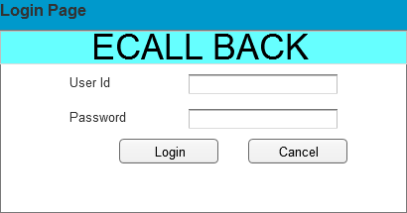

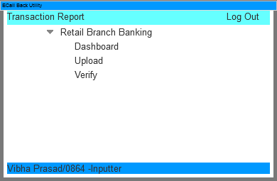

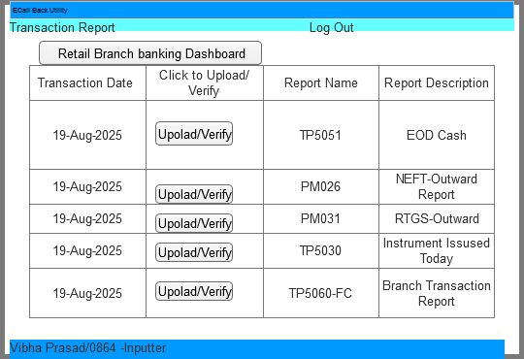

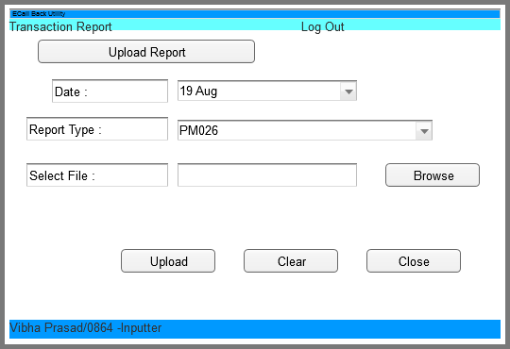
Verifier Page
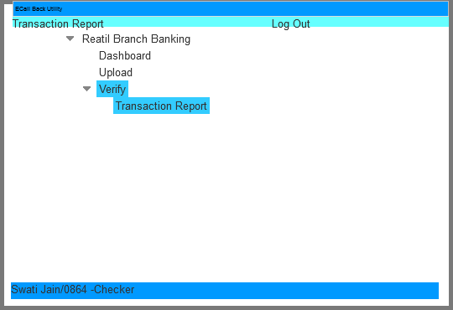

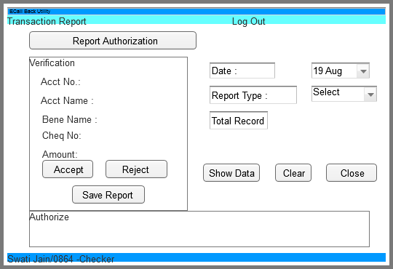
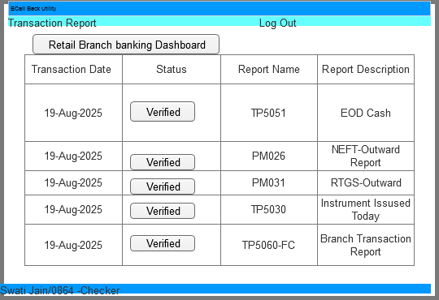

Document 8 -Tools -Visio and Axure
Write paragraph on your exp using Visio and Axure for the project.
In the E-call Back project, where the online verification of reports replaces the earlier manual verification done at branches, different tools were used to visualize and design the system. Two of the main tools were Ms Visio and Axure RP
Visio: A diagramming tools by Microsoft
Simple Use: Helps to draw process flows, workflows and system diagrams.
Use in E-Call Back Project: ---Used to show the ‘AS-Is process (manual branch verification)
---Used to design the T0-BE process (Online verification)
----Makes it easy for stakeholders to visualise steps, responsibilities, and data movement.
To prepare a practical, flexible, easy to make, easy to understand flow chart or organizational chart the ultimate choice, in most cases, will be MS Visio, an innovative wat to visualize a business process. Visio enables to learn about organizational setup, flow of documentation, and procedures along with cause-and-effect diagrams, the most important is that the diagram is self-explanatory for presentation purpose.
Axure RP: A tool for creating wireframes, prototypes and mock-ups of applications
Simple Use: Helps to design and show screens of how the online system will look and work before actual development.
Use in E-Call Back Project: ---Used to create screen designs of the online verification portal (eg Login Screen, Verification report, report view)
---Helps business users and developers see and agree on the design before coding starts.
---Useful during User Acceptance Testing (UAT) discussions.
A clickable prototype in Axure allows a user to click ‘Verify Report’ and see the report, without writing real code.
Visio ----Best for process flow diagram (what steps happen)
Axure ----Best for screen prototypes (how the system will look and feel)

Document 9- BA Experience
Project Overview: The E-Call Back Project aimed to digitize the manual reporting and voucher verification process in the bank. Earlier, Branch staff printed and physically submitted reports, which were verified manually. With this portal, staff now upload reports online, and designated officers verify them against physical vouchers in streamlined workflow.
My experience as BA in following phases:
1.Requirement gathering: Used Moscow technique to prioritize core functionalities like uploading reports, verifying against vouchers, and status tracking/showing on dashboard.
- When client stakeholders were unavailable, I coordinated with alternate contacts to ensure information flow.
- Validate requirements using FURPS model (Functionality, Usability, Reliability, Performance, Supportability)
- Identified duplicate and conflicting, requirements and eliminated them during walkthroughs.
- Used prototyping to clarify how uploaded reports would appear and be validated.

2.Requirement Analysis:
- Created UML diagrams to explain the report upload and verification flow
- Developed Activity Diagrams to show step-by-step process
- Branch logs in---Upload reports---Other branch staff verifies with physical vouchers---Status updated
- Communicated visuals and logic with development team for clarity and collected feedback. Took feedback from team members, made correction and ensure alignment between business and technical teams.
- Prepared both Business Requirement Specification (BRS) and Software Requirement Specification (SRS).
- 3.Design:
- Converted use case like Upload Report, Verify Report and Reject Report into test scenarios.
- Engaged client for feedback on solution and validation logic.
- Wrote/Designed positive and negative test scenarios (e.g. invalid file format, wrong data range, successful verification mismatch, network failure)
- Maintained Requirement Traceability Matrix (RTM)
- Prepared mock data for various reporting frequencies (Daily, Weekly, Monthly)
- Prepare test data requirements (KYC details, report reference numbers)
- Ensure compliance requirements are embedded into solution design.

4. Development:
- Organized Joint Application Development (JAD) sessions to clarify requirements and process logic.
- Addressed non-cooperative or confuses team members through one-on-one clarification meetings.
- Shared workflow diagrams and validation rules for each stage of upload and verification.
- Help regular meetings with technical and business users to bridge communication gaps.

5. Testing:
- Derived test case from use cases (e.g. Upload, Verify, Reject)
- Conducted system and integration testing before UAT.
- Sourced test data directly from client branches to simulate real-world scenarios
- Updated RTM with test results.
- Took sign-off after successful UAT.
- Helped client prepare for go-live with training and support material.
6. Deployment:
- Forwarded the RTM to the client to be included in the final Project Closure Document.
- Coordinated the preparation and distribution of end-user manuals detailing:
- How to upload reports
- How to verify reports with vouchers
- Common errors and resolutions steps
- Planned and organized training sessions for all bank staff involved in uploading and verifying reports.
- Ensured full attendance in training by sending calendar invitees, reminders and managing attendance through follow-ups.

