Document 6- Please prepare a use case diagram, activity diagram and a use case specification document.

Use Case Diagram

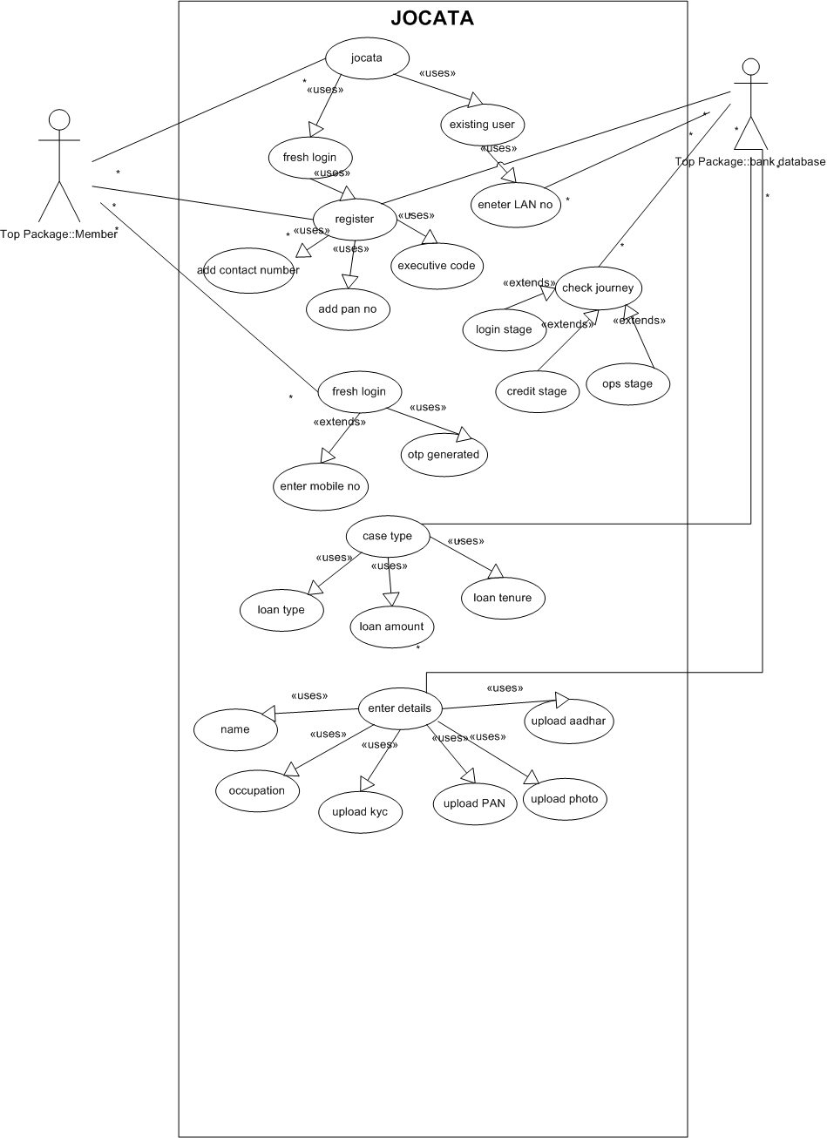

Activity Diagram

- Open Jocata to operate as a new user or existing user

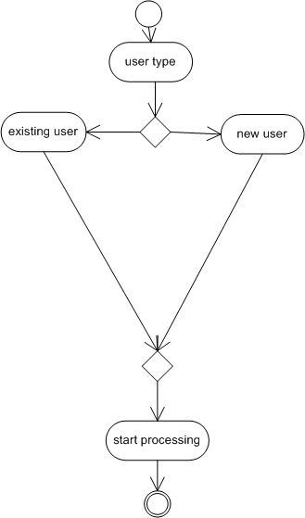

- Fresh login
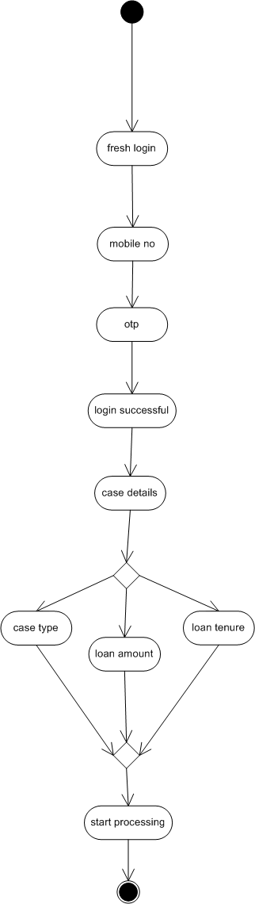
- Enter details to process.

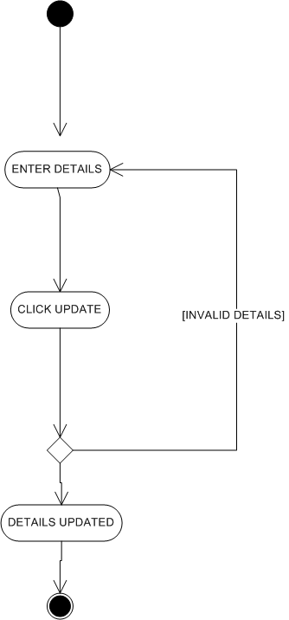

Use Case Spec
Section | Content
Use Case Name | Jocata Enhancement
Description | Customer applies for a new loan via Jocata, providing details and required documents.
Primary Actor | Customer
Secondary Actors | Ops team, Credit Team, Jocata (System)
Basic Flow | 1. Customer logs in → 2. Starts new loan application → 3. Fills personal, employment, KYC info → 4. Uploads supporting documents → 5. Accepts T&C → 6. Submits application → 7. Receives acknowledgment.
Alternate Flow | If application form incomplete: System shows prompt; Customer can save and resume later.
Exceptional Flows | System unavailable/timeout; Incorrect file format; Unverified KYC triggers rejection/hold.
Pre-Conditions | Customer logged in with valid credentials; Product and amount selected.
Post-Conditions | Application submitted and stored; Customer receives acknowledgment and tracking ID.
Assumptions | Customer has all required documents and details; Network connection is stable.
Constraints | File size/type limits on uploads; One active application per customer at a time.
Dependencies | Registration and login completed; KYC verification service is online.
Inputs | Personal info, income/employment details, documents, loan parameters.
Outputs | Application status, tracking number, email/SMS alert.
Business Rules | All fields must be completed; Documents must be valid (per KYC/AML); Application sent to scrutiny workflow.
Miscellaneous | User interface multilingual; Session auto-timeout for inactivity.

Document 7- Screens and pages
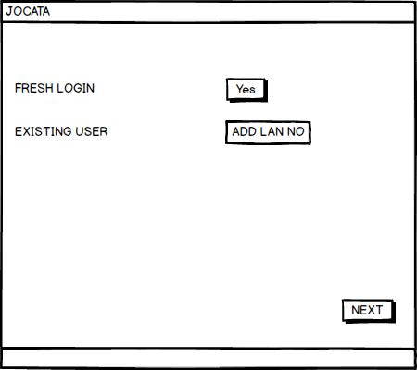
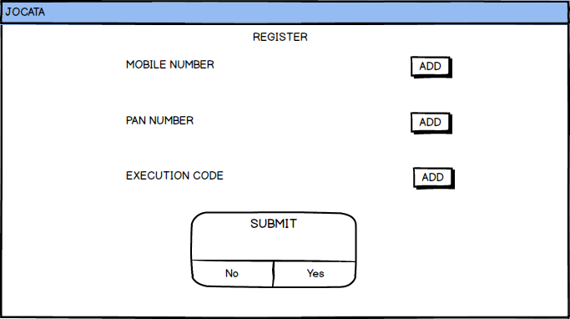
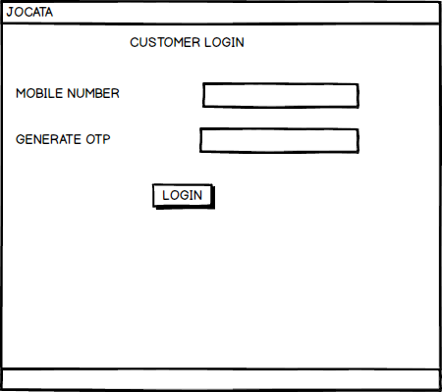
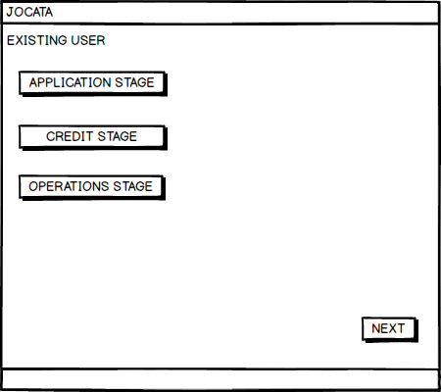
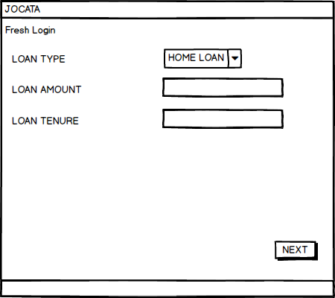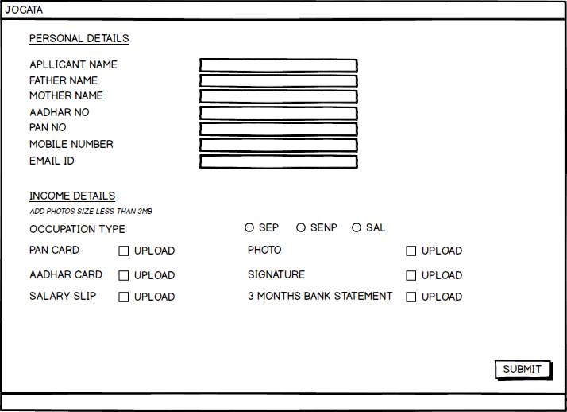

Document 8- Tools-Visio and Axure

Write a paragraph on your experience using Visio and Axure for the project.
I have found Microsoft Visio to be a valuable tool for our company. Overall, Microsoft Visio is a powerful diagramming tool, its extensive feature set and user-friendly interface make it a great choice for robust diagramming capabilities. I found the tool very useful for preparing Use Case diagrams and Activity diagrams.
I have found Axure tools really helpful because of its wireframing and prototyping capabilities. It has many features such as dynamic interactions, animation effects etc which are really helpful.

Document 9- BA experience
My experience as BA in following phases:
Requirement gathering:

To gather requirements, we used MOSCOW technique.
Client is not available for some period of time during this phase. So as a BA i need to source out point of contacts from his side and get the information asap.
I validate the requirements using FURPS technique
There are many requirements which are duplicated or repeated. We need to remove them immediately
Prototyping is used to give more specific requirements

Requirement Analysis:
We need to draw UML diagrams to visually describe the requirements
Activity diagrams also used to describe the process flow
Communicate the diagrams to team. Some team members might not agree with them and might make changes. As a BA we need to consider the points and make modifications
Prepare BRS and SRS

Design:
From the use case diagrams, we prepare test cases
Communicate with client on design and solution documents
Write negative test cases as well along with positive test cases.
Do not miss a single test case. It might have huge impact on project development in later stages
Prepare test data for testing
Update RTM. This is must as we need to make sure that all the requirements are met

Development:
Organized JAD sessions
Clarifying queries of tech team during coding
There might be some team members who doesn't agree with the concept or who doesn’t cooperate during JAD sessions. As a BA i handle the situation gently and had one on one discussion with them. Explained how their actions are going to affect the project. Setup healthy environment within the team.
Referred diagrams to code the Unit
Conduct regular meetings with technical team and client which is challenging. Some team members might not be available for the meeting. Recording the session and providing that to missed one and having one to one discussion later with that missed person is all i need to do

Testing:
Prepare test cases from use cases
Perform high level testing
Test data is requested by BA from client
Updated RTM
Take signoff from client
Prepare client for UAT

Deployment:
Forwarded RTM to client which should be attached to project closure document
Coordinates to complete and share end user manuals
Plans and organizes training sessions
Make sure all the candidates attend the meeting

